Researching and Analyzing Data
Md Bablu Kamali
Student Number: 1605371
Tutor Name: Diola Bijlhout
Topic: Online Shopping

Table of Contents
Introduction 2
Research question 3
Findings 3
Outcome of online shopping 3
Some drawbacks of increased online shopping business 6
Conclusion 8
References 9

Introduction
Expansion of online business has been significantly increased over the last few years. Several maintenance and regulatory facilities can be considered as the most motivating factors for rising online shopping business. Online shopping has gained customers faith over the quality of services and timely shipping of goods. However, online shopping has been putting some difficulties on the street shop; reliance of customer on online shop causes a significant decrease of profit and revenue of street shop. Online shopping business expansion is contributing to the business expansion and creating employment. Street shop is also important for customer to get instant product or services where online shop may require some time to deliver the services or products. However, increase in online business has putting negative impact to the street shop in term of revenue and profit generation. How online shop has been negatively affecting street shop has been evaluated in this report.

Research question
Online business taking place of street shop as many more retailers are concentrating on online shop instead of street business. Street business, however, faces the threat of existence for this reason. But online business may be good for the customers’ perspective; it is harming the national economy at the same time (Begg, 2013). Because increase in retailer business over online decreases street shop income and decrease in income causes decrease in tax. The main research question for evaluating the impact of online business on street business and impact on economy is:
- Whether rise in online shopping is good for economy and government income?
Online business has been facilitated by lower tax for some treasury tax base disappears sometimes. So the impact of online business has been affecting national growth indirectly. For the broad analysis some sub questions are developed. Those are given below:
- How street businesses are changing because of online shopping?
- How tax income of government affected due to online shopping?

Findings

Outcome of online shopping
Increase in online shopping business has given business a new level for serving the customer at the doorstep. Customers are getting required products and services easily just clicking on order and products are getting delivered within short period of time. The expansion of online shopping also increases the new entrepreneur to start business. Expansion of business is helping the national growth significantly and reducing customer effort to purchase a product.
Increasing national growth of business
Online shopping has been in the driving sit in retailing business over the recent times. Most of the customer seems to buy goods and services through online rather than going to the street shop. To fulfil the increasing demand numerous online business organizations has been working on expanding their corner shop (Butler, 2017). In this case we can use the example of John Lewis initiative to extend online shopping empire by 5000 independent retailers via thousands of corner stores. In this process John Lewis will conglomerate department stores to Collect+ scheme, which will allow customers to buy and return items bought. John Lewis customers will also be able to collect items at about 1,000 of those outlets in Scotland, Northern Ireland and south-west England which are causing the expansion of business.
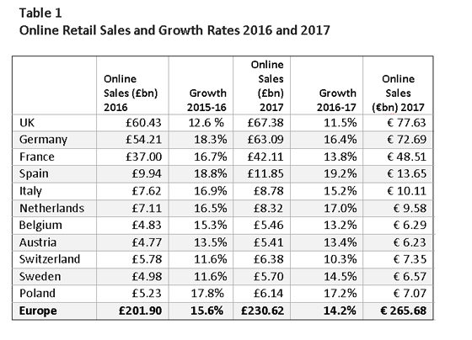
Figure 1Online retail sales and growth.
Source: World Economic Review, 2017
So-called facility introduced by John Lewis "click and collect" doubled at John Lewis in 2016 contributing 35% of online sales. About a quarter sales rose by 44% for John Lewis. This is the indication of business growth which leads 11.5% growth of UK online sales in 2016-17.
Increasing living standard
By the increase in online shopping people are having life with more simplicity and hassles. Now daily necessary product can be easy purchased and delivered to the home which makes the living standard. Besides, increase in business increases the national income at the same time (Brewister, 2017). Online business has been contributing in the growth of per capita income every year. People are finding online shopping more interesting for fulfilling necessary needs.
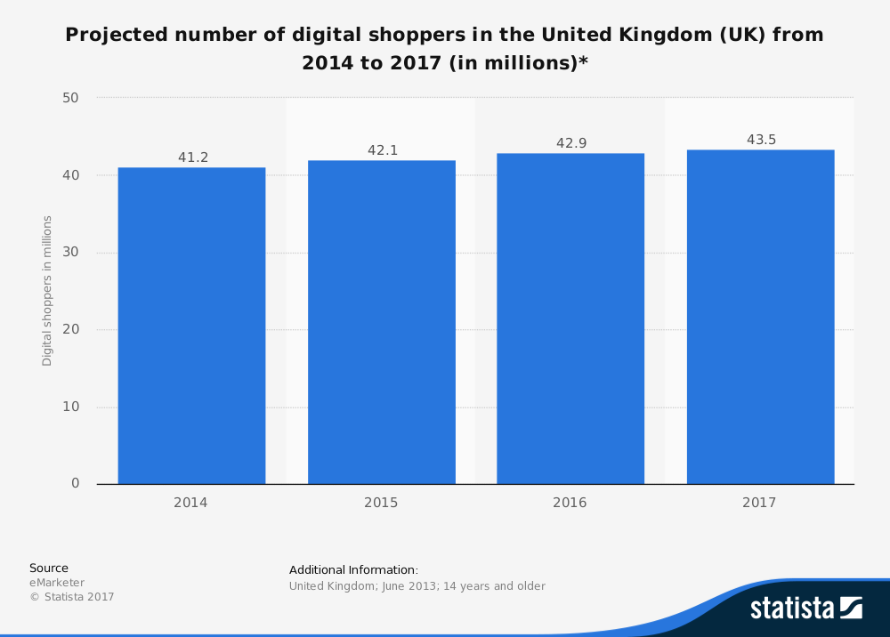
Figure 2Projected Shoppers in UK, Source: The Guardians, 2016
The graph shows the increase in online customers. In 2017, around 44 million people are projected to be digital shoppers which are the good indication of business. These will directly lead to the further development in living standard.
Contributing to the national economic growth
Being the third biggest contributor of economy contributing around 8% of GDP online shopping business has been getting more focus of the government. One of the member of UK's biggest tech investors has insisted the City and FTSE 100 companies to wake up and increase more to the internet and warning to the companies that there will be more casualties to come if they do not strengthen their online (Harvey, 2017). Another example can be given as, Saul Klein who is a partner of Index Ventures and former chief executive of Skype, said that digital business is now third biggest sector to the economy, but the City and the public sector are asleep and should consider the significance of this sector. He also mentions the "American internet companies like Google and Amazon who have walked and taken away the benefits UK should have. So importance of online shopping business has to consider with more importance to increase the scope of development.
Less cost of business
Online shopping business expansion in UK has decreased the carrying cost of materials to a significant level. Organizations are shifting from traditional business to online business due to this advantage. Basically biggest retailers are shifting to online business as Amazon, Tesco, Agro, Epson; Asus are doing great through online shopping business. Organization can minimize the carrying cost of products to the minimum level through online business. Because, an online business doesn’t require maintain costly interior, store materials or cautious maintenance for business activity (Brewister, 2017). Organizations are setting up a strong link up with customer through online advertising, showing the quality and details at the same time which gives customer numerous choices to purchase a product. However, customer and retailers both are having win-win situation from the expansion of retail shopping business.
Competing internationally
Online shopping business should be focused more to compete with the companies of other countries. The recent progress of online business is important for UK economy as still Amazon, Google and some other USA and foreign online shopping dominating the online business in UK.. To reduce the dominance of foreign companies in UK in online business the development and progress is a must for the betterment of the economic performance (O’Carroll, 2017). So the increase in online shopping business should be positive to the overall development of the economy. Recent stat shows that the value of Ecommerce in the UK was worth €153 billion in 2016 which can help in economic development significantly.

Some drawbacks of increased online shopping business
Online shopping has made shopping easier for customer. But there are some drawbacks of online shopping. Online shopping business may have gained customer confidence but there is high scope of doing fraud. Recent cases shows there are huge amount of money has been fraudulently disguised by some online fraud. Business activities through online however, is posing the threat on privacy of common people. Some of the negative impacts of online shopping business are:
Scope of fraudulence
Online shopping has increased the chance of doing fraud through giving inappropriate information and details of product. Sometimes quality and price don’t match at all. However this is very little in number. But in the recent days newspaper has published that online shoppers have lost 16 million pound last year through fraudsters. The report also mentioned that losers of money are between 20 to 29 years of age. Victims of that crime reportedly lost out while buying things like Yeezy trainers, Kylie Jenner makeup, and Fitbit watches. Major portion of cybercrime which is measured to be around 65% during that period were related to online auction sites mostly (Harvey, 2017). A year before similar cyber-crime incurred in which people lost around 10 million pound. This year shows 60% increase in losses over cybercrime to the online shoppers. Amazon was revealed using its Luxembourg subsidiary for avoiding tax paying in the UK and also Google's £2.5bn in UK revenue has resulted in tax bill of £3.4m in 2011 which are very low and fraudulent, as it channels profits via Ireland and Bermuda.
Negative impact on tax income
The increase in online shopping business is causing a huge decrease in the street shops which are contributing a large portion of tax to the government. But somehow online shoppers are avoiding the tax because of the disappearances of tax base. It has been warned by Chief executive of Kingfisher that the government has been losing out on one of its biggest sources of revenue because of the failure to reform the tax system to the online business to take account of online selling. Ian Cheshire who is the chief executive of Kingfisher, said that he would close 25% of his company's stores which were not under long-term leases and other arrangements which were making the closures expensive for Kingfisher. He also indicated that business rates the biggest charges on the retailer faces in developing business, around £120m contributed by retailers in the tax each year to the government (Brewister, 2017). If the retails businesses were to reduce by the number of current position by 25% fewer stores would be 25% less tax and government will get less tax which has been warned Cheshire, who also said that the company's revenue and profits would not be affected by any change in retail shop.
Decrease of street shop
Dependence on online shopping has been posing threat to the street shop. As though online business has reduced the hassles regarding product purchase, it still doesn’t fulfill customers expectation. But gradual decrease of market share for street shop not only affecting the economy but also making online shopping more necessary as customers have to rely on online shopping.
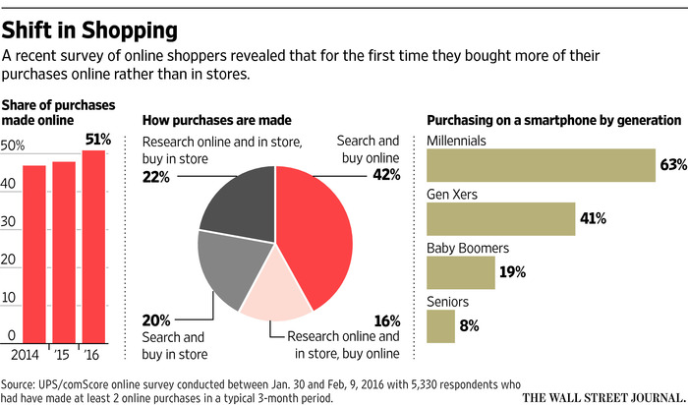
Figure 3Shift in shopping, Source: (Ecommerce Business, UK, 2017
Online shopping is mostly increases Privacy concern and Cybercrime Prone. Recent days cybercrime has been causing organization and bank account holders losing huge amount of money from their accounts. So, online business increase has been posing threat to the privacy, street shop and facilitated cybercrime in recent days.

Conclusion
Online shopping has been affecting the national economy both positively and negatively. Increase in business activities and reducing the cost of doing business online shopping business in an encouraging source for investment. Tax contribution, contribution to the per capita income, growth of living standard and overall economic development are the result of increasing online shopping. Klein one of biggest investors in UK tech said it is time to transform mission to boardroom thinking and predicted that digital business to grow 12.4% of the economy in 2016. Though there are some negative effects regarding privacy, cybercrime and decrease in street shoppers, increase in online shopping business is a good indication for economic development of UK.

References
D., Margea, C., Hurbean, L. & Artene, A.S. (2014), "Electronic Services for Business Environment", Procedia - Social and Behavioral Sciences, vol. 124, pp. 351-360.
Brewister, A. (2017). Ecommerce in the UK was worth €153 billion in 2016. [online] Ecommerce News. Available at: https://ecommercenews.eu/ecommerce-uk-worth-e153-billion-2016/ [Accessed 4 Dec. 2017].
Begg, D., (2013), Foundations of Economics, 5th ed., McGraw-Hill Higher Education
Butler, S. (2017). John Lewis to extend online shopping empire via thousands of corner stores. [online] the Guardian. Available at: https://www.theguardian.com/business/2013/feb/21/john-lewis-online-shopping-collect?INTCMP=ILCNETTXT3487 [Accessed 4 Dec. 2017].
Ecommerce News. (2017). Ecommerce in The United Kingdom - Ecommerce News. [online] Available at: https://ecommercenews.eu/ecommerce-per-country/ecommerce-the-united-kingdom/ [Accessed 4 Dec. 2017].
Harvey, F. (2017). Kingfisher chief warns of store closure over online firms' tax advantage. [online] the Guardian. Available at: https://www.theguardian.com/business/2013/mar/04/kingfisher-warns-of-store-closures [Accessed 4 Dec. 2017].
O&#x27;Carroll, L. (2017). City must wake up to digital growth, says tech investor. [online] the Guardian. Available at: https://www.theguardian.com/business/2013/mar/01/city-wake-up-digital-investor [Accessed 4 Dec. 2017].
Daniels, J.D., Radebaugh, L.H. and Sullivan, J.H., (2012), International Business Environments and Operations, 14th International ed., Prentice Hall, London

