Building Information Modelling

Assignment 1 – Client Letter and Draft BEP

Lecturer: Gavin Traylor
Student: Cai Gibbons
Student Number: 1907914
Course: Civil Engineering

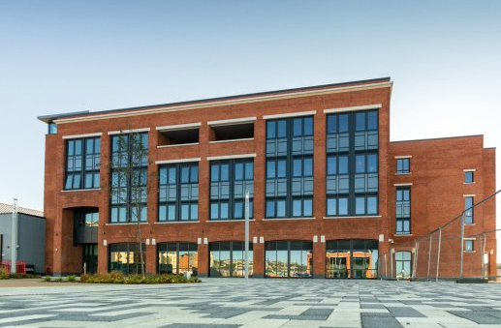

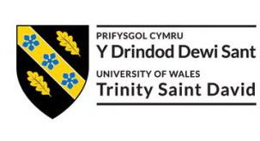

Contents List

1.0 - A BIM Execution Plan (BEP) (Page 3)

2.0 - Why a BEP is a Project Requirement (Page 4)

3.0 - BIM Levels (Page 4)

4.0 - Complying with BIM Level 2 (Page 5)

5.0 - BIM Level 2 Delivery (Page 5)

6.0 - Standards (Page 6)

7.0 - Conclusion (Page 8)

8.0 - Reference List (Page 21)

9.0 Image References (Page 23)

Cai Gibbons
Gibbons LTD
6 Malvern Terrace
Swansea, SA6 0BE
29th April 2021
Mr. John Jones
Swansea Council
16 Graig Road
Swansea SA3 8YT

Dear John Jones,
Please find below an understanding of how Ysgol Bae Abertawe is going to comply with BIM Level 2, supported by a draft BIM execution plan.

1.0 A BIM Execution Plan (BEP)

The key element in the acronym BIM is ‘information’, which is the objective behind creating a BEP. A BEP is used to facilitate the management of project information within a BIM adopted project. It can be explained as a plan created to make the execution of the ‘information modelling‘ process more efficient, through thorough planning. A BEP is integral to all new construction development projects and is critical in projects where collaboration is required at an international level. Practically, a BEP can be related to the equivalent of an RFI (request for information), which is commonly found in the Information Technology sector. The BEP is prepared as a response to the employer’s information requirements (EIR), with the expectations of the BIM process through a BIM template being prepared by the owner, with contractors or a design team then presenting their ways of delivering the project by outlining the complete construction process through the BIM execution plan. Project deliverables and information exchange protocols and requirements are detailed in the BEP, which is then reviewed and agreed by the owner.

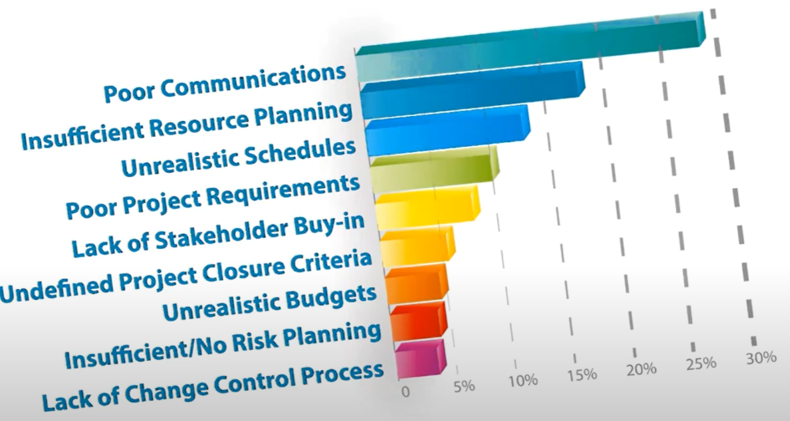
Fig 1 - The Causes of Project Issues

2.0 Why a BEP is a Project Requirement

Fundamentally, a BEP is a plan. Sufficient planning is detrimental in the construction industry and is the answer to a myriad of common project problems. Effectively, the BEP is a form of eliminating risks, which will only work if risks are identified in the first place. The chart above displays the most common complaints from the construction industry. The implementation of a BEP aids in combatting these problems, with co-ordination being a pushing factor that boosts communications, especially when complex designs are involved, which is often the case in large scale BIM projects. Co-ordination will aid in avoiding failures and identifying risks at an early stage. Another major factor is the ability to determine accurate project costings and then avoid over-spending. Importantly, project expectations are more aligned with the project realities through the use of a BEP, as it aids greatly in knowing exactly where you are within a project, as well as what process is the next step.

The use of a BEP is an acclaimed concept, which is highly acknowledged worldwide by process-orientated professionals within the industry, with the BEP being referred to as the ‘rule book’ of construction projects. Stakeholders benefit from this as it lays out the whole project in front of them, allowing them to gauge a thorough understanding and improving their involvement within the project team. In the case of there being a change in course or detail within the project, the general construction plan remains clear and can still be implemented. A professional BEP ensures that the broader view of the project is viewed, which results in cases of projects being under budget and delivered on time.

3.0 BIM Levels

Worldwide, BIM mandates are emerging. These mandates entail BIM policies that are to be implemented by the concerning government for centrally procured projects - regardless of their size. Some question the importance of these mandates, but when one embraces an open mind, they can recognise that government mandated BIM is aimed at reinventing the construction industry, through a leaner and more efficient process. Specifically, the United Kingdom has a set precedence with a heavy focus on the differing levels of BIM. Centrally, the levels of BIM are a set criterion that progress from level 0 to level 3. Distinctive milestones are highlighted, which gently shift the construction industry into a fully collaborative environment. The diagram below displays the BIM levels, alongside their milestones and relevant standard to comply with such a level.

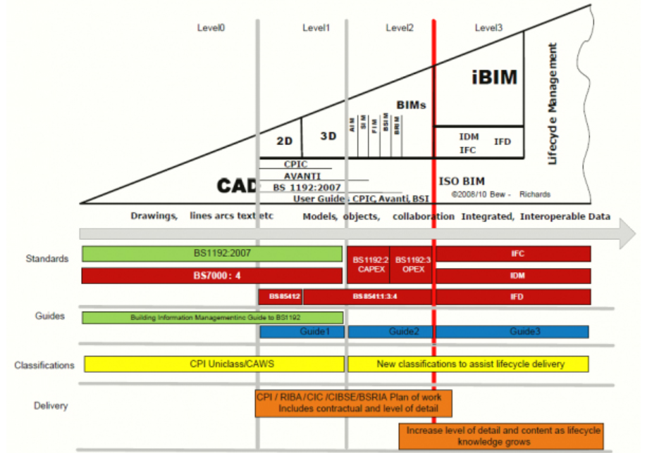
Fig 2 - Mark Bew’s BIM Wedge
CostX(2017)

4.0 Complying with BIM Level 2

The UK government set BIM level 2 as the minimum target for all centrally procured works in 2016. This meant that companies had to develop from previously working at BIM level 0 or 1 to meet the demands of the industry. Whereas BIM level 0 and 1 required the implementation of 2D and 3D CAD models, level 2 furthers this with the implementation of a collaborative working environment. This crucial aspect is bettered by improvements within the way information is shared between stakeholders. This does not necessarily mean working on a shared, single model (which is addressed in the implementation of BIM level 3) but may involve differing parties using various 3D models and forms of design information that are converted and shared using a common file format. An industry favourite is the Industry Foundation Classes (IFC) file format. This format is structured and re-usable, allowing all parties to combine data and models. This is an inherent positive as this allows for a more validated project audit, which further eliminates the risks of errors and reduces project waste. Ultimately, all asset information and project data is required to support efficient delivery from project start to finish, through standardised electronic transfer.
Plannerly (2021)

5.0 BIM Level 2 Delivery

To begin with, BIM level 2 requires a response to the Employer’s Information Requirements (EIR). This is done by preparing a BIM Execution Plan (BEP), a Master Information Delivery Plan (MIDP) and a Task Information Delivery Plan (TIDP). The use of intelligent software such as the NBS BIM toolkit can greatly aid with this. Using such software will provide a scheme for project deliverables, the roles and responsibilities of all parties involved, and the project schedule. Throughout the project, all team members are required to manage, store and exchange complex information, which is to be done through the use of a common data environment (CDE). The CDE offers a digitally shared workspace, in which everyone involved will exchange store project. The common data point that a CDE offers aids in managing the project development process.
NBS (2021)

To safely share project data, PAS 1192-5 used to be considered, but this has since been superseded by BS EN ISO 19650‑1:2018. This is explained in fig 5, but essentially it provides control over the way information is shared, ensuring it is being shared in a safe way. This is often governed by the software provider, with control required to access all information that is stored in the CDE, alongside the capability to manage and track shared data activity. Everyone involved in the CDE will benefit from knowing where specific data is stored, where to find it and what it means. A unified classification system is an intelligent way to achieve this, with a ‘common language’ being established. A single classification system makes locating project data quick and painless.

To continue from my previous recommendation of the use of the NBS toolkit, the BIM level 2 compatible classification system ‘Uniclass’ is a recommended system by professionals. This software offers consistent classification structure for all disciplines in the construction, with classification of items of all scales, ranging from large facilities to small products. The use of a classification system is a requirement for all BIM projects, as outlined in the BS EN ISO 19650 series, due to its essential format of identifying and managing the vast amount of information concerned in construction projects. Additionally, categorised information allows ease in calculating project costs, as well as categorising data for other important uses, such as briefings, annotations and CAD layering.

As stated in the UK Government BIM Working Party Strategy GOV (2011), collaboration is required through the use of 3D BIM to show all project information and requirements in a digital format. The software and data requirements detailed in the report are supplemented through the Construction Operations Building Exchange (COBie) format. As of January 2019, The UK National Annex within BS EN 19650-2 states that ‘non-geometric information exchanges in open data formats should be structed to meet the COBie format’ BSI (2021). An exact definition of COBie is included in page 59 of the Strategy Paper for the Government Construction Client Group, published in March 2011. Further analysis of this strategy reads “ In order to improve the measurement and management of public assets, it is recommended that public clients request that specific information be delivered by the supply chain. The specified information set, called COBie, delivers consistent and structured asset information useful to the owner-operator for post-occupancy decision-making” GOV (2011).

Typically, project information regarding a building is prepared in the form of drawings, specifications and bills of quantity. This requires a number of professionals to collaborate and then update findings throughout the construction phase. In many cases, this does not happen, or the documentation is supplied in paper format - making it difficult for the client to interpret. The driving force behind COBie is that essential information is collated in one format and then shared between the construction team at defined project stages. This data can be represented as a central spreadsheet containing all non-graphical data, which is to be stored, updated, and shared throughout construction. This data is eventually passed on to the client as a way of supporting the operations and maintenance of the project, as well as a form of verifying that the data collected meet the project requirements.

6.0 Standards

As highlighted in Fig 2, each BIM level is supported by relevant British Standards. To fully understand how to be compliant with BIM level 2 requirements, understanding and implementing these standards is detrimental. Besides British Standards, Publicly Available Specifications (PAS) and certain protocols are used to govern this process. As of January 2019, there was a standard overhaul and previously relevant standards transitioned to the new ISO standards BS EN ISO 19650‑1 and BS EN ISO 19650‑2. As a result of the publication of these new ISO standards, BS 1192 and PAS 1192‑2 have been withdrawn. This is explained in detail in the BSI Standards Publication Transition guidance to BS EN ISO 19650. The purpose of this transition is explained as “to help the readers and users of the UK standards familiarize themselves with the ISO standards as quickly and as easily as possible, and to move away from the UK standards that have now been superseded”. BSI (2021).


Fig 3 - The Transition of BS EN ISO 19650 -1 and -2

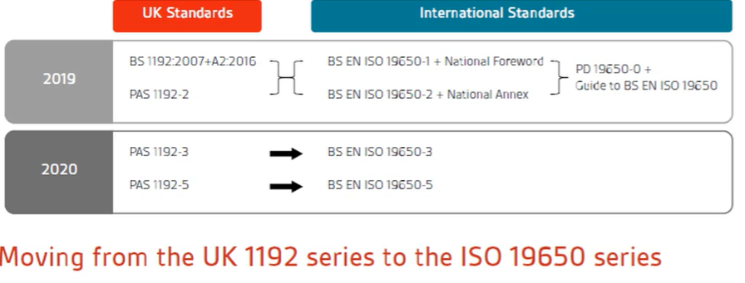
Fig 4 - Moving from the UK 1192 series to ISO 19650

In terms of the sector as a whole, the driving force behind this transition is the international value created, as with an internationally accepted approach, UK businesses will be able to compete and work on international projects, in a more effective manner. Moreover, a similar proposition as that to comply to BIM level 2, where a more systematic and standardized approach is taken to deliver projects on time and reduce project costs. The table below outlines standards that are required to be followed in accordance with complying to BIM level 2 within a project.

Document | Details
BS EN ISO 19650-1:2018 | Organization and digitization of information about buildings and civil engineering works, including building information modelling  (BIM). Information management using building information modelling concepts and principles.
BS EN ISO 19650-2:2018 | Organization and digitization of information about buildings and civil engineering works, including building information modelling  (BIM) -Information management using building information modelling. Part 2: Delivery phase of the assets.
BS EN ISO 19650-3:2020 | Organization and digitization of information about buildings and civil engineering works, including building information modelling (BIM). Information management using building information modelling. Operational phase of the assets.
BS 1192-4:2014 | Collaborative production of information. Fulfilling employer’s information exchange requirements using COBie. Code of practice.
BS EN ISO 19650-5:2020 | Organization and digitization of information about buildings and civil engineering works, including building information modelling  (BIM). Information management using building information modelling. Security-minded approach to information management.
PAS 1192-6:2018 | Specification for collaborative sharing and use of structured Health and Safety information using BIM.
BS 8536-1:2015 | Briefing for design and construction. Code of practice for facilities management (Buildings infrastructure).
BS 8536-2:2016 | Briefing for design and construction. Code of practice for asset  management (Linear and geographical infrastructure).
BSI (2021) Fig 5 - A Table to show Relevant Standards in Compliance with BIM Level 2

7.0 Conclusion

To conclude, by following the relevant standards listed throughout this piece, as well as the recommendations detailed, Ysgol Bae Abertawe can successfully be constructed to satisfy BIM level 2. Please read the attached draft BEP to understand exactly how this is going to come to fruition.

Kind Regards
Cai Gibbons

BIM Execution Plan

Project Name: Ysgol Bae Abertawe

Project Number: 5010

Project Address: Slipway Road, Maritime Quarter, Swansea SA1 1YB

Date: 29th of April 2021

Prepared By: Cai Gibbons

Contents

- Section 1 - Response to EIR (Page 11)
- Section 2 - Project Information (Page 11)
- Section 3 - Roles and Responsibilities (Page 11)
- Section 4 - Management and Documentation (Page 13)
  - - PIM Deliverable Strategy (Page 13)
  - - Approval of Information (Page 13)
  - - PIM Authorisation Process (Page 14)
  - - Agreed Processes for Collaboration & Information Modelling (Page 14)
  - - Clash Detection (Page 14)
  - - Common Data Environment (Page 15)
  - - Task Information Delivery Plan (Page 15)
  - - Master Information Delivery Plan (Page 15)
  - - COBie (Page 16)
- Section 5 - Standards, Methods and Procedures (Page 16)
  - - Volume Strategy (Page 16)
  - - PIM Origin and Orientation (Page 16)
  - - File Naming Convention (Page 16)
  - - Object Naming (Page 17)
  - - Layer Naming Convention (Page 18)
  - - Drawing Sheet Template (Page 18)
  - - Annotations, Dimensions, Abbreviations, and Symbols (Page 18)
  - - Attribute Data (Page 18)
- - Section 6 - IT Solutions (Page 20)
  - - Software Versions (Page 20)
  - - Exchange Formats (Page 20)
  - - Process and Data Management Systems (Page 20)

The following is a drafted outline of a BIM execution plan, with annotation sufficient enough for each relevant section to be explained and used as a template for future projects. Each section is completed to fit the given scenario. Specifically, the following five sections will be analysed.
- Project Information
- Management
- Planning and Documentation
- Standards, Methods and Procedures
- IT Solutions

Typically, a BEP contains certain section that are constructed in response to the EIR. These areas will not be explained in detail, as an EIR is not included as part of the fictional brief and therefore will not be considered.

Project Delivery Manager - Name | Company Responsible
Cai Gibbons | Gibbons LTD
Fig 1 - Project Delivery Manager Detailing
1.0 Section 1-Response to EIR

Generally, the first section of a BEP is a direct response to the EIR, with a table outlining which parts of the BEP document satisfy the EIR. As previously mentioned, in the given scenario an EIR is not available, so this section will not be further elaborated upon.

2.0 Section 2-Project Information

This section is used to display information relating to important project details. For larger projects, this section requires greater depth. Some projects may require an explanation of why BIM is being adopted, in cases where the client is not familiar with the BIM process. This section is used to provide alignment with the client and to ensure that important project information is understood by all of the involved parties.

Project Name: | Ysgol Bae Abertawe
Project Number: | 5010
Project Description: | Delivery of a ‘state of the art’ infant school in Swansea
Site Name: | Slipway Road, Maritime Quarter, Swansea  SA1 1YB
Site Description: | Slipway to Beachfront
Facility Name: | Ysgol Bae Abertawe
Facility Description: | Infant School
Project Design Start Date: | 20/5/21
Project Construction Start Date: | 23/8/21
Project Completion Date: | 23/8/22
Fig 2 - Project Information

3.0 Section 3-Roles and Responsibilities

This section is used to highlight the project roles and their concerning responsibilities. For large scale projects, this can be an extensive list. The role of each worker is displayed, alongside a resources ‘tag’ that is used throughout this document as a way of referring to the relevant person. Aligning the scope with the needs of the project will aid all involved. Contact information is noted, ensuring each team member is contactable throughout.

Name | Company | Role | Resources | Contact Information
Cai Gibbons | GIB Ltd | Client | Client1 | CaiG12@outlook.com
Daniel James | GIB Ltd | Architectural | Arch1 | DanJ56@outlook.com
Phillip Williams | Dragon Eng | Mechanical | Mech1 | Williams84@outlook.com
John Jones | Afon Eng | Electrical | Elect1 | Jones78@outlook.com
Fig 3 - Personal Roles and Responsibilities

This table highlights the employer’s representative responsibilities, applied to each individual.

Responsibility | Resource
Capture Key Decision Points | Client1
Produce Plain Language Questions | Client1
Capture Required Standards, Methods, and Procedures | Client1
Ensure the Appointment of a Project Information Manager | Arch1
Review the Supplier Information Exchanges against the EIR | Client1
Fig 4 - Employer’s Representative Responsibilities

This table highlights the project information manager responsibilities, applied to each individual.

Responsibility | Resource
Enable Information Exchanges through a CDE | Arch1
Maintain and Receive Information Into the Information Model | Arch1
Enable Integration and Coordination of Information | Arch1
Configure Information for Project Outputs | Arch1
Populate the Information Exchange Format | Arch1
Accept/Reject Information Exchanges | Arch1
Fig 4 - Project Information Manager Responsibilities

This table highlights the project delivery manager responsibilities, applied to each individual.

Responsibility | Resource
Assure Delivery of Information Exchanges | Arch1
Confirm Suppliers Ability to Deliver Information Requirements | Arch1
Accept/Reject Information Exchanges | Arch1
Fig 5 - Project Delivery Manager Responsibilities

This table highlights the lead designer/contractor responsibilities, applied to each individual.

Responsibility | Resource
Coordinate Delivery of all Design Information | Arch1
Manage Information Development and Information Approvals | Arch1
Confirm Design Deliverables | Arch1
Overall Lead for Configuration Management | Arch1
Confirm Status and Approve Information for Issue | Arch1
Approve Design Changes Proposed to Resolve Clashes | Arch1
Fig 6 - Lead Designer/Contractor Responsibilities

This table highlights task team responsibilities, applied to each individual.

Responsibility | Resource  Architectural | Resource  Mechanical | Resource  Electrical
Production of Design Outputs Related to Specific Tasks | Arch1 | Mech1 | Elect1
Issue Approved Information | Arch1 | Mech1 | Elect1
Direct the Production of Information in compliance with SMP | Arch1 | Mech1 | Elect1
Direct the Production of Information Using Agreed Systems | Arch1 | Mech1 | Elect1
Confirmation that Information is Suitable for Issue | Arch1 | Mech1 | Elect1
Manage Spatial Coordination on behalf of the Task Team | Arch1 | Mech1 | Elect1
Propose Resolution to Coordination Clashes | Arch1 | Mech1 | Elect1
Develop Constituent Parts of the Information Model | Arch1 | Mech1 | Elect1
Production of Project Outputs | Arch1 | Mech1 | Elect1
Fig 7 - Task Team Responsibilities
4.0 Section 4-Planning and Documentation

4.1 PIM Deliverable Strategy

This section defines the deliverables that are to be exchanged at each major project milestone

 | Brief & Planning | Model Generation
Graphical Models |  | Native Discipline Models  Federated IFC Model
Non-graphical Data |  | Federated COBie
Documentation | BIM Execution Plan | Site Plans, Floor Plans, Elevations, Sections, Door Schedule, Window Schedule
Fig 8 - Deliverables Defined

4.2 Approval of Information

This section outlines the approval process when issuing information.
The individuals responsible for confirming approval of information will undertake the following steps;

- Check the deliverables compliance to relevant standards, methods and procedures. (See page 7 of client letter)
- If applicable, check deliverables for dimensional accuracy
- If applicable, check deliverables for spatial coordination
- If applicable, check deliverable for sufficient attribute data
- Sign checker box
- Check deliverable for completeness to satisfy purpose
- Update suitability code
- Update revision code
- Sign approver box

Non-conformity within a deliverable will result in rejection. Rejected deliverables will be amended by the information author, with the approval process reset and repeated.

4.3 PIM Authorization Process

This section offers conformity to the authorisation process when receiving information.
The person responsible for the review of supplier information will undertake the following steps;

- Confirm ability to assess deliverable against IT constraints
- Check deliverable against the exchange of information table
- Review deliverable appropriateness against the client strategic purposes.
- Update suitability code
- Update revision code

Authorization must be completed within 5 working days to prevent delays.

4.4 Agreed Processes for Collaboration & Information Modelling

This section confirms how information is managed and exchanged. Information is to be developed to satisfy the client strategic purposes outlined within their EIR. Graphical and non-graphical information is to be developed in accordance with the responsibility matrix. An example of a Responsibility Matrix is shown below. The participation by various roles in completing tasks or deliverables for a project is clearly displayed.
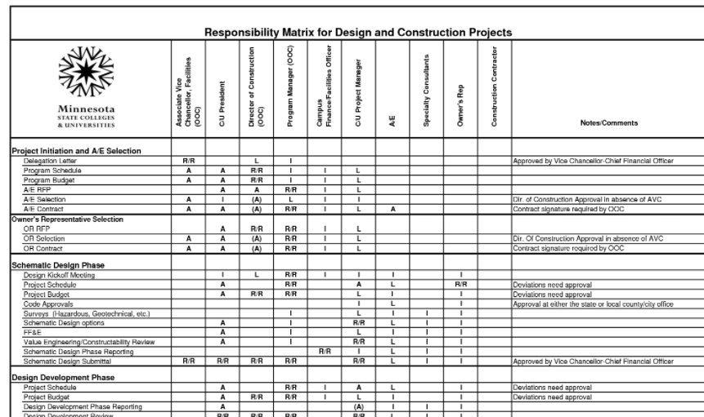
Fig 9 - Example Responsibility Matrix
4.5 Clash Detection

As Autodesk software is to be used throughout this project (AutoCAD and Revit) the plug in ClashMEP ‘Real time clash detection’ is to be used in the instance of checking for clashes within the project models.

4.6 Common Data Environment (CDE)

To allow for greater collaboration and to comply with BIM level 2, a common data environment (CDE) is required. This can simply be common folders on a server, but a web-based file-sharing application, such as NBS Chorus would be suitable for this project. The CDE itself is not a collaborative tool, but it may be used with one or more collaborative tools. Using intelligent software such as NBS Chorus aids in creating a sophisticated CDE, where The BIM Toolkit can set the project requirements and identify roles / responsibilities and outputs at each stage of the project. Then NBS Chorus refines these requirements through the decision-making process, linked to the geometry models, product data (in NBS Source) and standards / regulatory data.” Wilkinson (2020). File naming, suitability and revision conventions are outlined in section 5.0. Models and deliverables will be placed onto the NBS Chorus cloud server for viewing, access and authorization of information. The Digital Plan of Works in the NBS BIM Toolkit will provide a scheme for the project deliverables, the schedule, and everybody’s roles and responsibilities at every stage of the project. To satisfy the data security requirements outlined in BS EN ISO 19650, data is encrypted and protected by the NBS server.

4.7 Task Information Delivery Plan

This section confirms the production of Task Information Delivery Plans (TIDP). TIDPs are available upon request, but an example TIDP is displayed below.

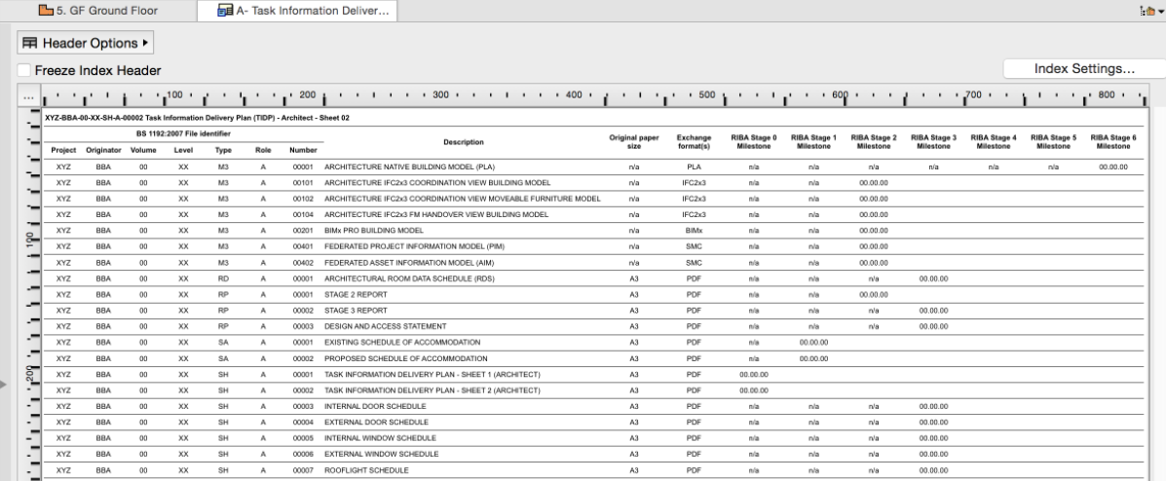
Fig 10 - Example TIDP
4.8 Master Information Delivery Plan

This section confirms the production of a master information delivery plan. This is the primary plan used to manage the project and is produced to satisfy the EIR. An example template of a MIDP is shown below.

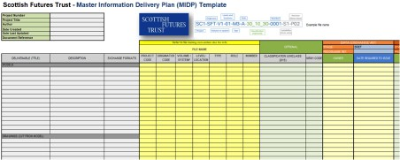
Fig 11 - Example MIDP

4.9 CoBie

Note: COBie Construction-Operations Building Information Exchange

Cobie is to be used as a central spreadsheet where primarily non-graphical data is to be stored, updated and shared through the project lifecycle. Eventually, the client will receive this and use it to support the operations and maintenance of the building. COBie also aids in verifying that our data meets the requirements of the project.

5.0 Section 5-Standards, Methods and Procedures

This section ensures the BEP conforms to the requirements of BS EN ISO 19650-1-2 and other standards listed as relevant on page 7 of the client letter.

5.1 Volume Strategy

This section defines any specified geometric subdivision within the project. There is no defined volume strategy required for this project, therefore deliverables are to be denoted with the volume code ‘ZZ’ to satisfy the file naming convention highlighted in fig 13.

5.2 PIM Origin and Orientation

This section defines the common origin point for spatial coordination. An OS grid reference is used, with the project base point origins highlighted below.

Reference | Position
Ground Floor FFL | 0 (mm)
Project Base Point | 00000 N, 00000E (mm)
Building Point 1 | 192364.7 N, 265976 E (mm)
Building Point 2 | 192364.7 N, 265976 E (mm)

Fig 12 - Common Origin Points
5.3 File Naming Convention

This section confirms the file naming conventions, in accordance with BS EN ISO 19650. The diagram below detail how files are to be named, followed by a worked example.


Fig 13 - File Naming Convention

Project Number | Originator | Volume | Level | File Type | Role | Classification  (optional) | Number
5010 | CG | xx | GF | DR | A |  | 1001
5010 | CG | xx | GF | DR | S |  | 1001
 |  |  | 02
 |  |  | ZZ
Fig 14 - File Naming Convention Cont
In addition to complying with BS EN ISO 19650‑1:2, the number field will be further distinguished through the use of a Uniclass 2015’ top level code for the first two digits and one of the following series numbers for the third digit:

Series | Drawing
xx1xx | Plans
xx2xx | Elevations
xx3xx | Sections
xx4xx | Large-Scale Views
xx5xx | Details
xx6xx | Schedules & Diagrams

Fig 15 - Number field
Note: Uniclass is a consistent classification structure for all disciplines in the construction industry,
containing tables classifying items of any scale from a large facility such as a railway, down to products such as a CCTV camera in a railway station.

5.4 Object Naming

This section confirms the object naming convention, in accordance with BS EN ISO 19650. Further reading on the classification of files in accordance with this standard can be found at bimportal.scottishfuturestrust.org.uk

Source | Type | SubType
Author,  Manufacturer | See Ifc[Type] | See ...TypeEnum  See product name
Fig 16 - Object Naming

All objects types shall also be named following the following convention: [...TypeEnum]Type[Number] e.g DoorType01.

5.5 Layer Naming Convention

This section confirms the layer naming convention.

Role | Classification | Presentation | Description
See BS 1192, section 10.2 | See Uniclass2015 | See BS 1192, section 12.2 | See Uniclass2015
Fig 17 - Layer Naming
5.6 Drawing Sheet Template

The purpose of this section is to specify and standard drawing sheet templates.
All drawings produced for this project shall utilise the ISO 5457 compliant drawing sheet provided.
All deliverables shall include the following ISO 7200 compliant title block.

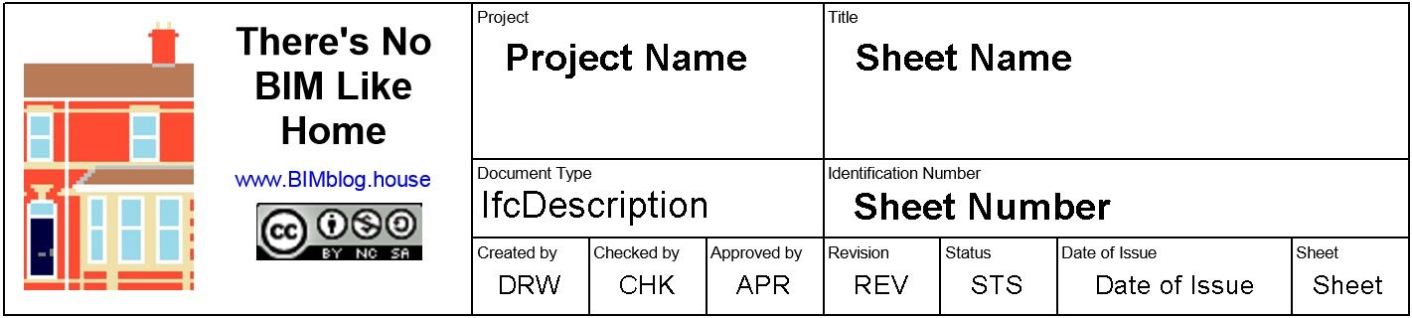
Fig 18 - Drawing Sheet Template

5.7 Annotations, Dimensions, Abbreviations, and Symbols

The purpose of this section is to define references for Annotations and Symbology.
All Annotations, dimensions, and symbols for this project will comply with BS 8541-2. Although ISO 22014 and ISO 22057 are under development to supersede BS 8541, parts 1-6, it is still relevant for this project. (BSI 2021).
All Abbreviations used will be sourced from the BRE BIM Terminology Tool http://www.bre.co.uk/bimterminology.jsp. Any abbreviations not sourced within this tool will be scheduled below:

Term | Acronym | Definition
Fig 19 - Other Abbreviations
5.8 Attribute Data

This section defines the attribute data to be exchanged. All employers specified attribute data has been identified and shall be delivered where appropriate. A single classification code shall be included on each object, describing it’s primary function. An example of attribute data that complies with his is shown below. Please note, the relevant standard shown in this example has now been superseded.
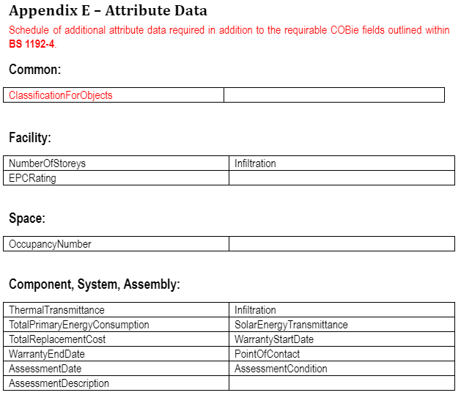
Fig 20 - Attribute Data

When exchanging project information, the Revision and Status code out convention outlined in the diagram below shall be applied as attribute data to all files. D codes shall be exclusively for unapproved information exchanged to aid in at-risk preparatory work. Information with a D code status shall not be referenced to generate any deliverables.

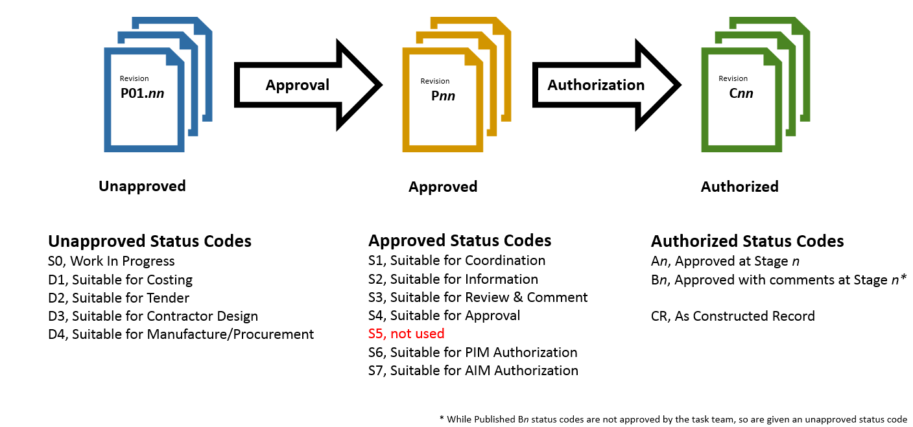
Fig 21 Revisions and Status Code

When inputting geometry information the following convention shall be complied with:

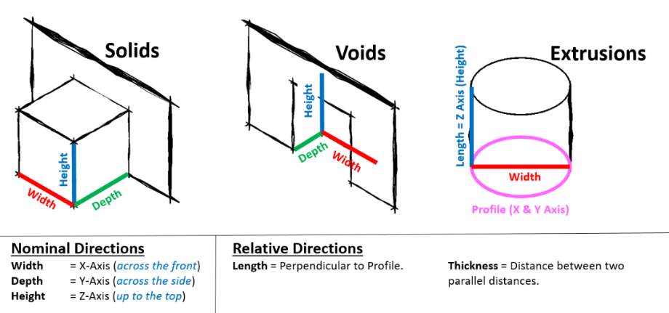

Fig 22 - Inputting Geometry
6.0 Section 6-IT Solutions

This section of the BEP covers the requirements of BS EN ISO 19650‑2:2018

6.1 Software Versions

This section confirms the software and version that is to be used throughout the project. Deliverables are to be generate using only the software detailed below.

Company | Purpose | Software | Version
Autodesk | 2D Modelling | AutoCAD | 2021
Autodesk | 3D Modelling & Creating of Drawings | Revit | 2021
CodePlex | Federation & IFC Export | xBIM | 2.4.1.29
Fig 23 - Software Versions
6.2 Exchange Formats

This section defines the exchange formats required for use throughout the project.

Export Software | Format | Version
AutoCAD | .dwg | 2021
Revit | .rvt | 2021
Revit | .ifc | 2021, 2x3
xBIM | .xls | COBie-UK 2021
Revit | .pdf | -
Fig 24 - Exchange Formats
6.3 Process and Data Management Systems

Data is to be managed in a linear format, supported by the diagram below. As such, a data management system is not required.
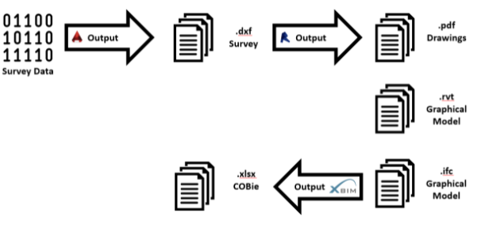
Fig 25 - A Linear Data Management System

Reference List

BIM - Building Information Modelling - ISO 19650
Author - BSI (2021)
Source - www.bsigroup.com

BIM Levels Explained
Author - NBS (2021)
Source - www.thenbs.com

BIM Levels and Mandates Explained
Author - CostX (2021)
Source - www.itwocostx.com

Reaching BIM Level 2
Author - Plannerly (2021)
Source - plannerly.com

Standards Referenced:
- BS EN ISO 19650-1:2018
- BS EN ISO 19650-2:2018
- BS EN ISO 19650-3:2020
- BS 1192-4:2014
- BS EN ISO 19650-5:2020
- PAS 1192-6:2018
- BS 8536-1:2015
- BS 8536-2:2016
Source - www.bsigroup.com + Transition guidance to BS EN ISO 19650

The Little Book of BIM
Author - BSI (2021)
Source - www.bsigroup.com

The UK National Annex
Author - BSI (2021)
Source - www.bsigroup.com

Transition guidance to BS EN ISO 19650
Author - BSI (2019)
Source - BSI Standards Publication PD 19650‑0:2019 - Incorporating Corrigenda No. 1

UK Government BIM Working Party Strategy
Author - GOV (2011)
Source - Gov.uk

Image References
Client Letter

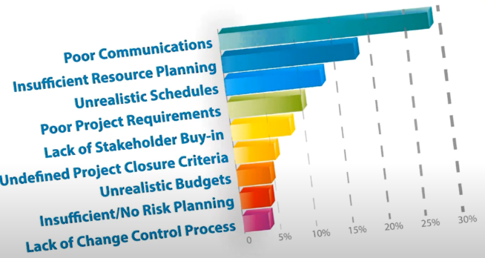
Fig 1 - The Causes of Project Issues
Source - Plannerly.com

Fig 2 - Mark Bew’s BIM Wedge
Source - www.itwocostx.com
Fig 3 - The Transition
Source - Provided Educational Content
Fig 4 - Moving from the UK 1192 Series to ISO 19650
Source - Provided Education Content

Document | Details
BS EN ISO 19650-1:2018 | Organization and digitization of information about buildings and civil engineering works, including building information modelling  (BIM). Information management using building information modelling concepts and principles.
BS EN ISO 19650-2:2018 | Organization and digitization of information about buildings and civil engineering works, including building information modelling  (BIM) -Information management using building information modelling. Part 2: Delivery phase of the assets.
BS EN ISO 19650-3:2020 | Organization and digitization of information about buildings and civil engineering works, including building information modelling (BIM). Information management using building information modelling. Operational phase of the assets.
BS 1192-4:2014 | Collaborative production of information. Fulfilling employer’s information exchange requirements using COBie. Code of practice.
BS EN ISO 19650-5:2020 | Organization and digitization of information about buildings and civil engineering works, including building information modelling  (BIM). Information management using building information modelling. Security-minded approach to information management.
PAS 1192-6:2018 | Specification for collaborative sharing and use of structured Health and Safety information using BIM.
BS 8536-1:2015 | Briefing for design and construction. Code of practice for facilities management (Buildings infrastructure).
BS 8536-2:2016 | Briefing for design and construction. Code of practice for asset  management (Linear and geographical infrastructure).
Fig 6 - A Table to show Standard Compliance with BIM Level 2
Source - Personally Produced - Information from Transition guidance to BS EN ISO 19650 (2019)

BIM Execution Plan
Note: All tables/images unless otherwise stated are sourced from ‘Post Contract-award
BIM Execution Plan’ by Dan Rossiter.

Project Delivery Manager - Name | Company Responsible
Cai Gibbons | Gibbons LTD
Fig 1 - Project Delivery Manager Detailing

Project Name: | Ysgol Bae Abertawe
Project Number: | 5010
Project Description: | Delivery of a ‘state of the art’ infant school in Swansea
Site Name: | Slipway Road, Maritime Quarter, Swansea  SA1 1YB
Site Description: | Slipway to Beachfront
Facility Name: | Ysgol Bae Abertawe
Facility Description: | Infant School
Project Design Start Date: | 20/5/21
Project Construction Start Date: | 23/8/21
Project Completion Date: | 23/8/22
Fig 2 - Project Information

Name | Company | Role | Resources | Contact Information
Cai Gibbons | GIB Ltd | Client | Client1 | CaiG12@outlook.com
Daniel James | GIB Ltd | Architectural | Arch1 | DanJ56@outlook.com
Phillip Williams | Dragon Eng | Mechanical | Mech1 | Williams84@outlook.com
John Jones | Afon Eng | Electrical | Elect1 | Eric78@outlook.com
Fig 3 - Roles and Responsibilities

Responsibility | Resource
Capture Key Decision Points | Client1
Produce Plain Language Questions | Client1
Capture Required Standards, Methods, and Procedures | Client1
Ensure the Appointment of a Project Information Manager | Arch1
Review the Supplier Information Exchanges against the EIR | Client1
Fig 4 - Employer’s Representative Responsibilities

Responsibility | Resource
Enable Information Exchanges through a CDE | Arch1
Maintain and Receive Information Into the Information Model | Arch1
Enable Integration and Coordination of Information | Arch1
Configure Information for Project Outputs | Arch1
Populate the Information Exchange Format | Arch1
Accept/Reject Information Exchanges | Arch1
Fig 5 - Project Information Manager Responsibilities

Responsibility | Resource
Coordinate Delivery of all Design Information | Arch1
Manage Information Development and Information Approvals | Arch1
Confirm Design Deliverables | Arch1
Overall Lead for Configuration Management | Arch1
Confirm Status and Approve Information for Issue | Arch1
Approve Design Changes Proposed to Resolve Clashes | Arch1
Fig 6 - Lead Designer/Contractor Responsibilities

Responsibility | Resource  Architectural | Resource  Mechanical | Resource  Electrical
Production of Design Outputs Related to Specific Tasks | Arch1 | Mech1 | Elect1
Issue Approved Information | Arch1 | Mech1 | Elect1
Direct the Production of Information in compliance with SMP | Arch1 | Mech1 | Elect1
Direct the Production of Information Using Agreed Systems | Arch1 | Mech1 | Elect1
Confirmation that Information is Suitable for Issue | Arch1 | Mech1 | Elect1
Manage Spatial Coordination on behalf of the Task Team | Arch1 | Mech1 | Elect1
Propose Resolution to Coordination Clashes | Arch1 | Mech1 | Elect1
Develop Constituent Parts of the Information Model | Arch1 | Mech1 | Elect1
Production of Project Outputs | Arch1 | Mech1 | Elect1
Fig 7 - Task Team Responsibilities

 | Brief & Planning | Model Generation
Graphical Models |  | Native Discipline Models  Federated IFC Model
Non-graphical Data |  | Federated COBie
Documentation | BIM Execution Plan | Site Plans, Floor Plans, Elevations, Sections, Door Schedule, Window Schedule
Fig 8 - Deliverables Defined
Fig 9 - Example Responsibility Matrix
Source - bimportal
Fig 10 - Example TIDP
Source - bimportal
Fig 11 - Example MIDP
Source - bimportal

Reference | Position
Ground Floor FFL | 0 (mm)
Project Base Point | 00000 N, 00000E (mm)
Building Point 1 | 192364.7 N, 265976 E (mm)
Building Point 2 | 192364.7 N, 265976 E (mm)

Fig 12 - Common Origin Points

Fig 13 - File Naming Conventions

Project Number | Originator | Volume | Level | File Type | Role | Classification  (optional) | Number
5010 | CG | xx | GF | DR | A |  | 1001
5010 | CG | xx | GF | DR | S |  | 1001
 |  |  | 02
 |  |  | ZZ
Fig 14 - File Naming Conventions Cont

Series | Drawing
xx1xx | Plans
xx2xx | Elevations
xx3xx | Sections
xx4xx | Large-Scale Views
xx5xx | Details
xx6xx | Schedules & Diagrams
Fig 15 - Number Field

Source | Type | SubType
Author,  Manufacturer | See Ifc[Type] | See ...TypeEnum  See product name
Fig 16 - Object Naming

Role | Classification | Presentation | Description
See BS 1192, section 10.2 | See Uniclass2015 | See BS 1192, section 12.2 | See Uniclass2015
Fig 17 - Layer Naming

Fig 18 - Drawing Sheet Template

Term | Acronym | Definition
Fig 19 - Other Abbreviations

Fig 20 - Attribute Data

Fig 21 - Revision and Status Code
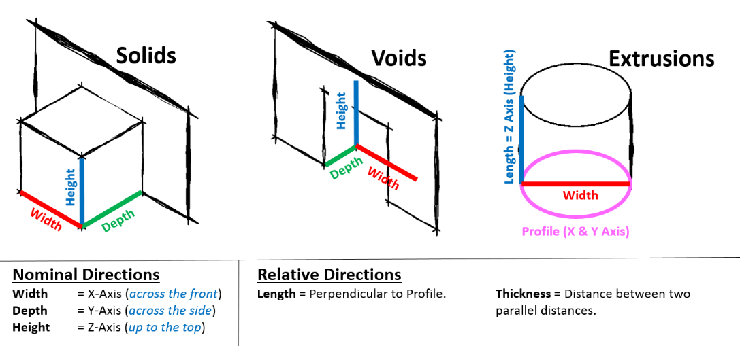
Fig 22 - Inputting Geometry

Company | Purpose | Software | Version
Autodesk | 2D Modelling | AutoCAD | 2021
Autodesk | 3D Modelling & Creating of Drawings | Revit | 2021
CodePlex | Federation & IFC Export | xBIM | 2.4.1.29
Fig 23 - Software Versions

Export Software | Format | Version
AutoCAD | .dwg | 2021
Revit | .rvt | 2021
Revit | .ifc | 2021, 2x3
xBIM | .xls | COBie-UK 2021
Revit | .pdf | -
Fig 24 - Exchange Formats

Fig 25 - A Linear Data Management System

