My business plan

(1922306)



SAFE AND ACCURATE LOGISTICS
ALWAYS PROVINDING THE BEST SERVICES SINCE 2020
BUSINESS OWNERS AND PARTNERSHIP:
DAVID STEFAN LUPU AND ANGELA CORNELIA LUPU

One of the key elements of supply chain operations is logistics, which includes the purchase, storage, and delivery of items to their destination. The main goals of logistics management, a thorough process, are to improve organisational profitability and customer satisfaction. Managing logistics is a crucial aspect of company because it involves important tasks like gathering raw materials, controlling inventories, managing distribution, filling orders, and so on. (Editor, 2022)

INTRODUCTION
My name is David Stefan Lupu, I am 34years old Romanian and
I have always enjoyed vehicles and driving, even as a small youngster. I began learning how to fix cars, bikes, ATV’s, and anything that hade a motor and could be driven on roads at a young age, and when I was old enough to drive, I took the test and passed with all the necessary categories for driving both cars and lorries.
As my enthusiasm for vehicles grew, I made the decision to turn it into a business that would satisfy both my need to drive and my need to work with cars.
I love to work with people and cars, and my experience on selling cars grew. I have been dealing as a private in Romania and Italy, and now that I have moved to the UK, I Wales to be more exact, I found the opportunity and chances to develop all my passions in something nice and profitable.

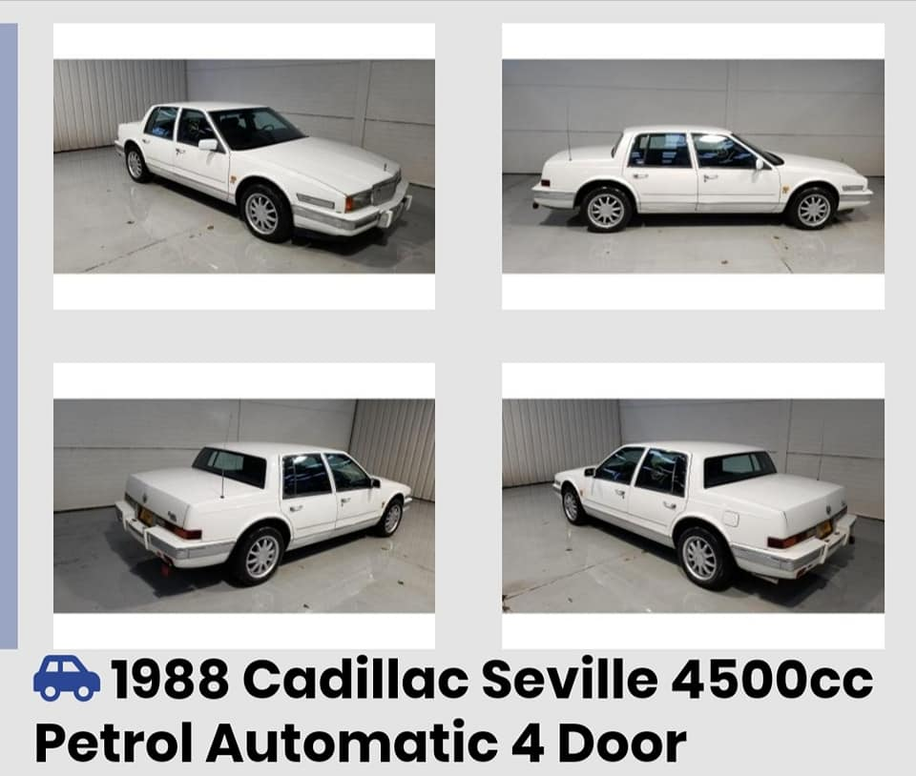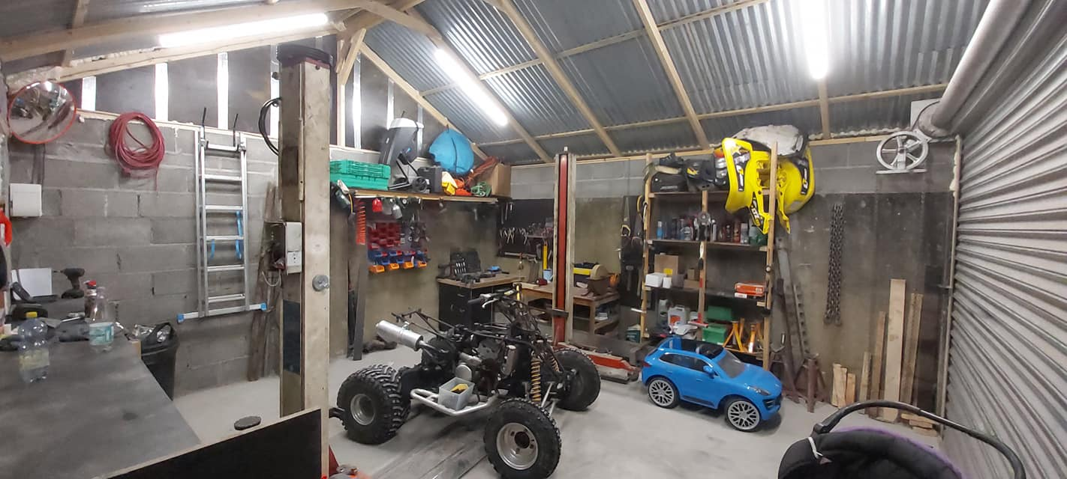

Product – service
What your product or service can do for them is the only thing that matters to your customer. As a result, give making your product the best it can be a priority and optimise your product lines as necessary. This strategy is referred to as "product-led marketing." Product considerations in a marketing mix cover every facet of the offering you're making. This comprises:
Design
Quality
Features
Options
Packaging
Market positioning

My company has two branches. The first is logistics, and the second is car sales.
Distribution logistics has a unique subset known as branch logistics, often known as trade logistics or retail logistics. Here, the focus is on delivering the proper goods to points of sale or stores in a safe, timely, and effective manner.
The products that a truck driver is assigned to transport are their responsibility. They are in charge of following to a timetable and making sure that the products are delivered undamaged, intact, and according to the customer's specifications.
The second division works with buying and selling cars as well as repairing minor accidents and cosmetic damage before reselling the vehicles.
There will always be a demand for food supplies in retail stores, and drivers will always be needed to deliver things quickly and safely.
Because individuals need automobiles to commute to work and travel, the market will also have need for car dealers.
You don't have to worry about the weather or using the public transportation if you need to run out and get some fast items. A vehicle makes life easier in many ways and facilitates numerous everyday duties.
Even though there are many rivals in my sector, I stand out because I am focusing more on accessible vehicles for families as well as all levels of income.
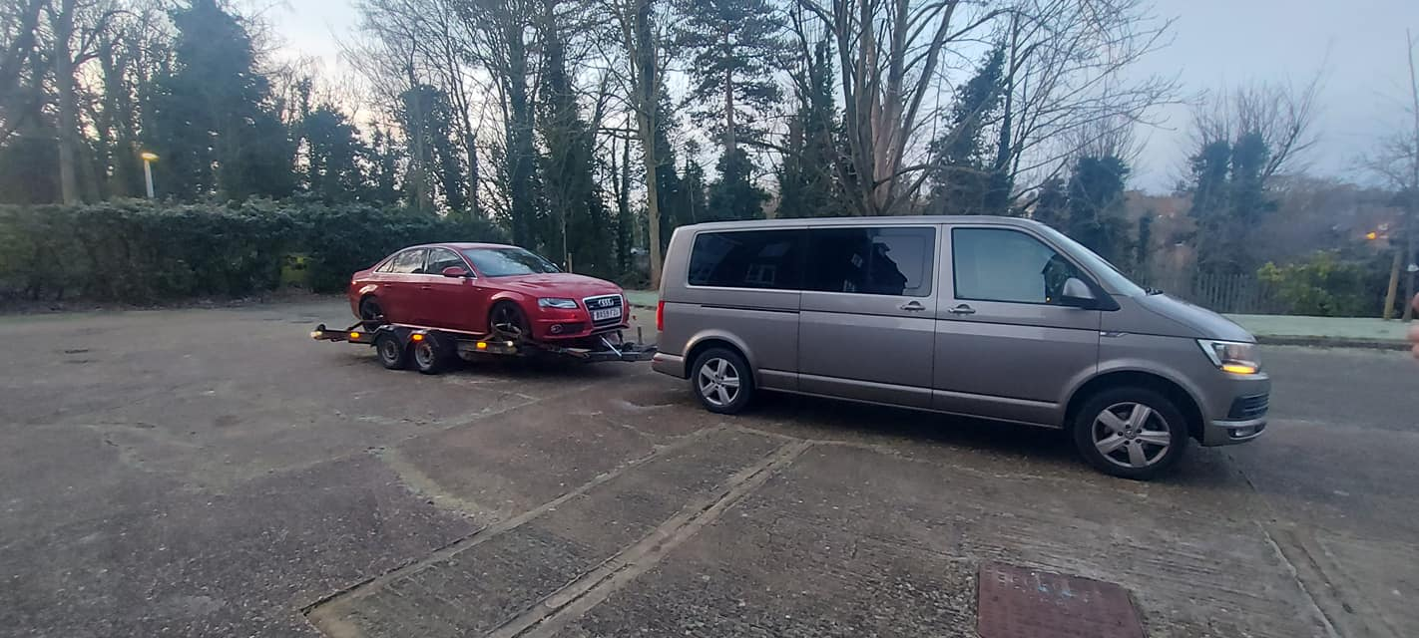

Marketing activities

A marketing activity is a strategy that a staff member uses to successfully advertise a company in order to raise brand awareness, enhance sales, or develop relationships with clients. These actions are often used by marketing to engage, connect with, and inform customers about a business and its products. This makes sure the brand stands out from rivals and draws the target audience's attention.
To do a good market activity is necessary to use the 7 P’s marketing model mix.
The 7Ps marketing model professionals was originally devised by E. Jerome McCarthy and published in 1960 in his book Basic Marketing.
Companies can also use the 7Ps model to set objectives, conduct a SWOT analysis and undertake competitive analysis. It's a practical framework to evaluate an existing business and work through appropriate approaches whilst evaluating the marketing mix elements. (Gandolf, 2010)
In my business, on the marketing side I will use price, place, product and promotion.
Price
Think about your pricing strategy's goals and how price will interact with the rest of your marketing plan. While marketing products, consider the following inquiries:

Will you charge more for the more expensive versions?
Can you establish a lower price and view it as an investment in growth, or do you need to immediately pay costs?
Will you run promotions for purchases?
How low can you go before people start to doubt your abilities?
How high can you raise your prices before people start to complain?
Do people view you as a premium brand or a discount brand?

Promotion
The component of the marketing mix that the public is most aware of is promotion. Advertising on television and in print, content marketing, coupons or set-aside discounts, digital strategies, social media tactics, email marketing, display ads, marketing communication, search engine marketing, public relations, and more are all included
These promotional channels work together to form an omnichannel approach that unifies the consumer base's experience throughout the whole marketing mix. For instance:
A client uses their phone to check pricing and read reviews after seeing an in-store promotion.
They look at the company's website, which highlights a distinctive quality of the goods.
Reviews regarding that feature have been requested by the company. These reviews can be found on reputable review websites.
After the buyer purchases the item, you send them a thank-you email.

Place
Where will your product be sold? Your placement decisions, which go beyond physical sites, will be informed by the same market research that guided your judgements about your product and price. These are some factors to take into account regarding location:
Where are consumers going to look for your product?
Should they hold it in their hands while doing so?
Will marketing to customers directly from your own e-commerce website increase sales, or will people search for you on external marketplaces?
Do you prefer dealing with consumers directly during the buying process, or do you prefer a third party to handle customer support issues?

Before starting the business and figuring out how to do better advertising, I did market research by surveying people on social media about their favourite cars (engine, model, years), what prices they are willing to pay for a car, and other car-related questions. These questions are mainly related to cars and are assisting me in deciding where to invest and preventing me from buying vehicles that may take a while to sell.
I am heavily promoting my business via social media, particularly Facebook, Instagram, and TikTok, as well as placing online ads on marketplaces like Gumtree.
Before traveling to see the automobile in person, customers will be able to view offers and information on cars on the company's website much more easily.
Another strategy I'm thinking is to create flyers or even a commercial banner to post, for instance, on bus stations and to place on the company's vehicle a promotional sticker.
All of this will cost between 500 and 1000 pounds once every several months, but it is a wise investment.

Physical resources

What are the physical resources ?
The materials that the business employs to create its goods or services are known as physical resources. They consist of real estate, structures, tools, and machines.

There is an online store for the company as well as a physical one developed at my home.
All the paperwork, bills, and other items are stored safely out of children's reach and other risks in the office, which is a space in the house that has been designated specifically for this purpose.
I still have to spend money on a computer, printer, and office supplies; these expenses will be deducted from my capital costs.
I still need to put money down to buy my own lorries and trailers for the logistics division.
A trailer costs from 15,000 pounds, and a decent truck starts at roughly 22,000 pounds; these charges are subtracted from operating expenses.
For the automotive branch, I still require a site where I can store more cars and conduct sales. The prices are variable and when the perfect moment will be the costs will be capital costs. As for the advertising part of the business, mortgage, internet and company phone those are going to be fixed costs.

Financial resources

Financial resources are among the many various sorts of resources that a business can use, and they are also one of the most crucial. The reason for this is that a corporation cannot continue or expand if it lacks sufficient cash.
Business entities can raise capital in a few distinct methods. One way is by investing, which can be done with equity or debt. Debt is the process of borrowing money and having it repaid with interest, whereas equity is the exchange of ownership in a firm for cash. Revenue, or the cash received as payment for the sale of goods or services, is another means for businesses to raise money.
Human resources are another resource class used by companies. Employees who work for the business in exchange for a salary are included in this. Skills and expertise that can be used to produce goods or services are also included in human resources.
Also, companies require natural resources including lumber, minerals, water, and land. They must be secured through either purchase or lease and are necessary for production.

I had to start the logistic branch when I originally chose to start my own business in order to be able to drive a lorry. I had roughly £10,000 in my personal savings at the time, which I used to pay for the necessary liability insurance as well as the services of an accountant to handle the essential paperwork.
In order to extend the logistics, I had to take out a loan in the amount of about £50,000 in the name of the business to pay for the costs of purchasing the trailer and lorries needed at the outset.
I had to invest the about 10,000 pounds I had saved when I had the notion to expand the firm to include an automobile branch, to buy a trailer to transport the cars, I hade to invest money in the cars I was auctioning for, and also use this money for all the necessary adjustment the cars are needed to be made.
I will still need to buy a bigger trailer for the cars to be delivered, money that will take from the remaining cash from the loan I made for the logistics.

Human resources
The department in charge of all personnel matters and operations involving personnel is known as human resources. We also refer to the entire workforce of an organisation by this word. We'll emphasise human resources as a business function in this definition of HR. (Marinaki, 2022)
A job description is a document that outlines the crucial qualifications, responsibilities, and abilities needed to carry out a particular task. How success is determined in the position will be covered in a thorough job description so that it may be used in performance reviews.

As my experience for this business I have been working in the car sales market before opening this venture for at least 12 years.
The company has me as the main owner and my wife has 4 shares in the company, making her a shareowner and partner in the business, so deciding which role everyone has it is easy. As the business will grow I will need other lorry drivers so for this I am taking in my hands the HR and operations manager, because of the experience that it needs to be looked at in the drivers, makes me eligible for this role.
As the marketing part, that goes in to my wife hands because she has experience in the IT and online market.
As I said before, with the acquisition of other lorries, experienced drivers will be needed, and the advertising for this will be made online and by word ( other drives recommending my business or directly recommending the drivers name to me)
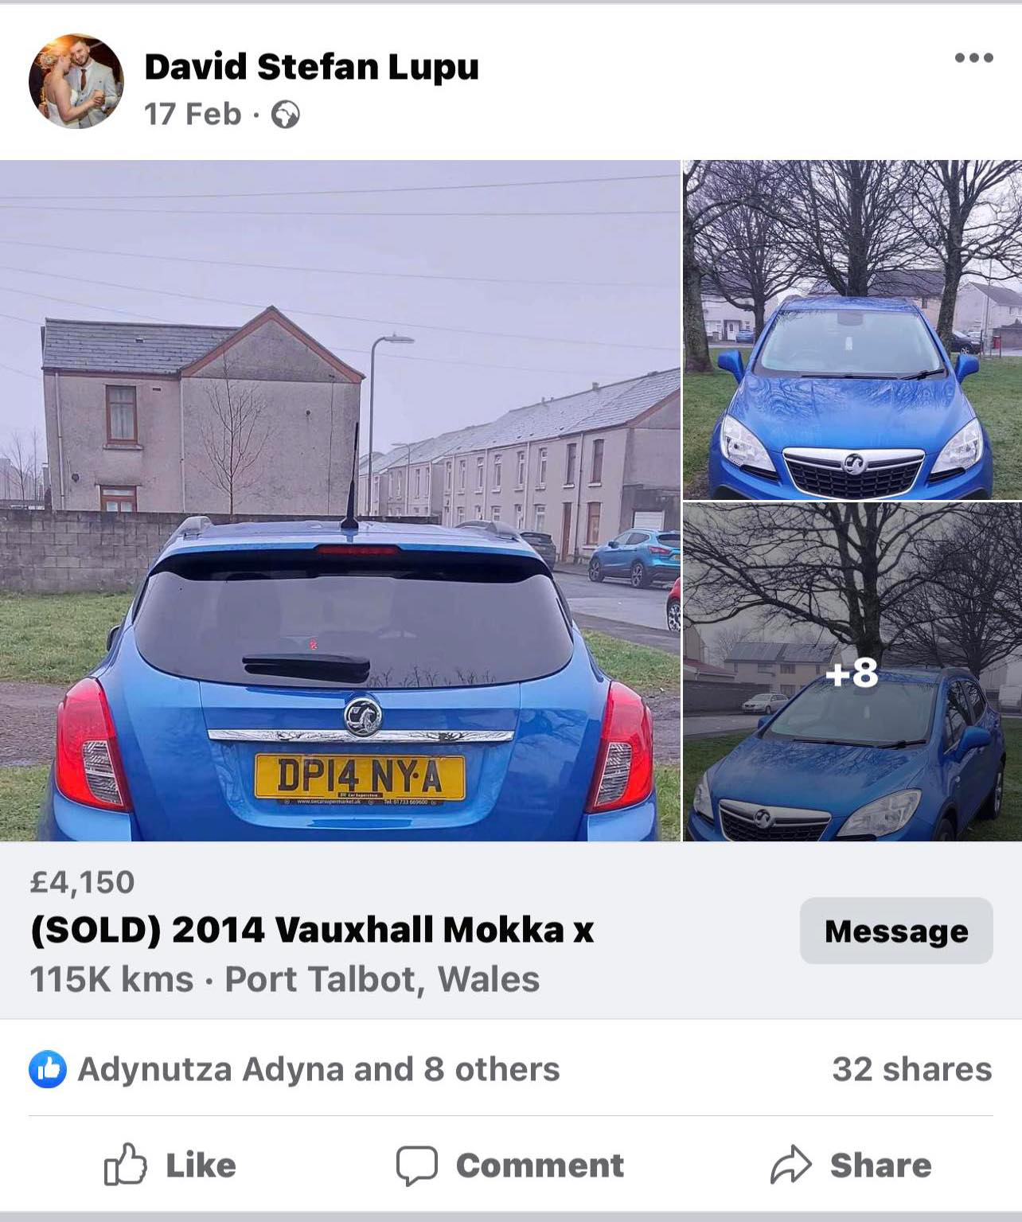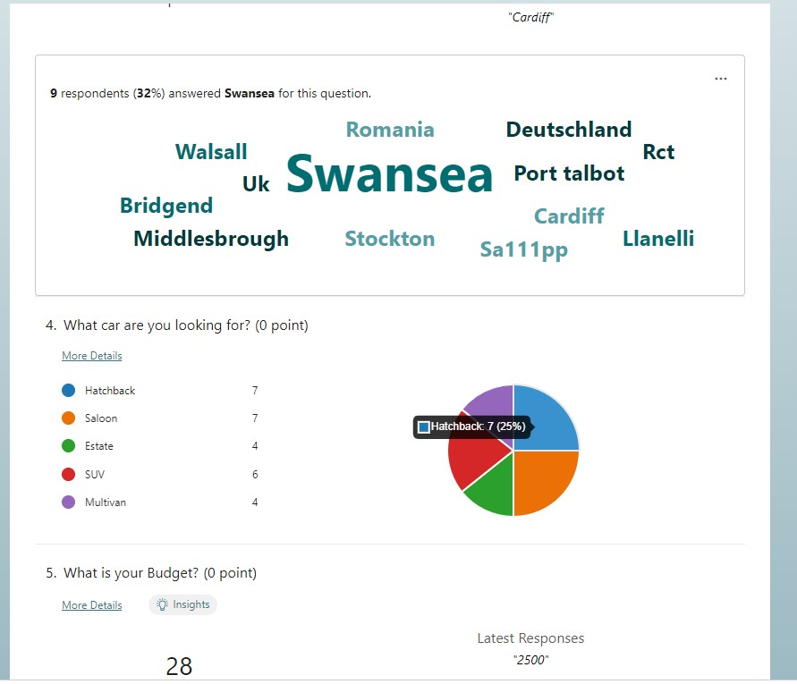

Before taking any action I hade to do a swot analysis that would help me to see were I stand because, opening a new business today, making loans and spending money is a risky situation, especially when you have a family to maintain, house mortgage and other surprise expenses.
- STRENGHTS
Safe and accurate transport 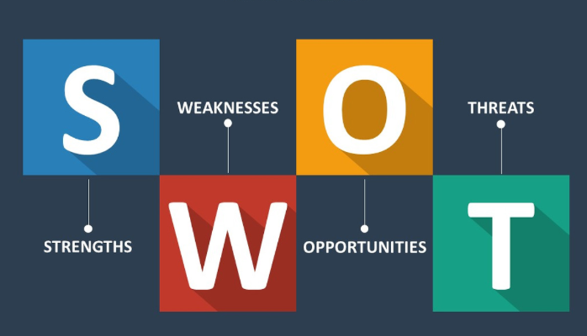
Prices of cars accessible for all budgets
Customer satisfaction
- OPPORTUNITIES
Expanding the logistic branch
Investing in a location for more cars
- WEAKNESESS
Fuel prices increasing
Taxing more
- THREATS
Market full of competitors

50MINUTES (2015) The marketing mix: Master the 4 PS of Marketing. Cork: Lemaitre Publishing.
Baker, M.J. and Hart, S.J. (2016) The marketing book. London: Routledge, Taylor & Francis Group.

Broadbent, M. and Cullen, J. (2015) Managing financial resources. London: Routledge.
Editor (2022) 10 key objectives of Logistics Management, Axestrack. Available at: https://www.axestrack.com/logistics-management/#:~:text=The%20main%20objective%20of%20logistics,delivery%20of%20products%20or%20goods. (Accessed: March 17, 2023).
H., J.T.D. (2012) Cash flow analysis and forecasting the definitive guide to understanding and using published cash flow data. Chichester: Wiley.
Marinaki, A. (2022) What is Human Resources (HR)?, Recruiting Resources: How to Recruit and Hire Better. Available at: https://resources.workable.com/hr-terms/human-resources-definition#:~:text=In%20an%20organization%2C%20Human%20Resources,resources%20as%20a%20business%20function. (Accessed: March 17, 2023).
Marketing mix and the 7 PS of Marketing (no date) Mailchimp. Available at: https://mailchimp.com/en-gb/marketing-glossary/marketing-mix-7ps/#:~:text=Initially%204%2C%20these%20elements%20were,%E2%80%9C7%20P's%E2%80%9D%20mix%20elements. (Accessed: March 17, 2023).
Mullins, J.W. and Walker, O.C. (2013) Marketing management: A strategic decision-making approach. New York: McGraw-Hill.
Nowroth, A. (2023) Sales and business models in the logistics industry: Ensuring growth with innovative strategies. Springer.
Pahl, N. and Richter, A. (2007) SWOT analysis: IDEA, methodology and a practical approach. Munchen: GRIN Verlag.
Take online courses. earn college credit. Research Schools, Degrees & Careers (no date) Study.com | Take Online Courses. Earn College Credit. Research Schools, Degrees & Careers. Available at: https://study.com/academy/lesson/what-are-physical-resources-in-business.html#:~:text=Physical%20resources%20are%20tangible%20items,the%20actions%20of%20the%20company. (Accessed: March 17, 2023).
Team, M.J.V. (2022) What is product-service system and how does it work?, MJV Technology & Innovation. Available at: https://www.mjvinnovation.com/blog/what-is-the-product-service-system-and-what-is-its-relationship-to-sustainability/#:~:text=A%20Product%2DService%20System%20(or,to%20benefit%20from%20using%20them. (Accessed: March 17, 2023).
Types of logistics (no date) KEYENCE. Available at: https://www.keyence.com/ss/products/auto_id/logistics/basic/field.jsp (Accessed: March 17, 2023).
What is a job description? (no date) Betterteam. Available at: https://www.betterteam.com/job-description (Accessed: March 17, 2023).

Appendix


