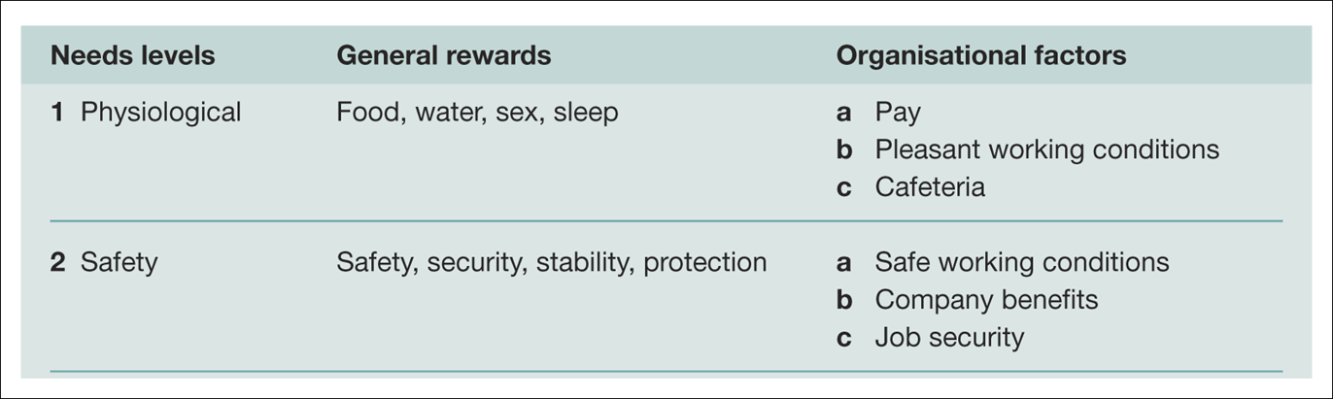

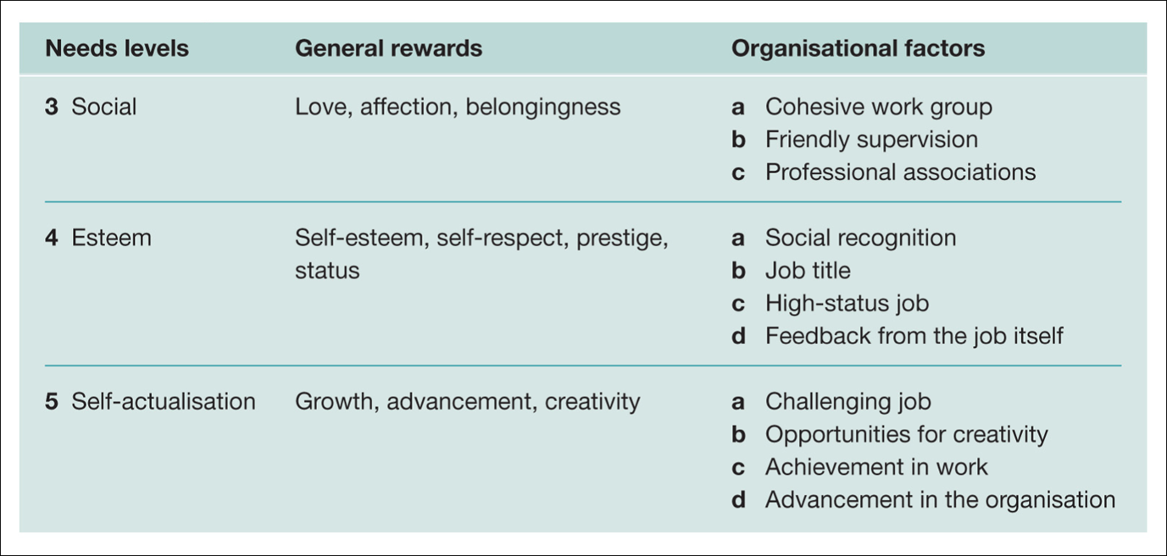

Alderfer developed a modification of Maslow’s hierarchy with the ERG theory which is more flexible than Maslow’s theory in three basic respects. First the theory collapses Maslow’s five need categories into three: existence needs relate to a person’s desire for physiological and material wellbeing; relatedness needs represent the desire for satisfying interpersonal relationships; and growth needs are about the desire for continued personal growth and development.
Second, while Maslow’s theory argues that individuals progress up the hierarchy as a result of the satisfaction of lower-order needs (a satisfaction-progression process), ERG theory includes a ‘frustration-regression’ principle, whereby an already satisfied lower-level need can become activated when a higher-level need cannot be satisfied. Thirdly, according to Maslow, a person focuses on one need at a time. In contrast, ERG theory contends that more than one need may be activated at the same time. Managers need to examine the workplace environments continually to remove or reduce any organisational constraints that will restrict opportunities for personal growth & development.
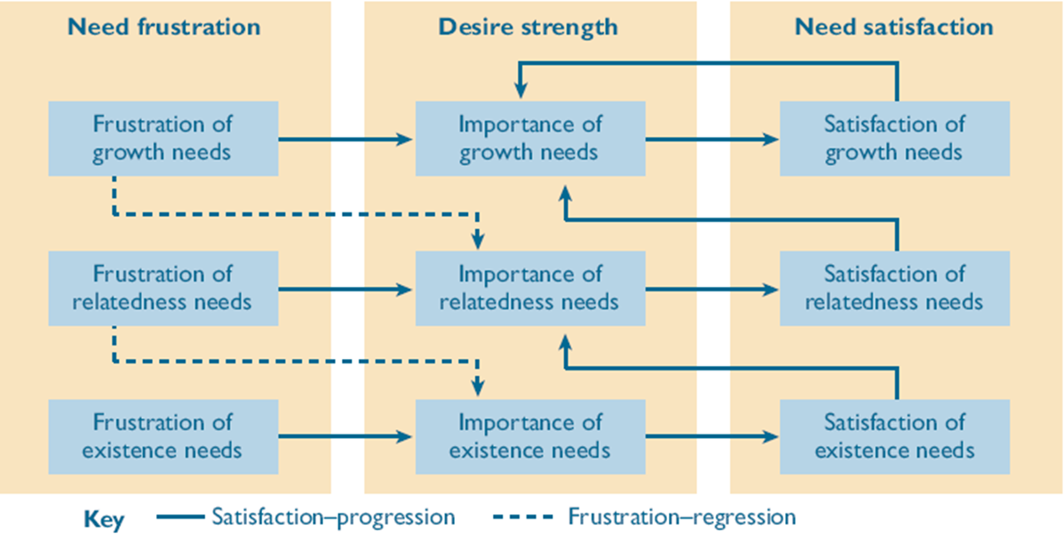
Alderfer’s modified need - hierarchy model (ERG theory
Existence needs - concerned with sustaining human existence and survival and covers physiological and safety needs of a material nature.
Relatedness needs - concerned with relationships to the social environment and covers love or belonging, affiliation, and meaningful interpersonal relationships.
Growth needs - concerned with the development of potential and covers self-esteem and self-actualisation

Hertzberg is another famous theorist in this area – interviewed accountants and engineers in the 1950s in the USA.
He asked people to remember incidents which had made them feel good about their work, and others which had made them feel bad.
What made people satisfied was different to what made people dissatisfied.
= two factor theory
One set of hygiene and maintenance factors – they prevent dissatisfaction.
Other set of motivators or growth factors – if present they motivate people to achieve more and perform better
NB – bit complicated this – it’s not a satisfaction/dissatisfaction scale – it measures the strength of positivity not negativity – the opposite of dissatisfaction is not satisfaction but simply no dissatisfaction.

So the hygiene factors are a bit like the base of Maslow’s pyramid , his lower level needs
The motivators are a bit like the top of the pyramid – the higher level needs. These are the things managers must focus on if they’re to motivate people to give their best. Need both however. Motivators are about what people are allowed to do and their quality of work experience – they’re what motivate people.

Hertzberg argues that it is more likely that good performance leads to job satisfaction rather than the reverse
Some concerns about his research methodology – the way he did it – which we don’t have time to explore here – see Mullins if you’re suitably gripped.

Herzberg’s two-factor theory, also known as the motivator-hygiene theory distinguishes between sources of work dissatisfaction (hygiene factors) and satisfaction (motivators). Herzberg and his associates noticed that the factors identified as sources of work dissatisfaction (dissatisfiers or hygiene factors) were different from those identified as sources of satisfaction (satisfiers or motivation factors).
Effective managers have to achieve two distinct outcomes to maximise job satisfaction and, simultaneously, to minimise job dissatisfaction.
Herzberg’s two-factor theory, also known as the motivator-hygiene theory distinguishes between sources of work dissatisfaction (hygiene factors) and satisfaction (motivators). Herzberg and his associates noticed that the factors identified as sources of work dissatisfaction (dissatisfiers or hygiene factors) were different from those identified as sources of satisfaction (satisfiers or motivation factors).
Effective managers have to achieve two distinct outcomes to maximise job satisfaction and, simultaneously, to minimise job dissatisfaction.

Hertzberg
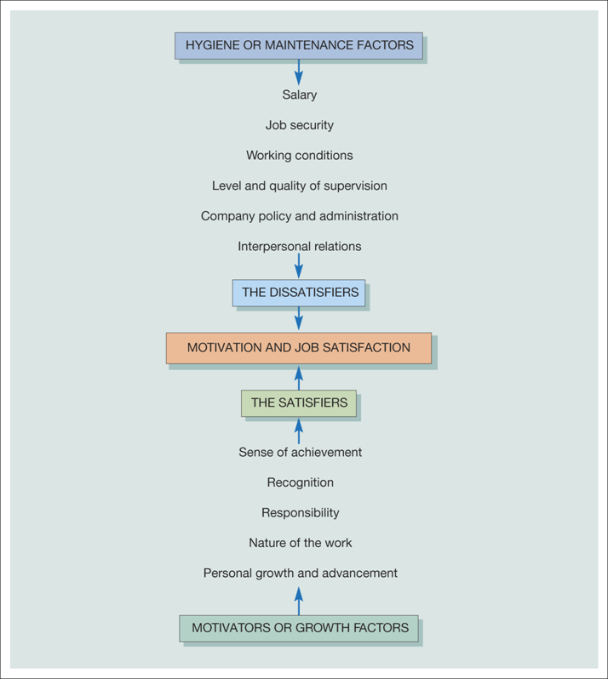

Maslow, Alderfer and Herzberg
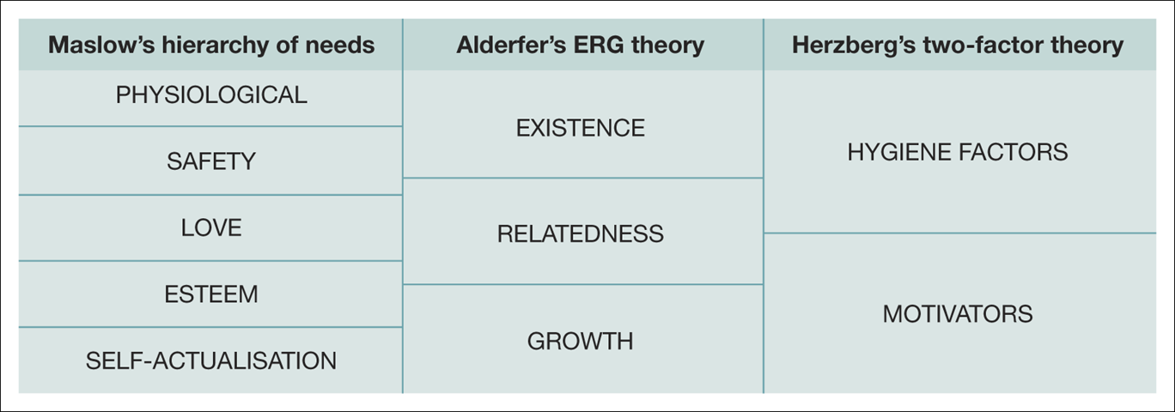

Content theories - Offer ways to profile or analyse people to identify the needs that motivate their behaviours
- What motivates
Process Theories - Help us understand the thought processes that take place in the minds of people that act to motivate their behaviour
- how/why people are motivated

