Student Name: | Larisa Leparda
Student Number: | 1808629
Module No: | BMSK4003_LON
Module Title: | Digital Skills and Research Method
Lecturer: | Anupam Mazumdar

Introduction

Literature Review

Research Methodology:

- Qualitative research methods

- Quantitative research methods

-Population

-Sample

-Sample frame
Data collection process:
Ethical Consideration of the research

Limitation of the research

Findings, Analysis and Discussion

Recommendation for future

Conclusion

Reference list

Introduction

This report is about Employee Job Satisfaction survey questionnaire, in Home Care ,consisting five closing questions based on quantitative research in the form of Likert 5-Point Scale. I will also conduct primary research, questioning top – level home care employees about their workplace satisfaction. I will take a sample of 100 employees from whom I will gather my information about what makes them happy at work. Using Bar-Graphs will show the results. I'm going to analyse the graphs, discuss various aspects and secondary sources factors. Consequently, through this research, give a summary of the findings. This will help to better understand the relationship between job satisfaction of employees and how it can affect the organization's productivity and turnover.
Aim: To identify the employee job satisfaction on workplace , Care Home .
Objectives: To understand the concept of employee job satisfaction.

Literature Review

Employee Job Satisfaction in Home Care
Job satisfaction refers to measuring contentedness of employee at their job place. This means whether they want to work at their work place or not (McVicar, 2016). Employees are the one of the most important components which assist in providing services at Home care centres.
According to Rob Wengrzyn (2019) job satisfaction can be achieved with the help of rewards, compensation which are provided to them at home acre organisation. Home care associations works to provide services to old, ill people. Hence it is important to provide them satisfaction, so best services can be delivered to suffering individuals.
According to Emily Holland (2019) there are 5 factors which assist in satisfaction of employees at care home. These factors are Engagement, Respect, praise and appreciation, Fair compensation, Motivation, Life satisfaction. When employee is engaged in their work, then their productivity is good. When employees are satisfied, then this they are satisfied so giving best. In order to satisfy employee, it is important to pay them fair remunerations. There are some personal aims and objectives for which employee is working at home care organisation (Hebson, Rubery and Grimshaw, 2015).
For instance: with working style and services of an employee’s consumer or client's family is satisfied, then that personnel have to be praised in front of others. This makes good impression in their mind and achieves satisfaction. It is important that mangers of care home organisation have to provide opportunity of decision making to employees, so they are satisfied as they are important part of organisation. This makes the responsible for their working, so they perform activities to get positive outcome (Hur, Moon and Jung, 2015).

Research Methodology

According with Kumar (2011), “research is a process for collecting, analysing and interpreting information to answer questions. But to be qualify as research
, the process must have certain characteristic: It must, as possible, be controlled, rigorous, systematic, valid and veritable, empirical and critical.”

Qualitative and Quantitative research methods

Qualitative research is “the collection of extensive data on many variables over an extended period of time, in a naturalistic setting, in order to gain insights not possible using other types of research”. (Megersa, 2015)
Quantitative research can be defined “as a type of empirical research into a social phenomenon or human problem, testing a theory consisting of variables which are measured with numbers and analysed with statistics in order to determine if the theory explains or predicts phenomena of interest.” (Yilmaz ,2013)
For this research I use quantitative research because I need analysing the employee job satisfaction in Home Care, in this case I use questionnaire, “written list of questions “(Kumar,2011), closed questions. I collected information by mailed the questionnaires at 100 employers.
I will use graphs for communicate analysed data, is useful to understand and effectively communicate what it is supposed to show and pie chart for representing data graphically in the circle, this can be used to represent 100 per cent.

Population
A research population is usually a large collection of individuals or objects which is the main focus of a scientific inquiry. Research is being done for the benefit of the population. However, because of the large population, researchers are often unable to test each individual in the population because they are too expensive and time-consuming. That’s way researchers are based on sampling technique. (Anon ,2019).
Sample and sample size

In terms of research, a sample is a group of individuals, objects, or items taken for measurement from a larger population. To ensure that we can generalize the findings from the research sample to the population as a whole, the sample should be representative of the population. (Thh.nhs.uk,2019)
In quantitative questionnaires, that aim to propose generalisations from a particular data, the participants of the research are usually called the "sample," which represents the case or unit component of the research. The sample size is intended to designate the amount of e people involved. (Costa et. Al.,2019).

Sample frame
According to Turner (2019) “sampling frame is the set of source materials from which the sample is selected.”
This questionnaire will be carried out within a home care, where altogether 235 employees are working. Therefore, I will be choosing only 50 employees who will be my sample that I will conduct my survey on; Employee Job Satisfaction.

Data collection process:
For this research I use quantitative research using primary data analysing the employee job satisfaction at workplace, in this case I use questionnaire , “written list of questions “, closed questions .to collecting information I mailed the questionnaires at 100 employers working in health and social care , exactly home are employer .

Ethics in data collection:

According to Collins Dictionary (1979), ethical means “in accordance with principals of conduct that are considered correct, especially those of a given profession or group”. For this research I ask permission of the Health and Social Care organization before, the organization will remine unnamed and I précised that research is just for study reason.

Limitation of the research
In this research the first problem was not have unlimited resources, the research suffers from the quality of the composition of the sample, the size of staple is to small and I found difficult find significant relation from data, limited access to data, time for my research.

Findings, Analysis and Discussion

Employee Job Satisfaction

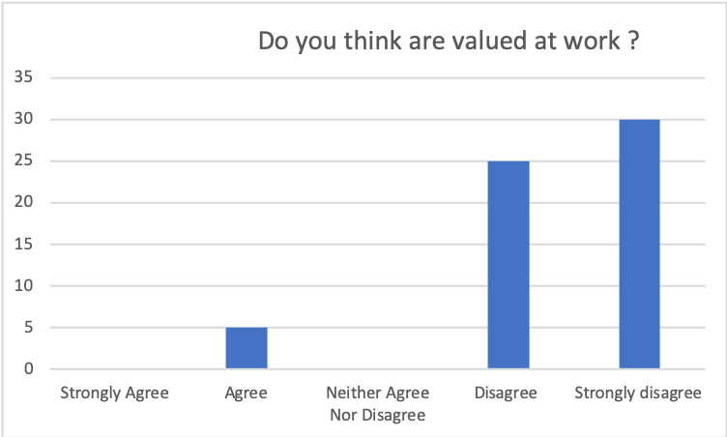

Strongly Agree | Agree | Neither Agree Nor Disagree | Disagree | Strongly disagree
0 | 5 | 0 | 15 | 30

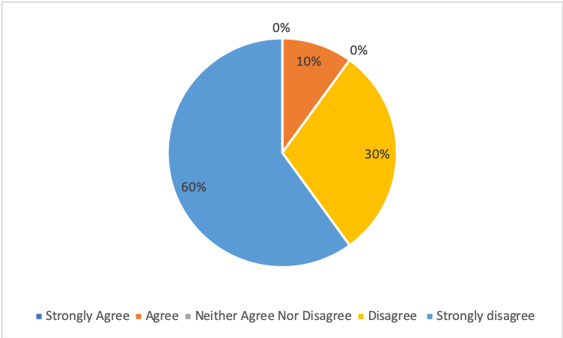

Q1: Graph Analysis : Felling valued at work essential for high job satisfaction. In fact 60% strongly disagree, 30% disagree and just 5% agree whit this. This meaning the organization need improve and appreciate more their employee.

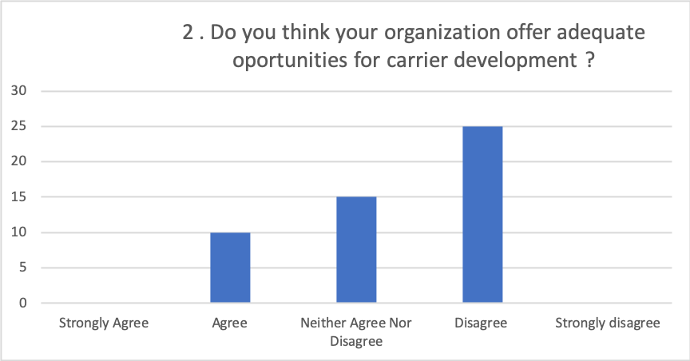

Strongly Agree | Agree | Neither Agree Nor Disagree | Disagree | Strongly disagree
0 | 10 | 15 | 25 | 0

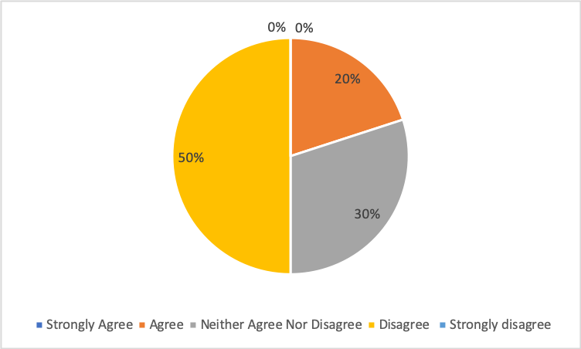

Q2.Graph analysis : According to my research just 20% of employees are satisfied about the organization and opportunity for development. 30% neutral and 50% disagree that mean if the organization don’t support the carrier growth employers will not be satisfied.

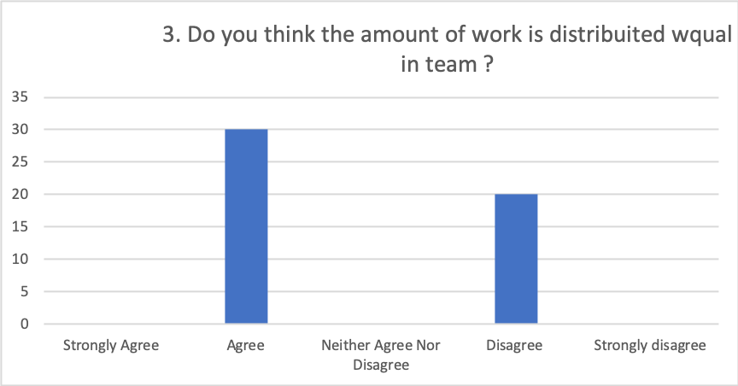

Strongly Agree | Agree | Neither Agree Nor Disagree | Disagree | Strongly disagree
0 | 30 | 0 | 20 | 0

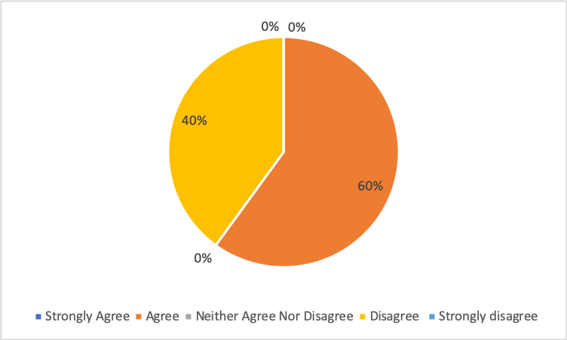

Q3. Graph analysis: More than half of employees agree, that’s mean the organisation have a good point in organization of work .

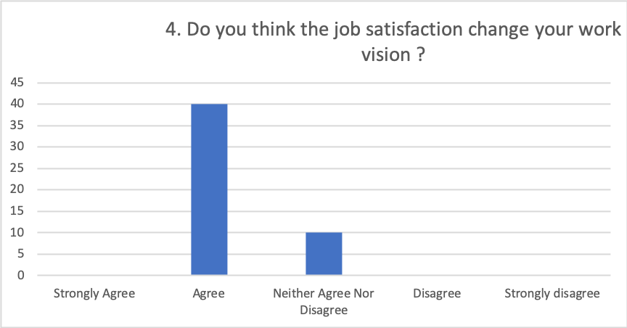

Strongly Agree | Agree | Neither Agree Nor Disagree | Disagree | Strongly disagree
0 | 40 | 10 | 0 | 0

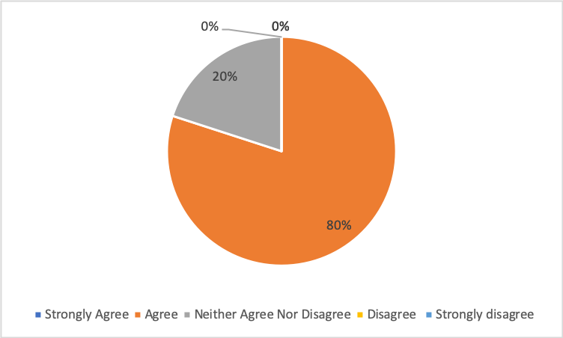

Q4. Graph analysis: 80% agree , the organization need have a high level in job satisfaction , if the employer are happy the productivity grow.

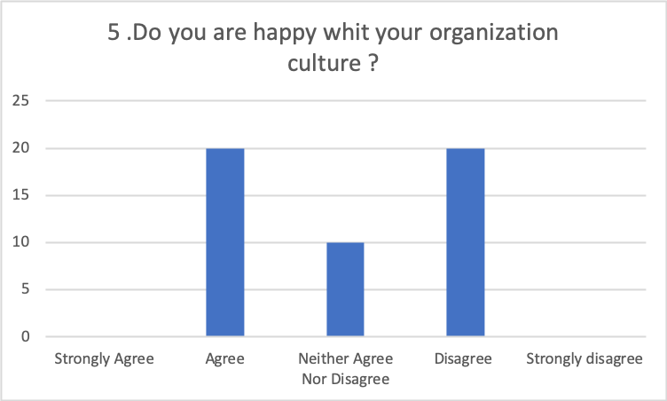

Strongly Agree | Agree | Neither Agree Nor Disagree | Disagree | Strongly disagree
0 | 20 | 10 | 20 | 0

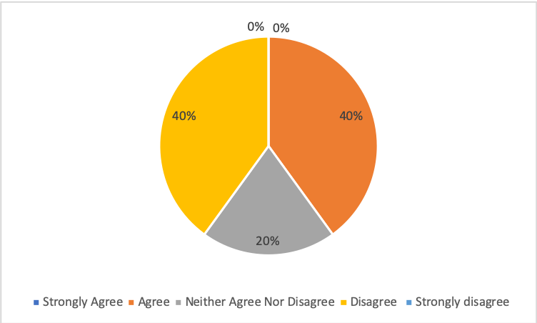

Q5. Graph analysis: the culture in organization helps employers to creating relationship, culture and work environment. In this research employers are satisfied and not in the same time , just 20% are neutral .

Recommendation for future

After this research I can say that most of employers are unsatisfied in their workplace. With this questionnaire about Employee Job Satisfaction I understand who important is the opinion of staff in the workplace.
A good organization, culture, training for career development will be necessaire for successful job satisfaction.

Conclusion

In conclusion, employees not satisfied I their job produce unsatisfied results. The organizations need understanding employers needs, make staff happy , because happy staff more productivity , in health and social care if the employers are happy the patient are happy and safety.

Reference list

Anon, (2019). [online] Available at: https://explorable.com/research-population?fbclid=IwAR1jI5DJCCfPa9E0DEAPQAFRNh1QJyEbWhGXbiymUJd0y9zS4zI0xj1HAfc [Accessed 2 May 2019].
Atkinson, P., Coffey, A. and Delamont, S. (2001). A debate about our canon. Qualitative Research, [online] 1(1), pp.5-21. Available at: https://journals.sagepub.com/doi/abs/10.1177/146879410100100101?casa_token=ojDPqLgoQtsAAAAA:iV_KvkQ-hzWnZtSDOUP5XVBbFqlmuqhT79Ae2Lg8gC85aMIW0MBMrXRQ_4GwH-jxeVsWb8Gxa-DK [Accessed 12 Apr. 2019].
G. Turner, A. (2019). [online] Unstats.un.org. Available at: https://unstats.un.org/unsd/demographic/meetings/egm/Sampling_1203/docs/no_3.pdf [Accessed 2 May 2019].
Hebson, G., Rubery, J. and Grimshaw, D., 2015. Rethinking job satisfaction in care work: looking beyond the care debates. Work, employment and society. 29(2). pp.314-330.
Hur, W. M., Moon, T. W. and Jung, Y. S., 2015. Customer response to employee emotional labor: the structural relationship between emotional labor, job satisfaction, and customer satisfaction. Journal of Services Marketing. 29(1). pp.71-80.
Holland. E., 2019. 5 Key Factors to Finding Job Satisfaction. [Online]. Available through: <https://chopra.com/articles/5-key-factors-to-finding-job-satisfaction>.

Kumar, R. (2011). Research methodology. 3rd ed. London: sage publications LTD.
McVicar, A., 2016. Scoping the common antecedents of job stress and job satisfaction for nurses (2000–2013) using the job demands–resources model of stress. Journal of nursing management, 24(2), pp.E112-E136

Megersa, D. (2015). The Management of KG Schools: The Case of Dilla University Community School. OALib, [online] 02(05), pp.1-15. Available at: https://www.scirp.org/(S(i43dyn45teexjx455qlt3d2q))/reference/ReferencesPapers.aspx?ReferenceID=1811842 [Accessed 7 Apr. 2019].
Smolowitz, J. and et. al., 2015. Role of the registered nurse in primary health care: Meeting health care needs in the 21st century. Nursing Outlook. 63(2). pp.130-136.

Thh.nhs.uk. (2019). [online] Available at: https://www.thh.nhs.uk/documents/_Departments/Research/InfoSheets/16_sampling_research.pdf [Accessed 1 May 2019].
Wengrzyn, R., 2019. What is Job Satisfaction: Definition, Causes and Factors. [Online]. Available through: <https://study.com/academy/lesson/what-is-job-satisfaction-definition-causes-and-factors.html>.

Williams, K. N., Ilten, T. B. and Bower, H., 2016. Meeting communication needs: Topics of talk in the nursing home. Journal of psychosocial nursing and mental health services. 43(7). pp.38-45.

Yilmaz, K. (2013). Comparison of Quantitative and Qualitative Research Traditions: epistemological, theoretical, and methodological differences. European Journal of Education, [online] 48(2), pp.311-325. Available at: https://pdfs.semanticscholar.org/f45f/993702833849749b3ddd83e1673728d569eb.pdf [Accessed 12 Apr. 2019].

