Ethical Issues

Ethics Form

APPLICATION FOR ETHICAL APPROVAL

In order for research to result in benefit and minimise risk of harm, it must be conducted ethically. A researcher may not be covered by the University’s insurance if ethical approval has not been obtained prior to commencement.

The University follows the OECD Frascati manual definition of research activity: “creative work undertaken on a systematic basis in order to increase the stock of knowledge, including knowledge of man, culture and society, and the use of this stock of knowledge to devise new applications”. As such this covers activities undertaken by members of staff, postgraduate research students, and both taught postgraduate and undergraduate students working on dissertations/projects.

The individual undertaking the research activity is known as the “principal researcher”.

Ethical approval is not required for routine audits, performance reviews, quality assurance studies, testing within normal educational requirements, and literary or artistic criticism.

Please read the notes for guidance before completing ALL sections of the form.

This form must be completed and approved prior to undertaking any research activity. Please see Checklist for details of process for different categories of application.

Delete the Guidance Notes at the end of the form BEFORE submitting your application

SECTION A: About You (Principal Researcher)
Full Name: |  | Leanne Dawney
Tick all boxes which apply: |  | Member of staff: | ☐ | Honorary research fellow: | ☐
Undergraduate Student | ☒ | Taught Postgraduate Student | ☐ | Postgraduate Research Student | ☐

Faculty/School/Centre: | Childhood and Education
Campus: | Carmarthen
E-mail address: | 1807563@student.uwtsd.ac.uk
Contact Telephone Number: | 07548275720
For students:
Student Number: | 1807563
Programme of Study: | BA Education Studies: Primary
Director of Studies/Supervisor: | Helen Griffiths / Lynwen Roberts

SECTION B: Approval for Research Activity
Has the research activity received approval in principle?  (please check the Guidance Notes as to the appropriate approval process for different levels of research by different categories of individual) |  | YES | ☒ | NO | ☐
 |  |  |  | Date
If Yes, please indicate source of approval (and date where known): Approval in principle must be obtained from the relevant source prior to seeking ethical approval | Research Degrees Committee |  | ☐
 | Faculty Research Committee |  | ☐
 | Other (write in)  Lecturer Lynwen Roberts |  | ☒ | 13/12/19

SECTION C: Internal and External Ethical Guidance Materials
Please list the core ethical guidance documents that have been referred to during the completion of this form (including any discipline-specific codes of research ethics, and also any specific ethical guidance relating to the proposed methodology). Please tick to confirm that your research proposal adheres to these codes and guidelines.
UWTSD Research Ethics & Integrity Code of Practice | ☒
UWTSD Research Data Management Policy | ☐
BERA guidelines | ☒

SECTION D: External Collaborative Research Activity
Does the research activity involve collaborators outside of the University? |  | YES | ☐ | NO | ☒
If Yes, please provide the name of the external organisation and name and contact details for the main contact person and confirmation this person has consented to their personal data being shared.as part of this collaboration.
Institution
Contact person name
Contact person e-mail address

Has this individual consented to sharing their details on this form? |  | YES | ☐ | NO |  |  | ☐
Are you in receipt of a KESS scholarship? |  | YES | ☐ | NO |  |  | ☐
Is your research externally funded |  | YES | ☐ | NO |  |  | ☐
Are you specifically employed to undertake this research in either a paid or voluntary capacity? | Voluntary | YES | ☐ | NO |  | ☐
 | Employed | YES | ☐ | NO |  | ☐
Is the research being undertaken within an existing UWTSD Athrofa Professional Learning Partnership (APLP) | If YES then the permission question below does not need to be answered. | YES | ☐ | NO |  |  | ☐
Permission to undertake the research has been provided by the partner organisation | (If YES attach copy)  If NO the application cannot continue | YES | ☐ | NO |  |  | ☐

Where research activity is carried out in collaboration with an external organisation
Does this organisation have its own ethics approval system? | YES | ☐ | NO | ☐
If Yes, please attach a copy of any final approval (or interim approval) from the organisation

SECTION E: Details of Research Activity
Indicative title: | Learning through doing – what concrete, experiential learning opportunities are there in a primary school?
Proposed start date: | 13/12/19 | Proposed end date: | 29/04/20
Introduction to the Research (maximum 300 words)
Ensure that you write for a Non-Specialist Audience when outlining your response to the three points below:
- Purpose of Research Activity
- Proposed Research Question
- Aims of Research Activity
- Objectives of Research Activity
Demonstrate, briefly, how Existing Research has informed the proposed activity and explain
- What the research activity will add to the body of knowledge
- How it addresses an area of importance.
Purpose of Research Activity

The research activity will find out what concrete, experiential learning opportunities are there in a primary school?

(this box should expand as you type)
Research Question

What opportunities are there to learn through doing

(this box should expand as you type)
Aims of Research Activity

Observing learning through doing

(this box should expand as you type)
Objectives of Research Activity

Observing 10 days of experiential learning at a primary school

(this box should expand as you type)
Proposed methods (maximum 600 words)
Provide a brief summary of all the methods that may be used in the research activity, making it clear what specific techniques may be used. If methods other than those listed in this section are deemed appropriate later, additional ethical approval for those methods will be needed.
Structured observation using a table.
Unstructured observation during the day.

(this box should expand as you type)

Location of research activity
Identify all locations where research activity will take place.
A local primary school

(this box should expand as you type)
Research activity outside of the UK
If research activity will take place overseas, you are responsible for ensuring that local ethical considerations are complied with and that the relevant permissions are sought. Specify any local guidelines (e.g. from local professional associations/learned societies/universities) that exist and whether these involve any ethical stipulations beyond those usual in the UK (provide details of any licenses or permissions required). Also specify whether there are any specific ethical issues raised by the local context in which the research activity is taking place, for example, particular cultural and/or legal sensitivities or vulnerabilities of participants.
N/A

(this box should expand as you type)
Use of documentation not in the public domain: Are any documents NOT publicly available? | NO | ☒
 | YES | ☐
If Yes, please provide details here of how you will gain access to specific documentation that is not in the public domain and that this is in accordance with prevailing data protection law of the country in question and England and Wales.

(this box should expand as you type)

SECTION F: Scope of Research Activity

Will the research activity include: | YES | NO
Use of a questionnaire or similar research instrument? | ☐ | ☒
Use of interviews? | ☐ | ☐
Use of diaries? | ☐ | ☒
Participant observation with their knowledge? | ☒ | ☐
Participant observation without their knowledge? | ☐ | ☒
Use of video or audio recording? | ☐ | ☒
Access to personal or confidential information without the participants’ specific consent? | ☐ | ☒
Administration of any questions, test stimuli, presentation that may be experienced as physically, mentally or emotionally harmful / offensive? | ☐ | ☒
Performance of any acts which may cause embarrassment or affect self-esteem? | ☐ | ☒
Investigation of participants involved in illegal activities? | ☐ | ☒
Use of procedures that involve deception? | ☐ | ☒
Administration of any substance, agent or placebo? | ☐ | ☒
Working with live vertebrate animals? | ☐ | ☒
Other primary data collection methods, please explain in this box  For example, ‘focus groups’. Please indicate the type of data collection method(s) in this box and tick the accompany box. | ☐ | ☒
Details of any other primary data collection method:  (this box should expand as you type) | ☐ | ☒
If NO to every question, then the research activity is (ethically) low risk and may be exempt from some of the following sections (please refer to Guidance Notes).

If YES to any question, then no research activity should be undertaken until full ethical approval has been obtained.

SECTION G: Intended Participants

Who are the intended participants: | YES | NO
Students or staff at the University? | ☐ | ☒
Adults (over the age of 18 and competent to give consent)? | ☒ | ☐
Vulnerable adults? | ☐ | ☒
Children and Young People under the age of 18? (Consent from Parent, Carer or Guardian will be required) | ☒ | ☐
Prisoners? | ☐ | ☒
Young offenders? | ☐ | ☒
Those who could be considered to have a particularly dependent relationship with the investigator or a gatekeeper? | ☐ | ☒
People engaged in illegal activities? | ☐ | ☒
Others (please identify specifically any group who may be unable to give consent) please indicate here and tick the appropriate box. | ☐ | ☒
Other – please indicate here:  (this box should expand as you type) | ☐ | ☒

Participant numbers and source
Provide an estimate of the expected number of participants. How will you identify participants and how will they be recruited?
How many participants are expected? | Up to 30 pupils  2 teachers  (this box should expand as you type)
Who will the participants be? | Teachers and primary school children  (this box should expand as you type)
How will you identify the participants? | School identified and approached  (this box should expand as you type)

Information for participants: | YES | NO | N/A
Will you describe the main research procedures to participants in advance, so that they are informed about what to expect? | ☒ | ☐ | ☐
Will you tell participants that their participation is voluntary? | ☒ | ☐ | ☐
Will you obtain written consent for participation? | ☒ | ☐ | ☐
Will you explain to participants that refusal to participate in the research will not affect their treatment or education (if relevant)? | ☒ | ☐ | ☐
If the research is observational, will you ask participants for their consent to being observed? | ☒ | ☐ | ☐
Will you tell participants that they may withdraw from the research at any time and for any reason? | ☒ | ☐ | ☐
With questionnaires, will you give participants the option of omitting questions they do not want to answer? | ☐ | ☐ | ☒
Will you tell participants that their data will be treated with full confidentiality and that, if published, it will not be identifiable as theirs? | ☒ | ☐ | ☐
Will you debrief participants at the end of their participation, in a way appropriate to the type of research undertaken? | ☒ | ☐ | ☐
If NO to any of above questions, please give an explanation
(this box should expand as you type)

Information for participants: | YES | NO | N/A
Will participants be paid? | ☐ | ☒ | ☐
Is specialist electrical or other equipment to be used with participants? | ☐ | ☒ | ☐
Are there any financial or other interests to the investigator or University arising from this study? | ☐ | ☒ | ☐
Will the research activity involve deliberately misleading participants in any way, or the partial or full concealment of the specific study aims? | ☐ | ☒ | ☐
If YES to any question, please provide full details
(this box should expand as you type)

SECTION H: Anticipated Risks

Outline any anticipated risks that may adversely affect any of the participants, the researchers and/or the University, and the steps that will be taken to address them.

If you have completed a full risk assessment (for example as required by a laboratory, or external research collaborator) you may append that to this form.
Full risk assessment completed and appended? |  | Yes | ☐
 |  | No | ☒
Risks to participants
For example: emotional distress, financial disclosure, physical harm, transfer of personal data, sensitive organisational information
Risk to Participant:  The risk to the participants is minimal. However, their time is precious, and some anxiety could develop if they have insufficient time to take part in the investigation.  (this box should expand as you type) | How will you mitigate the Risk to Participant  I will explain to the participant that their participation is voluntary and that they may withdraw at any time.  (this box should expand as you type)
If research activity may include sensitive, embarrassing or upsetting topics (e.g. sexual activity, drug use) or issues likely to disclose information requiring further action (e.g. criminal activity), give details of the procedures to deal with these issues, including any support/advice (e.g. helpline numbers) to be offered to participants. Note that where applicable, consent procedures should make it clear that if something potentially or actually illegal is discovered in the course of a project, it may need to be disclosed to the proper authorities
(this box should expand as you type)
Risks to investigator
For example: personal safety, physical harm, emotional distress, risk of accusation of harm/impropriety, conflict of interest
Risk to Investigator:  (this box should expand as you type) | How will you mitigate the Risk to Investigator:  (this box should expand as you type)
University/institutional risks
For example: adverse publicity, financial loss, data protection
Risk to University:  This research is being carried out in the name of the University. If ethical guidelines are not followed, the University’s reputation could be at risk.  (this box should expand as you type) | How will you mitigate the Risk to University:  I will ensure that I follow ethical guidelines and the advice of my lecturers.  (this box should expand as you type)

Disclosure and Barring Service
If the research activity involves children or vulnerable adults, a Disclosure and Barring Service (DBS) certificate must be obtained before any contact with such participants. | YES | NO | N/A
Does your research require you to hold a current DBS Certificate? | ☐ | ☐ | ☐

SECTION I: Feedback, Consent and Confidentiality

Feedback
What de-briefing and feedback will be provided to participants, how will this be done and when?
Verbal feedback will be provided at the of the placement. The participant will be offered a copy of the research findings.

(this box should expand as you type)
Informed consent
Describe the arrangements to inform potential participants, before providing consent, of what is involved in participating. Describe the arrangements for participants to provide full consent before data collection begins. If gaining consent in this way is inappropriate, explain how consent will be obtained and recorded in accordance with prevailing data protection legislation.
Consent form and information sheet provided for participants.

(this box should expand as you type)
Confidentiality / Anonymity
Set out how anonymity of participants and confidentiality will be ensured in any outputs. If anonymity is not being offered, explain why this is the case.
No names of participants will be used, or the name of the setting.

(this box should expand as you type)

SECTION J: Data Protection and Storage
In completing this section refer to the University’s Research Data Management Policy and the extensive resources on the University’s Research Data Management web pages (http://uwtsd.ac.uk/library/research-data-management/).
Does the research activity involve personal data (as defined by the General Data Protection Regulation 2016 “GDPR” and the Data Protection Act 2018 “DPA”)? | YES | NO
“Personal data” means any information relating to an identified or identifiable natural person (‘data subject’). An identifiable natural person is one who can be identified, directly or indirectly, in particular by reference to an identifier such as a name, an identification number, location data, an online identifier or to one or more factors specific to the physical, physiological, genetic, mental, economic, cultural or social identity of that natural person. | ☐ | ☐X
If YES, provide a description of the data and explain why this data needs to be collected:
(this box should expand as you type)
Does it involve special category data (as defined by the GDPR)? | YES | NO
“Special category data” means sensitive personal data consisting of information as to the data subjects’ –  (a) racial or ethnic origin,  (b) political opinions,  (c ) religious beliefs or other beliefs of a similar nature,  (d) membership of a trade union (within the meaning of the Trade Union and Labour Relations (Consolidation) Act 1992),  (e) physical or mental health or condition,  (f) sexual life,  (g) genetics,  (h) biometric data (as used for ID purposes), | ☐ | ☐X
If YES, provide a description of the special category data and explain why this data needs to be collected:
(this box should expand as you type)
Will the research activity involve storing personal data and/or special category data on one of the following: | YES | NO
Manual files (i.e. in paper form)? | ☐ | ☒
University computers? | ☐ | ☒
Private company computers? | ☐ | ☒
Home or other personal computers? | ☐ | ☒
Laptop computers/ CDs/ Portable disk-drives/ memory sticks? | ☐ | ☒
“Cloud” storage or websites? | ☐ | ☒
Other – specify: | ☐ | ☒
For all stored data, explain the measures in place to ensure the security of the data collected, data confidentiality, including details of password protection, encryption, anonymisation and pseudonymisation:
(this box should expand as you type)
All Data Storage
Will the research activity involve any of the following activities: | YES | NO
Electronic transfer of data in any form? | ☐ | ☒
Sharing of data with others at the University? | ☒ | ☐
Sharing of data with other organisations? | ☐ | ☒
Export of data outside the European Union or importing of data from outside the UK? | ☐ | ☒
Use of personal addresses, postcodes, faxes, emails or telephone numbers? | ☐ | ☒
Publication of data that might allow identification of individuals? | ☐ | ☒
Use of data management system? | ☐ | ☒
Data archiving? | ☐ | ☒
If YES to any question, please provide full details, explaining how this will be conducted in accordance with the GDPR and DPA (and/or any international equivalent):
The data will be shared only with the module lecturers.

(this box should expand as you type)
List all who will have access to the data generated by the research activity:
The investigator.
The module lecturer.

(this box should expand as you type)
List who will have control of, and act as custodian(s) for, data generated by the research activity:
The investigator.

(this box should expand as you type)
Give details of data storage arrangements, including security measures in place to protect the data, where data will be stored, how long for, and in what form. Will data be archived – if so how and if not why not.
All data will be stored on the investigator on their password protected computer.

(this box should expand as you type)
Please indicate if your data will be stored in the UWTSD Research Data Repository (see https://researchdata.uwtsd.ac.uk/ ). If so please explain. (Most relevant to academic staff)
No.

(this box should expand as you type)
Confirm that you have read the UWTSD guidance on data management (see https://www.uwtsd.ac.uk/library/research-data-management/) | YES | ☒
 | NO | ☐
Confirm that you are aware that you need to keep all data until after your research has completed or the end of your funding | YES | ☒
 | NO | ☐

SECTION K: Declaration
The information which I have provided is correct and complete to the best of my knowledge. I have attempted to identify any risks and issues related to the research activity and acknowledge my obligations and the rights of the participants.

In submitting this application I hereby confirm that I undertake to ensure that the above named research activity will meet the University’s Research Ethics and Integrity Code of Practice
Signature of applicant: | L M Dawney | Date:  13.12.19

For STUDENT Submissions:
Director of Studies/Supervisor: | Lynwen Roberts | Date:  13.12.19
Signature: | l.Roberts | Date:  13.12.19

For STAFF Submissions:
Head of School/Assistant Dean: | Mrs Sally-Anne Watts | Date:  1st May 2020
Signature: |  | Date:  1st May 2020

Checklist: Please complete the checklist below to ensure that you have completed the form according to the guidelines and attached any required documentation:
☒ | I have read the guidance notes supplied before completing the form.
☒ | I have completed ALL RELEVANT sections of the form in full.
☒ | I confirm that the research activity has received approval in principle
☐ | I have attached a copy of final/interim approval from external organisation (where appropriate)
☐ | I have attached a full risk assessment (and have NOT completed Section H of this form) (where appropriate) ONLY TICK IF YOU HAVE ATTACHED A FULL RISK ASSESSMENT
☒ | I understand that it is my responsibility to ensure that the above named research activity will meet the University’s Research Ethics and Integrity Code of Practice.
☒ | I understand that before commencing data collection all documents aimed at respondents (including information sheets, consent forms, questionnaires, interview schedules etc.) must be confirmed by the DoS/Supervisor, module tutor or Head of School.
☒ | I have deleted the guidance notes before submitting the PG2 for consideration

RESEARCH STUDENTS AND STAFF ONLY
All communications relating to this application during its processing must be in writing and emailed to pgresearch@uwtsd.ac.uk , with the title ‘Ethical Approval’ followed by your name.
You will be informed of the outcome of your claim by email; therefore it is important that you check your University and personal email accounts regularly.

STUDENTS ON UNDERGRADUATE OR TAUGHT MASTERS PROGRAMMES should submit this form (and receive the outcome) via systems explained to you by the supervisor/module leader.

This form is available electronically from the Academic Office web pages: http://www.uwtsd.ac.uk/academic-office/

Participation Consent Form
School’s Safeguarding Policy

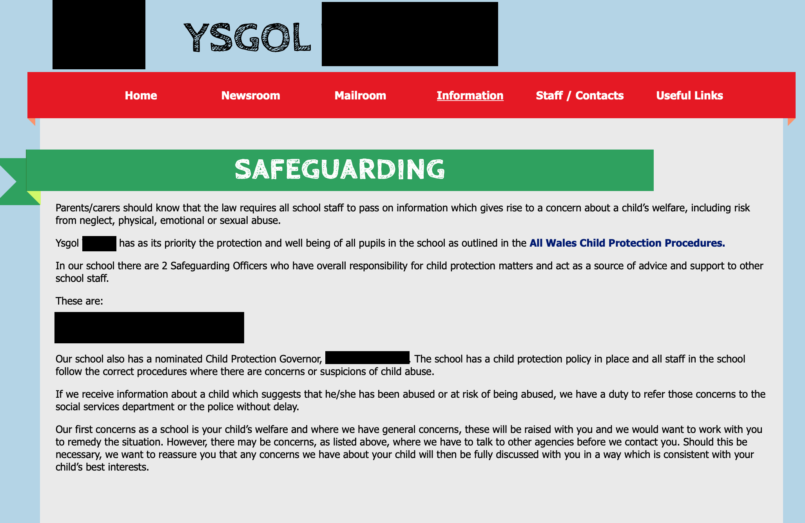

A screenshot of the school’s safeguarding page on their website.

The school outlines it’s safeguarding and child protection policies in the All Wales Child Protection Procedures. It is as follows:

Child Protection Policy and Procedures for Schools

YSGOL (SCHOOL NAME CENSORED)

Introduction

“We all share a responsibility for safeguarding and promoting the welfare of children and young people, whether as a parent or family member, a friend or neighbour, an employer or as a paid or volunteer worker. All members of the community can help to safeguard and promote the welfare of children and young people and should act to do so if they have concerns about a child’s welfare.” (Safeguarding Children: Working Together under the Children Act 2004) Click to view document*

  - Ysgol (censored) fully recognises the contribution it makes to child protection.

  - Our school is committed to ensuring the safety and protection of all children and will take action to safeguard their well-being, and acknowledge that children have a right to protection.

  - Our school acknowledges the importance of its role in the welfare of children and young people and, through the general ethos of the school, will seek to encourage children in need of support to come forward.

  - Ysgol (censored) will work with multi-disciplinary partners within the statutory framework established by:

- (censored) Safeguarding Children Board (CSCB)
- The All Wales Child Protection Procedures 2008
- Safeguarding Children: Working Together under the Children Act 2004 Section 28
- Safeguarding Children in Education – the role of local authorities and governing bodies under the Education Act 2002
- CSCB – Handling Allegations of Abuse Made Against Adults who Work with Children and Young People.

Our policy applies to all staff and volunteers working in the school and governors. This includes staff working in the school, such as the catering and cleaning staff, who may not be employed by the governing body – for example, staff employed by contractors. Teaching assistants, lunchtime supervisors, caretakers, administrative and support staff, governors, as well as teachers, can be the first point of disclosure for a child or a concerned parent.

The policy will be reviewed annually under the direction of the Local Authority Designated Officer for Safeguarding in Education, taking into account any new policy documentation
and/or guidance.
*The school reinstates the All Wales Child Protection Procedures (2008) statement that it is based on the principle that the protection of children against harm is the responsibility of all adults working with children (Children in Wales, 2008).

In Wales, the Welsh Government using the United Nations Convention on the Rights of the Child as a guide for child protection policies. The All Wales Child Protection Procedures (2008) inform and guide each local and regional safeguarding board across Wales. Lindon (2012) says that effective safeguarding processes depend on clear policies and linked procedures, it is also crucial that settings have a shared understanding that it is everyone’s responsibility (Lindon, 2010). The school reinstates this message with emphasis stating that the policy applies to all.

Topic Based Information

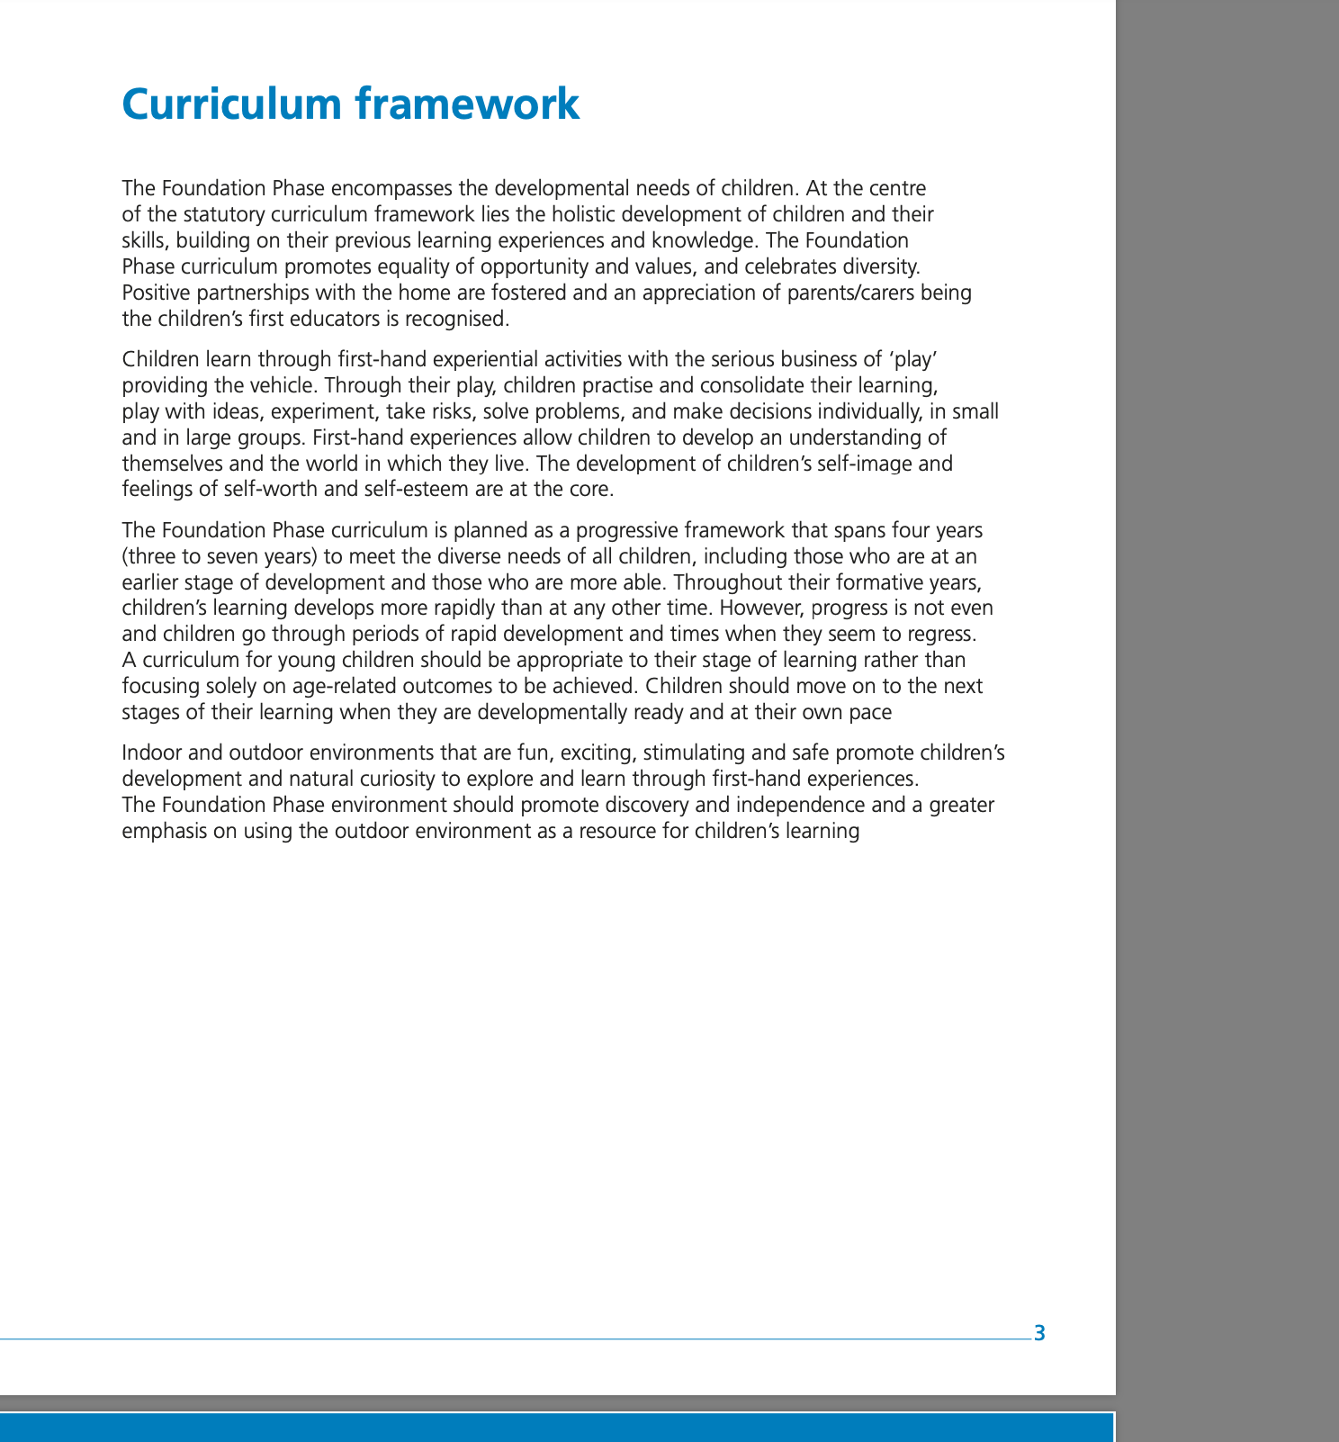
The Foundation Phase (2015)

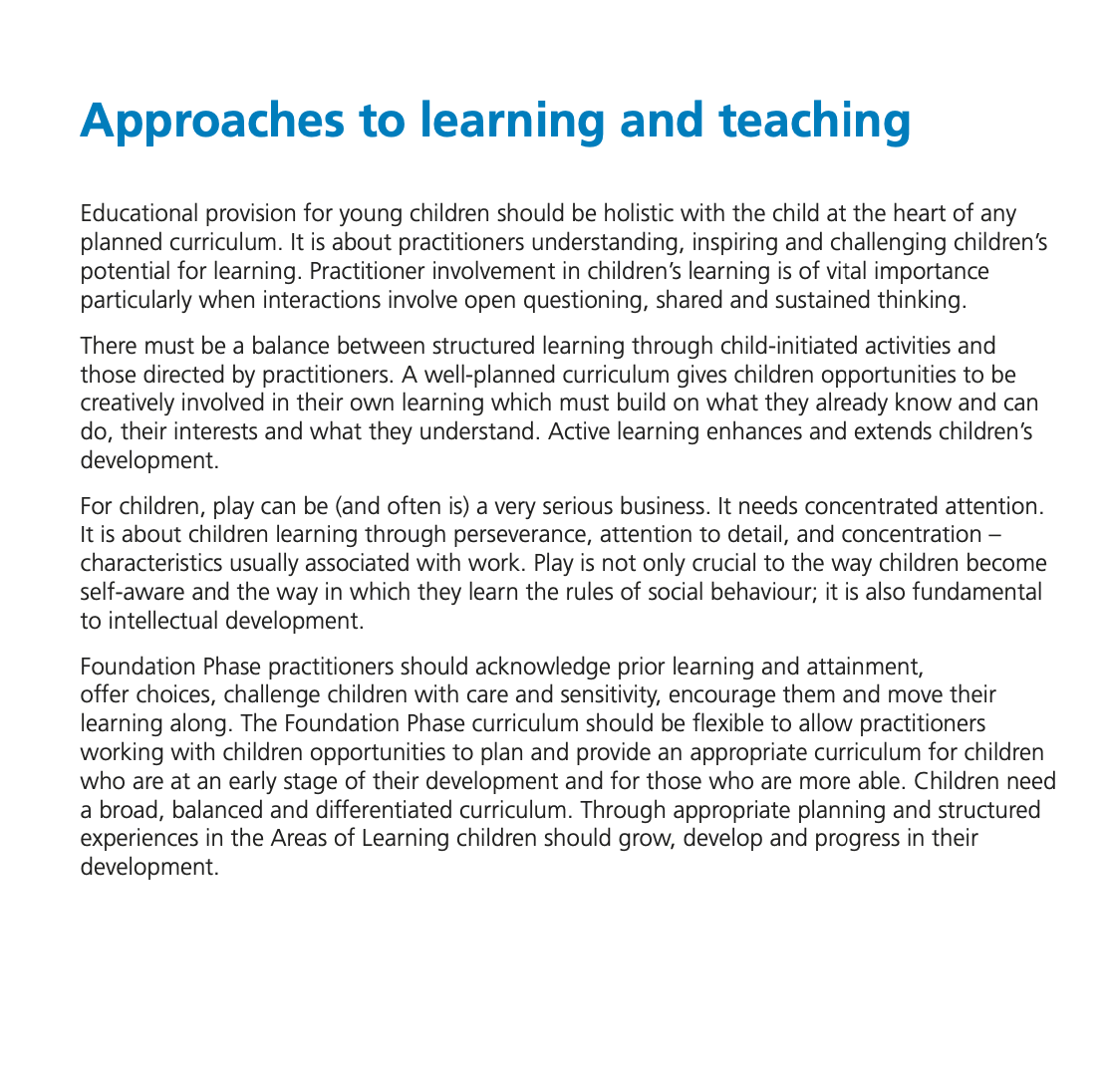

The Foundation Phase (2015) is a crucial framework in regards to learning through doing. It states
Children learn through first-hand experiential activities with the serious business of ‘play’ providing the vehicle. Through their play, children practise and consolidate their learning, play with ideas, experiment, take risks, solve problems and decisions individually, in small and large groups. First-hand experiences allow children to develop an understanding of themselves and the world in which they live (Welsh Government, 2015 p. 3).
It also goes on to state
Indoor and outdoor environments that are fun, exciting, stimulating and safe promote children’s development and natural curiosity to explore and learn through first-hand experiences. The Foundation Phase environment should promote discovery and independence… (Welsh Government, 2015).

School Prospectus
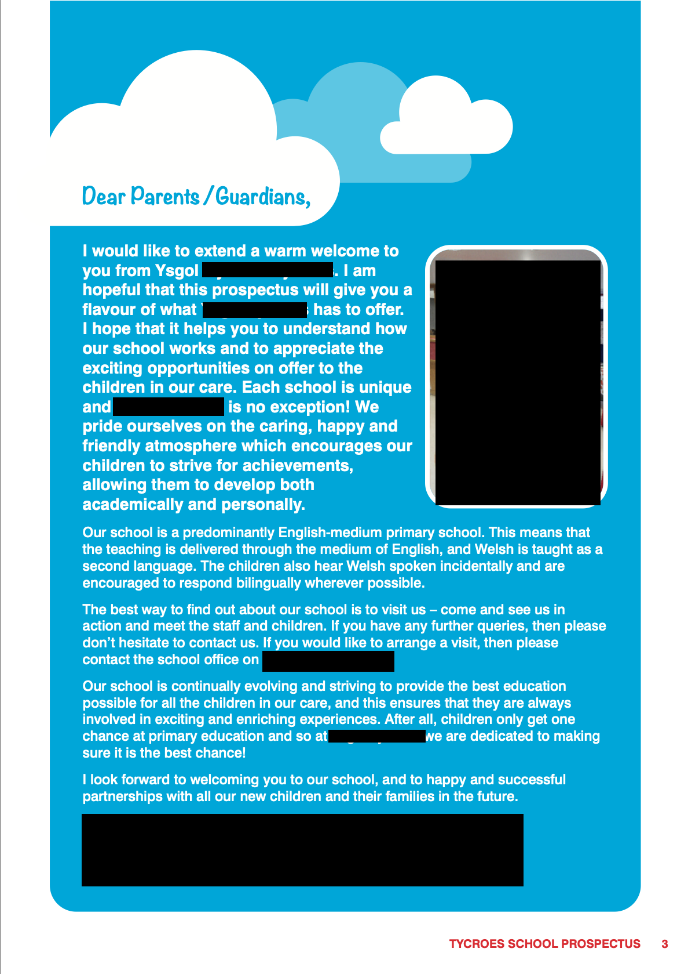

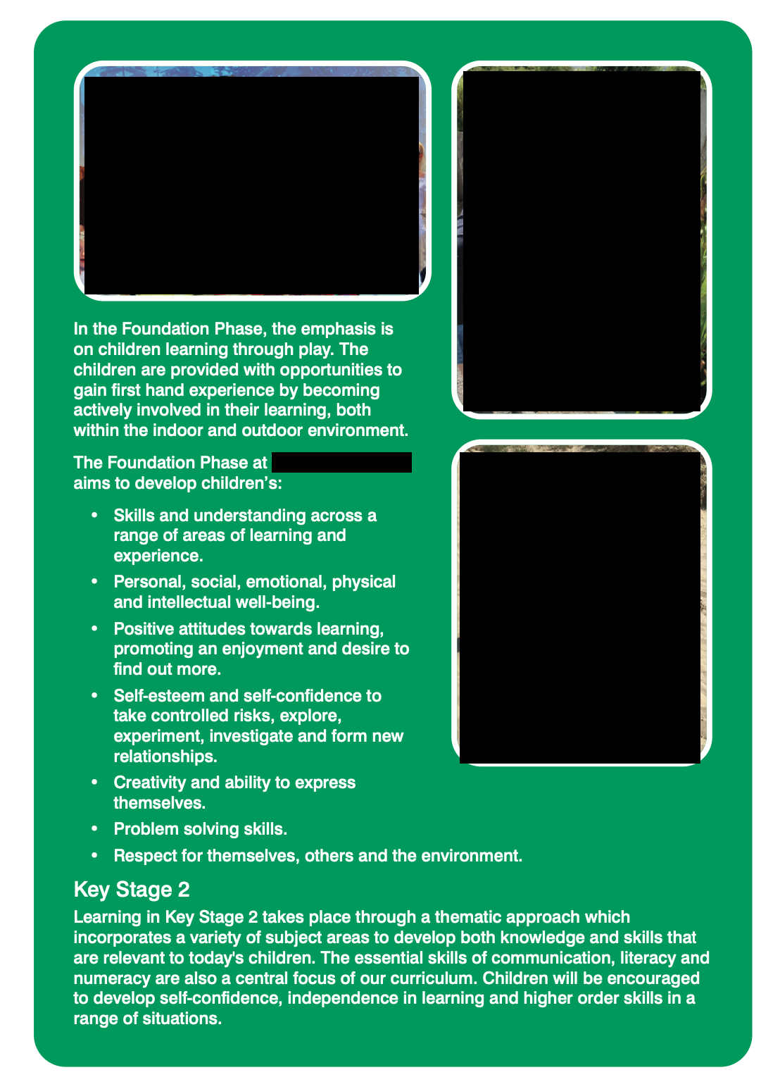
In the school’s prospectus, as highlighted, they place importance on the Foundation Phase’s (2015) ideology of active, experiential learning. This was seen during the time spent at the school through experiential indoor activities, outdoor play and Welly Wednesday which the researcher would have had the opportunity to see.
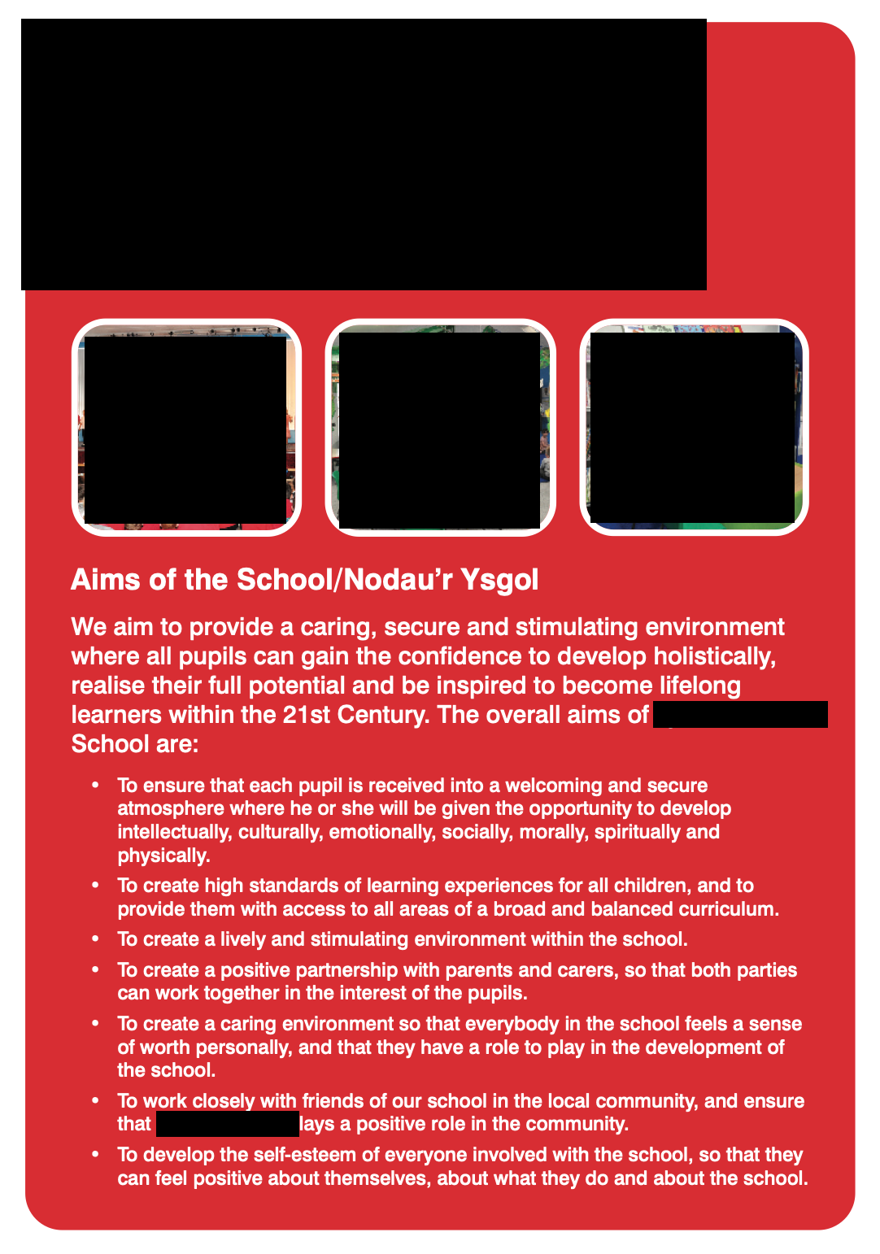

Estyn Report

The school’s Estyn report was issued in November 2015.

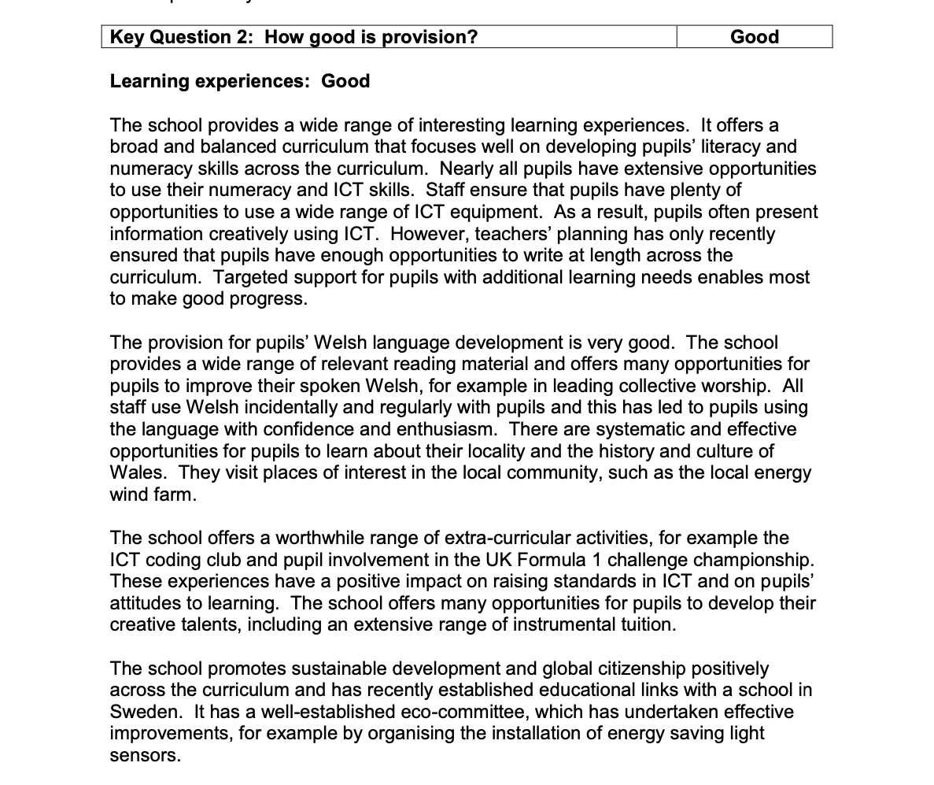

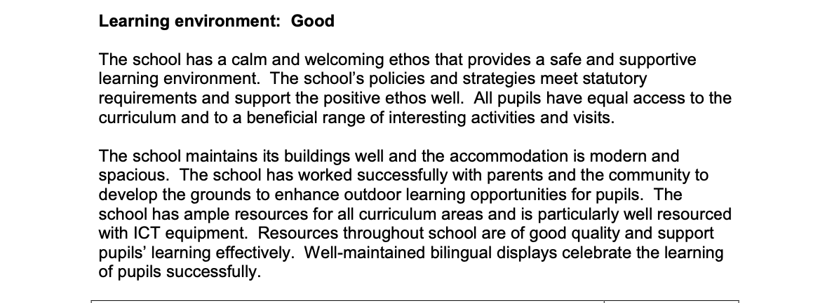

In a discussion, the class teacher explained that on Wednesdays, the children took part in ‘Welly Wednesday’. This included forest and outdoor sensory activities.

Estyn Active and Experiential Learning

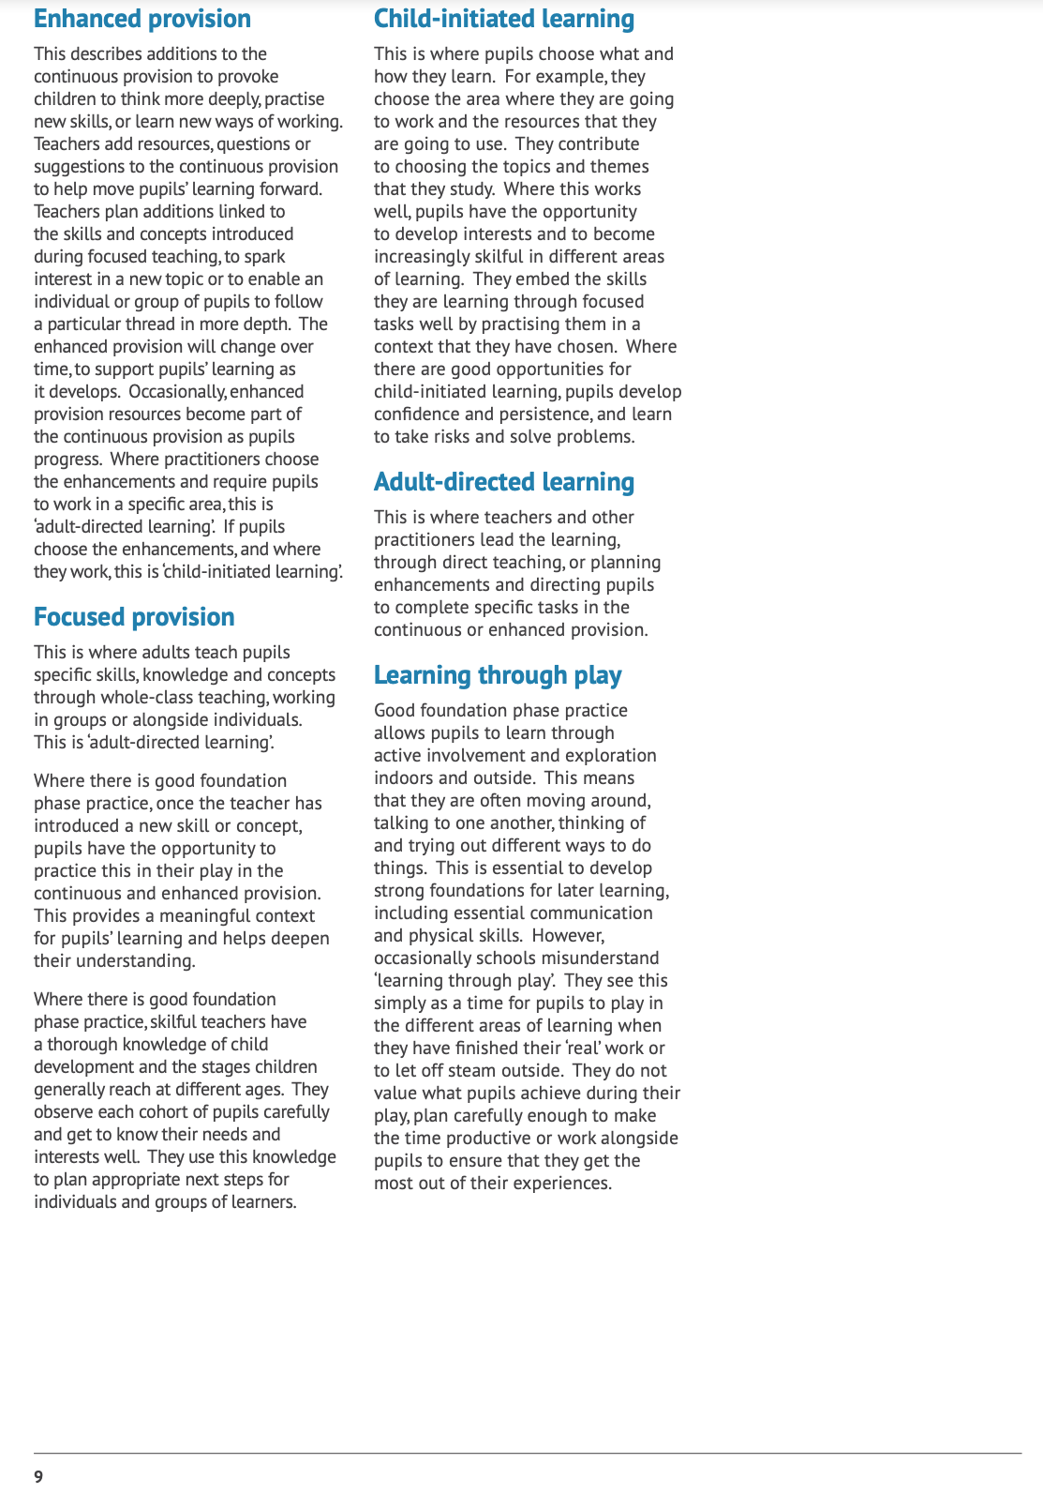
I

In a document about active and experiential learning released by Estyn (2017) they support the Foundation Phase (2015) and Kolb’s model of experiential learning (1984) that stating good practice is to give children the opportunity to learn through active opportunities both indoors and outside.
The Kolb Learning Style Inventory 4.0: Guide to Theory, Psychometrics, Research & Applications
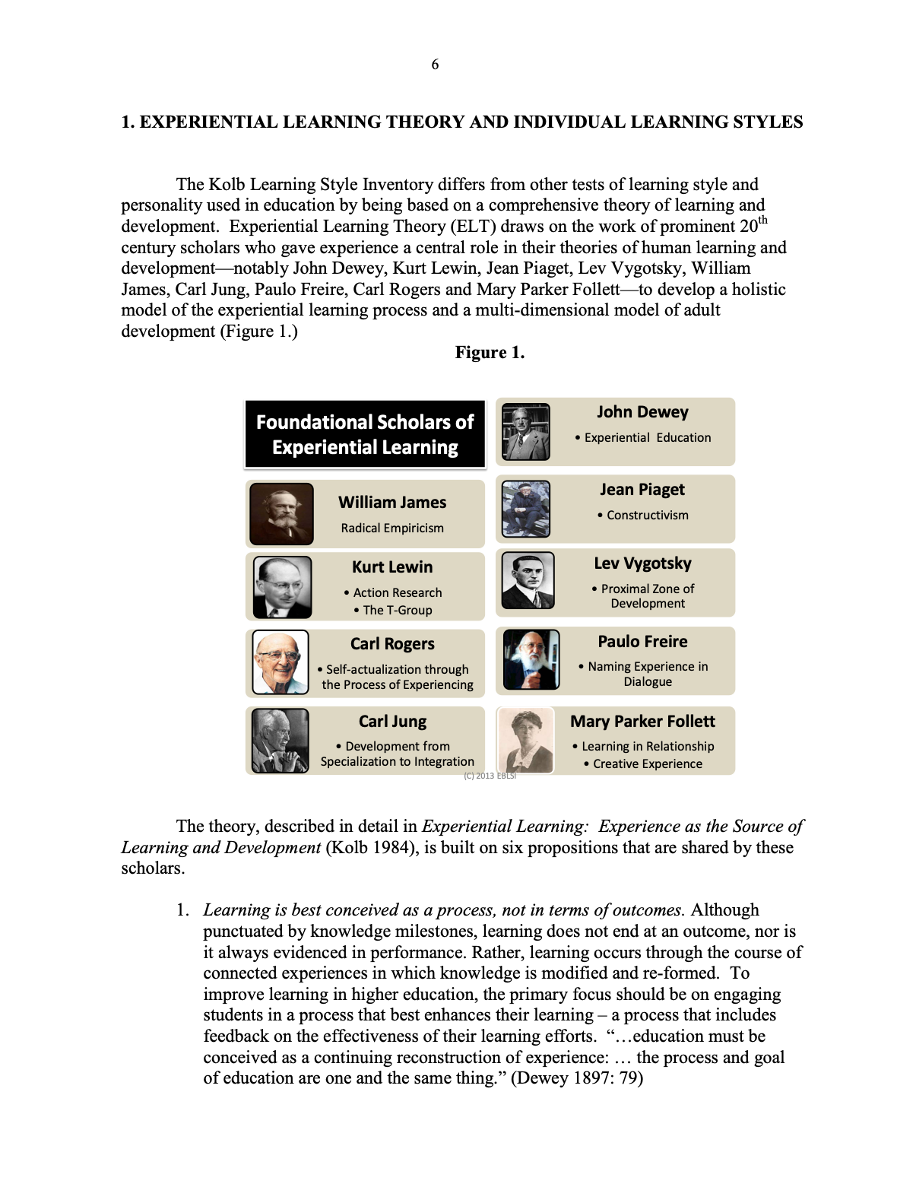



Friedrich Froebel, Lev Vygotsky, Jean Piaget and John Dewey are amongst some of the educational scholars who spoke of experiential learning (Kolb and Kolb, 2013).

The concept of experiential learning and John Dewey's theory of reflective thought and action

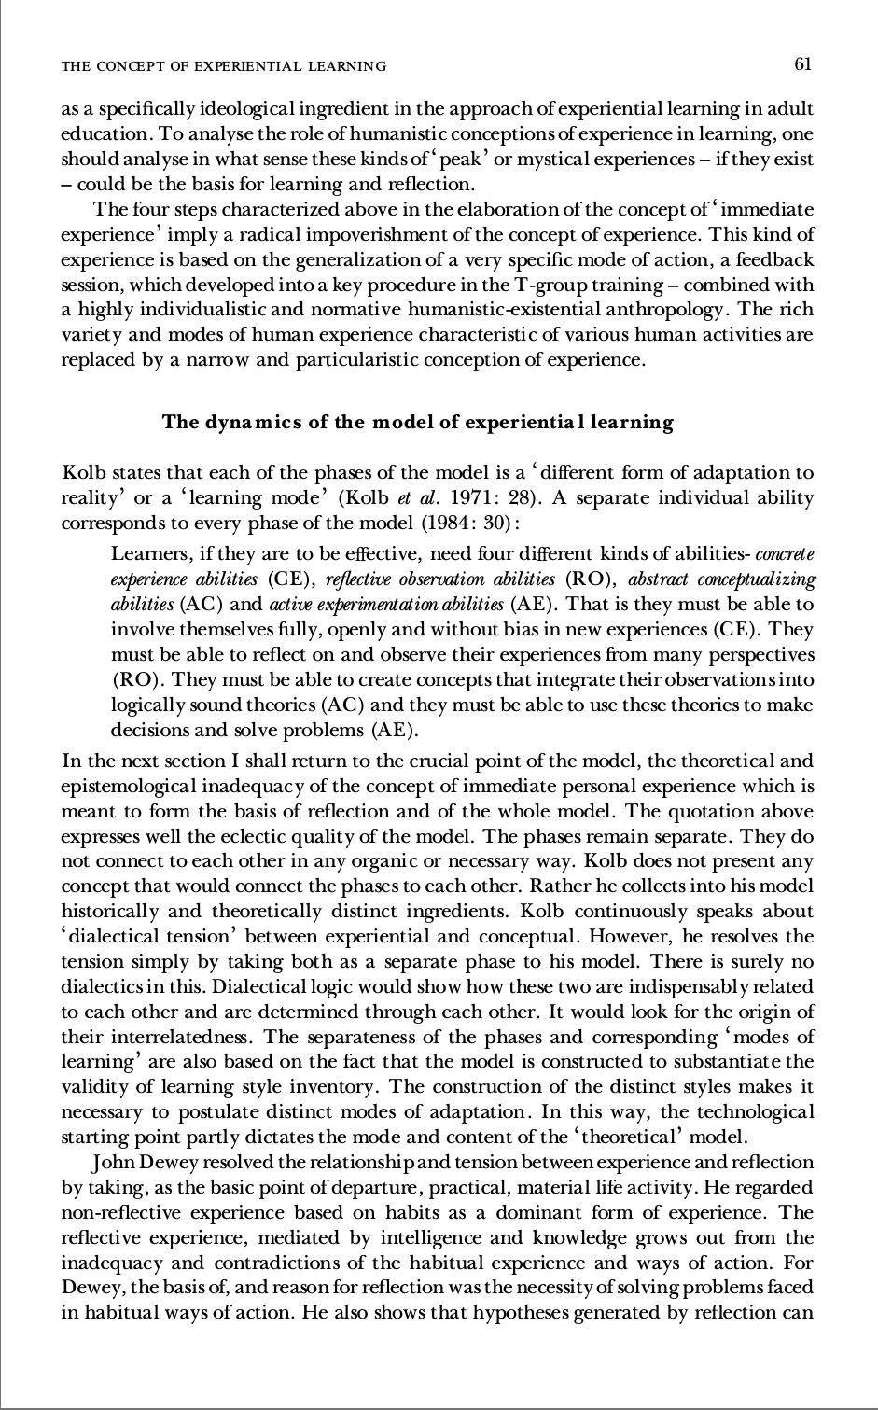
The above all support experiential learning. The school’s prospectus draws on the Foundation (2015) phases’ ideology and ethos and is incorporated into their way of learning. The theory behind the Foundation Phase is supported by Kolb’s (19983) experiential learning theory model in which was used as a guide and tool within this research study.

The Foundation Phase in Wales – time to grow up?

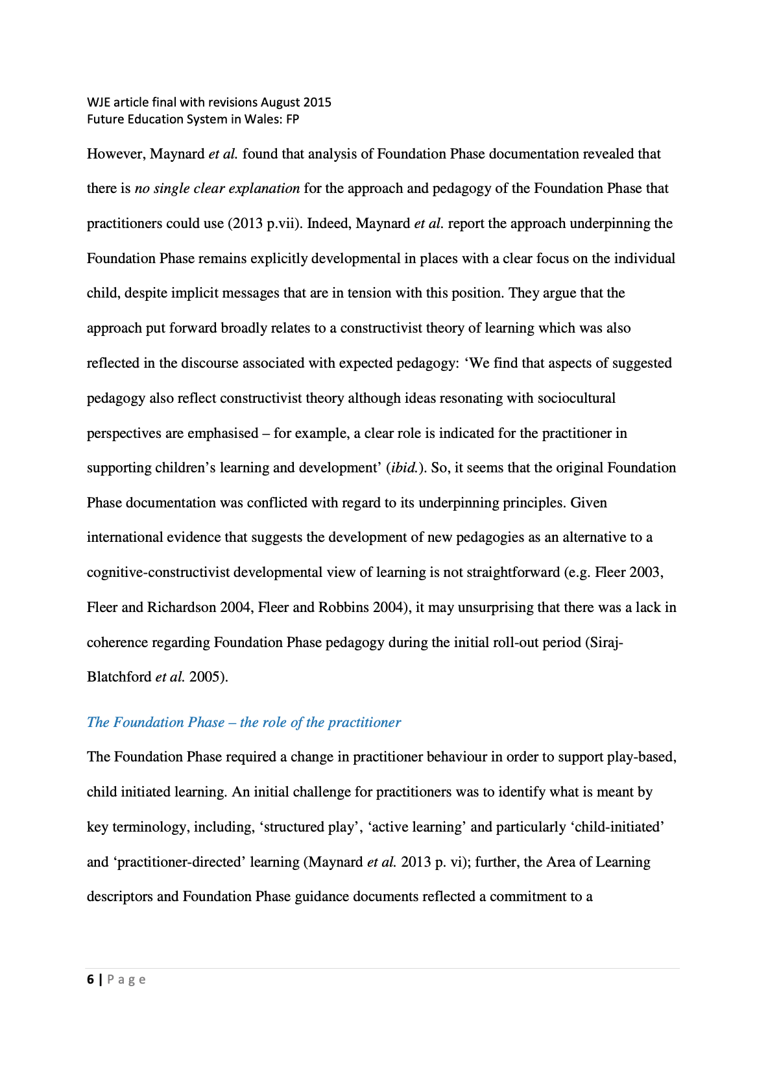
In this paper by Waters (2016) there are criticisms towards the Foundation Phase (2015). It states that the theory behind the pedagogy is slightly unclear as a ‘cognitive-constructivist developmental view of learning is not straightforward’ (Waters, 2016, p. 6). It goes on to explain that practitioners must need a clear, shared understanding of what concepts such as ‘structured play’ and ‘active learning’ actually mean within a practical setting.

Methodological Information

*It is important to note that only four out of the proposed ten days were able to be completed in placement due to the Coronavirus outbreak 2020.

Reflective Diary

Reflective Placement Diary
Dyddiadur Lleoliad Adlewyrchol

What happened?
Beth ddigwyddodd?

What went well?  ---------------------------------------------------  Beth aeth yn dda? | In my short time, I was able to see a few examples of experiential learning. I was able to see and understand how this way of learning is used in activities and incorporated into the classroom. I was also had a good insight to the enhanced provision and how this helps aid children’s learning and development.
What were the main challenges / problems/ difficulties you faced?  -----------------------------------------------------  Pa heriau/ broblemau ddigwyddodd? | As I was with a younger class, the activities mostly focused on the concrete activity and testing rather than the reflective observation and abstract conceptualization. Also, because it was a younger class there was less focused learning outcomes and at the time the school was preparing for a Welsh award which took some time that they would normally be in areas and having Well Wednesday, away.  Due to the coronavirus I was only about to complete four days out of the proposed ten.
How did you react to the challenges?  ----------------------------------------------------  Sut ymatebaist i’r heriau? | I focused more on the experiential learning I had seen and used this to draw and refer to literature and theory. I also observed how hands-on learning was used in a classroom within a less structured way. I also was able to have a conversation with the class teacher in which she was able to tell me about Welly Wednesday along with other things that I did not have the opportunity to observe.
How did you feel?  -----------------------------------------------------  Sut oeddet ti’n teimlo? | I thoroughly enjoyed my time at placement, and it was good to see the literature and theories that I had been reading about in a practical form.
What surprised you?
-----------------------------------------------------
Beth oedd yn syndod i ti?
What were you familiar with?  -----------------------------------------------------  Beth oeddet ti’n gyfarwydd ag ef? | I was familiar with being within a Foundation Phase setting.
Have your beliefs and expectations changed or been challenged?  -----------------------------------------------------  Ydy dy gredoau neu dy ddisgwyliadau wedi newid neu wedi cael eu herio? | It was interesting that the Foundation Phase is sometimes criticized for allowing children to have too much independence however after spending time within the classroom it was clear how much planning goes into the areas so my beliefs had not been challenged and I agree with the Foundation Phase’s ethos and ideology.

Critiquing your experience

Beirniadu dy brofiad

How well did you think you managed the challenging situation?  -----------------------------------------------------  Pa mor dda wyt ti’n meddwl y rheolaist y sefyllfa heriol? | I think I maximized the small amount of time that I had at the setting as much as I could and used the information that I was able to gather effectively.
Has this experience changed your mind or opinion in any way?  -----------------------------------------------------  Ydy’r profiad hwn wedi newid dy feddwl neu dy farn mewn unrhyw ffordd? | No, it has not.
Were you given any feedback (formal or informal)? Can you seek further advice from anyone in order to give you another perspective?  -----------------------------------------------------  A gefaist adborth (ffurfiol neu anffurfiol)? A fedri di ofyn am gyngor pellach er mwyn cael safbwynt arall? | I was given feedback by the class teacher in an informal way. She verbally told me that I had been a great help within the classroom.
Is there any other reading or research you could follow up regarding the subject matter?  ----------------------------------------------------  Oes darllen neu ymchwil a fedri wneud ynglyn â’r mater? | I read up on the learning theories in regard to experiential learning and the Foundation Phase.
What skills do you need to develop to address this incident more effectively in the future?  -----------------------------------------------------  Pa sgiliau sydd angen i ti eu datblygu er mwyn mynd i’r afael â’r digwyddiad yma yn fwy effeithiol yn y dyfodol? | To be able to pick apart activities more and reflect more effectively.
What conclusions have you drawn?  -----------------------------------------------------  Pa gasgliadau a wnest? | My expectations were met about how experiential learning would be used and implemented.

What next?

Given the same event; would you do anything different next time?  ----------------------------------------------------  Gyda’r un digwyddiad eto, a fyddet yn gwneud rhywbeth yn wahanol y tro nesa? | I would go to a class with an older age group to compare the difference.
What are the key lessons learned for future use?  Beth yw’r gwersi allweddol ar gyfer y dyfodol? | When conducting a research study again, I will improve my reflection skills and look at my topic more critically.
How might your learning feed into your assignment/s?  ----------------------------------------------------  Sut fyddi di’n defnyddio’r dysgu yn dy aseiniad/au? | The learning will feed into more than one of my assignments as the Foundation Phase and learning through doing is a central topic in education. I have been able to look into this further and experience it.

Osterman and Kottkamp (1993) describe reflective practice as a means where practitioners can ‘develop a greater self-awareness about the nature and impact of their performance’ This awareness creates opportunities for professional growth and development. Schon (1983) explains both reflection in action and on action. Reflection in action is about making the best decision in the moment and professional thoughtfulness. Reflection on action is usually applied to past events (Grigg, 2010). The practitioner reflects on what has happened, what went well and what could be improved. This links to and is applied in the reflective diary.

It also important when reflecting in a research study to consider and be mindful of the BERA (2018) guidelines.

Action Plan

Objective | Activity | Date | Status
DBS | Show designated safeguarding officer a copy of my DBS | First day | Complete
Designated officer for child protection | Find out the name of the designated safeguarding officer of child protection | First day | Complete (censored information)
Check timetable | Find out what class will I be in | First day | Complete  Nursery/Reception
Structured observations | Ask if I can do structured observations (and carry out observations) | First day | Complete  Teacher said yes.
Discuss observation method | Ask if its suitable to use an a5 notebook | First day | Complete.  Teacher said yes.

Observation Templates and Observation Notes

Observation Templates

Lesson/activity: numicons on whiteboard | Did I see this happening | What I saw
Concrete experience – the activity | Yes | Counting the holes in the numicons
Reflective observation – sharing thoughts, processing | Yes | The children worked together in pairs
Abstract conceptualization – reflecting on the experience | Yes | Writing down the number of holes in to numicon next to the correct one.
Testing - applying what was learnt | Yes | Incorporating them into playdough – the children pushed the numicons into the playdough to make holes. They then counted these.

Lesson/activity: reading a story | Did I see this happening | What I saw
Concrete experience – the activity | Yes | Reading the story together as a class.
Reflective observation – sharing thoughts, processing | Yes | Speaking to one another about what part comes next.
Abstract conceptualization – reflecting on the experience | Yes | Adding a part of the story onto the class storyboard.
Testing - applying what was learnt | Yes | Trying to remember and repeat the sequence of the story.

Lesson/activity: learning sounds on the carpet | Did I see this happening | What I saw
Concrete experience – the activity | Yes | Using phrases to help learn sounds and tracing letters with fingers.
Reflective observation – sharing thoughts, processing | Yes | Processing the sounds the teacher had said by taking turns in joining in with the phrases and tracing.
Abstract conceptualization – reflecting on the experience | Yes | Pronouncing the sounds.
Testing - applying what was learnt | Yes | Taking turns to pronounce the sounds and writing them down.

Lesson/activity: learning sounds on the carpet | Did I see this happening | What I saw
Concrete experience – the activity | Yes | Using phrases to help learn sounds and tracing letters with fingers.
Reflective observation – sharing thoughts, processing | Yes | Processing the sounds the teacher had said by taking turns in joining in with the phrases and tracing.
Abstract conceptualization – | Yes | Pronouncing the sounds.
Testing | Yes | Taking turns to pronounce the sounds.

Raw Observation Notes

Day One

Show class teacher the action plan.

Designated safeguarding officer: headteacher.

Deputy safeguarding officer: deputy headteacher.

Central Referral Team: (censored information).

Learning sounds on the mat
- Using phrases to help learn
- Tracing letters with fingers

Day Two

- Learning sounds on the mat
- Learning about Welsh Valentine’s Day
- Practicing Welsh Songs
- Going on a bear hunt – add something to the story board each time.

Day Three

Use of numicons
- Counting them – writing number next to it
- Incorporating them with playdough e.g. pushing down to make holes which can be counted

Making patterns
- Spots
- Stripes

Brought hearts into playdough to fit in with learning about the Welsh Valentines.

Children have been learning Welsh all week and got a bronze award – the children learnt through singing and dancing.

- Sounds matching game
- Golden time

Enhanced Provision

Photos get taken of focus activities which get put into an assessment folder which is full of notes and observations.

Planning gets changed every two weeks – focus on three key learning skills a week. The activities get modelled on a Monday.

On Wednesday, the children take part in ‘Welly Wednesday’. These are forest activities that all take place outside. The teacher notes that it is not just about ‘bringing things outside’.

All activities are aimed to promote independence. Staff are distributed with this in mind.

The class is made up of different areas such as the outdoor area, maths area and sand pit
- small world is left out for the term
- playdough can be switched up

Follow children’s interests and adopt to themes.

The current theme is ‘oceans and ponds. Always use a story for the theme. We’re Going On A Bear Hunt is the story used for this theme – this is used to plan sensory areas outside. Stories are used to learn through actions.

Focus tasks can be anything. There are no worksheets used within this classroom.

The children have three books. The books are
- Busy books
- Independence books
- Target books

The class take part in a lot of ‘recount work’ – who, what, where.

The use ‘Fred in your head’ from Read, Write. Inc. as a big learning tool.

The class uses Pie Corbett, Pobble 365 and Talk For writing.

A lot of oracy – building on imagination.

Emphasis on constantly reinforcing literacy and numeracy. It is brought into everything.

The class is currently working towards the curriculum. All children have different abilities and so activities are differentiated.

Some think that there is too much independence.

Assessment for learning

Use of the rocket system taken off, landing and landed.

Introducing the traffic light system that the children will colour in themselves.

Reference List

British Educational Research Association (2018) Ethical Guidelines for Educational Research. Available at: https://moodle.uwtsd.ac.uk/pluginfile.php/179091/mod_resou-rce/content/1/BERA%20ethical%20guidlines%202018.pdf (Accessed: 15 July 2020).

Cawson, P. (2008) Safeguarding children: a shared responsibility. Chichester: John Wiley.

Children in Wales (2008) All Wales Child Protection Procedures. Available at: https://www.childreninwales.org.uk/policy-document/wales-child-protection-procedures-2008/ (Accessed: 13 July 2020).

Estyn (2017) Active and experiential learning. Available at: https://www.estyn.gov.wales/sites/www.estyn.gov.wales/files/documents/Estyn%20Active%20and%20experiential%20learning_E_Accessible_1.pdf (Accessed: 19 July 2020).

Grigg, R. (2010) Becoming an outstanding primary teacher. Harlow: Pearson.

Kolb, D. and Kolb, A. (2013) The Kolb Learning Style Inventory 4.0: Guide to Theory, Psychometrics, Research & Applications. Available at: https://www.researchgate.net/profile/David_Kolb/publication/303446688_The_Kolb_Learning_Style_Inventory_40_Guide_to_Theory_Psychometrics_Research_Applications/links/57437c4c08ae9f741b3a1a58/The-Kolb-Learning-Style-Inventory-40-Guide-to-Theory-Psychometrics-Research-Applications.pdf (Accessed: 19 July 2020).

Lindon, J. (2012) Safeguarding and child protection 0-8 years. 4th edn. London: Hodder Education.
Osterman, K. F., & Kottkamp, R. B. (1993). Reflective practice for educator: Improving schooling through professional development. Thousand Oaks, CA: Corwin Press Inc.
Reijo Miettinen (2000) ‘The concept of experiential learning and John Dewey's theory of reflective thought and action’, International Journal of Lifelong Education, 19(1), pp. 54-72.
UNICEF (date unknown) Convention on the Rights of the Child. Available at: https://www.unicef.org/child-rights-convention (Accessed: 13 July 2020).
Waters, J. (2016) The Foundation Phase in Wales – time to grow up? Available at: https://repository.uwtsd.ac.uk/715/1/Waters,%20J.(2016)%20The%20foundation%20phase%20in%20Wales%20-%20time%20to%20grow.pdf (Accessed: 28th April 2020).

Welsh Government (2015) Foundation Phase Framework. Available at: https://hwb.gov.wales/storage/d5d8e39c-b534-40cb-a3f5-7e2e126d8077/foundation-phase-framework.pdf (Accessed: 19 July 2020).

Welsh Government (2015) Foundation Phase Framework. Available at: https://hwb.gov.wales/storage/d5d8e39c-b534-40cb-a3f5-7e2e126d8077/foundation-phase-framework.pdf (Accessed: 19 July 2020).

