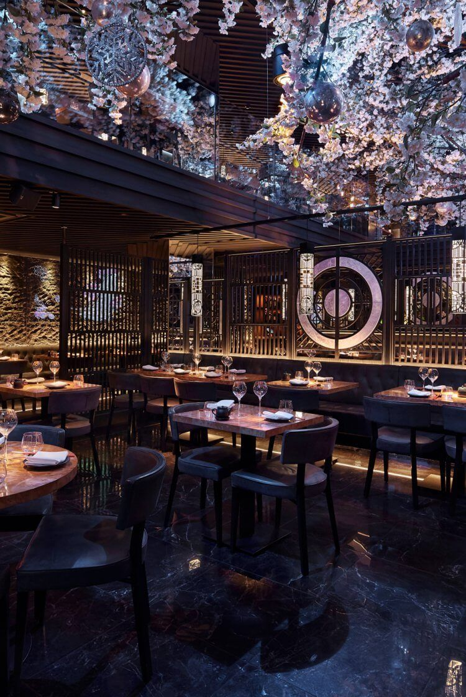

Digital Skills and Research Methods
  - BMSW4003
Irina Tanase | 1920088 | 31.03.2023

BMSW4003

Tutor: Christian Felices
Author: Irina Tanase
Student ID: 1920088
Website login details: www.weebly.com
Account: irinatanase20@hotmail.com
Password: University1

Introduction………………………………..1

Market research………………………………………….1

Analysis of the questionnaire data …………………………………..2-6

Website design and rationale ……………………………………………..6-9

Summary…………………………………………………………………………9

Introduction
Living in an era with busy lives and busy streets, in the busiest city of Wales (Cardiff), another restaurant is opening its doors, but this time something magical and delicious will make its appearance to the public. Spice Hub Restaurant is a new business and the main objective of it is to delight its customer with the most fresh and delicious taste of spicy food and tasty drinks. A report for the business will be made as reports are critical and important source of information. This report is made to ensure that the business will be successful and will achieve all 5 objectives as Specific, Measurable, Achievable, Realistic and Timely -SMART. In this report will also be found an analysis of social and digital media platform with a proposed website design and rationale.
Market research
The essence of marketing is knowing who your customer is and what do they want (Market Research, 2014, online). Market research is an essential tool throughout all stages of developing new products. Nonetheless, insufficient use of available research methodologies increases the likelihood of failure in market-negotiated innovation (Vidor et al, 2023). Thanks, due to primary research there are many methods which can be applied, methods as personal contact with the customer so you can understand what is their opinion or orientation about the product, services or idea (Primary market research methods, 2021). Primary market research, also known as field research, is new research conducted by a company. It entails gathering new data and information that has not previously been gathered. Primary research provides a business with customized research that is tailored to its specific needs. More companies are conducting primary market research to better understand new markets, create products and services that customers want, and attract them with the right marketing message.
Analysis of the questionnaire data
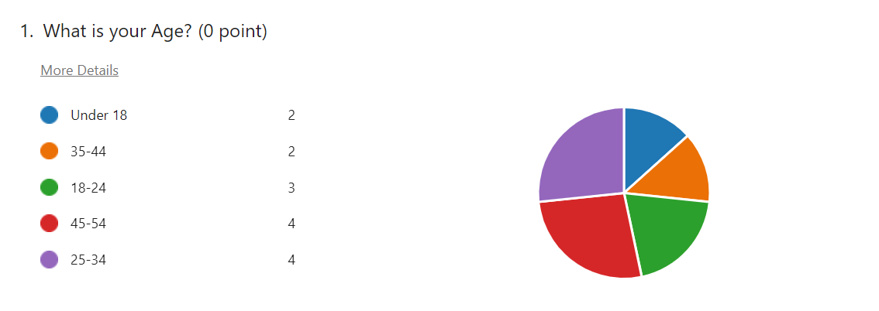

As it can see, the picture indicated that all category of age is paying interest in Spice Hub Restaurant and on spicy food. But the ones who chose it more is the age category 25-34, 45-54. McFona (2020) mentioned that 59% of people aged 18-34 preer very spicy food.

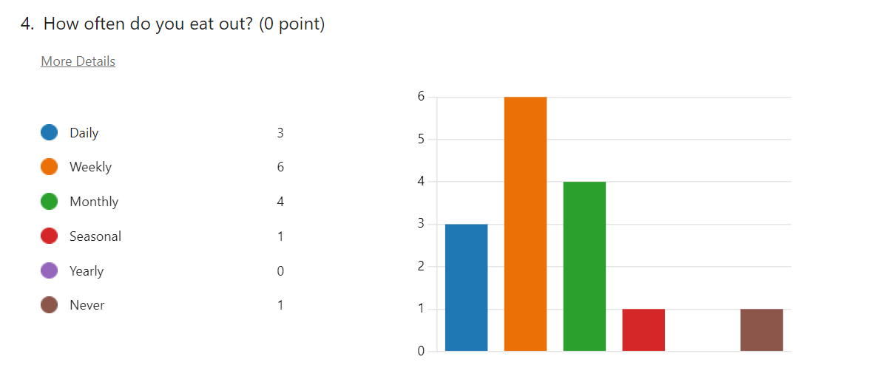

The next picture is helping understand that the majority of people are eating out weekly so a lot of publicity can be used to make the customer be attracted to Spice Hub Restaurant. Techniques as Instagram story and reels, flyers, and also discounts can be a good solution on growing up the clientele. How Frequently Do Brits Eat Out? According to data published earlier this year from a Kitchen Stories survey conducted in 2019, 39% of respondents said they dine out once a month. 34% dined out a few times per month, 18% once per week, and 9% several times per week.
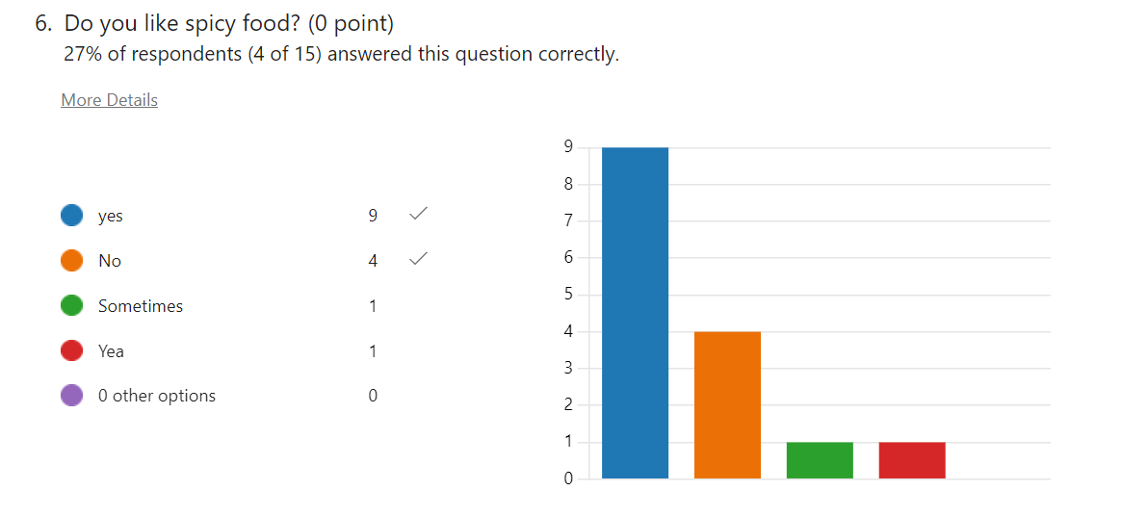

Majority of people in today’s days love spicy food. Chili pepper is a staple of culinary culture around the world, particularly in China, Mexico, and Italy (Dend, Y., et al, 2016).
We have a mild defense response when we eat spicy foods. Our heart rates rise, our breathing increases, and our adrenaline starts to flow. Rozin(2022) argues that people use spicy food as a type of “constrained risk” or “benign masochism”. Because spicy foods cause your body - specifically your pituitary gland and hypothalamus - to release endorphins. Endorphins are a happy chemical that gives you an instant feeling of pleasure from head to toe. People crave spiciness in the same way that they crave something sweet or salty.
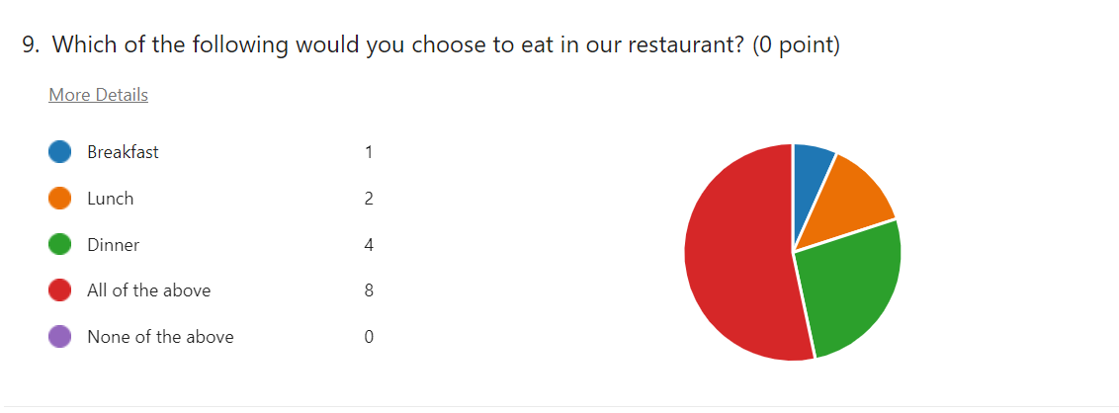
According to the question, the menu of the restaurant need to provide all of the above as mentioned: Breakfast, Lunch, Dinner. Thorn (2022) mentioned that individuals who suffer with health problems, or even those who do not, may notice long-term improvements in their general well-being by eating spicy or spice-enriched foods in the morning or as their first meal of the day.

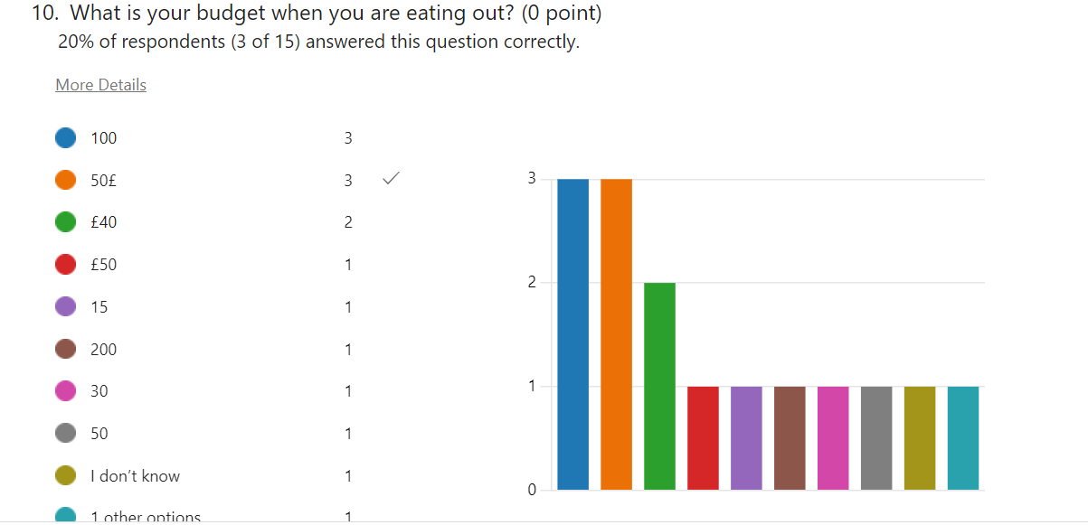
According to the quiz information most people are willing to pay between 50£-100£. Taking in consideration the quiz answers, the menu should be accordingly and roughly the similar price. In almost every industry, one in every four customers is ready to pay up to 10% more if they know they will receive excellent customer service. The hospitality sector is the major winner, with 31% of customers willing to pay up to 10% more and 10% willing to spend more than 30% more (Hyken ,2021).
Website design and rationale
Designing a website is a special task that blend visual art with technological one (Jenkins, 2013). A good website design should be simple, functional and consistent and avoiding overcomplicating it. The relationships between the elements engaged in good design are about creating a balance between them (Beaird., Walker., Alex., 2020). Good website design is influenced by a number of elements, including consistency, colors, font, images, simplicity, and usefulness. The way a website is perceived depends on a number of important design considerations. A well-designed website can encourage users to take action by fostering trust.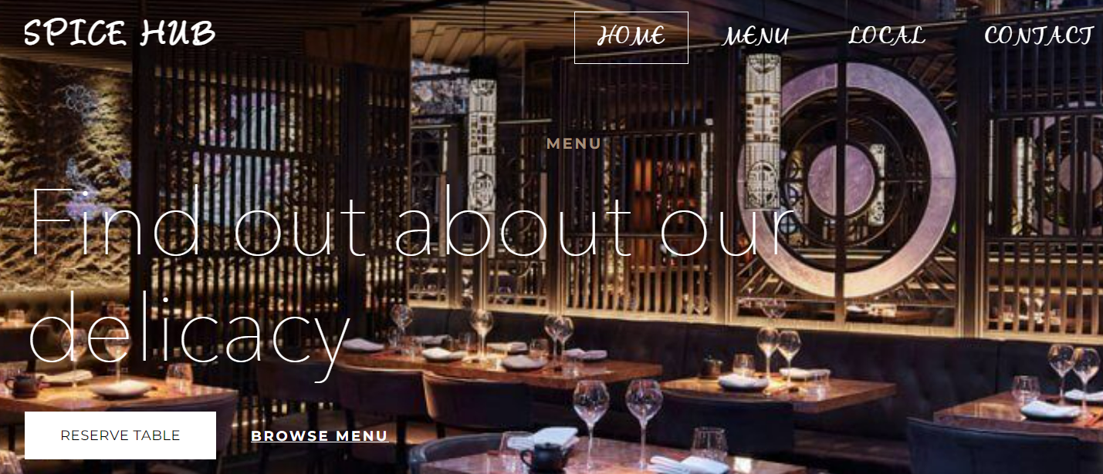

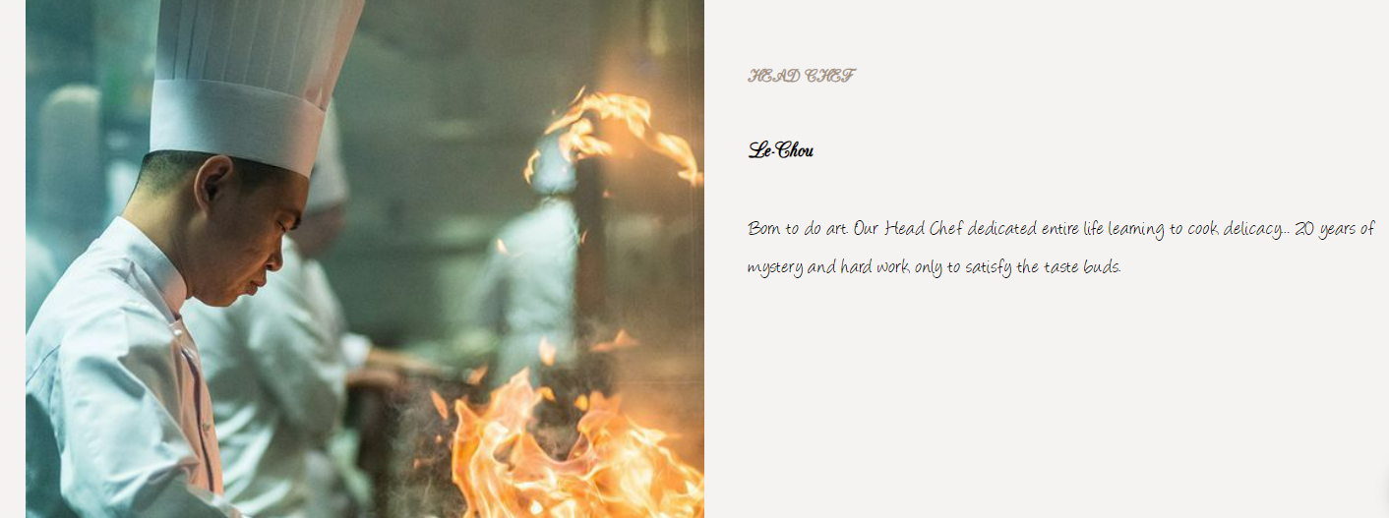
Allen (2016) mentioned that colors appear to be properties of things in our environment: for instance, physical objects, like apples, marigolds, and football shirts; illuminants, like the sun; and liquids, like coffee and beer.
Colors were thought to emerge from the mutual interactions of light and darkness. Nowadays, darkness is primarily defined as the absence of light. Darkness, on the other hand, was thought to have a positive existence of its own in the ancient world, like some kind of black soup that could be mixed in various proportions with the white soup of light (Kernell, 2016). Spice Hub Restaurant have a combination of both light colors and dark colors as those two added up together give a mix of fantasy. Kernell (2016) mentioned that each color may be judged on its own.
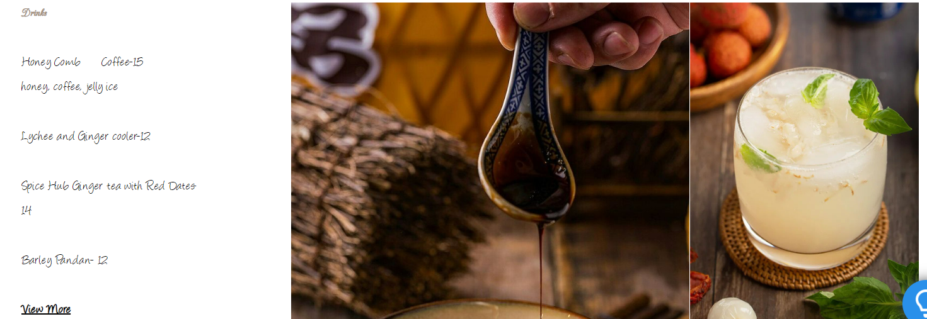
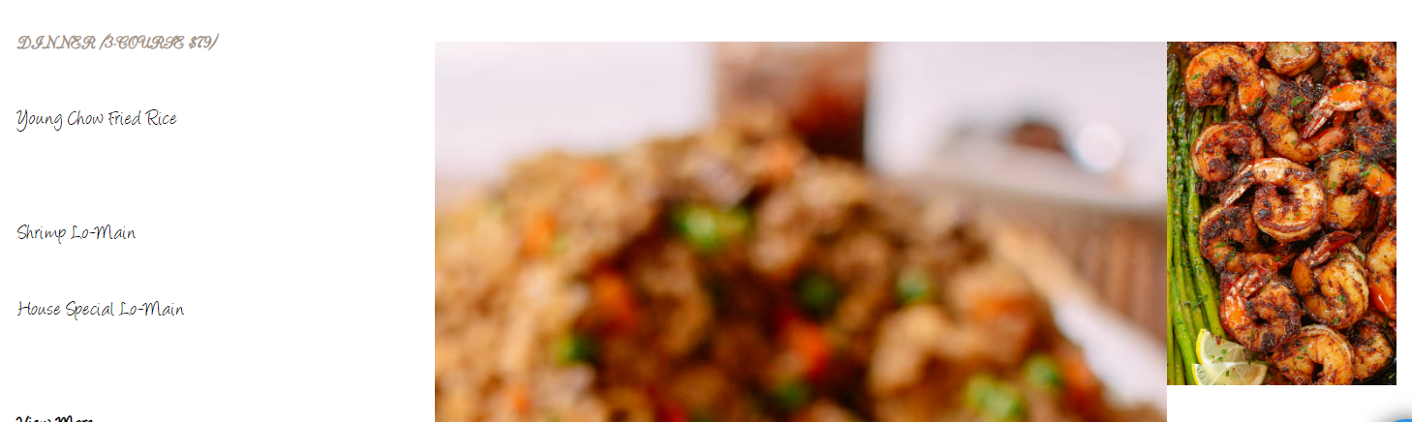

The menu should direct product sales in a way that entices customers. Inspire the imagination, which increases the likelihood of a sale. It should properly and appetizingly explain dishes. It should reassure guests that they are making a good choice. It should, of course, sell. Brown is a humble color, and it is the color of soil-provider of nutrients for growing food, brown functions as a natural worm providing an earthy balance for vibrant tones while white represent purity and innocence. Those 2-color added up together give the menu another kind of high-up class.
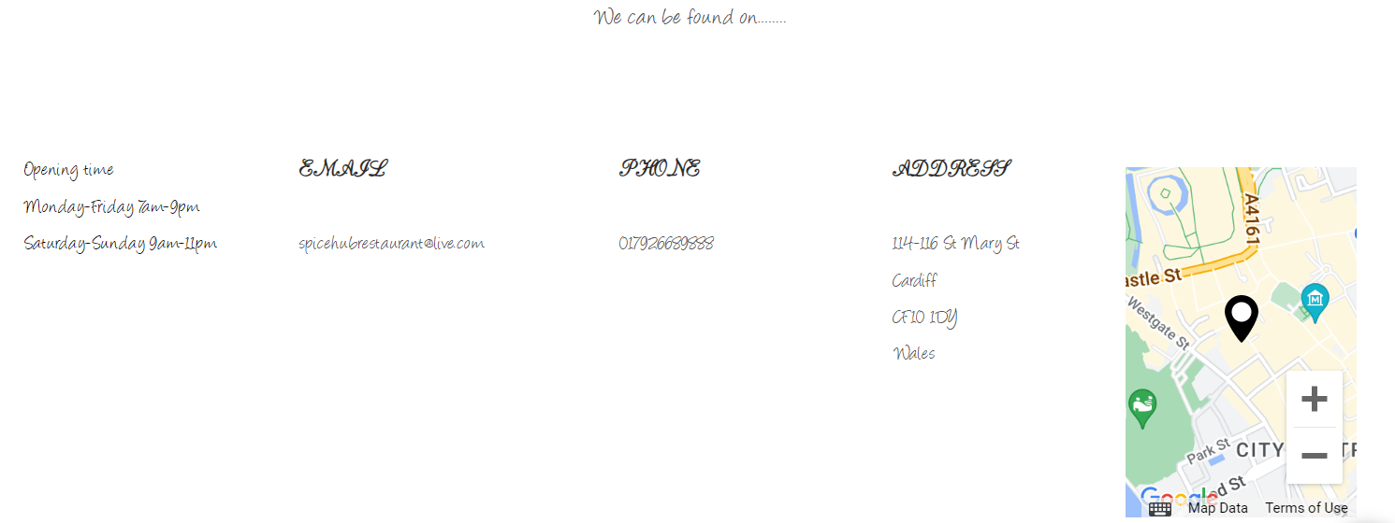
The picture above clearly represents the address where Spice Hub Restaurant can be found, the email address, phone number, opening time and a live google map. White and black color is a good mix of color when something formal is explained.
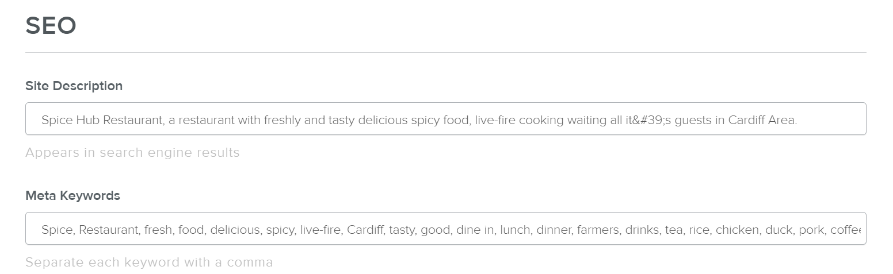
SEO is the practice of optimizing your web pages to achieve a high ranking in Google and other search engines' search results. In other words, when people search online, they are more likely to come across your website. SEO is now a common marketing activity. While search engine optimization is a highly technical practice, it is also a marketing function that must be treated as such. SEO practitioners, whether online or offline, must understand the company's services, products, overall business strategy, competitive landscape, branding, future site development goals, and related business components (Enge, 2012). SEO projects necessitate forethought and planning to achieve the best results, and SEO should be considered and incorporated throughout all stages of a website development or redevelopment project.
Summary
To run a successful restaurant, staff will be the most important factor in keeping customers returning. The kitchen staff is a restaurant's backbone, while the front of house staff is the public face and protagonist. From start to finish, the guest experience must be seamless and immersive. Parking, seating, service, food and beverage quality, payment process, departure, and all interactions with staff and management in between must be flawless. The goal is to outperform expectations at each stage. When a restaurant fails to meet expectations, even in one area, it can ruin a guest's entire experience and result in a negative review.
Spice Hub Restaurant will move to the next stage after doing all the researches : marketing via visual media and social media will be a must but also will take in consideration promotional and discount strategies as newspapers, radio, discount coupons and television commercials.

Reference List
Allen, K. (2016) A naïve realist theory of colour. First edition. Oxford: Oxford University Press.
Beaird, J., Walker, A. and Walker, A. (Alex J.. (2020) The principles of beautiful Web design. Fourth edition / Jason Beaird, James George & Alex Walker. Fitzroy, Victoria, Australia: SitePoint.
Deng, Y. et al. (2016) ‘Some like it hot: The emerging role of spicy food (capsaicin) in autoimmune diseases’, Autoimmunity reviews, 15(5), pp. 451–456. Available at: https://doi.org/10.1016/j.autrev.2016.01.009.
Enge, E. and Enge, E. (2012) The art of SEO. 2nd ed. Beijing: O’Reilly.
Hyken Shep (2021) Forbes https://www.forbes.com/sites/shephyken/2021/08/29/customers-will-pay-more-for-this/?sh=54f2786316c6
Jenkins, S. (2013) Web design all-in-one for dummies. 2nd ed. Indianapolis, Ind: John Wiley and Sons.
Kernell, D. (2016) Colours and colour vision : an introductory survey. Cambridge: Cambridge University Press.
Kernell, D. (2016) Colours and colour vision : an introductory survey. Cambridge: Cambridge University Press.
Market Research (2014). New York; NY:INC.
McFona (2020) Trend Insight; Sweet Heat.
Primary Market research methods (2021). Place of publication not identified. Business professor.
Rozin Paul (2022) Life:; www.bigthink.com
Thorn, B. (2022) ‘Breakfast returns with healthy, spicy and indulgent options’, Nation’s Restaurant News, 56(4)
Vidor,G., Meideros,J., Zin,R., Vieira,G., 2023. Market research and the new product development process. https://doi.org/10.21203/rs.3.rs-2416649/v1.

