John Hamilton

Fault Tree Analysis
By John Hamilton

Contents
1 Fault Tree Analysis (FTA) 1
1.1 What is an FTA? 1
1.2 How does an FTA work? 2
2 Make Hot Drink FTA 3
2.1 FTA Calculation 3
2.2 Logic Gate Calculations 5
2.2.1 AND Gate 5
2.2.2 OR Gate Calculations 5
3 Human Factors 6
3.1 Human Factor considerations in FTA 6
4 Conclusion 6

Table of Figures

Figure 1- FTA Example of Overheating Motor [3] 2
Figure 2-FTA Make Hot Drink Diagram 4
Figure 3- Event Probability Table 4
Figure 4-FTA probability Values for making a Hot Drink 5

Table of Equations
Equation 1-AND Gate Calculation 6
Equation 2-OR Gate Calculations 6

1 Fault Tree Analysis (FTA)

What is an FTA?

The FTA is a visual block diagram which can be used to convey sub-system and low-level failures which may cause a high-level failure in a system/process. It can account for combination failures which could enable full system failure and therefore allows for new methods to make a system more robust. The FTA uses a probabilistic safety management system for a process, and this therefore enables for accurate values to be given for the probability of success for undertaking a specific process. An FTA is beneficial for users to understand where failure modes can occur from a top-down view and can implement safety measures to reduce risk in a process/system. An FTA can be used as an alternative to a Failure Mode Evaluation and Analysis (FMEA) table as it focuses on all system failures that may occur [1]. FTA diagrams are predominantly used by designers, safety case engineers, safety engineers, project managers and manufacturing engineers. This allows these stakeholders to understand root cause analysis and implement Line of Defence (LOD) in the workplace or system safety measures which enable the decrease of system failure likelihood [2]. where an example of an FTA for the overheating of a motor is displayed in Figure 1.
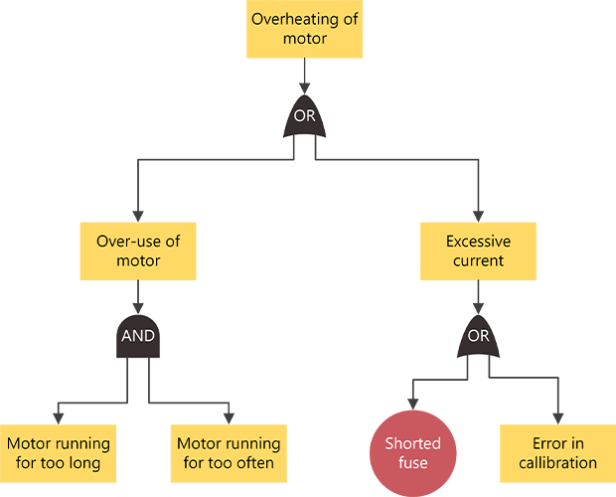

Figure 1- FTA Example of Overheating Motor [3]

How does an FTA work?
The FTA process works by understanding the process of the system and how it operates and using the terminology of the process to integrate logic gates and accumulate the risk of a failure in the system to occur. The top-level failure is clearly labelled at the top of the FTA and the symbol underneath each heading symbolises the logic gate which is applicable for the failure to occur. More failures across the system are then stated which could have an impact on the top-level failure and these are connected to the top-level failure by logic gates (AND and OR gates). The process is repeated until the lowest events are captured and enable for robust prevention methods to be implemented.

The FTA failures can then be calculated to enable for each failure to have a probabilistic chance of failure. Depending on the logic gate type values may be added or multiplied. For AND gate logic gates the values are multiplied and for OR logic gates the values are added together. This provides an overall probabilistic view of the failures throughout the process as well at the top-level probabilistic value for failure during the process.

Make Hot Drink FTA

2.1 FTA Calculation
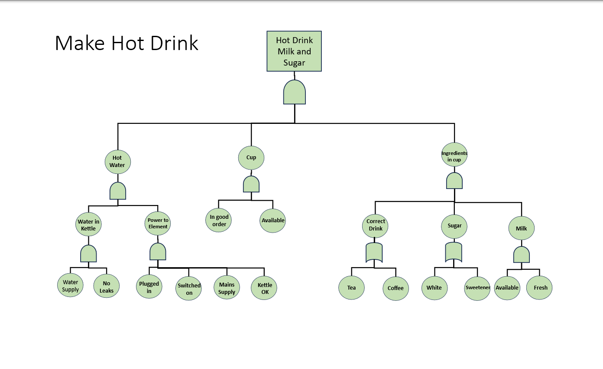
The FTA process for making a hot drink was commenced using an event probabilistic table. This provided values for each of the failures starting at low-level failures within the FTA and an FTA which required probabilistic values to be added for each failure within the diagram. The FTA and Values are shown below in Figures 2 and 3.

Figure 2-FTA Make Hot Drink Diagram

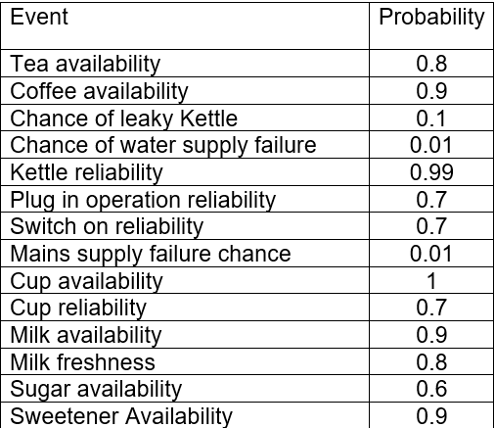

Figure 3- Event Probability Table
This process commenced by calculating the events in terms of probability of availability in contrast to some values being measured from the probability of non-availability. Two values were calculated separately as different failure opportunities were present dependent on the end users fatigue state which therefore decreased the likelihood of producing a hot drink correctly. Below demonstrates the calculations produced in figure 4.
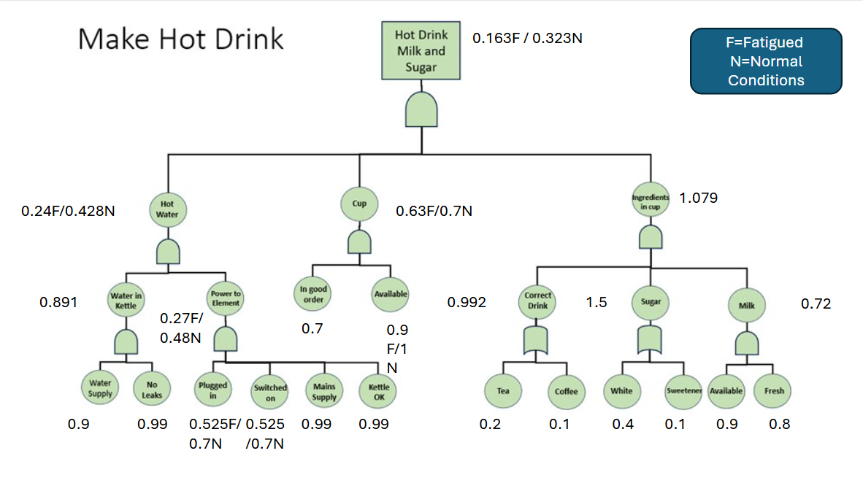
Figure 4-FTA probability Values for making a Hot Drink

2.2 Logic Gate Calculations

2.2.1 AND Gate
The formula for AND gates probability calculations consist of multiplying values from the low-level failures that may have an impact on high level failures within the system. The formula for this calculation is shown below in Equation 1.

P(A n B n C )
Equation 1-AND Gate Calculation

2.2.2 OR Gate Calculations
The formula for OR gates probability calculations consist of taking each value and subtracting 1, multiplying together the resultant values and then subtracting 1 once more. This can be seen below in equation 2.

P = 1- (1-[PA1]) (1-[PA2]) (1-[PA3])
Equation 2-OR Gate Calculations

3 Human Factors

3.1 Human Factor considerations in FTA
Due to the users’ fatigue state this significantly impacted the likelihood a hot drink being produced correctly and therefore two results were calculated showing likelihoods when the user is in a normal state versus when he is fatigued. The users’ ability to produce a hot drink was severely impacted particularly when plugging in the kettle as well as their ability to select a cup. The plugging in of the kettle success rate was 75% less when fatigued which took the probability value down from 0.7 during normal conditions versus 0.525 when the user was fatigued. In addition to this the users’ ability to select a cup would drop 90% of the probability event value when under a fatigued state. This therefore reduced the likelihood event of selecting a cup to a value of 0.9. The impact of this then influenced the multiplication of values and therefore produced an overall value of 0.163 when the user was fatigued in comparison to 0.323 as shown above in figure 4.

Conclusion
The FTA is a useful way to understand the potential failures which could cause a system to fail. It can be significantly affected by human factors which can significantly reduce the likelihood of success probability; however, this depends on the system/process which is being analysed as part of ethe FTA. In this case the FTA likelihood is relatively low in terms of the process which is being undertaken by the user, and this is made more unlikely due to the factor of fatigue.

References

[1] | T. Hessing, “Fault Tree Analysis,” 60 study guide.com, [Online]. Available: https://sixsigmastudyguide.com/fault-tree-analysis/#:~:text=Fault%20Tree%20Analysis%20(FTA)%20is,level%20failures%20(top%20events).. [Accessed 27 March 2024].
[2] | Rockwell Automation, “Fault Tree Analysis (FTA),” Rockwell Automation, [Online]. Available: https://fiixsoftware.com/glossary/fault-tree-analysis/#:~:text=Fault%20tree%20analysis%20(FTA)%2C,maintenance%20teams%20prioritize%20corrective%20actions.. [Accessed 28 March 2025].
[3] | Fault Fixers, “Fault Tree Analysis (FTA),” Fault Fixers, [Online]. Available: https://www.faultfixers.com/glossary/fault-tree-analysis-fta. [Accessed 27 March 2024].

