Chapter 1: Executive Summary
Chapter 2: Company Description
2.1 Introduction
Sense Mortgage & Residential is a proposed mortgage advisory and financial services firm based in London, designed to deliver transparent, personalised, and technology-enabled advice to clients navigating the UK property finance market. Operating within a highly regulated financial environment, the firm aims to bridge the gap between traditional advisory practices and modern consumer expectations for clarity, efficiency, and digital accessibility. As the UK mortgage sector continues to evolve in response to regulatory reform, digital transformation, and volatile market conditions, the establishment of Sense Mortgage & Residential reflects a timely and strategically aligned business opportunity (UK Finance, 2024; FCA, 2023).
This chapter outline the triple bottom line framework for demonstrating the sustainability of the business in the market. This chapter will also outline the organisation’s identity, mission, vision, core values, legal and operational structure, founding inspiration, unique value proposition, and strategic advantages.
2.1.1 Triple bottom line framework


Source: Author Illustration (2025)
Sense Mortgage & Residential is a newly established mortgage advisory firm designed to operate within the UK’s regulated financial services environment, offering transparent, personalised, and technology-enabled advice to clients across London and Southeast England. While the firm’s primary objective is to support customers in making informed mortgage and protection decisions, its business identity is also shaped by a broader commitment to responsible and sustainable practice. To reflect this wider organisational approach, the Triple Bottom Line (TBL) framework People, Planet, and Profit is incorporated into the foundation of the business model.

From a People perspective, the firm emphasises fair treatment, ethical advice, and transparent communication to ensure that clients receive high-quality guidance throughout the mortgage process. This aligns with the firm’s mission and core values, as well as the FCA’s Consumer Duty requirement to deliver good customer outcomes. Within the organisation, TBL emphasises employee welfare, training, and professional development as essential elements of long-term operational success.

Regarding the Planet dimension, Sense Mortgage & Residential recognises the increasing importance of environmental responsibility within professional service sectors. Although the business model does not involve physical production, it contributes to sustainability through paperless processes, digital documentation, remote working, and reduced carbon emissions associated with travel. This reflects broader trends in financial services where digitalisation supports environmental efficiency (Deloitte, 2023).
2.2 Business Identity
Sense Mortgage & Residential positions itself as a client-centred mortgage intermediary offering regulated mortgage and protection advice to first-time buyers, home movers, re-mortgage customers, and property investors. The identity of the business is shaped by three central characteristics:
Transparency – providing clear, jargon-free explanations of mortgage products, affordability assessments, and lending decisions.
Professionalism – upholding rigorous compliance standards in line with the Financial Conduct Authority (FCA).
Technology Integration – utilising digital tools to streamline fact-finding, documentation, case tracking, and client communication.
In a market where clients increasingly expect faster processing, digital documentation, and accessible advisory support, the business identity combines human expertise with digital efficiency to meet modern expectations (PwC, 2023).
2.3 Legal Structure and Regulatory Framework
Legal Structure
To ensure regulatory compliance, operational efficiency, and manageable growth, Sense Mortgage & Residential will adopt an Appointed Representative (AR) business model under a Financial Conduct Authority (FCA) authorised network. The selected network will provide regulatory oversight, compliance support, lender access, and continuous monitoring.
Organisational Structure
Sense Mortgage & Residential will operate as a private limited company (Ltd) registered with Companies House in the United Kingdom. The Ltd structure is the most appropriate for a mortgage intermediary due to its limited liability, clearer governance, tax efficiency, and suitability for future expansion (Companies House, 2024).
This legal structure provides several advantages:
- Limited liability protection for owners and directors.
- Clear separation between personal and business finances.
- Eligibility to become an Appointed Representative under an authorised network.
- Professional credibility within the financial services sector.
- Scalability, enabling additional advisers to be hired or contracted under the business entity.
Directors of the company will be responsible for strategic decision-making, ensuring compliance with FCA requirements, and overseeing operational activities.

2.3.1 FCA Authorisation Approach – Appointed Representative (AR) Model
As an AR, Sense Mortgage & Residential will not require direct FCA authorisation. Instead, the firm will be authorised to conduct regulated mortgage and insurance mediation activities through its financial network.
Table 1: Financial structure as AR model
This structure includes:
Full compliance oversight by the selected network.
Approved Person / Senior Management Function (SMF) approval for the Principal Director.
Mandatory compliance audits, training, and ongoing supervision.
Access to lender panels, insurance panels, GI providers, and professional systems.
The AR model is the preferred structure for new mortgage advisory firms because it lowers regulatory risk and reduces the cost and complexity of initial compliance setup.
Legal and Regulatory Requirements
To operate legally within the UK mortgage market, the business will adhere to:
Financial Conduct Authority (FCA) Handbook – including MCOB (Mortgage Conduct of Business), SYSC (Systems and Controls), and PRIN (Principles for Businesses).
Data Protection Act 2018 & UK GDPR – for secure handling of client information.
Anti-Money Laundering (AML) Regulations – implementing ID verification, source of funds checks, and AML reporting procedures.
Complaints Handling under DISP Rules – ensuring all complaints are managed within FCA guidelines.
Professional Indemnity Insurance (PII) – required under FCA policy to protect against advisory risk.
Source: Author Illustration (2025)
This model reduces regulatory burden, lowers operational risk, and accelerates market entry, making it the preferred route for new advisory firms (FCA, 2023).

The business will also prepare all necessary internal documents, including:
- Treating Customers Fairly (TCF) Policy
- Compliance Monitoring Plan
- Data Protection Policy
- Client Engagement Terms / Terms of Business (TOB)
- Complaints Procedure
- Adviser Competency and Training Record
Ownership and Governance:
The company will be owned and overseen by the principal director, who is responsible for:
- Strategic direction
- Compliance oversight (in conjunction with the network’s compliance team)
- Advisor recruitment and training
- Financial management

Operational management, including staff and administrative functions. A governance framework will be established to support decision-making, manage risk, and maintain full compliance with FCA expectations regarding accountability and oversight.
Employment and Adviser Model will be in place- the business will employ or contract a combination of Mortgage Advisers (CeMAP-qualified/non-qualified). A paraplanning and Administration Support Staff will be required for smooth run of the business. Compliance and file-checking support (via the network and internal processes)
All advisers will operate under the Sense Mortgage & Residential brand, using the same CRM system, compliance processes, and documentation standards.

2.3.2 Compliance Responsibilities
Although Sense Mortgage & Residential will operate under the regulatory supervision of its principal FCA-authorised network, the firm retains significant responsibility for upholding core compliance standards across all aspects of its operations. This includes maintaining full adherence to the FCA’s Treating Customers Fairly (TCF) principles, ensuring that all advice and interactions prioritise positive customer outcomes. The firm is additionally required to comply with the Consumer Duty framework, which places an enhanced obligation on financial service providers to deliver transparent products, clear communication, and services that enable customers to make informed decisions. Beyond regulatory expectations, the organisation must also ensure strict compliance with UK GDPR requirements, protecting client data through secure storage, controlled access, and responsible processing practices. Anti-money laundering (AML) protocols form another critical element of the firm’s responsibilities, requiring robust ID verification processes, monitoring for suspicious activity, and maintaining accurate records to prevent financial crime. Finally, the business must demonstrate full audit readiness through precise and organised documentation, enabling both the network and the FCA to review files, decisions, and procedures at any time. Together, these responsibilities ensure that the firm operates with integrity, transparency, and accountability within a highly regulated industry. The AR structure ensures that the firm meets the FCA’s expectations for professional competence, integrity, and consumer protection (FCA, 2022).
2.3.3 Comparison of FCA Networks
Selecting an FCA-authorised network is an important decision for any Appointed Representative (AR) firm because the network provides supervision, compliance support, training, and access to lenders. For Sense Mortgage & Residential, choosing the right network will shape the long-term stability and growth of the business. This section compares three well-known networks Quilter, Openwork, and City Plus to understand which organisation offers the best fit for the firm’s regulatory and operational needs.
Quilter Financial Planning is one of the largest financial advice networks in the UK and is well known for its strong compliance standards and structured support systems. The network offers extensive adviser training, regular CPD programmes, and a detailed file-checking process. According to Quilter (2024), its compliance framework is designed to reduce adviser risk and maintain high-quality advice. These strengths make the network attractive for firms seeking strong supervision. However, larger networks such as Quilter often charge higher network fees and may have stricter administrative requirements, which can increase workload for smaller or newly formed advisory firms (FCA, 2023).

City Plus Network is much smaller and has a more limited market presence. Smaller networks often provide personalised support and direct access to senior compliance staff, which may be useful for new advisers. However, City Plus does not have the same depth of compliance resources, technology systems, or lender access as larger networks. Smaller networks may also face operational challenges or restrictions depending on FCA oversight cycles. FCA reports (2023) note that smaller networks sometimes have slower onboarding processes or reduced capacity to support firms that wish to scale. Because of this, City Plus may suit individual advisers but may not provide the stability and infrastructure needed for a growing firm like Sense Mortgage & Residential.

Table 2: key differences between the three networks are summarised.
Criteria | Quilter | Openwork | City Plus
Compliance Strength | very strong | Strong | Limited
Training & CPD | Extensive | Strong | Basic
Technology Systems | Advance | Good | Limited
Lender Panel Access | Very wide | Wide | Narrow
Network Fees | Higher | Moderate | Lower
Business Stability | Very high | Very high | Moderate
Best suited for | Firms wanting strict compliance and strong support | Firms wanting balance and growth | Small advisers with limited demand
Source: Author Illustration (2025)
Openwork Partnership is also a large and long-established UK network, supporting both mortgage and financial advisers. Openwork is known for providing a balanced level of compliance oversight and commercial flexibility. The network offers strong adviser training, good technology systems, and wide access to lender panels. Research from the Intermediary Mortgage Lenders Association (IMLA, 2023) notes that networks like Openwork benefit from stable market relationships and well-organised support structures. Compared with Quilter, Openwork may offer slightly more flexibility and a more collaborative culture, which can help new firms establish themselves without feeling restricted by heavy administrative demands.

2.4 Mission Statement
The mission of Sense Mortgage & Residential is:
“To empower clients to make confident property finance decisions through transparent, compliant, and digitally enhanced mortgage and protection advice.”
This mission reflects the organisation’s commitment to safeguarding customers’ interests, simplifying the mortgage process, and promoting financial wellbeing.

2.5 Vision Statement
The long-term vision of the firm is:
“To become a trusted, innovative, and customer-led mortgage advisory hub in Southeast England, recognised for excellence, compliance, and digital efficiency.”
This vision aligns with industry trends toward digital transformation, elevated consumer expectations, and higher regulatory standards (EY, 2023).

2.6 Core Values
The core values of Sense Mortgage & Residential form the foundation of its business culture and guide every aspect of its operational decision-making. Integrity is central to the firm’s identity, ensuring that all client interactions are conducted honestly, ethically, and in full compliance with regulatory standards. Transparency supports this principle by promoting clear communication and full disclosure, enabling clients to understand the rationale behind each recommendation. A commitment to compliance excellence ensures that all advisory activities fully align with FCA expectations, safeguarding both clients and the business. The organisation is equally driven by a client-centred service philosophy, placing customer needs, preferences, and financial well-being at the forefront of every stage in the advisory journey. Innovation plays a complementary role by encouraging the use of digital tools and modern systems to improve efficiency, accuracy, and overall service quality. Finally, professional competence is consistently reinforced through ongoing continuing professional development (CPD), ensuring that advisers maintain up-to-date knowledge of market trends, regulatory changes, and best practices in mortgage advice.

2.7 Founding Background and Business Inspiration
The inspiration for Sense Mortgage & Residential emerged from the founder’s personal experience within the UK financial advisory and mortgage sectors. Over the past decade, the industry has faced several challenges such as increased regulatory scrutiny under the Mortgage Market Review and Consumer Duty. Complex lender criteria, making advice more essential. Fragmented customer service among traditional brokers. Growing customer demand for hybrid digital-human advisory models.
Research by Deloitte (2023) shows that 67% of UK borrowers prefer a combination of online tools and personalised advice. Similarly, UK Finance (2024) notes that clients increasingly expect digital documentation, rapid communication, and proactive updates.
The founder identified an opportunity to build a firm that is customer-driven rather than sales-driven. Introduce a digital-first service without losing the human advisory element. It will also be compliance-strong, reducing the risk of regulatory breaches operationally efficient through automation and systems integration.
The firm’s creation reflects a personal and professional motivation to transform the mortgage advisory experience into one that is modern, supportive, and trustworthy.

2.8 Unique Value Proposition (UVP)
Sense Mortgage & Residential’s unique value proposition is built on the following pillars:

1. Hybrid Digital–Human Advisory
Clients receive personalised advice supported by automated workflows, leading to faster mortgage processing and fewer errors. Research indicates that hybrid models significantly improve customer satisfaction in financial services (McKinsey, 2023).

2. Compliance-Led Advice
Unlike many smaller brokers with inconsistent processes, Sense Mortgage & Residential integrates robust compliance systems, ensuring accuracy, transparency, and adherence to FCA guidelines.

3. Long-Term Client Relationship Approach
The firm provides annual mortgage reviews, protection reassessments, and ongoing financial guidance. This relationship-based approach increases client lifetime value and retention (Kotler & Keller, 2023).

4. Bespoke Support for First-Time Buyers and Investors
Tailored guidance is offered for complex affordability profiles, portfolio lending, and remortgage strategies, differentiating the firm from basic comparison sites.

5. Faster and Modern Case Management
Using CRM tools, digital ID verification, and automated communication, clients experience a smoother and more transparent journey.
Together, these attributes create a competitive advantage in a crowded market that often lacks innovation.

2.9 Strategic Advantage
Sense Mortgage & Residential possesses several strategic advantages that position the firm strongly within the UK mortgage advisory landscape.

2.9.1 Digital Operational Framework
Digital platforms streamline tasks such as case tracking, document collection, and affordability analysis. This reduces administrative burdens and enhances customer experience—an advantage supported by industry-wide digital transformation trends (Accenture, 2023).

2.9.2 Strong Compliance Structure through AR Model:
By leveraging network supervision, the firm benefits from reduced regulatory risk. A dedicated person will be there for professional file-checking allowing the company establishing lender relationships. Company will be more audit compliance, therefore, strengthens credibility and operational reliability.

2.9.3 Differentiation in Customer Experience
In contrast to high-volume advisory firms, Sense Mortgage & Residential adopts a boutique service approach that emphasises personalised attention and transparent communication.
2.9.4 Scalable Business Model
The organisational structure allows smooth expansion by onboarding additional advisers, paraplanners, and administrative support as demand grows. The digital-first design ensures scalability without significant fixed costs.

2.9.5 Strategic Market Positioning
Operating in London and Southeast England—regions with the highest property values and transaction volumes—creates access to a strong and resilient client base (ONS, 2024).

2.10 Summary
Chapter 2 outlined the triple bottom line framework for assuring the sustainability of Sense mortgage and residential. It mentions the core identity and structure of Sense Mortgage & Residential, describing its mission, vision, values, and legal foundation. The business is positioned as a transparent and client-focused mortgage advisory firm operating under the FCA’s Appointed Representative model. Its core values integrity, transparency, compliance excellence, innovation, and professional competence shape its service approach and culture. The chapter also explained the founder’s motivation, highlighting gaps in the market relating to inconsistent service standards and limited digital adoption across traditional brokers. Sense Mortgage & Residential aims to address these gaps through a hybrid digital-human advisory model. Comparison of FCA networks Quilter, Openwork, and City Plus demonstrated important differences in compliance strength, support, technology, and stability. Based on this analysis, Openwork was identified as the most suitable network for the business due to its balanced support structure and strong reputation. Overall, the chapter established a clear foundation for the firm’s regulatory alignment, strategic direction, and operational values.

Chapter 3: Market Research
3.1 Industry Overview
The UK mortgage market is one of the most developed lending environments in Europe, with gross mortgage lending reaching approximately £310 billion in 2024 (UK Finance, 2024). Despite wider economic fluctuations, including inflationary pressures and rising interest rates, demand for mortgage products has remained resilient due to structural housing needs, demographic growth, and ongoing activity among both new entrants and existing homeowners. London and the Southeast of England remain the most active regions in terms of property transactions and lending, driven by higher property values, substantial housing demand, and strong labour market conditions (ONS, 2024).

Following chart shows the demand of Mortgage industry in recent years:
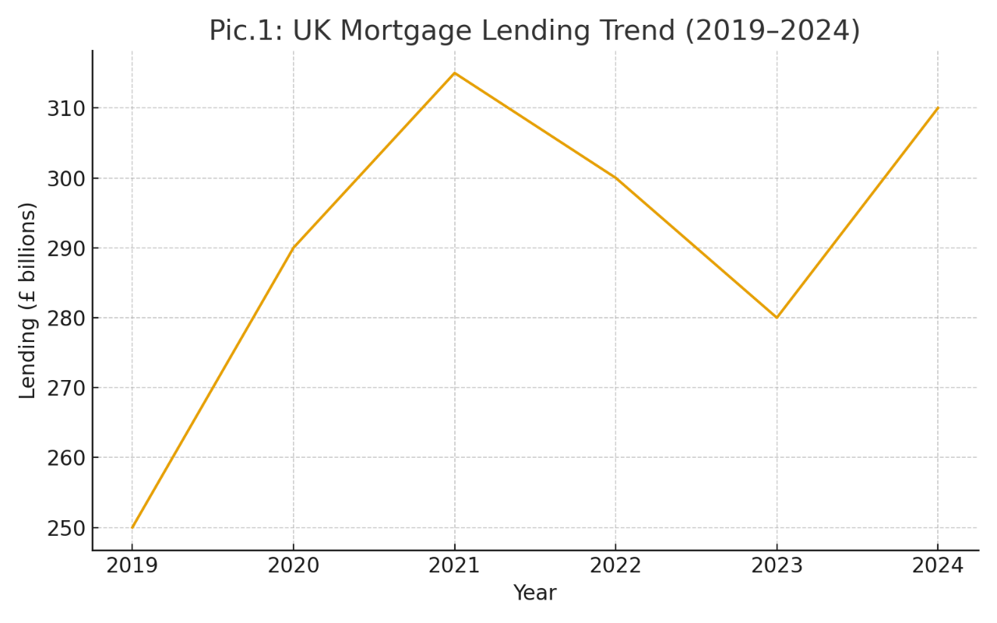

Source: UK Finance (2024). Mortgage Trends Report.
Regulatory frameworks, particularly the Mortgage Market Review (MMR), Consumer Duty, and the Senior Managers and Certification Regime (SM&CR), have reshaped the landscape by increasing expectations for affordability assessments, record-keeping, and customer outcomes. Advisory firms are required to demonstrate higher levels of competence, audit readiness, and transparency in communication. This regulatory environment raises the standards for market entry but simultaneously creates opportunities for compliant, technology-enabled firms such as Sense Mortgage & Residential (FCA, 2023).

Digital transformation continues to influence both consumer behaviour and operational processes. Lenders and brokers increasingly deploy automated affordability systems, digital ID verification, and online fact-finding tools. Research by PwC (2023) indicates that over 60% of UK borrowers now prefer mortgage advice that blends human expertise with digital engagement. These trends provide a favourable context for firms that integrate technology and personalised advice into their service model.

3.2 Market Segmentation, Targeting, and Positioning (STP Framework)
The UK mortgage market comprises diverse customer groups with varying financial circumstances, motivations, and advisory needs. Sense Mortgage & Residential applies the Segmentation, Targeting, and Positioning (STP) framework to define its strategic focus. Market segmentation is based on demographic, behavioural, and financial characteristics. Key segments include first-time buyers, remortgage clients, home movers, buy-to-let investors, and high-net-worth clients. Each segment presents different levels of complexity, product requirements, and expectations for advisory support.

The distinctions between these groups can be summarised in the table below:
Segment | Characteristics | Needs | Opportunity Level
First-Time Buyers | Early-stage buyers with limited experience | Guidance, affordability assessment, education | High
Remortgage Customers | Existing homeowners seeking better rates | Competitive comparisons, efficient processing | High
Home Movers | Individuals and families relocating | Timelines, chain coordination, flexibility | Medium
Buy-to-Let Investors | Portfolio or individual landlords | Tax considerations, portfolio structuring | High
High-Net-Worth Clients | Multiple income streams, complex finances | Bespoke lending solutions | Medium
Table 3: Target Market Segmentation Overview
Source: Author Illustration (2025)

Based on demand potential and alignment with the firm’s strengths, the primary target segments are first-time buyers, remortgage customers, and buy-to-let investors. These groups require extensive advisory support, particularly due to complex affordability criteria, changing interest rate environments, and differing lending policies across financial institutions (Moneyfacts, 2024).

Following chart shows more details about Market Segmentation:
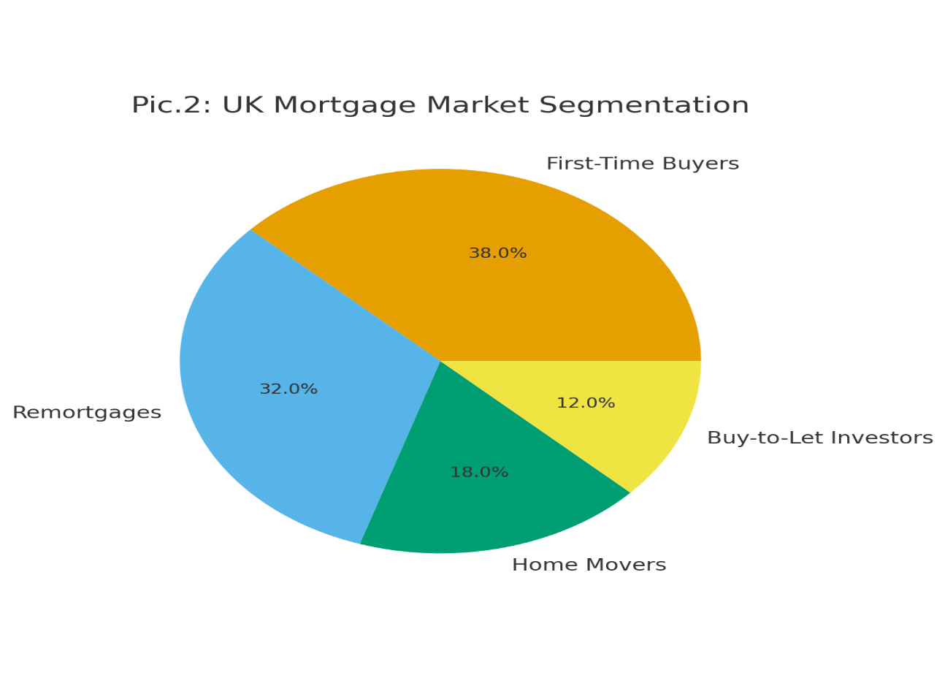

Source: ONS (2024) UK Housing Market Release; Moneyfacts (2024) Mortgage Trends.

The firm positions itself as a transparent, client-focused, and digitally supported advisory service. This positioning differentiates Sense Mortgage & Residential from comparison websites, which lack tailored advice, and from high-volume brokerage firms, which often prioritise speed over personalised guidance. The firm’s emphasis on compliance, accuracy, and digital communication reinforces its competitive positioning within these segments.

3.3 Customer Needs and Demand Patterns
Mortgage customers increasingly prioritise clarity, trust, and convenience. Studies emphasise that many borrowers find the mortgage process complicated, especially when navigating lender criteria, understanding interest rate implications, or preparing documentation for affordability checks (Deloitte, 2023). First-time buyers typically seek guidance and reassurance throughout the process, while remortgage clients prioritise efficiency and transparent rate comparisons. Buy-to-let investors require informed advice related to rental yield calculations, tax implications, and long-term portfolio strategy.
Demand for digital engagement has also increased considerably. Borrowers expect faster processing times, digital document submission, automated updates, and the ability to track progress through mobile or online portals. According to McKinsey (2023), consumers place high value on hybrid advisory models where technology enhances, rather than replaces, personalised guidance. This trend benefits firms that integrate CRM platforms, digital ID verification, and automated communication tools into their service delivery.

Another notable trend is the rising demand for ongoing mortgage support rather than transactional interactions. Borrowers increasingly expect advisers to conduct regular product reviews, provide refinancing updates, and oversee long-term financial wellbeing. This shift underscores the need for firms to maintain continuous relationships with clients, offering structured aftercare programmes that reinforce trust and loyalty (Kotler & Keller, 2023).

3.4 Competitive Analysis
The competitive landscape is shaped by a mixture of national brokerages, online mortgage platforms, local advisory firms, and bank-employed advisers. Porter’s Five Forces model provides a structured understanding of competitive pressures within the sector.

New entrants face moderate barriers due to the availability of the Appointed Representative (AR) model, which simplifies regulatory entry. However, maintaining compliance with FCA standards, managing technology investments, and building lender relationships require significant operational capability, limiting entry by under-resourced firms (FCA, 2023). Borrowers possess strong bargaining power because mortgage rates and lender products are easily accessible through online comparison tools, enabling customers to compare advisers and negotiate fees with relative ease. Competitive rivalry is intense due to the presence of established firms, including London & Country, Habito, and various national networks. Yet, many large firms struggle to provide personalised service, relying instead on high-volume processing. This opens a competitive gap that more client-focused firms can exploit.
Comparing to other large business Sense Mortgage and Residential can promise to provide following services for establishing strong base in the market.

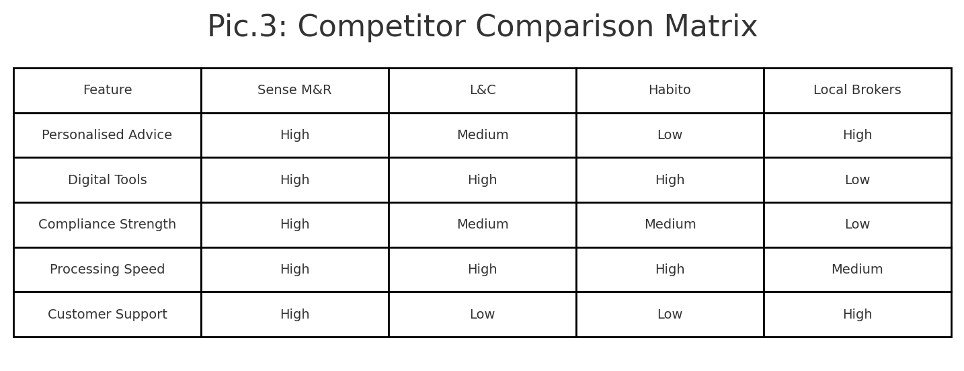

Source: Author Illustration (2025)

The threat of substitutes, such as AI-driven advice systems or fully automated platforms, is increasing but currently limited by the complexity of borrower circumstances and the need for human judgment in affordability assessments. Suppliers—primarily lenders—hold moderate power, as they frequently adjust criteria and stress-testing parameters; however, intermediaries account for a significant portion of mortgage distribution, giving brokers substantial influence in product placement (UK Finance, 2024). Overall, the environment favours firms that offer strong compliance, personalised service, and digital efficiency.

3.5 Market Validation Approaches
The business concept for Sense Mortgage & Residential is supported by multiple validation techniques. Secondary market research from UK Finance, the FCA, and industry analytics confirms that demand for mortgage advice remains robust, driven by regulatory complexity, economic volatility, and the continued need for lending guidance. Consumer research reports from Deloitte (2023) and PwC (2023) further validate the preference for hybrid advisory models, indicating that customers appreciate the reassurance of human advisers combined with the speed and convenience of digital systems.

Competitor benchmarking highlights operational gaps among existing firms, particularly regarding transparency, compliance consistency, and personalised service delivery. Many high-volume brokers rely on rapid processing and standardised advice pathways, leaving a niche for firms that provide more detailed, client-specific support. Data from industry sources such as Moneyfacts (2024) also demonstrate ongoing demand among segments like first-time buyers and remortgage customers, driven by interest rate fluctuations, maturing fixed-rate products, and increased preference for financial stability. The combination of regulatory trends, consumer behaviour insights, and economic indicators confirms the viability and timeliness of the business model.

3.6 SWOT Analysis of Sense Mortgage & Residential

A SWOT analysis brings together the key internal and external factors identified in the earlier sections of the market research chapter. It provides a structured assessment of the firm’s strengths, weaknesses, opportunities, and threats, helping clarify its strategic position within the UK mortgage advisory market. Conducting a SWOT analysis is useful for translating market analysis into actionable strategic insight (Kotler & Keller, 2023). The analysis below considers internal capabilities such as compliance culture, service quality, and technology adoption, alongside external market forces such as regulatory changes, consumer trends, and competitive pressures.
SWOT Analysis of Sense Mortgage & Residential
Strengths | weaknesses
- Strong compliance culture supported by Openwork network.  - Hybrid digital-human advisory model supporting efficiency.  - Personalised service and transparent communication.  - Professional brand identity and modern technology stack | - New brand with no established market reputation.  - Limited initial operational capacity (small team).  - Higher workload risk on founder in early phases.  - Dependence on network systems may limit flexibility.
Opportunities | Threats
- Growing demand for hybrid advisory models.  - Increased remortgage activity due to rate changes.  - Rising first-time buyer interest in trusted advisers.  - Ability to scale cost-effectively through digital systems. | - Strong competition from both large brokers and digital platforms.  - Regulatory tightening increasing administrative workload.  - Economic uncertainty impacting borrowing levels.  - Market disruption from fully automated mortgage tools.

Interpretation of SWOT Findings
The SWOT analysis shows that Sense Mortgage & Residential is well positioned to enter the market, with strong advantages such as its compliance-driven model and hybrid digital–personal service approach. These strengths align with growing consumer demand for transparent and efficient mortgage advice (McKinsey, 2023) and are reinforced by the support provided through the Openwork network, which enhances regulatory confidence and operational structure (FCA, 2023).

However, the firm’s newness presents challenges, particularly limited brand recognition and a small initial team, which may affect early client acquisition and capacity. These weaknesses can be managed through targeted marketing and gradual recruitment as demand increases.

Externally, the firm benefits from rising demand among first-time buyers and strong remortgage activity during periods of rate fluctuation (UK Finance, 2024). Digital tools create opportunities for scalable growth without proportionate cost increases. At the same time, threats such as strong competition, potential regulatory tightening, and economic uncertainty must be managed through effective planning and maintaining operational flexibility.
Overall, the SWOT analysis indicates that the firm has a strong foundation for growth, provided that early-stage weaknesses and external threats are addressed proactively.

3.7 Summary
Chapter 3 examined the UK mortgage market through industry analysis, segmentation, customer needs, competitor evaluation, and the application of the SWOT framework. The research showed that the market remains active and opportunity-rich, particularly among first-time buyers and remortgage clients, who increasingly value clear, technology-supported advice. The competitor analysis highlighted strong competition from large brokerages and digital platforms but also revealed a service gap for firms offering personalised and compliance-focused support.

The SWOT analysis provided a consolidated view of Sense Mortgage & Residential’s strategic position. The firm benefits from strong internal strengths, including a hybrid advisory model and compliance support through the Openwork network, while early-stage weaknesses such as limited brand recognition and small team capacity must be managed carefully. Opportunities in digital scalability and rising consumer demand support business growth, whereas threats such as economic uncertainty and regulatory pressure require ongoing risk management. Overall, the chapter demonstrated that the firm is well positioned for sustainable entry into the mortgage advisory market, with a clear understanding of both internal capabilities and external market conditions.

Chapter 4: Marketing and Sales Strategy
4.1 Unique Selling Point (USP)
Sense Mortgage & Residential differentiates itself in a competitive mortgage advisory market by positioning its service as transparent, compliant, and digitally enhanced while maintaining a personalised, relationship-focused approach. Many mortgage brokers focus primarily on quick application processing or volume-driven models, which often reduces the quality of personalised advice. In contrast, Sense Mortgage & Residential is built around a hybrid model that combines the efficiency of digital systems with the reassurance of professional guidance. This is particularly important as research shows that customers increasingly prefer advice that blends digital convenience with human interaction (McKinsey, 2023). The firm’s USP also emphasises compliance excellence, supported by a carefully selected FCA-authorised network, ensuring that advice is delivered with strong oversight and regulatory consistency. Its focus on technology-enabled workflows—such as digital fact-finding, automated updates, and secure document uploads offers a smoother and more transparent experience, especially for first-time buyers and remortgage clients who often require regular communication and reassurance.

4.2 Branding and Corporate Identity
Brand identity is an essential part of building trust in the financial services sector, where credibility, professionalism, and customer reassurance play central roles. The branding of Sense Mortgage & Residential is designed to reflect stability, clarity, and integrity. The recently created sample logo uses a shield and home symbol to communicate protection and security, supported by a navy-blue colour scheme associated with trust and professionalism. According to Kotler and Keller (2023), strong brand identity supports customer recognition, enhances perceived reliability, and reinforces long-term client relationships.
Proposed Brand Elements: a proposed brand identity framework shows relevant criteria considered during branding and corporate identity.
Table 4: Brand Identity Framework
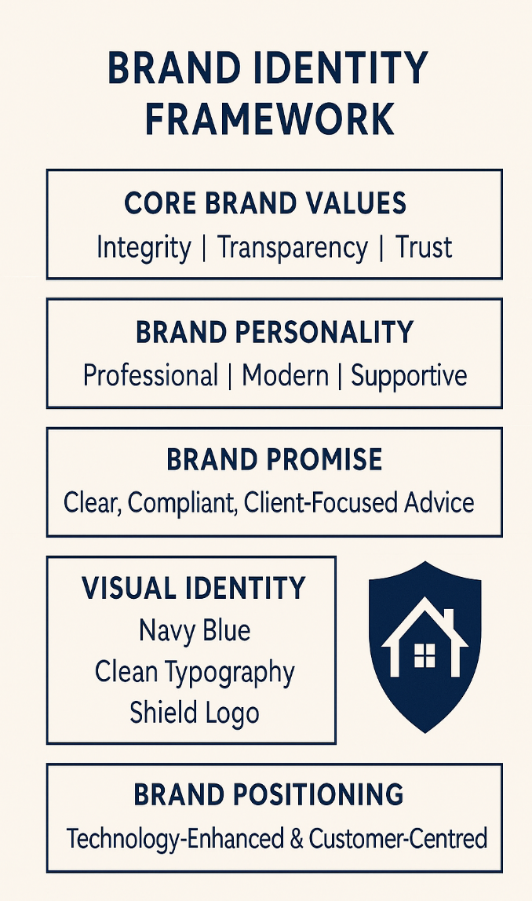
- Primary Colour Palette: Navy blue, white, and soft grey colours often associated with financial trust and clarity.

- Typography: Clean sans-serif font for accessibility and professionalism.

- Logo Concept: A shield combined with a house icon, symbolising financial protection, guidance, and homeownership security.

- Tone of Voice: Clear, calm, trustworthy, and informative.

- Brand Personality: Approachable, knowledgeable, transparent, and dependable.

Source: Author Illustration (2025)
Branding will be consistently implemented across all touchpoints, including the firm’s website, digital documents, social media content, stationery, and adviser email signatures. This helps build a professional and cohesive visual identity, supporting a stronger market presence.

4.3 Positioning Strategy
Positioning refers to how the business presents itself in the minds of consumers. Sense Mortgage & Residential positions itself as a trusted, ethical, and technology-supported mortgage adviser offering reliable, clear, and customer-oriented services. The firm aims to differentiate itself from online-only platforms such as Habito, which may lack the depth of personalised advice, and traditional brokerages that often use outdated processes and manual documentation. The business will position its service as both modern and personalised, responding to the increasing demand for advice that is fast, transparent, and guided by strong regulatory compliance. This positioning approach is supported by the STP framework findings from Chapter 3, which show that first-time buyers and remortgage clients especially value clear communication and guidance throughout the process (Deloitte, 2023).

4.4 Marketing Mix (7Ps)
The Marketing Mix provides a structured approach for implementing Sense Mortgage & Residential’s marketing strategy.
Product
The core service offering includes mortgage advice, remortgage support, buy-to-let lending guidance, and insurance protection planning. The service is enhanced through digital tools such as CRM systems, automated communication, and document-sharing platforms. These elements combine to create a complete advisory experience that supports customers from initial enquiry through to mortgage completion.

Price
The business will adopt a transparent and competitive fee model, aligned with market norms. Some cases may be fee-free where remuneration is received from lenders, while complex cases may involve a fixed adviser fee. Transparent pricing builds trust and supports compliance with Consumer Duty requirements (FCA, 2023).

Place
The firm will operate through a hybrid service model, providing advice remotely through digital platforms and face-to-face where required. This approach aligns with modern client expectations and widens the geographical reach of the firm.

Promotion
Marketing activities will include social media advertising, search engine optimisation (SEO), educational content, referral partnerships, review platforms, and targeted digital campaigns. The firm will prioritise educational content—blogs, guides, checklists—to build authority and support first-time buyers seeking clarity.

People
The quality of advice depends heavily on adviser expertise. Advisers will receive continuous training, participate in CPD programmes, and follow strong compliance protocols in line with network requirements.

Process
A structured advisory process ensures consistency, compliance, and positive client outcomes. Digital tools will support onboarding, document collection, affordability checks, and application tracking.

Physical Evidence
Physical evidence refers to tangible cues that reinforce the brand. These include the professionally designed logo, branded documents, website design, online reviews, adviser profiles, and presentation templates.

4.5 Sales Channels
Sense Mortgage & Residential will use a combination of digital and relationship-based sales channels. The primary channels will include the company website, social media platforms (Facebook, Instagram, TikTok, LinkedIn), Google Search campaigns, and email marketing. The firm will also develop referral partnerships with estate agents, accountants, solicitors, and insurance advisers. These partners often provide warm leads and ongoing introductions, which can significantly increase revenue potential.

Additionally, existing clients represent an important sales channel through repeat business and long-term remortgage cycles. Regular follow-up communication, annual mortgage reviews, and protection reassessments will help maintain strong client relationships and support a stable revenue pipeline.

4.6 Digital Strategy
Digital marketing plays a central role in the firm’s overall strategy. A well-designed website will act as the main entry point for clients, featuring lead capture forms, guides for first-time buyers, calculators, and clear calls to action. SEO will be used to improve visibility on Google, supported by content such as blogs, FAQs, and video guides on social media. Paid advertising through Google Ads and Facebook will help target specific segments, especially first-time buyers and re-mortgage clients.

The firm will implement a CRM system to manage enquiries, track leads, and automate communication. Automation will support client updates, missing document reminders, review alerts, and appointment scheduling. Digital identity verification tools will also be integrated to streamline onboarding and reduce administrative delays. This digital approach aligns with industry research showing that customers increasingly expect fast, user-friendly, and paperless processes (McKinsey, 2023).

4.7 Marketing Budget
The initial marketing budget will focus on high-impact, cost-effective activities. Core expenses will include website development, branding design, CRM subscription, content creation, Google Ads, and social media promotion. A sample first-year budget is outlined below:

Table 5: Sample Marketing Budget (Year One)
Activity | Estimated Cost (£)
Website Development | £800 – £1,200
Branding & Logo Design | £300 – £500
CRM & Automation Tools | £600 – £900 annually
Google Ads | £150 – £300 per month
Social Media Ads | £100 – £200 per month
Content Creation | £300 – £600
Total Estimated Budget | £3,000 – £5,000
Source: Author Illustration (2025)
The marketing budget focuses on scalable digital activities that provide measurable results. As the business grows, the budget can be increased to include more advanced campaigns, paid partnerships, or professional video production.

4.8 Summary
Chapter 4 presented the marketing and sales strategy for Sense Mortgage & Residential. The firm’s marketing direction focuses on its core strengths: transparency, strong compliance, digital innovation, and personalised support. The branding strategy establishes a clear and trustworthy identity supported by a professional logo, modern colour palette, and consistent tone. The marketing mix outlines the service offering, pricing approach, promotional activities, process structure, and physical elements that reinforce the brand. The chapter also identifies key sales channels such as digital marketing, referral partnerships, and ongoing client relationships. A structured digital strategy ensures visibility, efficiency, and customer engagement, while the marketing budget provides a realistic financial plan for establishing market presence. Together, these elements create a strong foundation for attracting and retaining clients in a competitive mortgage advisory market.

Chapter 5: Operations Plan
5.1 Overview of Operational Approach
The operations plan explains how Sense Mortgage & Residential will structure and deliver its mortgage advisory services in a consistent, compliant, and client-centred manner. As a regulated financial intermediary, the firm must maintain robust internal systems to support service quality, regulatory conformity, and customer satisfaction. Operational excellence is essential for reducing risk, improving efficiency, and providing a smooth customer experience. The overall operational model is built on a hybrid digital-human approach, incorporating technology, professional advice, and strong compliance oversight. This model aligns with wider industry trends, as customers increasingly expect faster service, digital documentation, and real-time updates throughout the mortgage journey (McKinsey, 2023).

5.2 Service Delivery Workflow
The service workflow is designed to ensure a consistent and structured process from initial enquiry to post-completion aftercare. Each stage is supported by digital tools to ensure efficiency, accuracy, and compliance with FCA requirements.

To illustrate the flow of operations, the following diagram outlines the full end-to-end journey:
End-to-End Mortgage Advisory Workflow:
Author Illustration, 2025

This structured workflow ensures that each client receives the same high standard of service, while compliance checks and documentation are conducted at appropriate milestones. Digital identity verification tools (IDV), secure document portals, and CRM automation further support timely progression and reduce operational delays. This approach supports FCA Consumer Duty outcomes by ensuring clarity, consistency, and meaningful communication throughout the customer journey (FCA, 2023).

5.3 Location and Business Infrastructure
Sense Mortgage & Residential will operate through a flexible, hybrid structure that combines a physical office presence with remote advisory capabilities. The business will be based in London, providing strategic proximity to a large client base and key professional partners such as conveyancers, accountants, and estate agents. However, most services will be delivered through virtual channels, including secure video calls, cloud-based document sharing, and digital signatures. This approach reduces overhead costs, supports scalability, and matches the preferences of modern consumers, many of whom favour convenient online mortgage processes (Deloitte, 2023).

The firm’s infrastructure includes:
Author Illustration, 2025

5.4 Technology and CRM Systems
Technology plays a central role in the operations strategy. The business will adopt a modern CRM system such as Acre, One Key, or Mortgage Brain, depending on compatibility with the chosen FCA network. CRM systems provide structured data collection, automated reminders, case-tracking dashboards, and audit trails. They are essential for meeting FCA documentation requirements and ensuring that every client receives consistent service.

The key advantages of integrating a CRM system include improved productivity, enhanced client communication, error reduction, and stronger compliance evidence (PwC, 2023). In addition, tools such as digital fact-finds, automated affordability calculators, client document portals, and email automation significantly reduce administrative workload.
A simple table summarises the firm’s technology stack:

Table 6: Technology Systems Supporting Operations
System / Tool | Function | Source / Type
CRM Platform | Case management, compliance checks, automation | Acre / One Key
Digital ID Verification | AML, KYC compliance | Third-party IDV tools
Sourcing Software | Mortgage product research | Mortgage Brain / Twenty7Tec
Cloud Storage | Secure document storage | Google Workspace / Box
E-Signature Tools | Digital compliance and onboarding | Docu Sign / Adobe Sign
Source: Author Compilation (2025)
This technology ecosystem supports efficient operations, reduces processing time, and ensures full compliance with the FCA’s expectations for documentation and data protection (FCA, 2023).

5.5 Compliance and Quality Assurance
Compliance is fundamental to the firm’s operational model. As an Appointed Representative under Openwork, the business will receive structured oversight that includes file reviews, training, supervision meetings, and compliance audits. This support is essential to meet FCA requirements and maintain high-quality advice.

The compliance strategy includes mandatory AML checks, affordability assessments, suitability report documentation, audit trails, and complaint-handling procedures. Systems will be aligned with the network’s compliance portal, allowing secure uploading of documents and ensuring case approval before submission to lenders. This layered approach ensures that operational risk is minimised, and advisers maintain competent and compliant practice.

A flow diagram of compliance responsibilities demonstrates clarity:
Compliance Oversight Structure
Source: Author Compilation (2025)
This model ensures that compliance is embedded into every stage of operations rather than treated as an administrative afterthought.

5.6 Key Operational Partners
The firm’s operations rely on strong professional partnerships. These include the FCA network (Openwork), mortgage lenders, surveyors, conveyancers, protection providers, and digital service companies. Strong relationships with solicitors and valuers are essential for smooth case progression, particularly during complex transactions or property-related legal checks. Research shows that customers expect mortgage firms to coordinate with third-party professionals efficiently to reduce delays and maintain communication (IMLA, 2023).

Operational partnerships support component:

These relationships are central to delivering a seamless customer experience.

5.7 Capacity Planning and Scalability
The firm’s operational model is intentionally designed to scale. Initially, Sense Mortgage & Residential will operate with one lead adviser and one part-time administrator or paraplanner. As case volume increases, the business will expand its team, supported by Openwork’s onboarding and training pathways.

A projected growth table supports operational planning:

Table 7: Capacity Planning and Staff Growth (Years 1–3)
Year Advisers Admin Staff Estimated Case Capacity
Year 1 1 1 (PT) 15–20 cases/month
Year 2 2 1 (FT) 30–40 cases/month
Year 3 3–4 2 (FT) 50+ cases/month
Source: Author Projection (2025)

This structured expansion ensures operations remain manageable, compliant, and financially sustainable.

5.8 Risk Management in Operations
Operational risks include system outages, compliance breaches, documentation errors, partner delays, and economic fluctuations affecting client demand. Risk mitigation includes technology backups, dual-layer file checking, compliance supervision through Openwork, secure data storage, and maintaining relationships with multiple lenders and conveyancers. The hybrid business model also reduces location risk by enabling remote working if office access becomes restricted, which increases operational resilience (EY, 2023).

5.9 Summary
Chapter 5 explained how Sense Mortgage & Residential will deliver its advisory services through a structured operational model supported by technology, compliance oversight, professional partnerships, and scalable processes. The chapter demonstrated how the firm will manage workflow, infrastructure, CRM systems, compliance responsibilities, and staffing growth to maintain high-quality service and strong regulatory adherence. The inclusion of diagrams, tables, and projected capacity planning provides additional evidence of operational readiness and supports academic expectations for clarity and structure.

References:
Accenture (2023) Digital Transformation in UK Financial Services. London: Accenture.
Companies House (2024) Incorporation and Company Structures in the UK. London: HM Government.
Deloitte (2023) UK Mortgage Consumer Insights Report. London: Deloitte.
EY (2023) Financial Services Outlook 2023–2025. London: Ernst & Young.
EY (2023) Operational Resilience in Financial Services. London: Ernst & Young.
FCA (2022) Principles for Businesses (PRIN). London: Financial Conduct Authority.
FCA (2023) Consumer Duty Policy Statement PS22/9. London: Financial Conduct Authority.
FCA (2023) Consumer Duty: Strengthening Supervision of Mortgage Intermediaries. London: Financial Conduct Authority.
Habito (2024) Digital Brokerage Services Overview. London: Habito.
IMLA (2023) Intermediary Mortgage Market Report. London: Intermediary Mortgage Lenders Association.
Kotler, P. and Keller, K. (2023) Marketing Management. 16th edn. Pearson Education.
London & Country Mortgages (2024) Service Overview and Adviser Support Model. Bath: L&C Mortgages.
McKinsey & Company (2023) Digital Transformation in Mortgage Lending. London: McKinsey.
Moneyfacts (2024) Mortgage Trends Update. London: Moneyfacts Group.
ONS (2024) UK Housing Market and Regional Analysis. London: Office for National Statistics.
Openwork (2024) Network Adviser Support and Training Framework. Swindon: Openwork Partnership.
PwC (2023) Future of Mortgage Intermediation in the UK. London: PricewaterhouseCoopers.
Quilter (2024) Network Support and Adviser Compliance Framework. London: Quilter Financial Planning.
UK Finance (2024) Mortgage Trends Report. London: UK Finance.

