Service Improvement Report: Analysing Clinical Governance and Patient Safety Failures in the Lucy Letby Case at the Countess of Chester Hospital
Module Code: LCHS7006
Module: Quality Assurance and Service Improvements
Assignment Title: Service Improvement Report
Lecturer’s Name: Dilhara Mampitiya
Student Name: Hetvibahen Chauhan
Student Id: 2522438

Table of Contents
1.Introduction 3
2. Main body 4
2.1 Defining the quality problem 4
2.2 Fishbone Diagram analysis 5
2.3 Donabedian Model 7
2.4 SWOT analysis 9
3.0 Recommendations 10
3.1 Establish an independent neonatal patient-safety governance structure 10
3.2 Introduce a strengthened escalation pathway 11
3.3 Strengthen Freedom to Speak Up and psychological safety 12
3.4 Apply PDSA to implementation 13
3.5 Use Lean principles to remove barriers to escalation 14
3.6 Apply Six Sigma principles to incident and mortality surveillance 14
4 Conclusion 15
5 References 16

1.Introduction
Quality and safety of patients are some of the basic obligations that healthcare organizations have. The provision of high quality of health services entails the services being safe, effective, timely, patient focused, equitable and well governed. In the context of the National Health Service (NHS), clinical governance is the system within which healthcare service providers are supposed to sustain and enhance the quality of their services. Nevertheless, the failure may arise when there are issues in relation to leadership, incident reporting, workforce management, communication and organizational learning. The case of Lucy Letby who used to work as a neonatal nurse at CoCH serves as an extreme illustration.
Lucy Letby was charged with the murder of seven infants and attempted murder of six other infants while serving as a nurse in the neonatal unit of the hospital between 2015 and 2016. This was followed by a statutory public inquiry into the matter known as the Thirlwall Inquiry in order to inquire into the matters surrounding the infants and the actions of those concerned as well as governance, management, escalation, monitoring, and culture of the NHS. In particular, according to the Terms of Reference for the Thirlwall Inquiry, one must consider if there is any role played by the governance and management of the Trust in failing to safeguard the infants and whether there should be any change in NHS governance and professional regulation (Department of Health and Social Care, 2023).
The quality issue that has been selected for this report is the failure to detect, escalate, investigate, and act on repeated concerns in a high-risk neonatal care unit. This does not narrow down the blame on an individual staff member in the health care facility. In the area of quality improvement, such a stance would be inadequate since patient safety issues are related to the interplay of people, process, leadership, staffing, technology, and regulation.
The importance of this issue lies not only in the Countess of Chester Hospital. The safe treatment of patients is dependent on the ability of healthcare professionals to detect problems, raise incidents and questions without any fear. According to NHS England, a positive safety culture is the culture that enables continuous learning, psychological safety teamwork and speaking up from the side of healthcare professionals, patients and their relatives (NHS England, 2026a). In addition, research has shown that the psychological safety may have an impact on communication of healthcare workers, although the connection between psychological safety and the outcomes for patient safety is complex (Montgomery et al., 2025).
In this regard, the organisational quality problem is evaluated critically with the help of the Fishbone Diagram, Five Whys, Donabedian Model and SWOT analysis. All of these models are used simultaneously due to the fact that none of them can provide the explanation of the complex situation in healthcare alone. Fishbone Diagram helps to define the categories of the factors, Five Whys explores the chain of causes, Donabedian Model allows to distinguish three types of deficiencies, and SWOT is used as a strategic approach.

2. Main body

2.1 Defining the quality problem
Failure of the organisation's clinical governance and patient-safety system to recognise patterns of concern, escalate credible clinical warnings, investigate adverse events and implement timely corrective action within a high-risk neonatal service.
Clinical governance focuses on setting up systems whereby organizations are held accountable for continuous improvement in the quality of services provided and the protection of standards. According to Scally and Donaldson (1998), clinical governance is a system whereby NHS organizations become accountable for continuously improving quality and protecting high standards of care. The definition of clinical governance is particularly applicable to the Letby case since the case does not focus only on the performance of clinicians but also the ability of the organization to identify and address risks.
The severity of the case makes it suitable for establishing the Thirlwall Inquiry. The terms of reference include conduct of both clinical and non-clinical staff and management, governance and escalation, external review, professional regulation, and NHS culture (Department of Health and Social Care, 2023). The case is therefore an ideal basis for analyzing the issue of quality management.
One of the disadvantages of individualistic theory is the tendency to create a "bad apple" theory regarding patient safety. According to Reason (2000), accidents within an organization are most often the product of a number of latent conditions and active failures, as opposed to just one error. Latent conditions in healthcare include insufficient staffing, poor communication, inadequate supervision, wrong organizational structure, and deficient safety processes. Individual responsibility for the act is not taken away when wrongdoing is found, but rather whether there were enough barriers within the organization that would detect and prevent such harm.

2.2 Fishbone Diagram analysis
The Fishbone Diagram, or Ishikawa cause-and-effect diagram, provides a structured approach for identifying multiple potential contributors to a quality problem. It is particularly useful for complex healthcare problems because it prevents managers from immediately assuming that one person or one event represents the entire cause.
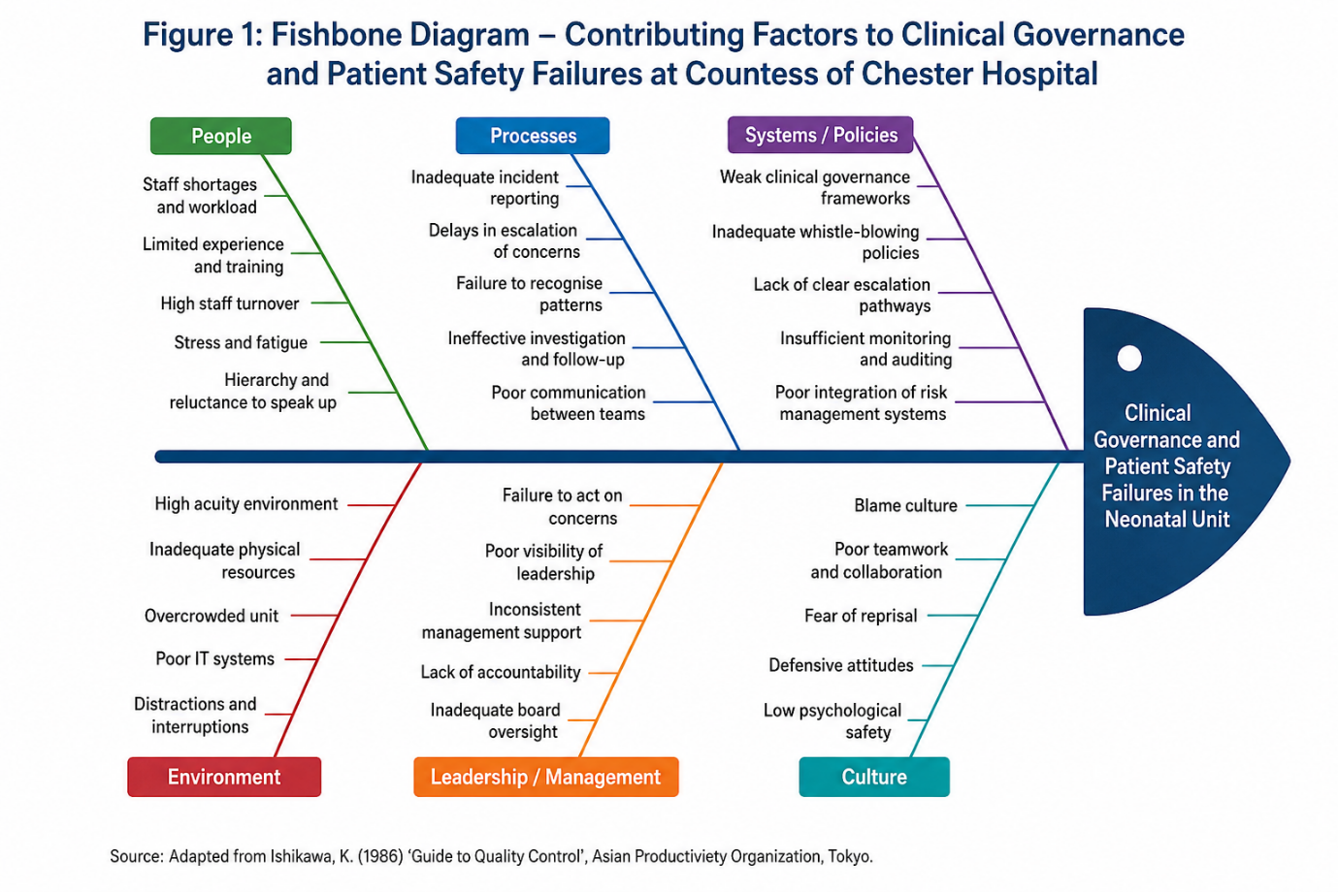
The first one is people. Neonatal care is heavily reliant on properly trained nurses, doctors, and consultants. In relation to the issue of inadequate staff numbers, the available literature is pertinent because inadequate workforce capacity may limit supervision, increase workload, and make escalation harder. Staffing cannot be seen as a complete explanation for the problem, however, since organizations with limited resources can nevertheless set up adequate escalation and surveillance systems.
The second factor is process. Patient safety requires proper reporting, investigating, escalation, and learning from accidents. When accidents are reported individually, without aggregation and analysis of the data on trends, repeated accidents may stay hidden. According to Vincent and Amalberti (2016), managing safety in an organization requires an understanding of the reality of how healthcare works rather than just investigating individual incidents.
Thirdly, we can discuss leadership and governance. The report of the Thirlwall Inquiry addresses how managers reacted in regard to the problems related to Letby and what impact organizational culture, management, and governance had on failures to ensure safety for babies (Department of Health and Social Care, 2023). Consequently, leadership becomes a crucial variable of quality rather than a marginal issue of management.

Fourthly, we can mention information and technology. Quality assessment and patient safety depend on the availability of timely and valid information. Donabedian (1988) maintains that assessing quality implies understanding the causal relationship between structural attributes, care processes and results. In relation to the Letby case, one could not detect unusual patterns without using information provided by individual care events.
Categories related to the environment and external system make up the last group of factors. Issues associated with the shortage of workforce, service design, regulations and external pressures on the NHS may have an impact on quality locally. In particular, issues concerning staffing, skills and the environment of the neonatal unit were found to exist by The Guardian’s coverage (The Guardian, 2024).

2.3 Donabedian Model
Donabedian's (1988) model divides healthcare quality into structure, process and outcome. The framework is particularly valuable because it connects organisational resources and arrangements with care processes and ultimately with patient outcomes.
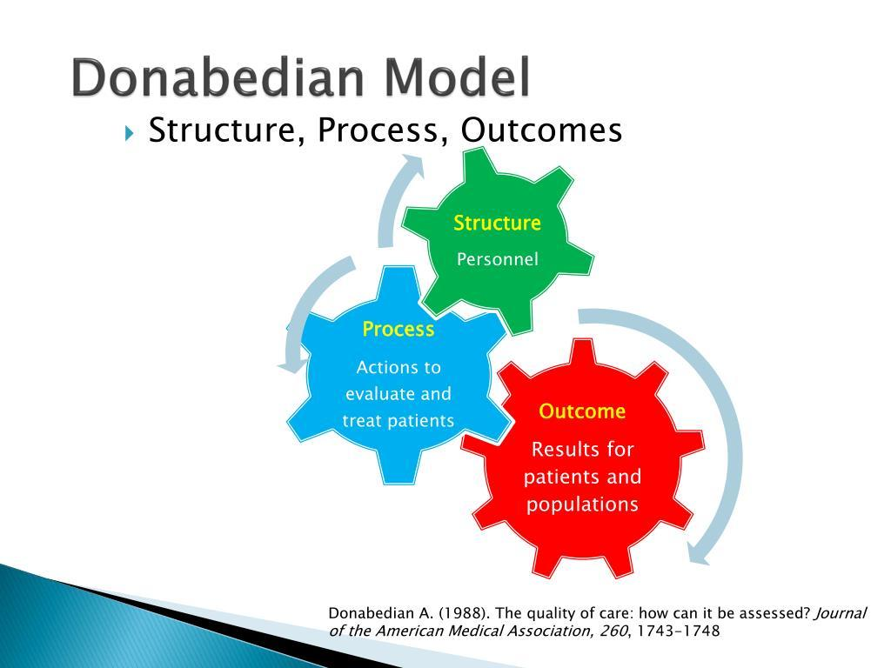

Structure
Structure factors are staffing, professional competence, facilities, leadership structures, governance structures, information systems and organisational resources. There is clear evidence from the case that staffing and service capacity was a concern. Structure factors may not necessarily lead to the cause of death, but they make a high risk service more vulnerable.
Leadership can also be termed as structure factor. Good governance will require accountability, appropriate escalation process and board oversight. If the clinical issues are unable to be escalated without the person(s) responsible for the service, there is a structure problem in the safety structure.
Process
Process issues are about the activities undertaken by healthcare organisations. In this situation, such processes would be incident reporting, mortality monitoring, clinical audit, escalation, communication between staff, whistleblowing, safeguarding and referral elsewhere.
Incident reporting systems should not only involve reporting incidents but should transform information into learning and improvement. The Freedom to Speak Up policy from NHS England states that organisations should foster workers' raising of their concerns and using them to improve care (NHS England, 2022). NHS England guidance also stresses that organisations should thank workers who raised concerns, listen, follow-up and learn from them (NHS England, 2026b).
Outcomes
Outcome refers to the result or consequence of healthcare processes. In newborns, these include death rates, illness, deterioration, parent satisfaction, staff satisfaction, and staff trust in the organization.
The case of Letby is an example of the worst-case scenario as far as patient safety outcomes are concerned since it involved the death and attempted murder of infants in the healthcare environment. Nevertheless, the aim of quality analysis should not be to assume that every adverse outcome is as a result of governance issues but to find out if the organization’s processes were able to spot the red flags.
It is thus clear from the Donabedian framework that there is a connection between weak structures leading to unsafe processes and unsafe processes contributing to poor outcomes. The limitation of this framework is that it looks linear. However, today’s healthcare environment is more dynamic; outcomes could feed back into the structure and process as well. Despite this, it is very useful for organizing evidence and for finding out what needs to be improved.

2.4 SWOT analysis
SWOT analysis provides a strategic assessment of internal strengths and weaknesses and external opportunities and threats. It is useful for translating the root-cause analysis into organisational strategy (Siddiqui, 2021).
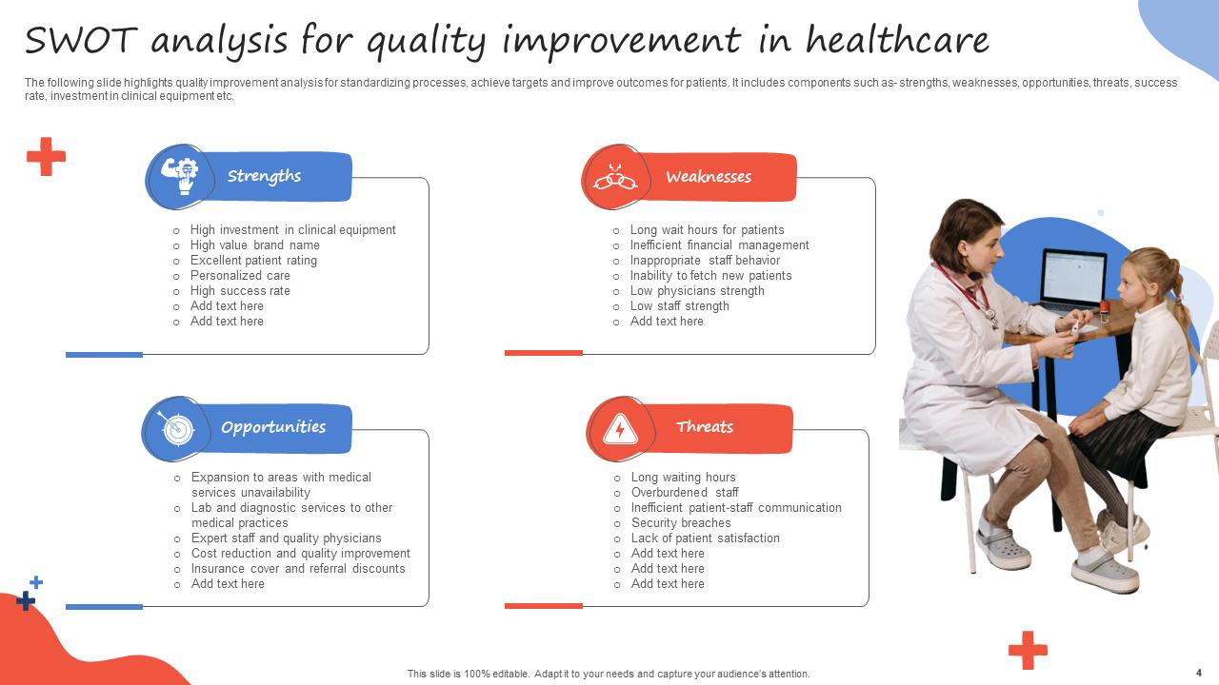

Strengths
The one major advantage of the Countess of Chester Hospital is that it falls under the umbrella of the NHS, which has existing structures of clinical governance, patient safety, professional regulation, incident reporting, and Freedom to Speak Up. All of these will serve as an excellent basis for improving patient safety and organizational learning. As per NHS England (2026), a good safety culture relies on teamwork, learning, and raising of concerns. Thus, the organization already has the required systems and professionals, which means there is no need to create an entirely new quality structure.
Weaknesses
Some of the weaknesses observed include inefficient escalation, communication challenges, governance weaknesses, and barriers to whistleblowing. The Thirlwall Inquiry is investigating whether there were proper communications regarding the issues concerning Letby and if there was any contribution by the culture and governance of the trust that resulted in the failure to protect the babies (Department of Health and Social Care, 2023). This shows that there might be a gap between having the policies and the effective communication and implementation of the policy in terms of taking appropriate action.
Opportunities
Some of the key opportunities include improving Freedom to Speak Up, conducting independent investigations, digital surveillance of patient safety and multidisciplinary governance. There is potential for the organization to incorporate the incident reports, staffing, mortality rates and concerns by staff members in a patient safety dashboard. Also, quality improvement methods such as PDSA, Lean and Six Sigma may be employed for testing and implementation of the change (Taylor et al., 2014).
Threats
The major risks involved are manpower shortage, staff fatigue, change resistance, defensive organizational culture and reputation management. As per NHS England (2026), staff health and staffing issues can affect patient safety, which means that further governance measures need to be put in place without any excess bureaucracy. Further, the potential existence of a blaming approach to the Letby issue may lead to the fact that staff members do not feel free to voice any concerns. Hence, learning, responsibility and psychological safety, but not fear, should be achieved through improvements.

3.0 Recommendations

3.1 Establish an independent neonatal patient-safety governance structure
Recommendation one is that there should be a Neonatal Safety and Quality Committee which reports to the Trust Board. The committee should comprise members such as neonatal consultants, senior neonatal nurses, the medical director, the director of nursing, the patient safety lead, Freedom to Speak Up champion, data analyst, and an independent non-executive director.
The committee should review:
- neonatal mortality and morbidity;
- unexpected clinical deterioration;
- incident reports;
- staffing and skill-mix data;
- safeguarding concerns;
- complaints and family concerns;
- Freedom to Speak Up data;
- investigation completion and action implementation;
- repeated themes and near misses.
The recommendation takes into account the weakness in the area of governance as seen from the Fishbone and Donabedian analysis. This aspect is crucial since quality cannot be entrusted wholly to the frontliners.

3.2 Introduce a strengthened escalation pathway
A standardised escalation pathway should be introduced for repeated unexpected deterioration, unusual mortality patterns, suspected clinical misconduct and concerns about staff competence or behaviour.
A "red flag" system should trigger review when:
- there is an unexpected neonatal death
- multiple unusual collapses occur
- staff raise repeated concerns about an individual or process
- a pattern emerges across incident reports
- staffing levels fall below defined safety thresholds
- a serious incident remains unresolved beyond an agreed timescale.
The process should set out who gets the concern, who investigates it, when an outside review is needed, and how the whistleblower gets a response.
This is in line with the Freedom to Speak Up principles that encourage workers to speak up and for leaders to listen and respond (NHS England, 2022).

3.3 Strengthen Freedom to Speak Up and psychological safety
The organisation should ensure that staff have multiple routes for raising concerns, including line management, Freedom to Speak Up Guardians, clinical governance, HR, safeguarding and external regulatory routes.
Training should focus on:
- speaking-up skills
- respectful challenge
- psychological safety
- recognising deterioration
- escalation
- professional accountability
- responding to colleagues who raise concerns.
Psychological safety needs to be assessed every year using employee surveys, along with qualitative interviews. Psychological safety and some patient safety outcomes have been correlated with each other in the research of Montgomery et al. (2025), although the correlation is a complicated one. As such, psychological safety cannot be treated as an independent strategy;
it must be accompanied by robust reporting and governance mechanisms.

3.4 Apply PDSA to implementation
It will be useful to use the PDSA method as the main way to implement the intervention since it will involve making changes in the complicated clinical setting. As was noted by Taylor et al. (2014), PDSA is often used, but at the same time, its documentation and implementation can be poorly done.
Plan
In the first three months, the neonatal unit must develop baseline data on the reporting of incidents, time taken to escalate issues, staffing and level of confidence in raising issues amongst the staff. A small multidisciplinary group must develop the escalation pathway and dashboard.
Do
The new model should first be rolled out within one neonatal ward or certain shifts. Staff members must be provided with training and an escalation pathway. A representative from Freedom to Speak Up should be present in governance meetings.
Study
Data should be reviewed monthly. Measures should include:
- number of concerns raised
- time from concern to acknowledgement
- time from concern to investigation
- proportion of investigations completed
- staff confidence in speaking up
- number of repeated incident themes
- action-plan completion.
Qualitative feedback should also be collected because quantitative data alone may not reveal whether staff feel genuinely safe.
Act
If there is improvement in the process, then the process will need to be expanded throughout the neonatal department. On the other hand, if there is no improvement, then the reason needs to be investigated and another PDSA cycle is needed.

3.5 Use Lean principles to remove barriers to escalation
Lean methodology focuses on reducing waste and improving value within processes. In healthcare, Lean Six Sigma has been applied to improve efficiency and reduce process defects, although the evidence base is stronger for operational processes than for highly complex clinical governance problems (Rathi, Vakharia and Shadab, 2022).
Concern identified → reported → acknowledged → triaged → investigated → escalated → action agreed → action implemented → learning shared.
Any unnecessary delay, duplication or unclear responsibility should be removed.
However, Lean should not be interpreted as "doing more with fewer staff". In neonatal care, adequate staffing and clinical expertise are safety requirements. The objective should be to eliminate administrative waste and process delays while protecting clinical capacity.

3.6 Apply Six Sigma principles to incident and mortality surveillance
Six Sigma can complement Lean by focusing on variation and defects. The DMAIC sequence—Define, Measure, Analyse, Improve and Control—can be applied to the incident-management pathway.
Define: Define delayed escalation and incomplete investigation as quality defects.
Measure: Establish baseline rates and turnaround times.
Analyse: Identify variation between departments, shifts and incident types.
Improve: Introduce standardised reporting, escalation triggers and governance review.
Control: Use monthly dashboards and board-level review to sustain gains.
This is especially important since the aim is not just to generate more reports. Even when an organisation has a high reporting rate, if the reports are not taken seriously, it could still have bad safety culture. Hence, the quality measure must consider the entire journey from reporting to learning.

4 Conclusion
Analysis shows that the issue of quality resulting from the Lucy Letby case is not confined to criminal activities and that there are several deficiencies in terms of governance, leadership, communication, escalation and learning within the organization. From the Fishbone diagram, there were several interrelated factors which caused the problems and included staff issues, poor process, leadership and governance, and organizational culture. The Five Why’s analysis showed how deficiencies in escalation and communication could become patient safety threats. From the Donabedian model, it was clear that quality must be taken into account at structural, process and outcome levels, while the SWOT analysis showed organizational strengths and opportunities that can be used to counter weaknesses and external threats. The above frameworks show that a systems-based approach must be taken to healthcare quality (Donabedian, 1988; Reason, 2000).
In consequence, the key area of improvement is creating a pro-active and transparent culture of patient safety, when problems will be heard, thoroughly investigated, escalated, and transformed into learning for the organization. Therefore, Freedom to Speak Up, incidence and mortality monitoring, proper escalation procedure, accountability at the board level, and proper staffing and expertise will be vital. All of those changes should be made through the quality improvement process, based on the PDSA cycle, with the use of Lean and Six Sigma approach, accompanied by the measurements of sustainability of changes (Taylor et al., 2014). The lesson learned from the case study is that the process of quality assurance in a hospital should not be based only on the policy and reporting system, but also include a process where information becomes an action.

5 References
Ahmed, S., Manaf, N.H.A. and Islam, R. (2013) ‘Effects of Lean Six Sigma application in healthcare services: a literature review’, Reviews on Environmental Health, 28(4), pp. 189–194.
Batalden, P.B. and Davidoff, F. (2007) ‘What is “quality improvement” and how can it transform healthcare?’, Quality and Safety in Health Care, 16(1), pp. 2–3.
Berwick, D.M. (2003) ‘Improvement, trust, and the healthcare workforce’, Quality and Safety in Health Care, 12(Suppl 1), pp. i2–i6.
Card, A.J. (2017) ‘The problem with “5 whys”’, BMJ Quality & Safety, 26(8), pp. 671–677.
Department of Health and Social Care (2023) Thirlwall Inquiry: Terms of Reference. London: DHSC.
Donabedian, A. (1988) ‘The quality of care: How can it be assessed?’, JAMA, 260(12), pp. 1743–1748.
Dixon-Woods, M., McNicol, S. and Martin, G. (2012) Ten challenges in improving quality in healthcare: lessons from the Health Foundation's programme evaluations and relevant literature. London: Health Foundation.
Edmondson, A.C. (1999) ‘Psychological safety and learning behavior in work teams’, Administrative Science Quarterly, 44(2), pp. 350–383.
Edmondson, A.C. (2018) The Fearless Organization: Creating Psychological Safety in the Workplace for Learning, Innovation, and Growth. Hoboken, NJ: Wiley.
Ishikawa, K. (1986) Guide to Quality Control. Tokyo: Asian Productivity Organization.
Leis, J.A. and Shojania, K.G. (2017) ‘A primer on PDSA: executing plan-do-study-act cycles in practice, not just in name’, BMJ Quality & Safety, 26(7), pp. 572–577.
McDermott, O., Antony, J., Bhat, S., Jayaraman, R., Rosa, A. and Marolla, G. (2022) ‘Lean Six Sigma in healthcare: a systematic literature review on motivations and benefits’, Processes, 10(10), 1910.
Montgomery, A., Chalili, V., Lainidi, O., Mouratidis, C., Maliousis, I., Paitaridou, K. and Leary, A. (2025) ‘Psychological safety and patient safety: A systematic and narrative review’, PLoS ONE, 20(4), e0322215.
NHS England (2022) The Guide for the NHS on Freedom to Speak Up. London: NHS England.
NHS England (2026a) Safety Culture. London: NHS England.
NHS England (2026b) The Future of Freedom to Speak Up. London: NHS England.
Reason, J. (2000) ‘Human error: models and management’, BMJ, 320(7237), pp. 768–770.
Rathi, R., Vakharia, A. and Shadab, M. (2022) ‘Lean six sigma in the healthcare sector: a systematic literature review’, Materials Today: Proceedings, 50, pp. 773–781.
Scally, G. and Donaldson, L.J. (1998) ‘Clinical governance and the drive for quality improvement in the new NHS in England’, BMJ, 317(7150), pp. 61–65.
Siddiqui, A.A. (2021) ‘SWOT Analysis (or SWOT Matrix) Tool as a Strategic Planning and Management Technique in the Health Care Industry and Its Advantages’, Biomedical Journal of Scientific & Technical Research, 40(2), pp. 32035–32042.
Taylor, M.J., McNicholas, C., Nicolay, C., Darzi, A., Bell, D. and Reed, J.E. (2014) ‘Systematic review of the application of the plan-do-study-act method to improve quality in healthcare’, BMJ Quality & Safety, 23(4), pp. 290–298.
The Guardian (2024) ‘A superbug, doctor shortages and a neonatal unit “out of its depth”: failures at Lucy Letby hospital revealed’, 8 September.
Vincent, C. and Amalberti, R. (2016) Safer Healthcare: Strategies for the Real World. Cham: Springer.
Vincent, C., Burnett, S. and Carthey, J. (2014) ‘The measurement and monitoring of safety’, BMJ Quality & Safety, 23(2), pp. 102–110.
World Health Organization (2021) Global Patient Safety Action Plan 2021–2030: Towards Eliminating Avoidable Harm in Health Care. Geneva: WHO.
World Health Organization (2020) Patient Safety Incident Reporting and Learning Systems: Technical Report and Guidance. Geneva: WHO.
Institute for Healthcare Improvement (IHI) (2023) Science of Improvement: How to Improve. Cambridge, MA: Institute for Healthcare Improvement.
Langley, G.J., Moen, R., Nolan, K.M., Nolan, T.W., Norman, C.L. and Provost, L.P. (2009) The Improvement Guide: A Practical Approach to Enhancing Organizational Performance. 2nd edn. San Francisco: Jossey-Bass.
Care Quality Commission (2016) Countess of Chester Hospital Quality Report. Newcastle upon Tyne: CQC.
Thirlwall Inquiry (2026) The Thirlwall Inquiry: Examination of events at the Countess of Chester Hospital and their implications following the trial and convictions of Lucy Letby. London: Thirlwall Inquiry.

