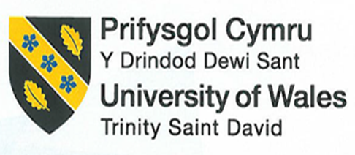 | Student No: | 2414865
 |  | Salvador Puma
 | Module Title: | Marketing Essentials
 | Module Code: | BMIH4009
 | Lecturer: | Natalie Brailsford
Marketing Plan
Launch
2025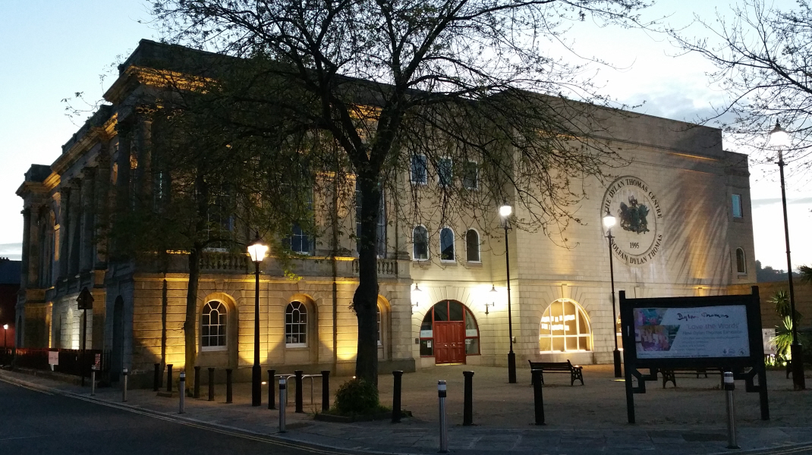The Thomas Dylan Building

INTRODUCTION

The proposal of this marketing plan is to advertise our new facility, the Thomas Dylan building. Inside is the Vivian Hall, a glamorous function room enough to fit up to 200 guests, it has its own kitchen, bar, handicap access, and plenty of parking.
This marketing plan includes our wedding packages, the objective is to have the Vivian Hall hire primarily for such event, not discarding any other type of events such as companies meeting, retirement parties, office parties, and the list goes on.
Like I mention, our focus is on weddings, and to do that we need to have on overview of what are plan is,
Briefly, this marketing plan well have step-by-step guides and how to reach our goal, it will take a lot of research, time, dedication and investment to do so.

MARKETING OBJECTIVES

This wedding package is set to launch by November 25, 2025, located at the Vivian Hall at the Thomas Dylan building. Inspired as a romantic celebration, (A Dream of a Night) package, at a price set at €6.000, ideal for mid-sized weddings for up to 100 guests it well include the ceremony room mention above, with a private bar area, a seated three-course wedding breakfast, evening buffet with dessert station, up to 5 hours of music provided by a professional DJ, and elegant floral centrepiece for each table.

MARKET RESEARCH

The goal is to use the Vivian Hall to be hired for any event. What can be done to increase bookings and revenue for the coming year? Firstly, it is imperative to think about goals and what appropriate angle we must take to achieve a successful wedding menu.
The goal is to become one of the top wedding venues in the area, promote a new area or venue feature (Outdoor ceremonies for example) to attract specific couples, in this case the millennials aged 24 to 35.
But first, how can they find us? How can they make an inquiry?
Every marketing plan is different, this could range from a new website, an increased budget for Facebook ads or even investment in wedding venue directories. I think millennial wedding couples invest in a wedding photographer, and so should we. Quality photos can instantly grab a couple's attention and sell the venue without them even reading a word, along with (Question, brochure, quote, viewing).
Word of mouth is one of the best forms of marketing. I will let friends and family, even a stranger knows about the Vivian Hall, what we offer and use them as a marketing tool via a social media they're using, that will link to their website by a specific keyword.
Furthermore, I have found very little threat from competitors around the area as we are in a prime location, surrounded by views, and places to visit, which I will discuss in my swot analysis.

TARGET MARKET AND CUSTOMER PROFILE

As mentioned earlier, my target is millennials. Young educated people that love the city lifestyle, usually from age 20 to 35 not thinking about having children, most of them have university degrees, with an excellent start on their careers, earning a good salary, and like to have extra money. Although they haven't landed their dream job, they must split the bills.
Usually they live in rental accommodation, typically modern flats with public transportation services, less likely to own a car and need to walk to many destinations including local shops.
One of the most popular forms of media used by millennials is social networks. Millennials use social networking sites, such as Facebook and Twitter, to create a different sense of belonging, make acquaintances, and to remain connected with friends.

SWOT ANALYSIS

One advantage that the Thomas Dylan building has is his name, British citizens are proud of that. That gives us strength to achieve our goal, with the support from the locals and team members we can make it work, we have qualified people that can organized and make it better, that's what makes us unique a different from other organizations we know and value our guest, we studied exactly what we are selling, that is what give us the strength along with the location of the building, and what the city centre can offer.
However, we are in the process of make it happen compare with are competitors we are in a weak stage, we don't have the audience to make it happen, we need to team efficiency and additional support, apply the techniques to hardness this opportunity, a make improvement we need to get into social media and advertise, we need to focus on our competitors see what are they doing and is up to us make it better we do that by eliminating the threats.
Another thing to consider is having local connection with the church, especially if we are doing weddings, we can implement with a package.
See appendix Below

UNIQUE VALUE PROPOSITION

The Dylan Thomas Centre is home to a year-round programme of literary events, including book launches, plays, poetry evenings, changing exhibitions and science talks, it has a lot to offer free exhibitions on the life and work of Dylan Thomas. Free children's trails. Offering free family activities. A free activity space open for self-led play, with games, dressing up, reading corner, creative writing, puppets, and crafts, suitable for all ages.
It is also preparing to promote the Vivian Hall for specials events, such as weddings, birthdays, and many more.
The keys benefit of the Dylan Thomas building, for one is located next to Fabián way, provides easy exit to your next destination, about a minute walk to Swansea famous (Wind Street) you well find pub's, and places to dine, a five-minute walk to the city centre you will see our very own Swansea market, a casino, and supermarkets like Tesco, Aldis, and many more all within walking distance.
It also has a big parking space in front of the building, easy handicap access, hotels for overnight stay, café area located on the ground floor, a bar and the second floor, and a kitchen for your banquet experience.
Comparing with other facility, the Dylan Thomas offer a unique service, fare prices, and convenience.
For example, the delta Marriott does not offer wedding packages, no free parking, it is long distance walk to city centre, no breakfast for any events, and overprice.

MARKETING MIX

Our product are wedding packages for the locals that are planning to get married between the ages of 24-35 that can afford to pay a wedding package of £6.000 for 100 guests, at our historical building the Dylan Thomas, we have prepared the Vivian Hall for that memorial moment and that unique special day. Details can be found on our website, request a brochure via mail, or you're welcome to visit are facilities and have a look what we can offer. Book now for a tour and one of are qualified staff, are ready to answer your quest.

MARKETING ACTIVITIES

My target is to attract millennials between the age of 24-35, the o- rentals hub, there are big into social media such Facebook and E-mails.
Best choice to promote will be Facebook, using a reel of the facilities, set up weeding style a view of the outside landscape, and the staff a tour of the kitchen, and the city gates to launch the package, in combine with other social media platforms like YouTube, and engage with potential customer online, target their e-mail as a secondary form of connecting with them on a personal 1 to 1 level to identified what are their needs and try to reach them more effectively.

PROMOTING METHODS

I suggest the best way to get to our target audience is through social media, use the best platform to get to them is Facebook, this group is always connected on social media upload the reel into Facebook, give them some useful information for example how to get in touch we us like a direct phone number, or E-mail address, so we can facilitate are work.

GANNT CHART

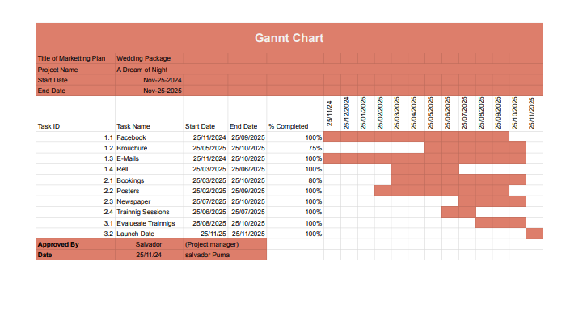

MONITORING
The aim is to have 5 bookings by the middle of the next year, but I am just getting started, and we are new, we need to concentrate and promote, show your face through social media let them what we offer and get to know the customer, gather information what they like, ask if they have any special request.
Monitoring the amount of time they visit our website, read any massages, how can we make them a loyal customer, so they come back, informed them about our wedding packages.
Keeping track of our expenses, keep track of the budget, calculate the investment to predict the net profit from each customer, so we can invest more in social media keep on eye on progress and objectives.

CONCLUSION

This marketing plan is to foresee the investment of our future wedding package, with the collaboration of the team, and our customers, this event is bound to get a good rating.
Thanks to social media, and the amount of research, we meet are goal, because our standards are high.
I was able to sell my wedding package for 100 people, and book for next year, to my surprise all the planning and monitoring pay off.

Appendix 1
Swot Analysis

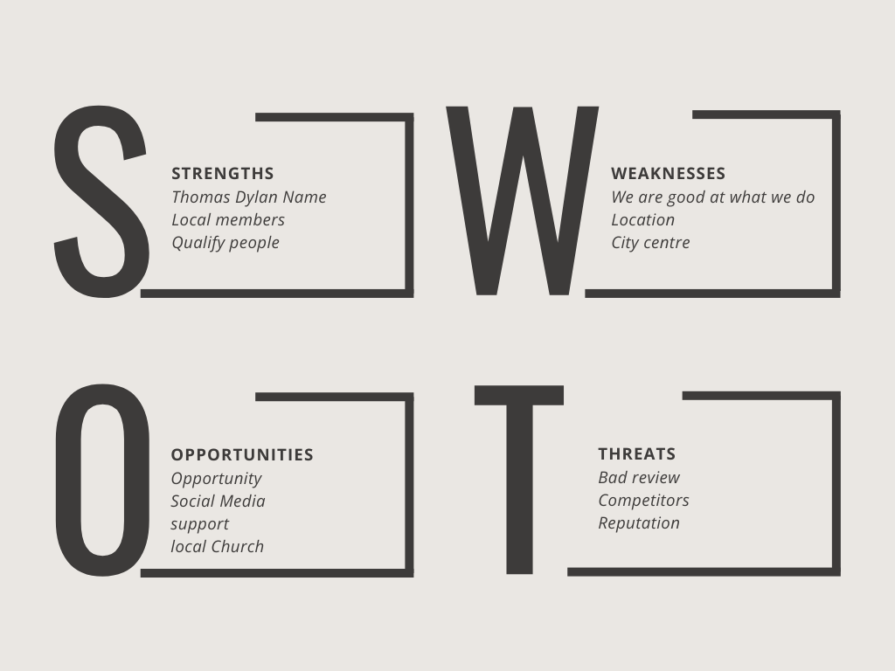

References

Kotler, Philip, Armstrong, Gary, ; Harris, Lloyd C, He Howie (2020), Principal of marketing

P.R Smith and Ze Zook. Marketing communications: integrating online and offline, customer engagement and digital technologies. Seventh edition, Kogan Page, 2019.

Hudson, Simon, Hudson, Louise, Understanding today’s customer. In Marketing for tourism, hospitality & events: a global & digital approach, by Hudson, Simon, Hudson, Louise, First edition, London, Sage Publications Limited, (2017)

Housden, Matthew, Market information and research, 2nd edition, Amsterdam, Boston, Elsevier, (c2010).

Chaffey, Dave, Ellis-Chadwick, Fiona. Digital Marketing strategy, implementation and practice 7th edition, Harlow Pearson, (2019).

2024 How to perform swat an analysis https://www.investopedia.com/terms/s/swot.asp

2024 Millennials demographic group https://www.britannica.com/topic/social-media

2024 Marketing to millennials Guide https://www.emarketer.com/insights/millennials/

2024 Target Market: Definition, Purpose, Examples, Market Segments
https://www.investopedia.com/terms/t/target-market.asp

2024 Target Market vs. Target Customer
https://smallbusiness.chron.com/target-market-vs-target-customer-20674.html

2024 Target Market Profile | Overview & Examples
https://study.com/learn/lesson/target-market-profile-concept-examples.html

2024 Marketing Mix: The 4 PS of Marketing and How to Use Them
https://www.investopedia.com/terms/m/marketing-mix.asp

2008 Market Monitoring
https://www.sciencedirect.com/topics/engineering/market-monitoring

2024 What Is a Promotion? https://www.investopedia.com/terms/p/promotion.asp

2024 Value Proposition: How to Write It With Examples
https://www.investopedia.com/terms/v/valueproposition.asp

