

University of Wales Trinity Saint David
School of Engineering
Design, Development and Manufacturing–3 Jaw COBOT End effector
Faith Over
1904483
Manufacturing Systems Engineering
21/06/2021
ACMA5002 MANUFACTURING DESIGN & TECHNOLOGY

Contents Page

Contents
Contents Page ii
1. Introduction 3
2. Manufacturing process proposal 5
3. Design and development work undertaken 7
4. Manufacturing process design 16
5. Conclusion 20
5. REFERENCES 21
Works Cited 21
Appendix 22

Introduction

Before one can review the proposed design, a design specification must first be created to ensure that the correct priorities are made, and correct direction is followed. This helps to ensure all customers’ “wants & desires” are effectively translated into design attributes (Liu & Zhang, 2008). To analyse anticipated customer needs for the COBOT (collaborative robot) claw, a customer driven quality management system was utilised - the house of quality (HOQ) tool. This ensures that it is the customer’s actual needs which are driving the product design and process design and not purely perception or emotive will of the designers (Chan & Wu, 2005).
A HOQ (house of quality) contains the customer needs, which are listed as “what’s” on the left side. These are rated by “relative importance” on a 5-point scale. A HOQ then lists technical measures as “how’s” across the top, which are the engineering attributes or methods which relate to the listed “what’s”. These “how’s” have “improving correlations” which simply identifies in what direction each of the “how’s” should be improved to increase customer satisfaction (e.g. an increase or decrease in weight). At the centre of the HOQ tool is the relationship matrix which highlights the level of relationship between the “what’s” and “how’s”. At the top of the HOQ tool is the correlation matrix which establishes the relationships and correlations between each of the listed “how’s” (Chan & Wu, 2005).
Figure 1: A section of the HOQ tool which displays the relative weight of both the “whats” and “hows” highlights that jaw dexterity and ensuring that the jaw will not damage components it is handling, and thus the gripper motion range, are the most important aspects of the design process. The next highest rated “what” is the gripper strength and the next highest rated “how” is interchangeable or adaptable grippers. This HOQ highlights that; due to the nature of customer demands for pick and place COBOTS over industrial machines is the range of tasks they can be programmed and re programmed to do, therefore grippers which can also carry out a wide range of tasks but will not damage items it is handling is important for customers.
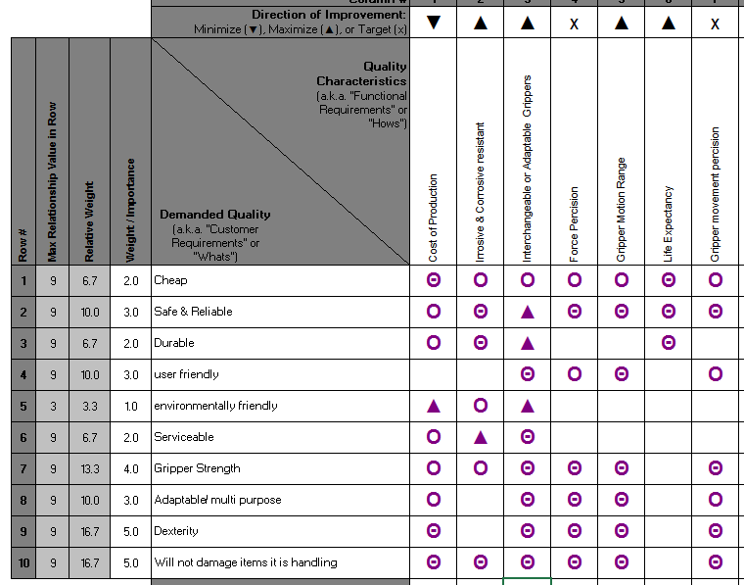
Figure 1: A section of the HOQ tool which displays the relative weight of both the “whats” and “hows”

The material selection will be imperative for satisfying these needs and designing a manufacturing process. As gripper strength and dexterity is highly ranked, a material which does not erode, is not brittle and does not have a high elasticity rating is required, however “does not damage components” suggests a softer material which will not scratch or mark components is needed. As these two material property requirements contradict, a dual material gripper is needed. A design with pads on it is suggested. ALUMINIUM ALLOY A380 has been suggested for the jaw due to its ability to be casted with a variety of finishes, high operating temperatures, corrosion resistance and dimensional stability whist still providing a lightweight solution (DYNACAST, 2021).
As dexterity was highlighted as one of the most important features of the gripper to customers, some elements must be changed: the current design does not accommodate pick and place of small components, due to the position of how all the jaws close together, a small gap is still present even when fully closed. It is suggested that the top plane of the jaw is changed to a more triangular shape rather than rectangular.
The main difference between COBOTS and industrial robots is that they are smarter, reprogrammable and multi-purpose – many customers choose cobots due to their wide range of application, comfort in the knowledge that the COBOT can always be reprogrammed to a different task if the current task is not providing enough payback. As this is the main driver of choosing a COBOT over a robot, the gripper head must also be as adaptable for different tasks. It is suggested that the design is changed so that a different claw may be easily clipped into the motor if desired this will provide a more “plug and play” solution, increasing the ease of customer upgrades.

Manufacturing process proposal

The manufacturing process will have to be able to satisfy demand for 1000 to 2000 units per week. To decide which manufacturing processes will be able to satisfy this, Takt-time is used to calculate the output speed required. Takt-time provides the basis for determining the pace of manufacturing to meet customer demand (keim, 2019).
$$TaktTime =\frac{Time Available}{Units Required}$$
If we work on the basis of 7.5 hours in a day (8 hour shifts, minus breaks) and 5 working days in a week, this means our takt time is:
$TaktTime =\frac{ (7.5*60)*5}{2000}$ = 1.125 minutes.
NB: we multiplied 7.5 hours by 60 to convert into minutes.
This calculation shows that 1 unit must be produced every 1.125 minutes aka 67.5 seconds to satisfy customer demand with minimum resources. If the manufacturing process chosen does not meet this requirement the business has multiple options such as, increase the head count on the process, increase the number of shifts or increase the number of manufacturing lines producing this product. However, as cost is a main driver of this product, none of the changes are recommended as they will all lead to an increase in cost to the business.
Die Casting has been chosen to make the; jaw, cylinder and drive plate. This is due to the accuracy, reliability and speed of the process. (Paulsen, 2020). As die casting has fewer steps within the raw material to finished part process, it provides faster production cycle time, and can create parts to tighter tolerances (DYNACAST, 2020), which will be required if the cobot jaw is to handle small components. This method also has a long tool life, which reduces maintenance downtime and cost.
Once the components are die-casted, they need to be assembled with pins. This will be hand assembled at first, until volumes justify investment in automation. Following the proposed design, the manual assembly process would roughly use the following 6 steps:
- screw motor into cylinder
- insert drive shaft into worm
- insert worm into drive shaft
- attach joints to drive shaft
- insert worm and shaft through cylinder and motor
- Insert jaws into cylinder
- Attach jaws to joints
These seven steps can be reduced by utilising a design for assembly component appraisal table, for example the worm and the drive shaft can be fabricated as one unit to remove step 3, this would also make steps 3 & 5 easier as less dexterity would be required with a larger component.
Simillarly, two of the four screw holes in the cylinder can be removed so that the motor is affixed to the cylinder with only two screws instead of four, stability can be ensured by keeping two holes diagonally opposite eachother in the cylinder. This would halve the time taken to complete step 1. This can actually be taken one step further by reducing pins all together to affix the motor and the cylinder alltogether, by recessing the cylinder head and adding pins to the motor so a push and twist fit can be added. This would reduce time taken for step 1 into seconds, and is a task which could be easily automated in the future. :
Figure 2: Example of a push and twist joint:
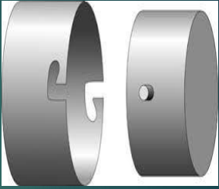

Figure 3: Path for the shaft and worm

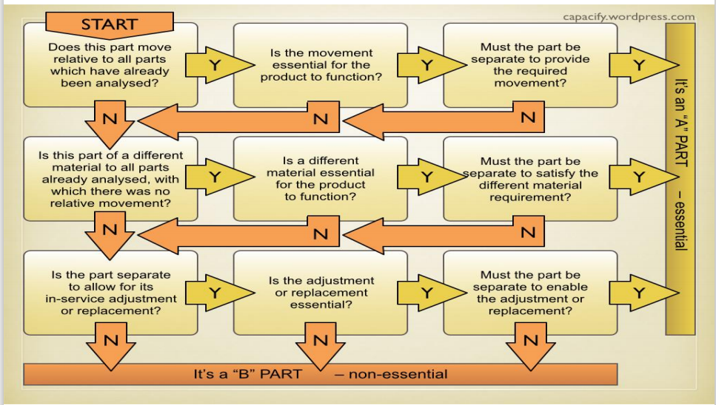
Figure 4:Path for the four screw holes to affix the motor into the Cylinder

Design and development work undertaken
Building from the HOQ, component appraisal and design for manufacturing methods used above, the changes to the proposed design are:
- Removal of the four screw holes into the cylinder and adding a recess in the cylinder shaft and addition of pins to the motor to allow for a twist lock mechanism for the cylinder into the head – this will assist in speeding up production by reducing assembly time and requiring a less complicated die cast mould. This will also be increasing the end customers usage and flexibility by providing more of an immediate plug and play solution,
- Amending the COBOT claws into pyramid shapes to increase the scope of components the claw can handle by reducing the lower size limits for the components
- Fabricating the shaft and worm into one singe component to speed up assembly
Before this is translated into a design, a PFMEA was conducted to review whether any further changes are required. Every process step is covered in the PFMEA to ensure there are no gaps are missed, therefore a full end to end description of the manufacturing steps of each process (die casting and manual assembly) is displayed in the PFMEA below. The PFMEA has highlighted that the highest risk processes are the manual assembly processes, automation, adding testing and scanning systems are proposed to mitigate these risks.
The PFMEA (process failure modes effects analysis) also highlights that the design of the cylinder may cause a low yield rate in the ejection step of the die casting process, therefore one further design change has been proposed:
- Round off the outside of the pin attachment extrusion on the cylinder

Figure 5: Cylinder pin attachment extrusion highlighted
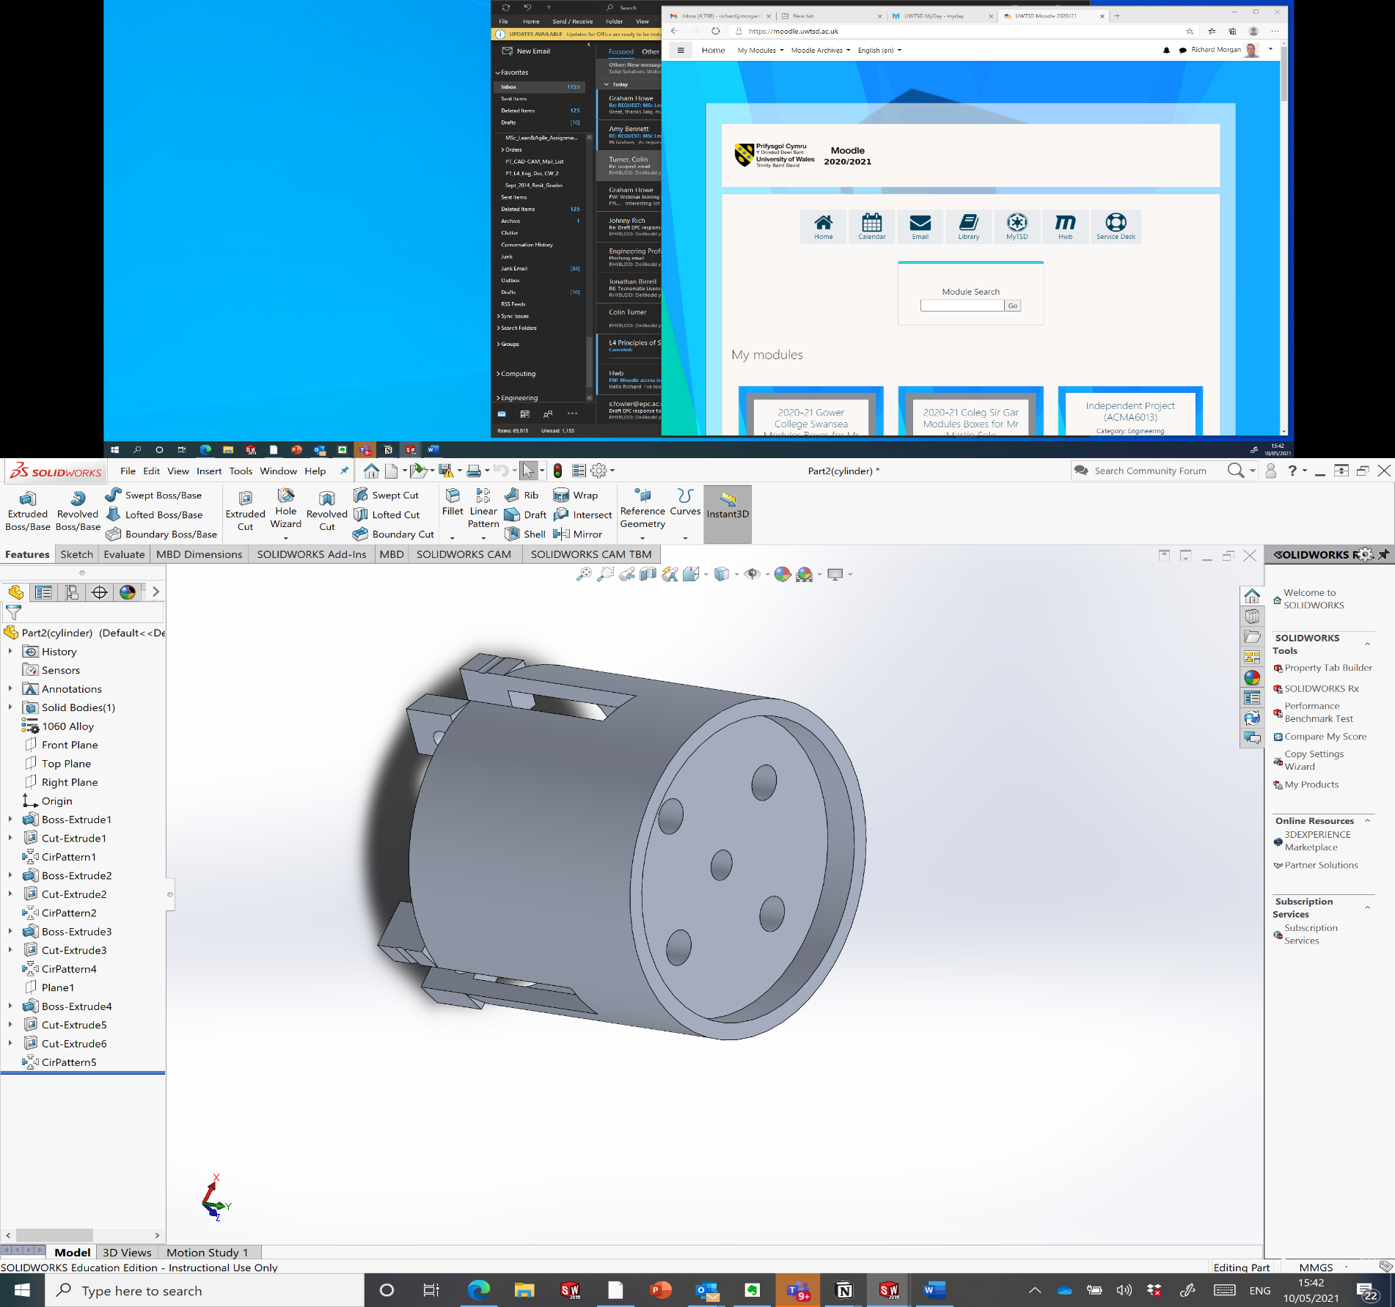

Table 1: PFMEA for assembly process
FAILURE MODE AND EFFECTS ANALYSIS
Item: | 3 CLAW COBOT JAW ENDER |  |  | Responsibility: |  | Quality |  |  |  | FMEA number: | 1
Model: | REV 1 |  |  | Prepared by: |  | Faith Over |  |  |  | Page : | 1
Core Team: | NPI, Production, Quality, Supply Chain |  |  |  |  |  |  |  |  | FMEA Date (Orig): | 21/06/2021 | Rev: |  | 1
Process Function | Potential Failure Mode | Potential Effect(s) of Failure | Sev | Potential Cause(s)/ Mechanism(s) of Failure | Occur | Current  Process  Controls | Detec | RPN | Recommended Action(s) | Responsibility and Target Completion Date | Action Results
 |  |  |  |  |  |  |  |  |  |  | Actions Taken | Sev | Occ | Det | RPN
clean die halves and add ejection lubricant | dirt and debris is left on the die | tarnished finish and/or misshaped parts casted | 5 | die not cleaned properly from wrong chemicals or pressure | 2 | visual inspection at manual sanding process | 1 | 10 |  |  |  |  |  |  | 0
clamp die halves together | incorrect pressure applied | misshaped parts, may not assemble | 5 | molten metal leakage | 2 | visual inspection at manual sanding process | 1 | 10 |  |  |  |  |  |  | 0
ingot added to furnace and retained at set temperature | ingot doesn’t fully melt | feed error into cast | 6 | ineffective temperature control | 2 | temperature control mechanism | 1 | 12 |  |  |  |  |  |  | 0
molten metal injected into closed dies | metal starts to solidify before die is filled | incomplete/ mis-shaped parts casted | 4 | speed of injection is too slow | 3 | outfeed velocity control mechanism | 1 | 12 |  |  |  |  |  |  | 0
Molten metal cools in die | metal does not solidify | wasted material, low yield | 2 | incorrect cooling temperature or time | 2 | temperature control mechanism | 1 | 4 |  |  |  |  |  |  | 0
die halves are open and solidified die casting is pushed out of the die | part sticks to die and does not eject | unable to remove parts from cast | 2 | force of ejection process not high enough | 3 | force control mechanism | 1 | 6 |  |  |  |  |  |  | 0
die halves are open and solidified die casting is pushed out of the die | part sticks to die and does not eject | unable to remove parts from cast | 4 | Cast has small intricate detail which is harder to extract | 3 | none | 1 | 12 | Re design the mechanism on the cylinder which the jaws are affixed to, so that the extrusion does not stick out past the cylinder |  |  | 2 | 3 | 1 | 6
trimming of excess material from flash or runner system | break off too much or too little | misshaped parts, may not assemble | 5 | human error | 5 | visual inspection at manual sanding process | 4 | 100 | invest in trim dies to automate the process and ensure tighter tolerances are achievable |  |  | 5 | 1 | 1 | 5
Move components to Final assembly | incorrect parts fed to operators | assembly built to wrong configuration | 7 | human error | 4 | control cards | 3 | 84 | implement a component scanning system |  |  | 7 | 4 | 1 | 28
Affix motor to cylinder | connection is not properly made | motor will not drive claw movements | 6 | human error | 4 | operator inspection | 8 | 192 | introduction of end of line test |  |  | 6 | 4 | 1 | 24
insert shaft and worm assembly into drive plate | drive shaft and worm assembly mounted backwards | operator will be unable to take assembly further; drive shaft will not affix to cylinder | 1 | human error | 4 | poke-yoke with different hole diameter | 1 | 4 |  |  |  |  |  |  | 0
attach joints to drive plate | operator adds joints to wrong side of drive shaft extrude | operator will be unable to take assembly further; claws will not affix to joints | 1 | human error | 4 | poke-yoke with pin holes for jaw and joints not aligning | 1 | 4 |  |  |  |  |  |  | 0
add worm, shaft, drive plate and joint assembly into cylinder and motor assembly | Sub-assemblies not fully inserted into each other | motor will not drive claw | 6 | shaft is not fully inserted into the motor | 5 | work instructions | 8 | 240 | introduction of end of line test |  |  | 6 | 5 | 1 | 30
attach jaws to joints and cylinder | jaws attached wrong way round | jaw will not function | 7 | human error | 3 | work instructions | 3 | 63 | introduction of end of line test |  |  | 7 | 3 | 1 | 21
pack units | assembly improperly packaged | assembly damaged in transit | 7 | human error | 3 | packaging instructions | 5 | 105 | introduce warehouse inspection |  |  | 7 | 3 | 1 | 21
send to warehouse | order improperly labelled | orders sent to wrong customers | 6 | human error | 2 | warehouse inspection | 2 | 24 | implement outer box barcodes and scanning systems in the warehouse |  |  | 6 | 2 | 1 | 12

The drawings for the assembly and modified components (Cylinder, Motor, Jaws, Shaft & Worm assembly) are below:

Manufacturing process design
The manufacturing process overview for these units will follow the below process flow:

As the Die Casting and Die Trimming processes are automated processes suitable for high volume manufacturing, special attention needs to be paid to manual final assembly as it is by nature slower and at higher risk of error escapes.
A simple U-shaped manufacturing cell design has been chosen for this operation as it is headcount can be easily changed form 1-3 operators without having to change the cell infrastructure. This flexibility will allow for quick adaptations to demand with high levels of variability, suitable for demand fluctuations of a range of 1000-2000 pieces a week (100% variance). How each station is set up in this U-shaped cell will depend on the process time it takes for each step of the process, and subsequently how these steps are distributed to the three operators to create an evenly loaded well balanced cell. A playbook has been created to validate whether the process time meets the takt time and assist in calculating headcount required.
As you can see in the playbook below, the entire process time is 155 seconds – more than double the TATK time, therefore at least three operators will be needed if the line was to run on a single shift basis. The split of the workload and process sequence is highlighted in the playbook shown below. This split allows for a 9-7 second variance for each operator to complete their task whilst still meeting customer demand.

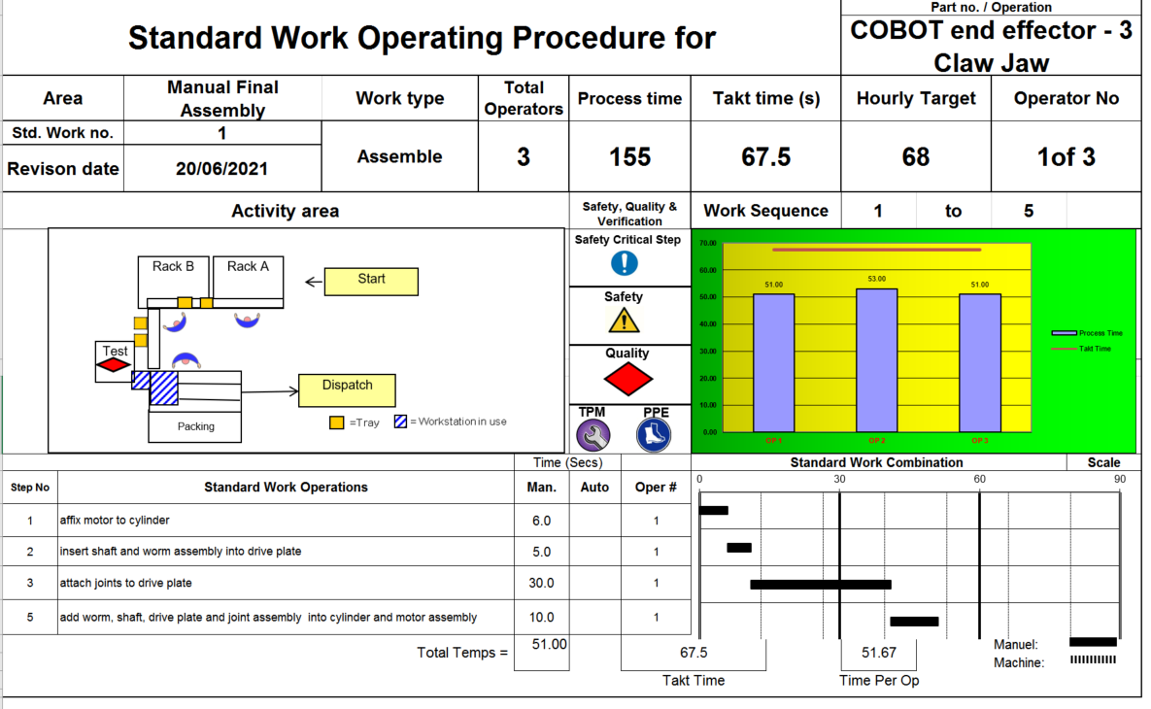

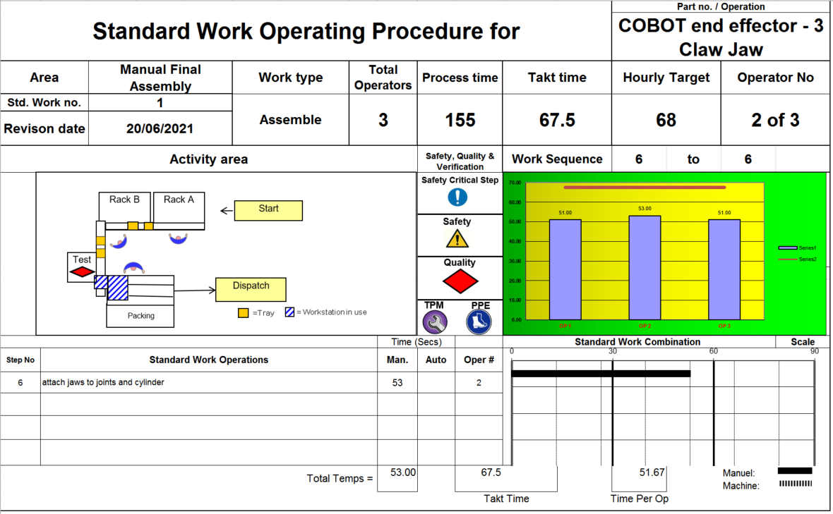
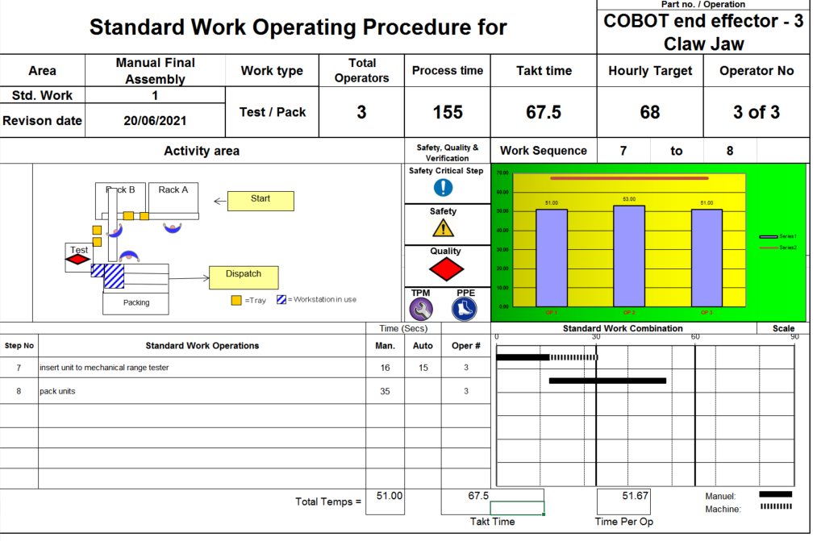

Conclusion

A variety of methods was utilised to analyse the effectiveness of the design. First a HOQ was used to review how well the design meets customer requirements, then a component appraisal table and a PFMEA were used to review how appropriate the proposed design is for assembly and the below design changes were made:
- Removal of the four screw holes into the cylinder and adding a recess in the cylinder shaft and addition of pins to the motor to allow for a twist lock mechanism for the cylinder into the head
- Amending the COBOT claws into pyramid shapes to increase the scope of components the claw can handle by reducing the lower size limits for the components
- Fabricating the shaft and worm into one singe component to speed up assembly
- Round off the outside of the pin attachment extrusion on the cylinder
The resulting design is now able to better handle very small components due to the increased precision of the claw, and a claw which can be easily interchanged to enable the claw to be as flexible to customers needs as a COBOT solution is. The changes to remove the screw holes in the cylinder, fabricate the shaft and worm together and to round off the outer edge of the cylinder all aide in increasing yield of production, reducing rejects and increasing the speed of manufacturing.
Further changes recommended to increase the claw’s dexterity is to add an additional joint to the claws so that their movement more closely represents that of human fingers. The downside in this of course is that the design will increase the parts needed to manufacture and assemble, thus increasing the cost of the solution.
The main criticism of the new design is that although the COBOT jaws nest together very precisely, this also means that they have now naturally formed a sharp point. This causes issues to both the operators working with the COBOT and also the components it is handling: As COBOTs are designed to work alongside humans without any separation (unlike industrial automated machinery), increasing the risk of a human operator turning around without realising the COBOT head is there and accidentally cutting themselves with the jaw. Furthermore, though this design might be able to perfectly handle intricate pick and place tasks, such as microchips on a PCBA, it would struggle with the handling of larger items, and increase the risk of scratching components if the COBOT’s calibration is off. This was highlighted in the introduction and pads were recommended to be affixed to the jaw. A suggested future improvement is the idea of rubber sleeves to go on each of the jaws, to protect both components and operators form the sharp edges of the design. In addition to this, it is recommended the outer edge of the COBOT jaws are rounded off to remove the risk of the sharp edgse facing outwards.

REFERENCES

Works Cited
Chan, L.-K. & Wu, M.-L., 2005. A systematic approach to quality function deployment with a full illustrative example. OMEGA - The international Journal of Management Science, 33(1), pp. 119-139.
DYNACAST, 2020. ABOUT DIE CASTING. [Online]
Available at: https://www.dynacast.com/en-gb/specialty-die-casting/about-die-casting
[Accessed 11 June 2021].
DYNACAST, 2021. ALUMINIUM ALLOY A380. [Online]
Available at: https://www.dynacast.com/en-gb/resources/material-information/die-cast-metals/aluminium/aluminum-alloy-a380
[Accessed 06 June 2021].
keim, E. M., 2019. Takt Time and Workload Balancing. The Journal for Quality & Participation, January, Volume 1, pp. 30-32.
Liu, X. & Zhang, W. J., 2008. An Analytical Approach to Customer Requirement Satisfaction in Design Specification Development. IEEE TRANSACTIONS ON ENGINEERING MANAGEMENT, February, 55(1), pp. 94-102.
Paulsen, G., 2020. 8 Ways to Create a Metal Part and Their Use Cases. [Online]
Available at: https://www.xometry.com/blog/8-ways-to-create-a-metal-part-and-their-use-cases/
[Accessed 11 June 2021].

Appendix

