Submission deadline: Blogs: 19th June, by 11:59pm
Managing Projects in Organisations. Blog.
Lecturer: Giulia Chifar (BMSW5009_SWAN)
Piotr Czubinski 2237463
Blog 1: A Journey from Uncertain Concepts to a Meaningful Charitable Project.

How do we select a realistic and useful project? Our group project is the St Thomas Church Charity Food Donation Project. It is for the benefit of St Thomas Church charity. I am in a group together with Raluca, Claudio, Lustyna and Dre. We decided to work together because we know each other Level 4, so we had trust and good communication already. We voted for Claudio as our leader because he is reliable, punctual, and organised. We initially talked about different ideas, whether it was to use Amazon’s Donation of Hours scheme to clean poorer areas around Swansea or to organise a mindful session at university. As a back-up plan, Raluca contacted St Thomas Church Charity and received a positive response with a list of needed items. It made the charity project more realistic, attainable and community focused. My Belbin result was that I was a Monitor Evaluator. I can help by analysing ideas, comparing options, and questioning risks before decisions are made (Belbin, 2010). This was good for the project as it helped me think about the best way to do it. However, Belbin should not be applied too rigidly as research evidence about its validity is mixed and suggests that team roles can change depending on the situation (Mullins, 2016).

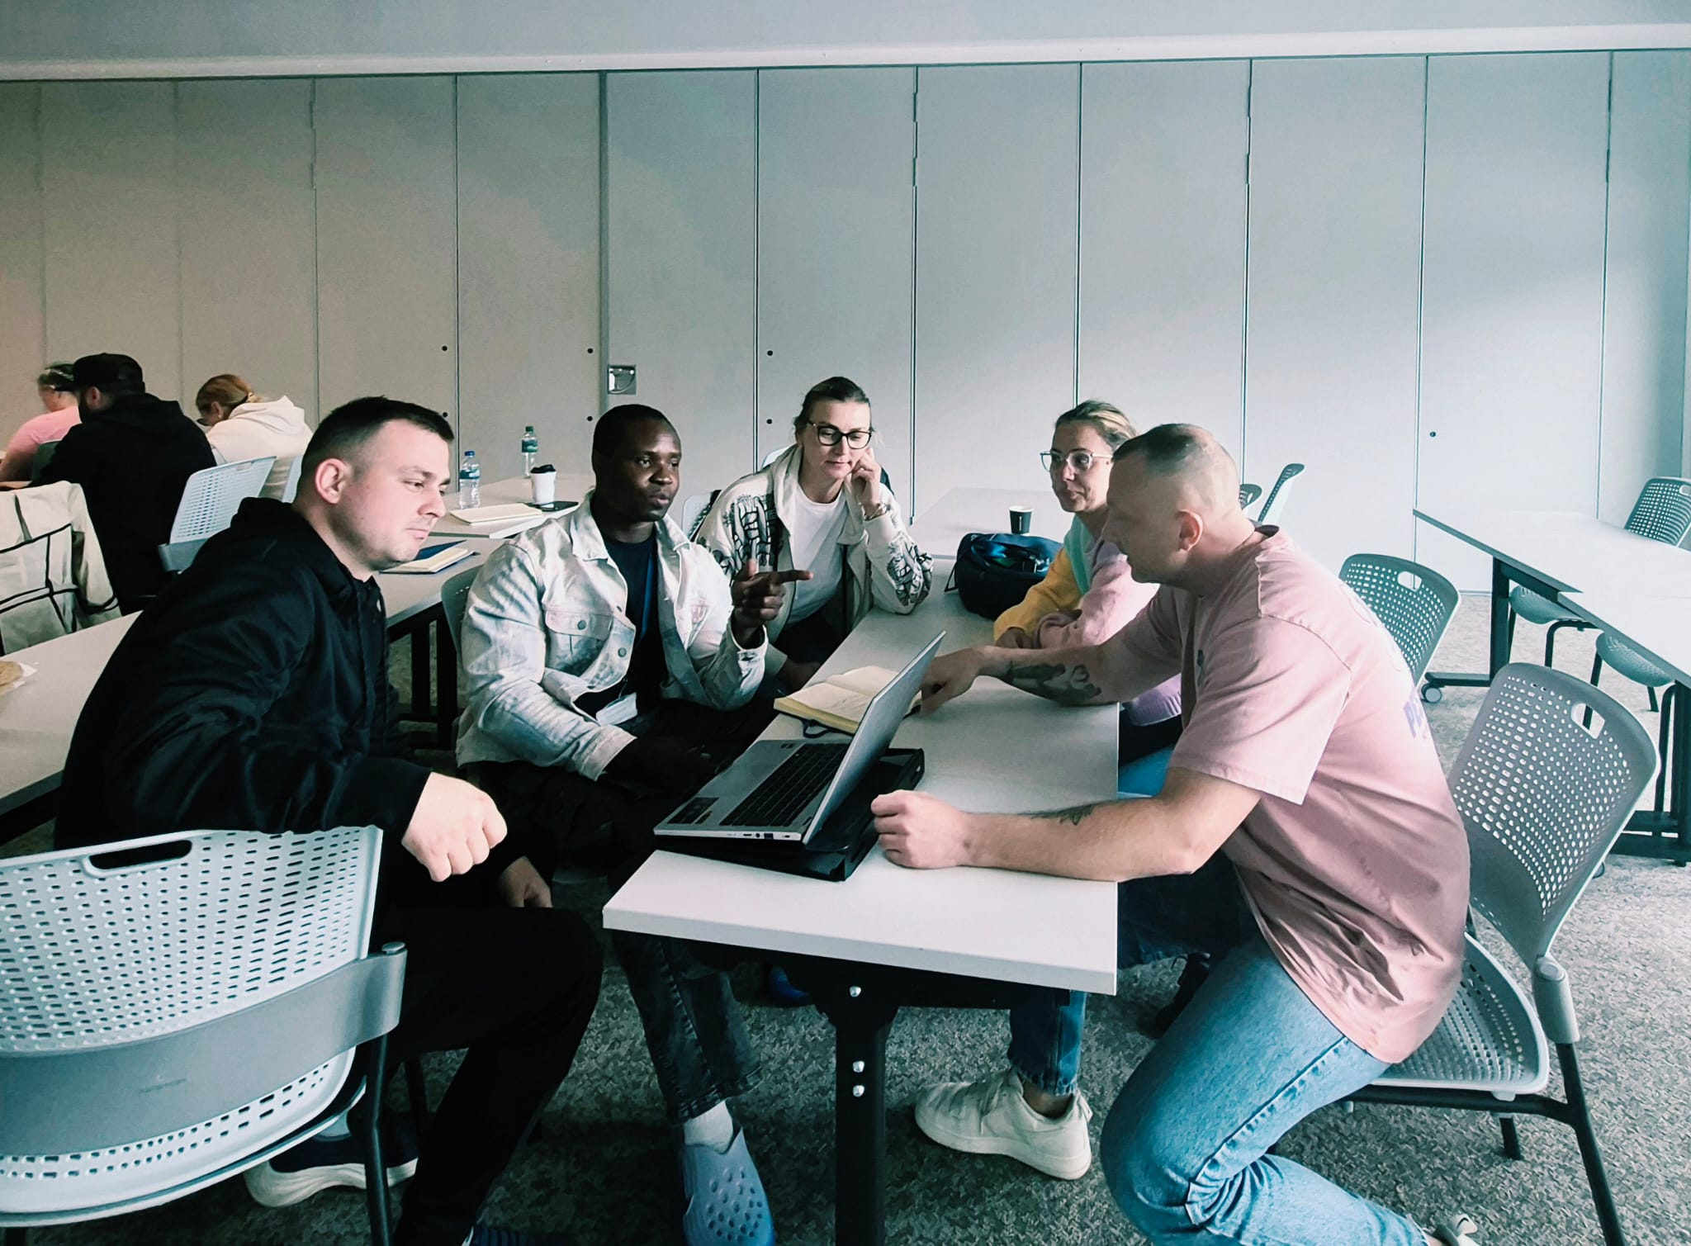

Blog 2: From Food Donations to a Real Project Plan.

At the initiation stage, our group developed the project into a more concrete and realistic charity donation campaign. We are trying to raise funds for St Thomas Church Charity by collecting food and small financial donations to buy items requested by the charity such as dry pasta, tinned food, sweetcorn, beans, and pasta sauce. Project initiation is important because it defines the purpose of the project, identifies stakeholders, and helps the team decide if the idea is achievable (Clegg, Skyttermoen and Vaagaasar, 2020). Our aims are to promote the campaign, gather donations from different groups and deliver the final items to charity. We divided the tasks according to our skills and contacts. Dre will create a Facebook page to spread the word. Justyna will make up leaflets with my number on to contact me. Raluca approached Tesco where she works and her manager agreed to speak to local Tesco stores about providing food donations. So, I decided to ask for small donations from Amazon night-shift workers and the 55+ community in St Thomas, because local older people often support charity projects. The project scope is restricted to a small local food donation campaign. This is not about solving a long-term poverty or running the charity’s wider work. Iron Triangle helped us to balance time, resources and quality. This proved that a focused donation project is more realistic than our earlier ideas (Kidston, Haward and Association for Project Management, 2015). Well-defined objectives and scope also reduce confusion and help control project work (Project Management Institute, 2021).

Blog 3: The People Behind the Project Stakeholders: Why They Matter.

Who really matters in a project? At first, I thought our St Thomas Church Charity Food Donation Project was mainly about collecting food. However, in our assignment of Managing Projects in Organisations, I realised that the success of the project is highly dependent on identifying and communicating with the right stakeholders. A stakeholder is anyone who is impacted by the project or who may influence the success of the project (Wysocki, 2014). The main stakeholders in our project are St Thomas Church Charity, our project team, donors, Amazon night shift workers, Tesco, the 55+ community in St Thomas and our module lecturer, Giulia.
Then we analysed these stakeholders with the Power/Interest Grid. This project management tool identified the stakeholders to be managed closely and those to be kept informed. St Thomas Church Charity is very interested as they will be receiving the donations and will have an influence over the project by telling us what items are needed. Our project team scores high on power and interest too, as we must plan, promote and deliver the project. Giulia also has influence because this project is part of our assessment, so her guidance and expectations matter. Donors, Tesco staff, Amazon workers and local residents have low power but high interest and need clear and simple information. Communication is important as poor communication can lead to confusion, delays and missed support. Good communication is essential to coordinate a project (Heagney ,2016). We used WhatsApp for team updates as we already had a group chat going and it was quick and practical. My biggest lesson is that good stakeholder management is not about contacting everyone equally, but about contacting the right people in the right way.

Blog 4: Meeting the Deadline: How Our Gantt Chart Helped Us Stay on Track.

Good project ideas need structure. For our St Thomas Church Charity Food Donation Project, we used a Work Breakdown Structure and a Gantt Chart. The WBS helped us to break down the project into smaller activities such as making brochures, creating the Facebook page, contacting Tesco, collecting donations, buying extra food, delivering supplies and recording proof. This made it easier to assign roles and helped the project to feel more manageable (Zecheru and Olaru, 2016). However, the WBS has its limits. It showed what needed to be done, but not when tasks should happen or which activities were dependent on the others. This is why the Gantt Chart was needed to structure the timeline. It enabled us to identify what happened first, what could overlap, how to work to the deadline. However, it could not adequately forecast unpredictability such as the response or donation levels of Tesco. Both tools were so valuable, but only if updated during the project (Lock, 2020).

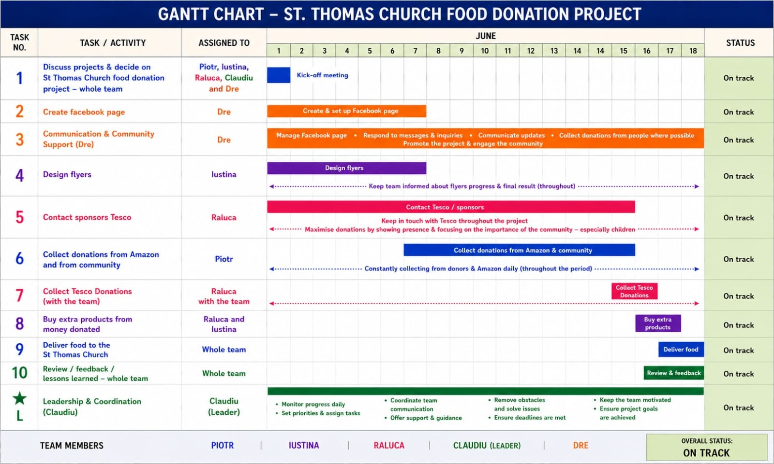

Blog 5: What I Found Out About Myself in This Project

Managing a project sounds easy until real people, deadlines and uncertainty come into play. This project proved to me that my biggest strength is reliability. As a Monitor Evaluator, I also helped thinking about risks, time pressure and if our plan was realistic.
But I also learned not to jump to conclusions too quickly. I first thought that collecting donations at university would not work because students may not be interested in giving to charity. Later, I saw other groups successfully run projects on the campus, which made me realise that I may have rejected this option too early. It was an important lesson to be more open-minded when planning a project. My development plan is to test assumptions before throwing out ideas and ask for feedback from sooner.
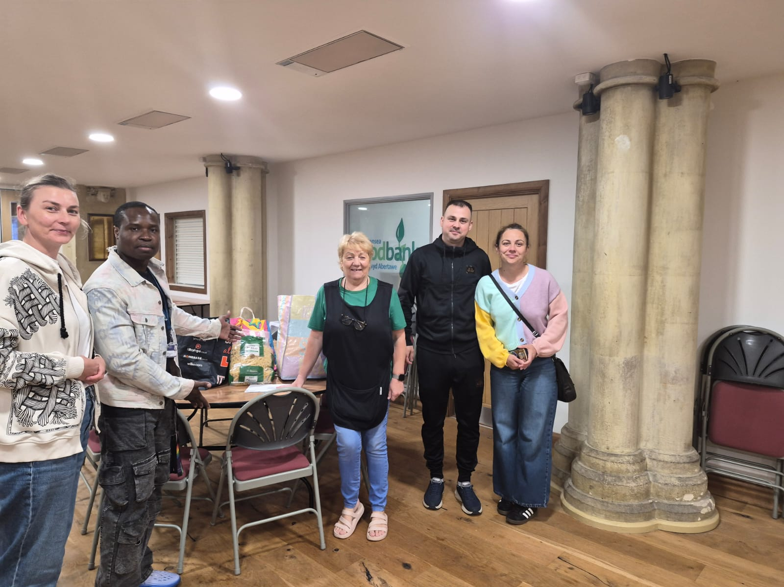

References:

Aritzeta, A., Swailes, S. and Senior, B. (2007) ‘Belbin’s Team Role Model: Development, Validity and Applications for Team Building’, Journal of Management Studies, 44(1), pp. 96–118. Available at: https://doi.org/10.1111/j.1467-6486.2007.00666.

Belbin, R.M. (2010) Team Roles at Work. 2nd edn. Oxford: Butterworth-Heinemann.

Clegg, S.R., Skyttermoen, T. and Vaagaasar, A.L. (2020) Project Management: A Value Creation Approach. London: Sage.

Heagney, J. (2016) Fundamentals of Project Management. 5th edn. New York: AMACOM.

Kidston, P., Haward, K. and Association for Project Management (2015) Planning, Scheduling, Monitoring and Control: The Practical Project Management of Time, Cost and Risk. Buckinghamshire: Association for Project Management.

Lock, D. (2020) Project Management. 11th edn. London: Routledge.

Mullins, L.J. (2016) Management and Organisational Behaviour. 11th edn. Harlow: Pearson.

Project Management Institute (2021) A Guide to the Project Management Body of Knowledge. 7th edn. Newtown Square, PA: Project Management Institute.

Wysocki, R.K. (2014) Effective Project Management: Traditional, Agile, Extreme. 7th edn. Indianapolis: Wiley.

Zecheru, V. and Olaru, B.G. (2016) ‘Work Breakdown Structure (WBS) in Project Management’, Review of International Comparative Management, 17(1), pp. 61–69. Available at: https://www.rmci.ase.ro/no17vol1/06.pdf (Accessed:18 June 2026).

