
ACCOUNTING FOUNDAMENTALS
LCBB4001
ASSIGNMENT A1


UNIVERSITY OF WALES TRINITY SAINT DAVID
STUDENT: AMNA MASAUD LECTURER: RITA UKACHI-LOIS
STUDENT ID: 2113737

SUBMISSION DATE: 1ST OF APRIL 2022

TABLE OF CONTENTS

QUESTION 1 2
a) INCOME STATEMENT 2
b) Explanation of the balancing of the statement of financial position 3
QUESTION 2 4
a) Ratios for 2020 and 2021 4
a) The financial position and performance of Sweets plc 7
REFERENCES 8

QUESTION 1
- Below will be shown the income and financial statements for Wales plc for the year that has ended on 31st of December 2021.

INCOME STATEMENT
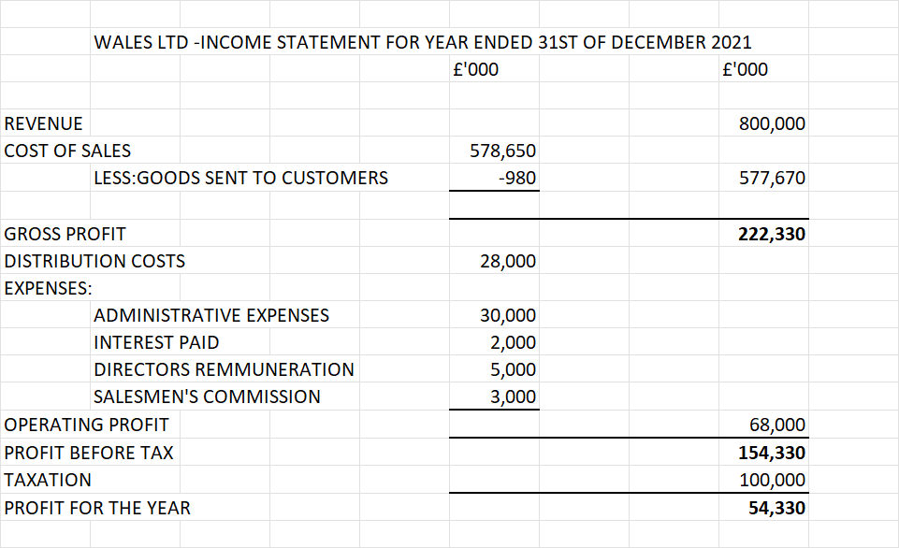

b) Explanation of the balancing of the statement of financial position
A statement of financial position illustrates the financial status of a company at a certain time. The businesses are requested to prepare this statement at the end of every financial year. It must be used the principle of double entry for the balance sheet to balance. If it doesn’t balance, it’s a sign that there is an error within the account entries.
The companies are allowed to choose the information that want to include, but a bare minimum should be kept:
- Assets: -non-current (investments over a long period of time), such as property, plant, equipment etc.
-current (the value of the owning that can be sold for cash and sponsor other operations) trade and other receivables, inventories etc.
- Liabilities (investments over a short period of time): trade, provisions, accruals
- Equity (the money that the company is using towards reinvesting or paying the remaining debt): interest, capital
Even if the companies are allowed to choose the details given in the statement, the assets and liabilities should be classified by current and non-current, and the entries should be done accordingly.
For the statement of financial position to be taken into consideration, the net assets must be equal with the total equity.
(Wood, 2012)

QUESTION 2

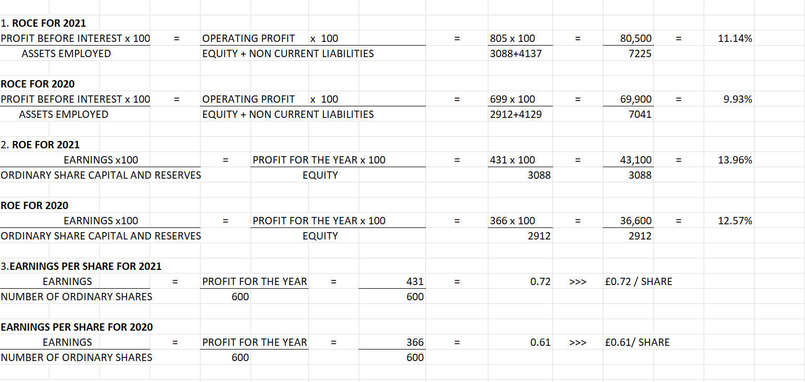
Ratios for 2020 and 2021

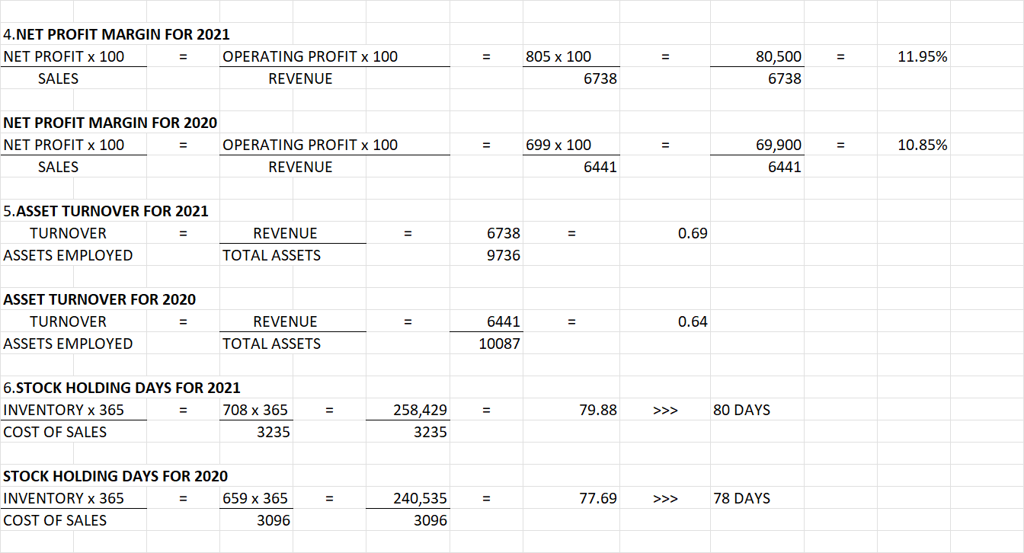

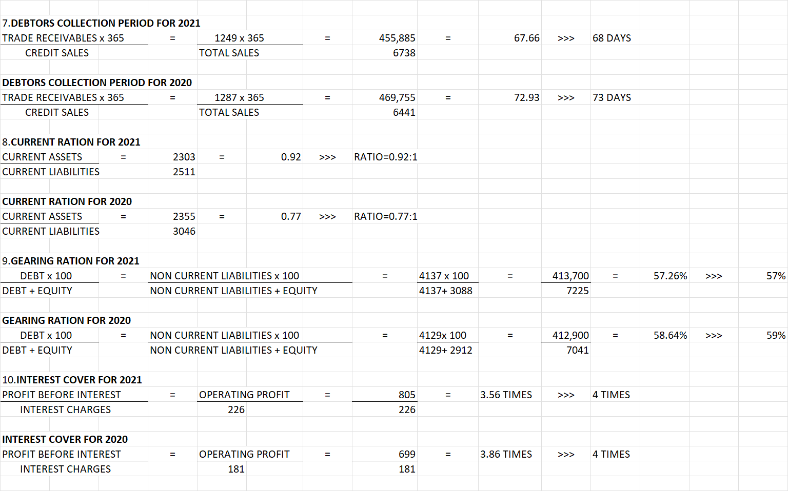

The financial position and performance of Sweets plc
Measuring the financial performance aims to transform the information into a suitable form for analysis. By using several financial measures, it is more benefic for the managers to find the financial problems of Sweets plc and provide appropriate solutions. (Doye, 2013)
According to Wood (2011), financial statements are in a continuous correlation with ratios, as without the last one will be lacking significative information. Ratios are used as a common way of measuring to discover the performance of a company. The involved parties (stakeholders, competitors, customers, lenders) of Sweets plc are all interested in analyzing company’s financial statements, but they might not need the same information. Therefore, ratios are helping them to find the targeted information. However, even if the company managed to increase its revenue from £6,441 in 2020, to £6,738 in 2021, it needs to constantly review the ratios to check if are getting better or worse and to take corrective action. The profit is measured by identifying the revenue generated for a certain period. (Atrill, 2017)

REFERENCES

Atrill, P. (2017). Accounting and finance for non-specialists. 10th ed. Harlow: Pearson Education.
Doye, D. (2013) Evaluating financial performance and position. Oklahoma Cooperative Extension Service.
Wood, F. (2011). Frank Wood's Business Accounting. 14th ed. Harlow: Pearson.
Wood, F. (2012). Frank Wood's business accounting 2. 12 ed. Harlow: Financial Times Prentice Hall.

