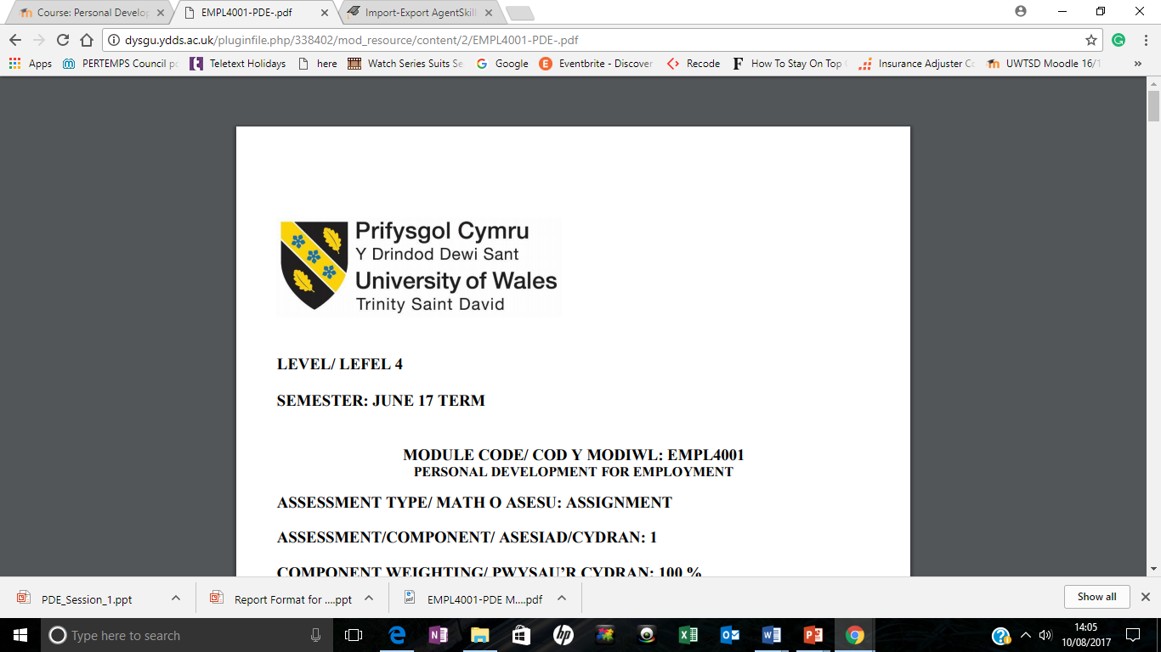

Abdullahi Osman-Abdi
Student Number: 1605533
Module Name: Employability
Module Leader: Shao Yuen
Module Code: EMPL4007
Word count: 1,782

EMPL4007 – Employability
Task 1
In this assignment, I will explain the purposes of a job description and person specification.
Personal Specification
Person specification is a written statement of educational qualifications, specific qualities, level of experience, physical, emotional, technical and communication skills required to perform a job (BusinessDictionary.com, 2017). It provides candidates with an in-depth description about the job; including job responsibilities, desired technical and physical skills, conversational ability and many other qualities that would be desirable for a role.
According to (Soas.ac.uk, 2017) the personal specification is the foundation during the recruitment process; as it helps candidates analyse whether they are eligible to apply for a job vacancy or not; it also supports recruiting team of an organisation understand what level of qualifications, qualities and set of characteristics should be present in a candidate to make him or her eligible for the job opening.
Another benefit of using this tool, is that it rules out any discrimination as the selection criteria must be fair; for example, recruiters must avoid discriminatory language or statements concerning race, ethnicity, colour, nationality, marital status, age, religious belief, sexual orientation, transsexuals, disability or age must not be used. Another hugely beneficial factor of the person specification, is that it outlines what type of behaviour the candidate would need to perform effectively within the role; for example, “the ability to work independently”; which allows candidates to paint a picture of what qualities they are looking for within a specific job role.
Job Description
The job description is used in the recruitment process to inform the applicants of the job profile and requirements; is an informative documentation of the scope, duties, tasks, responsibilities and working conditions related to the job listing in the organization through the process of job analysis (En.wikipedia.org, 2017).
The purpose of this is to provide applicants with an insight of the skills and qualifications that an individual applying for the job needs to possess. It essentially gives all the details which might be good for both the company and the applicant so that both parties are on the same page regarding the job posting. The Job description is the foundation for generating interview questions for applicants; it is almost a guideline for recruiters because it helps them make informed hiring decisions, by developing recruiting strategies that clearly outline the applicant’s role and responsibilities.
It is hugely important to have both recruiters and applicants on the same page throughout the application process; having a clear job description also allows for a basis on which to develop compensation plans that ensure jobs are being compensated in ways that reflect their levels of responsibility and qualification in the organization.
Finally, the overall purpose of job description, is to have the clear summary of liabilities and tasks. Job description plays a very important role in organizational resource management. It develops an organisation in managing and improving the abilities of the people in the following ways
- It explains that what an employer is expecting from his employee in the performance of his duties.
- Job description describes the necessary reference implements for discipline matters.
- It describes the clear role of the candidate for the job.
- It provides foundation to measure performance of a job.
- It provides necessary ideas for development and training.
- Job description enables an organization to organise its function in a constant mode and by this way an organisation can increase its effectiveness and success.
Overall, for the applicant, having a clear job description allows them to understand the responsibilities and duties that are required and expected of them; so that they can perform to the best of their ability and have an idea of what type of candidate, would be a tailor fit for the position advertised.

Abdullahi Osman
Mobile: 07490039671
Email: a.nageeye@hotmail.com
London Borough of Harrow
Store Manager
PERSONAL PROFILE
A competent and organised individual who can work as part of a team and manage several priorities at any time; I’m currently completing a Business degree at University of wales Trinity saint David. I am Well-spoken and possesses excellent communication skills, both written and verbal. I am hardworking, honest individual with great timekeeping skills, and always willing to learn. I’ve set up and ran a small successful business for 16 years. I possess years 16 years of managerial experience. I am both outgoing, and tactful, and have high levels of accuracy and attention to detail. Working independently in busy environments and within a team setting are just some of the qualities I possess.
KEY SKILLS AND COMPETENCIES
- Ability to communicate with people at various levels, whether it’s face to face or on the phone
- 16+ years managerial experience
- Excellent listening and problem-solving skills
- Good observation skills, great eye for detail
- The capacity to work alone, or part of a team depending on the situation
- Excellent communication skills and telephone manner
- Good keyboard skills and knowledge of customer service principles & practices
- A tactful, friendly but firm manner
- Well spoken, with excellent written communication skills
- Good organisational ability
- Hard working and able to work under pressure and make firm decisions.

EMPLOYMENT HISTORY
Imaan General Trading June 2000 - October 2016

Job role: General Manger

- Take responsibility for reduction in Stock Loss through whatever means necessary – daily/weekly line counts, waste/damage control etc.
- Ensure all Voids & Refunds are checked and monitored
- To increase sales of all products wherever possible, by means of promoting customer loyalty and encouragement of new business
- To merchandise products in an accurate and appealing way to capture the attention of customers and to achieve increased sales.
- To ensure staff and customers are aware of in store promotions or special offers through appropriate and full use of all approved promotional material.

Private Hire: October 1996 - April 2000

Job role: Control Room Manager

- Working in the taxi office over a radio system
- Providing job requests from the operator
- To ensure all drivers, are driving in a safe manner
- Making sure that the correct payment is given at the end of the journey
- Maintaining the quality of the vehicle and making sure it is fit to travel on the road always
- Keeping accurate records and performing administrative tasks, including filling out trip sheets
- Keeping up-to-date with changes in traffic legislation and knowledge of the local area

European Glass: January1996 - April 2000

Job role: Transport Manager

- Ensures Health and Safety, Environmental and Operator's Licence compliance, whilst delivering best in class customer service, measured against business KPIs for Safety, Service and Profitability.
- Provides creative, flexible, tenacious, diplomatic and consistent leadership to develop the Transport team.
- Understands and leverages the company’s operating systems and communication devices, ensuring that all reporting staff are using the systems and devices correctly and in full, to the benefit of the operation.
- Ensures timely completion of all administrative processes.
- Works closely with the warehouse team and other key stakeholders to ensure that all logistics solutions are fully integrated and designed to improve customer service.

EDUCATION
- Baanadir Highschool - Mogadishu, Somalia (1971 -1976)
- Baanadir College – Mogadishu, Somalia (1976- 1979)
- Undergraduate - University of Wales Trinity Saint David – London (2017 – Current)

QUALIFICATIONS
- BTEC Level 3 extended Diploma: Completed Achieved Distinction* Distinction* Distinction *
- 8 GCSE’s including Maths & English (A-C)

REFERENCES
Reference available on request

Task 3
Using the STAR model, I will be using my personal experiences to discuss both teamwork and problem-solving.
Teamwork &Problem Solving
To my understanding, problem solving is the ability to work through problems by using critical thinking skills to arrive at a solution. In the workplace teams must solve problems every single day. Problem solving as a team improves the chances of coming up with the best solution or result. Whereas team work, is when the whole team co-operates and contributes to the task; both correlates with each other, as these are both issues that arise together in a working environment.
Communication plays a major role in working in teams; this is because everyone needs to be on the same page for the best outcome for the required task. (Leonard, 2004) states effective communication and teamwork is essential for the delivery of high quality performance.
I previously worked in a team that lacked communication. This made it hard to see the progress of the team and meet the requirements at the workplace. Another issue I faced with my team, is that a few team members did not attend group meetings, as they noticed a lack of interest shown for the task, which created a lack of productivity and a dysfunctional team.
As Team leader, I had made sure that I had listened to all my colleagues and make sure that they were on the right track. Whilst working with my team, I identified strengths and weaknesses of each team member; to reduce the level of disputes, I provided each team member with the roles was the best fit based on their strengths and qualities.
As the deadline grew near, I noticed that a few members got upset because a few individuals were not contributing towards the task. I decided to create a strong system of communication, which aimed to eliminate any misunderstanding within the team. I created a log to document the team’s productivity, this included group member’s names and which task was allocated to each team member; this allowed the team to log any contribution they had towards the task and raise any issues they might be facing.
This helped the team communicate better, as the log reassured the team that all individuals were contributing towards the task and were on the right track. As the team lacked communication at the start of the task, I made sure after each group meeting; that an email would be sent to the team with an updated log, just to provide them with an insight of the overall team productivity and goal.
Overall, this boosted the team’s morale and allowed the team to interact more with each other, my team and I’s efforts paid off as we achieved appraisals from our senior manager who was impressed with the result of our project; this was down to good communication, transparency between group members and structure.

Bibliography
Soas.ac.uk. (2017). Human Resources Department at SOAS: Person specifications. [online] Available at: https://www.soas.ac.uk/hr/procedures/recruitment/bestpractice/personalaspecs/ [Accessed 27 Nov. 2017].
En.wikipedia.org. (2017). Job description. [online] Available at: https://en.wikipedia.org/wiki/Job_description [Accessed 29 Nov. 2017].
Leonard, M. (2004). The human factor: the critical importance of effective teamwork and communication in providing safe care. Quality and Safety in Health Care, 13(suppl_1), pp.i85-i90.
Cottrell, S. The Study Skills Handbook (2nd edition). Hampshire: Palgrave MacMillan, 2003. Pears, R. & Shields, G. Cite Them Right. Basingstoke: Palgrave MacMillan, 2011.

