Scrap Book
Object Research
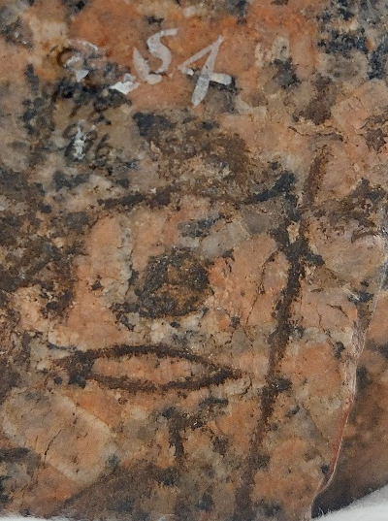
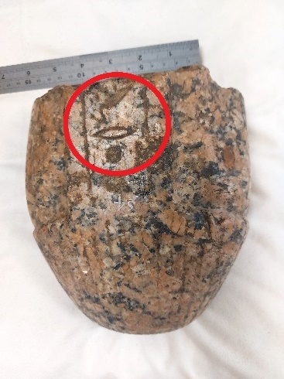
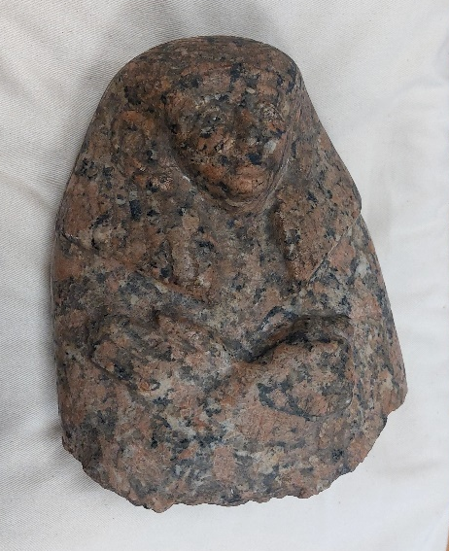
The object appears to originate from the Middle Kingdom Period of Ancient Egypt, the primary reasoning for this assumption is the notable feature of large ears included on the statue were seen to be popular during the Twelfth Dynasty period of the Middle Kingdom. The most prominent example of this is Pharaoh Sesostris III, who seemed to set the standard for the practice. It is argued that the reasoning for the big ears is so that the Pharaoh can be shown to listening to the people. The statue appears to have a width of 15cm, a height of 19cm and a diameter of 40cm. The material of which the artifact is carved from is Rose Granite, depicting a man of some importance due to the material used. The statue in this form presents the figure of a male from the bust up, the most likely reasoning for this is that the statue was broken into a number of pieces, this was most likely due to the boom in interest of Egypt’s ‘exotic’ nature during the Victorian period. The main reason we can guess this is the cause of its breakage is that we know that antiquity dealers would fragment objects in order to sell the pieces for a higher price. A further analysis of the statue fragment reveals not only that it was possibly connected to a plinth of some variety as indicated by the column on the back of the statue, on this column there appear to be hieroglyphs. The hieroglyphs depict a filled circle as well as an outline of an oval and some type of bird symbol, there potentially is a fourth symbol above the circle, however it blends in with the colouration of the statue. Through research I couldn’t find much reference to the symbols that had any real backing to them apart from miscellaneous posts on different internet pages. However, through these sites and compared information the oval represents the symbol for mouth and the filled circle representing a sieve and the bird possibly being an incomplete symbol for the sacred Ibis. With the possibility of these symbols, it can be concluded that the statue has some significance with the God Thoth. Due to this the meaning of this statue changes as it narrows down broad view of its significance as it could possibly now not just represent someone of importance but that of a priest of Thoth, however the divine role in which the figure acted in is not yet clear. Was it in relation to Thoth’s role as the divine being credited for creating the art of writing? In which case was the figure a scribe of significance. Or perhaps was this a Priest in the significance of Thoth’s role as a funerary God, after all it was him who would be the keeper of the Book of the Dead? Or the concept of divine justice and order of which he is associated with?
Object description
The object is a fragment of a statue originating during the Old Kingdom period of Ancient Egypt. The object is made out of Rose Granite although it has worn over time. The present version of the statue depicts a figuring with male features from the bust up, this is most likely due to the history of black-market dealers breaking artifacts of value up into smaller pieces to garner a higher profit. The figure appears to be wearing a form of headdress which can signify that the statue was possibly depicting someone of importance. The back of the statue has a column present which has hieroglyphs engraved on the back, the symbols mentioned include the symbol of the Ibis, a mouth and a sieve. The statue also has the persons arms crossed over the chest area, while having one hand splayed open and the other holding an object.
Label (Final)
Object: Egyptian Statue Fragment
Period: Old Kingdom (2055BCE – 1650BCE)
The object appears to be made of Rose Granite, depicting a male figure from the bust up, likely from when it was separated from the complete version. The figure appears to be wearing a headdress and having crossed arms holding something.

Advertisement
For an advertisement, the method which would have the further possible audience would be on social media due to the high majority of people connected to the internet. With platforms such as Facebook, Twitter, Instagram and TikTok being able to connect millions of people to each other and exposing them to advertisements. With this being the case, I think the best course of action for advertising is on the sites with the highest traffic such as the ones just mentioned. With the social media aspect, it is also key to remember that people will tend to post about when they have been out to places and possibly also photographs or videos, with this being the case it is also possible that this could then have a ripple effect of free publicity for the exhibition as people would possibly post about their day out, experiences etc. Knowing this is a possibility it would not only would word of the exhibition been spread but also could convince people who normally wouldn’t attend an exhibition to at least know about it and then possibly even attend. The advertisement itself for social sites would include phrases that would possibly persuade somebody to attend, pulling on the objects history and age as well as making it feel as a piece of collective history. To help the post reach a widest possible audience it would be wise to include hashtags as that way someone could with an interest in the period of history or the civilisation. Furthermore, the posts about the exhibit could also be posted into groups that are about similar things such as advertising to Ancient History groups as they would be more inclined to visit the exhibit as they would have a direct interest with the exhibit. Hasting could possibly include the following examples:
OldKingdom
OldKingdomEgypt
AcneitEgypt
Artifact
Statue
Exhibit
Hieroglyph
Hieroglyphs
[Locations name}
Museum
Priest
Thoth
History
AncientHistory
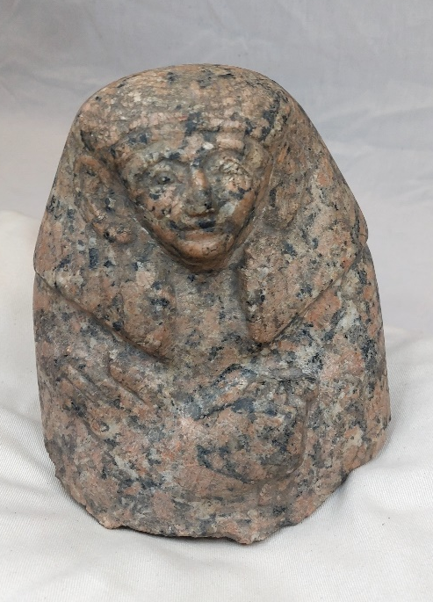
That being said, it should go without saying that ads for the exhibition/artifact should also be placed on the website of the venue as a type of coming up events as it would then possibly pique the interest of those who are contemplating attending the venue and as a result might possibly chose the visit the exhibition due to it aligning with their interests. The advertising should include at least a single image of the exhibition piece (Such as the imagine to the left). Having an image would be so that people can judge if they would want to see it in person or just look at it online, it also at least shows you what you would be looking at. The advertisement should also include some information in a brief description of the object noting the significance of its age and material and possible cultural significance. The advertisements could also be made into posters to be posted on social media as a way to no make the description a reading talk, with he poster advertisements focus instead on small bits of key information and making it not look boring but rather give the imagery a more excitable feel to them instead of it just being a picture and wording, it would be the key information and the piece while having a link to a booking page or a page which has more information to look into rather than having an information overload on the screen while trying to scroll and pass the time.
Advertisement Caption (Final)
For my advertisement the wording will possibly be presented as the following: “Come and see the top half of an Ancient Egyptian statue hailing from the Old Kingdom period at [Location/Venue]. This statue is a must see for anyone with the slightest interest in Ancient Egyptian craftsmanship or history as the object is anywhere between 3500 years old to 4000 years old. So come along as see this magnificent piece of history from one of the oldest civilisations in our collective history.”
The hashtags for this post will include relevant hashtags such as: #Statue, #OldKingdom, #AncientEgypt, #Hieroglyphics, #Museum and #Exhibit, to name a few. However, this method only works for platforms like Instagram and Twitter, while on Facebook the posts would most likely be posted in certain groups that relate to Museums, Ancient Egypt and the Old Kingdom of Ancient Egypt. Also, for further advertising opportunities the ad could be put on the venue or organisations website to have the event being advertised for people who visit the website to see what is upcoming.

Exhibitions Pitch
The exhibition will be a face-to-face physical exhibition as opposed to a virtual exhibition which has seemed to pop up since the Covid pandemic. Following the proposal form from York Museums Trust as a guide the following will outline the pitch.
Elevator pitch: in no more than three sentences summarise your proposal.
The purpose of showcasing the proposed artifact would be to spread the history of the Old Kingdom of Egypt as it a period of time for one of the 4 oldest recorded civilizations within human history. The potential for partnership within this artifacts exhibit could include charitable organizations or other collections which link to the Old Kingdom to further spread the knowledge of the history of the Old Kingdom. The potential audience for this exhibit would include researchers within the field of Ancient History as well as the common person looking for a day out and wanting to explore just a fragment of a culture’s history.
Who are the target audience?
The primary target audience for this exhibit is the common person, or more specifically somebody who doesn’t exactly have a background with the period of the object, in the hopes that it would potentially provoke interest in the historical period. However, the target audience would also be those who do study or work in the field relating to the artefact as they could observe an object from that period, and then produce further research on the time period, or could be used in ongoing research.
What is the budget?
The budget would vary depending on the circumstance; however, it would have to be enough to cover all costs for item care, rental of location (if needed) and any other outgoings required for the event.
Are there any fundraising opportunities?
Fundraising opportunities would come from the profits after the expenses have all been covered. The profits could go to a charity or project that is either currently in need of much support or something more relevant to the objects field of study.
Are there any partnership opportunities?
There are partnership opportunities for this exhibit as it can be paired with other artefacts from the period of the Old Kingdom in Egypt. This partnership would also be available to charities as mentioned above and with their support all profits will go to said organization. The nature of the organization could be of any type; however, a more relevant organization is preferred.
How is this project unique for YMT?
This project is unique for YMT as looking through the collection on display for the organization, this artifact would add a new variety to the collection as it branches into the Old Kingdom period of Ancient Egypt which from my research is underrepresented within the collection.

Gleason. J, The Big-Ears Pharaoh, Mind Renewers, 10/04/2012, https://mindrenewers.com/2012/04/10/the-big-ears-pharoah/
Bleeker, C. J. Thoth. In Hathor and Thoth, https://doi.org/10.1163/9789004378445_007

