THE ADOPTION OF INDUSTRY 4.0 TECHNOLOGIES BY SMEs – A REVIEW INTO THE IMPACTS, CONSTRAINTS AND HUMANISTIC ELEMENTS, USING PENDERYN AS A CASE STUDY

ACPA7004
Introduction to Industry 4.0

Student ID: 2127190
Word Count (Excluding Contents, References & Appendix) 4,904 words
Table of Contents

Introduction 3
Constraints applicable, specifically to the whisky industry and to Penderyn as an SME 4
Main Body 6
Statement 1: ‘The use of connected services, alongside simulation and VR technologies, will improve safety within the production environment’ 6
Statement 2: ‘The implementation of IoT technology will reduce operational downtime, protect against misuse and maximise critical plant lifespan’ 6
Statement 3: ‘Integration, both vertically and horizontally, alongside the benefits brought by connected services, will streamline processes, resulting in cost savings and greater efficiencies across production departments’ 7
Statement 4: ‘Connected services – the IIoT – streamlines/eradicates manual data gathering and revolutionises data interpretation’ 8
Statement 5: ‘Embedding of Industry 4.0 technologies across the entire operation is crucial for brand protection’ 8
Conclusion 10
References 11
Appendix 13

Introduction
Penderyn (officially The Welsh Whisky Company Limited) is an SME headquartered in the Brecon Beacons in South Wales, approximately 2.5 hours from London. The company produces a range of premium and super premium spirits, primarily award-winning Single Malt Welsh Whisky but also several gins, vodka, a cream liqueur and two rums. Founded in 1999, Penderyn has seen its operational capacity increase five-fold in recent years thanks to an ambitious schedule of plant upgrades and the building of an additional production and visitor experience facility in North Wales, seeing it’s turnover jump from approx. £7m to approx. £20m over the past decade. Penderyn is based in Wales (although operates through exports and brand engagement work worldwide) – a small country with a population of just over 3.1 million residents and a GDP estimated at £75.7m (Office for National Statistics, 2022).
Over the past twenty or so years, Penderyn has relied upon very manual and low-tech operating methods – in essence, part of its identity as a craft producer – the production facility in the Brecon Beacons has no automation at all, and uses the bare minimum of remotely controlled valves etc. instead utilising manual kit and relying upon operators watch and experience to monitor and direct every stage of the process. This is time consuming for operators and causes bottlenecks in some stages of operations, and is also costly as each daytime shift requires three operators, with two operators running night shifts. Due to the staffing levels involved and the requirement to manually monitor and control the entire process from start to finish, there is also a significant training cost to this operation. Each operator will undergo 3 months of training prior to being responsible for a process, and all operators are fully trained in all aspects of the operations.
As Penderyn embarks on its latest expansion – the building and commissioning of a new, additional state of the art production facility and accompanying visitor experience, the executive and technical teams are debating the way forward for distillery operations. The company is on the cusp of doubling its current production capabilities, and, with a global recession looming and price increases on raw materials filtering through every month, needs to streamline operations and maximise operational efficiencies. The answer appears to be to invest heavily in deploying industry 4.0 technology throughout the facilities – the main component technologies of which can best be summarised in figures 1 and 4, to be found within the appendix. According to PWC, ‘Distinct from Industry 3.0, which involved the automation of single machines and processes, Industry 4.0 encompasses end-to-end digitization and data integration of the value chain: offering digital products and services, operating connected physical and virtual assets, transforming and integrating all operations and internal activities, building partnerships, and optimizing customer-facing activities’ (PWC, 2018).
At present, there are many quirks and inefficiencies in the operating structure at Penderyn that the adoption of an industry 4.0 system would certainly address; to start with, all readings are taken manually and are written by hand onto paper records. Each day, one of the distillery technical managers retrieves these hand-written records from the production area and enters the data onto an Excel spreadsheet. This is the case for approximately 15 different records – this is time consuming and is vulnerable to human error; there may be occasions whereby the technical manager misreads data, or perhaps where the hand-written record is illegible. In addition, the data analysis and validation is not carried out to its full potential due to time constraints, and due also to the myriad different spreadsheets used to collect and save the production data – there is currently no connection between any of the collected data unless it is conducted manually and proactively; the implementation of industry 4.0 would, without a doubt, revolutionise this facet of the company.
There is currently very little formal link-up between the different operational areas within the business – indeed, some of the departments appear to operate almost in isolation, not knowing much about what their colleagues do day to day, or how their own operations affect, or are affected by, other areas of the business. To implement vertical integration, for example, could allow the bottling team an eye to what the cask disgorging team are scheduled to work on for the next month, allowing them to plan their own production timetable accordingly in order to maximise fill potential, and this, in turn, could be useful to the warehousing staff who can manage logistics to ensure space and packaging is available for the right products at the most appropriate time, when they are received in from the aforementioned bottling team.
In addition to this, one of the greatest resentments of the technical leaders within this SME is the lack of data validation and manipulation that is undertaken. The measurements and readings are taken manually as a matter of routine but, due to the highly inefficient way in which data is collected and stored, and partly also due to the team itself being small and thinly stretched, there is often no time to sift through the available data and manually feed that into graphs etc. for further interpretation or comparison. As a result, the team are missing the opportunity to spot patterns in operational outcomes, and the potential to improve efficiencies by acting to change the course of a process when given the chance.
However, whilst industry 4.0 may be seen as a natural progression, it is critical to recognise the constraints applicable to this situation; Penderyn is an SME manufacturing premium and super premium products during a time of national and global economic uncertainty. Whilst there are undoubtedly benefits to be had from embracing industry 4.0 advancements, careful consideration must be given to the company’s financial stability. Informal and off-hand estimates for integration of automation into the distillery processing kit at Penderyn have been upwards of £250,000; it is certain that the cost savings (detailed below) and improvements in efficiency (again, discussed in detail further along) will more than cover this cost within a 5-year timespan, but the executive team must be equally certain that the business will continue to exist for that duration in order to recognise the benefits. In the case of many SMEs, such a significant outlay, especially at such a turbulent time globally could be fatal; likewise, for a relatively young, independently-owned SME such as Penderyn, there are often other, more pressing things for such a sum to be spent on.
The business in question is also constrained by its location; Penderyn’s main production facility is situated in the Brecon Beacons – an area with poor mobile phone coverage, let alone 5G reception. The facility is located within an expanse found to have below 81% of homes and businesses benefitting from superfast and ultrafast broadband, with greater than 2.6% of homes or businesses within this area not meeting the Universal Service Obligation (OFCOM, 2019). The IIoT (and other such technologies) would need to rely solely upon Wi-Fi networking which could limit its range of operation throughout the plant depending on distance to the hardware/physical infrastructure – Penderyn’s critical components are spread across varying levels of the site, both within the building and within outbuildings elsewhere on the site. A further challenge posed by the location of this business is its proximity to support teams – Penderyn is around 2-3 hours from the major UK cities that are home to most technological support companies, and at least a days’ travelling from the industry-specific tech gurus who are all based in Scotland (due to the prominence of the Scotch whisky industry). Sourcing and developing the right technology and software for the company takes time therefore, or must be done remotely, and then installation and commissioning costs are greater still due to the location – these are not insignificant costs. In a country such as Wales – and as is certainly the case at Penderyn – there is likely to be a real lack of in-house skilled engineers who can readily design and deploy the desired technology, forcing the company to extend its search outside of the company, and most likely, outside of Wales itself, although the number of tech roles linked to industry 4.0 integration in Wales is growing rapidly (Welsh Government - Trade & Investment, 2022).
The adoption of an industry 4.0 standpoint can be a giant leap from the current operating model, therefore, for most SMEs, especially such as in the case of Penderyn – a company that has, until now, employed very little intelligent technology or connected services. Indeed, particularly within the manufacturing sector, digital revolution is not yet commonplace - ‘Just 10 percent of global manufacturing companies are Digital Champions, while almost two-thirds have barely or not yet begun on the digital journey.’ (PWC, 2018). It is understandable, then, that one of the major constraints to SMEs fully embracing the industry 4.0 movement is resistance from the executive teams. There are likely to be concerns around the initial financial outlay and the risk involved in terms of ROI. There may also, understandably be hesitation around the integrity and security of commercial or sensitive technical data, with the worry that this could be effectively stolen by competitors more readily than more traditional formats. There may well be debates over the ownership of such proprietary data, leading to a general mistrust of the systems. None of these issues are insurmountable, but in this situation, with new and emerging technology that the executive team may not necessarily understand, there is likely to be a fear of the unknown and, as a result, some considerable reluctance to taking the first steps to implementing an industry 4.0 operating model, particularly in an SME with a weak leadership team. SMEs within the manufacturing sector, perhaps surprisingly given that they stand to benefit so much, are not currently frontrunners in the adoption of industry 4.0 technologies – a 2018 report found that only 10% of companies within the manufacturing industry could be considered to be digital champions (PWC, 2018) – that is to say, ‘only a small group of companies is in a position to gain real competitive advantages from this operations revolution. These companies, which we call Digital Champions, are noteworthy because they view digitization in ways that are far-reaching and aggressively innovative, well beyond mere automation and networking.’ (PWC, 2018).
On the subject of executive resistance to implementing high technology operating methods, another angle to the humanistic view of this is that there is also likely to be some considerable pushback from those workers in the production chain who either stand to lose their roles during the initial adoption of the technology, or who perceive a potential threat to their role in the future. In much the same way that (some) shoppers and cashiers at supermarkets loathe the self-serve checkouts, distillery operations staff at an SME such as Penderyn may resent the very technology employed to (at least on a level) make their working lives easier. Staff may undertake minimal engagement with the new technologies in protest, refusing to utilise it to its full potential for fear that it will, one day, replace them. It is critical, therefore, that during any developmental or commissioning phases, that the executive team is sympathetic to employees concerns around the implementation, and that care is taken to explain the merits of such systems in a clear and sensitive manner. A further consideration is whether the existing workforce can be upskilled to use the emergent technology, or if they need to be supplemented or even replaced for this due to skill gap.

Main Body
However, if a company, especially one in the manufacturing sector, is able to realistically consider the adoption of an industry 4.0 strategy the potential longer-term benefits are notable, as addressed below.

The use of connected services, alongside simulation and VR technologies, will improve safety within the production environment
If we consider Penderyn as a case study – there are numerous areas of the plant equipped with hazardous equipment or requiring hazardous working practices, from extremely hot kit, to pressurised vessels, to working at height and confined space working. All operators undergo regular, formal training for these practices, all of which are fully risk assessed and have safe working procedures detailed for them. However, the repeat training and documentary updates are costly, and take operators time out of the operation to complete. In addition, no matter how well trained or experienced an operator may be, a momentary distraction or fleeting loss of concentration could result in an injury. By employing AI to co-function alongside the IIoT such as wearable technology, such reliance on human behaviours would be vastly reduced and the entire operation made inherently safer as a result. Many of the tasks currently being performed by humans could be taken over by autonomous robots or automated devices and, for example, the IIoT could utilise connected infrastructure throughout the plant to take measurements and readings at critical process points. This would, in many cases, drastically reduce the need for operators to work at height. Such technology would also proactively manage safety concerns during normal operations. For example, if an operator was to be working within a confined space, wearable technology incorporating oxygen sensors could signal him to evacuate the area if a risk to safe breathing conditions was detected. An additional sensor could be used to detect that the operator had fallen and could signal for assistance, and automatically shut down relevant nearby operations to ensure the persons safety until he could be removed from the area. Following on from this, the use of simulation and VR technologies has the potential to improve safety within the production environment by allowing technical leads to do a virtual walkthrough of a process prior to implementing any operational changes to ensure any obstacles (physical or otherwise) are removed. The use of simulation technology can also be utilised in staff training, allowing operators to familiarise themselves with equipment and techniques without risk to themselves, or risking damage to costly kit.

The implementation of IoT technology will reduce operational downtime, protect against misuse and maximise critical plant lifespan
There is also an argument that the adoption of industry 4.0 technology has the potential to protect operational facilities and processes as much as it could protect humans – for example, protecting the operation itself from sabotage. If vessels and associated ancillaries are connected via the IIoT, both hard and soft interlocks, as appropriate, can be incorporated to prevent unauthorised use, thereby protecting the security of the operation. Processes can be secured so that they are only able to be triggered by authorised operators, and only when pre-specified conditions are met. Another consideration centres around operational resilience – blockchain merged with systems integration really comes into its own when used to actively monitor the health status of operational equipment such as pumps, control panels and sensors; by monitoring this information the operational capabilities of such kit will potentially be far more robust and the lifespan maximised – PPM will be enacted to its full potential and the technical team will be better aware of scheduled downtime. Unexpected downtime through breakdowns would also be drastically reduced as a result of more active and in-depth equipment surveillance.

Integration, both vertically and horizontally, alongside the benefits brought by connected services, will streamline processes, resulting in cost savings and greater efficiencies across production departments
Whilst initially the financial outlay to secure and develop such technology may seem excessive, or even prohibitive, the return on investment is likely to be significant. PWC estimate that ‘digitized products and services generate approximately €110 billion of additional revenues per year for the European industry’ (PWC, 2015). The drastic reduction in labour hours (in the case of Penderyn, for example, if an industry 4.0 culture were to be fully embraced, the operation could be run by one operator on each shift, saving approximately 252 labour hours each week, with a further ongoing saving from reduced training costs) would be one aspect of this. There are further significant financial gains to be had from the process optimisation and subsequent resultant streamlining that would result from an industry 4.0 implementation. If bottlenecks in the operation are reduced or eradicated entirely, operational capacity is increased, resulting in a higher outflow of product. In the case of Penderyn, the net effect of this would be that the cost per litre to produce raw spirit would be significantly reduced, ultimately improving profitability.
By way of example, for a CAPEX spend of £500,000 (which is likely to be the minimum total investment, taking into account consultancy services, hardware, software and project development cost, amongst other things) which will yield a potential saving of 252 labour hours per week at a cost of £14 per hour (including employment costs) totalling £3,528 saved each week, giving a payback within 2.7 years.
In addition to these tangible cost savings, consideration must also be given to the improved adaptability of the operation resulting from the implementation of industry 4.0 technology. The IIoT and the connected technological infrastructure that it sits alongside empowers companies to adapt operating methods and technical parameters rapidly and without the delays of further staff training, manual adjustments etc. A company that is able to adapt rapidly in this way is better equipped for survival, and better able to compete in a fast-changing, dynamic market.
There are also significant gains to be had in terms of operational performance in a manufacturing environment, particularly – as is the case at Penderyn – those companies who process natural raw materials as part of their operations. Penderyn produces single malt whisky from malted barley – the quality and technical specification of this barley will vary from batch to batch, and year to year, depending on factors such as the crop species, the harvest conditions and the effectiveness of the malting process prior to delivery. At present, for each delivery of malt, the technical lead will review the accompanying certificate of analysis, then instruct the operations team on the most effective milling and mashing parameters to use to maximise sugar extraction and subsequent alcohol production. Midway through the process, at fermentation stage, the technical lead will again review all relevant data, including the ambient environmental conditions, in order to again outline the most effective production parameters to maximise alcohol yield. This is time consuming and subjective (depending on the skill and experience of the technical lead) – not to mention, leaving the operation vulnerable as if the technical lead is unavailable for any reason, then changes to parameters may be delayed resulting in an inefficient run. The use of AI systems (described in figure 2 within the appendix) would eradicate such inefficiencies by learning/predicting outcomes resulting from specific parameter alterations, then becoming able to predict which changes should be implemented in order to achieve the desired outcomes. Finally, the intelligence would be able to send commands to specific equipment to implement such changes e.g., alterations to mashing volumes, to intake temperatures and to yeast dosing. The result of this would be improved reliability of operational processes – it would remove the potential for human error and eradicate the issue of variability in judgements made by different technical leads – after all, humans have bad days, robots and machines do not.

Connected services – the IIoT – streamlines/eradicates manual data gathering and revolutionises data interpretation
As highlighted early on in this document, the current method for data recording, reporting and storage at Penderyn is very much a manual one, leaving little to no time for effective data interpretation, comparison, validation or manipulation. There are so many variables across the technical process - from temperature of the environment, to temperature of the product at various stages, process rates, pH, flow rates, malt specification parameters, yeast cell counts and myriad other influences – that a human review could never realistically pick up every pattern that occurs when one parameter influences another, especially if this happens infrequently. It would, therefore, be hugely beneficial for connected services, wearable technology and AI to take over the collection and management of production data to allow for its full potential to be realised. AI could be utilised to predict certain operational or quality-related outcomes when two or more factors co-exist, thus determinising the most effective/efficient next step in the process, with connected services then triggering an automatic response at the next stage to enact the recommendations.

Embedding of Industry 4.0 technologies across the entire operation is crucial for brand protection
One of the key factors of an industry 4.0 implementation is that such technology cannot be truly effective in isolation – after all, industry 4.0 is centred around integrations of technology, infrastructure and humanistic elements. Financial savings garnered at the back end of the production process will be all but wiped out if the front-end systems are not operating to a similar culture – the bottlenecks and supply chain inefficiencies will still be present, but will, if anything, be exacerbated by the increased productivity filtering down from the earlier stages. However, it is likely that, particularly within an SME such as Penderyn, there will be departments who wonder how such technology could be relevant to their activities – this is where industry 4.0 applications really come into their own. As a producer of luxury goods – premium and super premium single malt whiskies – and as a worldwide exporter, Penderyn must continually, and proactively, protect and defend its brand and its products from attempts at counterfeiting. The availability of fake spirits is an industry-wide problem and one which not only harms brand images and leaves a hole in company pockets, but one that is also dangerous for consumers. The integration of RFID or QR codes into packaging is one way in which counterfeit products can be detected and consumers can validate their spirits if they’re concerned that they may have a fake. The use of QR codes or similar can be utilised to allow consumers to confirm batch codes are authentic, or can even be embedded with unique markers to prove authenticity. It is estimated that there will be a ‘$4.2 trillion impact of counterfeiting and piracy on the global economy by 2022’ (World Trademark Review, 2021). In 2022, a team from South Korea was able to successfully validate authentic whisky, and detect counterfeit samples by developing an edible silk tag – ‘The code on the fluorescent silk tag is the equivalent of a barcode or QR code and is not visible to the naked eye. The tags are also edible, causing no issues if a person swallowed it while downing a shot of whiskey.’ (Futurity, 2022). Crucially, ‘The tags have not affected the taste of the whiskey.’ (Futurity, 2022). Whilst this technology is still in its early stages and is not yet in use within the spirts industry, it does demonstrate that the potential impacts of implementing industry 4.0 technology are far reaching, from raw operations right through to customer interactions.
Another technology that is currently in its infancy in terms of its use within the spirits industry is that of non-fungible tokens (NFTs). NFTs can be used to prove ownership of digital assets for example, product drawings, plant/factory P&IDs, videos, imagery etc. ‘Because NFTs contain an immutable record of transactions, third parties can easily confirm the origin of a physical world product connected to the NFT as well as current and past owners of the product connected to the NFT.’ (Foley & Lardner LLP, 2021). NFTs can therefore be implemented as part of a strategy to protect NPD against forgery or copyright attempts. If we consider the super-premium products that Penderyn sells – these include archive bottles which are ‘old and rare’ stock, highly collectable and priced accordingly. Whilst NFTs would likely be cost prohibitive (for the time being, at least) for the main product lines (which retail at approx. £40-80), unique digital artwork or digital certificates of authenticity could be linked to archive bottlings (which generally retail from £1500 upwards) in order to protect these editions from counterfeiting, thus preserving the integrity of the brand.
The use of specific blockchain technology can be invaluable when it comes to tracking assets or products through the production and distribution system to ensure regulatory compliance or as part of a quality assurance system. ‘Blockchain’s potential for transparency, as well as the immutable record it creates, could make it a powerful tool for regulators. The enhanced transparency it gives a business into its operations can serve regulators in the same way. That also gives it the potential to significantly ease companies’ compliance burdens’ (PWC, 2019).
In addition, the use of RFID technology and similar can be driven to give potential purchasers access to brand or product information via their smartphones, making packaging design easier and less constrained by space. There can also be significant savings on packaging as the same template can be used for several export countries, with the market/country specific information provided via embedded technology, rather than, for example having hundreds of thousands of cartons printed in 22 different languages.
In conclusion, despite the clear and many advantages of an industry 4.0 revolution, Penderyn, and the whisky industry as a whole, is constrained to a degree by its own image – the production of single malt whisky is still very much an artisanal process, celebrated by makers and consumers alike. Distillers are acutely aware of this dimension to their operations but are also mindful that they are, ultimately running a commercial venture that must be profitable. Most distilleries, Penderyn included, incorporate Visitor Centres as profit centres in their own right, allowing tourists to visit production areas. If these areas were no longer operated in the traditional, artisanal manner that they are known for, the attractiveness to visitors would be significantly diminished and the finished product would also, almost certainly, be viewed in a different light by consumers – as somehow less authentic. In addition to this, the majority of quality assessments on both raw materials and finished products are currently performed by a select team of 3 highly-trained technical staff by way of organoleptical analysis. The company would need to be steadfast in its knowledge that any technological intervention that sought to replicate this sensory analysis was completely reliable before fully embracing such innovation. Mackmyra, a Swedish producer of premium single malt whisky, has taken on the mantle of being the first single malt whisky distillery to bottle a whisky made by AI. ‘Intelligens’, released in early 2022, was the result of an AI algorithm – developed in partnership with Microsoft – ‘learning’ the most desirable flavour and aroma profiles by observing the work of the distillery’s Master Blender. Once it had learnt these preferences, the available matured whisky stock could be reviewed, far more rapidly than traditional methods, and the recipe for Intelligens was devised. Whilst there would undoubtedly be criticism from some consumers about this method steering the industry away from the artisanal experience that is part of its very existence, and whilst, as a result, this kind of product development is not likely to become mainstream for many years yet, it does illustrate just how big an impact the implementation of industry 4.0 technology can have on the industry – Intelligens was released to rave reviews and sold out quickly.

Conclusion
One of the clear recurring themes when considering the uptake of industry 4.0 technology is that the biggest step is the first one – it is crucial to have long-term executive buy in and absolutely critical that the company be certain that by funding such a revolution, in the short term, it is not compromising its actual survival. However, whilst there may be challenges in the initial design and deployment of the technology, perhaps due to the location of the company, as in the case of Penderyn, or possibly because such technology has never been utilised within that industry before, these are generally one-time problems. Once the systems are installed and commissioned, while they will likely need regular software upgrades, consumable replacements and, possibly, hardware updates, the entire system will not usually need to be replaced for a least a couple of decades. Each update will simply be building on top of what is existing, meaning that ongoing costs are significantly reduced.
However, it is crucial to consider the humanistic elements of any such deployment. Penderyn has, over 2 decades of operation, benefited from various grants and financial support from the Welsh Government. The majority of these grants were provided contingent on the company employing people; under EU categorisation, Rhondda Cynon Taf (the county in which the main Penderyn production sites are based) was referred to as an ‘objective 1 area’ meaning that it was considered to be a priority to improve regeneration and employment prospects in the area. Such grants allowed the company to increase its operational capacity four-fold, and without such grants in the future the company may find itself less able to invest in facility upgrades. Penderyn’s Chief Executive, Stephen Davies, states that ‘Our experience as a company is that to be successful, we need to be conscious of economies of scale, and so it follows that we need to be aware of economies of technology – we know that the operation doesn’t work so well at low levels of operation – for the first 10 years of operation we lost money as we weren’t covering the high costs of producing a premium/super premium product. We need to ensure that we don’t invest so heavily in emergent technology that, for the scale of our operation, the breakeven point is so far down the line as to make it untenable’ (Davies, 2022).

References
Davies, S., 2022. Emergent Technology Considerations at Penderyn [Interview] 2022.
Foley & Lardner LLP, 2021. Not By the Same Token: NFTs in Supply Chain. [Online]
Available at: https://www.foley.com/en/insights/publications/2021/11/not-by-the-same-token-nfts-in-supply-chain
[Accessed 2022].
Future Drinks Expo, 2022. Spirits Industry All Set To Leverage The 4th Industrial Revolution!. [Online]
Available at: https://futuredrinksexpo.com/en/blog/insights-64/spirits-industry-all-set-to-leverage-the-4th-industrial-revolution-333.htm
[Accessed 2022].
Futurity, 2022. EDIBLE QR CODE REVEALS IF WHISKEY IS FAKE. [Online]
Available at: https://www.futurity.org/edible-qr-code-whiskey-counterfeit-medications-2749182/
[Accessed 2022].
Infopulse, 2019. Challenges of Industry 4.0 Adoption in Manufacturing. [Online]
Available at: https://www.infopulse.com/blog/the-main-benefits-and-challenges-of-industry-4-0-adoption-in-manufacturing#:~:text=The%20Business%20Benefits%20of%20Industry%204.0%20Adoption%201,downtime%20reductions%20...%204%20Improved%20supply%2Fdemand%20matching%20
[Accessed 2022].
Jan Ola Strandhagen, L. R. V. G. F. J. W. S. A. B. H. S. N. S., 2017. Logistics 4.0 and emerging sustainable business models. s.l.:s.n.
Jo Wessel Strandhagen, E. A. J. O. S. &. L. R. V., 2017. The fit of Industry 4.0 applications in manufacturing logistics: a multiple case study. s.l.:s.n.
Leem, J. W. et al., 2022. Edible Matrix Code with Photogenic Silk Proteins. American Chemical Society/ACS Publications.
Mackmyra Swedish Single Malt Whisky, 2022. Intelligens AI 02. [Online]
Available at: https://mackmyra.co.uk/products/intelligens-ai-02
[Accessed 2022].
McKinsey & Company, 2022. Future Proofing The Supply Chain. [Online]
Available at: https://www.mckinsey.com/capabilities/operations/our-insights/future-proofing-the-supply-chain
[Accessed 2022].
OFCOM, 2019. Connected Nations Report, s.l.: s.n.
Office for National Statistics, 2022. GDP, UK regions and countries: October to December 2021, s.l.: s.n.
PWC, 2015. Industry 4.0 - Opportunities and Challenges of the Industrial Internet, s.l.: s.n.
PWC, 2018. Global Digital Operations 2018 Survey, s.l.: s.n.
PWC, 2018. Global Digital Operations Study 2018 - How industry leaders build integrated operations ecosystems to deliver end-to-end customer solutions, s.l.: s.n.
PWC, 2019. How can blockchain power industrial manufacturing?. [Online]
Available at: https://www.pwc.com/cl/es/publicaciones/assets/2019/pwc-blockchain-in-manufacturing.pdf
[Accessed 2022].
PWC, 2022. Industry 4.0: Opportunities and challenges of the industrial internet. [Online]
Available at: https://www.strategyand.pwc.com/gx/en/insights/industrial-internet.html
[Accessed 2022].
Science Daily, 2022. An edible QR code takes a shot at fake whiskey. [Online]
Available at: https://www.sciencedaily.com/releases/2022/06/220606134406.htm
[Accessed 2022].
Scotch Whisky Association, 2020. Scotch Whisky exports surge amidst backdrop of tariff uncertainty. [Online]
Available at: https://www.scotch-whisky.org.uk/newsroom/scotch-whisky-exports-surge-amidst-backdrop-of-tariff-uncertainty/
[Accessed 2022].
Scotch Whisky Association, 2022. 2021 exports show industry on road to recovery. [Online]
Available at: https://www.scotch-whisky.org.uk/newsroom/2021-exports-show-industry-on-road-to-recovery/#:~:text=Global%20exports%20of%20Scotch%20Whisky,value%2C%20to%20%C2%A34.51bn.
[Accessed 2022].
The Manufacturer, 2020. Digital solution could save Scottish Whisky industry millions. [Online]
Available at: https://www.themanufacturer.com/articles/digital-solution-save-scottish-whisky-industry-millions/
[Accessed 2022].
Thiel, C. & Thiel, C., 2015. Industry 4.0 – Challenges in Anti-Counterfeiting. s.l.:s.n.
Welsh Government - Trade & Investment, 2022. Fintech. [Online]
Available at: https://tradeandinvest.wales/key-sectors/fintech#:~:text=Almost%2044%2C000%20people%20are%20actively,and%20Wrexham%20in%20the%20north.
[Accessed September 2022].
Welsh Government, 2019. Wales 4.0 Delivering Economic Transformation , s.l.: s.n.
Welsh Government, 2019. Wales 4.0 Delivering Economic Transformation for a Better Future of Work, s.l.: s.n.
Welsh Government, 2022. Summary statistics for Wales, by region: 2020, s.l.: s.n.
World Trademark Review, 2021. We have a problem – influencers endorsing counterfeits (op-ed). [Online]
Available at: https://www.worldtrademarkreview.com/article/we-have-problem-influencers-endorsing-counterfeits-op-ed
[Accessed 2022].

Appendix
Figure 1 (Jo Wessel Strandhagen, 2017)
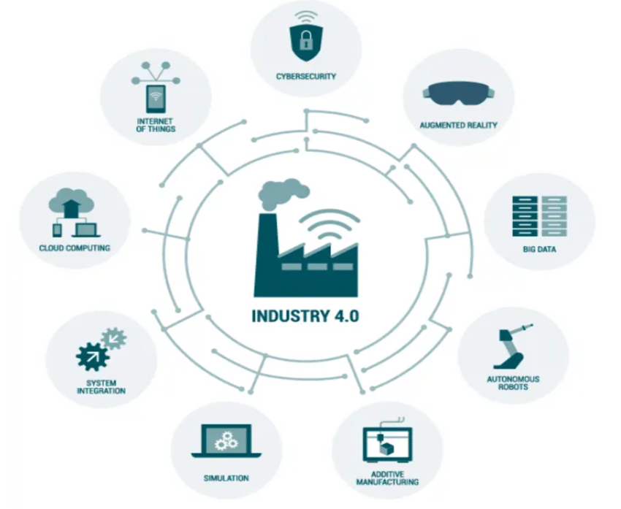

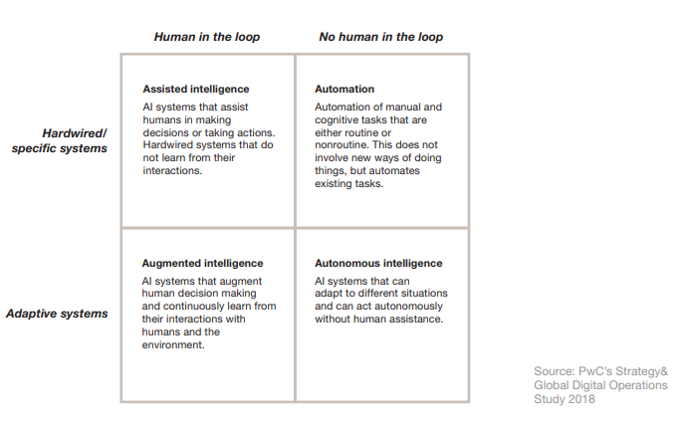
Figure 2 (PWC, 2018)

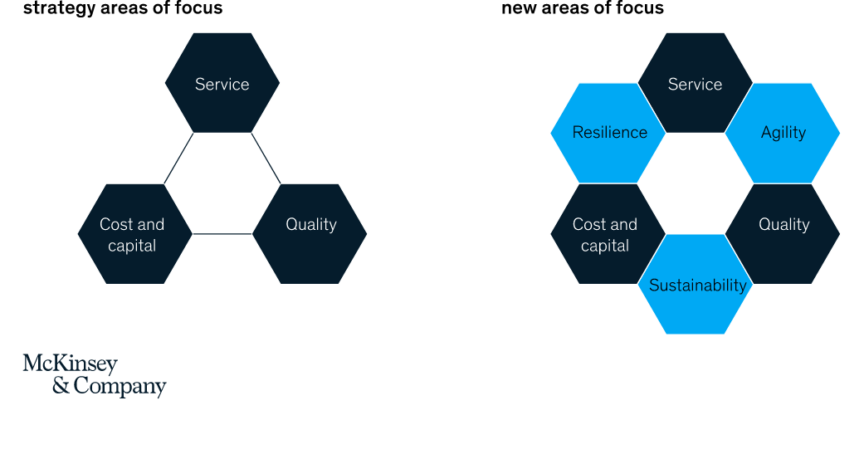
Figure 3 (McKinsey & Company, 2022)

Figure 4 (PWC, 2018)


