12/2/2021
University of Wales Trinity Saint David
Report on employability skills
Claudia Baragau
1905817

Table of Contents
Introduction 2
Employment Skills 2
Importance of Employment Skills 3
Work and work-life post Covid-19 4
Employment skills before Covid-19 5
Employment skills post Covid-19 6
Building resilience in the post-COVID-19 workplace 8
Building Emotional Intelligence in the post-COVID-19 workplace 9
Building Digital Competence in the post-COVID-19 workplace 9
Conclusion 10
References 11

Introduction
As the COVID-19 virus spreads and lock-down and slow-down measures are implemented, people worldwide are growing increasingly concerned about their jobs. Policies that safeguard employees from job risks and expand employment opportunities are critical. Numerous job profiles will become obsolete or disappear from the market, while others are poised to develop enormously and take over the tech sector in the coming years. As a result, it becomes vital for all persons (whether final year students or working professionals) to embrace these changes and equip themselves with the skills that will be in demand by businesses following COVID-19. As the world transitions to a digital society, countries are being advised to examine their labor needs in order to develop appropriate job possibilities through proper skills (particularly digital skills) and infrastructure.

Employment Skills
A person's employability is a measure of how likely they are to land a job with their skills, talent, education, and experience in mind. Employment Skills, as the name implies, this word refers to one's ability to get a job. This is dependent on a variety of factors, such as the level of education and experience of the individual. There is an important point to be made here. As a potential employee, you are given a score out of 10. Companies do not keep track of employability skills as a measure (Chen et al., 2020). An individual's work is reflected in their score. And, of course, your previous employment experience. It is via asking these questions that the hiring manager may narrow down the pool of applicants to those who are most like them.
To be "employable," a person must possess a certain set of personal characteristics. Because they are independent of your technical expertise and work experience, these talents are sometimes referred to as "soft skills" or "transferable skills." They may be used to nearly any profession, regardless of industry. Among the qualities employers look for in a potential employee are dependability, hard effort, and the ability to get along with coworkers.

Importance of Employment Skills
These "job-readiness" abilities are, in essence, important behaviors for any profession and are critical attitudes that enable a person to advance in his career while also effectively communicating:
- Establish a rapport with your coworkers
- Rectify issues
- Participate in and comprehend your team's role
- Make prudent career and employment selection decisions
- Self-sufficient and in command of one's career
The way a person interacts with people is influenced by their personality traits, habits, and attitudes. Employers value employability skills because they show how well you get along with coworkers, customers, and members of your team, as well as how well you'll be able to handle the demands of your job and achieve professional success (Masenya, 2021).
Employers place a high value on these specialized skills in prospective employees since they are essential to a well-oiled workplace. These basic and work-readiness abilities take a lot of time and money to develop. Employers now have more options and prefer to hire a technical expert with a diverse set of abilities in an environment when employment is scarce.
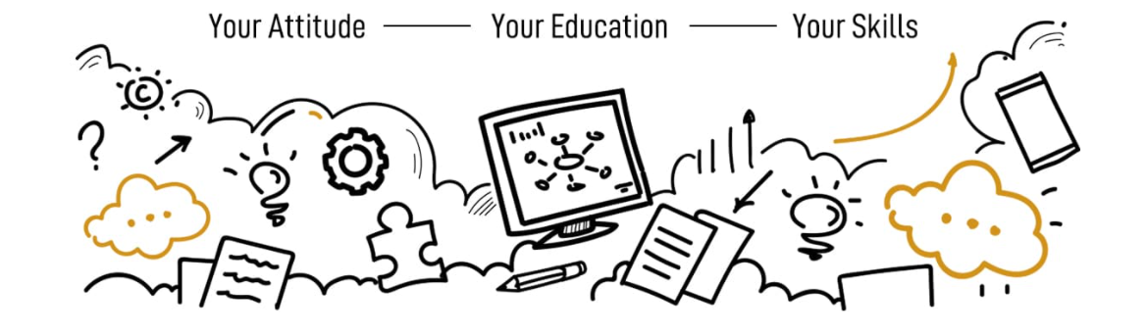
Figure 1: Framework of Employment skills

Work and work-life post Covid-19
As a result of the COVID-19 epidemic, global labor markets were severely disrupted in 2020. Millions of individuals were laid off or lost their jobs in the immediate aftermath of the shutdown, while others were able to work from home as businesses were forced to close. There were a few workers who were considered essential and were allowed to continue working in hospitals and grocery stores, on garbage trucks, and in warehouses, but under modified conditions to prevent the spread of the newly found coronavirus (Buheji and Buheji, 2020). To contain and mitigate COVID-19's spread, nearly every country in the world instituted containment and mitigation measures such as restricting individuals' movement, shutting down schools and other educational facilities, and postponing non-essential medical operations. However, even though these policies had a considerable impact on the labor market, particularly in the short term, they had a significant impact on countries and even within countries.
Regardless of the conditions, Covid19 has essentially "redefined" the new task order in a substantial way. Across a wide range of industries, from telemedicine to robotic process automation, and from online classrooms to virtual internships, technology transition is reshaping consumer habits and corporate models (Masenya, 2021).
This new normal necessitates attention to the creation of safe digital infrastructure, effective R&D collaboration between industry and academics, social-and-health orientation, continual forecasting of the future based on data-driven forecasts, as well as a wide range of other things. A simpler transition to "new habits and bigger prospects" can be achieved by incorporating all stakeholders in a comprehensive approach (Masenya, 2021).
It is indisputable that the future arrived sooner than planned, yet many countries and sectors have shifted to remote working to limit the spread of COVID-19, which has had a huge impact on how we function. As computer speed and storage capacity continue to rise, more and more organizations can collaborate virtually and globally. Employees can work from home while still being able to communicate with their colleagues via tools like Skype, VoIP, email, and cloud-based files. There is a wide variation in the extent to which the economy has undergone this shift. The manufacturing business relies heavily on shop floor workers to carry out their tasks. However, new ‘social distance' requirements necessitate a different method to restart manufacturing. Re-training and up-skilling of workers are necessary because of the rapid shift toward the production of healthcare equipment and new business models (Lau et al., 2021).

Employment skills before Covid-19
Before COVID-19, the biggest disruptions to work were caused by new technology and the expansion of international trade. First time COVID-19 has highlighted the value of physical work. Proximity in more than 800 vocations is quantified in this study by categorizing them into ten work zones due to their proximity to coworkers, client interactions, and their on-site or interior nature, as well as the number of interpersonal interactions involved.
In contrast to conventional sector definitions, this offers a new perspective on what it means to be employed. For example, in our medical care arena, only roles that necessitate close patient contacts, such as doctors and nurses, are included. In the computer-based office work arena, administrative staff of hospitals and medical offices are increasingly working from home. Pharmacists and lab technicians spend most of their time indoors, where they may use specialized equipment without having to interact with the public.
Even before the outbreak, people were debating the 'Future of Work' implications of Industry 4.0. We were also amid a globalization reversal, which had previously been one of the most important factors in the development of jobs in developing countries. Protectionism and the greater adoption of exponential technologies in developed economies have both slowed this process down, making it more difficult for products, services, labor, and capital to move freely. Everything from manufacturing to services has been impacted by Covid-19. Getting back to work and 'reimagining work,' as we embrace the new digital reality, will be the greatest challenge for firms, especially manufacturing, in their recovery.
As a result of the outbreak, production has been severely disrupted. Most organizations have inactive operations jobs as a result of the connection between labor and physical resources (retail stores, plants, etc.). Conglomerates have put the majority of their production capacity on hold, and a large number of well-known companies have taken precautionary measures to stop operations to protect their clients and staff. Certain occupations have seen an increase in productivity (Lau et al., 2021). Workers who perform tasks that necessitate both cognitive and creative thinking, as well as independence and project-based work with less reliance on physical closeness, have reported stable or even improved productivity (functions, such as product design, customer service, finance, and content creation). Commuting, socializing, and other time-consuming activities can be eliminated for the benefit of employees. The recovery phase of the economy has prompted companies to consider measures that are more accommodating to their workers.
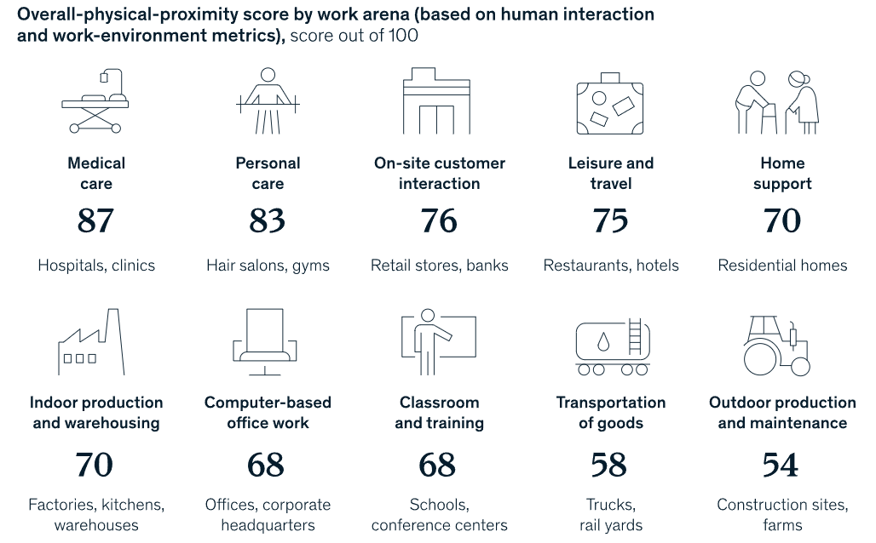
Figure 2: Work Arena pattern prior to Covid
Source: (Agrawal et al., 2020)

Employment skills post Covid-19
The economic impact of the COVID-19 pandemic is becoming more obvious as the disease spreads over the world. Nationwide economic declines, rising unemployment rates, and severe cash flow constraints among businesses are all consequences of public health policies aimed at slowing the spread of avian influenza. Several organizations have had difficulty adapting to the unexpected changes that have resulted from the widespread use of COVID-19, particularly the advent of lockdowns. Lockdowns have had an impact on around 80 percent of worldwide economic activity. The rapid spread of COVID-19 has compelled organizations to act quickly and allow experts to work remotely, when possible, in response to the problem. Some industries' use of technology-enabled remote work has shown to be a successful response to the challenge. Workers' safety has been ensured during these times thanks to the establishment of appropriate sanitary conditions and social distance within supply chains for the food and medical industries, as well as retail establishments (Hensvik et al., 2021). Companies throughout the world are focusing on Re-skilling and Re-training employees as well as
- Defining the needs of employees in a clear and concise manner
- Flight attendants who have basic medical training and the ability to cope with passengers under duress should be identified.
- Determining which specific digital skills are needed and can be taught digitally is required
- Employees who have completed their training will be given the duty of transitioning to new job obligations.
- To ensure quality standards are met while these personnel learns new skills for their new positions, it is important to keep an eye on them.
As a result of the pandemic, three major tendencies have been accelerated. COVID-19 has had a significant impact on the workforce by increasing the number of employees who work from home. We studied more than 2,000 activities used in roughly 800 occupations in eight focal nations to see how widespread remote employment would be following the epidemic. Some 20% to 25% of the workforces in industrialized nations may work from home between three and five days a week, according to our findings (Hensvik et al., 2021). Since the epidemic, four to five times more people are working remotely than there were before. This may cause a substantial shift in the distribution of employment, as people and businesses relocate from big cities to the suburbs and small towns surrounding them. Some tasks are best done in person, even if they are technically possible to perform remotely. Activities that may suffer from a reduction in efficiency when carried out remotely include negotiations, brainstorming sessions, crucial business decisions, sensitive feedback, and the onboarding of new staff (Kay et al., 2020).

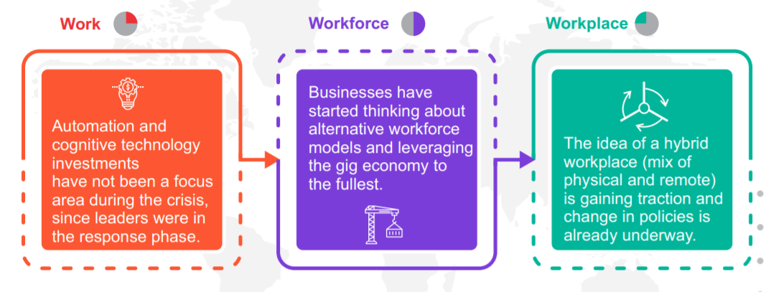
Figure 3: workforce and workplace transition
Source: (Gray et al., 2021)

Building resilience in the post-COVID-19 workplace
There has to be more accepting of the complete variety of experiences and obligations that all employees confront in their work and home lives in the future workplace.
Three pillars of post-COVID-19 recovery, and the associated opportunities and difficulties, are examined through the prism of the post-COVID-19 recovery future. The first step is to drive digital transformation, fuelled by universal, high-speed, and affordable connection, cross-border collaborations with robust data security standards, and government laws that enable working remotely. Building a healthy and resilient workforce is a second priority. Work and workplace paradigms are shifting, including a permanent move to the hybrid work model of office and work-from-home, and a powerful digital command center that allows a work-anywhere, live-anywhere, all-digital environment. As we move forward, how firms handle the possibilities and difficulties they face will determine their long-term success.
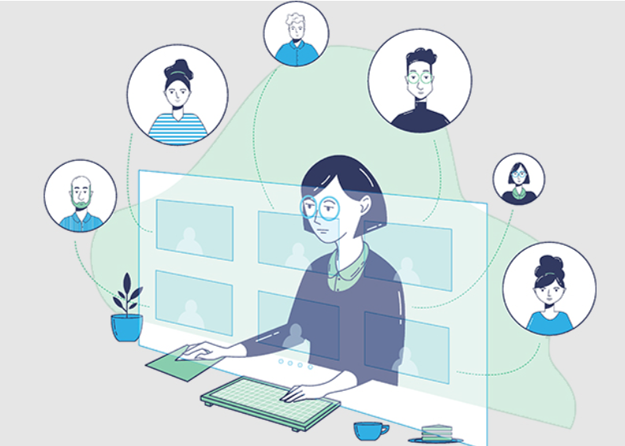

Building Emotional Intelligence in the post-COVID-19 workplace
EQ is not a new concept, but the COVID pandemic has made its utility and importance all the more critical for leaders to use it in their roles. Therefore, Coronavirus has avoided shining harsh spotlights on the shortcomings of leadership and how leaders might improve.
Work in the future will be more adaptable. There is a requirement for emotional intelligence to accomplish this goal. The definition of emotional intelligence (EQ) is a critical first step. People with high emotional intelligence (EQ) are better at controlling their emotions, fostering better interpersonal relationships, maximizing positive behaviour in stressful situations, and developing the ability to tap into positive, self-driving emotions (such as self-confidence and enthusiasm). Giving and receiving constructive feedback will be easier for leaders with high emotional intelligence (EQ). In the post-COVID era, the importance of emotional intelligence (EQ) will rise as our work becomes more flexible, remote, and ambiguous (Gill, 2020).
Traditional "hard" leadership qualities can be taught and developed in the same way that EQ can be taught and developed. Because the epidemic is new, many company leaders are unprepared to deal with the pressures this new era of workplaces on them as individuals and as a whole. However, leaders of the future must also have a larger degree of Emotional Intelligence (EQ) if they are to develop trust among their teams and nurture and motivate them to succeed.

Building Digital Competence in the post-COVID-19 workplace
The crisis has expedited digitization to assist decrease unnecessary physical encounters. This has necessitated reinventing work and, in some circumstances, partial job disruption and changes in the way workers conduct their tasks.
The pandemic had already prompted companies to rethink their employee training strategies. Several technological developments are transforming the nature of work as well as the skills required shortly, such as the rapid adoption of AI, the integration of analytics into business operations, and the expansion of remote work (Gill, 2020). A wide range of company operations necessitates constant reskilling and upskilling, as new roles are formed and others become obsolete. Almost every employee today is expected to have a working knowledge of digital technologies. Everyone in the company, regardless of department, must increase their digital skills if they want to be able to operate more effectively and efficiently with their co-workers and partners, as well as with customers, across many platforms. A company's competitive advantage can be maintained if its employees are technologically savvy enough to respond swiftly and effectively to changes in the business environment and client expectations.
As the pandemic's effects are felt for years, the workplace's reliance on technology will only grow. Remote work is here to stay, which is notable. Nearly half of companies polled by Gartner claim that at least 80% of their employees work remotely. Following Covid-19, a poll found that 48 percent of employees plan to continue working remotely at least part of the time (versus 30 percent before the pandemic). As a result of the economic downturn, the need to train a large number of employees on remote work practices has increased significantly. Businesses, for example, are shunning full-time employees in favor of cheaper contract workers because of the pandemic. A rise in employee turnover may necessitate more frequent training as a result (Hensvik et al., 2021).

Conclusion
Personal attributes that enhance one's "employability" include the development of "employability skills." Soft skills, or "transferable talents," are often referred to as such since they are unique from your technical knowledge and job experience and may be used to practically any position in any field. Since its start, COVID-19 has had a significant impact on not only how people work but also how they shop and eat, move around, and travel. There are long-term changes in the employment landscape that may need a large-scale reskilling of new workers because of this epidemic. There will always be a need for a wide range of skills in the workplace. Everyone has their own set of skills that makes it possible for them to make a valuable contribution to any organization. The capacity to recognize and utilise one's strengths is essential (Masenya, 2021).
In today's highly competitive job market, it is essential to stand out. That can be done with the help of employability skills. Despite the importance of possessing a relevant degree, many graduates will be able to provide it. A large number of businesses will now make recruiting decisions based on the additional skills that individuals bring to the job.

References
Agrawal, S., De Smet, A., Lacroix, S., Reich, A., 2020. To emerge stronger from the COVID-19 crisis, companies should start reskilling their workforces now. McKinsey Insights.
Bandaranaike, S., Quijano, E.P.O., Navarrete-Baez, F.E., 2020. A COVID-19 work-integrated learning strategy for entrepreneurial mindset reflections: A case study in Mexico. International Journal of Work-Integrated Learning 21, 467–489.
Buhari, M., Buheji, A., 2020a. Characteristics of ‘problem-based learning in post-COVID-19 workplace. Human Resource Management Research 10, 33–39.
Buheji, M., Buheji, A., 2020b. Planning competency in the new Normal–employability competency in post-COVID-19 pandemic. International Journal of Human Resource Studies 10, 237–251.
Chen, Z., Marin, G., Popp, D., Vona, F., 2020. Green stimulus in a post-pandemic recovery: the role of skills for a resilient recovery. Environmental and Resource Economics 76, 901–911.
DeFilippis, E.M., Stefanescu Schmidt, A.C., Reza, N., 2020. Adapting the educational environment for cardiovascular fellows-in-training during the COVID-19 pandemic.
Gill, R.J., 2020. Graduate employability skills through online internships and projects during the COVID-19 Pandemic: An Australian example. Journal of Teaching and Learning for Graduate Employability 11, 146–158.
Gray, B.J., Kyle, R.G., Song, J., Davies, A.R., 2021. Characteristics of those most vulnerable to employment changes during the COVID-19 pandemic: a nationally representative cross-sectional study in Wales. J Epidemiol Community Health.
Hensvik, L., Le Barbanchon, T., Rathelot, R., 2021. Job search during the COVID-19 crisis. Journal of Public Economics 194, 104349.
Kay, J., McRae, N., Russell, L., 2020. Two institutional responses to work-integrated learning in a time of COVID-19: Canada and Australia. International Journal of Work-Integrated Learning 21, 491–503.
Lau, S.S., Wan, K., Tsui, M., 2021. Evaluation of a Blended Career Education Course during the COVID-19 Pandemic on Students’ Career Awareness. Sustainability 13, 3471.
MacLeavy, J., 2021. Care work, gender inequality and technological advancement in the age of COVID-19. Gender, Work & Organization 28, 138–154.
Masenya, T.M., 2021. Promotion of digital entrepreneurship for youth employability in the post Covid-19 era, in: Handbook of Research on Sustaining SMEs and Entrepreneurial Innovation in the Post-COVID-19 Era. IGI Global, pp. 122–142.
Miani, P., Kille, T., Lee, S.-Y., Zhang, Y., Bates, P.R., 2021. The impact of the COVID-19 pandemic on current tertiary aviation education and future careers: Students’ perspective. Journal of Air Transport Management 94, 102081.

