  Component One:  What are the key skills required when working in the housekeeping team? 750 words (+/- 10%) | Student No: | 2132755
 | Module Title: | Operating Hotel Facilities
 | Module Code: | BMIH4006
 | Lecturer: | LAURENCE BLAKE
Several skills are required while working in a hotel’s housekeeping team. All the skills must be combined appropriately so that proper service can be provided to the clients of the firm (Pestle & Harris, 2019). One of the major skills that housekeepers must practice is time management. Housekeepers must accomplish a predetermined number of routine maintenance each day, and they typically work alone, though there are situations in which they collaborate with a small number of other cleaning staff. Housekeepers require several critical skills to guarantee that they can finish all washing on time, including effectively managing time and adhering to a timetable (Scanlon, 2021). They are also required to arrive promptly for scheduled cleaning appointments and complete the cleaning within the time specified by the customer. Therefore, I try to manage my time and housekeeping properly.
Again, the housekeepers must be attentive to details. For being successful in the job, housekeepers are required to have the best focus on the smallest of details (Humphreys, 2018). These people in the cleaning industry require to have the best eye for detail to successfully obtain the jobs, which range from combining a variety of household objects to guaranteeing that floors and surfaces are cleaned. A housekeeper will perform more effectively in their tasks if they are serious in their approach to completing their tasks. So, ensuring attentiveness is also a core focus of my housekeeping. Strong communication skill is also required. Housekeepers are required to maintain open lines of communication with customers, co-workers, and managers at all times to ensure that the requirements for each cleanliness are well comprehended (Carter, 2016). In the absence of strong communication abilities, a housekeeper runs the risk of being unable to fulfil the requirements of a given task or missing out on essential components necessary.
Interpersonal skill is also a core skill of housekeepers. They frequently communicate directly with consumers and are wished to collaborate properly with their co-workers (Wood, 2018). Dependability, collaboration, and proper accountability are examples of the common interpersonal abilities necessary for them to have to do their tasks on time. I am focusing more on this skill. I also need to make sure of flexibility. Many housekeepers must adjust their schedules throughout the day to accommodate the requirements of their customers. If a housekeeper is responsible for sweeping an office complex, for instance, they may be required to wait to begin their work until all of the workers have vacated the premises for the day. Some housekeepers put in hours during the night or very early in the day. A housekeeper's ability to multitask increases the likelihood that she will be hired for more tasks and hence earn more money. Customer service ensuring is also important. Housekeepers who want to be effective at their jobs need to have excellent customer service abilities. This is because their job is contingent on the client's acceptance; hence, ensuring that clients are pleased with a housekeeper's productivity is essential to achieving success in this line of business (Briggs, 2020).
Being well-structured is one of the most important qualities of a competent housekeeper. I can hone my organisational abilities by giving myself practice opportunities at home and making it a point to concentrate on organisation whenever I finish a certain task. When it comes to housekeeping, a wide variety of tools and supplies can be utilized (ÖZEN & Değirmenci, 2019). Laundry materials, vacuum cleaners, brooms, and other types of machinery are examples of the common types of equipment that housekeepers utilize to assist them in performing their duties more efficiently. I may accomplish my tasks more efficiently and successfully if I am familiar with the necessary tools for housekeeping and if I work on building my technical skills. The fundamental to being a successful housekeeper is having an understanding of what a client anticipates from my cleaning services (Bauman & Iwata, 2019). I will be able to ensure that consumers are pleased with the results of each cleaning if I maintain consistent communication with them. If they are unhappy with the service, I should ask them particular questions about what they think should be better.

Word Count | 726

Component Two:
Contribution to Overall Module Assessment: 25%
In this scenario – You have just been promoted to the team leader for a floor within the hotel. A guest complains that on their arrival, their room had not been properly cleaned. Create an action plan and answer the following questions.

Problem | Why did it happen? | What are you going to do? | How will you prevent this from happening in the future? | What measures would you introduce to improve team effectiveness?
Sticky Floors | The main reason behind the sticky floors is wax build-up. Here, this is a common issue on most of the floors of a particular hotel. This issue causes a huge problem. The guests of the hotel cannot touch the floors as the floors become sticky. Due to the wax build-up, this issue is created mainly. | To solve this problem, the wax remover must be used properly. Using other components or washing materials will not help in this case to reduce the sticky floors and therefore, the team members must be careful about using the wax remover. Using the wax remover on the floor will solve this issue. | As the wax build-up causes this issue, here the members of the cleaning team will ensure that the wax build-up is properly handled in the hotel rooms. If the wax build-up can be properly handled, it will be easier for the cleaning teams to prevent this issue in the future. | The effective use of wax remover technic must be introduced among the members of the cleaning team. If this can be ensured among the members of the cleaning team, it will be easy for them to reduce the stickiness within the floors.
Discoloured chrome | This issue happens due to the hard water on the floors. If the hard water remains on for a longer period on the floor the colour of the floor changes and therefore, the floor becomes discoloured. This looks dirty from the outside and the guests can provide bad comments on this. | To solve this issue, I will be using hard water removal. Here, the hard water removal will help the floors to wash the floors properly and it will also make sure that the floors do not get discoloured again, the workers of the hotel can reuse this technic if this issue happens again. | To prevent this issue, it will be made sure that any water or elements that are similar to water, will not be steaked in the floor for a longer period. As the floor becomes discoloured due to the water, the workers will make sure that water is properly cleaned from the floor. | One of the major things that can be done to ensure effectiveness is prompt cleaning. The team members of the hotel will clean the floor as early as possible so that the water is not contained in the floor for a longer time and if this is possible, then this issue will be solved.
Dull Floors | Sometimes the hotel floors can lose their shine. In this case, the hotel rooms can look dull. Here the main reason for becoming dull of the floor is getting too old. | To get back the shiny colour of the floor, the hotel members can shine the floors again. Moreover, the hotel members can also clean the floors in time so that the shininess of the floor does not reduce and they look like new | To prevent this issue, I will make sure that the floors are properly coloured in time. I will also make sure that I have maintained a proper cleaning schedule for the floors so that the dullness can be reduced. | To ensure the team’s effectiveness, I will arrange a proper training program on the ways to shine the floors and colour the floors in time as this will reduce the issue of dull floors.
Dirty Bathroom | Some of the bathrooms of the hotel rooms were dirty. The bathrooms were not dirty that much but they were not properly cleaned by the cleaning team and therefore, this was another issue that the guests were facing. | To eliminate this issue, I will be guiding the cleaning team to properly clean the bathrooms of the hotel rooms so that the guest cannot complain. Here the cleaning members will be ordered to double-use the washing materials. | To prevent this issue from happening in the future, I will make sure that all the bathrooms are properly checked by the cleaning members whether the bathrooms are appropriately cleaned or not. | To improve the team’s effectiveness, I will make a schedule for cleaning the bathrooms on time. This schedule will support the cleaning team to work effectively.
Unwashed Bedsheet | In some of the bed, bedsheet was not changed by the cleaning members of the housekeeping. Here, the bedsheet was looking dull and dirty. Therefore, the guests may complain about the hotel rooms. | To solve this issue, I will guide the housekeeping team to change the bedsheet in time. Here, if the bedsheets are changed in time, the bedsheet would be cleaned and therefore, the guests will not complain about the rooms. | To prevent this issue from happening in the future, an easy step can be taken. Here, one of the members of the housekeeping will check all the beds of the hotel whether the bedsheets are changed or not so that the unwashed bedsheets can be changed. | To improve the team’s effectiveness in this case, I will introduce monitoring activities. The monitoring activities will help the members of the team to check all the beds in time and to change the unwashed bedsheets.

Component Three:
Contribution to Overall Module Assessment: 50%
Your task is to create and prepare a presentation following the detailed scenario provided below.

As the floor housekeeping manager and given the recent guest complaints you need to put together a basic training presentation for your colleagues within the housekeeping team to get the best out of them, ensure that brand standard is being achieved and that Health and Safety procedures are also being followed.

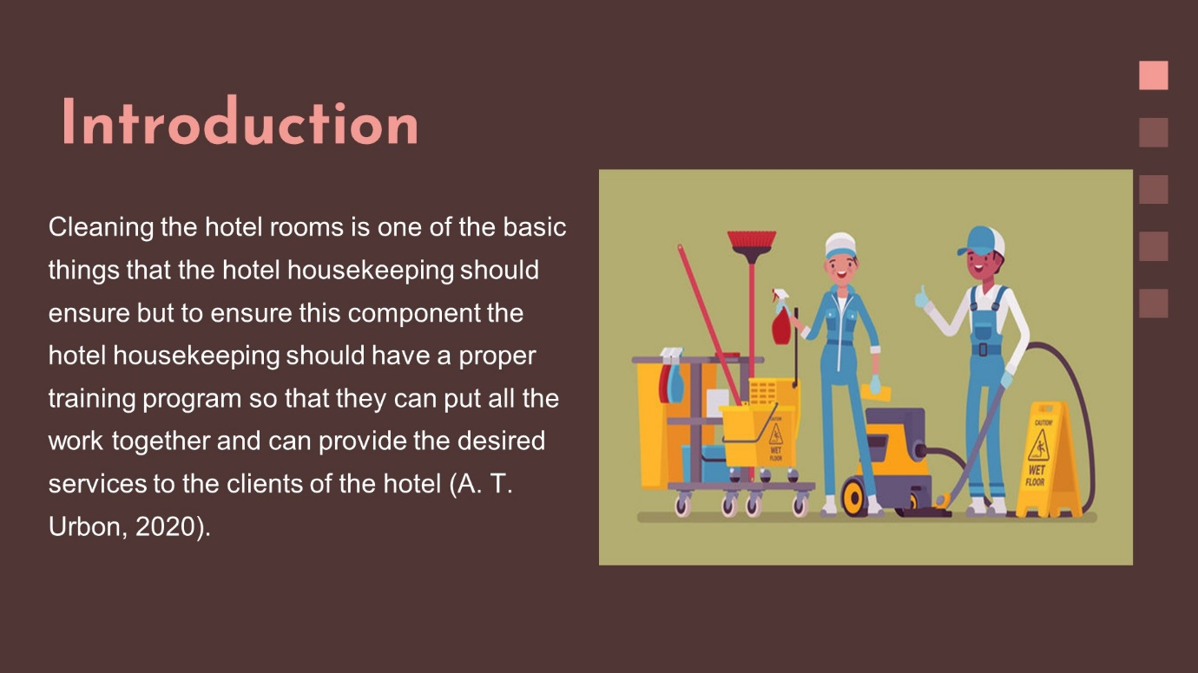

Training Notes: Training Notes: Cleaning the hotel rooms is one of the basic things that the hotel housekeeping should ensure but to ensure this component the hotel housekeeping should have a proper training program so that they can put all the work together and can provide the desired services to the clients of the hotel (A. T. Urbon, 2020). Moreover, some safety and health precaution training will be also provided for the members of the housekeeping team. At last, an employee engagement program will be also introduced. This presentation will include a training program and an employee engagement program for the members of housekeeping.
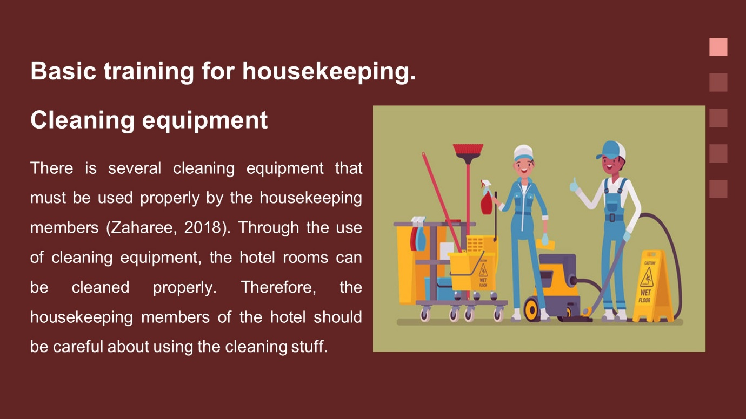

Training Notes: Training Notes: Several cleaning equipments must be used properly by the housekeeping members (Zaharee, 2018). The hotel rooms can be cleaned properly by using cleaning equipment. Therefore, the housekeeping members of the hotel should be careful about using the cleaning stuff. There are mobs, brushes, electric cleaning machines and many more that require proper training to use appropriately. Here, if the members of the cleaning team can use the tools appropriately, it will be easy for them to ensure proper cleaning of the house.
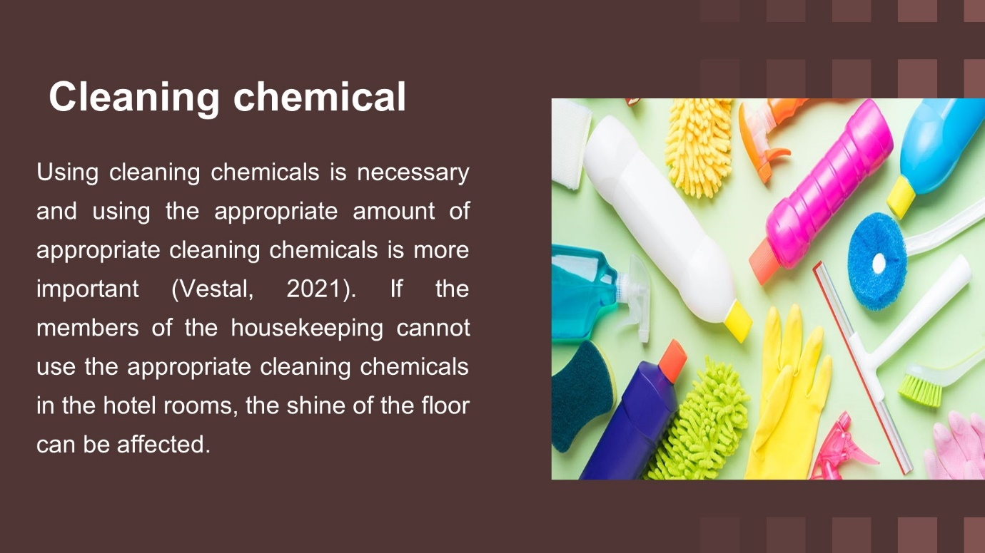

Training Notes: Training Notes: Using cleaning chemicals is necessary and using the appropriate amount of appropriate cleaning chemicals is more important (Vestal, 2021). If the members of the housekeeping cannot use the appropriate cleaning chemicals in the hotel rooms, the shine of the floor can be affected. Therefore, proper training will be provided to them. For cleaning floors there will require different cleaning materials, for cleaning the bathroom the cleaning chemicals will be different from the cleaning chemical that will require for cleaning the floor. Therefore, a training program will be arranged for the appropriate use of the cleaning chemical.
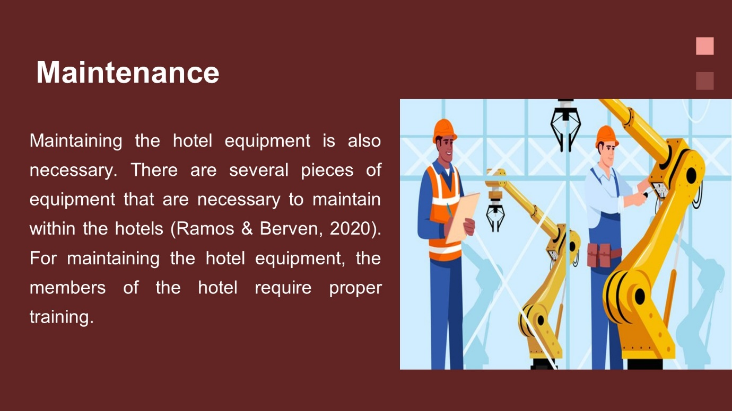

Training Notes: Training Notes: Maintaining the hotel equipment is also necessary. Several pieces of equipment are necessary to maintain within the hotels (Ramos & Berven, 2020). For maintaining the hotel equipment, the members of the hotel require proper training. Therefore, all the housekeeping staff will be brought under the maintenance training program. If the workers are not trained properly, it will be difficult for the firms to maintain the hotel equipment and therefore, maintenance is required.
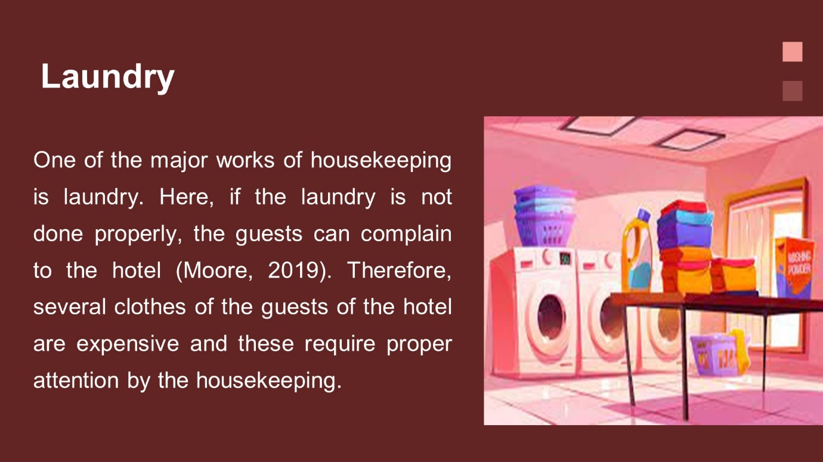

Training Notes: Training Notes: One of the major works of housekeeping is laundry. Here, if the laundry is not done properly, the guests can complain to the hotel (Moore, 2019). Therefore, several clothes of the guests of the hotel are expensive and these require proper attention by the housekeeping. In such cases, if the housekeeping staff are not provided with the proper training program, it will be difficult for the hotel to provide an appropriate laundry service to the consumers of the hotel. Therefore, ensuring proper training for the members of the housekeeping who are related to the laundry service is very much necessary.

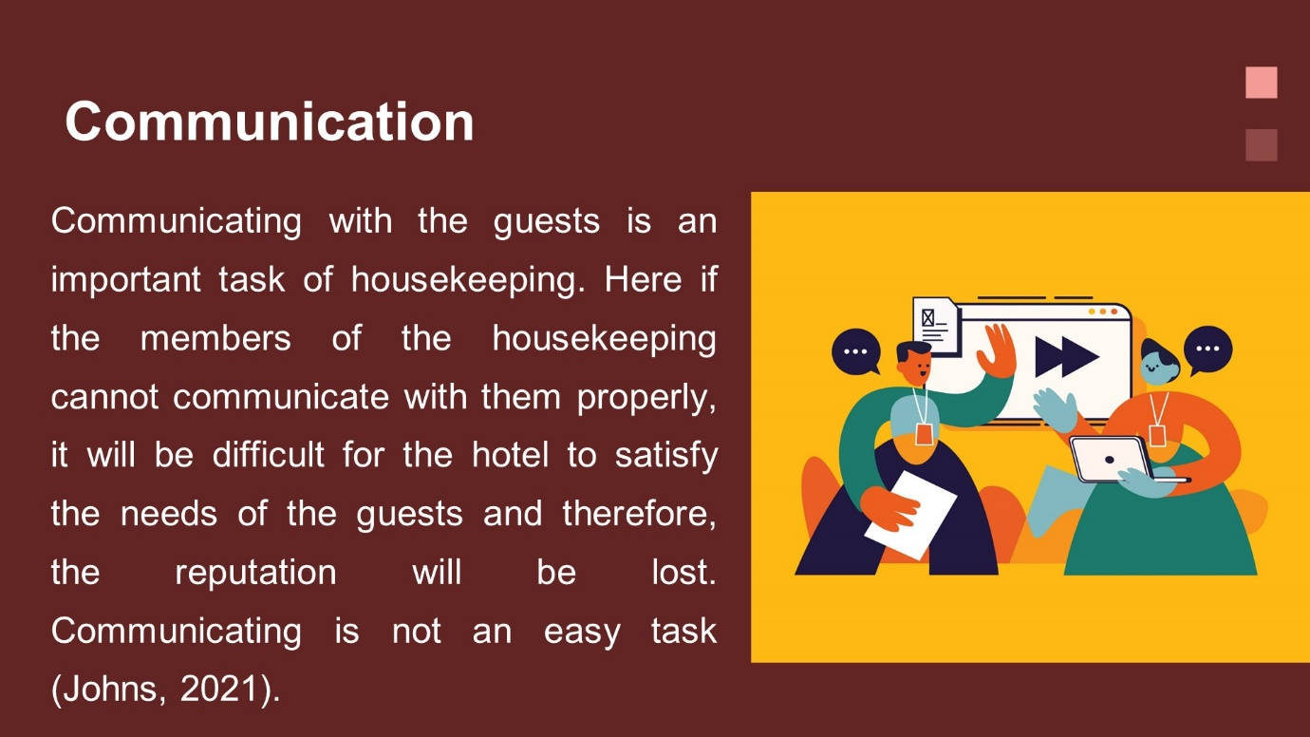

Training Notes: Training Notes: Communicating with the guests is an important task of housekeeping. Here if the members of the housekeeping cannot communicate with them properly, it will be difficult for the hotel to satisfy the needs of the guests and therefore, the reputation will be lost. Communicating is not an easy task (Johns, 2021). Therefore, the housekeeping of hotels should get proper training in this field so that they can properly communicate with the guests and can make proper interactions with them.
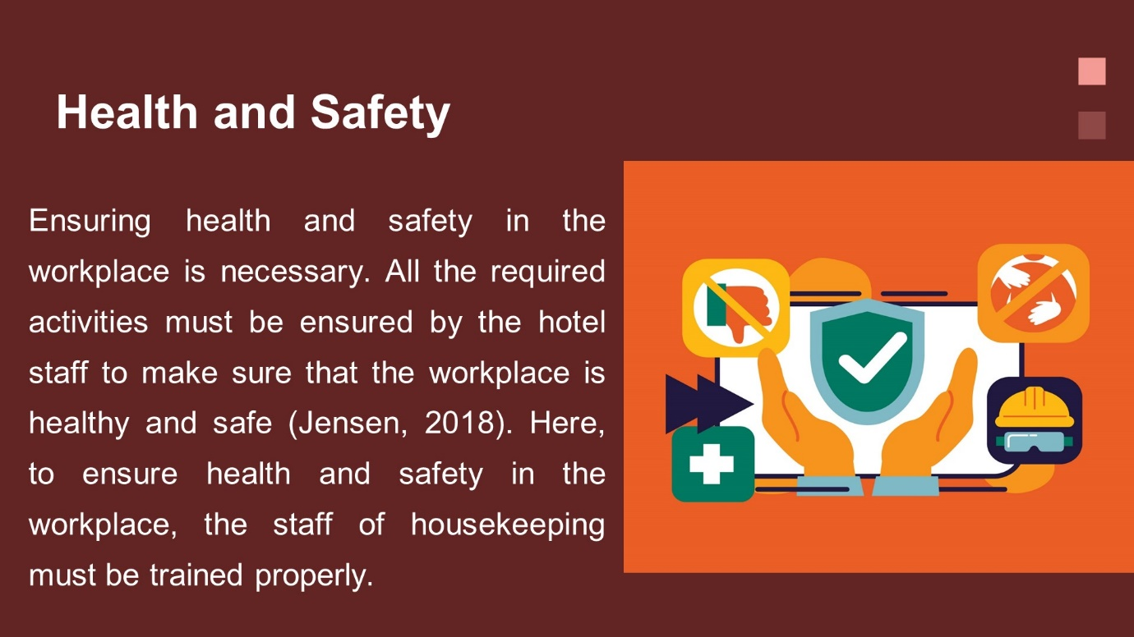

Training Notes: Training Notes: Ensuring health and safety in the workplace are necessary. All the required activities must be ensured by the hotel staff to make sure that the workplace is healthy and safe (Jensen, 2018). Here, to ensure health and safety in the workplace, the staff housekeeping must be trained properly. The housekeeping members should get the knowledge of using anti-virus chemicals while cleaning the hotel staff so that the bacteria can be kept away.
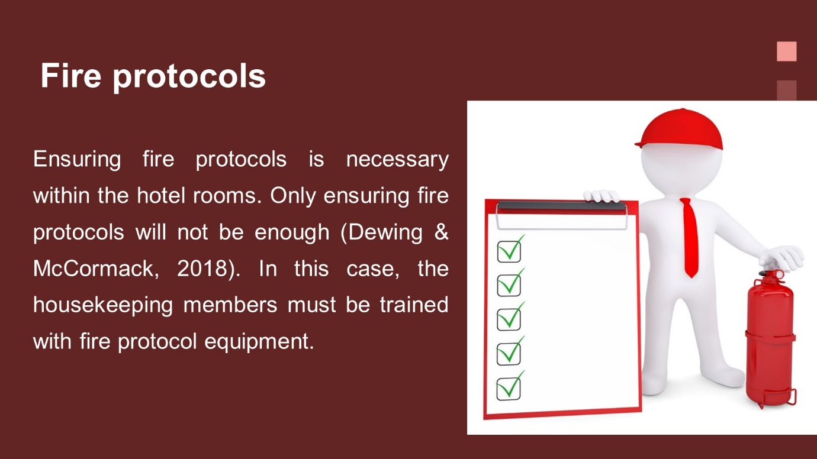

Training Notes: Training Notes: Ensuring fire protocols is necessary within the hotel rooms. Only ensuring fire protocols will not be enough (Dewing & McCormack, 2018). The housekeeping members must be trained with fire protocol equipment in this case. If the members of the hotel are properly trained with fire protocol equipment, it will be easy for them to use when something unexpected occurs in the hotel rooms.
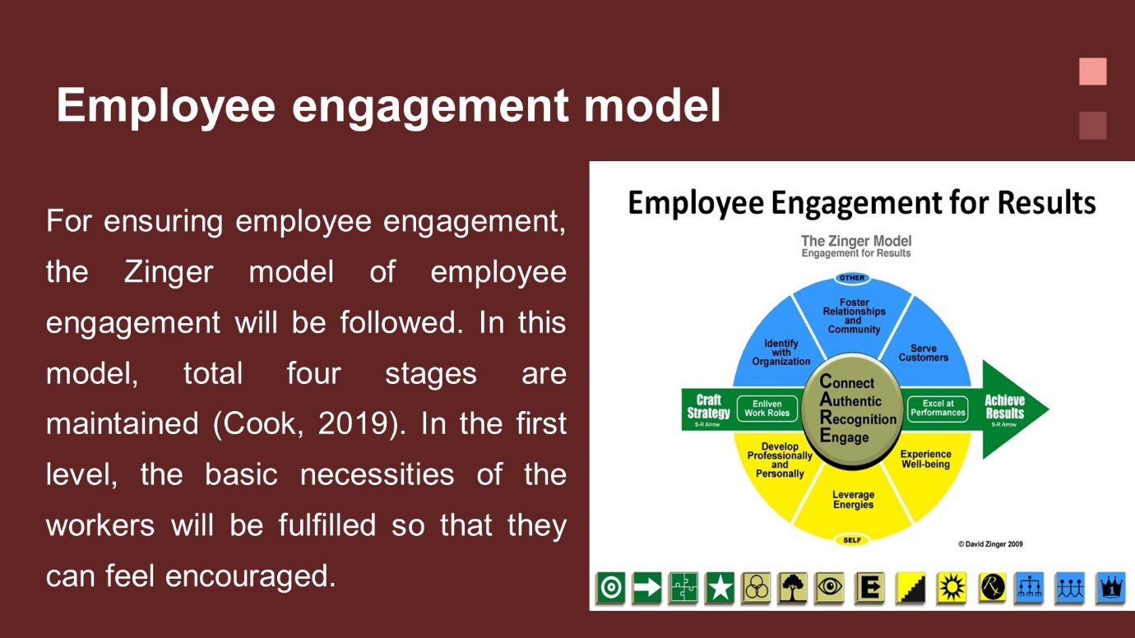

Training Notes: Training Notes: The Zinger model of employee engagement will be followed to ensure employee engagement. In this model, a total of four stages are maintained (Cook, 2019). In the first level, the necessities of the workers will be fulfilled so that they can feel encouraged. In the second level, all the staff of the hotel will be united through proper collaboration. Here the workers will work together to achieve the goals. In the third level, the performance of the workers will be boosted through proper measurement and proper monitoring. At last, at the top level, the hotel will see its output from employee engagement.
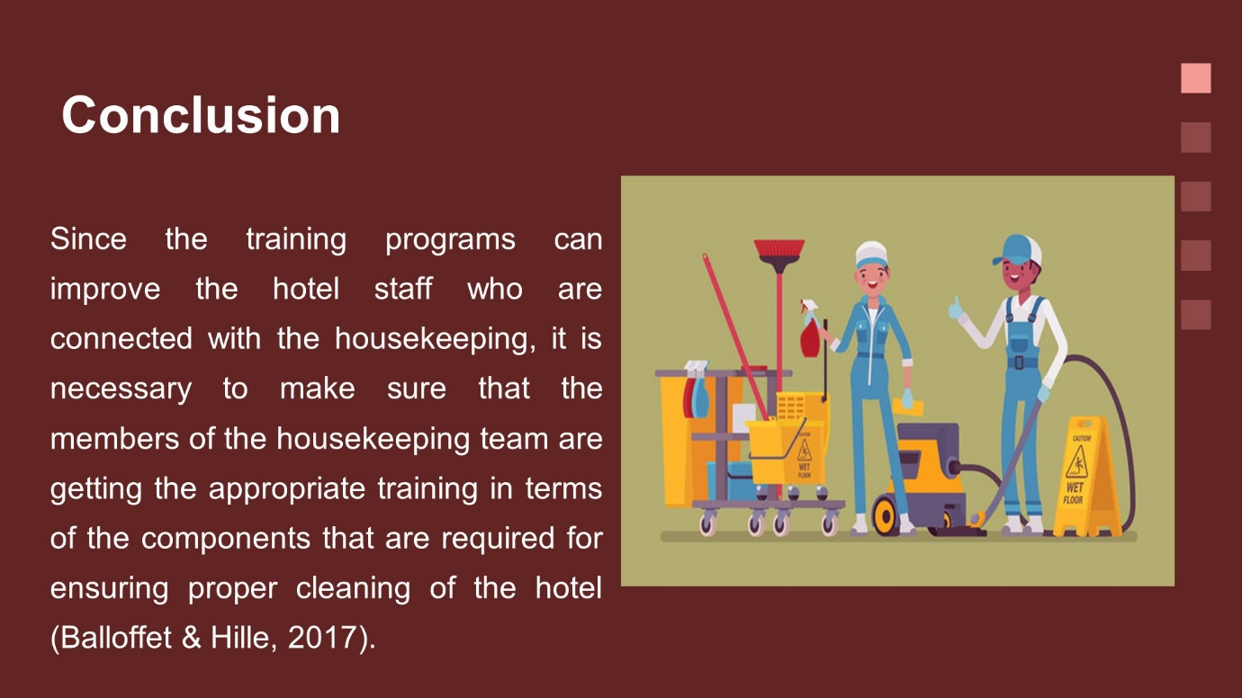

Training Notes: Training Notes: Since the training programs can improve the hotel staff who are connected with the housekeeping, it is necessary to make sure that the members of the housekeeping team are getting the appropriate training in terms of the components that are required for ensuring proper cleaning of the hotel (Balloffet & Hille, 2017). Moreover, the members of housekeeping should also get proper instruction in terms of employee engagement. The whole activity of housekeeping is not the work alone and therefore; proper employee engagement training will be provided to every individual in the team. These training programs will be effective in terms of ensuring a clean and hygienic work environment within the hotel.

References

Bauman, K.E. and Iwata, B.A. (2019) “Maintenance of independent housekeeping skills using scheduling plus self-recording procedures,” Behavior Therapy, 8(4), pp. 554–560. Available at: https://doi.org/10.1016/s0005-7894(77)80185-8.
Briggs, R. (2020) Make your place: Affordable, sustainable nesting skills. Bloomington, IN: Microcosm Publishing.
Carter, D. (2016) Basic Plumbing Services Skills. Melbourne, VIC: Cengage Australia.
Humphreys, D. (2018) Housekeeping skills for kids: Teaching them does 't have to be a chore. London: Tate Pub & Enterprises Ll.
ÖZEN, A. and Değirmenci, H.D. (2019) “The effectiveness of video modelling strategy to teach hotel housekeeping skills to individuals with intellectual disabilities,” Ankara Üniversitesi Eğitim Bilimleri Fakültesi Özel Eğitim Dergisi [Preprint]. Available at: https://doi.org/10.21565/ozelegitimdergisi.468778.
Pestle, R.E. and Harris, N.C. (2019) Adaptations of homemaking skills for the aged: Housekeeping. Tallahassee: College of Home Economics, Florida State University.
Scanlon, J. (2021) “Old Housekeeping, New Housekeeping, or no housekeeping?,” Journalism History, 30(1), pp. 2–10. Available at: https://doi.org/10.1080/00947679.2004.12062639.
Wood, A. (2018) “Housekeeping, citizenship, and nationhood in good housekeeping and modern home,” Women's Periodicals and Print Culture in Britain, 1918-1939 [Preprint]. Available at: https://doi.org/10.3366/edinburgh/9781474412537.003.0017.
David, J. (2018) The good housekeeping book of child care: Including parenting advice, Health Care & Child Development for newborns to preteens. New York: Hearst Books.
Dyche, J. (2019) Educational program development for employees in Health Care Agencies: Handbook for Managers, supervisors, nurses. Calabasas, CA.: Tri-Oak Educational Division.
Lehto, M.R. and Landry, S.J. (2018) Introduction to human factors and ergonomics for engineers. Boca Raton: CRC Press, Taylor & Francis Group.
Marlow, H.L. (2021) “Housekeeping services: Housekeeping, laundry supervisors voice basic training needs,” Hospital Topics, 45(3), pp. 85–87. Available at: https://doi.org/10.1080/00185868.1967.9950001.
Naik, S. and Srivastava, M. (2017) “A study on the relevance of professional training to healthcare housekeeping aide through SAP-Lap Inquiry,” Indian Journal of Public Health Research & Development, 8(4), p. 743. Available at: https://doi.org/10.5958/0976-5506.2017.00425.9.
Vestal, A.J. (2019) “Housekeeping services: Four-part training program offered at Florida School,” Hospital Topics, 47(2), pp. 60–60. Available at: https://doi.org/10.1080/00185868.1969.12083512.
A. T. Urbon (2020) “Closure report for housekeeping category corrective action unit 524 Nevada test site Nevada.” Available at: https://doi.org/10.2172/780903.
Balloffet, N. and Hille, J. (2017) Preservation and conservation for Libraries and Archives. Chicago, IL: American Library Association.
Cook, J.M. (2019) “The Advocacy Action Plan,” Social Justice and Advocacy in Counseling, pp. 74–81. Available at: https://doi.org/10.4324/9781315180687-21.
Dewing, J. and McCormack, B. (2018) Practice development workbook: Resources for health and social care teams. Chichester: Wiley-Blackwell.
Jensen, R.C. (2018) Risk reduction methods for occupational safety and health. Hoboken, NJ: Wiley.
Johns, S. (2021) Good housekeeping: For a successful safety program. Washington, D.C.: U.S. Dept. of Labor, Wage and Labor Standards Administration.
Moore, M.H. (2019) Parent partnership training program: A comprehensive skills program for the handicapped. New York: Walker Educational Book Corp.
Ramos, S.J. and Berven, B.A. (2020) “Quality Assurance Program Plan for the Radiological Survey Activities Program - Uranium Mill Tailings Remedial Action Project.” Available at: https://doi.org/10.2172/6008217.
Vestal, A.J. (2021) “Housekeeping services: Executive housekeeper survey shows diversity in people, jobs, training,” Hospital Topics, 46(1), pp. 67–70. Available at: https://doi.org/10.1080/00185868.1968.9952068.
Zaharee, M.E. (2018) “Training Program Review: Theater Battle Management Core Systems (TBMCS) training program evaluation.” Available at: https://doi.org/10.21236/ada402336.

