Feasibility Study Exploring the Integration of a Carbon Dioxide Liquefaction Plant into an Existing Liquified Natural Gas Regasification Terminal

Joshua Thomas
University of Wales Trinity Saint David
2113454
July 2024


Declaration of Authenticity
‘This thesis is the result of the author’s original research. It has been composed by the author and has not been previously submitted for examination which has led to the award of a degree.’
Signed: Date: 20th May 2024

Acknowledgements
I would like to express a great deal of gratitude to those who have supported me during this project. My dearest thanks go to my project supervisor for guiding me, my shift supervisor and shift team for affording me capacity to undertake the project. Additionally, I would like to thank my partner for providing motivation throughout the last three years of study.

Abstract
This report evaluates the feasibility of installing an integrated carbon dioxide liquefaction unit within the operational DragonLNG liquified natural gas (LNG) import and regasification terminal. The study presents potential synergy between DragonLNG and Pembroke Power Station (PPS) which are situated on opposite sides of the Milford Haven waterway. PPS is a combined cycle gas turbine power station operated by RWE, who have ambitious plans to decarbonise their power station following the launch of Pembroke Net Zero Centre (PNZC). One project being investigated is carbon capture and storage, targeting the capture of up to 2.55 million tonnes of post-combustion carbon dioxide across two phases of project.
Given the criticality of carbon capture and storage (CCS) to meet the UK's net-zero targets by 2035, this study explores the feasibility of utilising “cold energy” from the LNG regasification process to liquefy carbon dioxide from PPS. The proposed integration has a potential environmental and economic impact at DragonLNG, reducing scope one carbon emissions through lower fuel gas consumption.
Key findings include:
Analysis of Thermal Duties: The heat exchange required to liquefy carbon dioxide was calculated, with a total thermal duty for scenario one calculated at 14.753 MWh, and for scenario two at 29.075 MWh. It was found that there was sufficient thermal duty from LNG at minimum regasification flow to meet scenario one of the project, but an increased LNG flow rate was required to meet scenario two of the project.
Cost Savings and Environmental Impact: The integration offers potential savings in fuel gas costs and reduced carbon emissions due to lower fuel gas consumption, with additional benefits from reduced UK Emissions Trading Scheme (UK ETS) costs.
Pipeline and Infrastructure Requirements: The feasibility of a pipeline to receive gaseous carbon dioxide from PPS to DragonLNG was considered, with diameters ranging from 13.86 inches to 27.71 inches depending on flow velocity. Evaluation of the ability to directionally drill a pipeline of this diameter was given and the challenges were highlighted. There is currently a lack of evidence of direct carbon dioxide to liquefied natural gas heat exchangers, although potential options are found.

Timing Plan
The timing plan that has been utilised throughout the project can be seen below. Kerzner (2022) suggests the use of a Gantt chart to assist with defining the critical path to a project conclusion, although Geraldi & Lechter (2012) raise some limitations with the technique, such as determinism. Acknowledging that not all milestones will be able to be determined at the outset of the project, a simple Gantt chart has been used and was subject to minor changes during the project.

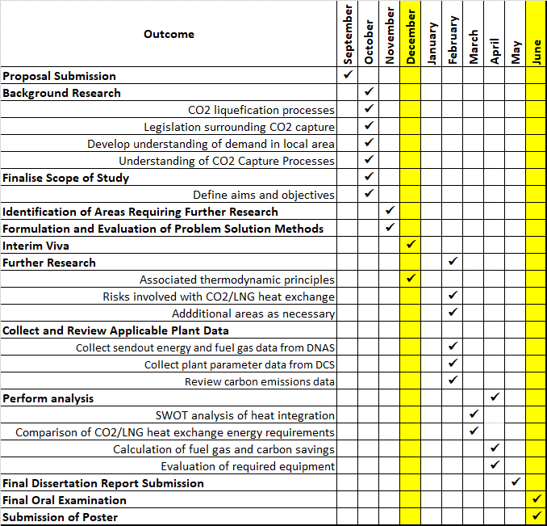
Report timing plan

Research Methods

Information Sources
A literature search has been conducted using the online library service provided by the University of Wales Trinity Saint David. The search made use of the EBSCOHost, Proquest Ebook Central, and VLeBooks databases. The use of these databases was determined due to their extensive collection of Engineering related research materials. The initial literature search was conducted on the 6th of October 2023 to begin background research. To gain an extensive understanding of existing research relating to this project, the following search terms were used: “carbon dioxide”, “carbon capture storage”, “liquified natural gas”, “liquefication”, “vaporisation”, “heat exchange”, “thermodynamics”, “latent heat”, “cold energy” and “heat integration”. The search terms were used in conjunction with one another as “inclusion” criteria where applicable to ensure the search results were applicable to this report. During the initial search, the exclusion criteria consisted of articles dated before 2019.
Following the initial literature search, it became evident that supporting articles from reputable media sources such as the BBC and Financial Times would be useful to frame the context of the report.
This report pertains to equipment specific to DragonLNG and as such confidential information stored on the DragonLNG “Documentum Apache Tomcat” server was used throughout the report. Examples of such documentation include the DragonLNG Operations manual (Watkins, 2024). These documents have not been appended to this report for matters of document control, although they can be requested for review where necessary.
The Emmerson “distributed control system” used to operate the DragonLNG terminal was accessed for historical plant data to improve the accuracy of figures used for data analysis. The plant data available is extensive and has been interrogated to support assumptions. Supporting data has been included in the appendices.
DragonLNG has a commercial interface known as the “Daily Nomination Allocation System” (DNAS). DNAS holds all commercial data and has been accessed to gather data on exported energy quantities, the volume of fuel gas used, and days on which gas was exported to the national grid. As the data collected from DNAS is commercially sensitive it has not been appended in this report although it can be made available upon request.

Ethical Considerations
The Engineering Council suggests all engineering professionals no matter age or skill level should have a duty to follow four principles focussed on ethical behaviour and decision making, Statement of Ethical Principles for the engineering profession (2017). On review of this statement, these principles closely align with those of the university as set out in the University Research Ethics & Integrity Code of Practice (2022). Examples of these common themes are honesty, transparency, and rigour. This report endeavours to follow these principles and the university guidelines strictly.

Glossary of Terms
BOG | Boil Off Gas
CO₂ | Carbon Dioxide
DLNG | DragonLNG
HP | High Pressure
LCO2 | Liquified Carbon Dioxide
LNG | Liquified Natural Gas
LP | Low Pressure
NRW | National Resource Wales
PNZC | Pembroke Net Zero Centre
PPS | Pembroke Power Station
SCV | Submerged Combustion Vapouriser
tCO₂e | Tonnes of CO2 Equivalent

Table of Contents
Declaration of Authenticity 1
Acknowledgements 1
Abstract 2
Timing Plan 3
Research Methods 4
Information Sources 4
Ethical Considerations 5
Glossary of Terms 5
List of Figures 8
List of Tables 9
1. Introduction 10
1.1 Company Background 10
1.2 Reasons and Relevance of Project 10
1.2.1 Pembroke Power Station 10
1.2.2 Carbon Capture 11
1.3 Aims & Objectives 11
1.4 Boundaries of Report & Assumptions 12
2. DragonLNG 13
2.1 Current Regasification Process 13
2.2 Submerged Combustion Vapouriser 14
2.3 Additional Examples of Heat Exchange at DragonLNG 16
2.3.1 Reliquefaction Plant (RP) 16
2.3.2 Boil Off Gas (BOG) Cooler 18
2.4 CO2 Liquification Opportunity 20
3. Review of Literature 21
3.1 Currently Associated Principles 21
3.1.1 Heat Exchange 21
3.2 CO2 Carbon Capture and Storage 24
4. Liquefaction of Carbon Dioxide 26
4.1 Considered Scenarios 26
4.2 Proposed Heat Exchange 27
4.3 SWOT Analysis of CO2 Liquefaction Proposal 28
5. Feasibility Study 29
5.1 Heat Exchanger Thermal Duties 29
5.1.1 Carbon Dioxide (CO₂) 29
5.1.2 Liquified Natural Gas (LNG) 32
5.1.3 Minimum LNG Mass Flowrate 35
5.1.4 Maximum CO2 Mass Flowrate 35
5.1.4 Summary of Findings 36
5.2 Associated Fuel Gas Cost Savings 37
5.2.1 Cost Saving of Consumed Fuel Gas 38
5.2.2 Cost Saving of Carbon Credits 39
5.2.3 Total Savings Comparison and Other Cost Considerations 39
5.3 Equipment Considerations 42
5.3.1 Carbon Dioxide Supply Pipeline 42
5.3.2 Vapouriser Technology 46
5.3.3 Liquified Carbon Dioxide Storage 48
6. Conclusion 53
7. Recommended Further Work 54
8. References 55
Appendices 61

List of Figures
Figure 2.1-1 – Regasification process flow at DragonLNG ……………………………..……..13
Figure 2.2-1 – A cutaway visual of an SCV (Yu, Sun & Yin, 2021)……………………….……14
Figure 2.2-2 – Aerial view of the six SCV’s located at DragonLNG……………………………15
Figure 2.3.1-1 – 3-D Model of Cold box utilised on DragonLNG’s Reliquefication plant……17
Figure 2.3.2-1 BOG Cooler located at DragonLNG……………………………………………..18
Figure 2.3.2-2 Shell & tube heat exchanger, (Parisher and Rhea, 2012)………..….………..19
Figure 2.4-1 – Phase diagram of LNG (Narheim et al, 2021)…………………………………..20
Figure 3.1.1-1 – Methane Phase Diagram (Engineers Toolbox, 2024)………………………..21
Figure 3.1.1-2 – Carbon Dioxide phase diagram, (Xin et al, 2021)……………………………22
Figure 4.2-1 – Visualisation of proposed heat exchange……………………………………….27
Figure 4.3-2 – SWOT Analysis of CO₂ liquefaction at DragonLNG……………………………28
Figure 5.1.1-1 – Enthalpy vs Temperature for Carbon Dioxide at 24.1bar (NIST)…………..29
Figure 5.1.2-1: Enthalpy vs Temperature curve for Methane at 120bar (NIST)………………32
Figure 5.1.2-1: Enthalpy vs Temperature curve for Methane at 100bar (NIST)………………33
Figure 5.2.3-1 – Graph of Cost Savings vs Costs Experienced………………………………..40
Figure 5.3.1-1 – Width of Milford Haven Waterway DragonLNG and PPS, (Google Earth, 2024)………………………………………………………………………………………….45
Figure 5.3.2-1 – Intermediary Fluid Vapouriser (Huang et al, 2023)…………………….…….46
Figure 5.3.3-1 – Current Layout of DragonLNG………………………………………………....47
Figure 5.3.3-2 – Spherical Storage Vessel (EPC Spherical Tank, 2023)………………..……48
Figure 5.3.3-3 – Cylindrical Storage Vessel (Pentair, 2024)………………………………..…..48

List of Tables
Table 1.4.1 - Composition of CO2 Supply to DragonLNG……………………………………...13
Table 4.1.1 – Process flow rates across various scenarios…………………………………….26
Table 5.2.3-1 – Comparison of Calculated Savings, 2023 Data…………………….…………39
Table 5.2.3-2 – Calculated Savings for Years 2021-2023……………………………..……….40
Table 5.3.2-3 Costs Saved as a Percentage of Total Cost, 2021-2023………………………41
Table 5.3.3-1 – Storage Volume Required Per Day……………………………………………..50

Introduction

1.1 Company Background
This report will explore aspects of the feasibly installing an integrated carbon dioxide liquefaction unit at the existing DragonLNG liquified natural gas (LNG) import and regasification facility located on the Milford Haven waterway in South-West Wales. (DragonLNG – Organisational Structure, 2024). The DragonLNG terminal received its first cargo in 2009 and can accept up to ninety-six shipments of LNG per year. DragonLNG is owned in a joint venture partnership between Shell and Ancala Partners Ltd, serving two throughput customers, Shell, and Petronas. On customer demand, DragonLNG regasifies LNG, which is exported into the national grid but is also able to exhibit zero-sendout conditions owing to their reliquefaction plant, commissioned in 2017.

1.2 Reasons and Relevance of Project

1.2.1 Pembroke Power Station
Pembroke Power Station (PPS) is a combined cycle gas turbine power station operated by RWE, located on the Milford Haven waterway opposite the DLNG terminal, Pembroke CCGT Power Plant (2023). PPS has 2.181GW of electrical generation capacity when all five units are operational.
Evidence of collaboration between DragonLNG and PPS already exists as members of the Celtic Freeport collaborating on a decarbonisation project described by Nye (2024) as a “multi-user service transit” (MUST) across the Milford Haven waterway, DragonLNG (2023).
RWE announced ambitious plans aimed towards decarbonisation which culminated in the form of the “Pembroke Net Zero Centre” (PNZC) launched in 2021, (RWE, 2021). The PNZC has several initiatives including the use of green hydrogen, floating offshore wind, and carbon capture, which is the focus of this report. The CCU project proposed by PPS is split into two scenarios, scenario one which will capture 1.3 million tonnes of carbon dioxide per year, and scenario two which will capture 2.55 million tonnes of carbon dioxide per year.

1.2.2 Carbon Capture
The capture of carbon dioxide emissions at PPS comes at a time when there is an industry wide movement towards net zero across the United Kingdom. The Department for energy security and Net Zero have set a commitment to have a decarbonised power system by 2035, 3. reducing emissions across the economy (2022). The Department for Energy Security and Net Zero (2023) describe the use of carbon capture and storage as a key technique to achieve this goal, expecting at least 5 MtCO2/year of engineered removals by 2030. Millard (2024) discusses the criticality of the current year as projects develop towards final investment decisions, noting that no major carbon capture project in the United Kingdom has reached such status yet.
A report of the largest carbon emitters in the Pembrokeshire Coast National Park Authority (2018) emphasises the importance of the carbon capture project at PPS. It was recorded that the PPS was responsible for an average of 1,088,512 tonnes of carbon dioxide per year, making it the only designated “major” emitter in the area. The second largest emitter was found to be South Hook LNG, although they emitted five times less volume of carbon dioxide compared with PPS.

1.3 Aims & Objectives
This report aims to evaluate three key aspects relating to the feasibility of liquefying carbon dioxide through a heat exchange with LNG within an existing LNG regasification terminal. To achieve this aim, the report looks to meet the following objectives:
- Introduce the potential synergy between a proposed Carbon Dioxide liquefaction plant with an existing Liquified Natural Gas (LNG) terminal.
- Define the various scenarios that have the potential to exist between the two LNG regasification and carbon dioxide liquefaction.
- Conduct a high-level SWOT analysis of the proposed project.
- Conduct a literature review of Carbon Capture and Storage and Cold Energy utilisation.
- Evaluate the thermal duties required to liquefy carbon dioxide and vapourise LNG.
- Calculate possible cost savings from operating carbon dioxide liquefaction.
- Discussion of equipment considerations including the feasibility of utilising a pipeline for carbon dioxide supply across the Milford Haven Waterway.

1.4 Boundaries of Report & Assumptions
This report assumes that the carbon dioxide capture process will be performed at PPS following the amine scrubbing process as set out by Rochelle (2009), first performed in the 1930s. The report assumes that gaseous carbon dioxide will be supplied to the DragonLNG terminal via pipeline with the gas composition seen in table 1.4-1.
Table 1.4-1 – Composition of CO2 Supply to DragonLNG

It is also assumed that the supply conditions of the carbon dioxide are a pressure of 24.1 bar and a temperature of 34ºC. The assumed pressure and temperature of the liquified carbon dioxide are 17.2 bar and -29.9 bar respectively. The assumptions for the carbon dioxide composition and conditions have been derived from discussion with Pembroke Power Station of their expectations for the project. It is assumed that there will be storage for between 2 and 7 days of liquified carbon dioxide to allow for regular shipping whilst also accounting for potential port delays.
This report assumes that a second jetty is feasible for carbon dioxide ship loading, based on the award of planning rights for a second jetty during the initial plant construction of DragonLNG. It also assumes that the United Kingdom government sanctions shipping as a viable export route and designates the Port of Milford Haven track two status. This report will comment on the export of carbon dioxide but not evaluate the jetty requirements in depth. There are synergies with the “Multiuser Service Tunnel” (MUST) project previously introduced, although these lie outside the boundary of this report, and it will be assumed that the carbon dioxide liquefication project will be executed as a stand-alone project.
The final assumption is that there is no significant change or deterioration in plant performance as current plant data has been used for figures of pressure and temperature within the regasification process.

DragonLNG

2.1 Current Regasification Process
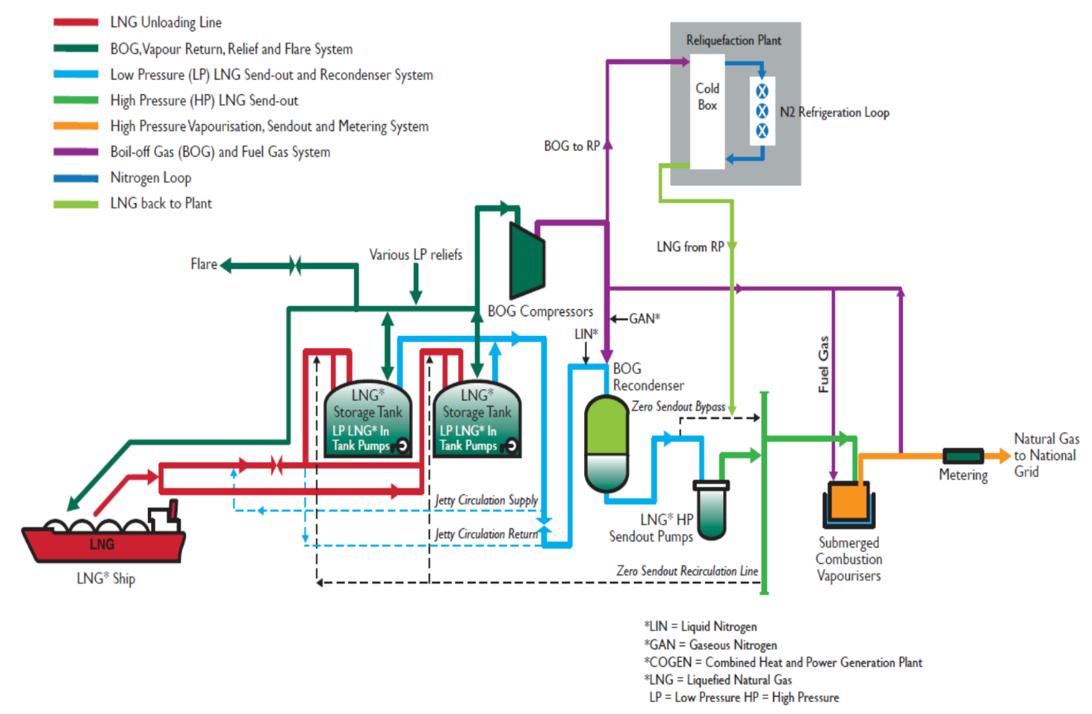
Figure 2.1-1 – Regasification process flow at DragonLNG

The regasification process utilised at the DragonLNG import terminal can be seen above in Figure 2. The regasification process is a common configuration across European liquefied natural gas (LNG) import terminals as described by Noor Akashah et al (2023). At DragonLNG the process begins by importing LNG via cargo carrier ships and pumping the LNG to be stored in two insulated tanks with a total 330,000m3 volume. Low pressure (LP) pumps situated inside each tank are utilised to generate a flow of LNG to a recondenser, which provides a head of liquid for five high pressure (HP) centrifugal pumps. The recondenser is also used to absorb boil off gas (BOG), approximately condensing 9 tonnes of BOG per hour during send out operations.
The HP pumps increase the LNG pressure up to 120 bar and supply six submerged combustion vaporisers (SCVs). LNG is vapourised in the SCVs creating a flow of natural gas that is exported to the National Grid at ambient temperature in a range of 54 bar to 94 bar, depending on national grid conditions. There is a strict specification that the gas must maintain with the Wobbe Index being a key factor, adjusted by DragonLNG using nitrogen injection.

2.2 Submerged Combustion Vapouriser
Generally, the vaporisation of LNG can occur using different mediums to provide the necessary heat transfer for the phase change from liquid to. At DragonLNG a submerged combustion vaporiser (SCV) uses water heated by burning fuel gas to provide heat input for phase change. Yu, Sun and Yin (2021) provide a visual representation of the heat transfer structure of an SCV which can be seen in figure 2.2-1. They also describe other methods of LNG vaporisation including “open rack vaporisers” (ORV) which utilise seawater for heat transfer, as well as ambient air vaporisers (ARV). In figure 2.2-2, an aerial view of the six SCVs found at DragonLNG can be seen.
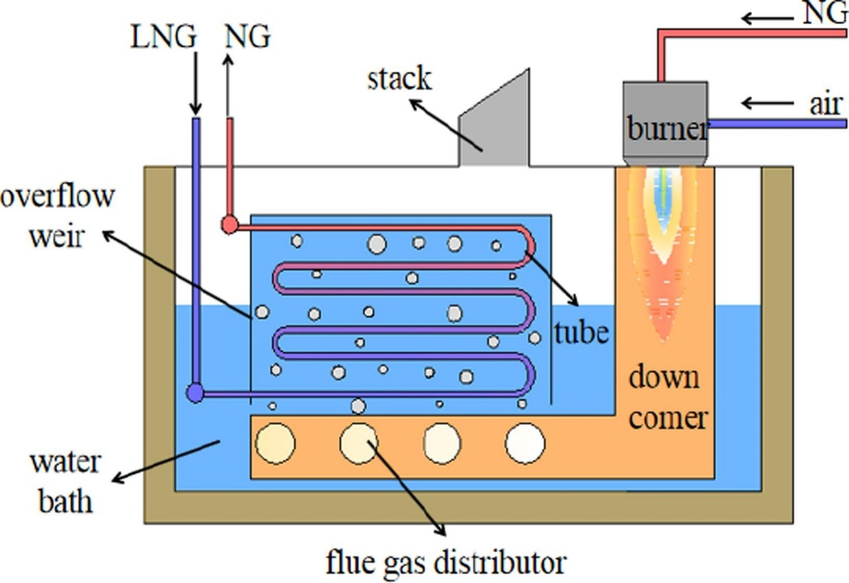
Figure 2.2-1 – A cutaway visual of an SCV, Yu, Sun & Yin (2021)

At DragonLNG, thermal energy is provided to the water bath through the combustion of natural gas (fuel gas). Flue gas is distributed into the water bath using sparges, heating the water evenly. LNG flows within a tube bundle situated in the water bath, where it absorbs the heat of the water bath and undergoes vapourisation. The natural gas exits the SCV, with control logic maintaining a 5oC outlet temperature by controlling fuel gas combustion.
During 2023, 615.3 GWh of fuel gas was consumed to meet the customers' send-out nominations. The commercial cost of associated with burning fuel gas as opposed to exporting it to the grid was £ 21.17 million. There are also associated carbon costs as burning fuel gas can contribute up to approximately 250,000 tonnes of carbon dioxide emissions per year, Pembrokeshire Coast National Park Authority (2018).
Reducing the volume of fuel gas utilised by liquefying carbon dioxide in the process can generate a significant cost saving for DragonLNG and its shareholders. Following the calculation of the thermal load that the carbon dioxide liquefication will utilise, these cost savings can be calculated.
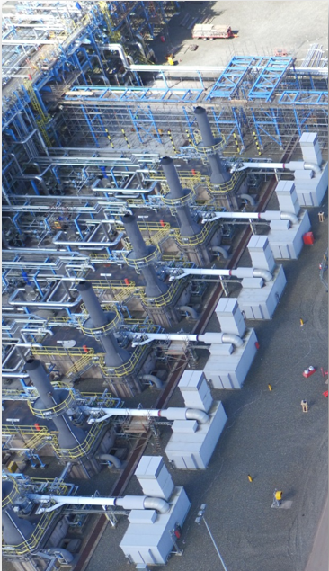
Figure 2.2-2 – Aerial view of the six SCVs located at DragonLNG
Water Bath
SCV Exhaust Stack
Combustion Air Blower

2.3 Additional Examples of Heat Exchange at DragonLNG

2.3.1 Reliquefaction Plant (RP)
Liquified natural gas (LNG) exists typically at -155ºC at atmospheric pressure, which are the storage conditions within the DragonLNG storage tanks. The LNG is maintained at this low temperature despite heat being absorbed from its surroundings through a process known as auto-refrigeration. As heat is absorbed by the LNG, boil off gas (BOG) is generated and removed from the storage tank, with the energy lost through this process being sufficient to maintain the remaining LNG as a liquid (Islam, 2023).
DragonLNG previously utilised a 50MW cogeneration power station of combined cycle gas turbine configuration to control BOG generation and maintain the storage tank pressures in the desired working range. Due to rising costs associated with the maintenance of aging equipment, and increasing environmental emissions regulation, a decision was made to decommission the power station. DragonLNG’s customers desired to maintain the current zero-sendout capability and so required an alternative means to manage storage tank pressures.
In 2015 construction commenced on a reliquefaction plant (RP), with the RP being commissioned in 2018 before the decommissioning of the cogeneration power plant. The objective of the RP unit is to re-liquify the generated BOG, returning it to the storage tanks as LNG and allowing the terminal to remain on “zero-sendout” mode with storage tank pressures maintained below 250mBar.
Nitrogen is cooled to a temperature of -168ºC and utilised as a refrigerant to re-liquefy BOG in a “Cold box”. The cold box is a heavily insulated three-pass aluminium plate and fin heat exchanger, which can be seen in figure 2.3.1-1. Nitrogen undergoes three stages of compression with air inter-coolers between each stage, compressing the nitrogen from a pressure of 6 bar to 40 bar. At 40 bar the nitrogen makes a first pass through the cold box to pre-cool the nitrogen from 37ºC to -112ºC. The precooled nitrogen then passes through an expander, dropping its pressure from 40 bar to 8 bar, with its temperature dropping from -112ºC to -168ºC. The nitrogen makes its second pass through the cold box, exiting at a temperature of 37ºC and returning to the first stage of the compression cycle. Boil off gas is supplied to the heat exchanger at 8 bar and 36ºC, exiting the cold box as LNG at -163ºC. LNG is then returned to the storage tanks using a centrifugal pump at a pressure of 15 bar. An overview of the reliquefaction plant can be seen in Appendix 1.

Figure 2.3.1-1 – 3-D Model of Cold box utilised on DragonLNG’s Reliquefication plant.
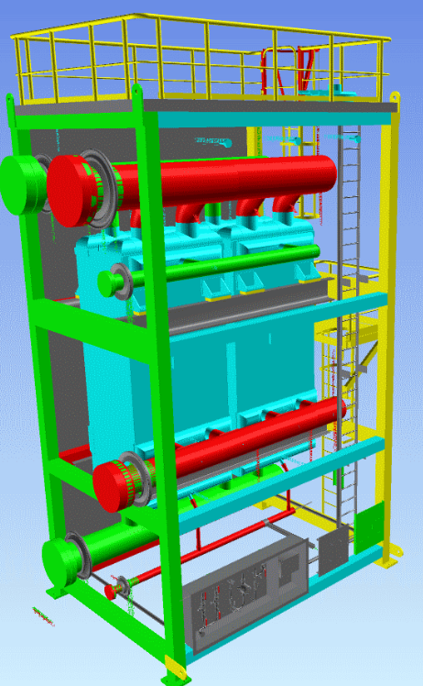
N2 supply from 3rd Stage
40bar, 37oC

N2 Outlet from Expander
8bar, 37oC
Plate & Fin
Heat Exchanger
BOG Inlet
8bar, 36ºC

N2 Outlet from 3rd Stage
40bar, -112ºC

N2 supply from Expander
8bar, -166ºC

LNG Outlet
-163ºC

Figure 2.3.1-1 above shows a cutaway 3D model to display the piping configuration within the cold box. This piping is surrounded by insulation known as perlite, as it is vital to maintain the correct temperature profile of the heat exchanger. Whilst having a high thermal efficiency when compared to other heat exchangers, plate and fin heat exchangers are susceptible to leakages from high heat transients (Heat Exchangers, 2023). In addition to the perlite insulation, the control system for cooling and warming the cold box is very precise to prevent additional stresses on the exchanger.

2.3.2 Boil Off Gas (BOG) Cooler
The boil off gas (BOG) cooler is a 304L stainless steel shell and tube heat exchanger used as part of DragonLNG’s regasification process. The principal purpose of the BOG cooler is to introduce heat to the flow of liquified natural gas (LNG) before it entering the submerged combustion vapourisers (SCV) to be vapourised. By introducing heat at this point, the LNG requires less energy input within the SCV to vapourise, and so fuel gas demand and associated costs are reduced. LNG flows through the tube side of the heat exchanger while the BOG gas passes through the shell side. The BOG flow exits the BOG cooler and enters the recondenser where it returns to a liquid state. The insulated bog cooler located at DragonLNG can be seen in figure 2.3.2-1.
Figure 2.3.2-1 BOG Cooler located at DragonLNG.
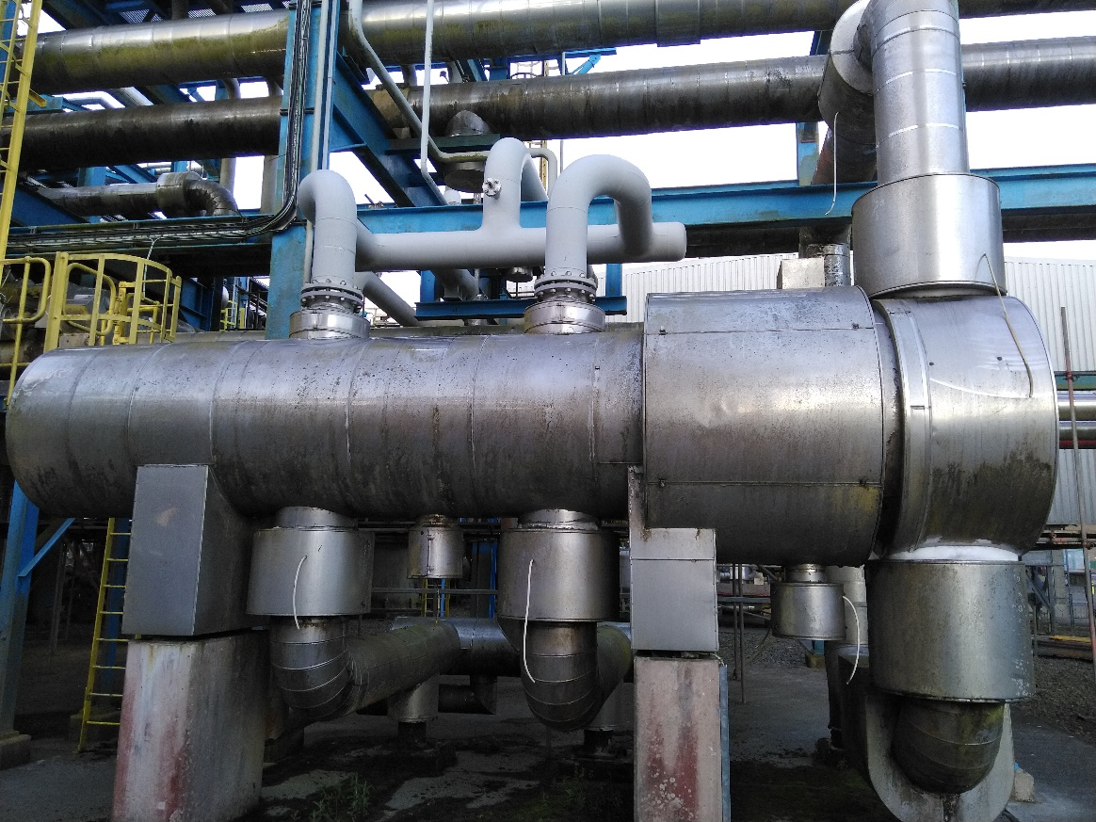
Shell Side In - BOG
Tube Side Out - LNG

Tube Side In - LNG
Shell Side Out - BOG

McGeorge (2012) makes a comparison of the advantages and disadvantages of both plate and fin heat exchangers, and shell and tube exchangers. It is suggested that shell and tube exchangers remain highly efficient at thermal transfer, although less so than plate and fin exchangers (Heat exchangers, 2023). One limitation noted is the need for a larger exchanger when using a shell and tube heat exchanger versus a plate and fin type exchanger, although this was suitable for DragonLNG’s regasification process on construction due to the lower cost of constructing shell and tube exchangers.
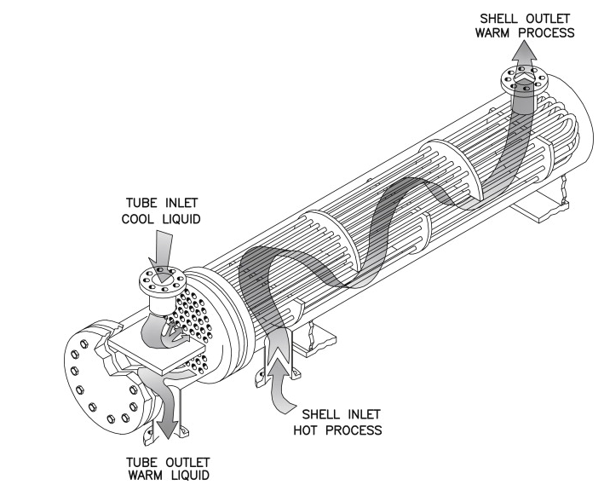

Figure 2.3.2-2 Shell & tube heat exchanger, Parisher and Rhea (2012)

Another disadvantage of shell and tube heat exchangers that McGeorge (2012) discusses is the common fouling of the tube bundle from the shell side fluid, and the requirement to remove the bundle for regular cleaning. Again, this issue does not occur regularly at DragonLNG due to the strict specification of the LNG and BOG that flow through the heat exchanger, with very little potential for trace elements to cause fouling. There are many designs of shell and tube heat exchangers with the number of passes and layout of baffles just two aspects that vary. A basic shell and tube heat exchanger can be seen above in figure 2.3.2-2.

2.4 CO2 Liquification Opportunity
The opportunity to liquefy carbon dioxide using a heat exchanger with liquified natural gas (LNG) exists downstream of the high-pressure (HP) pumps. This is due to the typical conditions of the LNG seen between the discharge of the HP pumps and the inlet of the submerged combustion vapourisers (SCVs). The pressure discharge of the pumps exists in a range of 100 bar to 120 bar, with an LNG temperature existing in a range of -137ºC to -150ºC dependent on the mass flow rate. The temperature and pressures quoted have been found from current plant data held on the DragonLNG distributed control system. There is evidence that due to the fixed output of the HP pumps, increasing flow rates have an associated drop in pressure at the SCV inlet.
Nerheim et al (2021) explore the phase diagram of LNG which exhibits a liquid and gas phase, including an area where both liquid and gas exist at the same time, this can be seen in figure 2.4-1. It is proposed that this stored cold is sufficient to successfully liquefy the carbon dioxide captured by CCS.
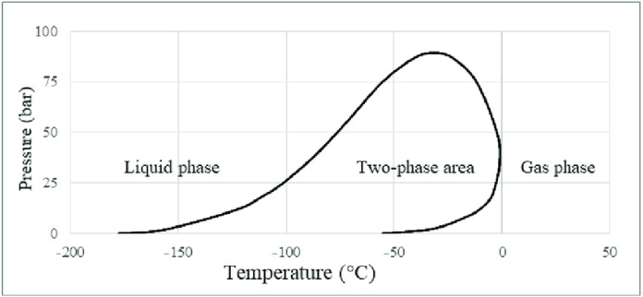
Figure 2.4-1 – Phase diagram of LNG (Narheim et al, 2021)

At present, the LNG is regasified at pressures of between 100 bar and 120 bar which leaves no potential for the two-phase area seen in figure 2.4-1 to exist within the SCV. Park et al (2019) describe this approach to LNG regasification as “cold-energy waste”, suggesting that cold energy could be better utilised. Examples include the provision of cooling for data centres, air separation, and carbon capture liquefication. These are all uses that Noor Akashah et al (2023) also explore and will be explored further in this report.

3. Review of Literature

3.1 Thermodynamics of Currently Observed Heat Exchange
Examples of heat exchanger have previously been discussed with regards to submerged combustion vapourisers (SCVs) in sections 2.2 and with respect to boil off gas liquefaction in section 2.3. The heat exchange within the SCVs occurs between the liquefied natural gas (LNG) flowing through the tube bundle, and the water situated in the water bath. Heat input is provided to the water bath through the combustion of methane fuel gas with flue gases sparged throughout the bath to disperse heat evenly.
Section 2.4 described the current regasification of LNG and the pressure conditions that prevent a two phase fluid of gas and liquid forming. This is further evidenced in the phase diagram of methane shown in figure 3.1.1-1 below.
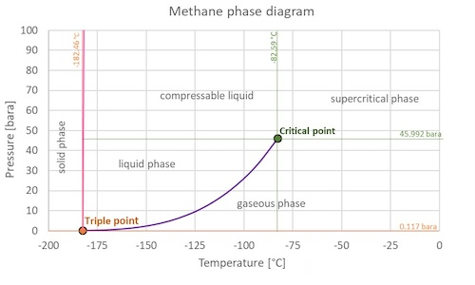
Figure 3.1.1-1 – Methane Phase Diagram (Engineers Toolbox, 2024)

Subcritical fluids require specific heat input or output to observe an increase or decrease in temperature, whilst also requiring a latent heat to undertake phase change at the phase boundary. For methane shown in figure 3.1.1-1 above, this is true at a pressure below 45.992 bar. As LNG is regasified at a pressure of between 100 bar and 120 bar, LNG enteres the SCV as a compressible liquid, transitioning to a supercritical fluid at temperature of 82.59ºC.
The transition of compressible liquid to supercritical fluid has no latent heat associated with phase transition, and so only specific heat needs to be considered (Hitchen and Dean 1993). This theory is challenged somewhat in description by Banuti et al (2019) who suggest a mechanism termed “pseudo-boiling” is observed across a finite range of the temperature change.
Turning to carbon dioxide at atmospheric pressure, carbon dioxide exists either in the solid or gaseous phase, subliming between the two during phase transition. When placed under pressure of 5.18 bar or more it becomes possible for carbon dioxide to be liquefied. The temperature and pressure parameters required to liquefy carbon dioxide are visually represented in figure 3.1.1-2.
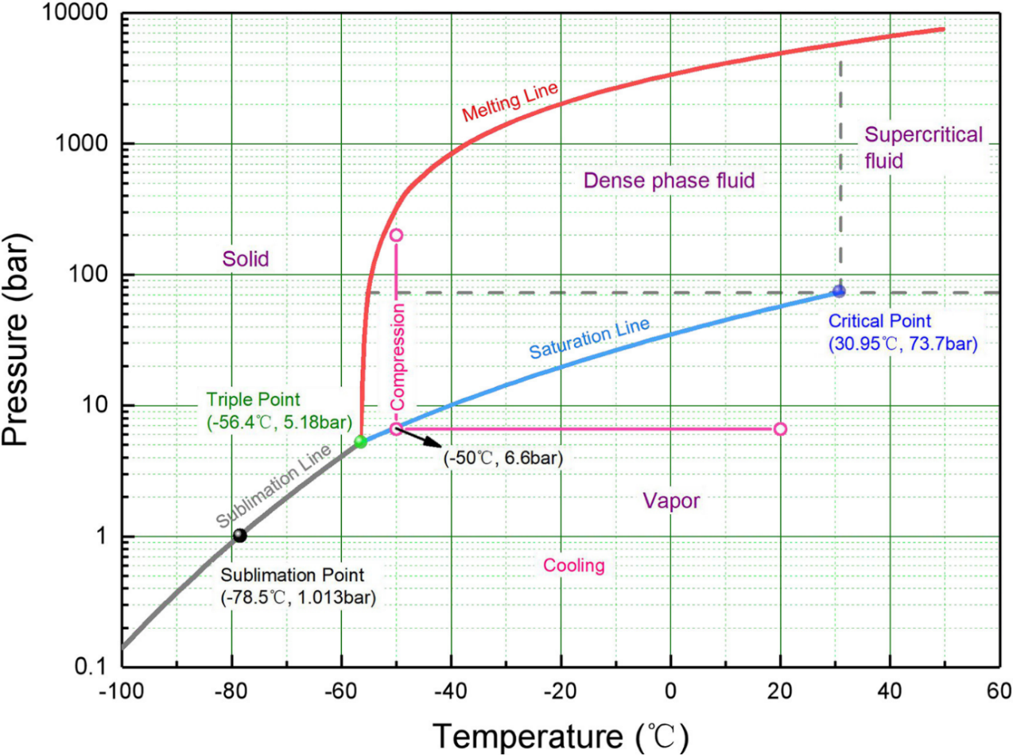
Figure 3.1.1-2 – Carbon Dioxide phase diagram, Xin et al (2021)
The importance of maintaining the liquefied carbon dioxide in the “dense phase fluid” stage is emphasised by Xin et al (2021) to prevent a solid product from forming which can cause equipment damage. Maintaining the liquified carbon dioxide in the dense phase fluid also reduces compression costs versus carbon dioxide in vapour form.

To calculate the heat transfer required to cause phase change, the latent and specific heat of vaporisation must be known. These are in handbooks such as that of Green, Southard and Perry (2019) but can also be found on the National Institute of Standards and Technology (NIST) website. Pauken (2011) explains that the latent heat of vaporisation and the latent heat of condensation are equal and change in relation to the pressure placed upon a fluid.

3.2 CO2 Carbon Capture and Storage
As climate change occurs there is a global effort to reduce the pace of which it is occurring, with a clear focus on reducing carbon emissions across the developed world. Carbon capture and storage (CCS) is one key strategy for mitigating climate change, although CCS remains largely under deployed. The literature on CO2 capture encompasses various methods, including pre and post-combustion capture in addition to emerging cryogenic technologies. This review collects findings from six key studies that focus on different aspects of CO2 capture, ranging from fundamental techniques to innovative technologies and their integration with cold energy processes.
A comprehensive review of methods for pre-combustion, post-combustion and oxy-fuel combustion carbon dioxide capture is provided by Madejski et al (2022). The authors further breakdown these methods into carbon capture techniques such as absorption, adsorption, membrane separation and chemical looping. The review describes the limitations and challenges associated with each technique and concludes that no single method is universally applicable, and application of a technique is unique to each carbon capture scenario.
Cryogenic separation is discussed by Madejski et al (2022) but is largely ruled out due to the expected cost associated with the technique. This is challenged by Shen et al (2022) who suggest there is potential for cryogenic technology to be applied to carbon dioxide capture in conjunction with other industrial processes. It is proposed that the integration of sympathetic processes that generate cold energy as a by-product such as carbon capture with liquefied natural gas regasification, has the potential to unlock significant energy efficiencies. The economic and thermodynamic implications of carbon dioxide compression-liquefaction in CCS systems is further explored by Xin et al (2021). The study focuses on utilising LNG cold energy and demonstrates the possibility to capture carbon dioxide whilst reducing energy consumption and associated operational costs. In doing so it is demonstrated that the utilisation of LNG cold energy can increase the economic viability of carbon capture, which has significant implications for large scale carbon dioxide capture projects.
An alternative to the use of cold energy, Yu, Gundersen, and Gençer (2021) examine the use of LNG cold energy in an Allam cycle power plant followed by carbon capture and storage. The Allam power cycle is described as a high-efficiency power generation process that inherently captures CO2 and benefits from the integration with LNG cold energy. This study highlights the potential for improved energy efficiency and reduced emissions through a detailed analysis of the implied energy conversion within an Allam power cycle process. This integration represents an innovative approach to combining power generation with carbon dioxide capture and storage.
Martin-Roberts et al. (2021) reflect on the progress of carbon capture and storage over the past decade, highlighting the mixed outcomes of these technologies. The study critiques the slow pace of adoption and the challenges faced by CCS projects, including regulatory hurdles, public acceptance, and high costs. Despite these setbacks, the authors identify promising trends, such as increased investment in CCS and a growing emphasis on carbon neutrality, suggesting that the next decade could see more significant progress in this area. The challenges faced by advancements in carbon capture technologies are further emphasised by Wilberforce et al (2021) who address challenges such as energy efficiency, cost and scalability. Both Martin Roberts et al (2021) and Wilberforce et al (2021) emphasise the need for continues research, innovation and deployment in this field.
To conclude, the literature of carbon capture technologies reveals a dynamic and evolving field with a range of methods and techniques. Madejski et al. (2022) provide a comprehensive overview of the traditional methods, while Shen et al. (2022) and Xin et al. (2021) explore innovative cryogenic technologies and their integration with LNG cold energy. Yu, Gundersen, and Gençer (2021) further demonstrate the potential for energy-efficient power generation with CO2 capture. Wilberforce et al. (2021) highlight the progress and challenges in carbon capture technologies, and Martin-Roberts et al. (2021) reflect on the setbacks and opportunities for future advancements. Collectively, these studies underscore the critical role of carbon capture in achieving carbon neutrality and mitigating climate change, while also pointing to the need for ongoing research and innovation to overcome existing challenges.

Liquefaction of Carbon Dioxide

4.1 Considered Scenarios
There are several scenarios to be explored which will influence the economic feasibility as well as opportunity of the proposed project. It is proposed that the carbon capture at Pembroke Power Station (PPS) will occur in two phases as previously discussed. The first phase will see 1.3 million tonnes of carbon dioxide per year exported from PPS, with the second phase increasing this export to 2.55 million tonnes per year.
There are also three defined commercial flow rates of natural gas export that DragonLNG operates as per their throughput agreement. The considered scenarios for comparison are seen in figure six. Minimum sendout describes the minimum export flow rate that the terminal can operate due to the minimum operating parameters of equipment such as the low pressure (LP) in-tank pumps. The send-out fiscal metering stream is also a constraining factor due to its calibration, an additional cause for 101 tonnes per hour to be the minimum terminal export rate per hour.
Maximum send out describes the highest flow rate that the customers can contractually demand, which will see DragonLNG incurring penalties for failing to meet. This flow rate is based on an N+1 operating philosophy, allowing maximum send out to be utilised while maintenance is carried out on an item of equipment, such as a submerged combustion vapouriser (SCV). Peak sendout is the maximum possible throughput that the customers can request and DragonLNG will endeavour to meet should equipment availability allow.
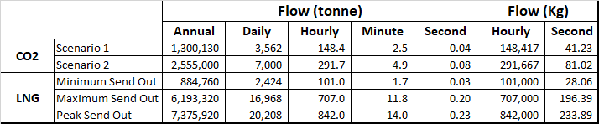
Table 4.1-1 – Process flow rates across various scenarios
The three commercial flow rates at DragonLNG are commonly referenced in energy quantities. This is due to natural gas being sold in terms of energy rather than volume. Minimum sendout of natural gas is 36.1GWh, with Maximum sendout being 252GWh and peak sendout being 298GWh. Approximate flow rates have been included relative to the typical LNG composition found at DragonLNG.

4.2 Proposed Heat Exchange
Heat exchangers are devices used to facilitate the heat transfer between two or more fluids of differing temperatures (Balaji et al, 2021). Heat exchangers can achieve different outcomes depending on the process parameters, leading them to be known as different items of equipment such as condensers, evaporators, or economisers for example.
A simple visualisation of the proposed heat exchange between liquified natural gas (LNG) and carbon dioxide can be seen in figure 4.2-1. The diagram serves to understand which fluid is known as the “cold” and “hot” fluid, as well as the temperature differences observed at the respective inlets and outlets of the heat exchanger.

Figure 4.2-1 – Visualisation of proposed heat exchange
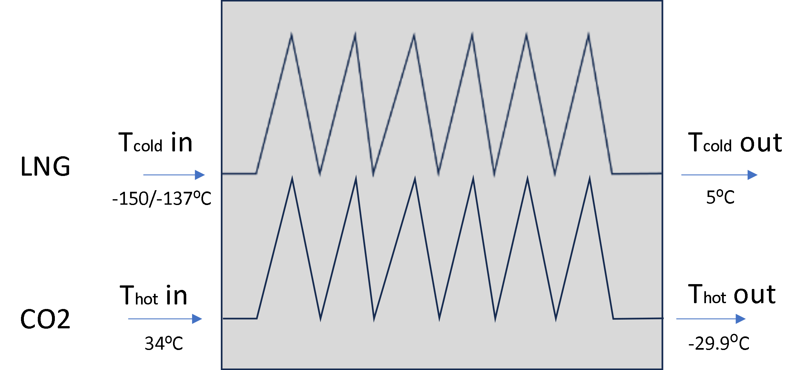

The diagram in figure 4.2-1 is for visualisation purposes and does not indicate whether the heat exchanger will be a parallel or counter flow exchanger as this is yet to be determined.

4.3 SWOT Analysis of CO2 Liquefaction Proposal
To better understand the internal and external advantages and disadvantages of integrating a carbon dioxide liquefaction a SWOT analysis has been performed. The SWOT analysis is described by Haan (2024) as a simple four-box framework that can be used to initiate strategic thinking, although Haan (2024) cautions the ease of including assumptions within a SWOT analysis and suggests further tools should be used to mitigate this possibility. Helms and Nixon (2010) also suggest the use of SWOT analysis as a useful tool to kickstart a project, although they also emphasise the limitations of the tool to a greater extent, suggesting the analysis is often vague and lacks sufficient context for effective strategic thinking. Despite its limitations, a SWOT analysis has been performed for this project following the literature review to provide context for the aspects under evaluation in the feasibility study. Figure 4.3-1 shows the outcome of the SWOT analysis performed for this report. The analysis highlights additional issues that would need to be evaluated outside of the feasibility study within this report, including changes to the current DragonLNG throughput agreement, challenge from residents and the challenges of constructing a second jetty at the terminal.
Figure 4.3-2 – SWOT Analysis of CO₂ liquefaction at DragonLNG

Feasibility Study

5.1 Heat Exchanger Thermal Duties

5.1.1 Carbon Dioxide (CO₂)
Carbon dioxide will be received in a gaseous state and condensed to a liquid state within the heat exchanger. To do this, sensible heat will be removed until the gaseous carbon dioxide reaches a temperature of -13.275ºC. At this temperature latent heat of condensation will be removed until the carbon dioxide undergoes a phase transition to a liquid. There will then be additional sensible heat removed until the liquid carbon dioxide reaches the desired temperature of -29.9ºC. This is visually represented in figure 5.1.1-1.
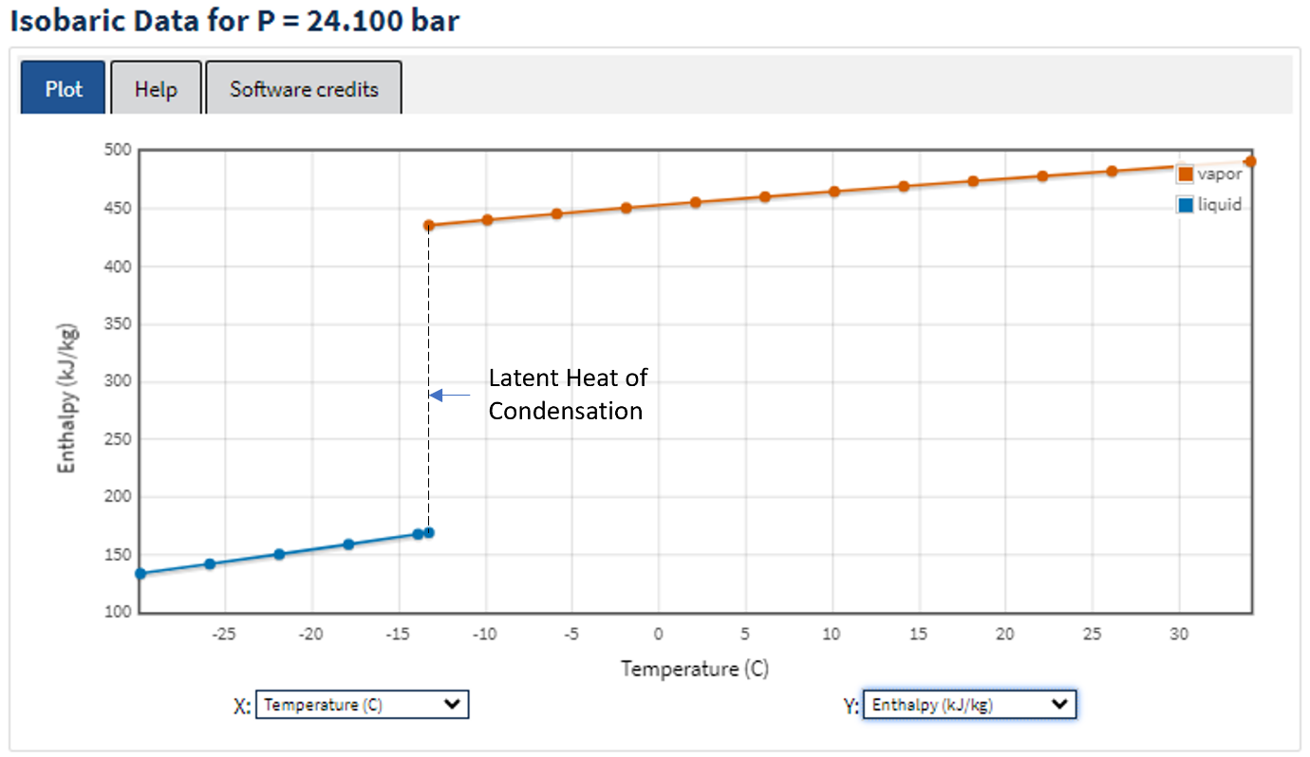
Figure 5.1.1-1 – Enthalpy vs Temperature for Carbon Dioxide at 24.1bar (NIST)
To find the total thermal duty the sensible heat removed from both vapour and liquid phase, and the latent heat of condensation must be determined. The formula used to find the sensible heat removed is:
$$\dot{Q}= \dot{m}* ∆H$$
From the NIST data shown in table X, the following is derived. At 24.1bar and 34ºC the enthalpy is 491.41 kJ.kg⁻¹ and at -13.275ºC it is 435.94 kJ.kg⁻¹. This gives a change in enthalpy of:
$$∆H=H_{2}- H_{1}$$
$$∆H=491.41-435.94$$
$$∆H=55.47 kJ.{kg}^{-1}$$
Scenario one of the carbon dioxide export has a mass flow rate of 41.23 kg.s⁻¹ and the second scenario of export has a mass flow rate of 81.02 kg.s⁻¹.
Using the above equation the sensible heat during vapour phase can be found for both project scenarios:
$$Phase One: \dot{Q}=41.23*55.47$$
$${\dot{Q}}_{vap}=2,287 KWh$$
$$Phase Two: \dot{Q}=81.02*55.47$$
$${\dot{Q}}_{vap}=4,494 KWh$$
The sensible heat removed from the liquid carbon dioxide occurs between -13.275ºC and -29.9ºC, with enthalpy values of 169.16 kJ.kg⁻¹ and 133.56kJ.kg⁻¹. Again, the change in enthalpy can be found:
$$∆H=169.16-133.56$$
$$∆H=35.6 kJ.kg^{-1}$$
Using the previously described mass flow rates with the change in enthalpy during the liquid phase, the following sensible heat values are found:
$$Phase One: \dot{Q}=41.23*35.6$$
$${\dot{Q}}_{Liq}=1,467 KWh$$
$$Phase Two: \dot{Q}=81.02*35.6$$
$${\dot{Q}}_{Liq}=2,884 KWh$$
The final component to be calculated is the latent heat of condensation, L_{v} associated with the phase change. At -13.275ºC the enthalpy of the gaseous carbon dioxide is 435.94kJ.kg⁻¹. The enthalpy of the liquid carbon dioxide at -13.275ºC is 169.16 kJ.kg⁻¹. Therefore:
$$L_{v}=H1-H2$$
$$L_{v}=435.94-169.16$$
$$L_{v}=266.78 kJ.{kg}^{-1}$$
The thermal duty for phase transition can be found as a product of latent heat and mass flow rate:
$$Scenario One: \dot{Q}=41.23*266.78$$
$${\dot{Q}}_{L_{v}}=10,999 KWh$$
$$Scenario Two: \dot{Q}=81.02*266.78$$
$${\dot{Q}}_{L_{v}}=21,697 KWh$$
The total thermal duty can be found by the sum of the sensible and latent heats, described below:
$${\dot{Q}}_{total}= {\dot{Q}}_{Vap}+ {\dot{Q}}_{Liq}+{\dot{Q}}_{L_{v}}$$
$$Scenario One: {\dot{Q}}_{total}=2,287+1,467+10,999$$
$${\dot{Q}}_{total}=14,753 KWh$$
$$Scenario Two: {\dot{Q}}_{total}=4,494+2,884+21,697$$
$${\dot{Q}}_{total}=29,075 KWh$$

5.1.2 Liquified Natural Gas (LNG)
The critical pressure for Methane is 45.992bar with the critical temperature being -82.586ºC. liquified natural gas (LNG) is delivered for vapourisation from the high pressure (HP) pumps at a pressure of between 100bar and 120bar, and a temperature of between -137ºC and -150ºC. Under these conditions the LNG exists as a compressible fluid.
The current heat exchange within the submerged combustion Vapouriser (SCV) see’s the LNG vapourised and exit the SCV at a pressure of above 55bar and at a temperature of 5ºC. During the calculation of thermal duty, it will be assumed that vapourised LNG will exit the carbon dioxide heat exchanger at a temperature of 5ºC. At a pressure of above 55bar and temperature of 5ºC, the methane will be in a supercritical phase.
There is no latent heat associated with phase changes to a supercritical fluid, and so only sensible heat needs to be considered. This is visually evidenced in the graph of temperature and enthalpy generated using the NIST database seen in figure 5.1.2-1.
With no associated latent heat, the following equation can be used to determine the thermal duty within the heat exchanger with respect to the methane flow.
$$\dot{Q}= \dot{m}* ∆H$$
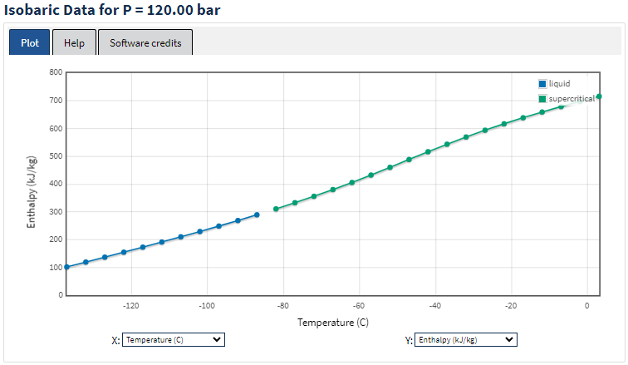
Figure 5.1.2-1: Enthalpy vs Temperature curve for Methane at 120bar (NIST)
At a temperature of -137ºC the enthalpy of Methane is found to be 101.71 kJ.kg⁻¹ and at a temperature of 5ºC the enthalpy is found to be 722.32 kJ.kg⁻¹. These values can be found in Appendix 3.2.
$$∆H=H_{2}- H_{1} \\ ∆H=722.32-101.71$$
$$∆H=620.61 kJ.{kg}^{-1}$$
Minimum send out infers a flow rate of 101 tonnes per hour of liquified natural gas, equivalent to a mass flow rate of 28.06 kg.s⁻¹. The heat transfer necessary for this scenario can be calculated as follows:
$$\dot{Q}=28.06*620.61$$
$$\dot{Q}=17,414.32 kWh$$
$$\dot{Q}=17.414 MWh$$
Repeating this process to determine the enthalpy change associated with maximum conditions, the NIST database returns a very similar enthalpy vs temperature curve as can be seen in Figure 5.1.2-2.
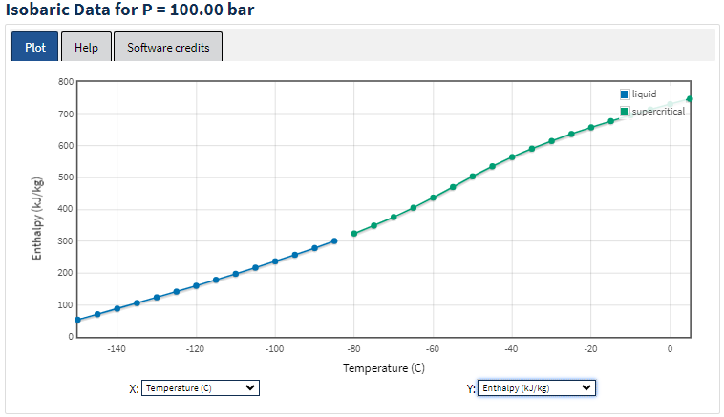
Figure 5.1.2-2: Enthalpy vs Temperature curve for Methane at 100bar (NIST)
At -150ºC the enthalpy of Methane is found to be 53.956 kJ.kg⁻¹ and at a temperature of 5ºC the enthalpy is found to be 746.89 kJ.kg⁻¹. These values can be found in Appendix 3.3 and the change in enthalpy can be calculated.
$$∆H=746.89-53.956$$
$$∆H=692.934 kJ.{kg}^{-1}$$
Maximum sendout infers a flow rate of 707 tonnes of LNG per hour, equivalent to 196.39 kg.s⁻¹.
$$\dot{Q}=692.934*196.39$$
$$\dot{Q}=136,085.31 Wh$$
$$\dot{Q}=136.09 MWh$$

5.1.3 Minimum LNG Mass Flowrate
As seen in figure eight on page nineteen, the liquified natural gas (LNG) mass flow rate associated with minimum sendout at DragonLNG requires 17.414 MWh to regasify. This is in comparison of the calculated 14.753 MWh and 29.075 MWh required to liquefy the first and second scenarios of carbon dioxide capture and export at Pembroke Power station (PPS) respectively. There is sufficient cold energy available in the minimum send out flow rate of LNG to liquefy the first scenario of CO2 storage, but not for the second scenario proposed.
The minimum flow rate of LNG to provide sufficient cooling to the second scenario of carbon dioxide flowrate can be calculated as follows:
$$\dot{m}=\frac{Q}{∆H}$$
$$\dot{m}=\frac{29,075}{620.61}=46.84kg.s^{-1}$$
This flow rate can be converted back to tonne per hour for comparison with DragonLNG’s commercial flow rates. In doing so it is understood that a flow rate of approximately 168 tonnes per hour of LNG is necessary to provide sufficient thermal duty to liquefy the full mass flow rate observed in scenario two of carbon dioxide capture, whilst regasifying the LNG as desired.

5.1.4 Maximum CO2 Mass Flowrate
This equation can also be used to understand the maximum mass flow rate of carbon dioxide that can be liquefied at DragonLNG’s peak flow rate. It has been shown previously in figure 6 that at “peak flow rate”, the mass flow rate of LNG per hour is 233.89kg.s⁻¹, therefore the thermal duty of the LNG at peak flow rate is:
$$\dot{Q}=233.89*620.61$$
$$\dot{Q}=145,154.5 kWh$$
A simple comparison of thermal duties shows that at peak mass flow rate of LNG through the DragonLNG terminal, there is sufficient thermal duty to liquefy approximately five times the mass flow of carbon dioxide found in phase two of the PPS carbon capture project, approximately 34,950 tonnes of carbon dioxide per day.
$$Peak LNG flow rate vs Phase two CO2 required thermal duty \\ \frac{145,154.5}{29,075}=4.992$$

5.1.4 Summary of Findings
To summarise, it was found that the minimum LNG flowrate of 101 tonnes per hour was sufficient to liquefy the mass flow rate of scenario one of the carbon dioxide project, but not for scenario two. To meet the second scenario, an increased mass flow rate of LNG to 168 tonnes per hour is required. Should the project be further progressed, conversations with the customers of DragonLNG should be sought to understand the appetite for increasing the minimum LNG throughput of the terminal to coincide with the second scenario carbon dioxide mass flow rate.
Should there be additional demand from other carbon capture sites on the Milford Haven Waterway, there is additional carbon dioxide liquefaction capacity at DragonLNG dependent on send-out rates. At peak flow rate, DragonLNG can liquefy up to 34,950 tonnes of carbon dioxide per day, although this would need to be matched with liquefaction plant and storage design.

5.2 Associated Fuel Gas Cost Savings

Liquified natural gas (LNG) that is vapourised in the process of liquefying carbon dioxide will contribute to customers export volumes without requiring the usage of fuel gas for vapourisation purposes. Of the natural gas exported to the grid, 1.3% is required to be utilised as fuel gas, Watkins (2024). DragonLNG currently reimburses its customers for the usage of fuel gas, with the expense calculated using the natural gas spot price and the volume of fuel gas consumed. Reducing fuel gas consumption will also reduce DragonLNG’s carbon emissions, which has an associated cost as the company are required to participate in the UK “Emission Trading Scheme” (UK ETS) (Natural Resources Wales, 2024).
In 2023, DragonLNG exported 48,411.93GW of natural gas to the national grid and consumed 615.3GW of natural gas as fuel gas in the process. Data extracted from the commercial system used at DragonLNG known as DNAS, “Daily Nomination Allocation System”, was used to collect these figures. The data also shows that in 2023 DragonLNG exported natural gas into the national grid on 228 days, with the remainder of the year utilising “Zero-Sendout” mode.
Natural gas prices have been volatile in recent years with geopolitical events having a significant impact on the spot natural gas price. Data from the office for national statistics (System average price, 2024) has been used to calculate an average natural gas price of £34,407.59 per GWh for 2023. This compares with an average gas price of £71,000 per GWh for 2022 and £39,000 for 2021 as reported by DragonLNG (Companies House, 2023).
DragonLNG are required by law to monitor and report their carbon emissions from scope one and scope two sources. The majority of their scope one carbon emissions are through the direct burning of fuel gas within the submerged combustion vapourisers (SCV’s). These emissions are visualised on a company tracker hosted on Microsoft PowerBI. The monthly and total carbon emission for the year of 2023 can be seen in Appendix 4, showing a total annual carbon emission output of 110,971 tCO2e for scope one emissions. By dividing the total carbon emissions per tonne by the amount of fuel gas consumed in GWh, it can be calculated that burning one GWh of fuel gas in an SCV generates 180.35 tCO2e. During 2023 the price of UK ETS carbon credits fell to a yearly average of €65/tonne (Reuters, 2024), which is the equivalent to approximately £56 per tonne.

5.2.1 Cost Saving of Consumed Fuel Gas
The total thermal duty necessary to liquefy the phase two flowrate of carbon dioxide found in section 5.1.1 equalled 29,075 kWh or 29.075 MWh. Calculating for 24 hours in a day and 228 days per year of sendout as DragonLNG experienced in 2023, this equals an energy requirement of 697.8 MW per day and 159,098 MW or 159.098 GW per year. Using the average natural gas price of £34,407.59 per GW calculated for 2023, utilising carbon dioxide liquefaction instead of burning fuel gas could save:
$$Cost saving of Fuel Gas=34,407.59*159.098$$
$$Cost Saving of Fuel Gas= £5,474,192$$
As DragonLNG consumed 615.3GW of fuel gas in 2023, at a calculated average natural gas price of £34,407.59 per GWh, it can be calculated that the cost of fuel gas for 2023 was £21,170,990.
$$Cost of Fuel gas in 2023=£34,407.59*615.3$$
If scenario two of the carbon dioxide liquefication was installed, a cost reduction of 25.9% of fuel gas can be calculated based on 2023’s sendout figures.
$$Cost saving as a percentage= \left(\frac{£5,474,192}{£21,170,990}\right)*100$$

Should DragonLNG change their operating method and become a baseload exporter of natural gas, exporting natural gas to the national grid every day of the year, there is potential further cost savings whilst maintaining the current levels of export. For the year of 2023 DragonLNG exported 48,411.93 GW of natural gas and consumed 615.3 GW as fuel gas over 228 days of sendout. Assuming the liquefaction of carbon dioxide occurred daily as the natural gas send-out profile was adjusted to daily sendout, the reduction of fuel gas energy required would increase from 159,098MW per year to 254,697MW per year. This is an increase in savings of approximately 62.5%. This will be discussed further in section 5.2.3.

5.2.2 Cost Saving of Carbon Credits
As discussed earlier in Section 5.2, 1GWh of fuel gas consumed to vapourise LNG currently generates 180.35 tCO2e of emissions. We have previously found that the thermal duty to liquefy the annual volume of carbon dioxide imported during scenario two reduces the fuel gas requirement by 159,098MW or 159.098GW in energy terms over a 228 day period.
With this information it can be calculated that during 2023, a carbon dioxide liquefication heat exchanger would have produced 28,693 tCO2e fewer carbon dioxide emissions from fuel gas combustion.
$$Carbon emission reduction=159.098* 180.35$$
At a UK ETS average carbon price of £56 per tonne for 2023, this would have an associated cost saving of £1,606,808.
$$Carbon cost saving=£56*28,6893$$

5.2.3 Total Savings Comparison and Other Cost Considerations
The calculations performed in sections 5.2.1 and 5.2.2 have been performed to find the associated cost savings for the carbon dioxide mass flow rate in scenario one of the Pembroke Power station (PPS) project on both a 228 day per annum basis as seen in 2023, and a 365 day per annum basis. The figures calculated can be seen in Table 5.2.3-1 for comparison.
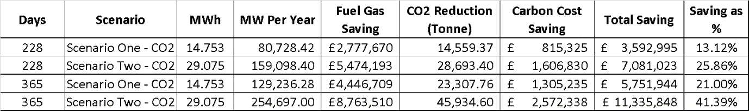
Table 5.2.3-1 – Comparison of Calculated Savings, 2023 Data.

There are additional associated costs associated with the reduction of fuel gas consumption such as the reduced electricity requirement to operate the 450kW air blower on each submerged combustion vapouriser (SCV) operated. Another cost reduction that would be experienced is the reduced demand for caustic chemical to balance the acidic pH of the SCV water baths caused by fuel gas emissions.
Following the calculation of savings based on data from 2023, the calculations were performed again for scenario two of the carbon liquefaction project based on data from 2021 and 2022. It has already been noted that during recent years the gas and carbon UK ETS prices have been volatile due to geopolitical events. Table 5.2.3-2 shows the yearly figures calculated including the average gas price and carbon pricing for both 2021 and 2022.
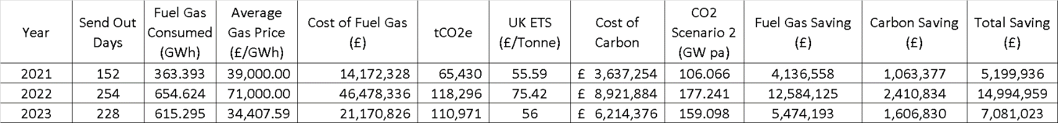
Table 5.2.3-2 – Calculated Savings for Years 2021-2023

The figures calculated show a cost saving ranging from approximately £5.2m per year to approximately £15m per year. A visual representation of the costs saving versus the total cost experienced can be seen in figure 5.2.3-1 below.
Figure 5.2.3-1 – Graph of Cost Savings vs Costs Experienced

The difference of approximately £10m of cost savings is largely down to the magnitude of increase that the gas price experienced in 2022. An evaluation of the costs saved as a percentage of total cost experienced shows the volatility in savings to be much narrower. This can be seen in table 5.3.2-3.
Table 5.3.2-3 Costs Saved as a Percentage of Total Cost, 2021-2023.

The percentage saving appears to be largely driven by the send-out profile of the terminal, with the key influencing factors being send-out volume and incurred fuel gas demand along with send-out days per year. As the thermal duty saved by the carbon dioxide heat exchange is fixed to a maximum of 29.075MWh or 697.8MWd, that there will be a great cost saving as a percentage on years with greater numbers of send-out days for the same natural gas export. This has been demonstrated previously in the increased percentage saving over a 365 day period of send-out versus the customers current send-out/zero send-out profile shown in table 5.2.3-1.
Further work including the input of customers would be required to determine if there was sufficient demand to change the send-out profile of DragonLNG. A key consideration is the seasonal fluctuation of gas price from winter to summer prices. Understanding of the change to customers profit margin from typically exporting during the winter months, to exporting on a base load profile must be understood and compared with savings found from liquefying carbon dioxide. Another factor for consideration is the maintenance schedule at DragonLNG. While the terminal operates a N+1 maintenance philosophy, large maintenance outages on the regasification plant are currently scheduled for the summer months to coincide with the typical period of zero-sendout. During the winter months when DragonLNG is typically exporting natural gas, maintenance is scheduled for the Reliquefaction plant. Any alterations to send-out profile will likely require amendments to the current maintenance schedule, with costs and availability deduction for doing so evaluated.

5.3 Equipment Considerations

5.3.1 Carbon Dioxide Supply Pipeline
A key consideration for the feasibility of the proposed project is the ability to supply gaseous carbon dioxide across the Milford Haven waterway, from Pembroke Power Station (PPS) to DragonLNG. It is assumed that this pipeline can be directional drilled and installed through the waterway bedrock. This feasibility study looks to calculate the pipeline size requirement for Phase 2 of the carbon dioxide project as this will be the maximum mass flow rate of carbon dioxide produced at the Pembroke Power Station.
It is known that the following is true:
$\dot{m}= ρ* A* V$ Where: $\dot{m}$ = Mass flow rate (kg.s⁻¹)
$ρ$ = Gas density (kg.m⁻³)
v = Velocity (m.s⁻¹)therefore :
$$A=\frac{\dot{m}}{ρ* v}$$
It is also known that
$A =\frac{π*D^{2}}{4}$ Where: A = Area (m²)
D = Diameter (m)
Therefore
$$D= \sqrt{\frac{A*4}{π}}$$
Substituting the first equation into the second:
$$D= \sqrt{\frac{\left(\frac{\dot{m}}{ρ*v}\right) * 4}{π}}$$
Mass flow rate was previously calculated and a figure of 81.02kg.s⁻¹ was obtained. The velocity of carbon dioxide within the system is currently unknown. Knoope et al (2013) expect velocities of carbon dioxide gas within a pipe to travel at between 5ms⁻¹ and 20ms⁻¹. Siegfanz et al (2024) found carbon dioxide to travel at a velocity of 11.8ms⁻¹ and 28.1ms⁻¹ although Peletiri et al (2018) argue velocities should not exceed 20ms⁻¹ for a gaseous flow. Peletiri et al (2018) continue by suggesting that 15ms⁻¹ should be used as a value of velocity when designing gas pipelines. For this calculation 5ms⁻¹ will be used to find a maximum pipeline diameter, and 20ms⁻¹ will be used to find the minimum pipeline diameter. The gas density is not currently known but can be calculated using the ideal gas law as follows:
$ρ= \frac{P}{R*T}$ Where: P = Pressure (Pa)
R = Gas constant J.kg⁻¹.`K⁻¹ t = Temperature (K)
The working assumption for pressure is 24.1bar, equivalent to 24.1x10⁵ Pa.
The gas constant R, for CO2 is 188.9Jkg⁻¹k⁻¹ (Pauken, 2011).
The working assumption for Temperature is 34ºC, equivalent to 307.15 K.
Therefore:
$$ρ= \frac{2,410,000}{188.9*307.15}$$
$$ρ=41.54kg.m^{-3}$$
With the gas density calculated, the pipe diameter can now also be calculated:
For a velocity of 5ms⁻¹:
$$D=\sqrt{\frac{\left(\frac{81.02}{41.54*20}\right)*4}{π}}$$
$$D= \sqrt{\frac{0.09752*4}{π}}$$

$$D=0.704m or 27.71 inches$$
For a velocity of 20ms⁻¹:
$$D=\sqrt{\frac{\left(\frac{81.02}{41.54*20}\right)*4}{π}}$$
$$D= \sqrt{\frac{0.09752*4}{π}}$$

$$D=0.352m or 13.86 inches$$

From the calculations it can be suggested that the minimum internal pipeline diameter should be 352mm and the maximum internal pipeline diameter should be 704mm.
Mohitpour et al (2012) describe pressurised carbon dioxide pipelines as largely being made of carbon steel. Jacobson (2014) supports this categorisation and discusses the challenges brought by transporting carbon dioxide in carbon steel pipelines, highlighting the common issue of “sweet corrosion” within these pipelines. It is suggested that this method of corrosion is caused by small volumes of water entrained within the carbon dioxide, forming carbonic acid thus creating the potential for corrosion. Water concentrations will need to be tightly monitored at PPS and other methods of inhibiting this corrosion mechanism explored.
There are two possible methods of installing the pipeline connecting DragonLNG and PPS across the Milford Haven Waterway. These methods are horizontal directional drilled (HDD) pipeline similar to techniques commonly used in the offshore oil and gas industry, or a trench laid pipeline on the riverbed similar to the “Multi-User Service Transit” (MUST) currently being evaluated between the two companies. A significant challenge to either method of installing the pipeline is the categorisation of the Milford Haven Waterway as part of the “Pembrokeshire Marine Special Area of Conservation (SAC), as well as the foreshore at both DragonLNG and PPS being areas included in the Milford Waterway Site of Specific Scientific Interest (SSSI). Both categorisations bring increased scrutiny and permitting challenges with a likely increased cost in ensuring all regulatory compliance is met.

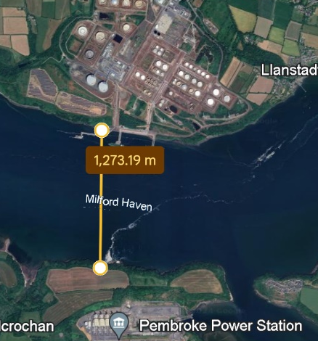
Figure 5.3.1-1 – Width of Milford Haven Waterway DragonLNG and PPS, Google Earth (2024).

The distance between DragonLNG and PPS is approximately 1.25km as seen in figure 5.3.1-1 above.
There is recent evidence of horizontal directional drilling being utilised in the UK to improve the natural gas infrastructure. In 2020 a new pipeline was installed across the Humber estuary, which has similar designations of special area of conservation (SAC) and site of specific scientific interest (SSSI). The pipeline installed was contained within a 3.65m diameter tunnel of 3km length (National Grid, 2020), showing the potential feasibility of installing a carbon dioxide pipeline in the Milford Haven Waterway.

5.3.2 Vapouriser Technology
Following a comprehensive literature review, there is a lack of evidence to suggest that direct carbon dioxide to liquified natural gas (LNG) heat exchangers are commercially available. This could be due to the infancy of the cold integration sector and a research focus on the proposal of new systems, as opposed to gaining in-depth theoretical and test data (Shen et al, 2022).
Literature currently suggests the reverse Brayton cycle is the most common method of liquefying carbon dioxide as part of processes such as natural gas extraction and liquefaction. This process involves multi-stage compression of a refrigerant followed by expansion, following the same principles utilised at DragonLNG’s reliquefaction plant previously described in section 2.3.1. Wang et al (2023) evaluate techno-economic aspects of using a nitrogen refrigerant for this purpose, although other refrigerants such as propane and butane are also commonly utilised.
There remains potential for a bespoke direct carbon dioxide to LNG heat exchanger to be developed for this project, although unique equipment items are likely to come at an increased cost due to design and development challenges. An alternative heat exchange process known as a “intermediate fluid vapouriser” (IFV) could be a different solution to generating a heat exchange between carbon dioxide and LNG. A IFV heat exchanger sees an intermediary refrigerant used between the cold fluid, LNG and with respect to this project, the hot fluid, carbon dioxide. An example of IFV heat exchanger can be seen in figure 5.3.2-1, which demonstrates the regasification of LNG using seawater as the hot fluid, and an intermediate fluid such as a propane or butane.
Figure 5.3.2-1 – Intermediary Fluid Vapouriser (Huang et al, 2023)
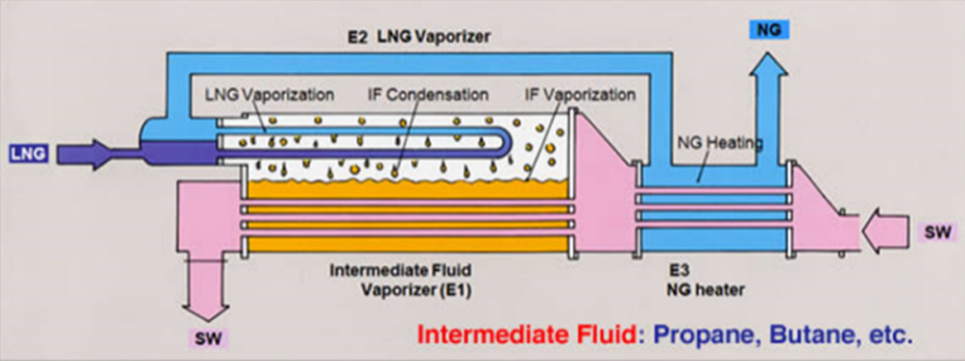

5.3.3 Liquified Carbon Dioxide Storage
There is currently unused space belonging to DragonLNG from land earmarked for future expansion of regasification facilities as well as land previously occupied by the cogeneration power plant. There is also existing infrastructure in the form of pipeline and pipe supports running from the regasification plant to the former cogeneration plant land. It can be seen in figure 5.3.3-1 that there are several areas that could be potentially utilised for carbon dioxide liquefaction.
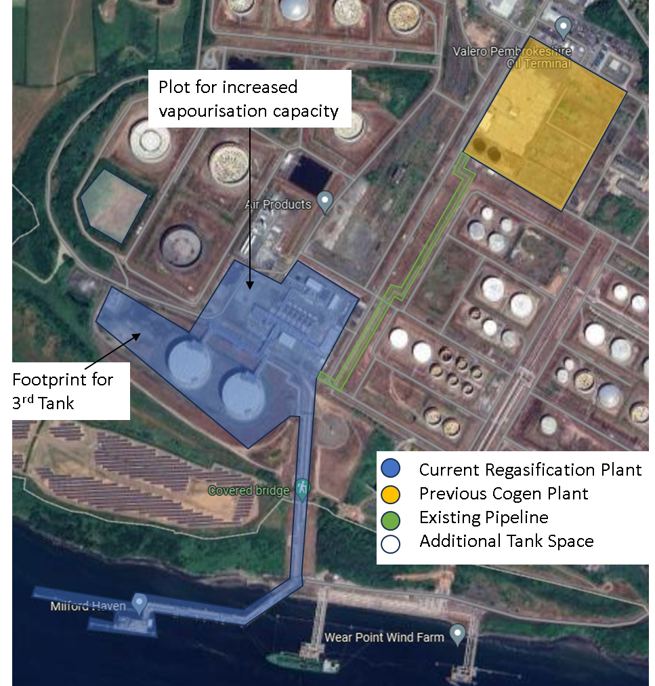
Figure 5.3.3-1 – Current Layout of DragonLNG

To store liquefied natural gas (LNG), DragonLNG have two nickel steel lined concrete storage tanks, cylindrical in shape with domed fixed roofs, capable of holding 165,000m³ of LNG each. These storage tanks are only suitable for low pressure cryogenic liquids, with DragonLNG’s storage tanks designed to hold a maximum pressure of 340mBar.
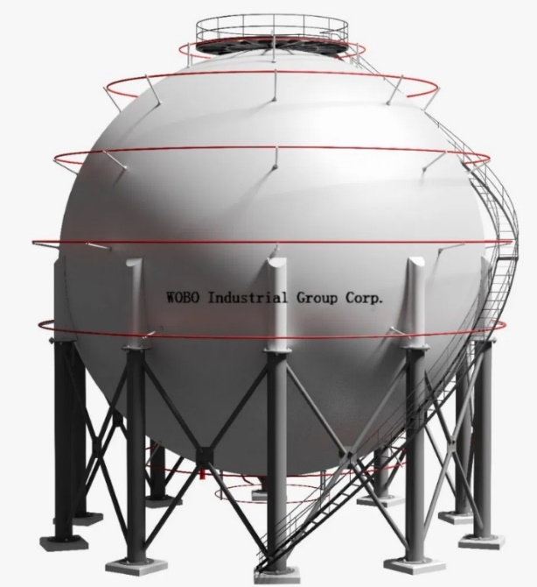
There are two storage tank designs that can be used for liquid carbon dioxide operating at a pressure of 17 bar. The two options are a horizontal cylindrical shaped tank known as a “bullet” or the alternative option is a spherical tank. There are advantages and disadvantages of both design, with cylindrical pressure vessels being cheaper and easier to manufacture than spherical vessels (A&G Engineering, 2022). Due to the even distribution of stresses of pressure on the inner tank walls in spherical vessels, they are considered more robust than cylindrical storage vessels and able to be in service to a greater pressure value for the same wall thickness. Examples of spherical and cylindrical storage vessels can be seen in figures 5.3.3-2 and 5.3.3-3.
Figure 5.3.3-2 – Spherical Storage Vessel, EPC Spherical Tank (2023)
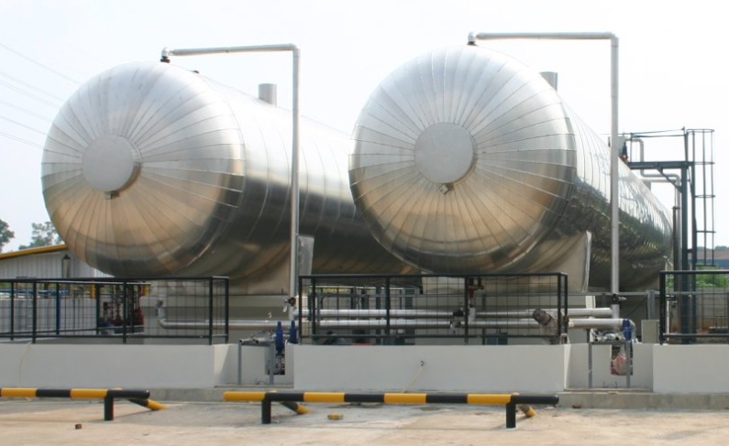
Figure 5.3.3-3 – Cylindrical Storage Vessel, Pentair (2024)
To find the diameter of tank required for storage of carbon dioxide, first the volume of liquefied carbon dioxide generated needs to be calculated. The volume can be found using the following equation:
$V= \frac{m}{ρ}$ Where: V = Volume (m3)
M = Mass (kg)
$ρ$ = Density (kg.m⁻³)
NIST data shows at 17.2 bar and -29.9ºC the density of carbon dioxide is 1,076.3kg.m⁻³. As mass is conserved, 7000 tonnes of gaseous carbon dioxide per day remains 7000 tonnes of carbon dioxide once liquified.
Therefore, the volume of liquefied carbon dioxide per day can be calculated as:
$$V=\frac{7,000*1000}{1076.3}$$
$$V=6,503.763 m^{3}$$
It has been assumed that between 2 and 7 days of liquefaction volume will require storing to allow for shipping exports. Table 5.3.3-1 shows the volumes of liquified carbon dioxide produced per day. The table also includes a 5% safety margin as one method to mitigate against overfilling the storage vessels.
Table 5.3.3-1 – Storage Volume Required Per Day
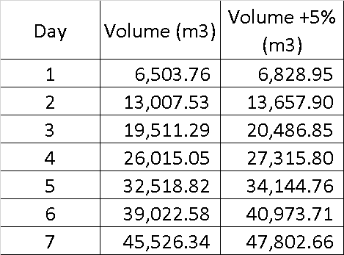

With the volume now calculated, calculation of required tank dimension can be made.
For horizontal cylindrical style pressure vessels there are already two installed at the AirProducts nitrogen facility that supplies DragonLNG that can be used as a guide. These vessels are used to store liquified nitrogen (LIN) and are approximately 40m in length. The following equation can be used to determine the radius required for a cylindrical pressure vessel:
$V= π* r^{2}*l$ Where: r = Radius (m)
l = Length of cylinder (m)
Rearranged for r the equation becomes:
$$r= \sqrt{\frac{V}{π*l}}$$
Assuming the length of storage vessel is 40m and each vessel is able to store one day’s volume of liquefied carbon dioxide plus 5% safety margin, a radius of 7.372m or diameter of 14.744m can be calculated.
$$r= \sqrt{\frac{6,828.95}{π*40}}$$
$$r=7.372m$$
To store up to seven days of liquified carbon dioxide volumes with this configuration of cylindrical vessel would require seven 40m long by 14.744m diameter vessels. If the vessel length was increased by 20m to 60m, two days of liquified carbon dioxide volumes could be stored in a vessel of 17.02m diameter.

For spherical storage vessels, the following equation can be used to calculate the required tank radius:
$V= \frac{4}{3}π*r^{3}$ Where: V = Volume (m³)
r = Radius (m)
Rearranging for r:
$$r= \sqrt[3]{\frac{V}{\frac{4}{3}π}}$$
Calculating for one day’s volume of liquified carbon dioxide plus a 5% safety margin, a radius of 11.769m or diameter of 23.59m can be calculated:
$$r= \sqrt[3]{\frac{6,828.95}{\frac{4}{3}*π}}$$
$$r=11.769m$$
To store up to seven days of liquified carbon dioxide volumes with this configuration of cylindrical vessel would require seven spheres with a 23.59m diameter. Should the diameter by increased to 29.66m (radius of 14.82m) then two days volume of liquified carbon dioxide plus 5% safety margin could be stored within the vessel.
The land previously used for the cogeneration plant is approximately 100m wide and 80 meters long. This suggests that it is potentially feasible to construct four spherical storage vessels of approximately 30m diameter, allowing for eight days of liquefied carbon dioxide storage volume.
Several additional aspects need to be considered with regards to the feasibility of constructing new storage tanks on the previously used cogeneration site. The first being its proximity to the village of Waterston and the potential for residents to challenge new development, with 30m tall spheres likely to be viewable from the village. Another aspect that requires evaluation is the risk associated with storing large volumes of liquified carbon dioxide under pressure and the proximity to both the village and the DragonLNG and Valero Petroleum Storage Terminal control rooms. Further conversation with storage vessel specialists is suggested as literature on vessel sizes of those required is not readily available.
Cost considerations should be understood to determine whether four more expensive spherical storage vessels would be preferred over seven cylindrical vessels. This should be evaluated with consideration to safety and a cost benefit analysis performed.

Conclusion
To conclude, it is found that there is clear potential for integration of a carbon dioxide liquefaction process within the existing DragonLNG regasification terminal. It has been demonstrated that carbon capture at Pembroke Power Station (PPS) could enable DragonLNG to reduce their fuel gas consumption, reducing the environmental impact of both organisations.
Through a comparison of calculated thermal duties, it is found that there is a sufficient energy balance between the proposed carbon dioxide liquefaction and liquified natural gas regasification mass flow rates to make integration feasible. Integration of the two processes would require a change in the current throughput agreements at DragonLNG, although integration has the potential for significant cost savings.
A pipeline between PPS and DragonLNG would be necessary, likely carbon steel with options for it to be installed subsurface or on the Milford Haven Waterway riverbed. This would require significant planning to mitigate environmental impacts and would require significant consultation with regulators such as Natural Resources Wales. There is evidence of successful installations elsewhere in the UK and would facilitate PPS in aligning with the reduction of carbon emissions targets set out in the UK’s net zero 2035 plan.
In essence, this feasibility study demonstrates aspects of technical and economic viability of the proposed integration whilst also underscoring the potential for collaborative efforts between DragonLNG and PPS to drive decarbonisation while simultaneously enhancing operational efficiency and reducing environmental impact. There is the potential for this project to play a major role in decarbonising the Milford Haven Waterway as the UK moves towards its net zero future.

Recommended Further Work
Short Term (Within 6 Months):
- Further explore the use of intermediary fluid vapourisers to allow second refrigerant process and maintain zero-sendout capabilities.
- The literature review performed found other uses for stored cold energy such as liquid air batteries, production of utility nitrogen and the use as cooling for data centres. A high level aspect of these projects should be identified and presented to DragonLNG to understand appetite for further project evaluation.
- Further research into the geological setting of the Milford Haven Waterway to support environmental impact assessment.
Medium Term (6 months to 3 years):
- Further explore potential configurations of storage vessels with input from specialist manufacturers.
- Environmental impact assessment of installing a pipeline between Pembroke Power Station and DragonLNG.
- Discussion with customers regarding the changing of send-out profile from send-out/zero send-out to a minimum daily sendout to meet carbon dioxide liquefaction requirements.
- Feasibility studies into additional “cold energy” projects.

Long Term (3 years plus):
- Collaborative approach to further planning and potential installation of pipeline between DragonLNG, PPS and Natural Resources Wales.
- Amendments to DragonLNG throughput agreement facilitated through negotiation with Petronas, Shell, DragonLNG and PPS.

References
3. reducing emissions across the economy (2022) GOV.UK. Available at: https://www.gov.uk/government/publications/net-zero-strategy/3-reducing-emissions-across-the-economy#vii-greenhouse-gas-removals (Accessed: 21 August 2023).
Carbon dioxide - thermophysical properties (2023) Engineering ToolBox. Available at: https://www.engineeringtoolbox.com/CO2-carbon-dioxide-properties-d_2017.html (Accessed: 31 February 2024).
The shape of pressure vessel heads (2022) A&G Engineering. Available at: https://www.agengineering.com.au/shape-of-pressure-vessel-heads/#:~:text=While%20pressure%20vessels%20can%20theoretically,shape%20to%20hold%20internal%20pressure. (Accessed: 19 April 2024).
Annual Report and Financial Statements for the year ended 31 December 2022 (2023) Companies House. Available at: https://find-and-update.company-information.service.gov.uk/company/04562711/filing-history.
Balaji, C., Srinivasan, B. and Gedupudi, S. (2021) ‘Heat exchangers’, Heat Transfer Engineering, pp. 199–231. doi:10.1016/b978-0-12-818503-2.00007-1.
Banuti, D. (2019) ‘The latent heat of supercritical fluids’, Periodica Polytechnica Chemical Engineering, 63(2), pp. 270–275. doi:10.3311/ppch.12871.
Department for Energy Security and Net Zero (2023) Carbon Budget Delivery Plan, GOV.UK. Available at: https://www.gov.uk/government/publications/carbon-budget-delivery-plan (Accessed: 12 November 2023).
DragonLNG (2023) RWE and Dragon LNG’s innovative project receives support from UK Research and Innovation. Available at: https://www.dragonlng.co.uk/general/rwe-and-dragon-lngs-innovative-project-receives-support-from-uk-research-and-innovation (Accessed: 29 January 2024).
Dragon LNG – Organisational Structure (2024) Dragon LNG. Available at: https://www.dragonlng.co.uk/organisational-structure/dragon-lng-ltd (Accessed: 10 February 2024).
EPC Spherical Tank (2023) Spherical Tank. Available at: https://www.wobogroup.com/product/EPC-Spherical-Tank.html (Accessed: 19 April 2024).
Gao, T. and Rochelle, G.T. (2019) ‘Co2 absorption from gas turbine flue gas by aqueous piperazine with intercooling’, Industrial &amp; Engineering Chemistry Research, 59(15), pp. 7174–7181. doi:10.1021/acs.iecr.9b05733.
Geraldi, J. and Lechter, T. (2012) ‘Gantt charts revisited’, International Journal of Managing Projects in Business, 5(4), pp. 578–594. doi:10.1108/17538371211268889.
Green, D.W., Southard, M. and Perry, R.H. (2019) Perry’s Chemical Engineers’ handbook. New York: McGraw-Hill.
Haan, S. (2024) SWOT analysis: Factsheets, CIPD. Available at: https://www.cipd.org/uk/knowledge/factsheets/swot-analysis-factsheet/#the-swot-framework (Accessed: 15 May 2024).
Heat exchangers (2023) Ipieca. Available at: https://www.ipieca.org/resources/energy-efficiency-database/heat-exchangers-2022 (Accessed: 16 March 2024).
Helms, M.M. and Nixon, J. (2010) ‘Exploring SWOT analysis – where are we now?’, Journal of Strategy and Management, 3(3), pp. 215–251. doi:10.1108/17554251011064837.
Hitchen, S.M. and Dean, J.R. (1993) ‘Properties of supercritical fluids’, Applications of Supercritical Fluids in Industrial Analysis, pp. 1–11. doi:10.1007/978-94-011-2146-0_1.
Islam, M.R. (2023) ‘Storage of petroleum fluids’, Pipelines, pp. 497–551. doi:10.1016/b978-0-12-820600-3.00008-1.
Jacobson, G.A. (2014) Pipeline corrosion issues related to carbon capture transport. Available at: https://www.icmt.ohio.edu/Articles/pdfs/May-MP-CCTS-feature.pdf (Accessed: 20 April 2024).
Jafarizadeh, B. (2022) ‘Project feasibility’, SpringerBriefs in Petroleum Geoscience & Engineering, pp. 1–12. doi:10.1007/978-3-030-96137-4_1.
Kerzner, H. (2022) Project Management: A systems approach to planning, scheduling, and controlling. 13th edn. Hoboken, NJ: Wiley.
Knoope, M.M.J., Ramírez, A. and Faaij, A.P.C. (2013) ‘Economic optimization of CO2 pipeline configurations’, Energy Procedia, 37, pp. 3105–3112. doi:10.1016/j.egypro.2013.06.196.
Liquid CO2 Storage Tanks - Pentair - products (2024) Pentair. Available at: https://foodandbeverage.pentair.com/en/products/pentair-liquid-co2-storage-tanks (Accessed: 19 April 2024).
Madejski, P. et al. (2022) ‘Methods and techniques for CO2 capture: Review of potential solutions and applications in modern energy technologies’, Energies, 15(3), p. 887. doi:10.3390/en15030887.
Maersk Broker (2022) Maritime transport of CO2. Available at: https://maerskbroker.com/wp-content/uploads/2022/11/Maritime-Transportation-of-CO2-ENG.pdf (Accessed: 12 November 2023).
Martin-Roberts, E. et al. (2021) ‘Carbon capture and storage at the end of a lost decade’, One Earth, 4(11), pp. 1569–1584. doi:10.1016/j.oneear.2021.10.002.
McGeorge, H.D. (2011) General Engineering Knowledge. London: Routledge.
Messenger, S. (2024) Climate change: Plan to capture, ship and bury power station’s CO2, BBC News. Available at: https://www.bbc.co.uk/news/uk-wales-68296155 (Accessed: 21 February 2024).
Mohitpour, M. et al. (2012) ‘Pipe material selection and fracture control’, Pipeline Transportation of Carbon Dioxide Containing Impurities, pp. 209–235. doi:10.1115/1.859834.ch7.
Natural Resources Wales / The UK Emission Trading Scheme (UK ETS) (2024) Natural Resources Wales. Available at: https://naturalresources.wales/permits-and-permissions/carbon-emissions/the-uk-emission-trading-scheme-uk-ets/?lang=en (Accessed: 29 February 2024).
Nerheim, A.R., Æsøy, V. and Holmeset, F.T. (2021) ‘Hydrogen as a maritime fuel–can experiences with LNG be transferred to Hydrogen Systems?’, Journal of Marine Science and Engineering, 9(7), p. 743. doi:10.3390/jmse9070743.
Noor Akashah, M.H. et al. (2023) ‘Utilization of cold energy from LNG Regasification Process: A Review of current trends’, Processes, 11(2), p. 517. doi:10.3390/pr11020517.
Nye, K. (2023) RWE and Dragon LNG’s innovative project receives support from UK Research and Innovation, RWE in the UK. Available at: https://uk.rwe.com/press-and-news/2023-11-30-rwe-and-dragon-lngs-innovative-project-receives-support-from-uk-research-and-innovation/ (Accessed: 15 January 2024).
Parisher, R.A. and Rhea, R.A. (2012) ‘Mechanical equipment’, Pipe Drafting and Design, pp. 112–133. doi:10.1016/b978-0-12-384700-3.00006-2.
Park, J. et al. (2019) ‘Economic process selection of liquefied natural gas regasification: Power generation and energy storage applications’, Industrial & Engineering Chemistry Research, 58(12), pp. 4946–4956. doi:10.1021/acs.iecr.9b00179.
Pauken, M. (2011) Thermodynamics for Dummies. Hoboken, NJ: Willey publishing, Inc.
Pembroke CCGT Power Plant (2023) RWE in the UK. Available at: https://uk.rwe.com/locations/pembroke-ccgt-power-plant/ (Accessed: 19 November 2023).
Pembrokeshire Coast National Park Authority (2018) Management Plan (2015-2019) Local Development Plan 2 (2015-2031) Background Paper No *: Carbon Sources. Available at: https://www.pembrokeshirecoast.wales/wp-content/uploads/2019/12/Carbon-Dioxide-Sources-Background-Paper-new-March-2018.pdf (Accessed: 19 November 2023).
Reuters (2024) Global Carbon Markets Value hit record $949 bln last year. Available at: https://www.reuters.com/markets/commodities/global-carbon-markets-value-hit-record-949-bln-last-year-lseg-2024-02-12/ (Accessed: 06 May 2024).
Rochelle, G.T. (2009) ‘Amine scrubbing for CO2 capture’, Science, 325(5948), pp. 1652–1654. doi:10.1126/science.1176731.
RWE (2021), RWE launches its Pembroke Net Zero Centre to help drive decarbonisation in South Wales. Available at: https://www.rwe.com/en/press/rwe-generation/2021-05-26-rwe-launches-its-pembroke-net-zero-centre/ (Accessed: 29 January 2024).
Shen, M. et al. (2022) ‘Cryogenic Technology Progress for CO2 capture under carbon neutrality goals: A Review’, Separation and Purification Technology, 299, p. 121734. doi:10.1016/j.seppur.2022.121734.
Siegfanz, A., Wagner, W. and Janoske, U. (2024) ‘Investigation of flow patterns in two-phase carbon dioxide in horizontal and vertical pipes’, Journal of Instrumentation, 19(03). doi:10.1088/1748-0221/19/03/p03003.
Statement of Ethical Principles for the engineering profession (2017) Engineering council. Available at: https://www.engc.org.uk/ethics (Accessed: 29 January 2024).
Subramanian, N. and Madejski, P. (2023) ‘Analysis of CO2 capture process from flue-gases in combined cycle gas turbine power plant using post-combustion capture technology’, Energy, 282, p. 128311. doi:10.1016/j.energy.2023.128311.
System Average Price (SAP) of gas (2024) Office for National Statistics. Available at: https://www.ons.gov.uk/economy/economicoutputandproductivity/output/datasets/systemaveragepricesapofgas (Accessed: 01 May 2024).
University of Wales Trinity Saint David (2022) ‘Research Ethics & Integrity Code of Practice’, Research Integrity and Ethics [Preprint]. Available at: https://www.uwtsd.ac.uk/research/research-integrity-and-ethics (Accessed: 21 January 2024).
Watkins, G (2024) DLNG-M-OM-001 – DragonLNG Operations Manual
Wilberforce, T. et al. (2021) ‘Progress in carbon capture technologies’, Science of The Total Environment, 761, p. 143203. doi:10.1016/j.scitotenv.2020.143203.
Wang, C. et al. (2023) ‘Techno-economic analysis on nitrogen reverse Brayton cycles for efficient coalbed methane liquefaction process’, Energy, 280, p. 128167. doi:10.1016/j.energy.2023.128167.
World record breaking pipeline insertion on River Humber Gas Project Now complete (2020) National Grid Group. Available at: https://www.nationalgrid.com/world-record-breaking-pipeline-insertion-river-humber-gas-project-now-complete (Accessed: 20 April 2024).
Xin, Y. et al. (2021) ‘The optimization and thermodynamic and economic estimation analysis for CO2 Compression-liquefaction process of CCUS system using LNG Cold Energy’, Energy, 236, p. 121376. doi:10.1016/j.energy.2021.121376.
Yu, H., Gundersen, T. and Gençer, E. (2021) ‘Optimal Liquified Natural Gas (LNG) cold energy utilization in an Allam cycle power plant with carbon capture and storage’, Energy Conversion and Management, 228, p. 113725. doi:10.1016/j.enconman.2020.113725.
Yu, K., Sun, J. and Yin, J. (2021) ‘Modeling and analysis of heat transfer in submerged combustion vaporizer under supercritical pressure’, Cryogenics, 116, p. 103287. doi:10.1016/j.cryogenics.2021.103287.

Appendices
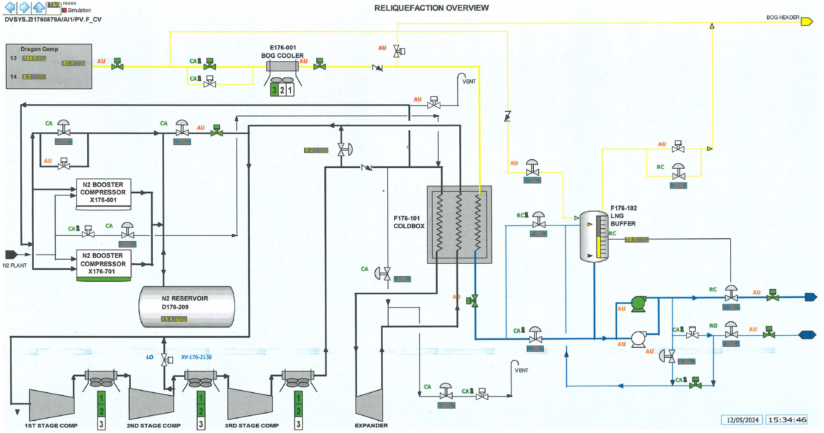
Appendix 1 – DCS Process Overview of Reliquifaction Plant
Appendix 2.1 – HP Pump discharge temperature and flow rate correlation
Minimum HP Pump Flow; Flowrate = 250m3hr-1, Temperature = -137 degrees Celsius

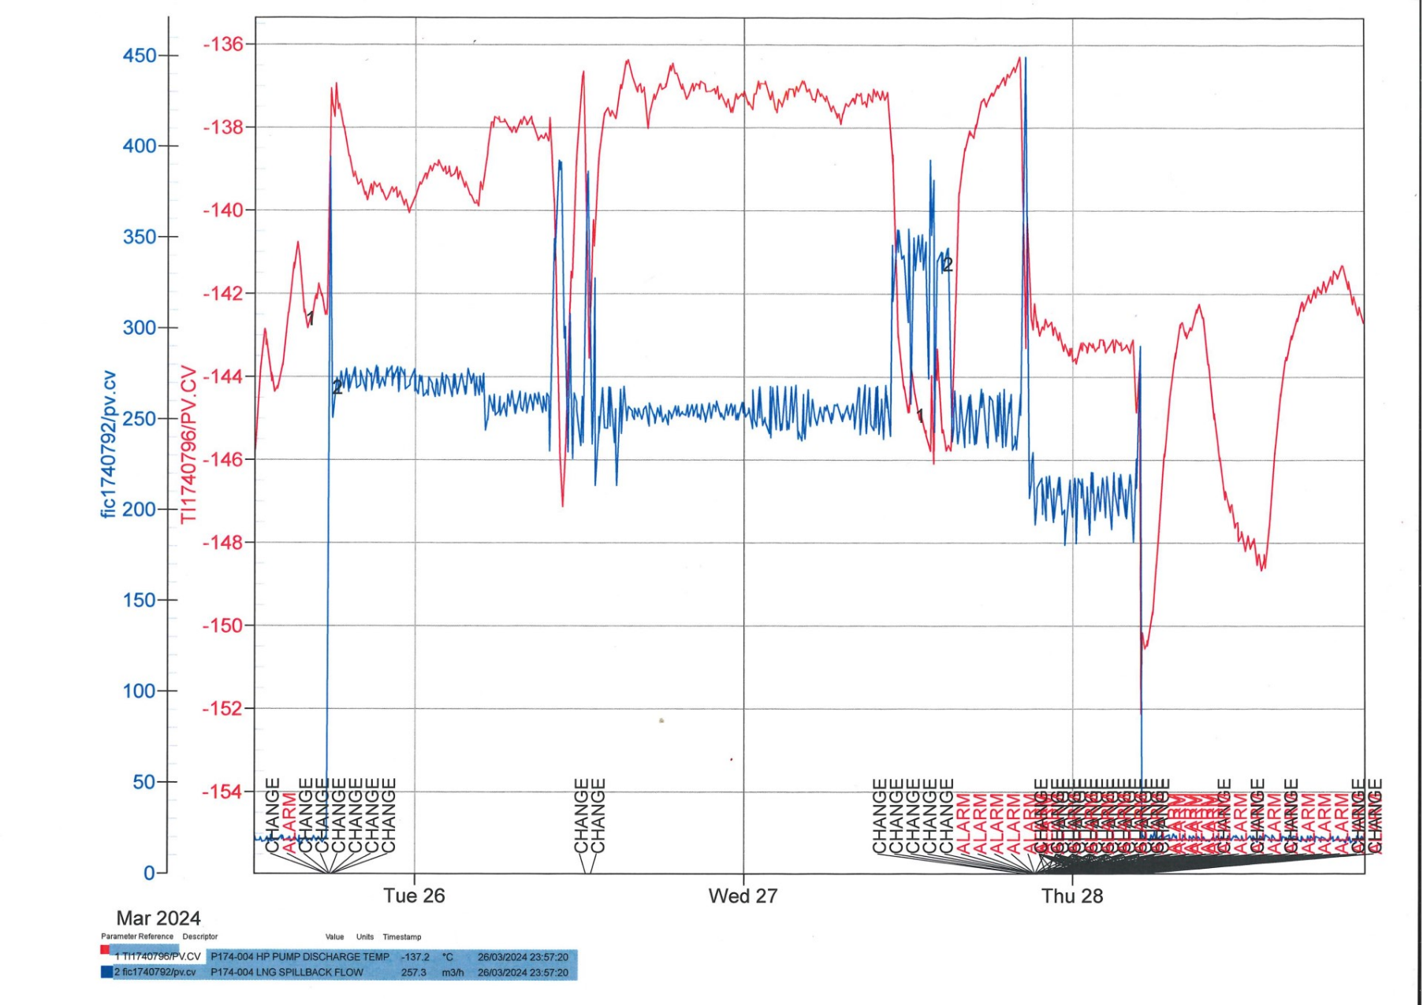

Appendix 2.2
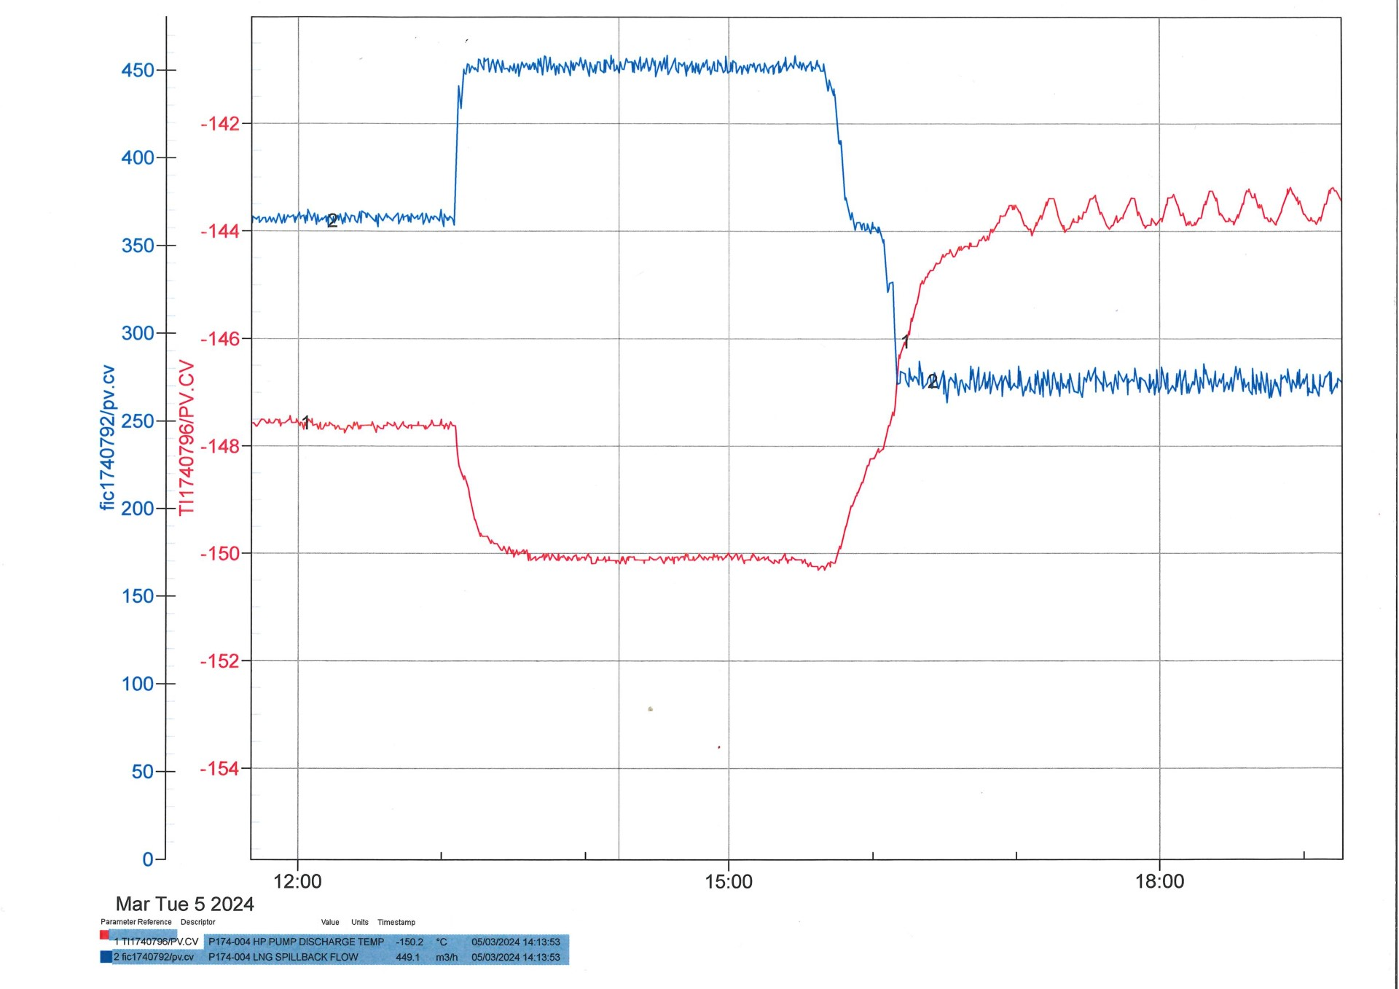
Maximum HP Pump Flow; Flowrate = 450m3hr-1, Temperature = -150 degrees Celsius
Appendix 3.1
Carbon Dioxide Data at 24.1 bar (NIST)

Appendix 3.2
Liquified natural gas (LNG) at 120 bar (NIST)

Appendix 3.3
Liquified natural gas (LNG) at 100 bar (NIST)

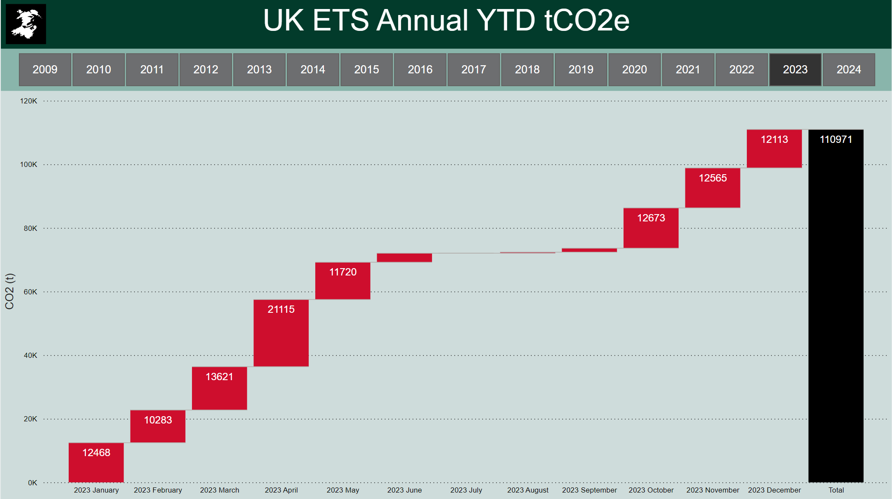
Appendix 4 – DragonLNG Scope 1 Carbon Emissions Tracker (2023)

SI units converted from metres to inches as the pipe diameter at DragonLNG are usually quoted in imperial units.
SI units converted from metres to inches as the pipe diameter at DragonLNG are usually quoted in imperial units.

