

Detection of Phishing URLs Using Supervised Machine Learning and Lexical Feature Engineering

by
Cai Perry

Supervisor: Simon Thomas

Project submitted as part of the requirements for the award of
BSc (Hons) Computing (Applied Computing)

May 2026

Contents
Table of Figures 3
Chapter 1 - Introduction 4
Chapter 2 – Background & Literature Review 5
2.1 – Phishing Overview 5
2.2 – Traditional Phishing Detection Methods 6
2.3 – Machine Learning Approaches 7
2.4 – Datasets and Feature Engineering 9
Chapter 3 – Research Questions & Problem Statement 10
3.1 – Problem Statement 10
3.2 – Aims & Objectives 11
Chapter 4 – Research Methodology 11
4.1 – Field of Study 11
4.2 – Expected Outcome 12
4.3 – Research methodology 12
4.3.1 – Research Philosophy 12
4.3.2 – Research Approach 12
4.3.2 – Research Strategy 12
4.4 – Risks and Limitations 13
4.4.1 – Ethical Considerations 13
4.4.2 – Validity, Reliability and Generalisability 13
4.5 – Data Evaluation Methods 13
4.5.1 – Data collection 13
4.5.2 – Data Evaluation 14
4.6 – Development Methodology 14
4.6.1 – Prototyping Methodology 14
4.7 – Hardware Resources 14
4.8 – Software Resources 15
4.9 – Human Resources 15
4.10 – Project Timeline 15
Chapter 5 – Implementation and Development 16
5.1 - Implementation overview 16
5.2 – Dataset Preparation and Preprocessing 17
5.2.1 – Tools and Environments 17
5.2.1 – Dataset Description 18
5.2.3 – Data Preprocessing 19
5.2.4 – Class Distribution 19
5.2.5 – Train/Test Split 20
5.3 – Feature Extraction Process 21
5.3.1 – Feature Design and Rational 21
5.3.2 – Feature Representation 22
5.4 – Model Development and Training 23
5.4.1 – Model Selection Rationale 23
5.4.2 – Model Training and Configuration 23
5.5 – Model Evaluation and Results 25
5.5.1 – Evaluation Metrics 25
5.5.2 – Results Comparison 26
5.6 – System Deployment 26
5.6.1 – Backend API (Flask) 26
5.6.2 – Frontend HTML 27
Chapter 6 – Evaluation and Discussion 27
6.1 – Overall Model Performance 27
6.2 – Interpretability Vs Performance 28
6.3 – Impact of Domain Based Splitting 29
6.4 – System Limitations 30
6.5 – Practical Implications 31
Chapter 7 – Project Conclusion 32
Chapter 8 – Appendix 33
Appendix A – Dataset Overview 33
Appendix B – Feature Extraction Code 34
Appendix C – Model Training 35
Appendix D – Full Model Output 36
Appendix E – Backend Screenshots 38
Bibliography 39

Table of Figures
Figure 1 - Phishing Activity Graph [4] 4
Figure 2 - Traditional Phishing Detection Methods [11] 6
Figure 3 - Rehman et al’s ML Phishing Performance metrics [17] 8
Figure 4 - Project Gantt Chart 15
Figure 5 - Dataset Section With Supporting Table 18
Figure 6 - Pie Chart Displaying Class Imbalance 19
Figure 7 - Domain Overlap Before Implementing GSS 20
Figure 8 - Decision Tree Classifier 23
Figure 9 - Random Forest Classifier 24
Figure 10 - Random Forest Classifier 24
Figure 11 - SVC Classifier 24
Figure 12 - Table of Model Evaluation Metrics 25
Figure 13 - Bening Frontend Output 27
Figure 14 - ML Models Performance Comparison Graph 28
Figure 15 - Confusion Matrix Before Domain Based Splitting 30
Figure 16 - Dataset Snippet 33
Figure 17 - Data Preprocessing 38
Figure 18 - ML Model Prediction Outputs 38
Figure 19 - Logistic Regression Confusion Matrix 39
Figure 20 - Decision Tree Confusion Matrix 39
Figure 21 - Random Forest Confusion Matrix 39
Figure 22 - SVC Confusion Matrix 40
Figure 23 - Model Output Comparison Table 40
Figure 24 - Model Comparison Graph 40
Figure 25 - Frontend Default View 45
Figure 26 - Frontend Bening Output 45
Figure 27 - Frontend Phishing Output 46

Abstract
Phishing is a type of cybercrime which often involves the use of deceptive URLs to mislead victims in order to reveal sensitive information. This project investigates the effectiveness of machine learning techniques for detecting phishing URLs using lexical features extracted directly from the URL string. The primary objective was to design implement and evaluate a classification system that is able to distinguish between benign and phishing URLs.
A dataset of labelled URLs was pre-processed through feature engineering, capturing the characteristics which make up a phishing URL, and multiple machine learning models were applied using a domain-based data splitting approach to ensure a realistic testing environment
Results demonstrated that all models achieved high classification, with random forest providing the best overall results across most of the used evaluation metrics. However, the trade-off between performance and interpretability was evaluated to come to that decision
Overall, the findings indicate that lexical feature-based machine learning models can provide a scalable approach to phishing detection but still suffer from some constrictions that limit other machine learning approaches. The system developed demonstrates practical potential for integration into real time cybersecurity applications, with opportunity for enhancements through expanded feature sets and continued model application.

Chapter 1 - Introduction
Phishing is one of the most common and damaging forms of cybercrime [1], which poses a serious online threat towards individuals, businesses and organizations. It is carried out by attackers attempting to deceive users in to revealing their sensitive information such as their username or password to a website or app, financial details such as their card information or links which lead to fraudulent bait websites that are built to closely imitate real ones [2]. These attacks are typically distributed at a large scale through means such as email services such as Gmail and outlook or messaging services, making them widespread and difficult to control, with industry investigations saying that phishing is the leading cause of data breaches [3], demonstrating the clear need for more proactive and effective prevention measures.
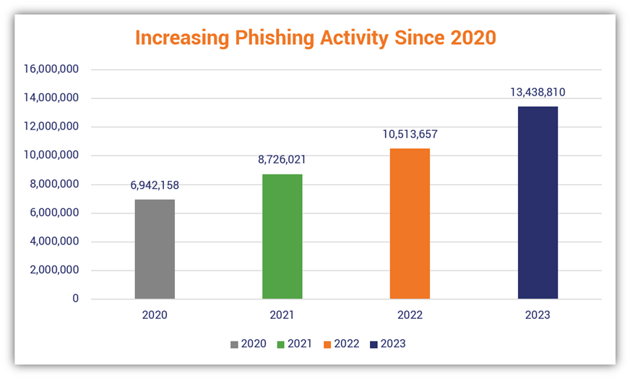
Figure 1 - Phishing Activity Graph [4]
One key component of phishing attacks is the use of malicious URL’s which are created to look trustworthy at a glance. Attackers often prey on exploits such as elongated URL’s, misleading sub domains, suspicious keywords and similar spelling to other known domains. Traditional phishing detection methods, which includes blacklist-based systems and manually written heuristic rules [5] have been deployed widely to combat this threat. Whilst these methods can be useful for known phishing websites, they lack adaptability, and can have serious limitations in detectability when coming against newer or “zero-day” [6] phishing scams that haven’t been reported
In response to these limitations, there has been a growing response in the application of AI and machine learning techniques into phishing detection. These machine learning systems are able to adapt where the heuristic systems aren’t. They are capable of learning patterns and characteristics from large datasets of phishing URLs, which allow them to generalise beyond preset rules. By being able to analyse the lexical structure of the URL’s, these systems aim to identify malicious behaviour automatically and at a larger scale. This makes machine learning to be the most promising approach to improving the detection accuracy into developing threats in an online space.
This project aims to focus on the use of machine learning to detect phishing URLs by analysing the structural properties. The primary objective is to design, implement and evaluate a prototype classification model which can differentiate between legitimate and phishing URLs with a high degree of accuracy. This project will explore suitable testing and training datasets, previous implementations of similar machine learning models for this purpose, machine learning algorithms, and correct evaluation techniques to identify which model has the best accuracy when making predictions. Particular emphasis is placed on the understanding on how well the model does predicting previously unseen URLs, as that would be simulating how it would work in real world deployment.

Chapter 2 – Background & Literature Review

2.1 – Phishing Overview
Phishing is a form of cyber-attack that involves attackers attempting to get victims to disclose sensitive information such as financial details, personal details or any authentication credentials by impersonating a trusted organisation [7]. Instead of exploiting technical vulnerabilities, phishing relies more on social engineering skills and can be carried out on a large scale. Phishing remains one of the most effective scams to carry out, due to its low cost, ease of deployment and its heavy reliance on human error, making it a persistent threat to individuals and businesses [7].
Modern phishing campaigns are often carried out through communication channels such as email, messaging services or social media platforms. One defining feature that is similar through all of these methods are the fact that they include a malicious URL that leads the victim to a fraudulent website that is created to closely resemble a real website such as online banking portals. Given the visually similar nature of these fraudulent sites, most unaware users will not be able to tell the difference, increasing the likelihood that they enter their sensitive information.
Attackers employ a large range of techniques in order to make phishing URLs appear real. These can include complex URL strings, misleading subdomains or ‘typosquatting’ which involves attackers register domain names which are deliberately misspelled, in hopes that users misspell the verified domain, directing them to the fake site [8].
Given the importance that URLs carry when committing to a phishing scam, it is imperative that prevention methods are able to quickly and accurately identify malicious URLs from legitimate ones. However, the rapid creation, and short lifetimes of phishing websites make consistent detection difficult [9]. Attackers will frequently generate new domains, allowing the phishing URLs to evade traditional detection methods that rely on reported threats. The constantly adapting nature of these scams highlight the need for detection approaches that can identify phishing URLs based on their intrinsic characteristics instead of prior knowledge alone.

2.2 – Traditional Phishing Detection Methods
Traditional phishing detection approaches have mostly relied on blacklist and heuristic based rules [10]. These methods form the foundation of many available security solutions and remain effective against known threats. However, their apparent limitations have become increasingly obvious with the advancement of phishing attack’s scale and complexity.
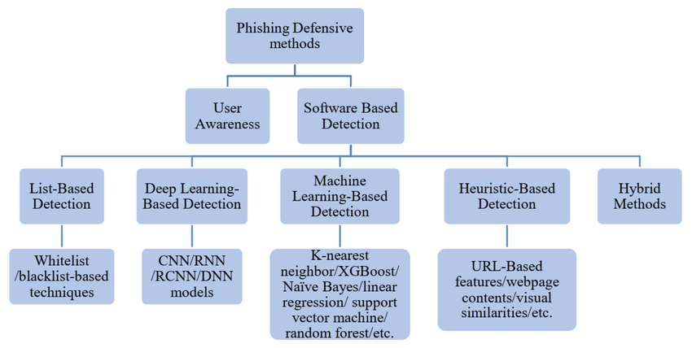
Figure 2 - Traditional Phishing Detection Methods [11]
Blacklist-Based detection is one of the most common methods used to identify phishing websites [12]. This practice involves maintaining a database of known malicious URLs and domains, which is then used to warn users when they access a site which has been archived in these databases. Known examples of blacklist-based detection include publicly available browser-based services such as repositories maintained by online security companies. Blacklist-based systems strengths are their hyper accuracy for previously known and registered websites; they fall short when faced with new URLs. These new URLs need to be discovered, reported and then verified before they can prevent visitors to the fraudulent sites. This leaves a window of exposure where victims can visit these sites and remain vulnerable to attacks.
Heuristic-based detection methods try to overcome some of these limitations by analysing the URLs or webpages for suspicious characteristics [13]. These systems rely on manually input rules, some common ones include excessive URL length, the presence of unusual characters, or the use of the IP address instead of the domain name. Some heuristics analyse also examine the webpages properties, including the form behaviour and any mismatches between links that are displayed, and the actual links. Although heuristic approaches do overcome some limitations that blacklist based approaches possess, they remain highly dependent on expert knowledge and can also struggle to adapt to new attack strategies [13]. Attackers can also deliberately modify their page structures and URLs to evade known heuristic rules, therefore reducing the longer-term effectiveness of this detection approach.
These systems, such as rule-based and signature-based systems [14] also face certain challenges related to maintenance and scalability. As phishing techniques change over time, so must the detection rules if the systems wish to remain effective. Updating can be error prone and often time consuming, requiring a lot of resources to carry out effectively and can lead to having a high false-positive rate, which block legitimate website, restricting their user’s movement and negatively impacting user experience. However, conservative rules may have the opposite effect, failing to detect subtler phishing attempts.
Overall, traditional detection methods do serve as an important foundation, and provide a solid baseline for protection, alone they are insufficient and all struggle to address the dynamic nature of modern phishing attacks. Their heavy reliance on prior knowledge, manual updates and static rules make makes it difficult for them to detect any newer phishing URLs. These shared shortcomings have motivated research into machine learning-based detection, which aims to automatically learn distinctive patterns from data and improve the detection accuracy for any unseen threats. This more recent transition to more data driven detection methods provides the basis for the approach explored in this project.

2.3 – Machine Learning Approaches
In response to the limitations imposed by traditional phishing detection methods, a substantial amount of research has been direct towards the exploration of machine learning techniques in phishing detection. Unlike black-list and rule-based systems, machine learning models aim to automatically learn patterns that distinguish phishing URLs from real ones [15]. This approach differs from the traditional approaches as it is able to generalise beyond static rules and previously reported threats, making them better suited in detecting zero-day phishing attacks.
Machine learning techniques in the early phases of testing, relied on supervised learning algorithms, where a model will learn from ‘labelled data’ [16]. Some classifiers include Logistic Regression, Support Vector Machines and Decision Trees etc. These models are trained from labelled datasets which purposely contain phishing URL’s mixed with real URLs, learning to associate any patterns with malicious behaviour.
In a study conducted by Rehman et al [17] investigated the effectiveness of multiple supervised machine learning algorithms for detecting phishing URLs in a large dataset. The authors evaluated classifiers such as KNN’s, Decision Tress and Random forests. Their experiments results were that the random forest classifier had achieved the highest classification accuracy, peaking at 99.99%, outperforming the other machine learning algorithms.
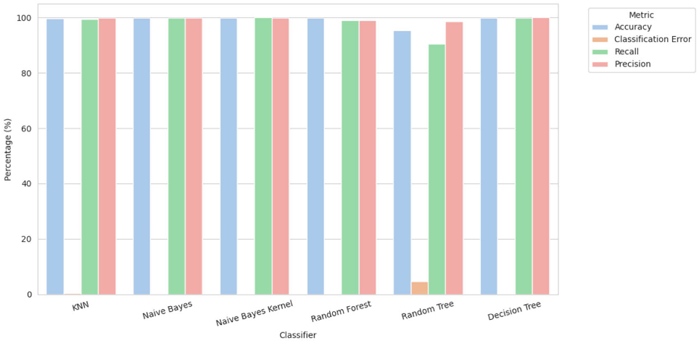
Figure 3 - Rehman et al’s ML Phishing Performance metrics [17]
The performance metrics of the study show that all of the machine learning algorithms had competitive scores with RF having the highest accuracy score, but by a minimal margin. Other performance metrics such as the recall score and the precision are also high for many of the models [17].
One aspect of feature-based ML approaches is the identification of discriminative features from URLs. Lexical features that are derived directly from the URL string are popular as they require little computational cost [18]. Examples include the number of digits and special characters present, the URL length, the number of subdomains and the presence of any suspicious key words. Whilst this has shown to be effective, feature engineering needs careful design, as overdesigning the features may reduce the model’s ability to generalise new patterns [18].
More recent research has explored the use of ‘deep learning techniques in phishing URL detection. Instead of relying on manually engineered features, these models can process URLs as sequences of characters, allowing the models to automatically learn hierarchical representation [19]. Whist studies have shown that these deep learning techniques yield improved performance compared to traditional machine learning methods, these algorithms need bigger datasets and a higher level of computational resources, which may impact their performance in certain instances.
Despite promising results shown in machine learning detection approaches, they still face several challenges. One common issue is database imbalance, as the number of legitimate URLs heavily outweighs the amount of phishing URLs, whist they may simulate how it would be in a real environment, when the data is split into testing and training data, the imbalance may bias the model’s performance. Models that are trained on static datasets may also suffer a similar problem with traditional methods, where they will struggle to adapt to newer phishing techniques if the dataset isn’t being regularly updated. More complex models also struggle to be easily interpretable, even though it may achieve high accuracy, simpler models are easier to explain and justify in security contexts.
Overall, the existing machine learning techniques research demonstrates that it is a viable method of phishing detection, mostly when using lexical features. However, there is still a need to evaluate the different ML model’s ability to generalise unseen URLs. This project builds on the existing work by investigating and comparing suitable machine learning models for phishing URL detection, with the emphasis on the performance metrics when evaluating.

2.4 – Datasets and Feature Engineering
Datasets play a major role in the development and the evaluation of machine learning phishing detection systems. Existing research relies on labelled datasets which contain both real and fake URLs, allowing the models to be trained and evaluated. Common sources of phishing URLs include publicly available database repositories such as PhishTank [20], which moderate verified phishing reports submitted by users or security organizations. Legitimate URLs are collected from trusted sources such as curated lists of well-known domains. Even though these databases are widely used, they may suffer from data imbalances due to the larger number of real URLs in comparison to fake URLs, this can influence the model’s performance if it isn’t carefully addressed.
In machine learning, feature engineering refers to the practice of extracting important characteristics from URLs that can be used as input to machine learning models [21]. Lexical features derived directly from the URL string are often prioritised for their efficiency and independence from any external data source. Lexical features used in the URL include the length of the URL, the frequency of special characters, or any suspicious key words such as ‘verify’ or ‘secure’. Other features may look at structural properties, such as if an IP address is being used instead of a domain name, which is a common instance among untrusted websites. Another may be if the URL contains any redirection symbols such as the ‘@’ symbol, or a second set of ‘//’.
Using additional features such as webpage content or the domain registration information can improve the detection accuracy, this approach often add complexity by relying on external data sources, which in turn reduces scalability. For this reason, it has been demonstrated that properly chosen lexical features extracted from the URL can still get high performance metrics when used with the appropriate machine learning models.

Chapter 3 – Research Questions & Problem Statement

3.1 – Problem Statement
Even with the wide range of detection methods, phishing still remains a significant cybersecurity threat considering they focus on deception rather than technical exploitation, allowing them to bypass many base level security protocols. The main component of these URLs is that it redirects the victims to a fraudulent site that are made to resemble real websites. Despite widespread rollout of anti-phishing methods, such as blacklist and heuristic based systems, these phishing URLs avoid detection, particularly in the early stages of an attack.
Existing Phishing methods struggle to address these problems in an efficient manner. These systems rely on predefined rules are limited in their ability to update as quickly as new phishing URLs are created. Other more complex solutions may require external data sources or possibly additional computing power and resources that reduce their overall efficiency. This creates a gap in between optimised detection accuracy and having interpretable deployment, especially in large scale environments where multiple URL analysis is required.
The problem addressed in this project combines both the issues of having a model which doesn’t have to rely on external data sources whist remaining easy to interpret and compare results between different machine learning models. More specifically, this project looks at whether machine learning models which are trained on lexical features that have been extracted directly from URLs can provide reliable phishing detection results without the need for webpage analysis. By shifting the focus on static features in the URLs and using multiple widely used machine learning algorithms, this project aims to try and balance detection performance with interpretability, acknowledging existing limitations in current machine learning approaches that are widely used by individuals and businesses today.

3.2 – Aims & Objectives
To ensure that the project remains on track, the main aim and required objectives are broken down to understand what resources and focus areas are needed to create the model to the highest of standard. The main aim of this project is to evaluate the effectiveness of machine learning algorithms for detecting phishing URLs using lexical features previously described, that are derived straight from the URL strings. By seeking to focus on features that can be taken from the URL itself, this project looks to explore a lightweight and scalable approach to phishing detection. This aim reflects the need to balance both the accuracy of URL detection, and having the model be efficient and easy to interpret for analytical purposes.

To achieve this aim, the project contains the following objectives:
- To conduct an in-depth review of existing literature based on both traditional and current phishing detection methods, with particular emphasis on machine learning techniques which use URL based features. Ensuring to identify strengths, weaknesses and possible gaps which may help inform the projects design.
- To select a publicly available phishing URL dataset and use data preprocessing techniques to moderate data quality and consistency for machine learning training and testing.
- To design and implement a feature extraction process that will capture lexical characteristics of URLs, such as the presence of special characters or digits, their length, the structure of the subdomain, and redirection patterns.
- To train and test multiple machine learning algorithms on the extracted features and to evaluate their induvial performance in terms of accuracy, recall and precision scores, and their ability to identify phishing URLs from real ones.
- To analyse and compare the performance scores between the models and assess trade-offs between the model’s overall effectiveness and interpretability. Continuing then to use this to provide insights into the practical application of URL based machine learning approaches to phishing detection.

Chapter 4 – Research Methodology

4.1 – Field of Study
The current field of study at the University of Wales Trinity Saint David is Bachelor of Science in Applied Computing. The final year project proposed inside this document focuses on detecting phishing URLs using a machine learning approach, with the aim of evaluating how extracting lexical features from URLs can be used to identify malicious web domains and prevent potential security breaches among individuals and companies.

4.2 – Expected Outcome
The expected outcome of this project is a well-structured evaluation on machine learning techniques when used for phishing prevention by extracting lexical features from said URLs. This project aims to identify whether the standard classifiers are able to reliably distinguish phishing URLs from real ones based solely on the characteristics of the URL. The results will include a comparison of the model’s performance metrics and identification of the most effective classifiers and an analysis of their efficiency versus their interpretability.
Using other studies that have researched into similar areas, such as the one looked at on section 2.3, it can be assumed that the predictive models will have a high percentage accuracy when predicting which URLs are phishing, It is then required that they be compared to see which one would benefit individuals and businesses the most, achieving the project aim by finding balance in a model’s effectiveness and interpretability.

4.3 – Research methodology

4.3.1 – Research Philosophy
This project will adopt a positivist research philosophy [22], which focuses on measurable objectives. Through the use of labelled datasets and the evaluation of machine-learning models with standard metrics, this project emphasises empirical observation and reproducibility. The approach to this project prioritises quantitative analysis [23] and testing hypothesis about model performance on URL based features.

4.3.2 – Research Approach
This project will adopt a deductive approach [24] using the literature in phishing detection and machine learning to practical application. Hypothesis containing the effectiveness of the multiple machine learning algorithms will be tested empirically using datasets and conclusions will then be drawn from measurable statistics based on each model’s performance.

4.3.2 – Research Strategy
The best research strategy for this project would be quantitative [25], based on its evaluative nature of measurable outcomes such as a model’s accuracy, precision, recall and F1 score. Multiple machine learning classifiers will be analysed and compared. This approach allows for an objective evaluation for which models perform the best at detecting phishing URLs, whilst maintaining a level of interpretability so that their evaluations can be easily shared.

4.4 – Risks and Limitations
In this project, potential risks and limitations relate to the dataset, the chosen features and the performance of the ML models. Additionally, practical challenges during implementation such as an imbalance between the classes, the quality of the data and any computational limitations that may disrupt the quality of the outcomes. Acknowledging these risks and making strategies to minimise the chance of them occurring so that the research and implementation remain correct is an underlying priority for the entire timeline for this project.

4.4.1 – Ethical Considerations
Ethical considerations include the correct and responsible use of publicly available datasets only, so that all sources of the research can be accesses and ensures that no personal data has been exposed. Furthermore, all testing will be conducted on offline datasets, and this project will comply with relevant data usage and protection guideline standards.

4.4.2 – Validity, Reliability and Generalisability
In this project, validity will be ensured through feature selection which are supported via prior literature in section 2 as indicators of phishing activity.
Reliability will be maintained through the project by documenting preprocessing steps, feature extraction methods and model configuration, this is so that if the research were to be reinvestigated, the same implementation could be followed to achieve the same results. Random seeds will be used to ensure the same data is used each time the programme has been run, to ensure reproducibility when testing.
The dataset will be the same throughout the project and will be noted in the appendix of the report, if ever the experiment were to be reproduced, this dataset would be expected to be used.
Although this study focuses on a single dataset, the models will be evaluated on unseen URLs which will be used to assess their generalisability. Limitations which may arise from variables such as dataset composition such as a class imbalance or incomplete coverage of phishing URL types, will be acknowledged and considered when interpreting the model’s results.

4.5 – Data Evaluation Methods

4.5.1 – Data collection
The data used will we sourced from a publicly available repository, such as the ones distributed by PhishTank [20] and OpenPhish [27] which contains both legitimate and phishing URLs. The data will be cleaned to remove any null values and any other inconsistencies.

4.5.2 – Data Evaluation
Evaluation of the data will involve multiple steps:
- Preprocessing: URL’s will be processed, cleaned and converted to lowercase to ensure consistent measuring of text.
- Feature extraction: Lexical features that have been previously identified in section 2.4 will be extracted
- Train/Test split: data will be split into the standard 70/30 split
- Model evaluation: Classifiers will be analysed and compared using precision, recall, accuracy and F1 score. Confusion matrices will also be deployed to examine the number of correct predictions.
- Comparison: All classifiers will be compared to determine the most effective approach, taking into account each model’s overall performance, computational efficiency and interpretability.

4.6 – Development Methodology
The development of this project will follow a prototyping methodology [28]. This allows for an incremental development strategy, evaluating and refining the project based on the performance results. Given the experimental nature of this project, prototyping is best suited, as it supports iterative improvements and comparison of the multiple classifiers. Each prototype will focus on a specific stage in development including feature extraction, model training and evaluation

4.6.1 – Prototyping Methodology
The process of prototyping will consist of multiple stages. Initially, a baseline will be developed using a classifier as a reference performance level. Subsequent prototypes will refine the feature set and introduce more ML algorithms. Performance metrics gathered at each stage will then be used to further guide improvements. One notable advantage of this approach is it enables early identification of limitations for each algorithm and reinforces that development changes are informed by quantitative results.

4.7 – Hardware Resources
This project will be carried out and developed using a market available PC which has suitable computing power to run the scripts and support data processing. No specialised hardware, such as the need for dedicated servers or GPU’s will be required for the completion of the planning, implementation or evaluation stages.

4.8 – Software Resources
The software resources that will be used in the project include:
- Python – This will be the language used for data processing, model implementation and evaluation
- VS Code – Main coding application
- Pandas and NumPy – Python libraries for dataset manipulation
- Scikit learn – Used for machine learning model training and evaluation
- Jupyter notebook – For experimentation and documentation of code
- GanttProject – Gantt chart editor for project planning and organisation
These applications will all be deployed across this project and have been chosen because of their shared suitability for completing this project.

4.9 – Human Resources
The project will be conducted primarily by the student in regard to research and development. Academic guidance and feedback will be given as needed by the project supervisor at key milestones in the project such as the interim viva, final viva and final submission. Whilst feedback is given to help guide decision making, it is important to note that no work completed during the length of the project, will be carried out by the supervisor, they exist to observe and advise.

4.10 – Project Timeline
To help manage the time of the project, a plan has been developed to break down each task into chronological objectives. The plan outlines key stages in the project such as background research for the literature review, implementation, evaluation and report writing. A Gantt chart has been created to help visualise each tasks duration and dependencies, ensuring that the correct time has been allotted for each task, and that the milestones have been met in suitable time.
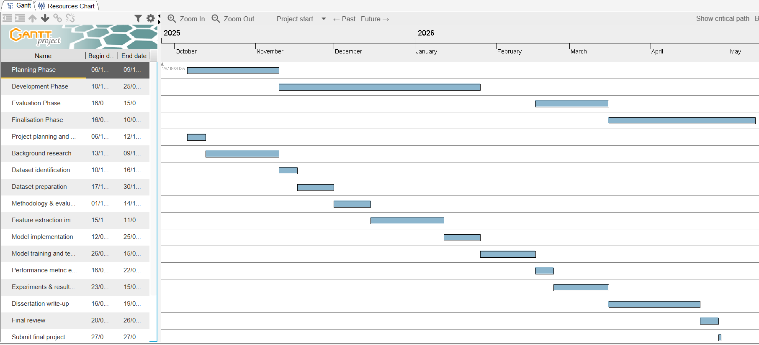
Figure 4 - Project Gantt Chart

Chapter 5 – Implementation and Development

5.1 - Implementation overview
This system follows a structed pipeline which consists of several key stages. Initially, a labelled dataset was collected from Kaggle [29] which contained both phishing and legitimate URLs and then pre-processed to ensure consistency and quality throughout the development process. This specific dataset had no null values or duplicate values, but preprocessing techniques were used as it allows for flexibility if the dataset were to be changed to test the models on different data. This stage is then followed by the feature extraction phase, which each URL is transformed into a set of numerical attributes which represent its lexical structure and structural characteristics. These features, when extracted, will then be used to train and evaluate multiple ML models within a controlled testing environment.
Model development and evaluation was originally coded in a jupyter notebook, but soon after was relocated to a VS code document, as that is where the other two sections are located, improving fluidity and ease of use when developing the rest of the project. Several supervised learning algorithms were implemented and compared using a consistent dataset and evaluation framework. Based on the comparative results the random forest classifier was chosen due to its strong ability to generalise unseen data, and requiring less computational power compared to a model such as an SVM.
To enable real world usage if developed further, the selected model was integrated into a backend project created using the flask framework [30]. The backend of this project exposes a RESTful API that will accept a user input URL, applies the same feature extraction process, which was used in training, and returns a classification output which determines whether its phishing or legitimate.
Lastly, a frontend was created to allow smooth user interaction with the interface, as using the terminal in the backend to input a URL can often prove complicated to many people, and as the average age of someone effected by phishing scams is 55+ [31] it can be assumed that having a simple to use interface would be preferred, as it can appeal to the main victim base of online phishing. This system was designed with usability in mind, ensuing that these users would have minimal problem interacting with the system.
The end-to-end workflow of this system can be described as a user would input a URL in the frontend interface, which will send a request to the backend API. This API processes the request and extracts the relevant features of the URL and applying the trained ML model, this prediction then returns to the frontend presented in a readable and digestible format.

5.2 – Dataset Preparation and Preprocessing

5.2.1 – Tools and Environments
The project first began development in a Jupyter notebook environment to support exploratory data analysis and experimentation with the dataset. Jupyter notebook was also selected due to its suitability for iterative development, which allowed for block testing of specific parts of the script, which allowed to narrow down errors at a faster rate than normal. Different parts of the script were also able to be tested separately such as the feature extraction methods, training the models and preprocessing whist providing visual feedback.
As the project progressed beyond the exploratory phase, the development environment shifted to Visual Studio Code (VSC). This transition was made to support a more structured workflow, consolidating all parts of the system including feature extraction, model training, backend API development and frontend integration, all within a single development environment. VS Code also provided project organisation through file structuring version control integration and real time debugging tools. Furthermore, moving away from a browser-based system improved the overall maintainability of the project.
In terms of dataset selection, publicly available phishing and legitimate URL’s dataset was used to train and evaluate the machine learning models. There dataset was chosen because of its real-world applicability to phishing scams, and its widespread use in any other academic research. The Kaggle dataset contained a generally similar amount of phishing and benign URLs, with benign taking the majority of entries at 134850, a noticeable amount over phishing’s 100945. However, with a dataset of this size, that difference shouldn’t skew prediction rates, as when the data is split, there are plenty of both phishing and benign URLs in each set.
The selection of a publicly available dataset also ensured that the project has adhered to ethical standards and GDPR as no personally identifiable information is available. Additionally, using previously established datasets reduces the risk of data bias being introduced through manually collected samples. Whilst this is true, using a static dataset also has the disadvantage of poor adaptability. If this project were to be deployed, one major vulnerability would be that the data the models have been trained do not update or adapt to new URL’s, risking then being falsely identified as benign when they’re phishing.
Overall, the beginning use of Jupyter notebook for ease of data exploration followed by the shift into a more structurally sound VSC development environment ensured flexibility in initial experimentation and stability when the project took shape in later iterations.

5.2.1 – Dataset Description
The dataset used in this project consist of a labelled collection of both phishing and benign. Each entry in the dataset contains a URL string alongside its label, along with the domain. The dataset was complied using sources which is commonly used in phishing detection research, ensuring it properly reflects realistic examples of both legitimate and phishing examples.
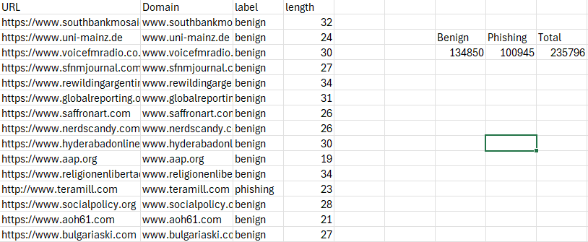
Figure 5 - Dataset Section with Supporting Table
An important consideration when selecting a dataset is the class imbalance [32]. Depending on the composition of the dataset used in this project, having an imbalance may influence model performance and therefore the overall accuracy. To aid this, metrics such as precision, recall and F1 score were also considered to give a more comprehensive assessment of the model’s performance.
This dataset was carefully selected so that it can provide a suitable foundation for training ML models as it properly reflects realistic URLs with clear labels for supervised learning. It includes many different phishing URLs so that each feature can be learnt, and it supports the extraction of lexical features, which form the basis of the research approach for this project.

5.2.3 – Data Preprocessing
Following Dataset selection, a selection of data preprocessing steps was employed to ensure that the dataset was consistent for machine learning training and testing. As machine learning models can be highly sensitive to inconsistencies within the data, this stage was necessary in making sure the output is as correct as possible [33]. When collecting the dataset, it was explicitly noted by the owner that there are explicitly no null values or duplicate entries, but these steps were employed regardless, because of the size of the dataset and if the dataset was ever to be changed, to train the models on new or different data, it could be swapped without the worry of preprocessing it beforehand.
The first step was standardising the URLs to lowercase. This was necessary on feature extraction as it is important that consistency was ensured, as URLs which had an identical structure but differed in letter casing could be treated as distinct inputs. By standardising them in this way, the extraction process is able to produce uniform outputs across the dataset.
Any duplicate or null values were also dropped from the dataset, as the presence of duplicate entries can introduce bias into the model’s prediction and null values were removed so that there were no errors during the feature extraction process.

5.2.4 – Class Distribution
An important part of the database is the distribution of instances which are split between phishing and benign. In real world scenarios, legitimate URLs significantly outnumber phishing URLs, which can lead to a class imbalance within datasets for machine learning. This imbalance can then influence model performance, particularly when using the ‘accuracy’ metric which may show misleading results if one class dominates the dataset.
The class distribution in this dataset was found to have a URL split of 57% legitimate and 43% phishing. This indicates a moderate class imbalance with benign URLs forming the majority. However, the class imbalance is not extreme when compared to real world scenarios, where legitimate scenarios dominate to a much larger extent. In machine learning, it is well established that significant class imbalance can lead to model bias towards the majority class, reducing their effectiveness at classifying minority instances, as shown in a paper by He, H. and Garcia [34].
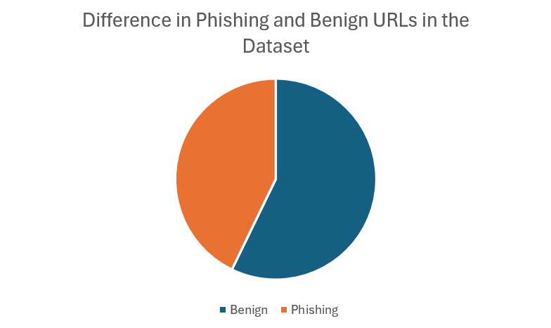
Figure 6 - Pie Chart Displaying Class Imbalance
Despite only having a moderate class imbalance, it is still important to be addressed in the context of phishing detection. Misclassifying phishing URLs as benign has significant security issues, therefore, evaluation metrics beyond just accuracy, such as precision, recall and F1 score are essential in this project to ensure the models predictive capabilities can be fully assessed.

5.2.5 – Train/Test Split
Following data cleaning and feature extraction, the dataset was divided into separate training and testing subsets to enable effective model evaluation. The standard ratio of 70/30 was used for the training and testing data. This approach ensures that there is more than a sufficient amount of data for the model to be trained on, whist reserving a smaller portion of data for the testing, as the more data which is used for training usually results in a higher predictive accuracy rating, because there is more data for the models to learn off of.
The training set was later fitted to each of the learning models, allowing them to learn the patterns and relationships between the extracted lexical features that appears in the cell before. The testing set is not exposed to the models during training, as it is essential models have unseen data to be tested with [35]. This is specifically important in the context of phishing detection, where the ability to classify unseen URL’s is critical to real world application of the project.
Originally, a train test split was used, as this is standard when splitting data. However, for this project URLs were grouped by their domain names, and the data was split by a GroupShuffleSplit method to ensure all URLs from the same domain were assigned to either specifically the training or testing set. Originally, the TrainTestSplit was used, but resulted in a lower prediction rate, incorrectly categorising 10,000 phishing URLs, and after implementing a domain overlap section, it revealed 2577 records appeared in both sets. After implementing GroupShuffleSplit it dropped to 0
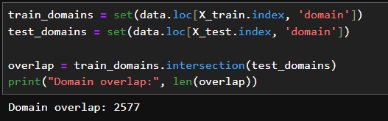
Figure 7 - Domain Overlap Before Implementing GSS
To ensure reproducibility across experiments and when testing, a random state was applied to the GroupShuffleSplit. This Guarantees that when the dataset is split into the training and testing sets, the same URLs appear in the respective subsets each time the process is executed [36].

5.3 – Feature Extraction Process

5.3.1 – Feature Design and Rational
The effectiveness of a machine learning model for the purpose of phishing detection is strongly influenced by the quality of the features used to represent the data. In the case of this project, a set of lexical features was derived directly from the URL string to capture textural and structural characteristics which are commonly associated with phishing activity. This approach was explicitly chosen for its computational efficiency and independence from external data sources, allowing for it to be easily scalable for real time detection systems.
The feature set used for this project was designed based on the patterns that have been identified in existing research, such as one conducted by Asif, H. Shirazi, and I. Ray highlighting the detection features in ML phishing detection [37]. One of the primary features was the overall length of the URL. Phishing URLs are often longer than legitimate ones, as attackers will use many subdomains or directories to obscure the real destination of the link. As a result, length checking the URL can serve as a useful indicator to malicious content.
Another important feature is the number of special characters which appear in the URL string. These characters include dots (.), hyphens (-) and slashes (/). A high frequency of these special characters can be an indication of phishing for misleading victims, similar to the length of the URL. For example, the use of multiple dots which create multiple subdomains can be used to mimic trusted domains, whilst hyphens and numeric characters are often utilised in ‘typosquatting attacks [38].
The presence of malicious words is also included in the feature extraction process. Terms such as ‘login’, ‘verify’ and ‘secure’ are frequently used in phishing URLs to reinforce legitimacy, or occasionally cause a sense of urgency in the victims. One issue with including full words in the feature extraction is that there are many words which appear in phishing URLs, and adding too many may cause overfitting in the model and leading to incorrect predictive output, so using the most common associated words layered with other lexical features maintains high performance through all models.
The use of HTTPS was included as a feature. While HTTPS is associated with security, it is not a definitive indicator for legitimacy in comparison to the other selected features, as phishing websites can also obtain SSL certificates [39]. However, when used in combination with other lexical features it can provide a useful insight into detecting possibly malicious content.
The selection of these features reflects a trade off between simplicity and effectiveness. By focusing detection efforts solely on lexical features, the system avoids the need for use of external data sources such as the webpage content which can introduce a layer of complexity and computing latency. However, this means that the model may miss more advanced phishing techniques that rely on visual deception on the webpage.
Overall, the chosen set of features displays a lightweight but effective representation of URLs enabling the ML models to learn meaningful patterns with phishing activity. The design aligns with the projects objective of developing a scalable and efficient phishing detection system based on lexical features from the URL.

5.3.2 – Feature Representation
Following the feature extraction process, the derived attributes were organised into a structured format that is suitable for application for the ML algorithms. Each URL is represented as a numerical feature vector, where each part was corresponding to a specific lexical characteristic which was extracted from the original URL sting.
These feature vectors were stored in a tabular data structure [40] using a data frame labelled ‘data’ in the script, where rows represented the URLs, and columns represented the extracted features. This format enabled direct compatibility with machine learning libraries such as scikit-learn.
All extracted features were coded numerically, to ensure compatibility with the machine learning algorithms. Features such as URL length and digit counts were represented as integer values, whilst Boolean features such as the presence of suspicious words were encoded as binary values. Having consistent numerical representation allowed the models to competently process information without requiring more encoding techniques.
This feature set was also kept consistent across all models to ensure a fair and controlled comparison. By using the same input representation for each ML algorithm, and difference in performance can be narrowed down to the models themselves rather than the variations in the data.

5.4 – Model Development and Training

5.4.1 – Model Selection Rationale
The chosen models for this project include logistic regression, decision tree, random forest and support vector machine. These were selected to provide a balanced comparison between interpretable linear models, and more complex nonlinear approaches. Using this combination enables the evaluation of both predictive performance and model interpretability, relating to the overall aim of the project.
Logistic regression was initially chosen as it serves as a good baseline classifier due to its simplicity and stronger interpretability. As a linear model, it estimates the probability of a URL belonging to the phishing category based on a weighted combination of input features. This allows for direct interpretation of feature influence, making it particularly useful in security applications where explainability is important.
The decision tree classifier was included due to its rule-based structure, which in nature provides clear decision-making logic. Decision trees segment the feature space into hierarchal rules, making them easy to interpret. This is advantageous in cybersecurity situations where understanding why a prediction is made can be as important as understanding the prediction itself. However, decision trees are prone to overfitting, particularly when performing on larger more complex datasets which can negatively affect the predictive output.
To address the limitations of single decision trees, the random forest algorithm was used. Random forest creates multiple decision tress using a random subset of data and features and aggregates their output to produce a final prediction. This approach reduces variance making it well suited for datasets with nonlinear features such as URL based phishing detection. Random forest is also widely well regarded for its strong classification performance, more so when feature relationships are complex and not strictly linear.
Finally, support vector machine, with a linear kernel was applied as a high dimensional classifier capable of finding an optimal decision boundary between classes. SVMs are effective in scenarios where the separation between classes isn’t immediately known and are also known for their strong generalisation performance. The linear kernel was also chosen to maintain some computational efficiency, and comparability with other linear models, but even with this applied, during testing, it was still recorded to be the longest model to deliver an output.

5.4.2 – Model Training and Configuration
Following on from the model selection, each classifier was trained using the extracted feature set mentioned in section 5.3.1 and the predefined training set. The training process involves fitting each model to the feature matrix (labelled ‘x’) from corresponding labels (labelled ‘Y’). All models were trained using the same dataset split to enable fair comparison when examining outputs.
The implementation involved the use of the scikit library, which provides the implementation of the selected machine learning models. The default parameters were generally kept the same to maintain consistency and to reflect real world use environments, with some minor adjustments applied where necessary to ensure stability when training.
For logistic regression, the maximum number of iterations were increased to 1000 to ensure convergence, given the large size of the dataset it’s analysing [41]. Additionally, the class wight was changed to ‘balanced’ to account for the slight dataset imbalance previously mentioned. The makes sure that the minority class (phishing URLs) is penalised more during training.
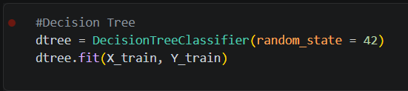
Figure 8 - Decision Tree Classifier
The decision tree classifier was also trained with a random state classifier. For this experiment, no depth constraints or pruning techniques were applied, allowing for the model to fully learn decision rules from the dataset [42]. Doing this however runs the risk of the model overfitting, it also enables a clearer comparison with ensemble methods.
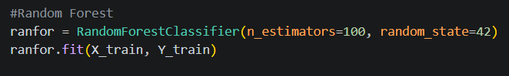
Figure 9 - Random Forest Classifier
The random forest classifier was fitted with 100 decision trees, which provides a balance between computational effectiveness and predictive performance. Each tree was trained on a random subset of the data and features, allowing the model to reduce the variance and improve on the model’s generalisation [43]. Another fixed random state was also applied to ensure consistent results across multiple tests of the system.
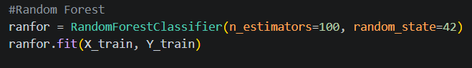
Figure 10 - Random Forest Classifier
The support vector classifier was fitted with a linear kernel, with the maximum number of iterations set to 5000. The linear kernel was chosen to maintain computational efficiency compared to other options such as ‘rbf’ which is often the default choice and still allows the model to find the best separating hyperplane between classes [44].
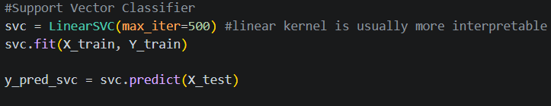
Figure 11 - SVC Classifier
No extensive hyperparameter tuning was included, as one aim of this project was to compare the performance between the baseline models of commonly used ML models under consistent conditions. This approach makes sure the evaluation is based on the models themselves, rather than the optimising strategies applied to them.

5.5 – Model Evaluation and Results

5.5.1 – Evaluation Metrics
To assess the performance of the machine learning models, a range of standard classification methods were employed [45]. This includes accuracy, precision, recall and F1 score. These metrics provide a comprehensive review of the predictive performance of the models, even more so in the context of phishing detection, where different types of classification errors carry varying levels of risk.
Accuracy measures the overall proportion of correctly classified instances; this provides a general indication of a model’s performance. However, the use of accuracy alone can be misleading in classification tasks where distributions are imbalanced, or where certain types of errors are more critical than others. In the context of this project, a model may achieve high accuracy whilst still failing to identify phishing URLs.
Precision evaluates the proportion of URLs predicted as phishing which actually appear as phishing in the dataset. This metric is important for analysing the reliability of positive predictions, as a low precision score would indicate a high number of false positives, leading to legitimate websites being flagged as phishing.
Recall measures the proportion of actual phishing URLs which have been correctly identified by the model. This is important in this project, as failing to detect a phishing URL (false negative) can expose users to significant risk. Having a high recall indicated that the model is efficient at detecting malicious instances.
F1 score represents the mean of precision and recall, providing a balanced measurement which accounts for both false positives and false negatives. This metric is useful when there is a need to balance detection with reliability, and its percentage will either increase or decrease depending on the percentage performance of recall and precision.
In addition to these metrics, confusion matrices were added to provide a detailed and understandable breakdown of classifications. This includes TP, TN, FP and FN.

5.5.2 – Results Comparison
The performance of each classifier was compared using the metrics outlined in the previous section. The results have been summarised in Figure 12 which presents the accuracy, precision, recall and F1 score for every model when tested on the unseen dataset.
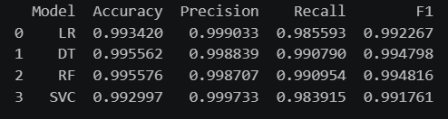
Figure 12 - Table of Model Evaluation Metrics
Overall, every model performed well with random forest performing the best in accuracy, recall and F1 score and being marginally beaten by decision tree in precision score. This indicates that ensemble methods such as random forest offer superior raw performance, even though all models performed exceptionally well.

5.6 – System Deployment

5.6.1 – Backend API (Flask)
The trained ML model was deployed using the flask framework in python. Flask was selected due to its simplicity, and flexibility when developing RESTful APIs for ML applications.
The backend system provides an endpoint that accepts a user input URL and processes it through the same feature extraction pipeline as used when training the models. This ensures consistency between training and real time prediction, and so that the model is picking up on red flags which reflect its training.
When a URL is submitted, the system applies the processing steps, including validation. The same lexical feature extraction methods are applied, generating a numerical vector representing the URL. This vector is passed to the trained RF model. Which then outputs a binary classification displaying as either phishing or legitimate
The model was loaded onto memory at runtime to allow it to perform without needing to be retrained. This allows the system to generate near instant results, making It suitable for real time detection scenarios. The API returns the output in a structured format which is then used by the frontend to display the result to the user

5.6.2 – Frontend HTML
A simple web-based frontend was developed by HTML to provide a simple interface for interaction with the phishing detection tool. The interface only allows the user to input a URL into a text field for analysis.
Upon submission, the frontend sends the URL to the flask backend, which processes the input and gives a result. This is then displayed on the interface along with a message letting the user know if the classification outcome, along with some colour coded visual feedback to help improve the immediate understanding.
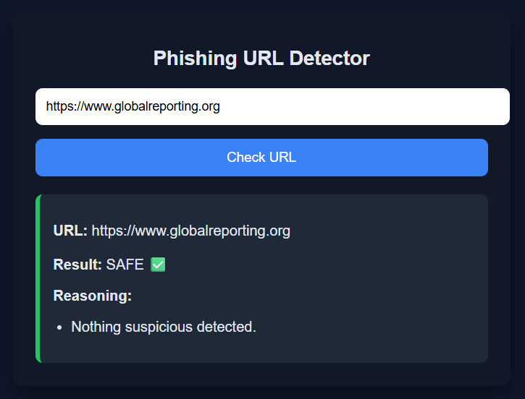
Figure 13 - Bening Frontend Output
The frontend as designed solely with ease-of-use in mind without any visual complexity, this ensures users can quickly check their URLs without requiring any additional knowledge of the underlying system, only needing to know what a URL is.

Chapter 6 – Evaluation and Discussion

6.1 – Overall Model Performance
The evaluation results demonstrate that all models are capable of effectively distinguishing between phishing and legitimate URLs using the selected lexical feature set. Across all classifiers, all performance metrics remained above 98% accuracy in all fields. This indicates that the extracted features successfully captured key structural patterns associated with malicious content. This also suggests that a lexical-only approach can be an effective lightweight baseline for phishing detection.
Among the evaluated models, random forest performed had the best majority performance, producing the highest score across multiple metrics, including F1, accuracy and recall. This performance can be attributed to it ensemble structure [46] which enables the model to capture more complex relationships within the feature space without a high risk of overfitting. As a result, RF demonstrated strong generalisation when applied to unseen data.
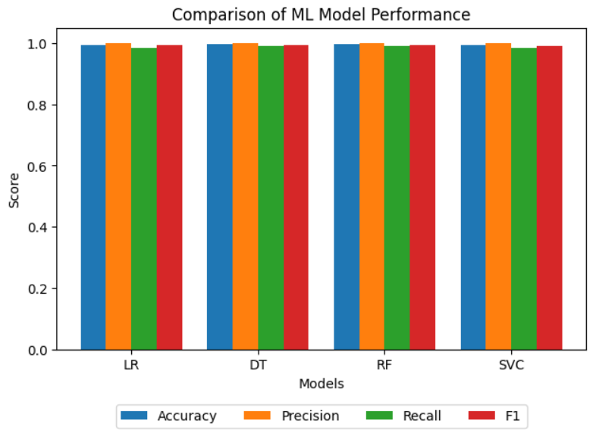
Figure 14 - ML Models Performance Comparison Graph
The decision tree achieved similar results compared to random forest, achieving an accuracy of 99.56% and an F1 score of 0.9948. Whist its competitive performance in these metrics may allow it to be chosen for deployment, its slightly lower recall compared to RF demonstrates that it has a marginally worse ability to correctly detect phishing instances, which may be attributed to its susceptibility to overfitting.
LR and SVM also demonstrated high performance, with accuracies of 99.34% and 99.30% respectively. Both models achieved precision scores over 0.999. However, their comparatively low recall scores (0.9856 and 0.9839), suggest they are more likely to miss some phishing URLs.
Overall, whist all models achieved around and over their expected performance, the results highlight subtle but important differences in their predictive capability. In particular, random forest demonstrated the most consistent balance across all evaluation metrics, supporting its selection for the most suitable model to be selected for deployment.

6.2 – Interpretability Vs Performance
One key objective of this project was to evaluate the machine learning models not only on their performance, but also in terms of explainability, with the aim of finding a suitable balance between the two for phishing detection. However, the results do not align perfectly and instead exist in a clear trade off relationship.
In terms of raw interpretability, logistic regression offers the most easily explainable decision making. Each feature is directly assigned a coefficient which directly influences the predicted probability of a URL being defined as phishing. This allows for a straightforward explanation of how individual lexical characteristics, such as length and presence of suspicious characters contribute to the model’s final decision. Similarly, the decision tree model provides rules-based structure that can be visually interpreted, allowing decisions to be traced back to explicit feature splits. However, whilst interpretable, its instability and insensitivity to data variations can reduce its reliability in more complex scenarios [47].
The SVM, whilst still based on a linear decision boundary to reduce computing power requirements, it still offers reduced interpretability compared to LR and DT. Although feature weighting [48] can be examined, the lack of intuitive decision formulation makes it difficult to translate it into readable explanations.
In contrast, the random forest achieved the highest overall performance across a majority of the metrics, at the cost of interpretability. As an ensemble method combining multiple decision trees, its predictions are derived from voting across multiple models, making individual decision pathways difficult to trace. While feature importance provides little insight into model behaviour, they do not offer the same level of transparency that can be found in models such as the DT and LR.
Although multiple models demonstrated strong performance, the final selection of random forest was based on predictive power over interpretability alone. Whilst models like logistic regression and decision tree are more interpretable in nature, their confusion matrices show a higher number of wrongly classified phishing URLs (at 438 and 280). When applying the outcome of this research into a real time deployment context, minimising incorrect classification takes priority over explainability. RF achieved the best overall performance with its ensemble structure allows it to reduce overfitting compared to a single decision tree and improves generalisation to unseen domains, which also aligns with the lexical based analysis strategy used in this project. Although it falls short in its interpretability, this trade off was considered to be acceptable given its superior performance compared to its competitors, and its higher suitability to being adapted into the real time phishing detector.

6.3 – Impact of Domain Based Splitting
A key methodological decision making in this project was the use of domain-based splitting [49] rather than a row-based train test split. This was implemented using a group splitting strategy where URLs from the same domain didn’t appear in both the training and testing sets. This approach was chosen to best reflect real world deployment conditions, where the model would be expected to classify unseen domains, rather than repeating variations of ones which it’s already seen.
In traditional random splits, there is a risk of URLs from the same domain appearing in both subsets of data, this leads to data leakage [50]. This is where the model indirectly learns domain specific patterns which also appear in the test set, artificially inflating results, displaying a high predictive performance, but when deployed, the chances that it misclassifies phishing URLs are very high, as seen in Figure 15, showing the confusion matrix missing 10,249 URLs even though it had classification accuracy rates of over 99%.
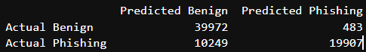
Figure 15 - Confusion Matrix Before Domain Based Splitting
By contrast, DBS forces the model to generalise at the domain level rather than memorising the patterns associated with specific URLs. This makes the classification more realistic, as phishing detectors in practice must be able to classify unseen domains. Although this approach may result in lower performance metrics compared to random splitting, it is absolutely the better choice in train test splitting due to its more reliable generalisation of the dataset.
In the context of this project, the use of domain-based splitting, strengthens the validity of the results, as it ensures the models performance is genuine predictive capability rather than memorisation of repeated domain features. This is even more so important with phishing detection, as attackers frequently generate new domains to avoid detection.
This approach improves the robustness of the evaluation process even with the cost of accuracy as it aligns more with real world development scenarios. It also provides a strong foundation for model comparison under conditions that better show its operational use.

6.4 – System Constraints
Despite strong performance across all models, several limitations must be acknowledged that effect the overall scope of the project. The primary limitation of this phishing detection system is how it utilizes lexical based features only. Whilst this was the project main goal, it does achieve it in a way where a lightweight model has been created, its overarching limitation of not being able to search deeper than the URL makes it unable to capture other malicious indicators such as webpage content or interaction patterns [51]. As a result, phishing attempts that more closely resemble real URLs may be missed.
A further limitation is one that many phishing detection systems have, as this project relies on a static dataset. In the context of the project this is fine, as it is only analysing the effectiveness of each ML model on unseen URLs, however in terms of further deployment where phishing techniques evolve overtime, the model effectiveness will decrease overtime unless constantly updated on new data, which in real life scenarios would cost money and manpower.
Although domain-based splitting does increase the evaluation realism, the dataset may still contain inherent sampling bias [52] as it doesn’t represent the diversity of real-world web traffic, this may influence how well the model generalises outside of the dataset environment.
From the perspective of the system, the implementation remains limited in terms of saleability and deployment readiness. The Flask API operates simply as a lightweight single request system but lacks depth in its features. The addition of load balancing, logging infrastructure would improve the systems detection rates with URLs outside the dataset. Similarly, the frontend provides a functional interface that achieves the goal of remaining simple to use, but lacks explainability features, such as a confidence rating.
There is also no hierarchy of features, where a URL could be legitimate, but because it contains too many subdomains or suspicious characters, it is classed as phishing. The presence of a feature hierarchy and confidence percentage meter would not only improve transparency for users, but it will also make the prediction more accurate. It may be worth noting that in future iterations to not classify URLs as binary (phishing or benign) but to have a gradient rating that uses the combination of lexical features to determine the level of likeliness that a URL is phishing, but even that come with its limitations.

6.5 – Practical Implications
Findings in this project have several practical implications for the development of real phishing detection systems. The results achieved demonstrate that ML models trained solely on lexical features can deliver high classification performance, suggesting that lightweight, feature based models can show some effectiveness in real world deployments where computational efficiency and rapid decision making is important.
In practical context, the random forest model can be integrated well into a backend security service to provide real-time URL classification [53]. This system could be embedded within email filtering services or network security tools to flag potentially malicious links before users interacted with them. The relatively fast inference time of these tree-based models makes them suitable for high traffic environments where a large volume of URLs must be continually processed.
However, the deployment of a system like this must consider the implications of the trade off between accuracy and interpretability. While the model performs well in identifying phishing URLs, its limited explainability may lower its suitability in situations where transparency is required, such as a system audit. Contrastly, simpler models such as logistic regression may be preferred in systems where justification of decisions are prioritised over the marginal increase in predictive performance.

Chapter 7 – Project Conclusion
This project set out to design, implement and evaluate a machine learning based system for detecting phishing URLs using lexical features only. The primary aim was to assess whether lightweight feature engineering, combined with supervised engineering could provide a good basis to a scalable approach to phishing detection without relying on external data sources such as webpage content.
The results of this investigation reveal that ML models are highly effective at the proposed task, with every model scoring at least 98% in every evaluation metric. In particular, the random forest achieved the best overall results, indicating a strong capability in capturing non-linear relationships between URL features and classification labels. However, the competitive performance in models like the linear SVM and logistic regression highlights the feature space is structured sufficiently to support multiple modelling approaches.
A key outcome of this study is the identification of the trade-off between interpretability and model performance. Whilst random forest provides the highest predictive performance (and was chosen because of this) it does so at the expense of readability. In contrast, logistic regression is easy to interpret, allowing for clear insight into how individual URL features influence the model’s final decision, but in this project, it performed the worst, misclassifying the most phishing URLs as benign. Analysing this trade-off reinforces that model selection in cybersecurity applications is highly dependent on operational priorities, particularly where the focus is either on maximising detection or understanding decision making.
The use of domain-based data splitting further strengthened the validity of the model evaluation by reducing data leakage, ensuing that the results shown are based in genuine model performance on unseen data, which reflects the real-world use cases of these tools.
Despite the strong results, the limitations of the project hold it back from being a full, deployment ready tool, such as its reliance on static data, or how domain-based splitting may not reflect the large variety of real-world URLs. However, these limitations open avenues for improvements in future iterations of this project, such as an integration of more feature rich datasets or the development of a continuously learning or retraining pipeline [54]. Such enhancements would improve the systems ability to adapt to evolving threats and increase the likeliness of real-world deployment.
Overall, this project demonstrates that ML techniques can be applied to phishing detection using a lexical feature-based approach, without the reliance on any external data sources, improving computational performance. By comparing multiple models and comparing then under realistic conditions, it highlights the importance of model selection and appropriate evaluation strategies. While the proposed system provides a strong prototype, the findings deliver a foundation for future improvements such as adaptability and real-world integration. As phishing attacks continue to develop and get more advanced, machine learning approaches remain a valuable and necessary component of any modern cybersecurity defence.

Chapter 8 – Appendix

Appendix A – Dataset Overview
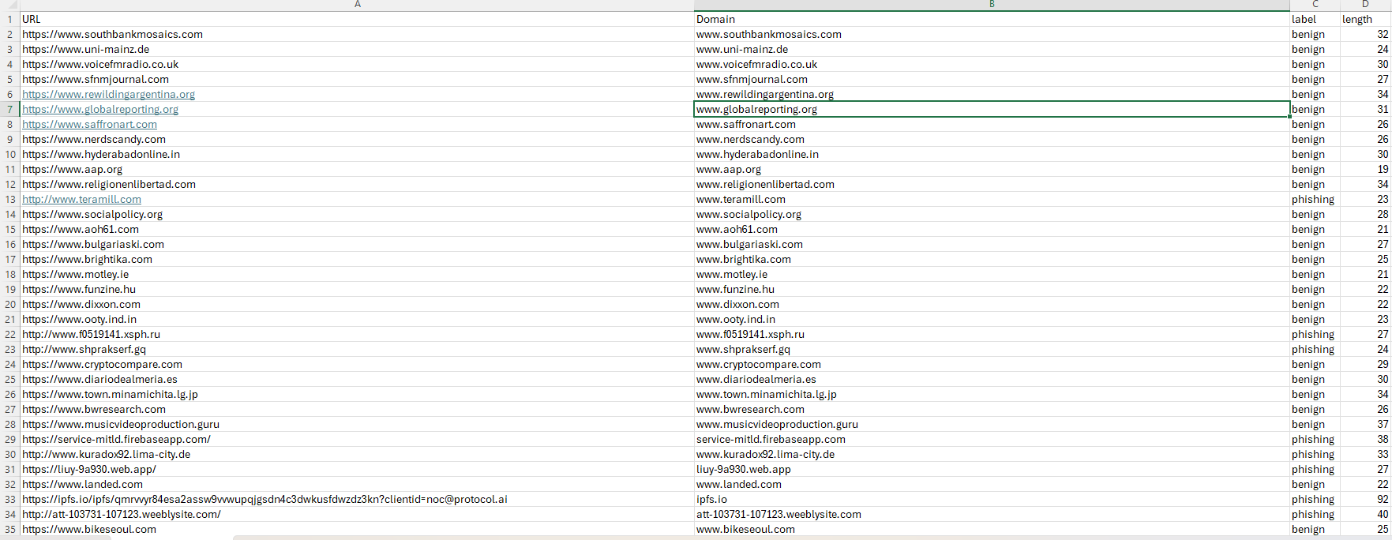
Figure 16 - Dataset Snippet

Appendix B – Full Model Comparison Code
import pandas as pd
import joblib
import os
import matplotlib.pyplot as plt
import numpy as np
from sklearn.model_selection import train_test_split
from sklearn.linear_model import LogisticRegression
from sklearn.tree import DecisionTreeClassifier
from sklearn.ensemble import RandomForestClassifier
from sklearn.svm import SVC
from sklearn.svm import LinearSVC
from sklearn.metrics import accuracy_score, precision_score, recall_score, f1_score
from sklearn.metrics import confusion_matrix, ConfusionMatrixDisplay
from urllib.parse import urlparse
from sklearn.model_selection import GroupShuffleSplit

#creating file path to locate the dataset
file_path = r"C:\Dissertation\phishing_dataset.csv"
#reading the dataset and then printing it
data = pd.read_csv(file_path)
print(data.head())
print(data.info())
#[DATA PREPROCESSING]
# Lowercase URLs
data['URL'] = data['URL'].str.lower()
# Remove duplicates
data = data.drop_duplicates(subset='URL')
# Remove missing values (this dataset has none, but good to keep if the dataset needs to be swapped)
data = data.dropna()

#[FEATURE EXTRACTION]
# URL length check
data['url_len'] = data['URL'].apply(len)
# Function to count number of '.'
def count_dots(x):
return x.count('.')
data['num_dots'] = data['URL'].apply(count_dots)
# Function to count number of '/'
def count_slashes(x):
return x.count('/')
data['num_slash'] = data['URL'].apply(count_slashes)
# Function to count number of '-'
def count_hyphens(x):
return x.count('-')
data['num_hyphen'] = data['URL'].apply(count_hyphens)
# Function to count number of digits
def count_digits(x):
count = 0
for c in x:
if c.isdigit():
count += 1
return count
data['num_dig'] = data['URL'].apply(count_digits)
# Function to check for @ symbol
def has_at_symbol(x):
if '@' in x:
return 1
else:
return 0
data['has_at'] = data['URL'].apply(has_at_symbol)
# Function to check for the word "login"
def login_present(x):
if 'login' in x:
return 1
else:
return 0
data['has_login'] = data['URL'].apply(login_present)
# Function to check for the word "secure"
def secure_present(x):
if 'secure' in x:
return 1
else:
return 0
data['has_secure'] = data['URL'].apply(secure_present)
# Function to check for the word "verify"
def verify_present(x):
if 'verify' in x:
return 1
else:
return 0
data['has_verify'] = data['URL'].apply(verify_present)
# Function to check the domain length
def dom_len(URL):
parsed = urlparse(URL)
return len(parsed.netloc)
data['dom_len'] = data['URL'].apply(dom_len)
# Function to check the number of subdomains
def count_sd(URL):
parsed = urlparse(URL)
domain = parsed.netloc
return domain.count('.') - 1 if '.' in domain else 0
data['count_sd'] = data['URL'].apply(count_sd)
# Function to check for 'https'
def has_https(URL):
if URL.startswith('https'):
return 1
else:
return 0
data['has_https'] = data['URL'].apply(has_https)

features = ['url_len','num_dots','num_slash','num_hyphen','num_dig','has_at','has_login','has_secure','has_verify','dom_len','count_sd','has_https']
X = data[features]
Y = data['label']
gss = GroupShuffleSplit(test_size=0.3, random_state=109)
groups = data['Domain']
train_idx, test_idx = next(gss.split(X, Y, groups=groups))
X_train = X.iloc[train_idx]
X_test = X.iloc[test_idx]
Y_train = Y.iloc[train_idx]
Y_test = Y.iloc[test_idx]

#Domain overlap (Displays and data leakage, should be 0)
train_domains = set(data.loc[X_train.index, 'Domain'])
test_domains = set(data.loc[X_test.index, 'Domain'])
overlap = train_domains.intersection(test_domains)
print("Domain overlap:", len(overlap))

#Logistic resgression
logreg = LogisticRegression(max_iter = 1000, class_weight = 'balanced')
logreg.fit(X_train, Y_train)

#Decision Tree
dtree = DecisionTreeClassifier(random_state = 42)
dtree.fit(X_train, Y_train)

#Random Forest
ranfor = RandomForestClassifier(n_estimators=100, random_state=42)
ranfor.fit(X_train, Y_train)

#Support Vector Classifier
svc = LinearSVC(max_iter=500) #linear kernel is usually more interpretable
svc.fit(X_train, Y_train)
y_pred_svc = svc.predict(X_test)

#Model Evaulation
def eval(name, model, X_test, Y_test):
Y_pred = model.predict(X_test)
print(f"--- {name} ---")
print("Accuracy:", accuracy_score(Y_test, Y_pred))
print("Precision:", precision_score(Y_test, Y_pred, pos_label='phishing'))
print("Recall:", recall_score(Y_test, Y_pred, pos_label='phishing'))
print("F1:", f1_score(Y_test, Y_pred, pos_label='phishing'))
print()
eval("Logistic Regression", logreg, X_test, Y_test)
eval("Decision Tree", dtree, X_test, Y_test)
eval("Random Forest", ranfor, X_test, Y_test)
eval("SVC", svc, X_test, Y_test)

def plot_cm(name, model, X_test, Y_test):
Y_pred = model.predict(X_test)

cm = confusion_matrix(Y_test, Y_pred, labels=['benign', 'phishing'])

disp = ConfusionMatrixDisplay(confusion_matrix=cm,
display_labels=['benign', 'phishing'])

disp.plot(cmap='Blues', values_format='d')
plt.title(f"Confusion Matrix - {name}")
plt.show()

plot_cm("Logistic Regression", logreg, X_test, Y_test)
plot_cm("Decision Tree", dtree, X_test, Y_test)
plot_cm("Random Forest", ranfor, X_test, Y_test)
plot_cm("SVC", svc, X_test, Y_test)

#Comparing results between ML models
results = []
MLmodels = [("LR", logreg), ("DT", dtree), ("RF", ranfor), ("SVC", svc)]

for name, model in MLmodels:
Y_pred = model.predict(X_test)
results.append({
"Model": name,
"Accuracy": accuracy_score(Y_test, Y_pred),
"Precision": precision_score(Y_test, Y_pred, pos_label='phishing'),
"Recall": recall_score(Y_test, Y_pred, pos_label='phishing'),
"F1": f1_score(Y_test, Y_pred, pos_label='phishing')
})

results_data = pd.DataFrame(results)
print(results_data)

# Set index
results_data.set_index("Model", inplace=True)
# Metrics to plot
metrics = ["Accuracy", "Precision", "Recall", "F1"]
# Create positions for bars
x = np.arange(len(results_data.index)) # number of models
width = 0.2

# Plot each metric
for i, metric in enumerate(metrics):
plt.bar(x + i*width, results_data[metric], width, label=metric)
# Formatting
plt.xlabel("Models")
plt.ylabel("Score")
plt.title("Comparison of ML Model Performance")
plt.xticks(x + width * 1.5, results_data.index)
plt.legend(loc='upper center', bbox_to_anchor=(0.5, -0.15), ncol=4)
plt.tight_layout()
plt.show()

Appendix C – Full Model Output
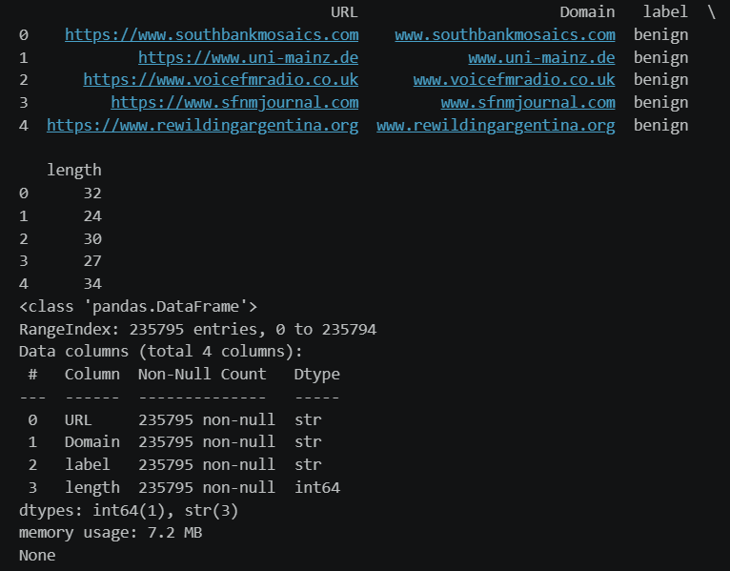
Figure 17 - Data Preprocessing
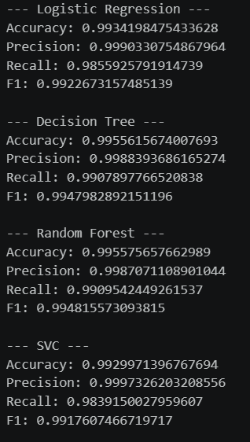
Figure 18 - ML Model Prediction Outputs
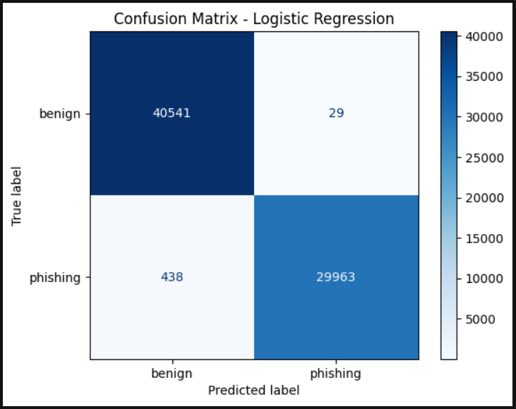
Figure 19 - Logistic Regression Confusion Matrix
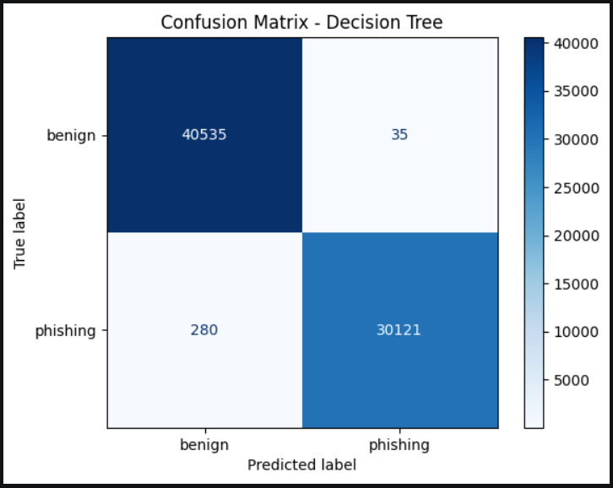
Figure 20 - Decision Tree Confusion Matrix
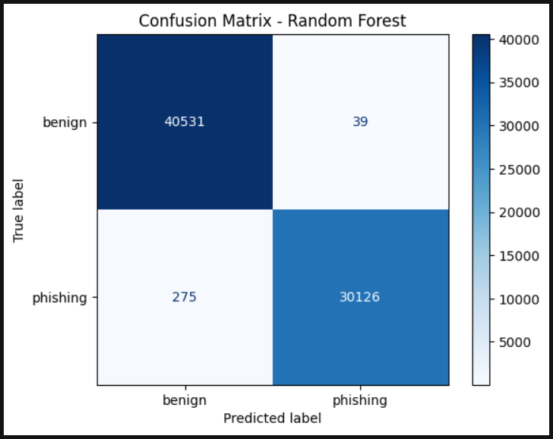
Figure 21 - Random Forest Confusion Matrix

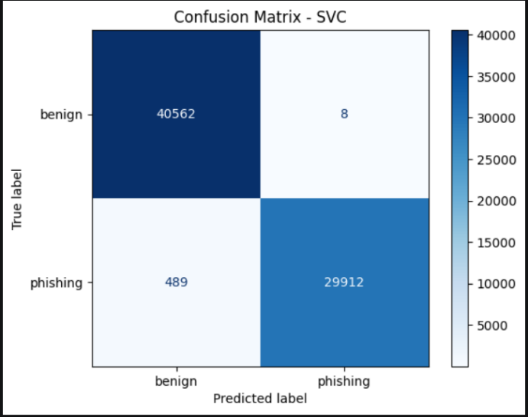
Figure 22 - SVC Confusion Matrix
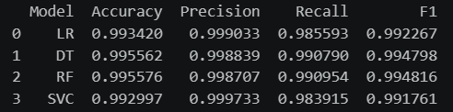
Figure 23 - Model Output Comparison Table
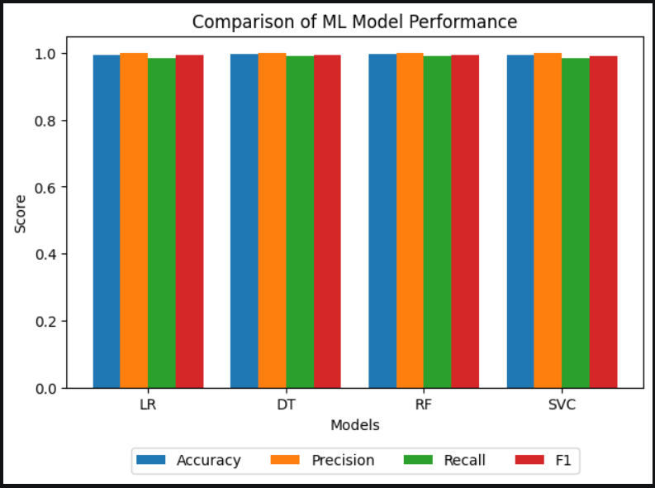
Figure 24 - Model Comparison Graph

Appendix D – Backend Full Code
from flask import Flask, request, jsonify
from flask_cors import CORS
from urllib.parse import urlparse
import joblib

app = Flask("PhishingDetector API")
CORS(app)

# load model
model = joblib.load("C:/Dissertation/Phishing_project/model/rf.pkl")

#Feature extraction
def extract_features(url):

parsed = urlparse(url)
domain = parsed.netloc

return [
len(url), # url_len
url.count('.'), # num_dots
url.count('/'), # num_slash
url.count('-'), # num_hyphen
sum(c.isdigit() for c in url), # num_dig
int('@' in url), # has_at
int('login' in url), # has_login
int('secure' in url), # has_secure
int('verify' in url), # has_verify
len(domain), # dom_len
domain.count('.') - 1 if '.' in domain else 0, # count_sd
int(url.startswith('https')) # has_https
]

# explaining why, if true, the model thinks its phishing
def explain_url(url):
reasons = []

parsed = urlparse(url)
domain = parsed.netloc

if len(url) > 75:
reasons.append("unusually long URL")

if url.count('.') > 3:
reasons.append("Too many subdomains")

if url.count('/') > 5:
reasons.append("Contains too many path levels")

if "@" in url:
reasons.append("Contains '@' symbol (commonly used in phishing scams)")

if sum(c.isdigit() for c in url) > 5:
reasons.append("Excessive numbers present")

if "https" not in url:
reasons.append("No HTTPS encryption detected")

if any(word in url.lower() for word in ['login', 'secure', 'verify']):
reasons.append("Contains suspicious keywords")

return reasons

@app.route("/detect_phish", methods=["POST"])
def detect():
data = request.get_json()
url = data["url"]

features = extract_features(url)

prediction = model.predict([features])[0]

# handle both cases
is_phishing = str(prediction).lower() == "phishing" or prediction == 1

return jsonify({
"input_url": url,
"is_phishing": int(is_phishing),
"prediction_raw": str(prediction),
"reasoning": explain_url(url) if is_phishing else ["Nothing suspicious detected."]
})

if __name__ == "__main__":
app.run(debug=True)

Appendix E – Full Frontend Code
<!DOCTYPE html>
<html lang="en">
<head>
<meta charset="UTF-8" />
<meta name="viewport" content="width=device-width, initial-scale=1.0" />
<title>Phishing URL Detector</title>
<style>
body {
font-family: Arial, sans-serif;
background: #0f172a;
color: #e2e8f0;
display: flex;
justify-content: center;
align-items: center;
height: 100vh;
margin: 0;
}

.container {
width: 500px;
background: #111827;
padding: 25px;
border-radius: 12px;
box-shadow: 0 10px 25px rgba(0,0,0,0.4);
}

h1 {
text-align: center;
margin-bottom: 20px;
font-size: 22px;
}

input {
width: 100%;
padding: 12px;
border-radius: 8px;
border: none;
margin-bottom: 15px;
font-size: 14px;
}

button {
width: 100%;
padding: 12px;
border: none;
border-radius: 8px;
background: #3b82f6;
color: white;
font-size: 15px;
cursor: pointer;
}

button:hover {
background: #2563eb;
}

.result {
margin-top: 20px;
padding: 15px;
border-radius: 8px;
background: #1f2937;
}

.safe {
border-left: 5px solid #22c55e;
}

.phishing {
border-left: 5px solid #ef4444;
}

ul {
padding-left: 20px;
}
</style>
</head>
<body>

<div class="container">
<h1>Phishing URL Detector</h1>

<input type="text" id="urlInput" placeholder="Enter URL..." />
<button onclick="checkURL()">Check URL</button>

<div id="result" class="result" style="display:none;"></div>
</div>

<script>
async function checkURL() {
const url = document.getElementById("urlInput").value;
const resultBox = document.getElementById("result");

resultBox.style.display = "block";
resultBox.innerHTML = "Checking...";

try {
const response = await fetch("http://127.0.0.1:5000/detect_phish", {
method: "POST",
headers: {
"Content-Type": "application/json"
},
body: JSON.stringify({ url: url })
});

const data = await response.json();

const isPhishing = parseInt(data.is_phishing) === 1;

resultBox.className = "result " + (isPhishing ? "phishing" : "safe");

resultBox.innerHTML = `
<p><strong>URL:</strong> ${data.input_url}</p>
<p><strong>Result:</strong> ${isPhishing ? "PHISHING" : "SAFE"}</p>
<p><strong>Reasoning:</strong></p>
<ul>
${data.reasoning.map(r => `<li>${r}</li>`).join("")}
</ul>
`;

} catch (error) {
resultBox.className = "result phishing";
resultBox.innerHTML = "Error connecting to backend.";
}
}
</script>

</body>
</html>

Appendix F – Frontend output
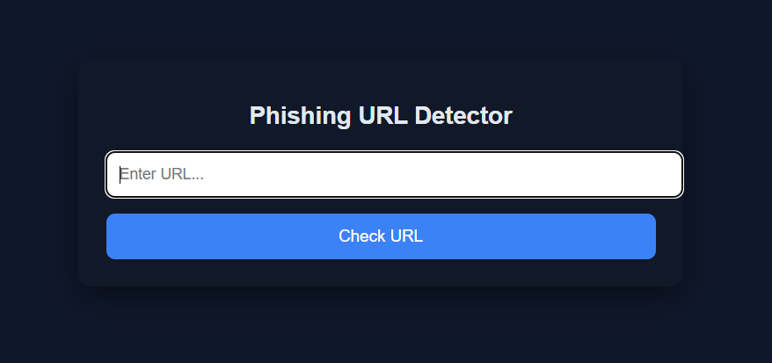
Figure 25 - Frontend Default View

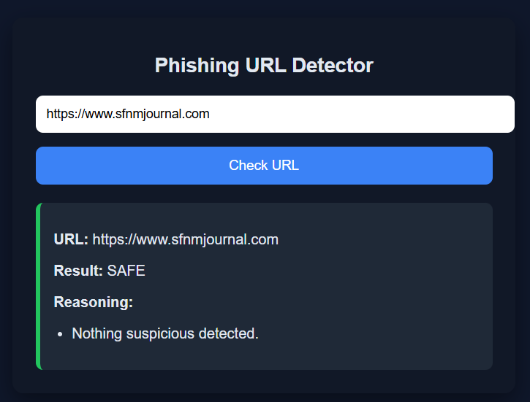
Figure 26 - Frontend Bening Output
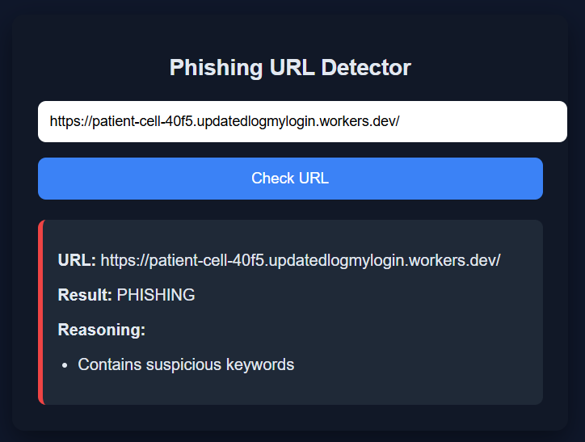
Figure 27 - Frontend Phishing Output

Bibliography
[1] “Phishing Guide - Security Guidance,” security-guidance.service.justice.gov.uk. https://security-guidance.service.justice.gov.uk/phishing-guide/#phishing-guide (accessed Dec. 19, 2026).
[2] M. Kosinski, “What is Phishing?,” IBM, May 17, 2024. https://www.ibm.com/think/topics/phishing (accessed Dec. 19, 2026).
[3] Government of the UK, “Cyber security breaches survey 2025,” GOV.UK, Apr. 10, 2025. https://www.gov.uk/government/statistics/cyber-security-breaches-survey-2025/cyber-security-breaches-survey-2025 (accessed Dec. 19, 2026).
[4] C. Crane, “Phishing Statistics: The 21 Latest Phishing Stats to Know in 2024,” Hashed Out by The SSL StoreTM, May 03, 2024. https://www.thesslstore.com/blog/phishing-statistics/ (accessed Dec. 19, 2026).
[5] T. Singh, M. Kumar, and S. Kumar, “Walkthrough phishing detection techniques,” Computers and Electrical Engineering, vol. 118, p. 109374, Aug. 2024, doi: https://doi.org/10.1016/j.compeleceng.2024.109374. (accessed Dec. 19, 2026).
[6] J. Fruhlinger, “Zero days explained: How unknown vulnerabilities become gateways for attackers,” CSO Online, Apr. 12, 2021. https://www.csoonline.com/article/565704/zero-days-explained-how-unknown-vulnerabilities-become-gateways-for-attackers.html (accessed Dec. 19, 2026).
[7] M. Khonji, Y. Iraqi, and A. Jones, “Phishing Detection: a Literature Survey,” IEEE Communications Surveys & Tutorials, vol. 15, no. 4, pp. 2091–2121, 2013, doi: https://doi.org/10.1109/surv.2013.032213.00009. (accessed Dec. 19, 2026).
[8] J. Spaulding, S. Upadhyaya, and A. Mohaisen, “The Landscape of Domain Name Typosquatting: Techniques and Countermeasures,” 2016 11th International Conference on Availability, Reliability and Security (ARES), Aug. 2016, doi: https://doi.org/10.1109/ares.2016.84. (accessed Dec. 19, 2026).
[9] M. Alanezi, “Phishing Detection Methods: A Review,” Technium: Romanian Journal of Applied Sciences and Technology, vol. 3, no. 9, pp. 19–35, Nov. 2021, doi: https://doi.org/10.47577/technium.v3i9.4973. (accessed Jan. 8, 2026).
[10] Shakirat Aderonke Salihu et al., “Detection of Phishing URLs Using Heuristics-Based Approach,” Nov. 2022, doi: https://doi.org/10.1109/ited56637.2022.10051199. (accessed Jan. 8, 2026).
[11] ResearchGate, “ResearchGate | share and discover research,” ResearchGate, 2024. https://www.researchgate.net/ (accessed Jan. 8, 2026).
[12] R. S. Rao and A. R. Pais, “An Enhanced Blacklist Method to Detect Phishing Websites,” Information Systems Security, pp. 323–333, 2017, doi: https://doi.org/10.1007/978-3-319-72598-7_20. (accessed Jan. 8, 2026).
[13] Fortinet, “What Is Heuristic Analysis?,” Fortinet. https://www.fortinet.com/resources/cyberglossary/heuristic-analysis (accessed Jan. 8, 2026).
[14] S. Roy, “Mastering Signature-Based Detection in Cybersecurity: Everything You Need to Know,” Fidelis Security, Jan. 29, 2025. https://fidelissecurity.com/threatgeek/network-security/signature-based-detection/ (accessed Jan. 8, 2026).
[15] S. Abu-Nimeh, D. Nappa, X. Wang, and S. Nair, “A comparison of machine learning techniques for phishing detection,” Proceedings of the anti-phishing working groups 2nd annual eCrime researchers summit on - eCrime ’07, 2007, doi: https://doi.org/10.1145/1299015.1299021. (accessed Jan. 8, 2026).
[16] GeeksforGeeks, “Supervised Machine Learning,” GeeksforGeeks, May 2018. https://www.geeksforgeeks.org/machine-learning/supervised-machine-learning/ (accessed Jan. 13, 2026).
[17] A. U. Rehman, I. Imtiaz, S. Javaid, and Muhamad Muslih, “Real-Time Phishing URL Detection Using Machine Learning,” pp. 108–108, Sep. 2025, doi: https://doi.org/10.3390/engproc2025107108. (accessed Jan. 13, 2026).
[18] M. Alshira’H, “Detecting Phishing URLs using Machine Learning Lexical Feature-based Analysis,” International Journal of Advanced Trends in Computer Science and Engineering, vol. 9, no. 4, pp. 5828–5837, Aug. 2020, doi: https://doi.org/10.30534/ijatcse/2020/242942020. (accessed Jan. 13, 2026).
[19] A. Mughaid, S. AlZu’bi, A. Hnaif, S. Taamneh, A. Alnajjar, and E. A. Elsoud, “An intelligent cyber security phishing detection system using deep learning techniques,” Cluster Computing, vol. 25, May 2022, doi: https://doi.org/10.1007/s10586-022-03604-4. (accessed Jan. 13, 2026).
[20] “PhishTank | Join the fight against phishing,” phishtank.org. https://phishtank.org/ (accessed Jan. 13, 2026).
[21] IBM, “Feature Engineering,” Ibm.com, Jan. 20, 2024. https://www.ibm.com/think/topics/feature-engineering (accessed Jan. 13, 2026).
[22] J. Dudovskiy, “Positivism - Research Methodology,” Business Research Methodology, 2020. https://research-methodology.net/research-philosophy/positivism/ (accessed Jan. 13, 2026).
[23] S. Taylor, “Quantitative Analysis,” Corporate Finance Institute, 2022. https://corporatefinanceinstitute.com/resources/data-science/quantitative-analysis/ (accessed Jan. 13, 2026).
[24] J. Dudovskiy, “Deductive Approach (Deductive Reasoning),” Business Research Methodology, 2025. https://research-methodology.net/research-methodology/research-approach/deductive-approach-2/ (accessed Jan. 13, 2026).
[25] W. M. Lim, “What is quantitative research? An overview and guidelines,” Australasian Marketing Journal (AMJ), vol. 1, no. 1, 2024, doi: https://doi.org/10.1177/14413582241264622. (accessed Jan. 14, 2026).
[26] GeeksforGeeks, “Python random.seed( ) method,” GeeksforGeeks, May 02, 2019. https://www.geeksforgeeks.org/python/random-seed-in-python/ (accessed Jan. 14, 2026).
[27] “OpenPhish - Phishing Intelligence,” openphish.com. https://openphish.com/ (accessed Jan. 14, 2026).
[28] B. Camburn et al., “Design prototyping methods: state of the art in strategies, techniques, and guidelines,” Design Science, vol. 3, no. 13, 2017, doi: https://doi.org/10.1017/dsj.2017.10. (accessed Jan. 14, 2026).
[29] M. Janety, “Phishing URL Dataset (URL and Label),” Kaggle.com, 2025. https://www.kaggle.com/datasets/marryjanety/phishing-url-dataset-url-and-label?resource=download (accessed Mar. 21, 2026).
[30] GeeksforGeeks, “Introduction to Web development using Flask,” GeeksforGeeks, Oct. 16, 2018. https://www.geeksforgeeks.org/python/python-introduction-to-web-development-using-flask/ (accessed Mar. 21, 2026).
[31] Age UK, “Scamming and its effect on vulnerable individuals,” 2016. Available: https://www.ageuk.org.uk/siteassets/documents/reports-and-publications/reports-and-briefings/safe-at-home/age_uk_briefing_fraud_and_scams_sept_2016.pdf (accessed Mar. 21, 2026).
[32] G. S. Hida and A. C. Alves Do Nascimento, “Overview of machine learning in class imbalance scenarios: Trends, challenges, and approaches,” Expert Systems with Applications, vol. 298, p. 129592, Mar. 2026, doi: https://doi.org/10.1016/j.eswa.2025.129592. (accessed Mar. 21, 2026).
[33] K. Pykes, “Data Preprocessing: A Complete Guide with Python Examples,” Datacamp.com, Jan. 15, 2025. https://www.datacamp.com/blog/data-preprocessing (accessed Mar. 21, 2026).
[34] H. He and E. A. Garcia, “Learning from Imbalanced Data - IEEE Journals & Magazine,” Ieee.org, 2009. https://ieeexplore.ieee.org/document/5128907 (accessed Mar. 21, 2026).
[35] C. Y. Wijaya, “Understanding Train-Test Splits,” Statology, Feb. 04, 2025. https://www.statology.org/understanding-train-test-splits/ (accessed Mar. 21, 2026).
[36] Rukshan Pramoditha, “Why do we set a random state in machine learning models? | Towards Data Science,” Towards Data Science, Apr. 30, 2022. https://towardsdatascience.com/why-do-we-set-a-random-state-in-machine-learning-models-bb2dc68d8431/ (accessed Mar. 21, 2026).
[37] Asif, H. Shirazi, and I. Ray, “Machine Learning-Based Phishing Detection Using URL Features: A Comprehensive Review,” pp. 481–497, Jan. 2023, doi: https://doi.org/10.1007/978-3-031-44274-2_36. (accessed Mar. 29, 2026).
[38] KeerthikaMsft, “What is typosquatting? | Microsoft Support,” Microsoft.com, 2026. https://support.microsoft.com/en-us/security/what-is-typosquatting (accessed Mar. 29, 2026).
[39] M. Thompson, “HTTPS Phishing Attacks: How Hackers Use SSL Certificates to Feign Trust,” Keyfactor, Oct. 11, 2021. https://www.keyfactor.com/blog/https-phishing-attacks-how-hackers-use-ssl-certificates-to-feign-trust/ (accessed Mar. 29, 2026).
[40] “Tabular Data Definition, Examples, Formats, and How to Tabulate Effectively – Azoo Blogs,” Cubig.ai, 2025. https://cubig.ai/blogs/tabular-data-definition-examples-formats-and-how-to-tabulate-effectively (accessed Mar. 29, 2026).
[41] GeeksforGeeks, “Logistic Regression in Machine Learning,” GeeksforGeeks, May 09, 2017. https://www.geeksforgeeks.org/machine-learning/understanding-logistic-regression/ (accessed Mar. 29, 2026).
[42] IBM, “What Is a Decision Tree?,” IBM, Nov. 02, 2021. https://www.ibm.com/think/topics/decision-trees (accessed Mar. 29, 2026).
[43] P. K. Anwla, “Random Forest,” TowardsMachineLearning, Jul. 16, 2021. https://towardsmachinelearning.org/random-forest/ (accessed Mar. 29, 2026).
[44] scikit-learn, “sklearn.svm.SVC — scikit-learn 0.22 documentation,” Scikit-learn.org, 2019. https://scikit-learn.org/stable/modules/generated/sklearn.svm.SVC.html (accessed Mar. 29, 2026).
[45] “ML Evaluation Metrics — Accuracy, Precision, Recall, F1, AUC Explained -,” - Engineering Content, Mar. 27, 2026. https://engineeringhulk.com/ai-ml/evaluation-metrics/ (accessed Mar. 29, 2026).
[46] “Ensemble Methods for Machine Learning,” Google Books, 2023. https://books.google.co.uk/books?hl=en&lr=&id=hoK3EAAAQBAJ&oi=fnd&pg=PR11&dq=machine+learning+ensemble+methods&ots=FczXIp219f&sig=vNCl7zGX-Xj4bloen_yt7j4Cnqg&redir_esc=y#v=onepage&q=machine%20learning%20ensemble%20methods&f=false (accessed Apr. 21, 2026).
[47] “1.10. Decision Trees — scikit-learn 0.23.2 documentation,” scikit-learn.org. https://scikit-learn.org/stable/modules/tree.html#complexity (accessed Apr. 21, 2026).
[48] I. Niño-Adan, D. Manjarres, I. Landa-Torres, and E. Portillo, “Feature weighting methods: A review,” Expert Systems with Applications, vol. 184, p. 115424, Dec. 2021, doi: https://doi.org/10.1016/j.eswa.2021.115424. (accessed Apr. 21, 2026).
[49] Adnan Mazraeh, “Advanced Data Splitting Techniques for Deep Learning and Domain-Specific Challenges,” Medium, Feb. 10, 2025. https://medium.com/@adnan.mazraeh1993/advanced-data-splitting-techniques-for-deep-learning-and-domain-specific-challenges-3fa3e6a2aaf8 (accessed Apr. 21, 2026).
[50] IBM, “Data leakage machine learning,” Ibm.com, Sep. 30, 2024. https://www.ibm.com/think/topics/data-leakage-machine-learning (accessed Apr. 21, 2026).
[51] L. Gallo, D. Gentile, S. Ruggiero, A. Botta, and G. Ventre, “The human factor in phishing: collecting and analyzing user behavior when reading emails,” Computers & Security, vol. 139, pp. 103671–103671, Dec. 2023, doi: https://doi.org/10.1016/j.cose.2023.103671. (accessed Apr. 21, 2026).
[52] S. Panzeri, C. Magri, and L. Carraro, “Sampling bias,” Scholarpedia, vol. 3, no. 9, p. 4258, 2008, doi: https://doi.org/10.4249/scholarpedia.4258. (accessed Apr. 21, 2026).
[53] S. Wali, Y. A. Farrukh, and I. Khan, “Explainable AI and Random Forest based reliable intrusion detection system,” Computers & Security, vol. 157, p. 104542, Oct. 2025, doi: https://doi.org/10.1016/j.cose.2025.104542. (accessed Apr. 21, 2026).
[54] E. Kytidou, T. Tsikriki, G. Drosatos, and K. Rantos, “Machine learning techniques for phishing detection: A review of methods, challenges, and future directions,” Intelligent Decision Technologies, Sep. 2025, doi: https://doi.org/10.1177/18724981251366763. (accessed Apr. 21, 2026).

