Word Count Task 1 - 2307

5CO003 Professional Behaviours and Valuing People

Task 1 AC-1.1

The Collins Dictionary definition of ‘Professional’ (2023) means “relating to a person’s work, especially work that requires special training’. Being ‘Professional’ incorporates behaviour, qualifications, and experience. According to Johnson (ND, quoted in Tokc-Wilde, 2022, para.4) being a professional is not only doing your job or having a qualification but conducting yourself in a competent, reliable, and respectful manner. Being professional reflects on our moral compass, the experiences, and values learnt throughout life such as equality and fairness. Clarke (ND, quoted in Tokc-Wilde, 2022, para.5) describes it as a collection of attributes that are developed over time such as reliability, accountability, honesty, and integrity.

People professionals (PPs) require a standard of education and/or experience to demonstrate their technical expertise. Membership to an organisation such as CIPD showcases knowledge, behaviour, and commitment to the highest professional standards (CIPD, 2022a). To be a member you agree to be governed by their code of ethics and adhere to the code of professional conduct.

The CIPD Profession Map identifies the core purpose of a people professional (PP) and highlights the skills, behaviours, and knowledge to fulfil that purpose through an international benchmark. PPs use the map to drive change, career progression and improve decision making, performance and confidence (CIPD, 2022b).

Task 2 AC-3.1

A PPs role is continually evolving so keeping up-to-date with legislation, caselaw and key trends will keep ideas and practices current. Employment related organisations such as ACAS, HR Expert and Indicator publish newsletters giving tips and advice like the following extract about the ruling on menopause from the House of Commons.
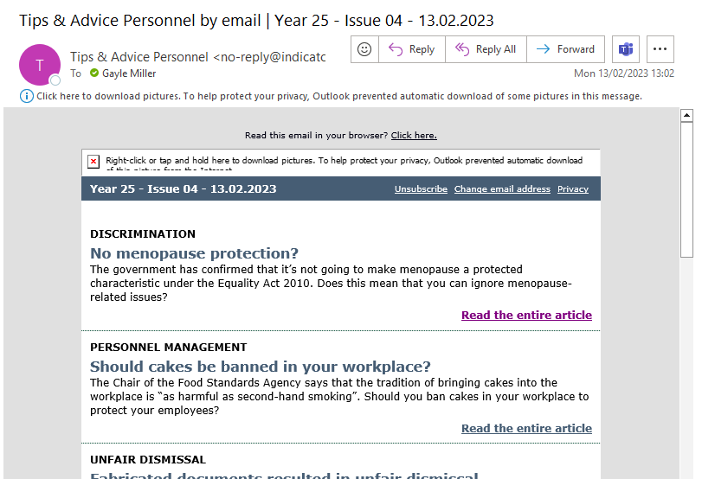
(Indicator, 2023)

The pandemic generated rapid change with a significant increase in the use of IT equipment and software. PPs adapted to online tools and combined working hours with daily routines and family commitments whilst facilitating these changes for everyone else (Al-Habaibeh et al, 2021). Policies were updated to reflect home working, software training provided and wellbeing checks implemented as people became isolated. The ONS reported people working at home increased from 14.5% in 2019 to 30.6% in 2022 showing many of these changes are here to stay (Moss, 2022).

Continued professional development (CPD) is a technique enabling individuals to engage in life-long learning that supports their role and future career. Individuals record CPD to meet the industry standard, maintain their professional memberships and ensure they are current in their area of expertise.

The CPD cycle helps structure your development in 4 stages, assess, plan, do, review. A self-assessment or needs analysis identifies weaknesses that can be developed to improve professional skills. Generating a plan outlining specific objectives will help focus on activities to support development. Attending events, training, and webinars helps meet these objectives. A review reflects on what has been learnt and what else is required (CPD, 2020).

The CIPD learning hub self-assessment tool identifies development needs and signposts additional resources providing a bespoke learning plan. The reflection tool helps think about the learning, how it applies and whether further action is required (CIPD, 2022c).

Task 3 AC-1.2

The law defines boundaries of right and wrong but behaving ethically is discretionary. Ethical values determine behaviour when making decisions. How we make decisions is important as wrong decisions can have a detrimental impact on individuals, the business and its reputation (Russell, 2022). Difficult decisions such as redundancy have a negative impact so must be handled ethically to ensure everyone is treated with respect, fairness, and integrity. Applying the CIPD eight ethical lenses when making decisions provides alternative ways of viewing the situation (Green, 2022).

Three ethical values I hold personally are honesty, integrity, and accountability. I believe honesty and integrity build trust. Having strong moral principles means things are done correctly, to the best of my ability and in the interest of others. My colleagues, know I will do my best to support them, offer guidance and challenge difficult situations. Tough decisions must be made but people trust that I will research every alternative to find the best possible outcome. Our firm has a flat hierarchical structure so little opportunity for career progression. A team member wanted to discuss promotion. I explained they were highly valued but if they wanted to progress they should consider another organisation and I would support them whichever decision they made. They moved to another company and are very successful.

Accountability builds trust. Everyone makes mistakes and I believe it is not the mistake that defines our character but how we handle it and what we learn from it. Accepting responsibility and working to correct it can be hard and have consequences, but it builds integrity. When I found I had missed a commission payment from the payroll I contacted the person apologised and made the payment immediately. I discovered an employee had been missed from the pension scheme so I notified all parties, calculated the benefit from the employer and presented a case for back pay as it was not the employees fault. It is just as important to take responsibility for others mistakes to resolve the situation as quickly and efficiently as possible. As a manager I encourage my team to notify me of any mistakes so we can address them immediately.

Task 4 AC-1.3

PPs must contribute confidently to discussions to convey what they want to shareholders and influence the desired outcome. PPs communicate in a variety of ways and through different levels of the organisation. Knowing your target audience and delivering your contribution accordingly can have a significant impact on your effectiveness. Find out what your audience knows already and pitch your message to fill in the gaps. All the key points should be supported with evidence. Different styles of communication can also have a positive impact. Visual aids can be helpful for individuals with visual learning styles and can also reinforce the main points with diagrams and charts which are more memorable. Handouts allow people to focus on the content rather than take notes and continue to think about the proposition after the presentation (Smith & Mitchell, 2022, p. 163-166). Thorough research ensures questions can be answered demonstrating professionalism and building confidence with the shareholders.

According to Yemm (2008, p. 21) the ability to influence people relies on improving our communication skills. He describes seven options which improve our strategy by connecting with the audience through friendliness, empowerment, visioning, building alliances, expertise, bargaining and positioning. It is not necessary to have power over someone to be able to influence them if you have a positive connection, clearly define the desired outcome, how it affects them and the benefits it offers.

Cialdini’s (Smith & Mitchell, 2022, p. 163) six rules of influence have helped understand how large numbers of people can be influenced. For example, lemming behaviour dictates people are more likely to comply if others have already done so. Liking means people are more likely to agree if they like you or if you share similarities, much like affinity or beauty bias (Murphy, 2022).

How we present our proposition influences the outcome. A clear and compelling tone of voice, speed of delivery, eye contact, facial expressions, interaction, and expert knowledge will improve participation, engagement and credibility (Rolleter, 2021).

Task 5 AC-1.4

PPs need to know when and how to raise a concern that conflicts with ethical values or legislation. It is important to inform, empower and support others to raise concerns too. Depending on the severity of the matter and those involved there are different ways to raise issues with employers such as informal discussions, raising a grievance or whistle blowing. Written policies must available in the staff handbook outlining the procedure. These must be followed by both parties to ensure the matter is dealt with in a legal, fair and consistent manner. Concerns should be raised as soon as is reasonably practicable so evidence can be gathered and no further harm can come to others. Organisations such as ACAS and Citizens Advise also provide guidance and support to deal with these matters.

An informal chat can be with a manager or someone in HR. Smaller organisations may not have HR representatives, but it should be someone you feel comfortable with and who has the ability to assist with your concern. If a satisfactory solution is not reached the matter can be raised formally through the grievance procedure (ACAS, 2022).

If there is no formal grievance procedure the ACAS Code of Practice should be followed. The grievance should be raised in writing and a meeting with the employer arranged in a reasonable time. Employees have the write to be accompanied by a colleague or union representative. After the meeting a decision will be made and the employer will write detailing the outcome giving the opportunity to appeal the decision. If the outcome is still unsatisfactory a claim can be made to the employment tribunal (Citizens Advice, 2019).

Whistle blowing is the disclosure of an employer’s wrongdoing which is in the public interest such as a criminal offence, a breach of health and safety regulations or breaking the law. Whistle blowers are protected by the Public Interest Disclosure Act 1998 and should not be treated unfairly or lose their job from whistle blowing (ICAEW, 2023).

In October 2022 an employment tribunal, Jhuti vs Royal Mail Group Ltd ruled unfair dismissal against Jhuti because a decision to dismiss had been made without all the available facts. Jhuti had made whistle blowing allegations concerning a colleague she suspected of fraudulent activity. Instead of being investigated the line manager raised concerns about poor performance leading to Jhuti’s dismissal by an independent manager who was not aware she had blown the whistle (CIPD, 2022d). This was an ethical conflict and a breach of legislation which resulted in Jhuti being awarded £100,000 in compensation. Handling the complaint appropriately would have avoided the financial and reputational damage to the business and emotional damage to the individuals. Having a policy is important and ensuring staff are trained, have the authority and support to carry out their duties is essential. Being accountable and having checks and balances in place will prevent similar situations.

Task 6 AC-2.1

Ethical people practice (EPP) benefits employees by making them feel included, valued and fairly treated through reward, recognition, equality, inclusion and consistent application of policies and procedures. For example EPP ensures employees are paid fairly, on time and everyone has access to reward schemes and training opportunities.

Organisations that implement fair recruitment processes, free from discrimination and bias create opportunities for candidates that would have been rejected before. For example home working policies allow candidates from long distances to apply or individuals with disabilities that prevent them from traveling (Carnahan & Moore, 2020).

Employers benefit from increased productivity, low employee turnover and a strong reputation.
EPP improves the decisions made by an organisation as they are based on good principles and values. Unethical decisions can result in legal action, poor morale and financial and reputational damage. According to Cook (2021) diversity, equality and inclusion initiatives create a better culture and improve employee attraction and retention.

The following theories reflect the fact that when we are emotionally and psychologically satisfied we are happier and healthier which according to Gifford & Young (2021) means we will perform better and drive productivity.

Maslow’s hierarchy of needs theory suggests that decision making is based on the fulfilment of psychological needs. Maslow splits the levels into deficiency needs at the bottom and growth needs at the top. A deficiency need means motivation decreases as the need is satisfied, for example the first level is the basic human need for food, water, and shelter. The second level is safety, the third love and belonging and the fourth esteem. The fifth level is self-actualisation and is defined as a growth need which increases motivation as the needs are satisfied the opposite to deficiency needs (McLeod, 2022).

Pink’s framework (Emerald Works Ltd, 2022) suggests that in the creative and innovative workplace of the 21st Century the “carrot and stick” approach to motivation is no longer suitable and should be replaced with intrinsic motivation where people are self-motivated through autonomy, mastery and purpose. There has been a significant increase in autonomy through home and flexible working which has improved employee wellbeing and work life balance whilst increasing productivity by 33% (CIPD, 2021). Mastery is the desire for self-improvement and is self-motivating. Purpose motivates individuals by showing how their contribution makes a difference, building trust and psychological attachment.

Task 7 AC-2.2

During the pandemic our employees had to work from home, so equipment and training were provided. Lockdown was difficult and had a unique set of problems but it highlighted the benefits of homeworking for the firm and employees.

We researched hybrid policies on ACAS (2021) and from other organisations. We conducted a survey to get employees feedback on home working. Some enjoyed working from home and less travel meant a better work life balance, others preferred the structure of coming to the office each day and separating work and home but flexibility for parental responsibilities and appointments would be advantageous. We asked employees how hybrid working would benefit them and the firm. We also asked if there was a preferred split of time between office and home. To ensure fairness and inclusivity we considered possibilities for roles that cannot be conducted from home.

As a small organisation and based on the employee feedback we implemented a policy which gave flexibility to all staff to work from home as long as there was cover in the office. There was no additional cost as equipment and training had already been provided. Good communication and staff supporting each other made this policy successful and has improved team moral. We cannot always facilitate everyone’s needs as the business has to come first but the increase in communication has resulted in everyone being more flexible.

References

ACAS (2021) Acas publishes new advice on hybrid working. Available at: https://www.acas.org.uk/acas-publishes-new-advice-on-hybrid-working#:~:text=Acas%20publishes%20new%20advice%20on%20hybrid%20working%2013,between%20working%20remotely%20and%20in%20their%20employer%E2%80%99s%20workplace. (Accessed: 07 March 2023).

ACAS (2022) How to raise a problem at work informally. Available at: https://www.acas.org.uk/how-to-raise-a-problem-at-work (Accessed: 15 February 2023).

Al-Habaibeh, A. Watkins, M. Waried, K. Javareshk, M.B. (2021) Challenges and opportunities of remotely working from home during Covid-19 pandemic. Available at: https://www.sciencedirect.com/science/article/pii/S2589791821000165 (Accessed: 07 February
2023).

Carnahan, B. Moore, C. (2020) Actively addressing unconscious bias in recruiting. Available at: https://www.hbs.edu/recruiting/insights-and-advice/blog/post/actively-addressing-unconscious-bias-in-recruiting (Accessed: 7 March 2023).

CIPD (2021) More employers reporting increased productivity benefits from homeworking compared to last summer, new CIPD research finds. Available at: https://www.cipd.co.uk/about/media/press/010421homeworking-increased-productivity (Accessed: 01 March 2023).
CIPD (2022a) Membership. Available at: https://www.cipd.co.uk/membership (Accessed: 06 February 2023).

CIPD (2022b) Explore the profession map. Available at: https://peopleprofession.cipd.org/profession-map?_gl=1*13wedfe*_ga*MzcwMzI4MDM4LjE2NjE4NTQyODQ.*_ga_D9HN5GYHYY*MTY3NTc3OTI3Ni4xNS4xLjE2NzU3NzkyNzcuNTkuMC4w (Accessed: 07 February 2023).

CIPD (2022c) My learning plan. Available at: https://learninghub.cipd.org/d2l/home/6720#gref (Accessed: 08 February 2023).

CIPD (2022d) Case law on whistleblowing. Available at: https://www.cipd.co.uk/knowledge/fundamentals/emp-law/whistleblowing/cases (Accessed: 15 February 2023).

Citizens Advice (2019) dealing with grievances at work. Available at: https://www.citizensadvice.org.uk/work/grievance-meetings/dealing-with-grievances-at-work/ (Accessed: 15 February 2023).

Cook, J. (2021) UK businesses risk talent shortages unless they focus on diversity and inclusion. Available at: https://www.businessleader.co.uk/uk-businesses-risk-talent-shortages-unless-they-focus-on-diversity-and-inclusion/#:~:text=Robert%20Half%2C%20a%20specialist%20recruiter%20is%20urging%20UK,find%20talent%20with%20the%20right%20skills%20in%202022. (Accessed 01 March 2023).

CPD (2020) An introduction to the CPD cycle stages. Available at: https://cpduk.co.uk/news/an-introduction-to-the-cpd-cycle-stages-and-definition (Accessed: 08 February 2023).

Emerald Works Ltd, 2022. Pink’s autonomy, mastery and purpose framework. Available at: https://www.mindtools.com/asmdp60/pinks-autonomy-mastery-and-purpose-framework (Accessed: 17 February 2023).

Gifford, J. Young, J. (2021) Employee engagement and motivation. Available at: https://www.cipd.co.uk/knowledge/fundamentals/relations/engagement/factsheet (Accessed: 01 March 2023).

Green, M. (2022) Ethical practice and the role of people professionals. Available at: https://www.cipd.co.uk/knowledge/culture/ethics/role-hr-factsheet#gref (Accessed: 10 February 2023).

ICAEW (2023) The public interest disclosure act 1998. Available at: Public Interest Disclosure Act 1998 | Whistleblowing | Legal | ICAEW (Accessed 15 February 2023).

Indicator (2023) Tips and advice personnel. Available https://www.tips-and-advice.co.uk/personnel/25/04/UKTAPSAR_EU25040101 (Accessed 09 February 2023).

Smith, J. & Mitchell, J. (2022) ‘The behaviour of the people professional’ in Studying Human Resource Management. 3rd edn. London: Kogan Page.

McLeod, S. (2022) Maslow’s hierarchy of needs. Available at: https://www.simplypsychology.org/maslow.html#:~:text=How%20many%20levels%20are%20there,esteem%2C%20and%20self%2Dactualization. (Accessed 17 February 2023).

Moss, R. (2022) Homeworking in the UK more than doubles. Available at: https://www.personneltoday.com/hr/homeworking-statistics-uk-2022-ons-hybrid-working/ (Accessed: 09 February 2023).

Murphy, N. (2022) Types of bias. Available at: https://cpdonline.co.uk/knowledge-base/safeguarding/types-of-bias/ (Accessed: 15 February 2023).

‘Professional’ (2023) Available at: https://www.collinsdictionary.com/dictionary/english/professional (Accessed: 31 January 2023).

Rolleter, B (2021) Presentation skills: 15 tips for effective presentations. Available at: https://www.cbs.de/en/blog/15-effective-presentation-tips-to-improve-presentation-skills/ (Accessed: 15 February 2023.

Russell, T. (2022) Ethical practice. Available at: https://peopleprofession.cipd.org/profession-map/core-behaviours/ethical-practice#gref (Accessed: 10 February 2023).

Tokc-Wilde, I. (2022) ‘What it means to be professional’, in ACCA. Available at: https://www.accaglobal.com/uk/en/student/sa/features/being-professional.html (Accessed: 31 January 2023).

Yemm, G (2008) Influencing others – a key sill for all. Available at: https://www.ims-productivity.com/user/custom/journal/2008/Summer/MSJ14Summer2008.pdf (Accessed: 15 February 2023).

Word Count Task 2 – 1250

Task 2

Activity 1 AC-2.3, AC-3.2

Many methods and tools are used to assess learning needs including SWOT analysis, appraisals and pier reviews giving 360 feedback (Gifford, 2022) which eliminates self-assessment bias issues. According to Megginson & Whitaker (2003) even unfair feedback offers ‘food for thought’. Each level of the Profession Map identifies the approaches needed to carry out the work allowing individuals to assess their training needs against the five core behaviours, ethical practice, professional courage and influence, valuing people, working inclusively and passion for learning.

(Appendix 1) I used the CIPD Learning Hub self-assessment tool (CIPD, 2022a) to set personalised development objectives. I assessed myself against the five core profession behaviours at associate level. Each section is broken down into multiple questions which you rate from emerging to exceeding. The hub offers recommendations through a variety of techniques to improve the areas of weakness.

Activity 2 AC-3.3

(Appendix 2) To create my learning plan I reviewed the recommendations given through the self -assessment tool and reflected on the feedback given during my 360 Appraisal which gives feedback from my manager and those I manage (CIPD, 2022b). I reviewed the tasks I am dealing with at the moment so I could choose the training that would be most beneficial at the current time. During my appraisal I was allocated an amount of formal training time and money for the year to remain up to date on specific areas of my role. I identified my learning style through a VARK questionnaire (VARK, 2023)which are auditory and kinaesthetic. Didau (2020) states that presenting information in the learners preferred style is wrong and should be presented in the appropriate context of what is being taught.

Having considered each of these factors, I chose resources that would help with a current project. I am implementing new software but am meeting some resistance which has created an ethical dilemma. I am focusing my learning in the core behaviour areas of ethical practice and professional courage and influence. I chose to watch a video on the science of persuasion which led to reading further articles on the subject. I have selected two courses on ethical practices and professional courage and influence. These courses are free and online so I can do them at my own pace over the next 3 months.

I am an advocate for self-directed learning as it gives me the autonomy to assess, select and manage my own learning activities. I find this empowering and motivational as I am investing in my own success. Self-directed learning within an organisation still needs to meet the organisation objectives (CIPD, 2018).

Activity 3 AC-3.4

I have used the CIPD Learning Hub reflection tool to reflect on how each activity impacted my behaviour and performance.

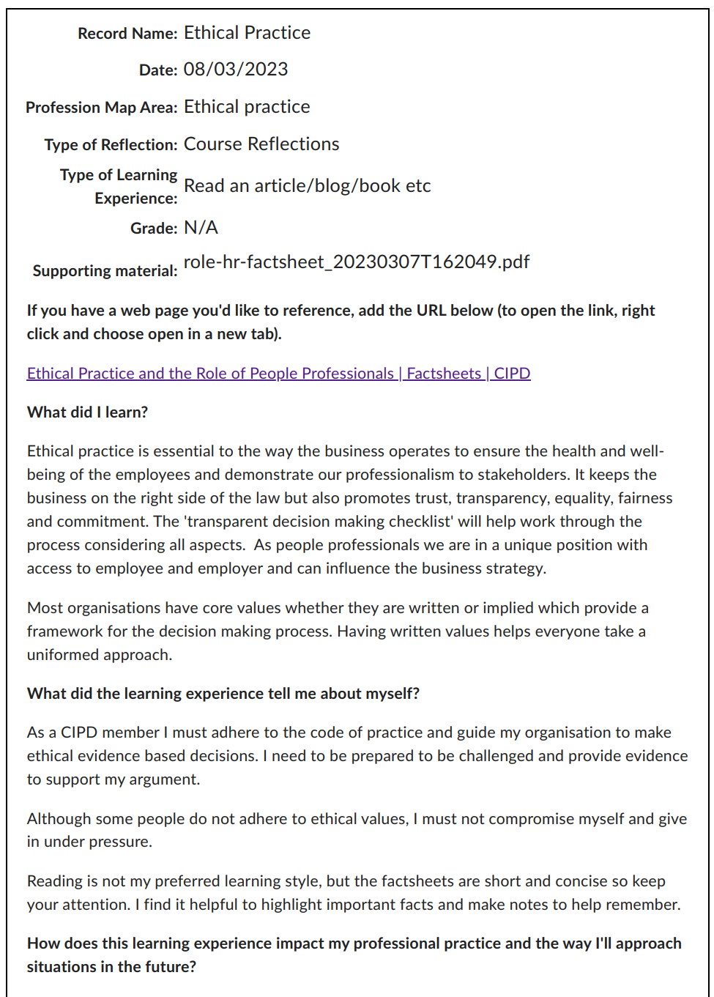
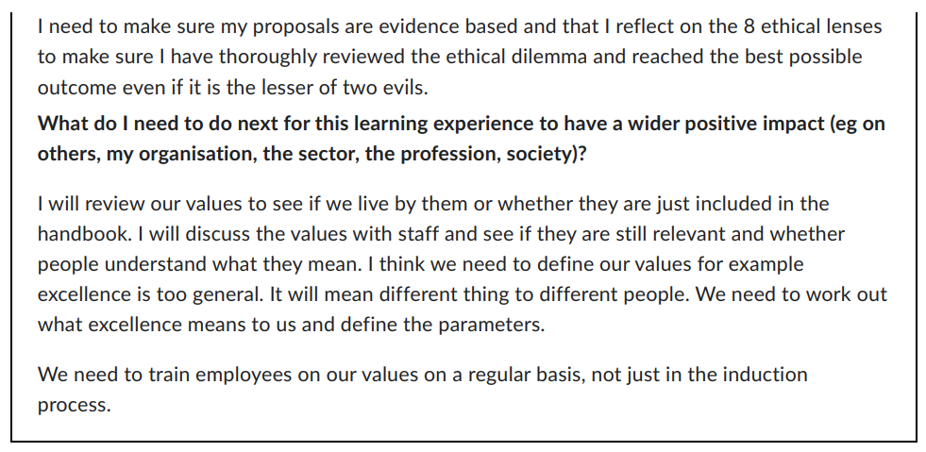

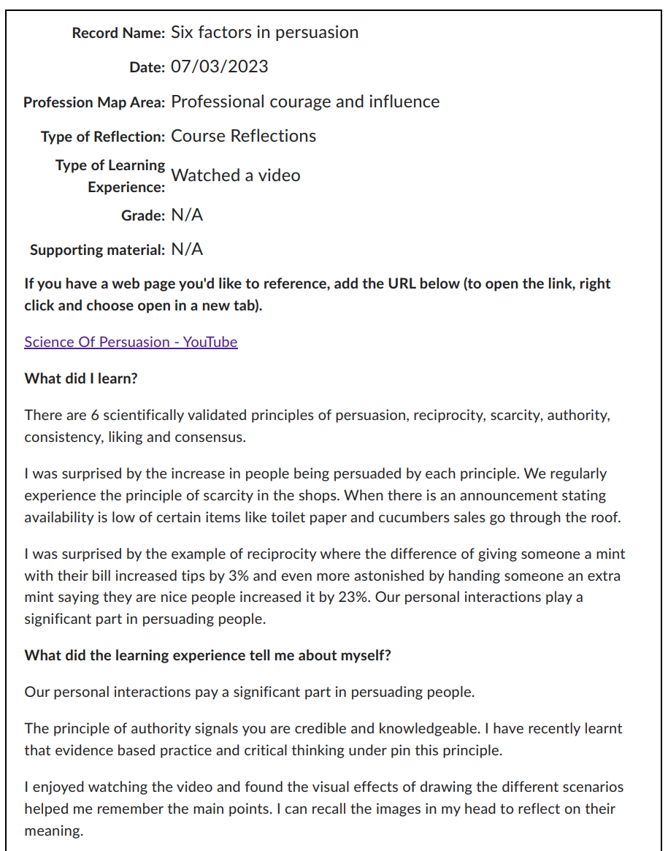

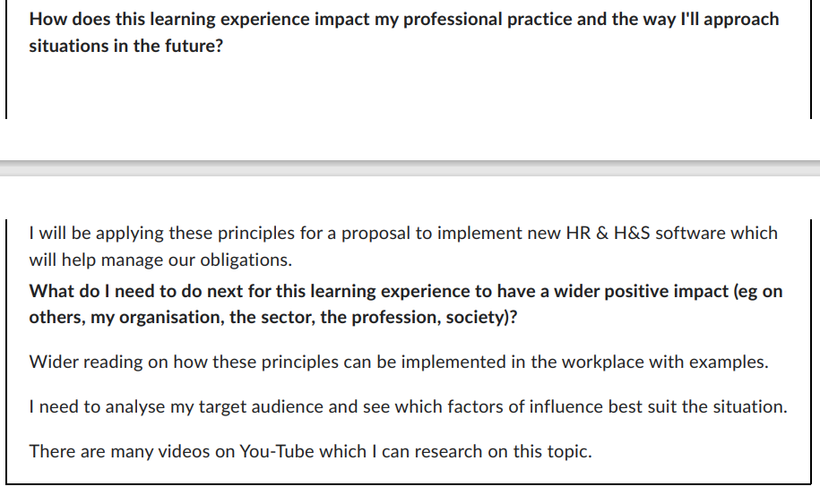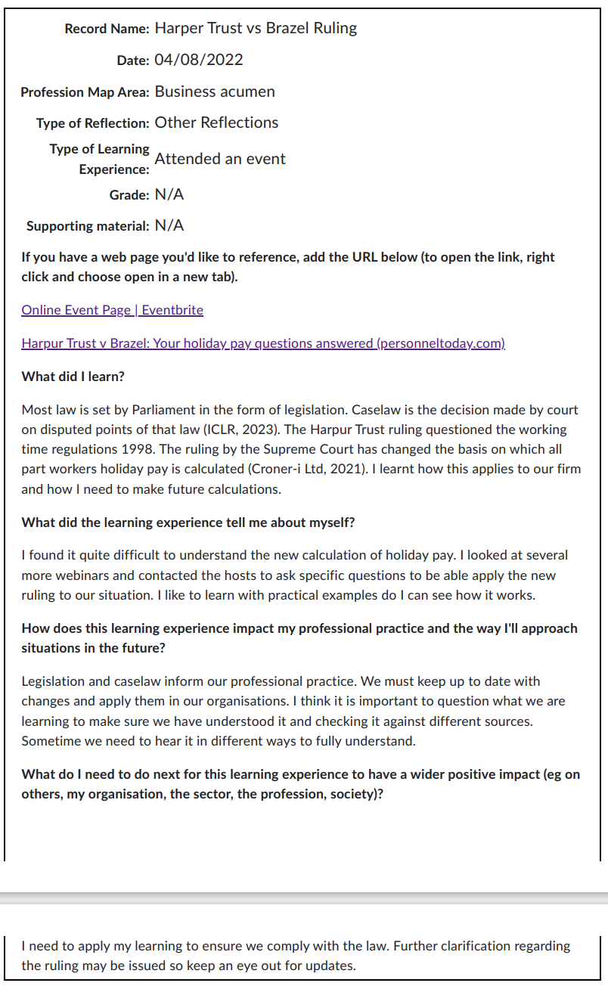

Appendix 1

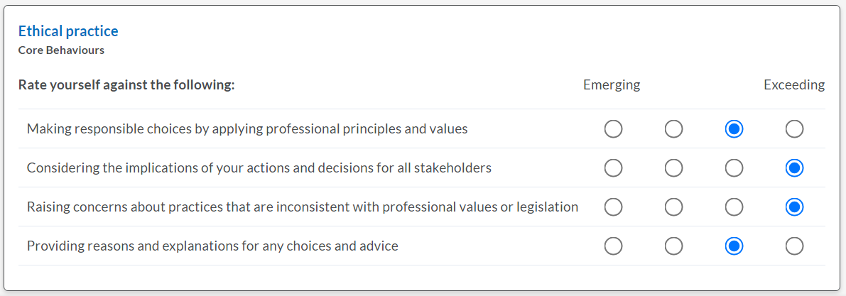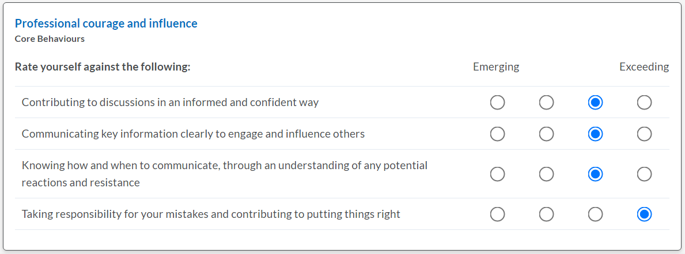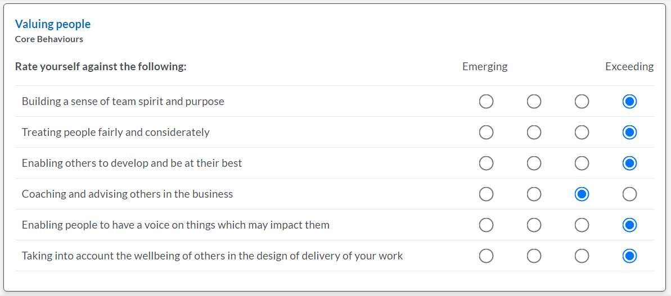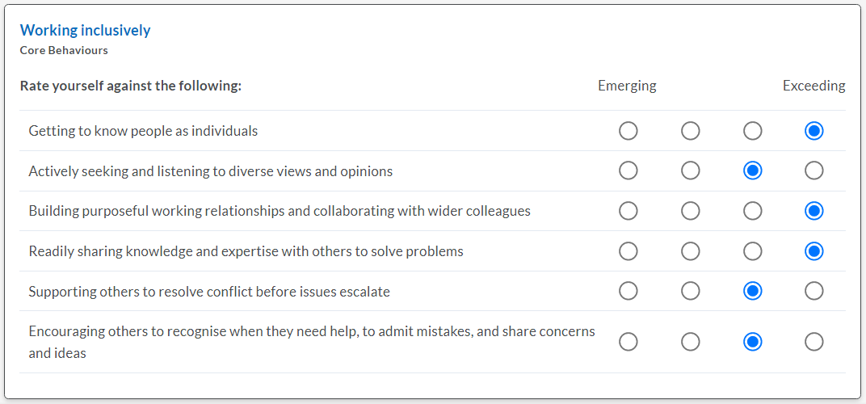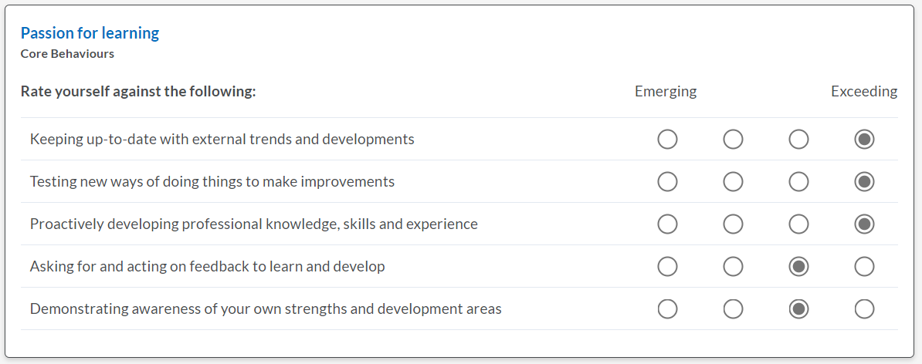

Appendix 2 – My learning plan

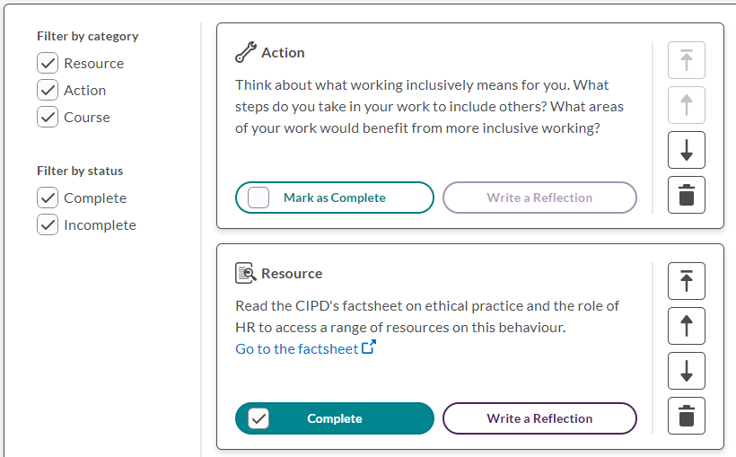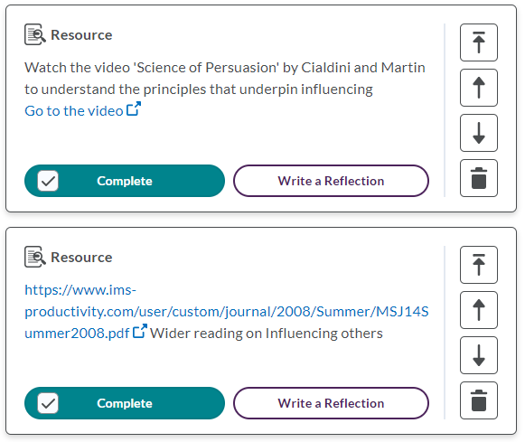
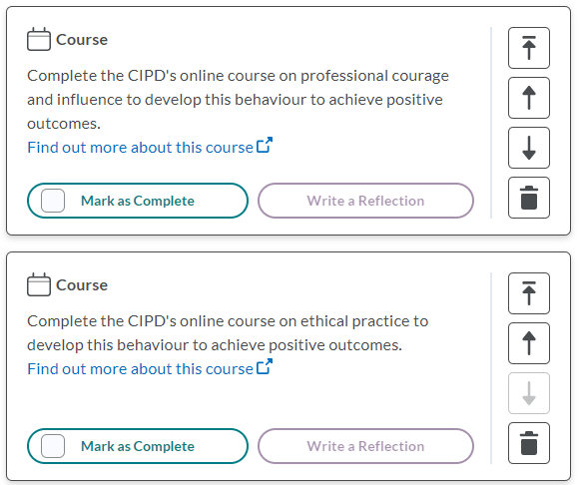

References

CIPD (2018) Self-directed learning: anarchy or opportunity? [video]. Available at: https://www.cipd.co.uk/podcasts/self-directed-learning (Accessed: 9 March 2023).

CIPD (2022a) The CIPD learning hub. Available at: https://www.cipd.co.uk/learn/learning-hub (Accessed: 09 March 2023).

CIPD (2022b) Performance reviews. Available at: https://www.cipd.co.uk/knowledge/fundamentals/people/performance/appraisals-factsheet#111981 (Accessed: 10 March 2023).

Croner-I Ltd (2021) Harpur Trust v Brazel: what you need to know for part-years workers. Available at: https://www.hr-inform.co.uk/news-article/harpur-trust-v-brazel-what-you-need-to-know-for-part-year-workers (Accessed: 12 March 2023).

Didau, D. (2020) Six myths about how we learn. Available at: https://www.bbc.co.uk/bitesize/articles/zqvxjsg (Accessed: 12 March 2023).

Gifford, J. (2022) Performance reviews. Available at: https://www.cipd.co.uk/knowledge/fundamentals/people/performance/appraisals-factsheet (Accessed: 12 March 2023).

ICLR (2023) What is caselaw? Available at: https://www.iclr.co.uk/knowledge/case-law/what-is-case-law/ (Accessed: 12 March 2023).

Megginson, D. Whitaker, V. (2003) Continuing professional development. Available at: https://books.google.co.uk/books?id=a-LG9lZMlWUC&pg=PA30&source=gbs_selected_pages&cad=2#v=onepage&q&f=false (Accessed: 7 March 2023).

VARK (2023) The VARK questionnaire – how do you learn best? Available at: VARK Learning Style Questionnaire: How do you learn best? (vark-learn.com) (Accessed: 9 March 2023).

