Managing Projects in the Organisation

Name:
Isac Ndejeya

Contents
Executive summary 4
Introduction 5
Project Management Approaches 7
Classical approach 7
Waterfall techniques 7
Agile project management 7
Scrum 7
Kanban 7
Lean 7
Tools and Techniques of project management 8
Cause and effect diagram 8
Risk Map 9
RACI 9
Shareholder Matrix 11
Radar chart 12
Project Charter 12
Project Name: 12
Business Case 12
Project Objectives 13
Major Deliverables 13
Proposed process 14
List of Proposed resources and related products 14
Proposed resources 14
Project customers 14
Customer requirements 15
Project stakeholders 15
Project manager 15
Preliminary schedule 16
Preliminary budget: 16
Approval requirements: 17
SWOT 17
Organizational structure 19
Gantt chart 21
Risk log 22
Personal Development Plan 24
Conclusion 25
References 26

Executive summary

Party and wedding planners company exist in substantial number. I have chosen also a wedding event Planners Company for this report that is Seymour Events Ltd. Seymour Events Ltd Company is based in Bristol. It is the company which offering the perfect events and wedding planning services to the clients. It provides services to the clients without any complexity of the clients. It is placed the UK top ranking wedding planners positions in the wedding and honeymoons abroad magazine in July 2019. Seymour Events Ltd tries to serve the client's best services compare to others.
Hayley Seymour is the founder and director of Seymour Events Ltd. He is working in create events and wedding industry from 2014. He is very committed and dedicated to his duties and responsibility.
Seymour Events Ltd takes various methods and techniques that help to the successful implementation of the project. They have a Facebook page for informing the clients and getting updated. Seymour Events Ltd. Always try to ongoing development by their tentative opportunity and strength.

Introduction

Project is a single use of the plan. It is closely related to the task that has a specific time and cost. I should be an important term as it is not a regular attempt .it could be short term or long terms but must be terminated. Therefore, it must have a finish line. The performance of the project should visible. The uniqueness of a project is an essential attribute. Performance, time and uniqueness are the most vital features of a project. It is the coordination of the uniqueness, timeline, and cost that control the activities from project launch to completion.
Seymour Events Ltd. Take various techniques and methods to implement the project and meet clients' expectations. They focus on the innovative design of the project activity with customers' conditions such as specific time and budget.
The planning, organizing, reporting, leading, controlling and implement are the terms associated with project management. Seymour Events Ltd. maintain a flow of the activities or schedule to meet the implementation and fulfill client expectations. They consider some specific terms in case of selecting a project manager such as authoritative in nature, planning capacity, decisiveness, proactive skill, good communication skills and motivation capacity to the subordinates. Project manager responsibility is limited by time. They are less flexible in terms of decision making. Every project maintains some process and phase to make easy the task. The project starts slowly because planning takes take more time to make it.
There are some important benefits for an organization of project provides here:
- Gained experience from conduct the project
- Maximum outputs with minimum resources
- Visible performance progress
- Flexible work environment
- Less complexity in a project

Every project related to the risk that refers to the uncertain condition which may have a positive or negative effect to implement the project. Seymour Events Ltd. Manages risks by taking some techniques. Risk can not be eliminated. It can be avoided, reduce or accept. These are the basic method and techniques for managing risk. Risk impact the scope, cost and schedules that are affected to poor-quality, overspend and late delivery.
There is some risk management process:
- Identify the risk
- Asses the related risk to the project
- Rank is and priorities
- Define risk management approach and actions
- Implement actions
- Monitor and reviews
Project monitoring and control indicates the balanced scorecard tools that supervise the performance of the project. it also measures and identifies strengths and weaknesses in directing corrective actions. It is implementing buy direct observations, meetings, regular progress report and overall supervisions of the project.

Project Management Approaches

Approaches refer to the techniques in project management range traditional to innovation one. It identifies and selects because it helps to operate the project and remove the complexity that makes the project easy. There is some important project are presenting below:

Classical approach
The classical approach indicates the traditional approach of a project. It is associated with conventional project management systems which may create complexity. Classical approach deals may be effective which is based on experiences and skill.

Waterfall techniques
It is one type of traditional approach but it turns the simple approach to innovation one. Waterfall approaches depend on the sentimental performance of activities. It helps to make decisions base on the non-numeric method which based on personal judgment.

Agile project management
Agile project management approach create based on the value-centered approach. An iterative project best option for agile. It also makes sure that the group activities and team collaboration. It ensures the flexibility of the project and reduces complexity.

Scrum
Courage, focus, commitment, openness and respect these things are included by the scrum. It is the perfect approach for team collaboration, development, goals, and accountability. It plays important roles in terms of stakeholder representation, development team and servant leader. It is best utilized in a small team.

Kanban
Kanban closely related to the scrum approach which motivates the individual. It provides standard quality and identifies the process that influences to process development. Flow management, using feedback loop, policies explicit, the progression of work and visualization are the general parties of the kanban approaches.

Lean
Lean provides the project competitive advantages by minimizing waste and increase customer value. It even improves the quality and reduced cost by controlling different types of wastages.

Tools and Techniques of project management

Any activities require some resources, tools, methods, and techniques to implement the activities according to the plan. So, the project does not the exception in case. It has to take some tools and techniques that help the project manager meets the client's needs. Seymour Events Ltd. Apply some tools and techniques to provide the best output to the project clients. As the event planner, they have to take standard tools and innovative techniques.

Cause and effect diagram
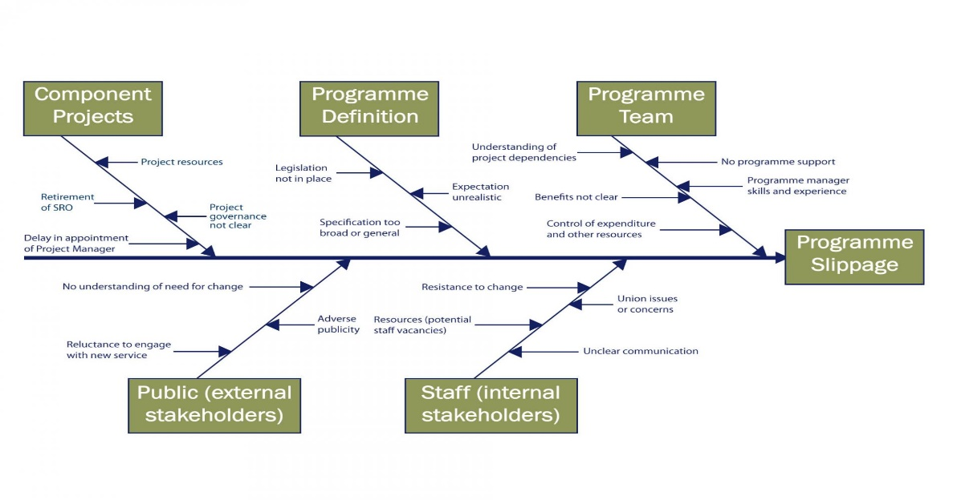
Figure: Cause and effect Diagram
Cause and effect diagram acquainted as the fish-bone diagram. It represents the probable causes and their influence on a task. It easy finds out the problems and their impact on the graphical representation. It may have more than one start and endpoints. This graph also shows the rapport between contributing terms. By this diagram, an organization easily identifies the feedback of the applied method.

Risk Map

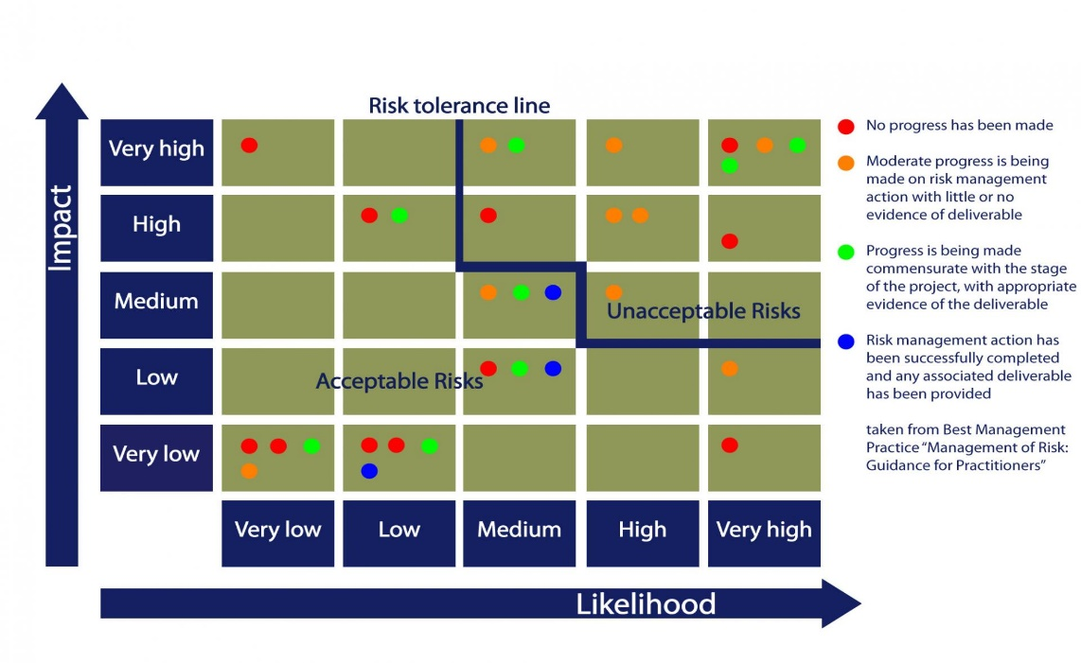
Figure: Risk Map
This graph shows the potential risk and impact of a project. It is a pictorial representation which indicates the risk in term of likelihood and its impact. Here, the risk is classified into several categories like weight method. It is derived risk from very low to very high in two axes likelihood and its impact. This graph shows the risk tolerance level, acceptable and avoidable risk level. It also shows the different conditions of risk by different color like red indicates no improvement has been made. On the other hand, yellow points are risk management made at a moderate level. Green points show the progress is being made and the blue points indicate the successful risk management made.

RACI
RACI is the abbreviated form of responsible, accountable, consulted and informed. Here, draw a table that shows the comparing tasks in terms of RACI elements. Here,
R- Responsible
A-Accountable
- Consultant
I- Informed

 | Bride’s Parents | Groom’s parents | Best Man | Close family | Vendors | Flower Girl
Florist | C | C | I |  |  | A R
Decorator | A |  | C |  | R
Bride Attire |  |  | A | R |  | I
Groom Attire | R | C |  |  | A
Photographer |  |  | R | A
Transportation | A | R |  | C |  | I

Figure: RACI Chart
RACI is a diagram that determines the participant’s roles and responsibilities who are involved in a project or an organization. it assists to the project organization to monitor and control by divide the team task. It also determines the overall process of project participants. Responsible indicates the people those who take the resources and task. Accountable represents the employees who are getting credit for success and liable for the failure of the project. The consult may include different financial planners and advisory firm. Informed indicates the team those who associated with the progress of the project performance.

Shareholder Matrix

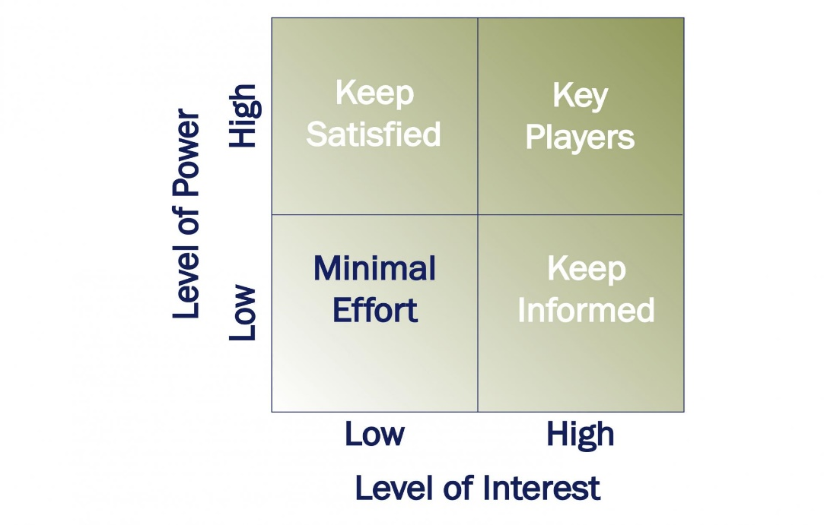
Figure: Shareholder Matrix
Shareholder matrix includes all parties who are directly or indirectly related to the organization such as top-level management, partner, suppliers and the ultimate uses including customer group. Effective matrix reconciliation the different conflict which may arise from various party personal interest. These conflicts may resolve by meeting and agreement.

Radar chart

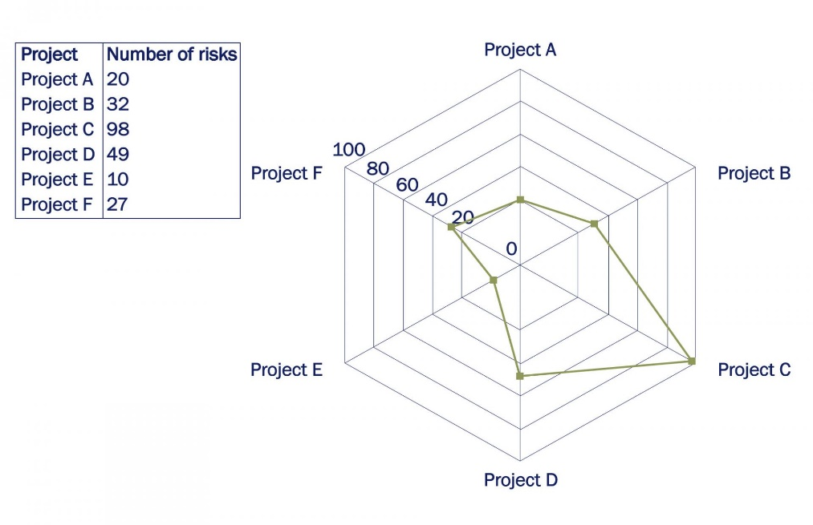
Figure: Rader Chart
Rader chart looks like a spider net that is why it's called a spider chart. This chart represents the different stages of risk related to the project. Hub point of the chart indicates the low value and the axis close to the edge indicates higher value. This chart includes a different project to make a better comparison in terms of easy decision making.

Project Charter
Project charter also named as a statement of work, estimate response document and business case. The project charter is very significant at the beginning of a project because what it is? Why it is useful and how it is really to set the formal authorization of a project. I have selected Bobby and May's jo wedding program as a part of my report. So here are some common elements that are found in project charter given below:
Project Name: Wedding Bells

Business Case
Mary Jo and Bobby Doe have agreed to get married on 30th November 2014. The duration was three months. The project is all about wedding activities. They want to best program so that they can do reminiscence after a couple of years. The main objectives of the wedding program to get a memorable experience for both parties and all the guests as well. They have decided to expense £25000 and the guest will be the highest 150.

Project Objectives
The wedding budget is fixed at £2500 for the entire program. In a hall, the program will be held and the participant will be maximum 150. It is expected to a great program with legal authorities. The wedding program duration will be 3 months and it will be in a reception hall.

Major Deliverables
- Thank you notes and Invitation cards
- Printed menu and programs
- Favors orders
- Transportation
- Program book officiate
- Experience photographer and videographer
- Flowers decorations
- Band for entertainment
- Rent a location for reception and ceremony
- Cake order
- Book decorator
The project does not cover the following things that are managed by the bride and broom:
Bachelorette and bachelor party
Wedding dress
Grooms attire
Bride’s attire
Honeymoon arrangements
Wedding rings
Hair and make arrangements

Proposed process

Project implementation will be done in the following terms:
- Breakdown budget providing
- Providing catering arrangements, cake arrangement, different choices of the wedding, wedding music and transportation choices
- Cost estimated associated with the budget
- Analyzing the proposed preference related to cost and client satisfaction.

List of Proposed resources and related products
All things required to the term of wedding program providing by the wedding or events organization. When third parties involved in the project planning and implementation then it is called project dependencies. It is general terms in project management. Project organization can transfer their task to reduce complexity.

Proposed resources
http://www.torontoweddingbands.com
http://www.royalcakesbyannette.com
http://www.matthewkozovskiphotography.com
http://www.ashleamacaulay.com
http://www.durhamweddingsource.com

Project customers
In this project, both party bride and groom are the ultimate customers of the project. The project manager has to meet the client expectation by proper planning, execution and provide the necessary things what the customers need related to the program.

Customer requirements
In this project, a high ending wedding is not the main objective. Here, do the best program within budget is the main objectives so that a proper plan can make and turn implement it according to the plan. The major things which are supposed to provide in the event must be supplied on time. Therefore, both parties expectation is proper management implement in this project. The customer wants to fair and smooth the improvement of the project.

Project stakeholders
Stakeholders refer to the party those who are directly or indirectly related to the project or parties influenced by the project's positive and negative feedback. There are some essential parties related to the project derives below.
In this project, the bride's parents are the main sponsors who provide financial support. They fixed the project budget and numbers of guests. They also derive their expectations from a project management organization.
Here, Bobby and marry are the core customers who have the right to make a decision and list the determined schedule.
On the other hand, wedding parties are not associated with the project decision and they don't have any responsibility regarding the project but they should be included the project planning.
Ultimately, the coordination between the project manager and the project t team required to execute the project regarding the plan and major decision making. They may have a rapport with the research activities of a project.

Project manager
A project manager is a person who has to generalize knowledge about the things regarding the project. A project manager takes a systematic approach to manage the project and they have limited flexibility.
Bride’s mother is the project manager who has the most authority regarding the project over the budget. Team member selection, task allocation, control, monitor, budget breakdown and scheduling activities are done by the project manager. She has to assure that project completion will be within a specific time and cost.

Preliminary schedule
Project customers approve the preliminary schedule. Project organization proposed some schedule to finalize the program date to the customers and they determine the final date.
September 1st to September 30th: Customers set and decides the following activities such as book wedding date, listed the guest name, book a photographer, select the ceremony and reception location, booked the florist, musicians, caretakers, start the plan menu, select and order wedding invitation, announcement and thank you note.
October 1st to October 31st: finalize guest list; mail and invitation; order any party favors; arrange for transportation on the wedding day; choose a bakery and order a wedding cake; decide on reception decorations and order or start making them.
November 1st to November 29th: finalize the menu for the reception; obtain a marriage license; keep a record of RSVPs and gifts receive; finalize the wedding flower with florist; confirm reservations and details with photographer, caretaker, videographer and any professionals including any special photo wanted, specific music during the first dance.

Preliminary budget:

Wedding Attire: Spend 15% of the total budget in terms of wedding attire.
Total budget: £25000*15% = £3750 available for wedding attire.
Reception: spend 40% of the total budget on reception.
Total budget: £ 25000*40% = £10,000 available for the reception.
For example, site fees, bar, and beverage, wedding cake, and catering cost, etc.
Music: Spend 10% of the wedding budget on music.
Total budget: £25000*10% = £2500 available for music.

Photography: spend 10% of the wedding budget on wedding photography.
Total budget: £25000*10% = £2500 available for the wedding photography.
Flowers: Spend 15% of the total wedding budget on flowers.
Total budget: £25000*15% = £3750 available for the flowers.
Stationary: Spend 5% of the total wedding budget on stationery.
Total budget: £25000*5% = £1250 available for the wedding stationary.
Additional expense: Spend 5% of the total budget on the additional expense.
Total budget: £25000*5% = £1250 available for the additional expense.
For example, marriage license fees; attendant's gifts; wedding day transportation, etc.

Approval requirements:
- Approved by project sponsors
- Approved by the bride
- Approved by groom

SWOT-(Strengths, Weakness, Opportunity, and Threats)
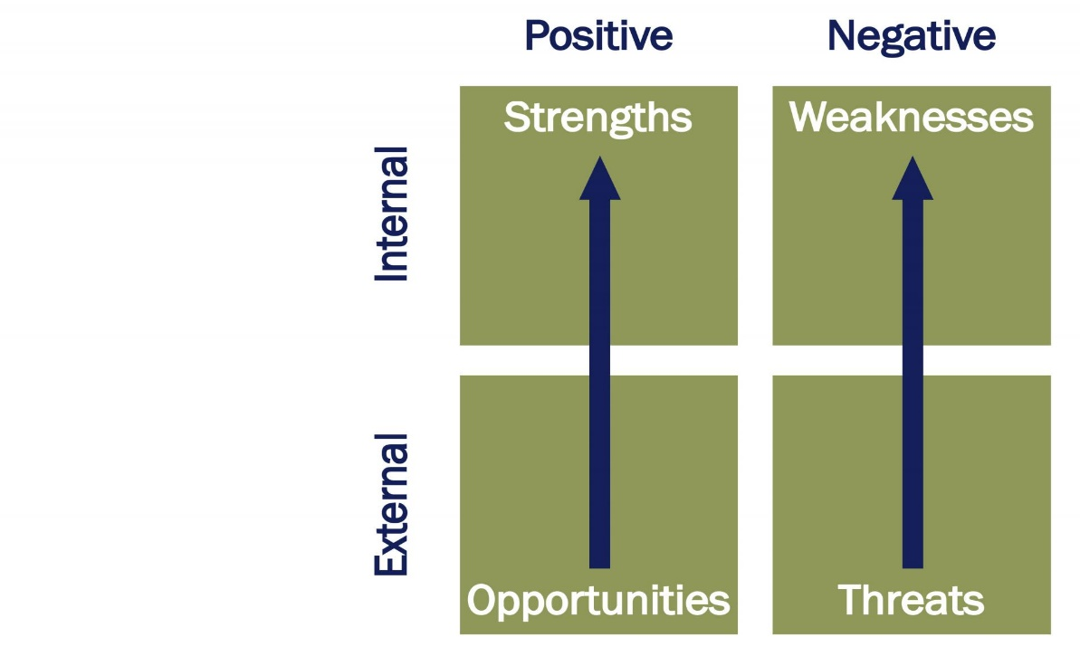
Figure: SWOT analysis
SWOT analysis is an effective method to know organizational overall conditions. It derives positive things like strength and opportunity. On the other hand, it derives negatives things like weaknesses and threats. It even represents the relationship between the internal and external environment. It also influences getting an opportunity when we reach it, maximizes the organization's strengths, overcomes the weakness and tackles the threats.
Some factors are mentioned here which I have faced and observe as a project manager related to the SWOT analysis.
Strengths
- Resource availability is one of the important strength which I have got as a project manager.
- Track record of the project functions and activities.
- Different level of rare skill employees who help the project most to accomplish.
- Well defined and specific process and systems.
- Another factor help the project as strength that is reputation.
Weakness
- Perceive a gap in knowledge and expertise among different employees.
- Deadlines and timescale is one of the vital weakness in a project.
- Project competing is another weakness to accomplish a project.
Opportunity
- Developing and emerging project
- Innovation with research and development.
- Infrastructure and technological development.
- Variability the client behavior.
Threats
- Different environmental factors affect the project most.
- Political influences
- Seasonal effects
- Effects of the economy.
- Threats from the competitor activity.

Organizational structure
Organizational structure can be different in different organizations in terms of the organizations' roles, responsibilities, functions, scopes, and objectives. The line of authority and control can be derived from the organizational structure. We see the organization in three ways such as functional organization, projected organization and matrix organization structure. In functional organization structure resources and managers are work in the same organization. It is dividing the organizational task according to the different department basis like the marketing department, finance department and so on. It has full control because it works as a small team. In the case of a large project, it may create complexity.
Projectized organization indicates the teamwork to implement a project. The project manager was responsible for the influence of a positive or negative result. He has the supreme authority in terms of the project. On the other hand, matrix organization derives from both functional and projectized organization. in this structure project manager and functional manager take the project responsibility. It boosts up the team effort and brings a good result. It has a major drawback as well like lack of unity of command.
From this different organizational structure what we use the wedding program of Mary Jo and Bobby Doe. We draw a diagram that clearly expresses the applied organizational structure.
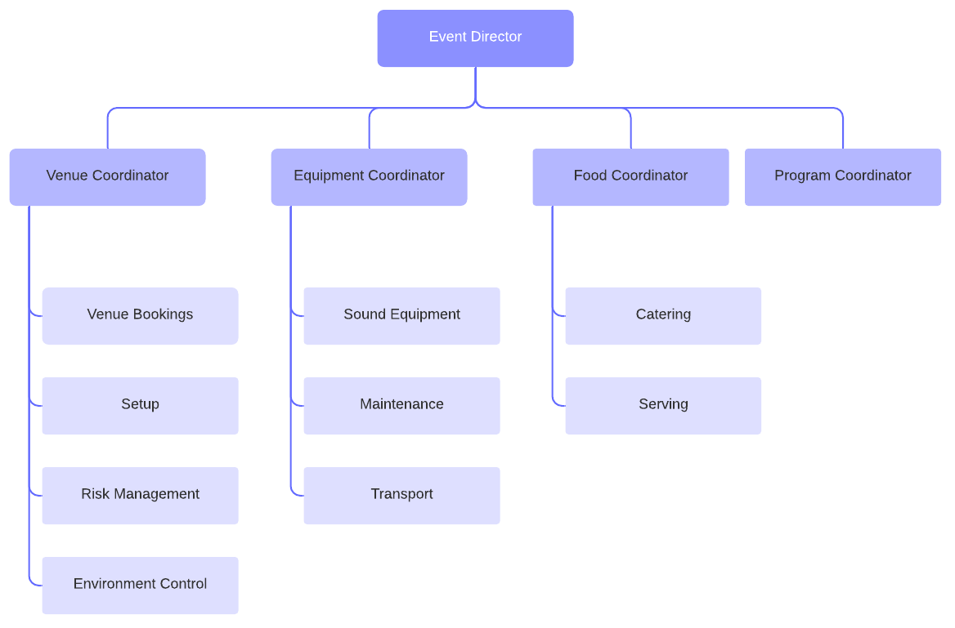

Figure: Event organization chart

The following graph clearly shows that activities are classified into four basic sections. Each section has some specific tasks and responsibilities. In this process, every department head will be responsible and accountable for the event director project manager. The project manager monitors and controls the four main department activities.

Gantt chart
Wedding Bells Project Planning
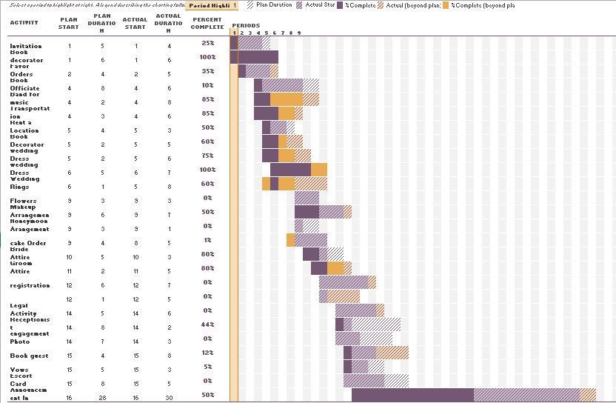
Gantt chart represents a specific task schedule at a specific time. What amount of task has already completed and what amount of task has to do, how to do? These things are represented in a single graph. It is an overall planning chart of the project. This chart derives from two axes such as the horizontal axis and vertical axis. The horizontal axis indicates the tie consume to do specific tasks and specific amounts of completion. On the other hand, the vertical axis represents the activities of how much support to the total project. Gantt chart represents the clear documentation of the task and determines each of the team member roles and responsibilities.
Work Breakdown Structure (WBS) is the process that exists in the Gantt chart. It derives step by step responsibility in terms of project time and resources. WBS classified the whole project into a small segment to easily monitor, control and implement the project goals and objectives. It focuses on the basic task of the project in hierarchical orders.
As a Gantt chart is a pictorial diagram, it can easily able to provide overall ideas about the project. The project can easily figure out and interpret this chart. It fixed determined the specific activities within budget resources and scheduled time. It even shows the percent completion of the total project. Gantt chart is a statistical tool that assists the whole project by the proper plan as it is the overall planning of a project.
Every project must have a clear statement of a project. Clear documentation of the project attracts the project client and helps the project manager by providing obvious concepts in term op project. So, it is a graphical chart that represents whole activities like project planning, monitoring, controlling, project selection, approval, project risk, project scopes, and project stakeholders and so on in a single chart.

Risk log
A risk log also is known as a risk register. It is created initial staged of the project which helps the project by the planning of risk management. Problems are identified and responsibility would be delegated to the team. There is a sample of risk log present below:

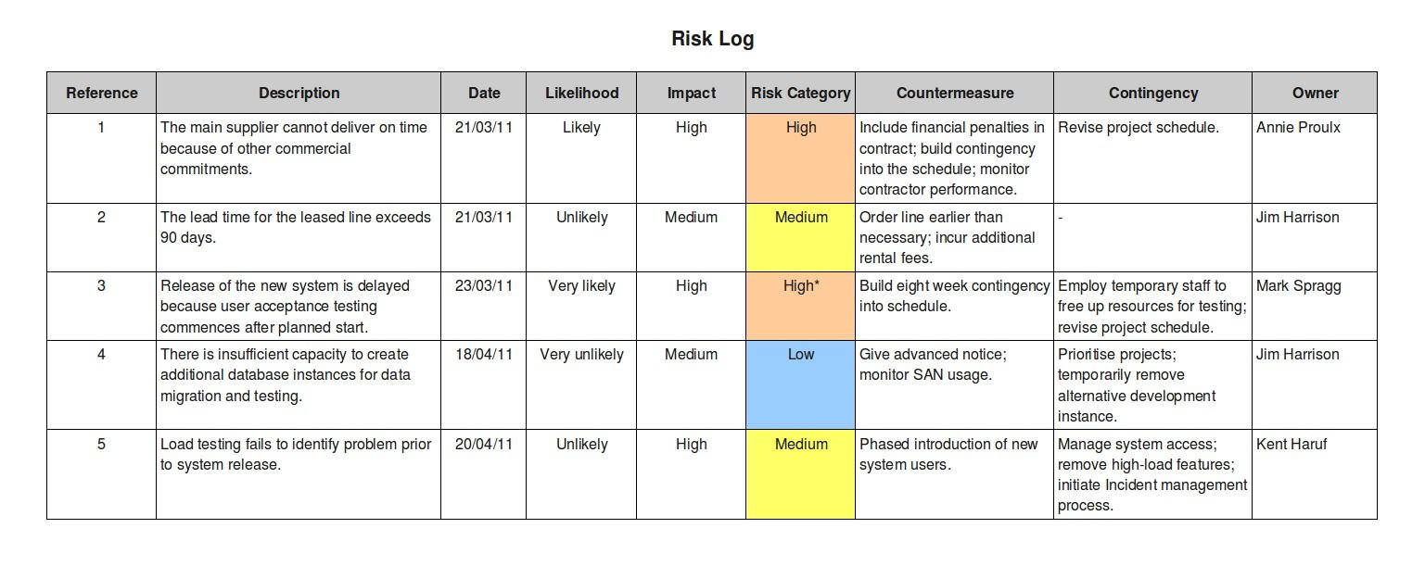
Figure: Risk Log
Risk is a term that is related to every project. Risk represents the future uncertainty that can be positive and negative. Identifying and analyzing the provable risk in the project to gain project goals is called project risk management. Risk can help the project by finding the weakness of a project and overcome the drawback. As I said before, the risk may have a positive and negative effect on a project. So, provable loss of injury, a potential problem that impedes the project and so on the negative impact of the risk. Similarly, it has some positive impact as well such as project manager always try to minimize negative risk and maximize the positive risk.
Project risk management process following some steps. Firstly, risk management planning which indicates how to find out risk and different approach to manage it. Secondly, identifying the risk which implies that identified risk which the project affected most. The next steps are controlling the risk, performing a quality risk analysis, planning risk response, and performing quantitative risk analysis.
Some factors captured the risk management plan such as roles and responsibility, budget and schedule, risk probability and its impact, methodology, tracking, risk documentation, shareholders tolerance and so on.
Several uncertain situations may arise in a wedding project like unexpected expenses, power failure, a large number of unexpected guests, unexpected rain or storm, mishap like the fire of accident, and last minute arrangements. These things guess based on the previous experience of historical data analysis.

Personal Development Plan

Personal development plant represents the things that help to the persons improve the own capability. It is also influence to gain project objectives in better way and make personal improvement. Personal development plan make the individual relevant, specific, time concern and measurable and force to continuous improvement.
Personal development Plan
No. | Deadline | Goal | Actions | Skill(Knowledge) Needed | Progress
Objectives 1 | June 2019 | Improving budgeting skills | Focus on taking basic financial and accounting course. | Enhancing communication and networking skill. | Determine to achieving goals by motivate the team.
Objectives 2 | Ongoing | Manage avoidance behavior. | Gain proper knowledge in terms of overcome unexpected delay. | Technical knowledge to use proper tools. | Gain skills to Identify the strong and weak point.
Objectives 3 | Ongoing | Taking better tools and techniques | Participants in the public speaking program to develop the speaking capacity. | Time manage capacity by ensuring effective and efficient way. | Teach how to overcome weakness in better way.

Conclusion

Project management of Wedding Bells has been selected different approach, tools, and techniques that influence the progress of the project manager and team member as well. Proper tools and techniques made the project easy and meet client satisfaction. In this project, the Gantt chart influences the whole project to conduct an inflexible and easy way. As Gantt chart shows the overall planning of the project and blueprint as well. The project may apply different tools and techniques to implement it. The organizational progress may arise by the project management.
Whatever happen project has some common terms in which project success and failure depend on such as time, cost, scope, quality, uniqueness, and customer satisfaction. Specific time, cost, and uniqueness are the basic attribute of a project. A project manager is supposed to select to manage the project. The project manager completes the following task like project planning, monitoring, controlling, and communicating with the project team. The project manager has a high authority in terms of the project. A project manager has some limitations also such as flexibility. Project managers do not everything if he wants. He has to maintain the project budget, scheduling, quality and the client expectation which may create an abstruse situation for a project manager.
A project manager is to follow some criteria regarding the project. Some special roles and tasks are conducted by the project manager. Acquiring and motivating project team that includes the selection of an efficient team member, employees who have some special skills. Try to boost up the budget by negotiating with the top-level management and ensure sufficient resources for a project. Besides, setting the organizational goals, communication, negotiation, and risk management activities are done by the project manager.

References
Anhoucke, M 2009, measuring time improving project performance using earned value management. Springer-Verlag, New York
Bedworth, DD & Bailey, JE 1987, Integrated Production Control Systems. John Wiley & Sons, New York.
Douglas, H 2009, the failure of risk management: why it is broken and how to fix it. John Wiley &Sons, San Francisco.
Hamilton, 2004, Handbook of Project Management Procedures. TTL Publishing Ltd, Henderson-Finda, NZ.
Hendrickson, C & Tung, 2008, "11. Advanced Scheduling Techniques.” Project Management for Construction (2.2 ed.). Prentice-Hall, London.
Lester, A 2007, Project management, planning, and control: managing engineering, construction, and manufacturing projects to PMI, APM, and BSI standards. Elsevier/Butterworth-Heinemann.
Lewis, R 2006, Project Management. McGraw-Hill Professional, New York.
Lock, D 2007, Project management. Gower Publishing Ltd, Aldershot
Muller, R & Turner, JR 2007 ‘Matching the project manager’s leadership style to project type’. International Journal of Project Management, vol. 25, no. 1, pp. 21-32.
Mantel, SJ Meredith, JR, Shafer, SM & Sutton, MM 2004, Core Concepts: Project Management in Practice. John Wiley & Sons, Inc., New York, NY
Meredith, JR & Mantel, SJ 2002, Project Management: A Managerial Approach. John Wiley & Sons, Inc., New York, NY
Newell, M & Grashina, M 2003, The Project Management Question and Answer Book. American Management Association, New York
Nigel, J 2005, Engineering project management, Blackwell Science Ltd, London
Ragsdale, CT 2004, Spreadsheet Modelling and Decision Analysis. Thomson/South-Western College Publishing, Cincinnati, OH.
Sebastian, N 2007, The Definitive Guide to Project Management. Prentice-Hall, London.

