Student Name: Mihaela Suruianu  Student ID: 2226557  Module Title: Foreign Languages and Cultural Awareness  Module Code: BMIH5003  Lecturer: Heidi Prosser  Date: 06 February 2024 | 
ASSIGNMENT 1: PORTFOLIO
(4 Components)

Component 1: Professional Reflection (500 words +/- 10%)

Weighting: 25%
Cultural refers to the concept which includes all the social behaviours, norms, and institutions that are found in human societies, beliefs, laws, customs, and arts of an individual living in those groups. Culture can change from person to person and within a distance of a few kilometers only. Cultural misunderstanding refers to the accidents in which the differences between different cultures lead to certain conflicts or mistakes.

Figure 1: Cross-cultural misunderstanding
(Source: BlueStream Marketing. 2013)
The situation can be understood with the application of a scenario that I witnessed in the last week of my placement at Rossington Hall in Doncaster. I have chosen the scenario in which Alex was a waiter in the hotel and worked at dinner time. At the time of working, Alex faced a cultural misunderstanding with the guest at the hotel. While Alex was working, one of the guests requested a dish that was traditionally prepared with a certain type of meat (Rustamov and Mamaziyayev, 2022). The guest was from a different culture in which there were certain dietary restrictions based on religious beliefs. Therefore, people from such cultural backgrounds are not allowed to consume that kind of meat. However, due to the language barrier as well as a lack of awareness of the guest’s cultural background, Alex served the dish as requested. When the guest realised his mistake, he expressed his dissatisfaction with the hotel.
In the chosen scenario, I have understood that cultural misunderstandings arise due to the lack of awareness on the part of Alex on the dietary restrictions of the guests based on their cultural and religious beliefs. Moreover, the issue was complicated more due to the language barrier which complicated the entire communication between Alex and the guest because even the guest was unable to communicate the specific restrictions to Alex clearly in the first place. Cultural misunderstandings in the Food and Beverage industry are common and can arise from differences in dietary practices, languages, and customs as well. As a server, Alex needs to be sensitive to the backgrounds of the guests so that they can offer inclusive and satisfactory services or dining experiences to the guests (Tursunovich, 2023). Therefore, this requires individuals in the Food and Beverage industry to develop cultural competence. This requires understanding and respecting the values, preferences, and beliefs of different cultures.
Additionally, from the scenario I have witnessed, I have realised Alex needs to develop several skills and changes in their behaviours. These skills have been defined as follows:
- Cultural competence: These are the primary skills that can prevent any misunderstandings in the future. Individuals like Alex need to educate themselves on different cultural practices. This can include attending training sessions and reading literature as well.
- Effective communication: This is a common skill that is required in every field. However, improvement of language skills is considered essential so that communication with guests from different backgrounds can be enhanced. This can include learning basic phrases in different languages and being able to use non-verbal cues so that clear communication can be ensured (Galante, 2022).

References:
Galante, A. (2022) Plurilingual and pluricultural competence (PPC) scale: The inseparability of language and culture. International Journal of Multilingualism, 19(4), pp.477-498.
Rustamov, I.T. and Mamaziyayev, Z.X. (2022) Development of speaking comprehension in teaching foreign language for professional purposes. Asian Journal of Research in Social Sciences and Humanities, 12(2), pp.227-233.
Tursunovich, R.I. (2023) Development of Communicative Competence in Teaching Foreign Language for Professional Purposes. In Proceedings of International Conference on Scientific Research in Natural and Social Sciences (Vol. 2, No. 1, pp. 26-33).

Component 2: Training Plan (500 words +/- 10%)

Weighting: 25%

Identified cultural misunderstanding (in a few words):
The training plan has been created based on the above cultural misunderstanding scenario.

Training plan (Why/What//Who/Where/When):
The plan has been discussed as follows:
Objective: The objective of the training plan is to equip the Food and Beverage team at Rossington Hall with the required skills and knowledge so that cultural misunderstanding can be prevented and navigated at the same time. The training plan aims to enhance the dining experience of the guests regardless of their diverse cultural backgrounds (Irkinovich, 2022).
Training components: The current training plan will include the following components as a part of the plan:
Cultural competence workshop: This aspect requires the company to conduct a comprehensive workshop which the cultural competence expert and consultants will lead. These experts will cover different topics like understanding cultural dimensions, recognition variation in dietary practices as well as fostering a culturally sensitive environment.
Language skills: This aspect of the training program will offer language training sessions which are emphasised basic phrases such as greetings and order taking which are spoken commonly in different languages as per the guest demographics of the hotel (Kim, 2020). This will include the company's leading practical training sessions like role-playing exercises so that real-world situations in which language barriers might lead to misunderstanding can be stimulated.
Diversity and inclusion training: This is the most vital aspect of the training plan in which diversity and inclusion training will be integrated into the regular staff development programs offered by the company. The focus of this plan will be on the creation of a welcoming environment for all the guests from different cultural backgrounds.
Effective communication: This part of the training will focus on enhancing the communication skills of the employees (Dubreil, 2020). In this, training on effective communication strategies and active listening will be offered.
Implementation of the plan: The training plan will be implemented through following the steps described below:
- The first step will be to schedule the workshops and training sessions so that the availability of the team can be accommodated.
- The next step is to utilise a mix of people and online training methods so that the accessibility of all the staff members can be ensured.
- At last, the team members will be encouraged to share their experiences as well as opinions so that a collaborative learning environment can be fostered.
Assessment of the plan: Rossington Hall must conduct periodic assessments so that the effectiveness of the training can be measured. The company can also collect feedback from employees and managers so that different areas of improvement can be identified, and further training programs can be customised accordingly.
Continuous improvement: Open Dining can establish a system through which it can create ongoing competency training and incorporate new insights and best practices in the hotel. The company also must regularly update the training materials so that it can stay competent with the dynamic cultural aspects (Saydakhmetova, 2020).

References:
Dubreil, S. (2020) Using games for language learning in the age of social distancing. Foreign language annals, 53(2), pp.250-259.
Kim, D. (2020) Learning language, learning culture: Teaching language to the whole student. ECNU Review of Education, 3(3), pp.519-541.
Onishchuk, I., Ikonnikova, M., Antonenko, T., Kharchenko, I., Shestakova, S., Kuzmenko, N. and Maksymchuk, B. (2020) Characteristics of foreign language education in foreign countries and ways of applying foreign experience in pedagogical universities of Ukraine. Revista Romaneasca Pentru Educatie Multidimensionala, 12(3), pp.44-65.
Saydakhmetova, D. (2020) Teaching Russian as a foreign language through stories. European Journal of Research and Reflection in Educational Sciences Vol, 8(5).

Component 3: Student Self-Reflection (500 words +/- 10%)

Weighting: 25%
Throughout my learning in this module, I have realised that cultural understanding has a huge significance in the Hospitality Industry. The understating has evolved through various experiences which have encouraged me to critically reflect on the importance of cultural sensitivity in this field. My reflection with the application of the Gibbs Model of reflection is as follows:
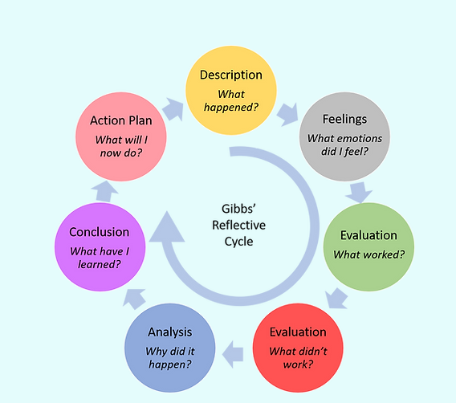
Figure 2: Gibbs reflective model
(Source: Jonathan Gibbon. 2019)
Description: This step is associated with describing the situation that has happened in the first place (Onishchuk et. al., 2020). My understanding of cultural awareness initially in the hospitality industry was only limited to surface-level factors like common greetings. My interactions were majorly based on the avoidance of cultural misunderstanding rather than embracing diversity to offer a better guest experience.
Feelings: In this step, the feelings or thoughts had at the time of experience are explored and how they have impacted the overall experience are explored. I felt a sense of responsibility however, I was overwhelmed by the prospect of catering to different cultural needs. As I have encountered challenges, the realisation of the importance of cultural awareness beyond etiquette has grown even more.
Evaluation: This step aims to evaluate what worked and what didn’t work in the situation. It includes analysis of positive and negative aspects. Over time, my prospects for the situation evolved as I encountered diverse scenarios in the food and beverage industry. I began to appreciate the impact of culture on the experiences of guests as well as their satisfaction with the hotel company.
Analysis: This step aims to make sense of what has happened in the overall experience (Makhmudov, 2020). Through the management of a diverse team of people as well as attending to an international clientele (considering the example of Alex), I have learned that cultural awareness is not only about avoiding downfalls but is also associated with a strategic approach so that guest experiences can be enhanced. Moreover, I have analysed that understanding cultural nuances has become more critical in the adaptation of communication styles, marketing strategies as well as delivery of services.
Conclusion: This is the next step, in which a conclusion on what has happened is made. The overall experience has highlighted the dynamic of cultural awareness as well as the integral aspect of the hospitality industry. The identification of the different needs of cultural groups and individuals has allowed us to customize the services accordingly.
Action plan: This is the last step, in which steps that can help in enhancing learning are led (Ho, 2020). From my experience, I have committed to continuous learning and staying updated on cultural trends so that the evolving needs of diverse guests can be adapted. I will also try to actively seek feedback from the guests I will be serving and the team members I work with so that I can identify areas for improvement in cultural responsiveness.
For example, a Japanese guest preferred a more private and serene environment. By recognizing this cultural preference, the company ensured their accommodation was in a secluded area, leading to a positive and memorable experience.

References:
Ho, Y.Y.C. (2020) Communicative language teaching and English as a foreign language undergraduates’ communicative competence in Tourism English. Journal of Hospitality, Leisure, Sport & Tourism Education, 27, p.100271.
Makhmudov, K. (2020) Ways of forming intercultural communication in foreign language teaching. Science and Education, 1(4), pp.84-89.
Onishchuk, I., Ikonnikova, M., Antonenko, T., Kharchenko, I., Shestakova, S., Kuzmenko, N. and Maksymchuk, B. (2020) Characteristics of foreign language education in foreign countries and ways of applying foreign experience in pedagogical universities of Ukraine. Revista Romaneasca Pentru Educatie Multidimensionala, 12(3), pp.44-65.

Component 4: Training Presentation (6 Slides)

Weighting: 25%
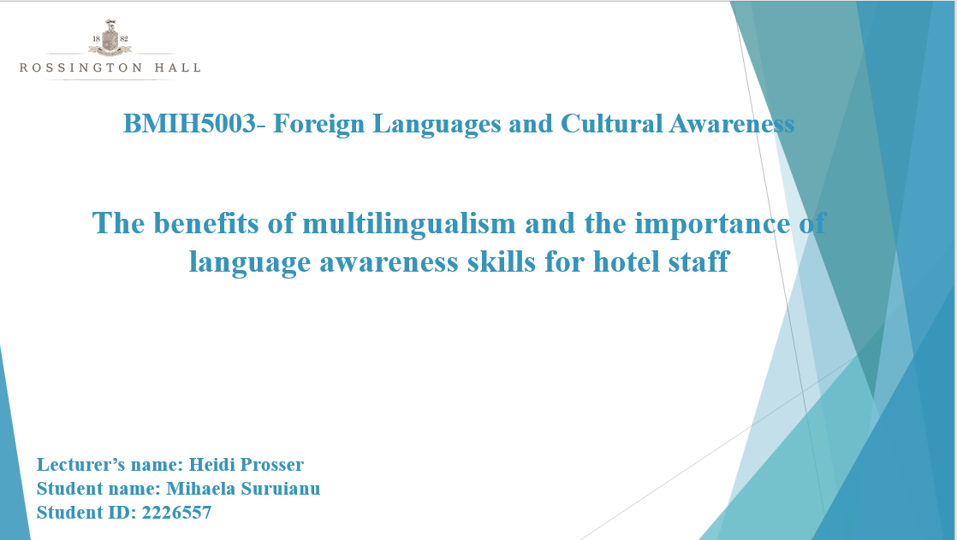
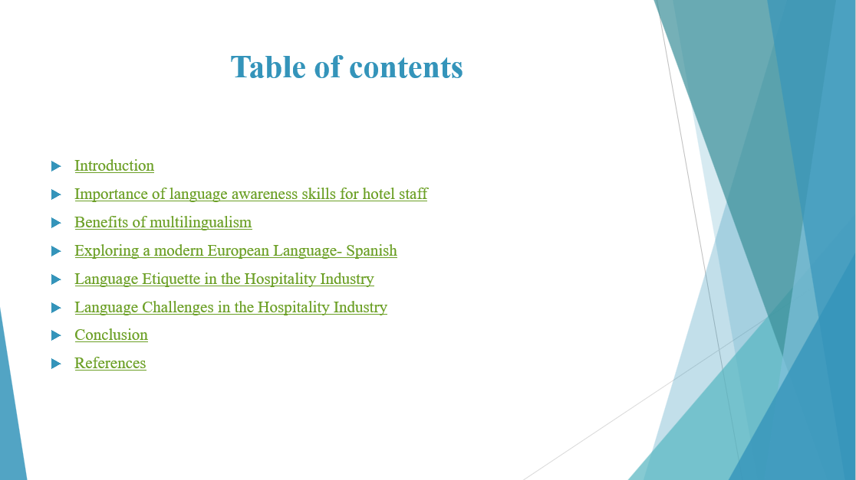
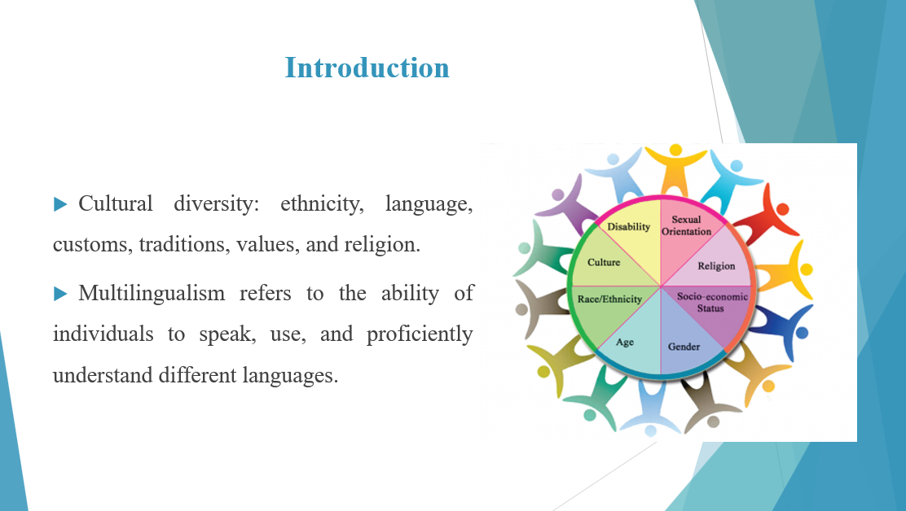

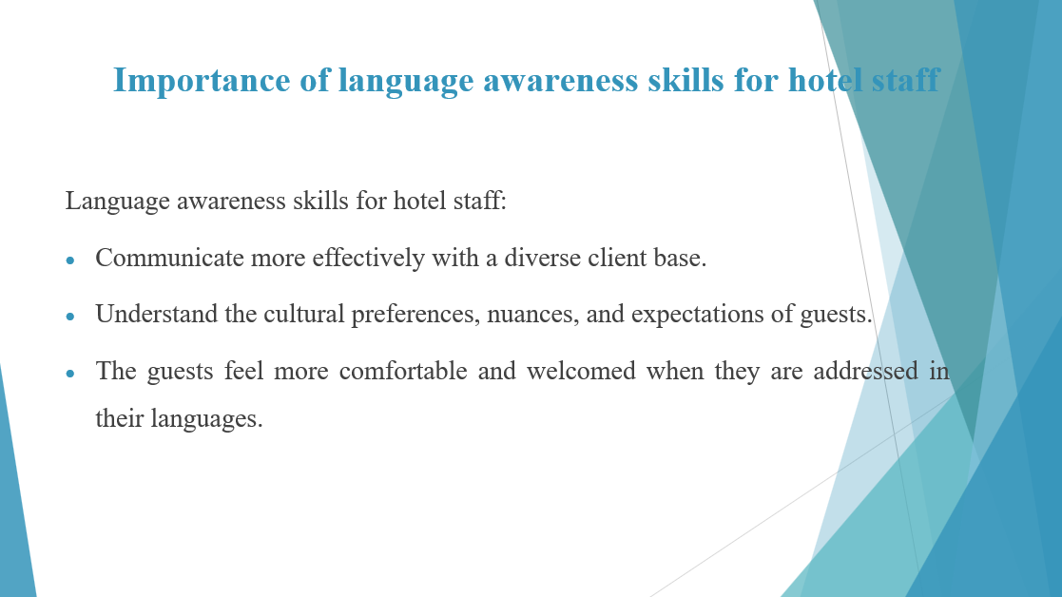
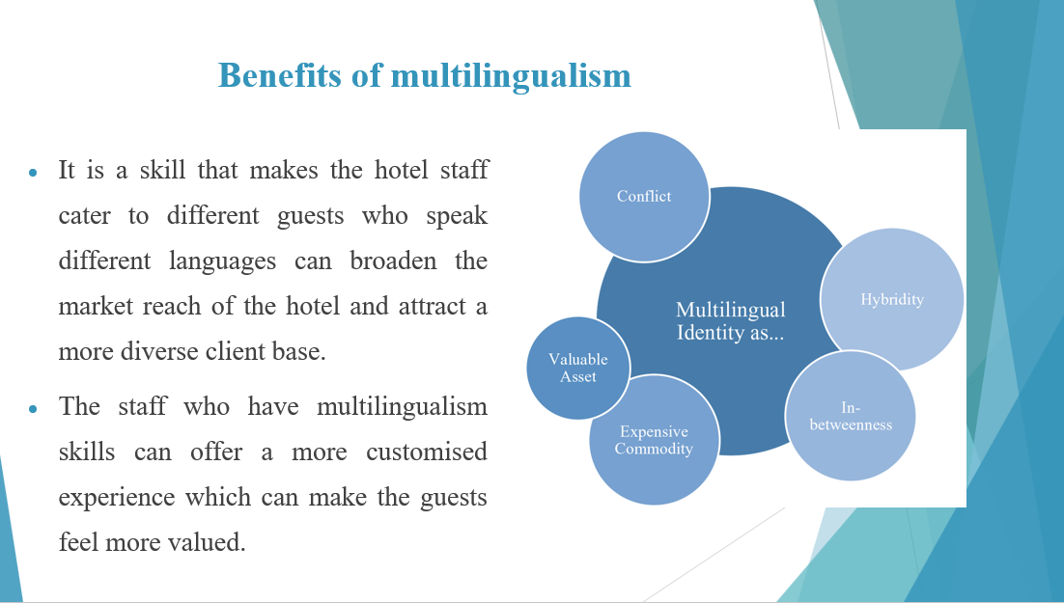

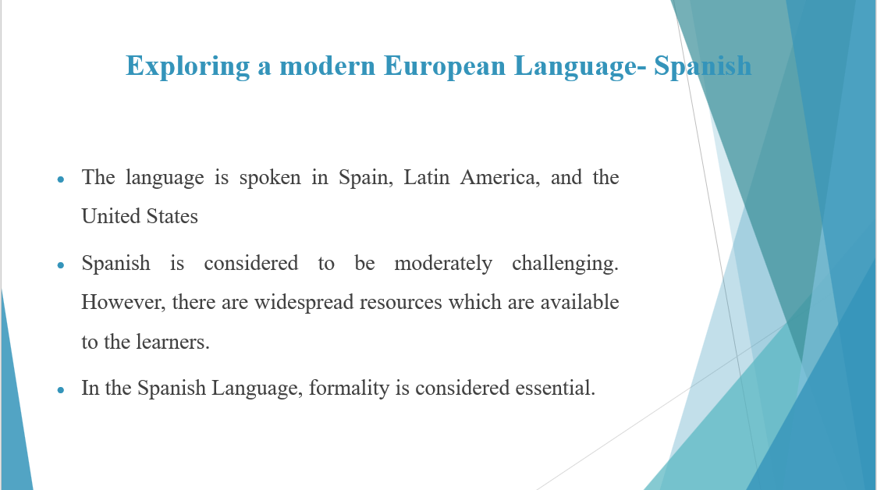
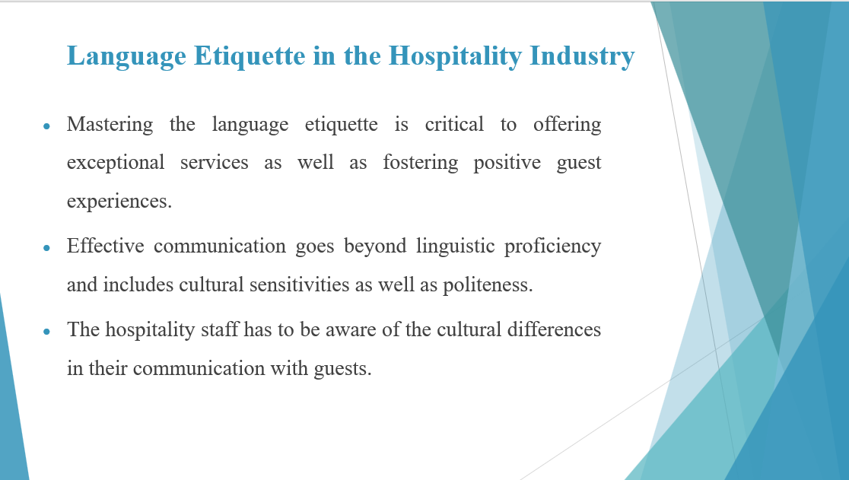

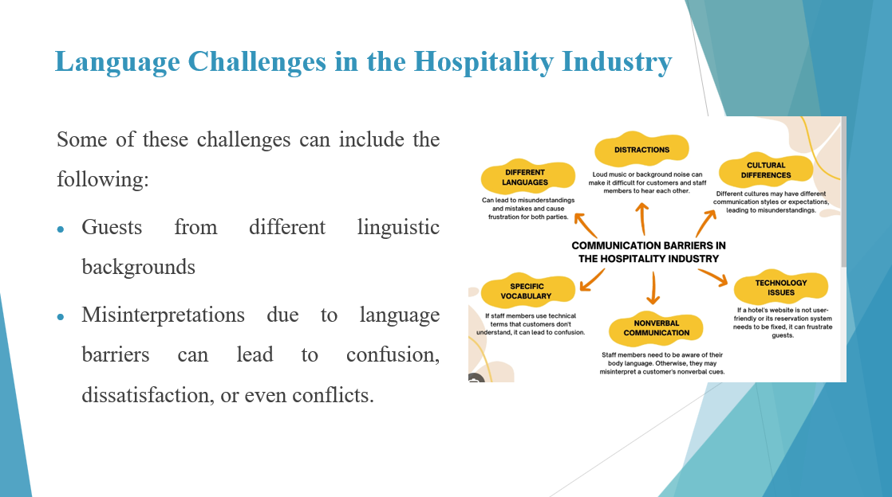

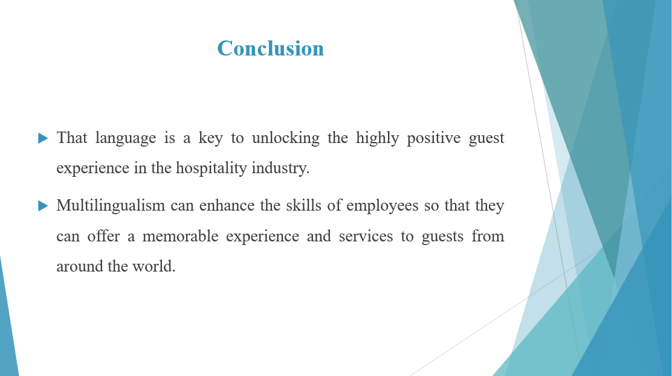

References (no screenshots):
American Occupational Therapy Association, 2020. Educator’s guide for addressing cultural awareness, humility, and dexterity in occupational therapy curricula. The American Journal of Occupational Therapy, 74(Supplement_3), pp.7413420003p1-7413420003p19.
Guillén, G., Sawin, T. and Avineri, N., 2020. Zooming out of the crisis: Language and human collaboration. Foreign Language Annals, 53(2), pp.320-328.
Reinhardt, J., 2020. Metaphors for social media‐enhanced foreign language teaching and learning. Foreign Language Annals, 53(2), pp.234-242.
Risager, K., 2020. Linguaculture and transnationality are the cultural dimensions of language. In The Routledge Handbook of Language and Intercultural Communication (pp. 109-123). Routledge.
Shin, J.Y., Dixon, L.Q. and Choi, Y., 2020. An updated review on the use of L1 in foreign language classrooms. Journal of Multilingual and Multicultural Development, 41(5), pp.406-419.

