Executive Summary

UNIQLO is an apparel retail store which is owned by the Fast Retailing Co,. Ltd. They target to open a 100 stores per year in Greater China (Mainland, Hong Kong and Taiwan) to be the Number 1 brand of the apparel retail store in Southeast Asia.

In the recent years, UNIQLO is very popular in Hong Kong, their price setting is affordable for the society and high quality product due to their Research and Development (R&D) Department keeps innovating and improving the product.

Nowadays, environmental pollution is a serious problem. Many developed countries regulate the policy to control the level of pollution. This is a complex problem in the textile industry which uses a large amount of electricity and water to produce the greenhouse gas emission and contaminated effluent (Hasanbeigi and Price,2015). So, they must propose the solutions to eliminate the problem. According to background of UNIQLO, they are connecting many textile manufacturers in China, Vietnam and India, etc. to assist them for the product creation. So, UNIQLO needs to take an action immediately to solve this problem. They can innovate a new technology to reduce the pollutant.

Due to the COVID 19 pandemic spreading over the word, many people trend to online shopping. So, UNIQLO needs to think about how to expand their market share in e-commerce. They can introduce the new technology in their online platform to attract more customers to buy their product.

Table of Contents
1. Introduction 1
2. Situation Analysis
2.1 External Analysis 1
2.2 Internal Analysis 3
2.3 SWOT Analysis 6
3. Segmentation, Targeting and Positioning 7
4. Marketing Mix 9
5. Future development 12
6. Recommendation 14
7. Conclusion 15
8. Reference 16
9. Appendices 18

1. Introduction
In the recent years of the fashion and clothing industry in Hong Kong, some strong brands of retailers are flourishing. The companies like UNIQLO, H&M, ZARA are doing their best to establish their brand name and brand identities, because these can help the consumer to remember and identify their product easily. So brand name should be a highly valued asset to the company once developed and managed successfully (Meyers-Levy, Louie and Curren, 1994).

UNIQLO is a casual wear retailer which is owned by a fashion and clothing holding company - Fast Retailing Co, Ltd. The first store was opened in Japan in 1984. The brand started to expand in a global market in 2001, now the stores have been opened in many countries around the world, including China, Hong Kong, USA, etc.

According to the 2022 annual report of Fast Retailing, “LifeWear” is a blueprint. They will follow and keep going with the process of production, transportation and sales. Also, one important thing of the blueprint is to protect the environment and staff in the supply chain which leads the customer to shop with the confidence.

Besides, the government regulates the Social Distancing Measures during the pandemic, so people trend to stay at home, this has been a change of the customer shopping behavior from offline to online. Therefore, UNIQLO requires to enhance the online platform for the market share expansion.

2.1 External Analysis of UNIQLO
PEST analysis is a tool which is used for understanding the strategic risk. It identifies the external environment changes and the impact of the brand’s competitive position (Sammut-Bonnici and Galea, 2014).

Political
- The Hong Kong government announced the Climate Action Plan 2050 in Oct 2021 (The Government of the HKSAR, 2022), the target is to challenge climate change and achieve the carbon neutrality or decarbonization (Rockström et al, 2017) which limits the global temperature to well below 2°C, so it helps to raise the awareness of the environmental protection in the society.
Figure 2.1 – Target of Climate Action Plan.
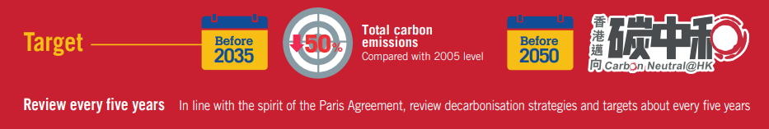
Source: Environment and Ecology Bureau, 2022

- Social distancing measures (The Government of the HKSAR, 2022) are regulated by the government due to the pandemic, the people must fulfill the relevant requirements on “LeaveHomeSafe” and the Vaccine Pass when they access the shopping mall. Therefore, the consumer may not desire to walk into the retail store.

- UNIQLO can enjoy the tariff-free treatment under the CEPA (Trade and Industry Department, 2022), so the result is high profit and increased spending on research and business development.
Economic
- China's economy is growing rapidly, and the demand for raw material is increasing from the manufacturer, especially cotton Linter. Refer to Figure 2.2, the cotton liner price keeps to increasing every year. It resulted in the cost of raw material is being higher than before.
- Figure 2.2 – Cotton linter Price in China
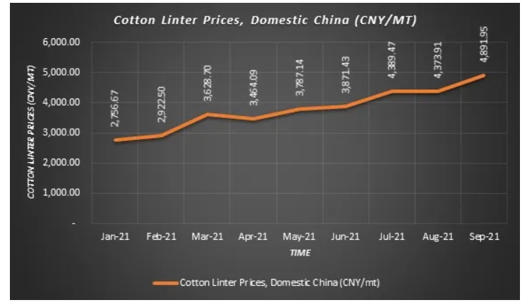
Source: Fibre2fahion, 2022
- Statutory minimum wage launched in 2011 and the current wage is 37.5 HKD per hour (Labour Department, 2022), if the government adjusts the wage again, the labour cost will increase and it may be passed on to the consumers.

- As the pandemic continues to affect Hong Kong, the local economy must suffer the great impact, many companies are laying off their staff and closing down. According to the news of the Hong Kong government, the unemployment rate increased to 5% between January and March 2022 (new.gov.hk, 2022). This should affect the apparel industry if the unemployment rate keeps to increasing.
Table 2.1: Unemployment rate in HK
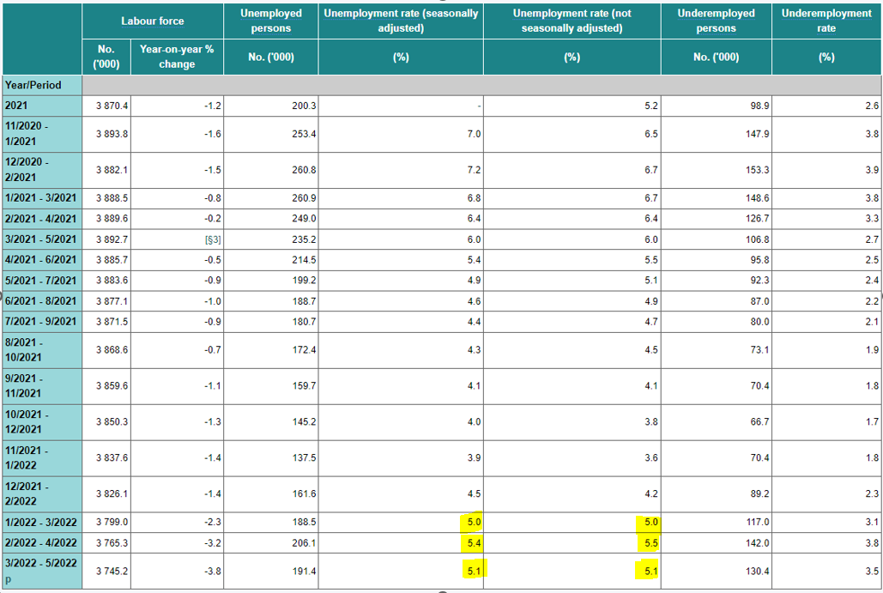
Source: Census and Statistic Department, 2022
Social
- Due to the pandemic impact in Hong Kong, most of the consumers will spend more time to shop online over offline.

- The population's aging trend is expected to continue. According to the 2021 Population Census, one in every five Hong Kong residents was aged 65 or over. Back in 2001, there was only one elderly person in every nine people. So UNIQLO may change the targeting of consumers and take care of their shopping behavior.

- Environmental protection awareness is on the rise, green consumerism is driving up in the market. Consumers expect the clothing industry to embed the new technology. So, UNIQLO’s product innovation and development is inevitable.

Technology
- Social media platforms such as, facebook, Instagram (IG) are very popular in the communication world. Most of the people will use the mobile phone to look for the new product and the promotion activities. UNIQLO also has a fan page in the social media platforms to launch their promoting, advertising and interacting with their loyal consumers.

- E-commerce penetration is growing rapidly due to most of the people using smartphones to shop on the internet. The 5G Network enhances the e-commerce in Hong Kong starting in 2020, this can facilitate the e-commerce under the high-speed connection.

- Using the new technology to develop the new product which can reduce the impact of the environment.

2.2 Internal Analysis of UNIQLO
Value chain analysis
It can be used to set up the competitive strategies, understand the internal sources of the competitive advantage which establish the interrelationship between create value and activities to gain the profit (Ensign ,2001).

Analysis the primary activities of UNIQLO
Inbound logistic:
UNIQLO makes sure to get a stable and high volume supply of the high quality materials, they will contact the material manufacturers directly in different countries.

Operation:
The merchandisers will cooperate with the R&D, production department and other divisions closely to determine the products of every season.

Outbound logistic:
UNIQLO has an inventory department to control the store inventory level. They will monitor and adjust the stock control every week and will arrange the product to fulfill the orders in every retail store.

Marketing and Sales:
UNIQLO will spotlight their good products which offer to customers and to be superior to their competitors among the market. The details will be analyzed in the Marketing Mix - 3.2.

Service:
UNIQLO has provided the pre-sale and pro-sale service for the customers. For example, they create a chatbot service for any customer enquiry. For the pro-sale service, they provide a 7-day free exchange service and pants alteration service.

Figure 2.1 - UNIQLO chatbot
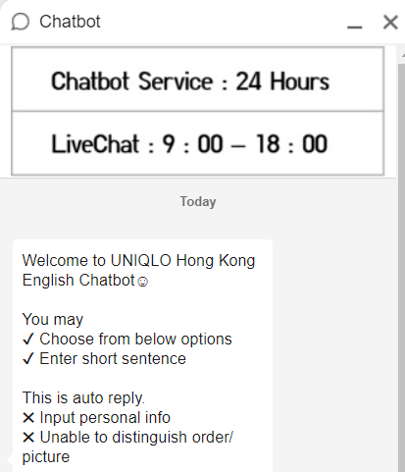
Source: UNIQLO, 2022

Analysis the secondary activities of UNIQLO
Firm Infrastructure:
UNIQLO has established a management execution system, so the decision-making and business execution do not depend on specific management division.
Also, they set up an information security office who inspects the entire company and cooperates with the IT department and legal department in each region where they have business operation.
Human Resource Management:
Fast Retailing established the Code of Conduct for Production Partners in 2004 (Fast Retailing, 2022), which prohibits child, forced labor, harassment, standard working hours, etc. Also, they will provide the training for the salespeople to improve the customer service in the store.

Technology development:
UNIQLO's R&D department mainly develops new products that respond to consumer requests. For instance, Hong Kong is hot and has high relative humidity in summer, their new innovative product will take care of the consumer needs.

Figure 2.2 - 3 innovative product lines - UV protection, AIRism and DRY-EX in QNIQLO
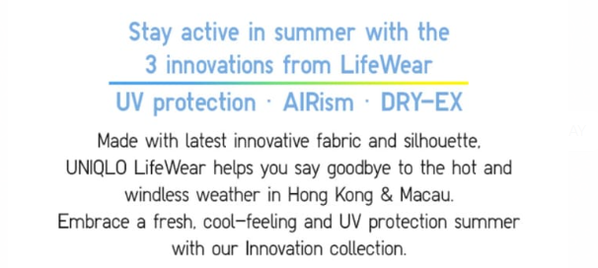
Source UNIQLO apps, 2022

Procurement:
Over the years, UNIQLO have built strong trustful relationships with the partner factories and hold annual meetings with factory managers to secure the quality of raw materials and deliver on time.

2.3 SWOT Analysis of UNIQLO
Business environment analysis is an essential part of the strategic management planning process. SWOT analysis has been praised for its simplicity and value in focusing on key issues which affect business development and growth (Pickton and Wright, 1998).

The below table is the SWOT (Strength, Weak, Opportunity and Threat) of UNIQLO.
Strength  - Strong brand image in the Asia region.  - Innovation the new product continuously.  - High quality and cheap price of products.  - low operation cost of SPA. | Weak  - Impact of environment, e.g.: pollution.  - E-commerce system is not high-tech enough.
Opportunity  - environmental protection awareness is on rise.  - E-commerce development is mature with the high-speed network.  - Innovation technology can attract the consumer to buy and increase the brand image. | Threat  - keen competition from existing market.  - Increase the cost of material and labour.

Inclusion of SWOT, they need to improve their weakness of environment problem and E-commerce system. Also, UNIQLO keep innovating the new product continuously to compete with the market competitors.

3. Segmentation Targeting & Positioning
UNIQLO's apparels are casual, comfortable and affordable. Their products offer a wide range of size and color for consumer selection. Based on the shopping experience in the retail store and browsing their website (UNIQLO, 2021), their current segmentation and Target shows as below:

3.1 Segmentation
Market segmentation is an actual process to identify the market segments, this process separates a wide range of consumers who base into subgroups of consumers, including current and potential consumers (Camilleri,2018).

UNIQLO’s clothing designs are casual, simple and provide a wide range of selection of sizes and color no matter the gender, sex and nationality. Therefore, This mass marketing strategy (Kotler, 1989) of clothing designs can fit the demand of the entire market and meet any consumer requirements.

3.2 Targeting
After the marketing segmentation has been completed, the company should pay more attention to the customer needs and wants, and then target the segment which can make more profit and will be served (Camilleri,2018).

UNIQLO’s retail stores separate different areas to display their products with different age and gender. Also, the stores are opened in the big shopping malls which are near the commercial and residential area. These can cover all kinds of consumers, no matter age, gender and occupation.

3.3 Positioning
Linked the segmentation and targeting stage in the marketing analysis and formulate the position among the competitive market. (Moutinho, 2000).

Analyze the competition with the other brands, products and consumer characteristics. Finally, UNIQLO position as the below Figure 3.1.
Figure 3.1. Positioning of the UNIQLO
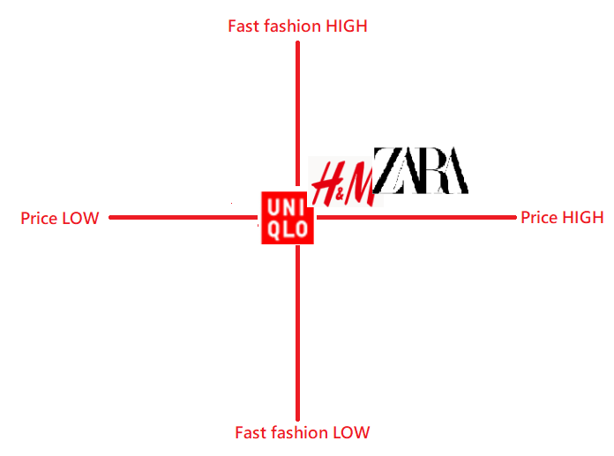
Source: Constructed by the Author

Considering the price, fast fashion among the competitors and list out the above Figure 3.1, UNIQLO's price range of the casual clothing is cheaper than H&M and ZARA.
However, their fast fashion is less than the competitors, because the style is simplicity.
Therefore, UNIQLO can differentiate the position among the competitors, because they can offer the cheaper price and high quality products in the market.

4. Marketing Mix (4Ps)
UNIQLO’s marketing strategy covers the 4Ps (Product, Price, Place Promotion) to analyze their brand. UNIQLO based on these 4Ps to lead their brand success in the fast fashion market.

4.1 Product
Product is that the company provides the physical product or service to the consumer who is willing to buy (Išoraitė, 2016).

Product range:
In order to satisfy and meet the consumers requirement, they provide consumers with enough choice for all kinds of consumers, such as men, women, kids and babies. So, they must find the suitable style in the wide range of size and color.
Figure 4.1 UNIQLO T-shirt of UNISEX, multiple of size and colour
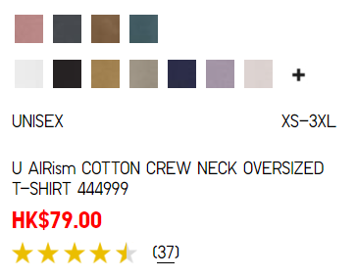
Source: Constructed by the Author

Product differentiation:
Many brands and retailers compete in the apparel market, each of them should provide similar products for the customer. So, UNIQLO develops the new technology product to attract the customers of the brand loyalty establishment, such as HEATTECH, AIRism, UV protection collection

4.2 Price
Pricing depends on the sales volume, there is an inverse relationship. The higher price, the sales decrease (Išoraitė, 2016).
Cost-plus pricing:
UNIQLO is an international brand and offers the high quality product at a rational price. They have adopted the cost-plus pricing (Guerreiro, Cornachione and Kassai ,2012) and delivered high customer satisfaction.

Competition oriental approach:
They have also faced the keen competition from the rival and have kept the price lower than them as they want to further penetrate the consumer market and grab the competitor's market share. So, the price cannot be set much higher than them - Figure 3.3.
Figure 4.2 Price setting of simple T-shirt - UNIQLO / ZARA / H&M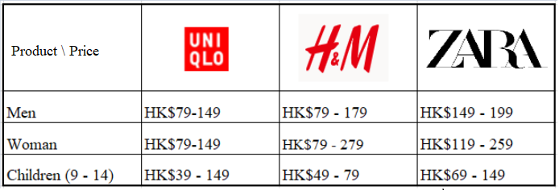
Source: Constructed by the Author

4.3 Place
Place involves the warehousing facilities, distribution channel, transportation method and inventory control management, so the products and services are moved from the manufacturer and service provider to customer (Singh, 2012).

SPA (Specialty retailer of private label Apparel):
UNIQLO is using the SPA business model which can show the customers and the manufacturers are connected directly and eliminate the intermediate links (Wei, J, 2017). Therefore, they are able to respond to the consumers in a short time and the products can reach the consumers as soon as possible.
The SPA model can lead the UNIQLO to control the consumer information directly, save the transportation expenditure and time, and develop the new product planning. Many big clothing retail companies also use this model, such as ZARA, GAP.
Internet:
Based on the previous PEST analysis, the internet is an essential communication tool for everyone. Consumers will use the smartphone & computer to access the digital market. UNIQLO already established a mobile application and online store for their e-commerce. Everyone can shop their online store to get the new product promotion and discount.

4.4 Promotion
Promotion is an important part of business strategy, and it is indispensable to the marketing process (Khan, 2014). It can make the consumer aware and encourage them to buy the product.

Sale promotion
UNIQLO always hold promotional activity in the retail store to attract the consumer, such as, Thanksgiving Day, four season festivals promotion. The promotions are likely to have a strong connection between the brand and the consumers.

Personal selling
UNIQLO will offer the training to salespeople, the training can provide the knowledge to the salespeople for their daily operation in the store and able to solve the consumer problem. This can increase the positive image of the brand.

Public relation
UNIQLO has hired Ayase Haruka as its brand ambassador. She is a famous actress in Japan and well known in Asia. She introduced UNIQLO’s new product in different media types (UNIQLO, 2022).

Online advertising:
UNIQLO already established the online store, apps store and will hold the live show regularly, the show will introduce the latest product, mix and match tips and limited offers.

Figure 4.3 Live show of UNIQLO
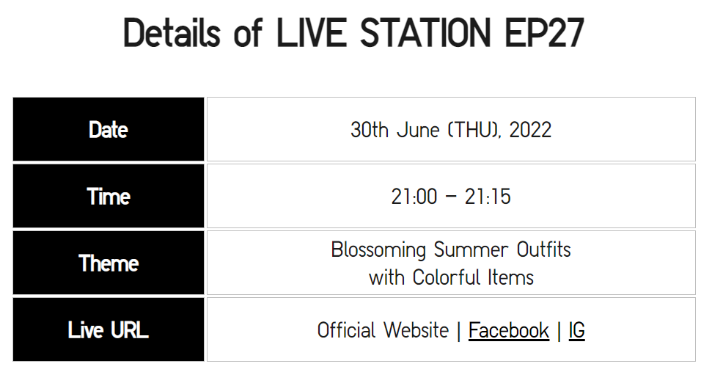

Source: UNIQLO, 2022

In conclusion of the 4Ps, UNIQLO can success to develop in their position and gain the competitive advantage in the market. Their wide range of product selection, cheap price with good quality, innovative technology, regular promotion, LIVE STATION, etc. These can increase the brand image in the society.

5. Future Development in the area of Marketing
UNIQLO is using fast fashion to run their business. Fast fashion refers to the apparel industry that manufactures and sells fashionable, but inexpensive, one-off clothing to the market. In recent years, consumers prefer the cheap and fast change style. However, they often ignore the supply chain to bring the impact of the environment.

Due to the rise of fast fashion, UNIQLO should rely on manufacturers where locate in China, Vietnam, India, etc., resulting in high energy consumption, chemical pollution, CO2 emission, textile and water waste from them (Niinimäki et al, 2020).
Figure 5.1 Garment-manufacturing supply chain
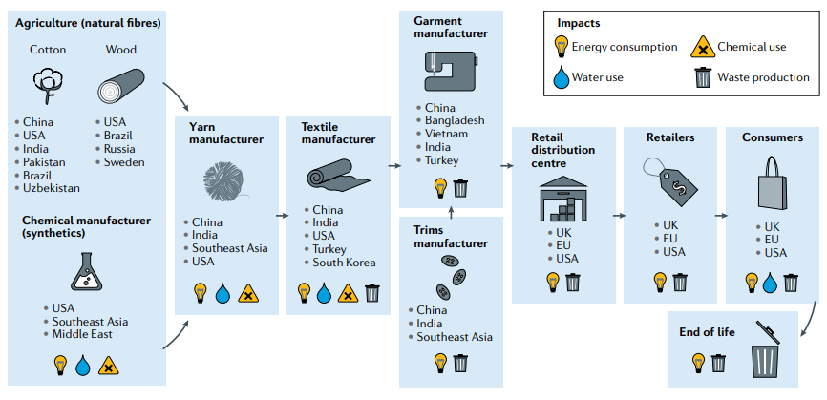
Source : Niinimäki et al, 2020

UNIQLO can launch the “Reformation” (Aderounmu, 2019), using superior technology to develop the new fabric in the textile industry and decrease the pollutant of the final product.

On the other hand, e-commerce is growing rapidly, fashion is the main sector to generate the revenue. Refer to Figure 4.2, fashion can generate around 2.5 billion in the online market during 2021, so UNIQLO need to enhance their current online platform, not only online advertising and promotion. They need to develop more technology function to attract the customer shopping in their apps and website.

Figure 5.2 Ecommerce - revenue by segment in HK
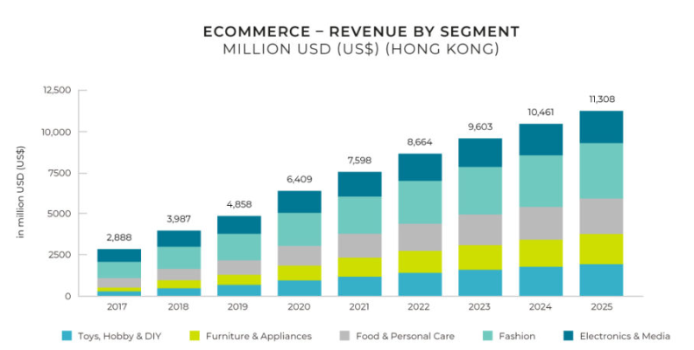
Source: statista, 2022

5. Recommendation
5.1 Goal of carbon neutrality
Environment protection is a trend of the global, many countries or regions have been announced the policy to protect the environment, Hong Kong government also respond to the spirit of the Paris Agreement and working toward the goal of carbon neutrality. Based on the SWOT’s weakness, they have an impact of the environment during manufacture the apparel. Refer to figure 5.1, many process has an impact of pollution in their supply chain. So, They require to develop more technological and functional products continuously. For instance, innovate the new material which uses the recycled waste to create the new product. This can increase the brand image of the apparel industry.
Fig5.1 Impact assessment result of UNIQLO
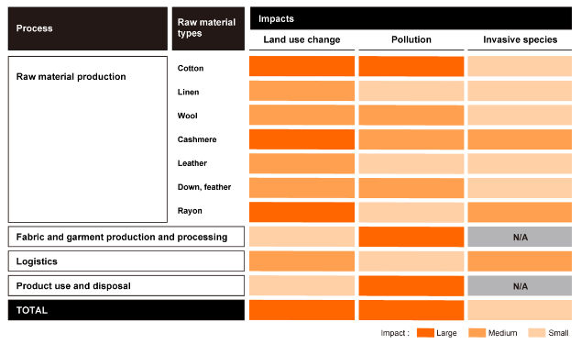
Source: Fast Retaining, 2022
5.2 Sustainable clothing becomes popularity
UNIQLO is a large retail store in Hong Kong, they need to commit the Corporate Social Responsibility, because it should affect the brand image in Hong Kong. So, they have a chance to strengthen their brand image on the innovate sustainable garments. There has been a change in the behavior and attitude of the consumer who will become more ethically awareness when they buy the products and services. Due to these consumers having a higher educated level in Hong Kong, they are welcome to buy the product which is made from the recycled product (Ting‐Yan and Christina, 2012). Actually, sustainable apparel is profitable in the future, according to the survey of the figure 5.1, people are willing to pay for it.

Figure 5.2 - How often do Vogue readers purchase sustainable fashion?
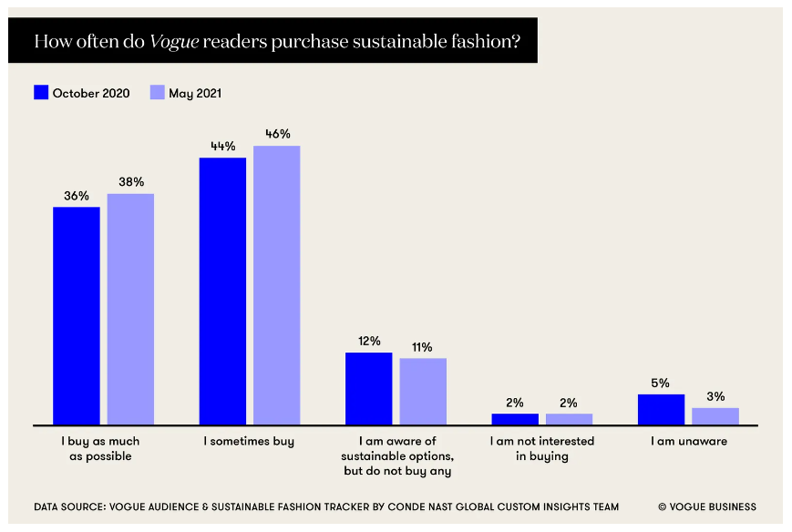
Source: VOGUE BUSINESS, 2022

5.3 Online platform enhancement
Big Data is a tool which does not only analyze the data, but it can predict the possibility of the event (Geroge, Haas and Pentland, 2014). So, it can foster a more personalized shopping experience. If UNIQLO SWOT’s weekness, if they import the big data technology, they can segment the consumer based on their age, gender, favorite to customize the marketing strategy individually and send the discount for them. This must attract more consumers. For example, Taobao is using the big Data, AI to boost click through rate (alizila, 2017).
Also, the membership does not offer a reward point at this moment . If the platform launches this function, the customer can use the point to redeem the coupon or product. The reward point function can also enhance the personalized shopping data.
6. Conclusion
UNIQLO understands that their brand name is a powerful tool in the industry, so they want to keep a good image for each customer. The company puts a lot of effort into emphasizing customer service and responding to the customers who care about. Also, company is moving on the sustainability, they need to commit the responsibility to the healthy earth, society and people.

Reference
Academic reference:
- Aderounmu, D., Calixto, Z., Castillo, J., & Leon, A. (2019). Reformation.
- Camilleri, M. A. (2018). Market segmentation, targeting and positioning. Travel marketing, tourism economics and the airline product, P.69-83.
- Du, H., Huang, Y., & Liu, Y. (2015, April). The Analysis of the SPA Apparel Company Strategy. In 2nd International Conference on Civil, Materials and Environmental Sciences, P.726-729. Atlantis Press.
- Emam, H. (2011). Real Estate Industry in Egypt: Segmentation, Targeting and Positioning Approach (Doctoral dissertation, Masters Thesis, University of Manchester, United Kingdom).
- Ensign, P. C. (2001). Value chain analysis and competitive advantage. Journal of General Management, 27(1), P.18-42.
- George, G., Haas, M. R., & Pentland, A. (2014). Big data and management. Academy of management Journal, 57(2), P.321-326.
- Guerreiro, R., Cornachione Jr, E. B., & Kassai, C. R. (2012). Determining The'Plus' In Cost-Plus Pricing: A Time-Based Management Approach. Journal of Applied Management Accounting Research, 10(1).
- Hasanbeigi, A., & Price, L. (2015). A technical review of emerging technologies for energy and water efficiency and pollution reduction in the textile industry. Journal of Cleaner Production, 95, P.30-44.
- Išoraitė, M. (2016). Marketing mix theoretical aspects. International Journal of Research-Granthaalayah, 4(6), P.25-37.
- Khan, M. T. (2014). The concept of ‘marketing mix’and its elements. International journal of information, business and management, 6(2), P.95-107.
- Kotler, P. (1989). From mass marketing to mass customization. Planning review.
- Meyers-Levy, J., Louie, T. A., & Curren, M. T. (1994). How does the congruity of brand names affect evaluations of brand name extensions?. Journal of Applied Psychology, 79(1), P.46.
- Moutinho, L. (2000). Segmentation, targeting, positioning and strategic marketing. Strategic management in tourismSingh, M. (2012). Marketing mix of 4P’s for competitive advantage. IOSR Journal of Business and Management, 3(6), P.40-45.
- Niinimäki, K., Peters, G., Dahlbo, H., Perry, P., Rissanen, T., & Gwilt, A. (2020). The environmental price of fast fashion. Nature Reviews Earth & Environment, 1(4), P.189-200.
- Pickton, D. W., & Wright, S. (1998). What's swot in strategic analysis?. Strategic change, 7(2), 101-109.
- Rockström, J., Gaffney, O., Rogelj, J., Meinshausen, M., Nakicenovic, N., & Schellnhuber, H. J. (2017). A roadmap for rapid decarbonization. Science, 355(6331), P1269-1271.
- Sammut-Bonnici, Tanya, and David Galea. "PEST analysis." (2014).
- Singh, M. (2012). Marketing mix of 4P’s for competitive advantage. IOSR Journal of Business and Management, 3(6), P.40-45.
- Ting‐Yan Chan & Christina W.Y. Wong (2012)The consumption side of sustainable fashion supply chain
- Wei, J. (2017, December). Study on Supply Chain Management of UNIQLO——Based on Quick Response. In 2017 7th International Conference on Mechatronics, Computer and Education Informationization (MCEI 2017) P89-93. Atlantis Press.

Other reference:
- 2021 population Census (2021) Available at: https://www.census2021.gov.hk.(Accessed: 28 Jun 2022)
- Alizila staff (2017) Mobile Taobao Uses AI, Big Data to Boost Engagement. Available at: https://www.alizila.com/mobile-taobao-uses-ai-big-data-to-boost-engagement/
- Census and Statistic Department (2022) official website. Available at: https://www.censtatd.gov.hk/tc/ (Accessed: 28 Jun 2022)
- Environment and Ecology Bureau (2022) Hong Kong's Climate Action Plan 2050 Available at: https://www.climateready.gov.hk/ (Access: 7 Jul 2022)
- Fast Retailing company (2022) Sustainability Report. Available at: https://www.uniqlo.com/tw/collection/sustainability/report/2022/2022FR_report.pdf (Accessed: 1 Jul 2022)
- Fast Retailing Company (2022) UNIQLO Business Model. Available at:
- https://www.fastretailing.com/eng/group/strategy/uniqlobusiness.html (Accessed: 25 Jun 2022)
- Fibre2fashion (2022) Price of cotton linter in China expected to rise in Q3 2021: TexPro. Available at: https://www.fibre2fashion.com/news/textile-news/price-of-cotton-linter-in-china-expected-to-rise-in-q3-2021-texpro-274312-newsdetails.htm?type=p (Accessed: 7 Jul 2022)
- H&M (2022) company official website. Available at: https://www2.hm.com/en_hk/index.html (Accessed: 25 Jun 2022)
- International Trade Administration (2022) eCommerce-Hong Kong & Macau. Available at: https://www.trade.gov/country-commercial-guides/ecommerce-hong-kong-macau (Accessed: 28 Jun 2022)
- Labour Department (2022) Statutory Minimum Wage. Available at: https://www.labour.gov.hk/eng/news/mwo.htm (Accessed: 27 Jun 2022)
- new.gov.hk (2022) Jobless rate rises to 5%. Available at: https://www.news.gov.hk/eng/2022/04/20220421/20220421_165147_500.html?yptr=yahoo (Accessed: 28 Jun 2022)
- The Government of HKSAR (2022) Government announces Hong Kong's Climate Action Plan 2050 Available at: https://www.info.gov.hk/gia/general/202110/08/P2021100800588.htm?fontSize=1 (Accessed: 1 Jul 2022)
- The Government of HKSAR (2022) Government further relaxes social distancing measures. Available at: https://www.info.gov.hk/gia/general/202205/04/P2022050300895.htm?fontSize=1 (Accessed: 27 Jun 2022)
- Trade and Industry Department (2022) CEPA. Available at: https://www.tid.gov.hk/english/cepa/legaltext/cepa_legaltext.html (Accessed: 27 Jun 2022)
- UNIQLO (2022) company official website. Available at: https://www.uniqlo.com.hk/zh_HK/index.html (Accessed: 25 Jun 2022)
- UNIQLO (2022) UNIQLO LIVE STATIO. Available at: (Accessed: 26 Jun 2022)https://www.uniqlo.com.hk/zh_HK/live.html
- VOGUE Business (2022) Customers care more about sustainability post-lockdowns. Now what? Available at: https://www.voguebusiness.com/sustainability/customers-care-more-about-sustainability-post-lockdowns-now-what (Accessed: 2 Jul 2022)
- ZARA (2022) company official website. Available at: https://www.zara.com/hk/zt/ (Accessed: 25 Jun 2022)

Appendices
No reward point function of the Apps


