St Fagans National Museum of History – Personal Reflection
On October 6th, we went on a field trip to St Fagans National Museum of History. We went around the museum, the gallery in the upstairs of the main building, and the various outside attractions. These photographs were taken by me at the time.

Kennixton Farmhouse and buildings
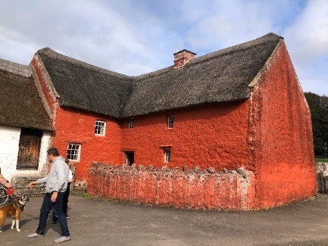
Kennixton Farmhouse (Pein, 2023).
This is the Kennixton building. The outside was painted a very vibrant red, which intrigued me into the building. The colour was believed to keep them protected from evil spirits and witchcraft (Amgueddfa Cymru, no date).

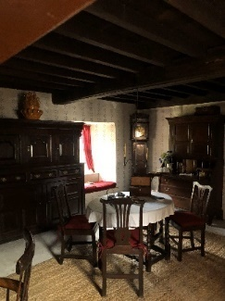
Main room, Kennixton Farmhouse (Pein, 2023).
The inside was decorated with furniture that would have been like the ones the family living there in the 1800s would have used (Amgueddfa Cymru, no date).

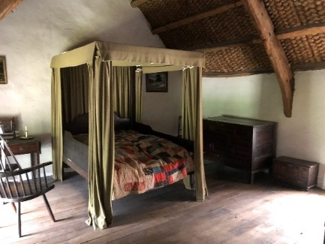
Canopy bed, Kennixton Farmhouse (Pein, 2023).
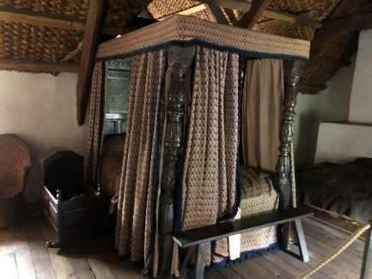
Canopy bed and cot, Kennixton Farmhouse (Pein, 2023).
The upstairs of the building had two bedrooms, each with a canopy bed. One of these rooms also had a cot to the side of the bed and another, lower quality bed on the other side. This was interesting to me, as it made me think about the people who lived in this house in the 1800s.

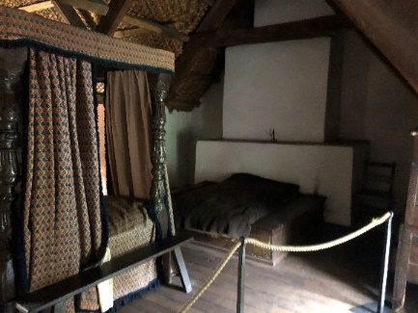
Spare bed, Kennixton Farmhouse (Pein, 2023).
The tenants of the house were the Rogers family, which at this time consisted of Leyshon Rogers and his wife and their three children, and a maid and a farm labourer lived in the house (Amgueddfa Cymru, no date).
With this knowledge, I began imagining the lives of the Rogers family. I had the idea that the bed most likely belonged to the husband and wife, and their youngest child could sleep in the cot next to them. The bed on the other side, I thought, could have belonged to the maid, who would take care of the baby if they woke up in the night. There is no basis to this speculation, I have no knowledge that this is the way it was, I just produced this theory based on the knowledge I have.

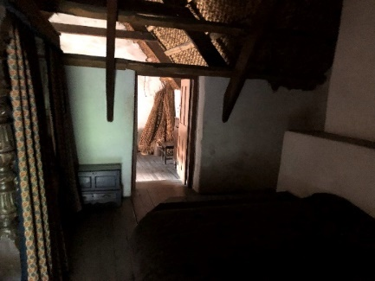
Room with straw, Kennixton Farmhouse (Pein, 2023).
Behind the spare bed, there was another room that was behind a barrier, so I could not get close to it, but I could see through the door that there was a collection of straw in the corner. Once again using only the knowledge I had, I produced the assumption that this room could have belonged to the farm labourer that lived with the family.

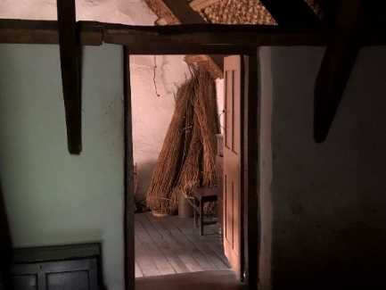
Close up of room with straw, Kennixton Farmhouse (Pein, 2023).
These presumptions are only from my knowledge and ideas of the time, the environment, and the family. In no way do I state that this is fact, but from the data that I was given, this is my hypothesis.

Rhyd-y-car Terrace
These buildings are a part of (the museum) named Rhyd-y-car Terrace. There are six houses all together, built in 1795, each one decorated to show a different period of history, namely 1805, 1855, 1895, 1925, 1955, and 1985 (Amgueddfa Cymru, no date).
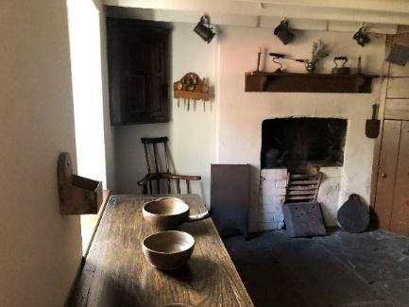
Set table, 1805 house, Rhyd-y-car Terrace (Pein, 2023).
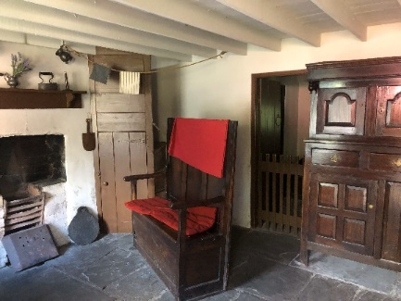
Decorated chair, 1805 house, Rhyd-y-car Terrace (Pein, 2023).
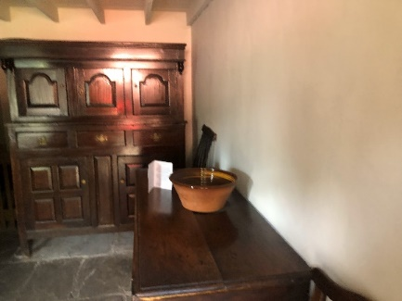
Cabinet and table, 1805 house, Rhyd-y-car Terrace (Pein, 2023).
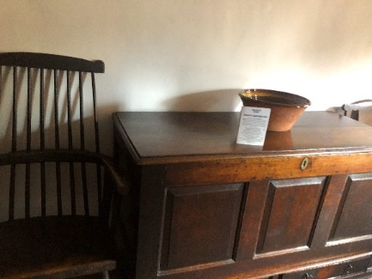
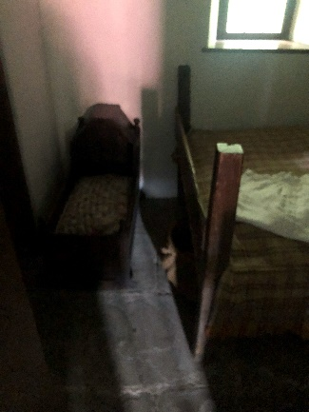
Table with ceramic bowl, 1805 house, Rhyd-y-car Terrace (Pein, 2023).
Cot in bedroom, 1805 house, Rhyd-y-car Terrace (Pein, 2023).

This is the 1805 house. This one does not look as decorated as some of the others, seemingly only having basic necessities. The bedroom only contains a bed and a cot, and the main room can boast only a simple fireplace, a large, undecorated wooden cabinet, two tables set with ceramic bowls, and the most colourful item in the room, a wooden bench decorated with red cushions.

The 1855 house looked slightly more embellished. The cabinet is decorated with ceramic figures of dogs, and two framed portraits hung above it. There was another cabinet displaying plates and decorative jugs. The fireplace has a simple covering, and the table was set with what seems to be teacups, and plates with bread and cheese.
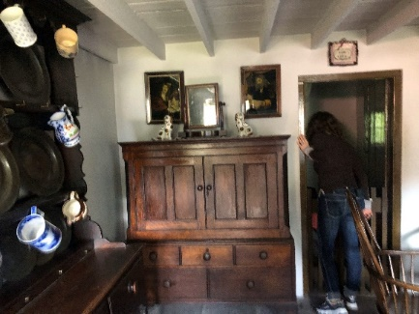
Cabinet and decorations, 1855 house, Rhyd-y-car Terrace (Pein, 2023).

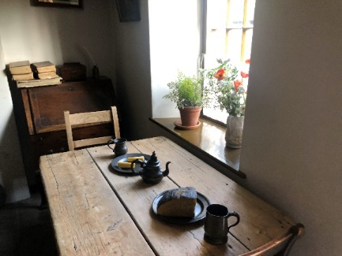
Set table, 1855 house, Rhyd-y-car Terrace (Pein, 2023).
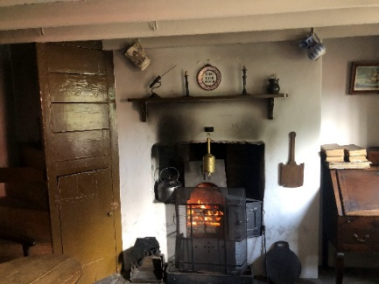
Fireplace, 1855 house, Rhyd-y-car Terrace (Pein, 2023).
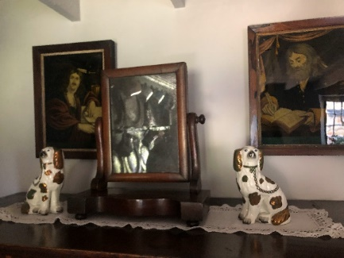
Portraits and decorations, 1855 house, Rhyd-y-car Terrace (Pein, 2023).
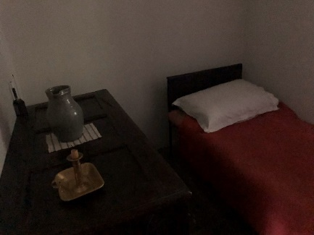
Bedroom, 1855 house, Rhyd-y-car Terrace (Pein, 2023).
The bedroom showed a single bed, and a bedside table, with a candle holder and a water jug.
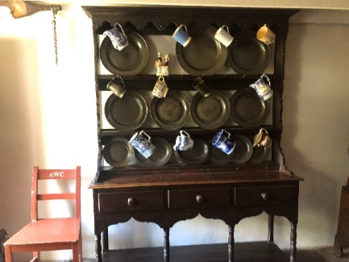
Cabinet with crockery, 1855 house, Rhyd-y-car Terrace (Pein, 2023).
These decorations show the change in culture between 1805 and 1855, displaying the higher embellishments the years brought to these houses.

The 1895 house also showed an increase in ornaments. The cabinet was once again decorated with ceramic figures of dogs, and an additional cabinet displayed various elegant and floral ornaments.

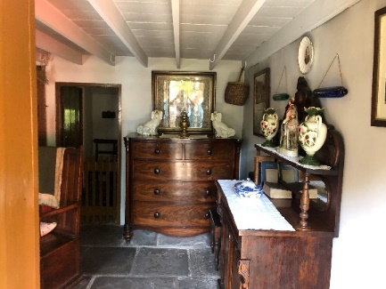
Decorated cabinets, 1895 house, Rhyd-y-car Terrace (Pein, 2023).
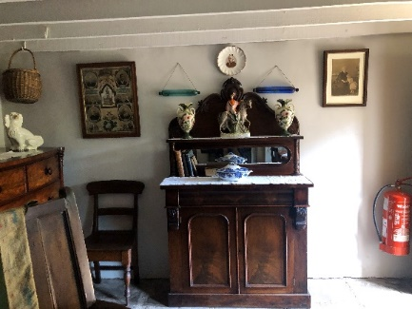
Decorated cabinet and framed pictures, 1895 house, Rhyd-y-car Terrace (Pein, 2023).
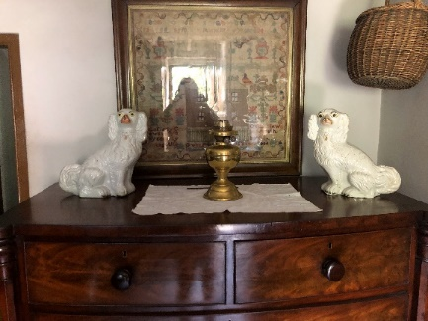
Cabinet decorations, 1895 house, Rhyd-y-car Terrace (Pein, 2023).
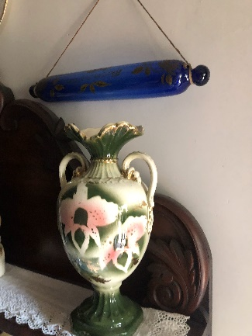
Ornamental vase, 1895 house, Rhyd-y-car Terrace (Pein, 2023).
I was drawn to one ornament in particular. This vase looked very extravagant. It is made with fancy patterns and gold lining on some of the edges.
These changes once again show the difference in culture between these two ages.

The house decorated in the style of the year 1925 was particularly interesting to me. In a personal conversation, one of the museum assistants, Gwion Rees (2023), shared the information that it was a Welsh tradition to bring the best bed downstairs when someone was going through the last few days of their life. The person would die in the best bed in the front room. In these houses, you would not be able to fit the bed in the front room because there would be so many people living in the one house. This meant that the tenants of these houses would have to die upstairs. However, the staircase is so narrow that they could not carry the corpse down the stairs. This created the problem of how to get the dead body downstairs and out of the house. A solution was invented to solve this problem – every house has a trap door in the ceiling. The tenants would move the floorboards away and push the dead body though the floor into the main room of the house. This was how the dead bodies would be transported through these houses. In the time that these houses were built, death was an extremely common event. This would mean that these trapdoors would frequently be used.
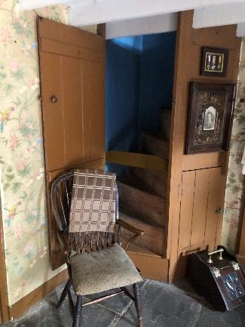
Staircase, 1925 house, Rhyd-y-car Terrace (Pein, 2023).
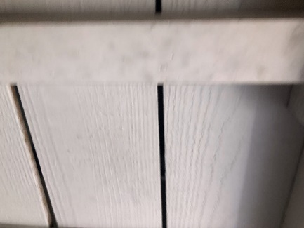
Ceiling boards, 1925 house, Rhyd-y-car Terrace (Pein, 2023).
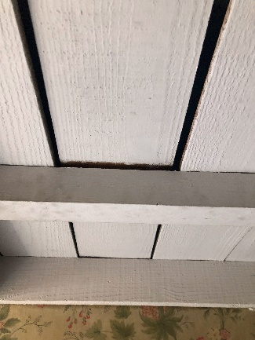
The trapdoor in the ceiling boards, 1925 house, Rhyd-y-car Terrace (Pein, 2023).
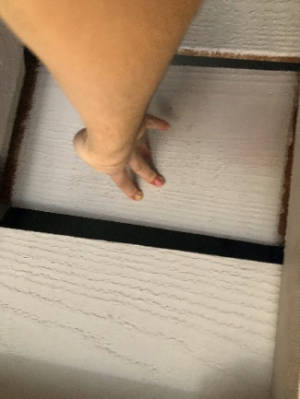
Demonstrating the trapdoor in the ceiling boards, 1925 house, Rhyd-y-car Terrace (Pein, 2023).

References
Amgueddfa Cymru (no date) Kennixton Farmhouse and buildings. Available at: https://museum.wales/stfagans/buildings/kennixton/ (Accessed: 21 October 2023).
Amgueddfa Cymru (no date) Rhyd-y-car Terrace. Available at: https://museum.wales/stfagans/buildings/rhydycar/ (Accessed: 21 October 2023).
Rees, G. (2023) Conversation with Naomi Pein, 6 October.
Pein, N. (2023) Kennixton Farmhouse.
Pein, N. (2023) Main room, Kennixton Farmhouse.
Pein, N. (2023) Canopy bed, Kennixton Farmhouse.
Pein, N. (2023) Canopy bed and cot, Kennixton Farmhouse.
Pein, N. (2023) Spare bed, Kennixton Farmhouse.
Pein, N. (2023) Room with straw, Kennixton Farmhouse.
Pein, N. (2023) Close up of room with straw, Kennixton Farmhouse.
Pein, N. (2023) Set table, 1805 house, Rhyd-y-car Terrace.
Pein, N. (2023) Decorated chair, 1805 house, Rhyd-y-car Terrace.
Pein, N. (2023) Cabinet and table, 1805 house, Rhyd-y-car Terrace.
Pein, N. (2023) Table with ceramic bowl, 1805 house, Rhyd-y-car Terrace.
Pein, N. (2023) Cot in bedroom, 1805 house, Rhyd-y-car Terrace.
Pein, N. (2023) Cabinet and decorations, 1855 house, Rhyd-y-car Terrace.
Pein, N. (2023) Set table, 1855 house, Rhyd-y-car Terrace.
Pein, N. (2023) Fireplace, 1855 house, Rhyd-y-car Terrace.
Pein, N. (2023) Portraits and decorations, 1855 house, Rhyd-y-car Terrace.
Pein, N. (2023) Bedroom, 1855 house, Rhyd-y-car Terrace.
Pein, N. (2023) Cabinet with crockery, 1855 house, Rhyd-y-car Terrace.
Pein, N. (2023) Decorated cabinets, 1895 house, Rhyd-y-car Terrace.
Pein, N. (2023) Decorated cabinet and framed pictures, 1895 house, Rhyd-y-car Terrace.
Pein, N. (2023) Cabinet decorations, 1895 house, Rhyd-y-car Terrace.
Pein, N. (2023) Ornamental vase, 1895 house, Rhyd-y-car Terrace.
Pein, N. (2023) Staircase, 1925 house, Rhyd-y-car Terrace.
Pein, N. (2023) Ceiling boards, 1925 house, Rhyd-y-car Terrace.
Pein, N. (2023) The trapdoor in the ceiling boards, 1925 house, Rhyd-y-car Terrace.
Pein, N. (2023) Demonstrating the trapdoor in the ceiling boards, 1925 house, Rhyd-y-car Terrace.

