

Public Health
(M5X00566)

Lecturer: Donna Morgan

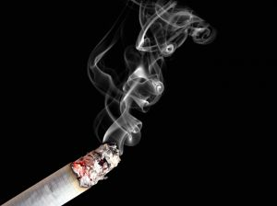
(Public Health Wales Observatory,2019)

Smoking in Wales
By: Saba Rejaee

Contents
Introduction: 4
Main body 5
Initiative 1: Smoking ban 10
Initiative 2: Cigarette Packaging 12
Initiative 3: Charities 15
Conclusion 17
References 18

Introduction:
Some countries like UK have some act and activities to reduce the increasing smoking. In the UK smoking in public places is banned and people are not allowed to smoke in public areas.
Smoking is a bad habit and will improve diseases, so the aims of this report is to evaluate the smoke free environment and investigate government’s plan of clear pathway to reduce the usage of smoking.
This report presents the UK government legislation and three major policy initiatives that all are trying to reduce usage of smoking and improve public healthcare.
This report presents a review of the legislation covering law, public opinion about smoking, cigarette businesses’ experience in marketing and smoke free law in the workplace and public areas in Wales and also in the UK.

Main body

A cigarette is much more than tobacco wrapped in paper. The chemicals process in cigarette smoke comes from different sources when a cigarette is made and used. Smoking is one of the biggest cause of death in most developed countries. Cancer Research UK in 2018 said: ‘’in the UK 13 people die every hour from a smoking disease and 1 in 5 UK adults smoke cigarettes, this amount estimated 9.4 million UK adult, are cigarette smokers.’’
“Smoking is such a huge public-health pandemic, that any intervention that will plausibly help, and for which adverse effects are implausible, should be tried.’’ said Michael Granovetter in 2013.
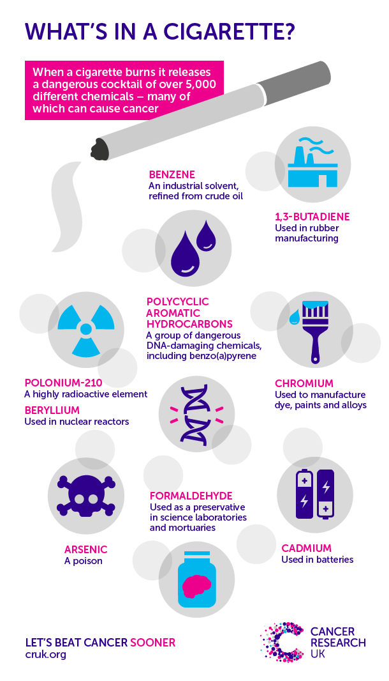
(Cancer Research UK, 2018)
-)
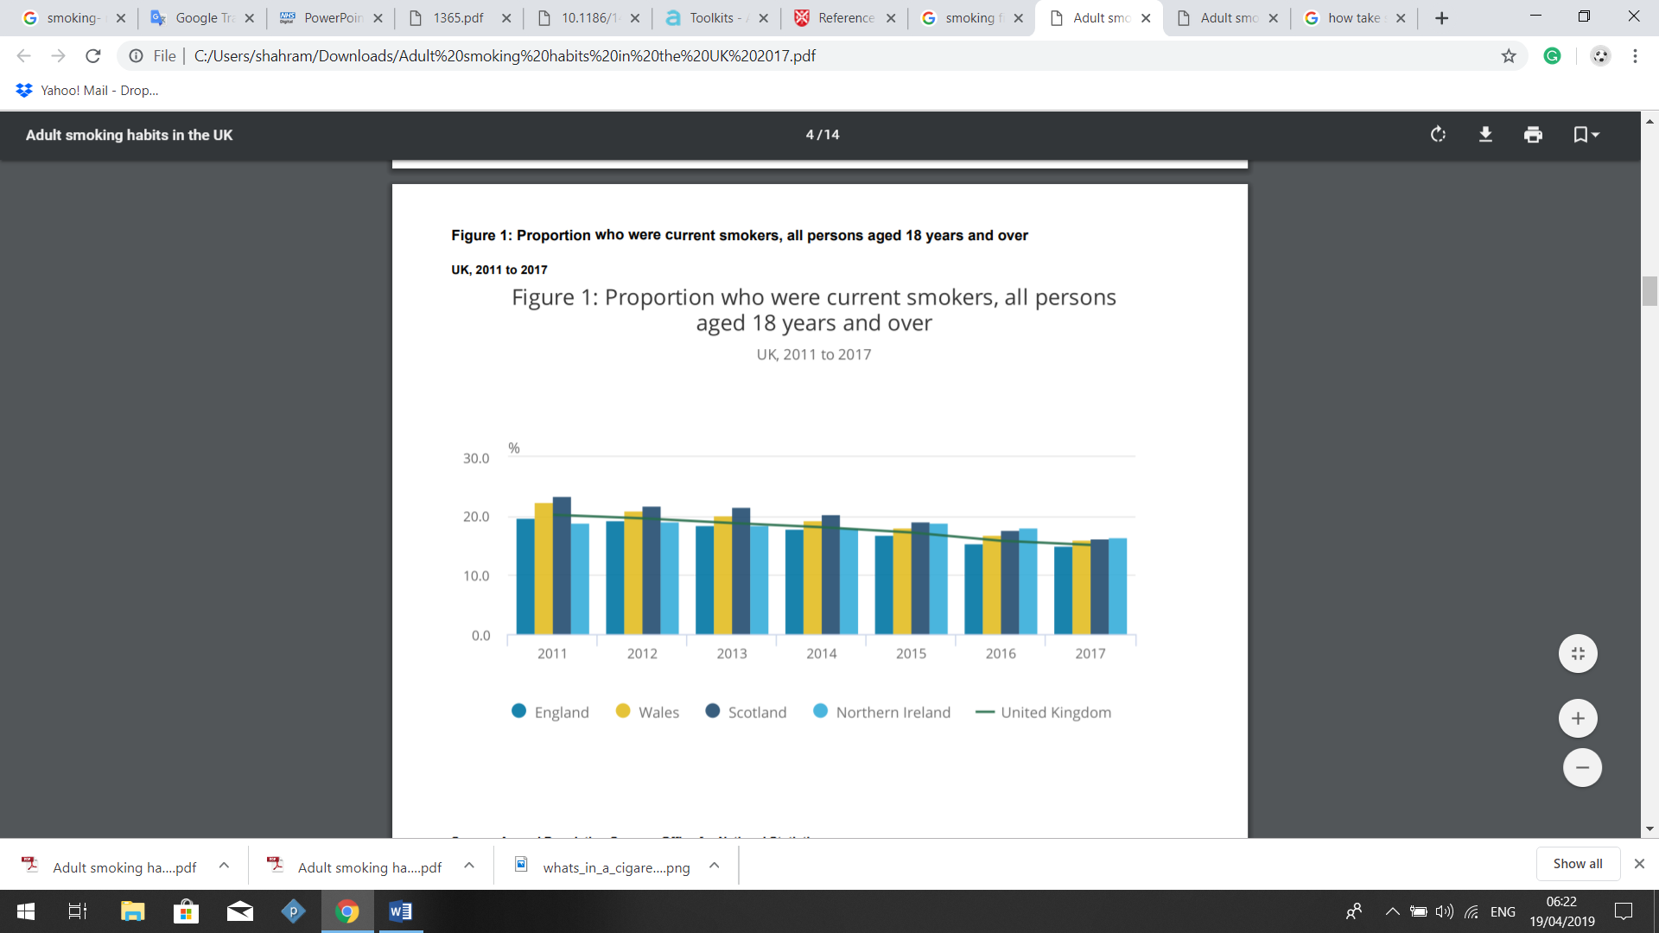
Smokers between 2011_2017 in the UK was 15.1% which is included 7.4 million in the population.
Above figure shows:
- Northern Ireland is highest smokers (16.5%, around 226,000 people).
- England had the lowest smokers (14.9%, around 6.1 million people).
- In Wales and Scotland, was 16.1%. (Around 386,000 people). (Officer for National Statistic, 2018)
- ‘’Adult smoking rate in Wales has reduced from 24% in 2008 and 2009, and the Welsh Government has stated to reduce smoking prevalence to 16% by 2020.’’ (Dr Grant, 2013)

World Health Organisation 2011 indicated: ‘’men smoke five times more than women, but this rates are very variable around the world.’’
The following figure shows the prevalence of cigarette smoking in Wales between men and women in 1978 to 2005. Shows there are higher percentages of men smoking than women.
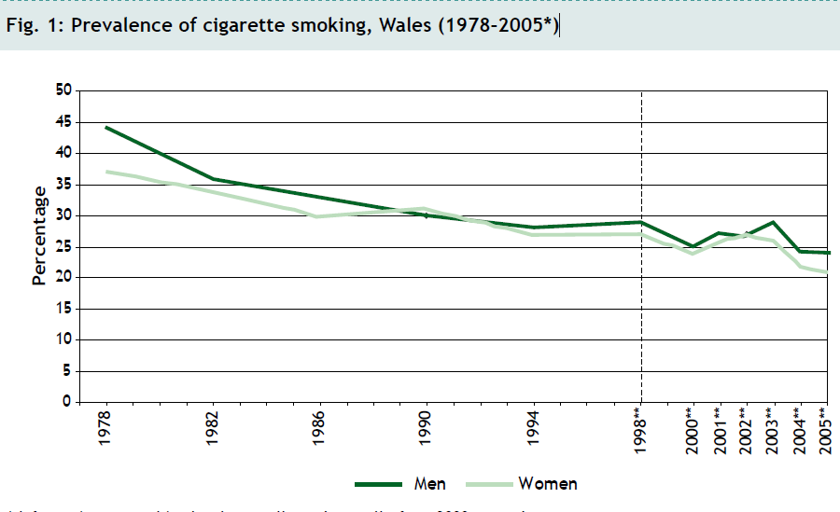

These days smokers are at highest risk of diseases, such as: stomach and duodenal ulcers, lung cancer, heart disease, and chronic obstructive pulmonary diseases like bronchitis and this is because that smoking be a public health issue. (Dolman, R. Gibbon, R. Roberts, C. 2007).
Smoking known as a public health issue in Wales, because remains the single largest cause of preventable diseases health in Wales, and a main cause of health problems.
Despite many attempts to reducing the prevalence of smoking in Wales, still there are around 490,000 adult who smoking in Wales. (NHS Wales, 2017).

Cambridge dictionary defined initiative as a ‘’new plan or action to improve something or solve a problem.’’(Cambridge English Dictionary)
West, Dimarino, Gitchell and Mcneill are all agree that The UK government has undertaken several major policy initiatives to try to increase usage of smoking cessation medicines. It is important to evaluate what effect, if any, these have had to inform future policy in the UK and internationally. (West et al, 2005)
Most important Government policy initiatives to try to reduce using of smoking, are included:
- Smoking ban
- Packaging cigarette
- Charities

Initiative 1: Smoking ban
Parliament voted to ban smoking and Scotland having been pioneered in national smoking bans in March 2006. Also in England, Wales and Northern Ireland smoke-free legislation is due to take effect between April and July 2007. (Timothy and Andreas, 2012)
Smoking ban legislation was introduced to create a healthy environment for society to live without smoke and protect workers, people and non-smokers in public from the harmful effects of smoke.
Evidences and reports clearly shows that it was effective on the people and smoke users tried to quickly manage their daily life and had strength benefits.
According to smoking ban ‘’in all enclosed public places and workplaces, such as pubs, bars, restaurants, factories, offices, public transport and, in certain circumstances, vehicles that used for work.’’ (Powlson, 2004)
The smoking bans prohibited smoking in all public places and it is illegal for people to smoke in public places like public indoor areas. According to this legislation, smokers’ people will not be allowed to smoke in public places because it was a serious risk to public health and also second hand smoke is much harmful for non-smokers. This act aims to ensure that every business and public places required to be smoke-free under the law and is ready when the ban on smoking started to work at 6am on 2 April 2007. (Welsh Government services and information, 2007)

Evaluations of smoking ban showed, it has had major public health benefits, like reducing rates of heart attack and pregnancy-related complications and also positive impacts on child health have also been seen. (Mackay, Haw, Ayres, et al, 2010).
Cochrane review which is created with a group of researchers who carried out evidence on the effects of laws banning smoking, published that:
- Evidence of smoking ban reduction in heart disease and deaths from smoking-related illnesses.
- The greatest drop in hospital for heart disease was in populations of people who was not smokers.
- Most advantage of smoking bans reduced stroke.
- Local NHS Stop Smoking Services have experienced over 20% increased demand as smokers have benefited from the more supportive environment to quit smoking.
- Researchers in Cochrane review, all are agree that smoke free in public places and workplaces has had a positive effect on the health of people in the UK and many respondents said they’d experienced personal benefits.
- Positive effect on the health of people in England.
- Many of people said they had enjoyed it.
- Health benefits. (Evidently Cochrane, 2016)
Smoking ban has few disadvantages like: not all of the smokers are able to cope with changes in their habits and their daily life, and if one smoker’s person tries to change bad habits, some other smokers people might find it very hard and also when the Government launched tobacco legislation, some people were unemployed and it was very hard for them to find a job which was good for their circumstance.

Initiative 2: Cigarette Packaging
Australia was first started to do standardised cigarette packaging in Australia and then UK Government in May 2012, started a national consultation proposed policy to introduce standard smoking packaging.
In the UK different smoking control applied to help reduce the number of new smoker’s people, including: using standardised packaging for smoke that called plain packaging. (Chantler and Lee, 2014)
“Smoking is such a huge public-health pandemic, that any intervention that will plausibly help, and for which adverse effects are implausible, should be tried.’’ said Michael Granovetter.
‘’Packaging is one of the tobacco advertisement industry’s primary promotional tools.’’ (Hammond, White, Anderson, Arnott and Dockrell, 2013)
All cigarette Packaging designed for attractive the customers like: the packaging shape, colour, brand and texture of cigarette packs.
In most countries such as the UK that smoking banned applied, factories in packaging have had focus on the product marketing efforts. Cigarette packaging will not only reduce the using of tobacco but can increase and notice people the effectiveness of health and harms of smoking and can reduce the attractiveness of cigarettes and increase awareness of the smoking risks in young people.
(Hammond, White, Anderson, Arnott and Dockrell, 2013)

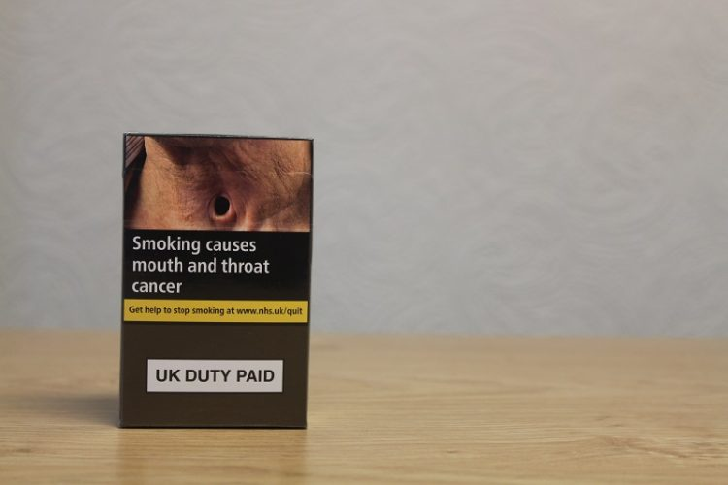

(Action on Smoking and Health Wales Cymru, 2017)

In the past decade, government increased focus on plain packaging among tobacco control and the aim of the plain pack includes colourful graphic health warnings but otherwise no colours, Packaging does not have brand imagery and logos, or brand name, so will cause tobacco products to reduce their advertisements. (Hoek et al, 2011)
Hughes, Arora and Grills, (2013) all are agree that: Plain packaging may decrease the use of tobacco, prevent initiation and experimentation but may have less effect on current users.
Research from ITC shows that smokers want to see more health information on cigarette packages and the research on pictorial warnings show that smokers are more interested to be noticed than text-only. (World Health Organization, 2007)

Initiative 3: Charities

One of the stop smoking service for Wales is ‘’Help me Quit.’’ Help Me Quit was supported by Public Health Wales and designed to give the largest number of smokers in Wales the best chance of quitting by helping them in locally available quit support. (An Independent Review of the Provision of Smoking Cessation Services in Wales, 2018)
GP can help smokers people quit smoking, GP can register the person in a "stop smoking" clinic and they doing different supports such as patches and gum, or they can start stop smoking medication.
NHS Stop Smoking is one of the service in the UK that can help with:
- ‘’Access to on-going support such as consultations with a trained advisor.
- Advice on and supply of stop smoking medicines if they're suitable for you.
- Speak to a pharmacist in store to check if the service is available in your area and if it could be right for you.’’
(NHS, 2018)

Action on Smoking and Health (ASH) is one of the other campaigning public health charity that works to eliminate the harm caused by tobacco and smoke. ASH started to work in January 1971 by the Royal College of Physicians.
ASH will provide information to smokers to making a plan for stop smoking, they will give stop smoking advice to person, carers, family, or other members who living with smokers person.
(ash.org.uk)
And also the British Heart Foundation in the UK, is a charity that working to end premature death from heart disease. They are involved in research, preventative activity and provide support and care to those living with heart disease.
Advantages of British Heart Foundation included:
- They will make a date to give up smoking.
- They will make a plan and think about what could help smoker’s person to stop smoking, like using a nicotine product, and have it ready before the date you plan to stop.
- Support and let your family and friends know that you're quitting. (British Heart Foundation)

Conclusion
According to this report, tried to use different data and information from a diversity of sources and researchers funding, such as the Welsh Government, ASH and British Heart Foundation.
However, there are not enough information in some data which do not allow the researchers measured them.
Welsh Government started a long term solution to reducing the use and cost of smoking in pregnant women, young children and children who are in danger of second hand smoke around them.
According to this long term plan, Welsh Government should make sure that they give enough information from base in school to the children and this can help to prevent more children using cigarette.
Smoking should not be advertised on social media and cigarette should be sold in plain packaging and reduce the attractiveness of smoking because smoking is a serious public health and causes serious health diseases and more than hundred people each year in the UK die from lung cancer caused by smoking.

References
- Action on Smoking and Health. Available at: http://ash.org.uk/category/about-ash/all-party-parliamentary-group-on-smoking-health. [Accessed Online 20th April 2019].

- Action on Smoking and Health Wales Cymru. (2017). Available at: https://ash.wales/ugly-cigarette-packs-arrive-in-british-shops/. [Accessed Online 19th April 2019].

- An Independent Review of the Provision of Smoking Cessation Services in Wales. (2018). Available at: https://gov.wales/sites/default/files/statistics-and-research/2018-12/180612-independent-review-provision-smoking-cessation-services-en.pdf. [Accessed Online 20th April 2019].

- British Heart Foundation. Available at: https://www.bhf.org.uk/informationsupport/risk-factors/smoking. [Accessed Online 20th April 2019].

- Cancer research UK (2018). What is in a cigarette? Available at: https://www.cancerresearchuk.org/about-cancer/causes-of-cancer/smoking-and-cancer/whats-in-a-cigarette-0 [Accessed: 19th April 2019].

- Cambridge English Dictionary. Initiative meaning in the Cambridge English Dictionary. [online] Dictionary.cambridge.org. Available at:
https://dictionary.cambridge.org/dictionary/english/initiative?q=Initiative. [Accessed Online 19th April 2019].

- Chantler C, Lee, W. (2014) Standardised packaging of tobacco: report of the independent review. London, UK.

- Dolman, R. Gibbon, R. Roberts, C. (2007). Smoking in Wales, Current Facts. Wales Centre for Health. Available at: http://www.wales.nhs.uk/sitesplus/documents/888/wch%20smoking%20ban%20report%20e%20final.pdf.

- DR Grant, A. (2013). The economic cost of smoking to Wales: a review of existing evidence. Available at: https://orca.cf.ac.uk/89325/1/cost_of_smoking_to_wales_2013.pdf P: 215-223.

- Evidently Cochrane. (2016). Available at: https://www.evidentlycochrane.net/national-smoking-bans-are-good-for-your-health/ [Accessed Online 19th April 2019].

- Granovetter, M. (2013). Cigarette packaging—EU progress, UK stalls. Vol 14. P 346.

- Hammond, D. White, C. Anderson, W. Arnott, D. Dockrell, M, (2013). The perceptions of UK youth of branded and standardized, ‘plain’ cigarette packaging. Action on Smoking and Health, London, UK. Vol. 24, No. 4, P 537–543

- Hoek, J. Gendall, P. Gifford, H. Pirikahu,G. McCool, J. Pene, G. Edwards, R. Thomson, G. (2011). Tobacco Branding, Plain Packaging, Pictorial Warnings, and Symbolic Consumption. Vol 22, Issue 5. P 630-639.

- Hughes, N. Arora, M. Grills, N (2013). Perceptions and impact of plain packaging of tobacco products in low and middle income countries, middle to upper income countries and low-income settings in high-income countries: a systematic review of the literature.

- Mackay, D. Haw, S. Ayres, J, G, et al. (2010). Smoke-free legislation and hospitalizations for childhood asthma. 363:1139–45.

- NHS. (2018). Take steps NOW to stop smoking. Available at: https://www.nhs.uk/live-well/quit-smoking/take-steps-now-to-stop-smoking/. [Accessed Online 20th April 2019].

- NHS WALES. (2017). Smoking. Available at: http://www.wales.nhs.uk/healthtopics/lifestyles/smoking. [Accessed 19TH April 2019].

- Officer for National Statistic (2018). Adult smoking habits in the UK. Available at file:///C:/Users/shahram/Downloads/Adult%20smoking%20habits%20in%20the%20UK%202017%20(2).pdf. [Accessed: 19th April 2019].

- Powlson, M. (2004). The Lancet's call to ban smoking in the UK. Volume 363, Issue 9406.

- Public Health Wales Observatory. (2019). Smoking. Available at: http://www.publichealthwalesobservatory.wales.nhs.uk/smoking#Top. [Accessed Online 19th April 2019].

- Timothy, H. Andreas, K. (2012). Smoking Ban and Life Satisfaction: Evidence from the UK. Vol. 17, P 27.

- Welsh Government services and information. (2007). what you need to know about the new smoke-free law. Available at: https://gov.wales/smoking. [Accessed Online 19th April 2019].

- West, R. Dimarino, M, E. Gitchell, J. Mcneill, A. (2005). Impact of UK policy initiatives on use of medicines to aid smoking cessation. Vol.14 (3), P.166_171.

- World Health Organization (2007). Available at: https://www.who.int/bulletin/volumes/87/8/09-069575/en/ [Accessed Online 20th April 2019].

- World Health Organisation (2011). Gender empowerment and female-to-male smoking prevalence ratios. [ONLINE] Available at: https://www.who.int/bulletin/volumes/89/3/10-079905/en/. [Accessed 19thApril 2019].

