HPAH5010 Entanglements: Exploring Interactions between the Aegean and the Near East.
Analysis of Ivory Spindle Whorls from Enkomi.

Deborah Mercer (1902778)

20/03/2022

Contents
Introduction 3
Theoretical Perspectives 4
Data 6
Discussion 12
Conclusion 16
Appendix 17
Reference List 23

Introduction
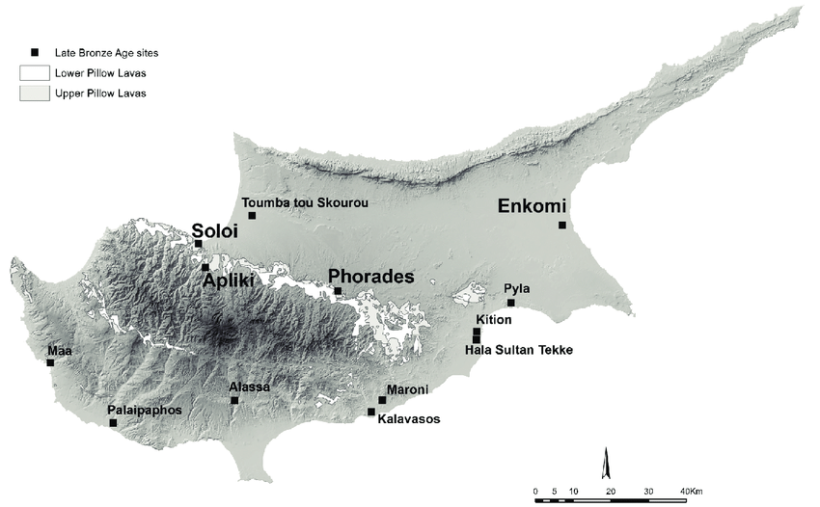
This report will explore what can be learnt about cultural entanglement in Late Bronze Age Cyprus (c. 1650-1050 BCE) through the analysis of spindle whorls. It will use the assemblage of 33 spindle whorls from Enkomi excavated by the British Museum in 1896 (Murrey et al., 1900) to examine the various cultural influences in Late Bronze Age Cyprus and how they are entangled within the sphere of textiles. By applying the four aspects of appropriation devised by Hahn (2004; 220-224) and the development of “material entanglement” (Stockhammer, 2011; 50-51) to the material composition and possible products of the spindle whorls, this report seeks to ”. discuss whether there is enough contextual evidence from the early excavations and comparisons to culturally similar sites (such as Ugarit) to identify the assemblage as an example of “material entanglement”. Enkomi was an important intersection of trade and diplomatic routes and, as such, was a cosmopolitan city of intermingling cultures and cultural exchange. This position on the periphery of many different societies and cultures enabled the continuous flow of technology, raw materials, finished objects, people and knowledge. The use and production of textiles are ubiquitous across time and cultures and the tools used in ancient societies. Spindle whorls especially are very simple, easy to transport or replicate, and easy to personalise, as well as obtaining new meanings depending on their materiality, making them perfect vectors for “cultural entanglement”.
Figure 1: The Island of Cyprus With the Main Bronze Age Cities Labelled. (https://www.researchgate.net/profile/Vasiliki-Kassianidou/publication/323883452/figure/fig2/AS:846259531313153@1578775403209/Map-of-Cyprus-with-sites-mentioned-in-the-text-produced-by-V-Ka)

Theoretical Perspectives
This report will analyse different features of the spindle whorls from Enkomi to explore cultural appropriation and “material entanglement”. Hahn suggests that the concept of appropriation should be considered a tool with which the local role of international goods can be explained (Hahn, 2004; 219). He identifies four aspects of modification involved in the transformation of an object from a commodity of economic value to an incorporated part of a person’s social identity (Hahn, 2004; 220-223):
1. Material Appropriation; the commodity obtains a personal value and can include a change in the form, such as decoration.
2. Objectification: the classification of an object into a known category within the household or society
3. Incorporation: the object obtains a new “correct” use from a local perspective
4. Transformation: the transformation of the object into something that has fully integrated into the local context. This does not mean that the item can no longer be seen as “foreign” as well as local.
These aspects will highlight the elements of the spindle whorls that have been appropriated from other cultures and enable a discussion on the “material entanglement”. Stockhammer (2011 50) defines “material entanglement” as “…the process of “material creation”…[that] results[s] in the creation of a new object that combines the familiar with the previously foreign”. At its most basic level, a spindle whorl holds the same social and cultural meaning and value, a weight on a stick used to create a thread, generally associated with women and women’s work (Barber, 1991; 7). However, nuances in material, shape, decoration and the location of the whorl can show cultural norms, the prevalence of specific raw materials and connections to foreign materials and ideas. By looking at the physical characteristics that were appropriated from different cultures, it will also be possible to hypothesise about the textiles that could have been created in Enkomi.

ENKOMI
The port city of Enkomi, Cyprus, is one of the most important sites for understanding the Late Cypriot Bronze Age (c. 1650-1050 BCE) as a wealth of archaeological material has been discovered (Crewe, 2007; 58). One of the reasons for the perceived importance of Enkomi is the extensive excavations that have taken place there, leading to a larger amount of evidence available for interpretation. During the first excavations carried out by the British Museum in 1896 and the Swedish Cyprus Expedition in 1930, only tombs were identified, and it was not until the French excavations under C. Shaeffer from 1934 to 1974 that the settlement was discovered. (Mountjoy, 2005; 125). The initial excavations have caused considerable problems in understanding the chronology of the city as they mistakenly believed the burial ground would be separate from the settlement area (Crewe, 2007; 59). When Shaeffer came to the site in 1934, he realised the connection between the settlement and the tombs as he had made the same mistake at the Late Bronze Age Syrian site of Minet el-Beida, an important harbour town for the kingdom of Ugarit. The tombs of Enkomi are located within the settlement and were in use for hundreds of years (Crewe, 2009; 28). The initial misinterpretation of the site is significant when analysing the objects held at the British Museum. Almost all the objects came from the 1897 expedition and therefore carried the baggage of early excavations. Alongside the misunderstanding of the site is the poor recording of the finds. Only the most “important” finds were thoroughly recorded and published (see Murry, 1900), leaving a huge number of “mundane” objects that could provide information about everyday life in Late Bronze Age Cyprus without context or provenance. The implications of these factors on interpreting the assemblage of spindle whorls from Enkomi is discussed below.

Data
The information available on the British Museum website is the primary source for this data (see appendix 1 & 2). This has created some complications which should be highlighted. Firstly, the report is dependent on the accurate recording of weights and measurements from the British Museum. There is at least one instance (ID 4, see Appendix 1) where the recorded weight was deemed unreliable based on the dimensions provided. There are several instances where there was no weight recorded at all (see appendix 1). Secondly, the British Museum provided only a single top-down photograph of the spindle whorls, making classification by shape difficult as it was not possible to view the profile. Because of this, the groups of whorl types centred on shapes in this report were created based on interpretations of the given dimensions and the photographs.

Whorl Shape and Size
From the assemblage of spindle Whorls from Enkomi, four shape types have been identified: disc, biconical, cone and dome. The most significant distinction worth highlighting is between “disc” and “dome”. This report determined that any whorl with a high >1cm would be designated a “dome”, and those with a height of <0.80cm would be designated a “disc” in order to differentiate between with a “low conical face” as described by the British Museum. Any whorls that fell in the 0.20cm are between these two points were assigned a group based on observations of the photograph. Of the four types, the disc was most common and occurred in various materials (Figure 2). It is most likely that further examination of the objects identified as “disc” here would show them as variations of the “conical-hemispherical shape” found throughout Cyprus and the Near East (Sauvage, 2013; 192).

Figure 2: Comparison of Spindle Whorls by type (Mercer, 2022)
The diameter ranged from 1.40cm to 4.90cm, with the average size being between 3cm and 4cm. In weight, the whorls vary from 1.02g to 27.10g, with the majority falling in the 3-20g range (Figure 3). This is consistent with the weight range of spindle whorls at other sites, such as Ugarit, where there is a weight range of 3-35g (Sauvage, 2013, 192).
Figure 3: Graph showing the relationship between weight and diameter with ivory indicated with red (Mercer, 2022)
The ratio between weight and diameter varies equally; however, a clear distinction can be seen among the material of the whorls. Due to the density of the material, the ivory dominates the “lighter” spindle whorls. The significance of this will be discussed below.

Decoration
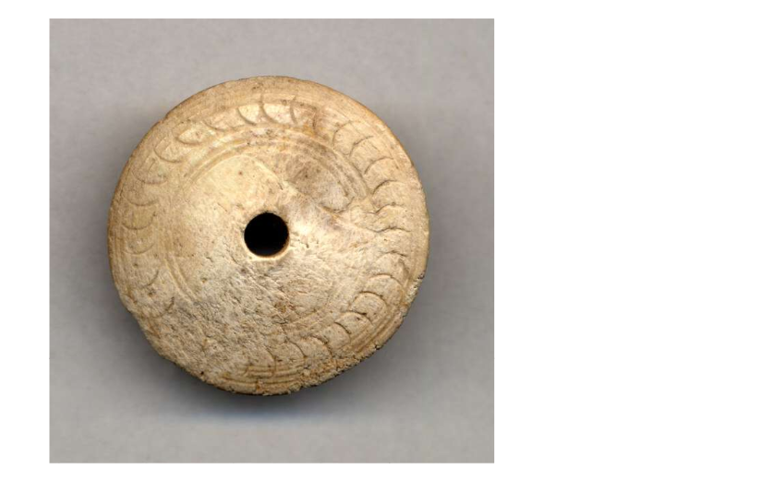
The majority of the spindle whorls from Enkomi held at the British Museum have some decoration on them. However, it is a relatively small sample size and should therefore not be taken as representative of the city as a whole. It is beyond the scope of this report to detail all the decorative elements seen on the whorls from Enkomi; as such, a single element has been selected to explore the role of decoration in the “material entanglement” of the spindle whorls. The most striking decorative element is found in the “leaf” motif on the outer edge (Figure 4). The “leaf” pattern is the most common motif found on the ivory whorls, though there are examples of it on stone whorls (figure 5).
Figure 4: Ivory whorl with "leaf" motif (ID no. 1)
Figure 5: Stone whorl with "leaf" motif (ID no. 27)

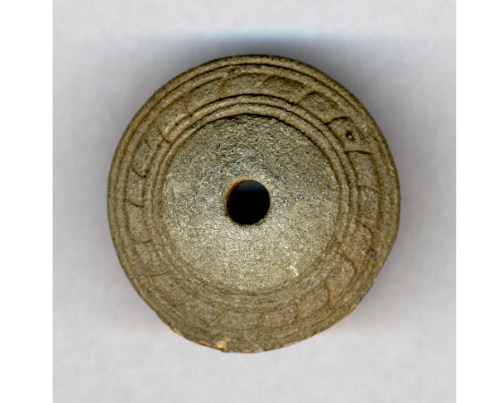
This element is unusual as it is not seen at all in the assemblage from Ugarit examined by Sauvage, and yet it can be seen on Late Bronze Age spindle whorls from Western Anatolia (Ergun, 2020; 13) on at least one whorl from Akrotiri, Thera (Vakirtzi, 2012; 229).
Moment of Inertia (MI)
The moment of inertia is an important parameter of spindle whorls as it helps in determining the thickness of the fibres and is calculated using the radius and the weight of the whorl. The larger the moment of inertia, the slower the spindle spins and the thicker the fibres used; the smaller the moment of inertia, the faster the spindle spins and the finer/softer the fibres used. The following equation was used to calculate the moment of inertia for the spindle whorls from Enkomi:
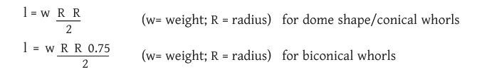

The following table (Figure 6) lists the spindle whorls from Enkomi and groups them according to their moment of inertia. The spindles are grouped as follows: <2g/cm², 2g/cm² - 9.9g/cm², 10g/cm² - 19.9g/cm², and >20g/cm². Due to the small sample size compared to other assemblages that have been analysed, such as Ugarit (Sauvage, 2013; 200-201), it is difficult to identify any trends across the group. However, it is significant that examples of ivory spindle whorls can be found in the two largest groups; 2g/cm² - 9.9g/cm² and 10g/cm² - 19.9g/cm². Due to the low moment of inertia of the first group (<2g/cm²), it is reasonable to assume these two objects are buttons or beads.
I.D. | Item Location | Diameter | Weight | Material | Moment of inertia (g/cm2)
14 | The British Museum; 1897,0401.1418 | 1.40cm | 03.10g | stone | 00.57
17 | The British Museum; 1969,0701.30 | 1.90cm | 01.02g | hippo ivory | 00.92
23 | The British Museum; 1897,0401.1369 | 3.10cm | 03.18g | hippo ivory | 02.86
24 | The British Museum; 1897,0401.1409 | 1.80cm | 08.27g | chlorite | 03.35
5 | The British Museum; 1897,0401.368 | 3.20cm | 03.03g | hippo ivory | 03.88
16 | The British Museum; 1897,0401.1392 | 2.20cm | 04.90g | stone | 05.39
21 | The British Museum; 1897,0401.1387 | 2.80cm | 06.20g | stone | 06.08
31 | The British Museum; 1897,0401.1406 | 2.50cm | 13.20g | chlorite | 07.73
27 | The British Museum; 1897,0401.1390 | 3.20cm | 08.30g | stone | 07.97
11 | The British Museum; 1969,0701.17.+ | 3.20cm | 06.64g | bone | 08.50
13 | The British Museum; 1897,0401.1391 | 3.20cm | 07.70g | stone | 09.86
20 | The British Museum; 1897,0401.1365 | 3.90cm | 05.28g | hippo ivory | 10.04
28 | The British Museum; 1897,0401.1365 | 3.90cm | 05.28g | pottery | 10.05
10 | The British Museum; 1897,0401.1366 | 3.70cm | 06.46g | hippo ivory | 11.05
6 | The British Museum; 1897,0401.1405 | 2.5cm | 14.30g | stone | 11.17
33 | The Brisih Museum; 1897,0401.1433 | 3cm | 11.20g | stone | 12.60
19 | The British Museum; 1897,0401.1363 | 3.9cm | 06.75g | hippo ivory | 12.83
1 | The British Museum; 1897,0401.1367 | 4cm | 07.64g | hippo ivory | 15.28
3 | The British Museum; 1897,0401.1434 | 3.10cm | 13.80g | stone | 16.58
29 | The British Museum; 1897,0401.1386 | 3.20cm | 13g | stone | 16.64
30 | The British Museum; 1969,0701.32 | 3.70cm | 10.70g | chlorite | 18.31
2 | The British Museum; 1969,0701.31 | 3.50cm | 12.20g | chlorite | 18.68
26 | The British Museum; 1897,0401.764 | 3.50cm | 13.70g | chlorite | 20.98
25 | The British Museum; 1897,0401.1364 | 4.90cm | 07.80g | ivory | 23.41
8 | The British Museum; 1897,0401.1389 | 3.60cm | 15.20g | stone | 24.62
12 | The British Museum; 1897,0401.1388 | 4.10cm | 14.50g | stone | 30.47
32 | The British Museum; 1897,0401.1403 | 3.20cm | 27.10g | stone | 34.69
18 | The British Museum; 1897,0401.1393 | 3.8cm | 19.70g | Chlorite | 35.56
15 | The British Museum; 1897,0401.1432 | 3.80cm | 25.20g | stone | 45.49
Figure 6: Table showing the whorls based on the MI (Mercer, 2022)

Discussion
Textiles were extremely important in ancient societies, and the demand for high-quality fabrics and raw materials, such as flax and wool, was a primary driver for establishing long-distance trade networks (Spinazzi-Lucchesi, 2018; 13). While most of the textiles themselves have perished due to their organic nature, many of the tools remain and can help in understanding the types of textiles produced at a specific site. Our understanding of spinning and weaving tools has been greatly enhanced by the experiments performed by the Copenhagen Centre for Textile Research (CRT); however, their research has primarily focused on the materials common to Northern Europe, such as wool terracotta and stone.
Alongside the understanding of the tools as the practical item is the interpretation of the spindle whorls as objects with the agency that reflect cultural entanglement. Within the assemblage of spindle whorls from Enkomi, the group made from ivory is the most informative. The first consideration is the use of ivory as a material. Technically, ivory comes from the tusks of elephants; however, in the Near East, ivory is also used to describe hippopotamus teeth. Most of the spindle whorls from Enkomi are identified as hippopotamus ivory (Figure 7) which is whiter, harder and denser than elephant ivory (REF Feldman, 248). Hippopotamus ivory is difficult to work with, and its small size limits its usage. However, these factors are actually beneficial in the production of spindle whorls. Spindle whorls are small, the assemblage from Enkomi ranging in diameter from 1.90cm to 4.90cm and in height from 0.40cm to 1.10cm, and thus would not require large amounts of material.
ID | Item Location | Culture/period | production date | Provenance | Type | Excavated | Height | Diameter | Diameter of hole | Weight | MI (g/cm2) | Material | Techniques
1 | The British Museum; 1897,0401.1367 | Late Cypriot IIC; Late Cypriot III | 1340bce-1050bce | Unprovinanced (U.202) | disc | Enkomi, Cyprus | 0.60cm | 4cm |  | 07.64g | 15.28 | hippo ivory | carved; drilled
5 | The British Museum; 1897,0401.368 | Late Cypriot IIC; Late Cypriot III | 1340bce-1050bce | unprovinanced; (U.203) | disc | Enkomi, Cyprus | 0.50cm | 3.20cm | 0.40cm | 03.03g | 03.88 | hippo ivory | carved, drilled
7 | The British Museum; 1897,0401.1371 | Late Cypriot IIC; Late Cypriot III | 1340bce-1050bce | unprovinanced (U.206) | disc | Enkomi, Cyprus | 1cm | 3.40cm | 0.65cm | NO WEIGHT RECORDED |  | hippo ivory | carved
9 | The British Museum; 1897,0401.1370 | Late Cypriot IIC; Late Cypriot III | 1340bce-1050bce | unprovinanced (U.205) | cone | Enkomi, Cyprus | 1.1cm | 3.40cm | 0.60cm | NO WEIGHT RECORDED |  | hippo ivory | carved
10 | The British Museum; 1897,0401.1366 | Late Cypriot IIC; Late Cypriot III | 1340bce-1050bce | unprovinanced (U.201) | dome | Enkomi, Cyprus | 0.95cm | 3.70cm | 0.95cm | 06.46g | 11.05 | hippo ivory | carved, drilled
17 | The British Museum; 1969,0701.30 | Late Cypriot IIC; Late Cypriot III | 1340bce-1050bce | (24.32) Tomb 24 | disc | Enkomi, Cyprus | 0.40cm | 1.90cm | 0.40cm | 01.02g | 00.92 | hippo ivory | carved, drilled
19 | The British Museum; 1897,0401.1363 | Late Cypriot IIC; Late Cypriot III | 1340bce-1050bce | unprovinanced (U.199) | disc | Enkomi, Cyprus | 0.70cm | 3.9cm | 0.50cm | 06.75g | 12.83 | hippo ivory | carved, drilled
20 | The British Museum; 1897,0401.1365 | Laye Cypriot IIC; Late Cypriot III | 1340bce-1050bce | unprovinanced (U.200) | disc | Enkomi, Cyprus | 0.40cm | 3.90cm | 0.50cm | 05.28g | 10.04 | hippo ivory | carved, drilled
23 | The British Museum; 1897,0401.1369 | Late Cypriot IIC; Late Cypriot III | 1340bce-1050bce | unprovinanced (U.204) | disc | Enkomi, Cyprus | 0.50cm | 3.10cm | 0.40cm | 03.18g |  | hippo ivory | carved, drilled
25 | The British Museum; 1897,0401.1364 | Late Cypriot IIC; Late Cypriot III | 1340bce-1050bce | unprovinanced (U.236) | disc | Enkomi, Cyprus | 0.60cm | 4.90cm | 0.70cm | 07.80g | 23.41 | ivory | incised, drilled

Figure 7: Data on only the ivory spindle whorls collected from the British Museum Website (Mercer, 2022)
The most common type of spindle in use at this time is the drop spindle, so-called because the spindle is suspended by the thread that is being produced.
It is an inevitability of spinning that at some point, the spindle will drop. If the whorl is made from a fragile material, it would be more likely to break. The durable nature of hippopotamus ivory means it would be able to withstand regular use as a practical tool. The ivory is a clear indication of cultural interaction as the most likely source for ivory in the Late Bronze Age was Egypt (REF Feldman, 251). The use of hippopotamus ivory for spindle whorls could have been for a practical purpose or as a symbol of textile production in foreign, exotic materials. The biggest hindrance in answering this question at Enkomi is the lack of context for the finds. While the expedition only investigated and recorded tombs, most of the spindle whorls lacked provenance and stratigraphy. Knowing if the ivory spindle whorls were dominant in settlement or funerary contexts would enable firmer ground with which to explore the entanglement of the objects. However, as the process of cultural appropriation is continuous, it is not necessary to know the entire journey or even the exact relationships between society and the artefact to be able to identify it as an object of entanglement (Stockhammer, 51).
The ivory spindle whorls could definitely have served the practical purpose of making it easier to spin finer, fragile fibres such as flax. Flax dominated textile production in Ancient Egypt (Barber, 199; 158), the most likely location for the material of the whorls themselves. While flax was cultivated in Cyprus, it was not produced in large quantities (Lucas and Fuller, 2020; 17), so any linin produced was probably on a small scale or from importing the raw material. However, experimental studies have shown that spindle whorls of 4g can be used to make a fine woollen thread when the raw material has been well prepared (Sauvage, 2013; 203). This would mean that at least half of the ivory spindle whorls from Enkomi could have been used to produce yarn from either flax or the more readily available wool.
Despite the “foreign” origins of the material for the whorl and its possible connection to the processing of “foreign” raw material, the decorations seen on the spindles appear to be either locally influenced or from a different culture. This would suggest that the ivory is being imported or gifted as raw material and then carved in Enkomi for a local market.
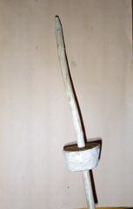
The examination of the MI is very informative. The selection of Ivory spindle whorls, though at the lighter end weight wise, show significant diversification in MI, representing all of the groups except the very heaviest. This means that with the ivory spindles alone, it would be possible to recreate the majority of textiles produced at Enkomi. This would suggest that the use of ivory was not for the processing of a specific material but that it carried a different social meaning. In her analysis of spindle whorls from Ugarit, Sauvage (2013; 202) notes that most of the ivory whorls were found in tomb contexts and only a few from within the settlement area. However, its prevalence in one area does not rule it out of another. It is possible that the highly decorated ivory spindle whorls were used in a ritualistic way only once or twice in a woman’s lifetime to create a specific textile (Carter, 2007; 89). The fact that the quantifiable analysis shows that a variety of threads could be produced the ivory spindle whorls highlights an important qualitative factor discovered by the CRT during experiments in spinning: the most important factor is the person spinning (Kania, 2013; 27). From my own early experiments in making drop spindles, I know that a spindle does not have to be perfect in order to work, nor is a person significantly limited in what they can produce by the tools being used (Figure 8).
Figure 8: Spindle made by author (Mercer, 2022)

Conclusion
The ivory spindle whorls from Enkomi pass through all four aspects of appropriation described by Hahn (2004; 220- 224). The ivory has been appropriated as a material (1.) with the inclusion of locally inspired decoration that indicates personal possession. The whorl has been objectified (2.) either as a tool for the production of textile or as a symbol of the production of textiles. The object has been incorporated (3.) into a “correct” usage within textile production methods of Enkomi, and it has transformed (4.) from a foreign “commodity” into an integral aspect of textile production and symbolism in the local culture. Despite there being different interpretations of the possible functional context of the ivory spindle whorls, it is still possible to see them as objects of “material entanglement” (Stockhammer, 2011; 51). The exotic material, locally inspired decorations and practical use within an established craft is evidence of many different creative dialogues taking place triggered by encounters with foreign materials and ideas (Stockhammer,2011; 55). The ivory spindles whorls are objects of entanglement found in one of the most culturally entangled places in the Late Bronze Age: Enkomi.

Appendix
Appendix 1
Table listing all the data obtained from the British Museum website in relation to the spindle whorls found in Enkomi.
I.D. | Item Location | Culture/period | production date | Provenance | Type | Excavated | Height | Diameter | Diameter of hole | Weight | Moment of inertia (g/cm2) | Material | Techniques
1 | The British Museum; 1897,0401.1367 | Late Cypriot IIC; Late Cypriot III | 1340bce-1050bce | Unprovinanced (U.202) | disc | Enkomi, Cyprus | 0.60cm | 4cm |  | 7.64g | 15.28 | hippo ivory | carved; drilled
2 | The British Museum; 1969,0701.31 | Late Cypriot II; Late Cypriot III | 1450bce-1050bce | (24.6) Tomb 24 | disc | Enkomi, Cyprus | 0.80cm | 3.50cm |  | 12.20g | 18.68 | chlorite | ground, polished, drilled, engraved
3 | The British Museum; 1897,0401.1434 | Late Cypriot II; Late Cypriot III | 1450bce-1050bce | Unprovinanced (U.286) | cone | Enkomi, Cyprus | 1.3cm | 3.10cm | 0.50cm | 13.80g | 16.58 | stone | drilled, engraved, ground
4 | The British Museum; 1897,0401.1404 | Late Cypriot | 1650bce-1050bce | unprovinanced (U.282) | biconical | Enkomi, Cyprus | 2.8cm | 3.30cm | 0.70cm | 40.40g suspected error (likely 4.40) |  | stone | drilled, engraved, ground
5 | The British Museum; 1897,0401.368 | Late Cypriot IIC; Late Cypriot III | 1340bce-1050bce | unprovinanced; (U.203) | disc | Enkomi, Cyprus | 0.50cm | 3.20cm | 0.40cm | 3.03g | 03.88 | hippo ivory | carved, drilled
6 | The British Museum; 1897,0401.1405 | Late Cypriot | 1650bce-1050bce | unprovinanced (U.283) | cone | Enkomi, Cyprus | 1.90cm | 2.5cm | 0.4cm | 14.30g | 11.17 | stone | drilled, ground, polished
7 | The British Museum; 1897,0401.1371 | Late Cypriot IIC; Late Cypriot III | 1340bce-1050bce | unprovinanced (U.206) | disc | Enkomi, Cyprus | 1cm | 3.40cm | 0.65cm | NO WEIGHT RECORDED |  | hippo ivory | carved
8 | The British Museum; 1897,0401.1389 | Late Cypriot II; Late Cypriot III | 1450bce-1050bce | unprovinanced (U.277) | disc | Enkomi, Cyprus | 1cm | 3.60cm | 0.5cm (noted as mm) | 15.20g | 24.62 | stone | drilled, ground, engraved, polished
9 | The British Museum; 1897,0401.1370 | Late Cypriot IIC; Late Cypriot III | 1340bce-1050bce | unprovinanced (U.205) | cone | Enkomi, Cyprus | 1.1cm | 3.40cm | 0.60cm | NO WEIGHT RECORDED |  | hippo ivory | carved
10 | The British Museum; 1897,0401.1366 | Late Cypriot IIC; Late Cypriot III | 1340bce-1050bce | unprovinanced (U.201) | disc | Enkomi, Cyprus | 0.95cm | 3.70cm | 0.95cm | 6.46g | 11.05 | hippo ivory | carved, drilled
11 | The British Museum; 1969,0701.17.+ | Late Cypriot IIC; Late Cypriot III | 1340bce-1050bce | (1.1) Tomb 1 | disc | Enkomi, Cyprus | 0.80cm | 3.20cm | 0.50cm | 6.64g | 08.50 | bone | carved, drilled
12 | The British Museum; 1897,0401.1388 | Late Cypriot II; Late Cypriot III | 1450bce-1050bce | unprovinanced (U.276) | disc | Enkomi, Cyprus | 0.50cm | 4.10cm | 0.50cm | 14.50g | 30.47 | stone | drilled, ground, engraved
13 | The British Museum; 1897,0401.1391 | Late Cypriot II; Late Cypriot III | 1450bce-1050bce | unprovinanced (U.279) | disc | Enkomi, Cyprus | 0.60cm | 3.20cm | 0.50cm | 7.70g | 09.86 | stone | drilled, engraved, ground, polished
14 | The British Museum; 1897,0401.1418 | Late Cypriot | 1650bce-1050bce | unprovinanced (U.287) | biconical | Enkomi, Cyprus | 1.40cm | 1.40cm | 0.30cm | 3.20g | 00.57 | stone | drilled, engraved, ground
15 | The British Museum; 1897,0401.1432 | Late Cypriot II; Late Cypriot III | 1450bce-1050bce | unprovinanced (U.284) | cone | Enkomi, Cyprus | 1.40cm | 3.80cm | 0.60cm | 25.20g | 45.49 | stone | drilled, engraved, ground, polished
16 | The British Museum; 1897,0401.1392 | Late Cypriot II; Late Cypriot III | 1450bce-1050bce | Unprovinanced (U.280) | cone (disc) | Enkomi, Cyprus | 0.90cm | 2.20cm | 0.40cm | 4.90g | 05.39 | stone | drilled, ground, engraved
17 | The British Museum; 1969,0701.30 | Late Cypriot IIC; Late Cypriot III | 1340bce-1050bce | (24.32) Tomb 24 | disc | Enkomi, Cyprus | 0.40cm | 1.90cm | 0.40cm | 1.02g | 00.92 | hippo ivory | carved, drilled
18 | The British Museum; 1897,0401.1393 | Late Cypriot II; Late cypriot III | 1450bce-1050bce | unprovinanced (U.46) | disc | Enkomi, Cyprus | 1cm | 3.8cm | 0.70cm | 19.70g | 35.56 | Chlorite | drilled, engraved, ground, polished
19 | The British Museum; 1897,0401.1363 | Late Cypriot IIC; Late Cypriot III | 1340bce-1050bce | unprovinanced (U.199) | disc | Enkomi, Cyprus | 0.70cm | 3.9cm | 0.50cm | 6.75g | 12.83 | hippo ivory | carved, drilled
20 | The British Museum; 1897,0401.1365 | Laye Cypriot IIC; Late Cypriot III | 1340bce-1050bce | unprovinanced (U.200) | disc | Enkomi, Cyprus | 0.40cm | 3.90cm | 0.50cm | 5.28g | 10.04 | hippo ivory | carved, drilled
21 | The British Museum; 1897,0401.1387 | Late Cypriot II; Late Cypriot III | 1450bce-1050bce | unprovinanced (U.275) | disc | Enkomi, Cyprus | 0.70cm | 2.80cm | 0.50cm | 6.20g | 06.08 | stone | drilled, engraved, ground, polished
22 | The British Museum; 1897,0401.863 | Late Cypriot | 1650bce-1050bce | (12.4) Tomb 12 | disc (cone) | Enkomi, Cyprus | 2cm | 4.40cm | NO DIAMETER RECORDED | NO WEIGHT RECORDED |  | clay | handmade
23 | The British Museum; 1897,0401.1369 | Late Cypriot IIC; Late Cypriot III | 1340bce-1050bce | unprovinanced (U.204) | disc | Enkomi, Cyprus | 0.50cm | 3.10cm | 0.40cm | 3.18g | 02.86 | hippo ivory | carved, drilled
24 | The British Museum; 1897,0401.1409 | Late Cypriot | 1650bce-1050bce | (88.2) Tomb 88 | biconical | Enkomi, Cyprus | 2.10cm | 1.80cm | 0.50cm | 8.27g | 03.35 | chlorite | ground, polished, drilled
25 | The British Museum; 1897,0401.1364 | Late Cypriot IIC; Late Cypriot III | 1340bce-1050bce | unprovinanced (U.236) | disc | Enkomi, Cyprus | 0.60cm | 4.90cm | 0.70cm | 7.80g | 23.41 | ivory | incised, drilled
26 | The British Museum; 1897,0401.764 | Late Cypriot II; Late Cypriot III | 1450bce-1050bce | (97.3) Tomb 97 | disc | Enkomi, Cyprus | 0.90cm | 3.50cm | 0.55cm | 13.70g | 20.98 | chlorite | engraved, ground, polished, drilled
27 | The British Museum; 1897,0401.1390 | Late Cypriot II; Late Cypriot III | 1450bce-1050bce | unprovinanced (U.278) | disc | Enkomi, Cyprus | 0.80cm | 3.20cm | 0.50cm | 8.30g | 07.97 | stone | drilled, engraved, ground
28 | The British Museum; 1897,0401.1407 | Late Cypriot I | 1650bce-1450bce | (88.50) Tomb 88 | biconical | Enkomi, Cyprus | 3.30cm | 3.30cm | 0.80cm | 21.60g | 29.40 | pottery | incised
29 | The British Museum; 1897,0401.1386 | Late Cypriot II; Late Cypriot III | 1450bce-1050bce | unprovinanced (U.274) | disc | Enkomi, Cyprus | 1cm | 3.20cm | 0.50cm | 13g | 16.64 | stone | drilled, engraved, ground, polished
30 | The British Museum; 1969,0701.32 | Late Cypriot II; Late Cypriot III | 1450bce-1050bce | (24.7) Tomb 24 | disc | Enkomi, Cyprus | 0.50cm | 3.70cm | 0.50cm | 10.70g | 18.31 | chlorite | ground, polished, engraved, drilled
31 | The British Museum; 1897,0401.1406 | Late Cypriot | 1650bce-1050bce | (88.1) Tomb 88 | biconical | Enkomi, Cyprus | 2cm | 2.50cm | 0.60cm | 13.20g | 07.73 | chlorite | ground, drilled, polished
32 | The British Museum; 1897,0401.1403 | Late Cypriot | 1650bce-1050bce | unprovinanced (U.281) | cone | Enkomi, Cyprus | 2.30cm | 3.20cm | 0.50cm | 27.10g | 34.69 | stone | drilled, ground
33 | The Brisih Museum; 1897,0401.1433 | Late Cypriot II; Late Cypriot III | 1450bce-1050bce | unprovinanced (U.285) | disc | Enkomi, Cyprus | 1cm | 3cm | 0.50cm | 11.20g | 12.60 | stone | drilled, ground, engraved, polished

Appendix 2
Table showing the descriptions and photographs supplied on the British Museum Website for the spindle whorls found at Enkomi.
ID | Item Location | Description | Image
1 | The British Museum; 1897,0401.1367 | 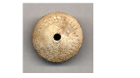 | 1.png
  Ivory (hippopotamus) spindle-whorl with one convex and one flat face; centrally drilled hole; carved decoration on the convex face of a band of arcs between two bands of concentric circles. B.M.
2 | The British Museum; 1969,0701.31 | Chlorite spindle-whorl; ground and polished with centrally drilled perforation; low conical with wide face flat; conical face decorated with engraved concentric circles and semi-circles. B.M. | 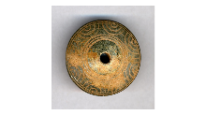  2.png
3 | The British Museum; 1897,0401.1434 |  | 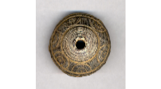  3.png
  Grey stone conical spindle-whorl; ground and polished; hole drilled through centre; decorated with engraved annules and bands. B.M.
4 | The British Museum; 1897,0401.1404 |  | 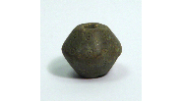  4.png
  Green stone biconical spindle-whorl; ground; hole drilled through centre; decorated with engraved annules; chipped at perforation on one terminal.
5 | The British Museum; 1897,0401.368 |  | 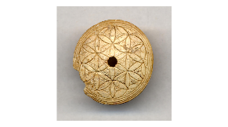  5.png
  Ivory (hippopotamus) spindle-whorl with one low conical and one flat face; centrally drilled hole; carved decoration on the conical face of concentric circles on outer edge with joining arcs forming rosettes on the interior; chip from one side of maximum diameter.
6 | The British Museum; 1897,0401.1405 | Purple stone conical spindle-whorl; ground and polished; hole drilled through centre; chips at narrow terminal and maximum diameter. | 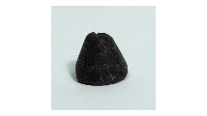  6.png
7 | The British Museum; 1897,0401.1371 | Ivory (hippopotamus) spindle-whorl with the broken off tip of a spindle remaining in the centrally drilled hole; the spindle-whorl has a flat upper surface with convex sides and a concave underside; the flat face is decorated with carved concentric circles, a band of arcs and double semi-annules on the interior; the preserved tip of the spindle is pointed; there is a large chip missing from one side of the whorl. | 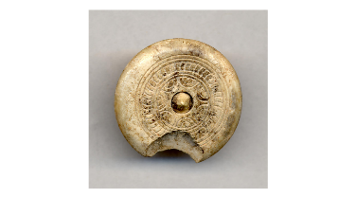  7.png
8 | The British Museum; 1897,0401.1389 |  | 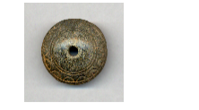  8.png
  Grey stone low conical spindle-whorl; ground and polished; hole drilled through centre; decorated with engraved semi-annules and bands; worn around narrow terminal and maximum diameter.
9 | The British Museum; 1897,0401.1370 |  | 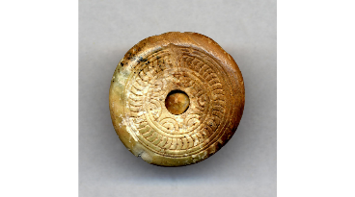  9.png
  Ivory (hippopotamus) spindle-whorl with the broken off tip of a spindle remaining in the centrally drilled hole; the spindle-whorl has a flat upper surface with convex sides and a concave underside; the flat face is decorated with carved concentric circles, a band of arcs and double annules on the interior; the preserved tip of the spindle is pointed; there is a chip missing from the underside of the whorl.
10 | The British Museum; 1897,0401.1366 |  | 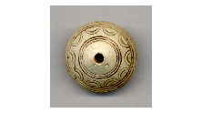  10.png
  Ivory (hippopotamus) spindle-whorl with one low conical and one flat face; centrally drilled hole; carved decoration on the conical face of double semi-annules between two bands of concentric circles.
11 | The British Museum; 1969,0701.17.+ | Bone spindle-whorl with one conical and one flat face; centrally drilled hole; undecorated; chipped at one edge. | 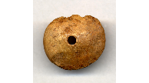  11.png
12 | The British Museum; 1897,0401.1388 |  | 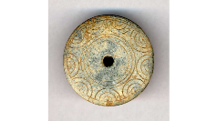  12.png
  Grey stone discoid spindle-whorl; ground; hole drilled through centre; decorated with engraved semi-annules and bands.
13 | The British Museum; 1897,0401.1391 |  | 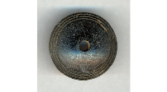  13.png
  Black stone low conical spindle-whorl; ground and polished; hole drilled through centre; decorated with engraved bands on conical face near exterior.
14 | The British Museum; 1897,0401.1418 |  | 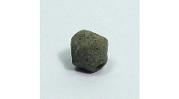  14.png
  Grey stone biconical spindle-whorl or bead; ground; hole drilled through centre; decorated with engraved annules; large chip at maximum diameter.
15 | The British Museum; 1897,0401.1432 | Black stone conical spindle-whorl; ground and polished; hole drilled through centre; decorated with engraved annules and bands; worn at both perforations and maximum diameter. | 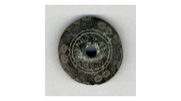  15.png
16 | The British Museum; 1897,0401.1392 | Grey stone conical spindle-whorl; ground with hole drilled through centre; decorated with deeply engraved bands. | 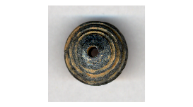  16.png
17 | The British Museum; 1969,0701.30 |  | 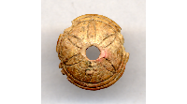  17.png
  Ivory (hippopotamus) spindle-whorl with one conical and one flat face; centrally drilled hole; carved decoration on the conical face of a six-petalled rosette in a double circle; edges damaged.
18 | The British Museum; 1897,0401.1393 |  | 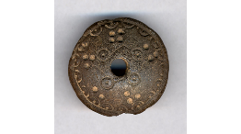  18.png
  Brown chlorite low conical spindle-whorl; ground and polished; hole drilled through centre; decorated with engraved annules, semi-annules, drilled dots, lines and a band on convex face; single engraved band on flat face; chipped at perforation and maximum diameter.
19 | The British Museum; 1897,0401.1363 |  | 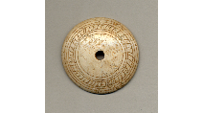  19.png
  Ivory (hippopotamus) spindle-whorl with one low conical and one flat face; centrally drilled hole; carved decoration on the conical face of a band of arcs between two bands of concentric circles.
20 | The British Museum; 1897,0401.1365 |  | 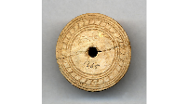  20.png
  Ivory (hippopotamus) spindle-whorl; disc-shaped, one face with rounded edges; centrally drilled hole; carved decoration on the convex face of a band of arcs between two bands of concentric circles; restored from two fragments.
21 | The British Museum; 1897,0401.1387 |  | 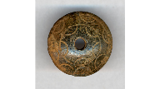  21.png
  Greenish-black stone low conical spindle-whorl; ground and polished; hole drilled through centre; decorated with engraved semi-circles and bands.
22 | The British Museum; 1897,0401.863 |  | 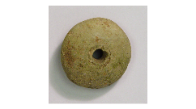  22.png
  Green clay centrally pierced biconical object; handmade; probably spindle-whorl or loom-weight; low-fired greenish clay; perforation not central.
23 | The British Museum; 1897,0401.1369 |  | 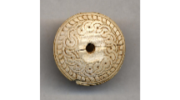  23.png
  Ivory (hippopotamus) spindle-whorl with one convex and one flat face; centrally drilled hole; carved decoration on the convex face of concentric circles, a band of arcs and a central cable pattern of double arcs and circles.
24 | The British Museum; 1897,0401.1409 | Chlorite biconical spindle-whorl; ground and polished; hole drilled through centre; small chips at either end. | 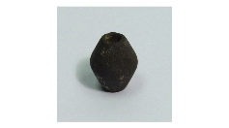  24.png
25 | The British Museum; 1897,0401.1364 | Ivory low conical spindle-whorl with centrally drilled perforation; incised with bands and semi-circles on convex face. | 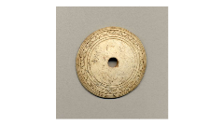  25.png
26 | The British Museum; 1897,0401.764 |  | 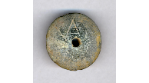  26.png
  Dark grey chlorite low conical spindle-whorl; ground and polished; hole drilled through centre; shallow parallel striations on flat side and radiating striations on conical side; conical face has engraved symbol, similar to a backwards ‘N’ with three parallel strokes intersecting the right-hand upright line; worn around narrow terminal and maximum diameter.
27 | The British Museum; 1897,0401.1390 |  | 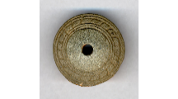  27.png
  Grey stone low conical spindle-whorl; ground; hole drilled through centre; decorated with engraved bands and cabling.
28 | The British Museum; 1897,0401.1407 |  | 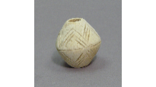  28.png
  Pottery biconical spindle-whorl; decorated with incised horizontal line at maximum diameter and sets of triple zig-zags above and below; completely desurfaced but probably originally Red Slip or Black Slip Ware; fabric pale cream.
29 | The British Museum; 1897,0401.1386 |  | 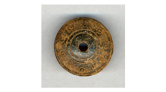  29.png
  Green stone low conical spindle-whorl; ground and polished; hole drilled through centre; decorated with engraved annules and bands; slight wear at narrow terminal and maximum diameter.
30 | The British Museum; 1969,0701.32 | Chlorite spindle-whorl; ground and polished with centrally drilled hole; one flat and one convex face; convex face decorated with engraved concentric circles and arcs. | 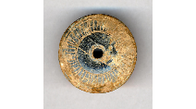  30.png
31 | The British Museum; 1897,0401.1406 | Chlorite biconical spindle-whorl; ground and polished; hole drilled through centre; small chips around hole at one end. | 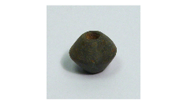  31.png
32 | The British Museum; 1897,0401.1403 |  | 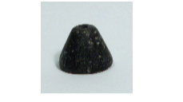  32.png
  Black stone conical spindle-whorl; ground; hole drilled through centre; chipped at maximum diameter.
33 | The British Museum; 1897,0401.1433 | Black stone low conical spindle-whorl; decorated with engraved semi-annules and bands; ground and polished; hole drilled through centre; worn around narrow terminal and outer edge. | 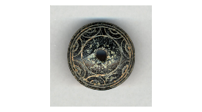  33.png

Reference List
Barber, E. 1991. Prehistoric Textiles. Chicherster: Princeton University Press.
Carter, T. 2007. ‘The Theatrics of Technology: Consuming Obsidian in the Early Cycladic Burial Area.’ In Archaeological Papers of the American Anthropological Association; Vol 17:1. Oakland, CA: University of California Press. Pp 88-107.
Crewe, L. 2007. ‘From lithograph to web: the British Museum’s 1896 Enkomi excavations’. Archaologia Cypria; Vol V: Pp 57-70.
Crewe, L. 2009. Feasting with the dead: Tomb 66 at Enkomi. In Kiely, T. (ed.), Ancient Cyprus in the British Museum: Essays in Honour of Veronica Tatton Brown, Trustees of the British Museum: London. Pp. 27-48.
Ergün, G. ‘Late Bronze Age Spindle Whorls and Loom Weights from Beycesultan in Western Anatolia: New Findings, New Observations. In Mediterranean Archaeology and Archaeometry; Vol 20, No. 2. [Accessed on http://maajournal.com/Issues/2020/Vol20-2/1_Ergun%2020(2).pdf] 20/03/2022. Pp 1-18.
Feldman, M. 2013. ‘The Art of Ivory Carving in the Second Millennium B.C.’ In Aruz, J., Graph, S.B., and Rakic, Y. (eds). Cultures in Contact: From Mesopotamia to the Mediterranean in the Second Millennium B.C. New York: The Metropolitan Museum of Art. Pp 248-257.
Hahn, H. P. 2004. ‘Global Goods and the Process of Appropriation’ In Probst, P and Spittler, G (eds). Between Resistance and Expansion: Dimensions of Local Vitality in Africa. Munster: LIT. Pp 213-231.
Kania, K. 2013 ‘ The Spinning Experiment: influences on yarn in spinning with a hand spindle’ In Hopkins, H. (ed). Ancient Textiles, Modern Science. Oxford: Oxbow Books. Pp 11-29.
Lucas, L., and Fuller, D. 2020. ‘Against the Grain: Long-Term Patterns in Agricultural Production in Prehistoric Cyprus’ https://doi.org/10.1007/s10963-020-09140-6.
Mountjoy, P.A. 2005. ‘The End of the Bronze Age at Enkomi, Cyprus: The Problem of Level III B.’ In The Annual of the British School at Athens; Vol 100 Centennial Volume. Athens: British School at Athens. Pp 125-214.
Murray, A., Smith, A. and Walters, H. 1900. Excavations in Cyprus, British Museum, London.
Sauvage, C. 2013. ‘Spinning from Old Threads: The Whorls from Ugarit in the Musée d'Archéologie Nationale and the Louvre Museum’ In Koefoed, H (ed) Textile Production in the Ancient Near East: Archaeology, Epigraphy, Iconography. Oxofrd: Oxbow Books. Pp 189-214.
Spinazzi-Lucchesi, C. 2018. The Unwound Yarn: Birth and Development of Textile Tools Between Levant and Egypt. Edizioni Ca’ Foscari, Venezia.
Stockhammer, P. 2011. ‘Conceptualizing Cultural Hybridization in Archaeology.’ In Stockhammer, P (ed). Conceptualizing Cultural Hybridization: A Transdisciplinary Approach. London: Springer. Pp 43-58.
Vakirtzi, S. 2013. ‘The Decorated Spindle-Whorls from Prehistoric Akrotiri, Thera.’ In Papadopoulos, A (ed). TALANTA: Proceedings of the Dutch Archaeological and Historical Society; Vol XLIV. [Accessed on http://www.talanta.nl/wp-content/uploads/2015/02/TAL-44-NAHG-H12.pdf] 20/03/2022. Pp 227–244.

