Chronic Heart Failure in the United Kingdom: A Critical Evaluation of Disease Burden, Holistic Care and Evidence-Based Long-Term Condition Management
Name:Yamasanga Mbembo
Student ID:2313662
Module code:LCHS7003
Assignment title:information booklet of longer term condition management

Table of Contents
1. Introduction 2
2. Clinical Overview, Epidemiology and Aetiology of Chronic Heart Failure 2
2.1 Definition, Pathophysiology and Clinical Classification 2
2.2 Global and UK Epidemiology and Disease Burden 3
2.3 Aetiology and Associated Risk Factors 4
3. Biopsychosocial and Familial Impacts of Chronic Heart Failure 4
3.1 Physical Consequences and Functional Limitations 5
3.2 Psychological Consequences and Emotional Well-Being 5
3.3 Social Consequences and Health Inequalities 6
3.4 Impact on Family Members and Informal Carers 6
4. Evidence-Based Treatment and NHS Management of Chronic Heart Failure 7
4.1 Pharmacological Management and Clinical Effectiveness 7
4.2 Non-Pharmacological and Rehabilitative Interventions 9
4.3 Multidisciplinary NHS Care and Service Coordination 10
5. Theoretical Models and Frameworks for Long-Term Condition Management 10
5.1 The NHS House of Care Framework: A UK Perspective 10
5.2 The Chronic Care Model: An International Perspective 11
5.3 Comparative Evaluation of the Two Models 12
6. Critical Evaluation of UK Health and Social Care Policies 13
6.1 National Policy and Clinical Guidance for Heart Failure Management 13
6.2 Local Integrated Care Systems and Community-Based Service Delivery 13
6.3 Policy Implementation, Health Inequalities and Service Improvement 14
7. Recommendations for Person-Centred Care, Self-Management and End-of-Life Support 14
7.1 Strengthening Personalised and Shared Decision-Making 14
7.2 Improving Self-Management Education and Digital Support 15
7.3 Enhancing Multidisciplinary and Community-Based Coordination 15
7.4 Integrating Palliative and End-of-Life Care 15
8. Conclusion 16
Reference List 17

1. Introduction
Chronic heart failure (CHF) is a major public health problem with chronic symptoms, functional impairment and a higher likelihood of hospitalisation and early mortality. It's not just a cardiovascular condition that needs to be managed; psychological wellbeing is important, as are social inequalities and the role of family caregivers. While there have been advances in therapy and associated outcomes, the management of the disease remains difficult, due to a lack of effectively integrated healthcare delivery and access to specialist services (McDonagh et al., 2023; NICE, 2025a).
This booklet critically appraises CHF in the UK health service setting, looking at both the epidemiology and the biopsychosocial impact and evidence-based treatment for CHF. It also reviews models of long-term condition management practised in the United Kingdom and internationally, national and local healthcare strategies and suggestions for integrated, person-centred care.

2. Clinical Overview, Epidemiology and Aetiology of Chronic Heart Failure

2.1 Definition, Pathophysiology and Clinical Classification
Heart failure is a clinical syndrome which occurs when there are structural or functional changes in the heart that result in the inability of the ventricles to fill or eject blood. Symptoms include shortness of breath, tiredness, peripheral oedema and decreased exercise capacity. Initially, an increase in neurohormonal activation and fluid retention may compensate for poor cardiac performance, but over time, this worsens (McDonagh et al., 2023).
Heart failure with reduced ejection fraction (HFrEF: ≤40%), mildly reduced ejection fraction (HFmrEF: 41-49%) and preserved ejection fraction (HFpEF: ≥ 50%). These are used as categories to help guide treatment, but do not account for the complexity of symptoms, comorbidities or prognosis. The diagnosis of HFpEF should not be based on symptoms alone or EF, because there is objective evidence of structural or functional cardiac abnormalities (McDonagh et al., 2023).
Table 1. Clinical Classification of Chronic Heart Failure
Classification | Left Ventricular Ejection Fraction (LVEF) | Clinical Characteristics
Heart Failure with Reduced Ejection Fraction (HFrEF) | ≤40% | Impaired ventricular systolic function; substantial evidence supports disease-modifying pharmacotherapy.
Heart Failure with Mildly Reduced Ejection Fraction (HFmrEF) | 41–49% | Mildly reduced systolic function; some treatments used for HFrEF also offer clinical benefits.
Heart Failure with Preserved Ejection Fraction (HFpEF) | ≥50% | Symptoms and signs of heart failure with objective evidence of relevant structural or functional cardiac abnormalities or raised filling pressures.

2.2 Global and UK Epidemiology and Disease Burden
The burden of heart failure is significant on an international level. In 2017, the Global Burden of Disease estimated that there were about 64.3 million people with HF, which is an increase from 1990 in absolute numbers (Bragazzi et al., 2021). However, historical estimates do not necessarily reflect current prevalence, and variations in classification and surveillance methods make comparisons between different countries difficult.
The British Heart Foundation cardiovascular statistics in the UK show it is still a significant burden due to cardiovascular conditions, including the need for hospital services, treatment and public resources (British Heart Foundation, 2025). This burden is especially important considering an elderly population in the context of multimorbidity.
Importantly, however, higher case numbers do not necessarily reflect declines in prevention. This may be due to the ageing of the population, better survival rates from cardiovascular disease and better diagnosis. This becomes important when considering the epidemiology and planning for NHS services. The inequities that persist further indicate that merely having access to treatment does not necessarily result in equitable healthcare outcomes.
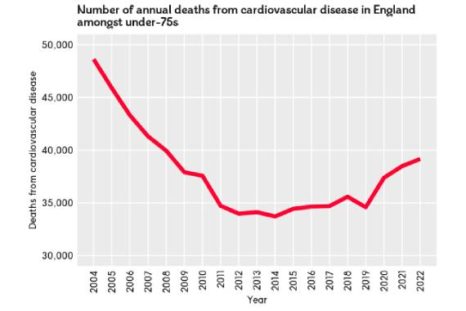
Fig 1. Cardiovascular disease prevalence and distribution across the United Kingdom.
Source: British Heart Foundation (n.d.).

2.3 Aetiology and Associated Risk Factors
Some of the most common causes of CHF are coronary artery disease, hypertension, valvular disorders and cardiomyopathies. Diabetes, obesity, chronic kidney disease and atrial fibrillation frequently complicate its development and management (Heidenreich et al., 2022).
In addition to the nonmodifiable determinants (age, inherited susceptibility), there are modifiable factors (smoking, hypertension, physical inactivity). But there are no individual lifestyle accounts. Cardiovascular diseases are influenced by poverty, the difficulties faced in accessing preventive services and socioeconomic disadvantage, which means that they can be affected by factors outside of the healthcare system (NHS England, n.d.-a).
Therefore, individual risk reduction and population-based approaches are needed to successfully prevent cardiovascular disease.

3. Biopsychosocial and Familial Impacts of Chronic Heart Failure
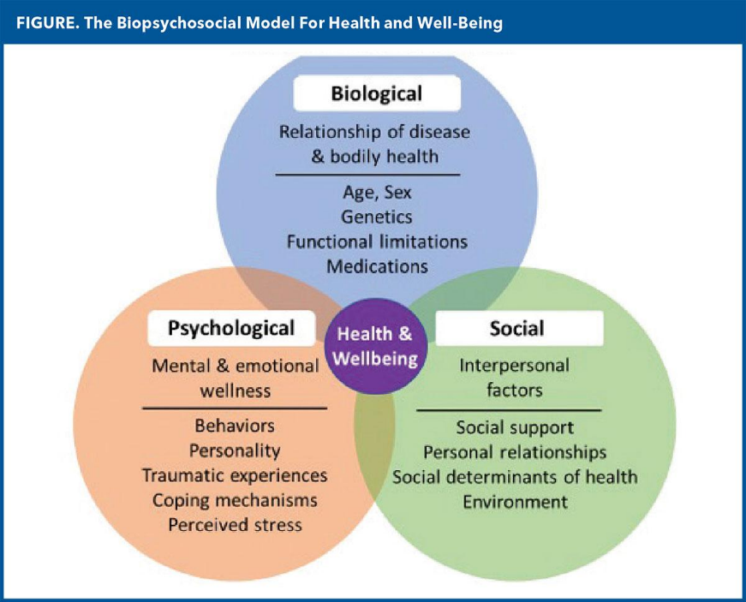
Figure 2. The interactive biopsychosocial model illustrating the relationships between physical, psychological and social determinants of health.
Source: Synthesis of Scientific Disciplines in Pursuit of Health: The Interactive Biopsychosocial Model.

3.1 Physical Consequences and Functional Limitations
Dyspnoea, fatigue, fluid retention and loss of physical capacity can significantly impact the ability of a person to perform daily activities due to CHF. Walking, household and personal care activities can become more difficult, impacting independence and quality of life. Deterioration can be recurrent, requiring admission to hospital and adding to deconditioning (Molloy et al., 2024).
However, cardiac measurements do not necessarily reflect disease severity. There are significant differences in functional limitation in patients with similar EF. Frailty, renal impairment, and other comorbidities make treatment more challenging, and treatments should not be based solely on disease classification (NICE, 2025a).

3.2 Psychological Consequences and Emotional Well-Being
Experiencing symptoms that are unpredictable will create anxiety and uncertainty and a lack of confidence in self-management. Depression and emotional distress can also affect motivation, adherence to medications and participation in rehabilitation. These can exacerbate physical constraints, thus worsening health and activity (McDonagh et al., 2021).
While pharmacological therapy is a core component of the treatment of CHF, improvements in survival do not mean that psychological suffering has been eradicated. A narrow biomedical focus could therefore ignore distress due to repeated hospitalisation, dependency and fear of worsening.
Improved assessment of psychological needs, ongoing support for communication with the patient and suitable referrals to mental health professionals should therefore be part of cardiovascular care (NHS England, 2023).

3.3 Social Consequences and Health Inequalities
CHF can impact employment, social relations and financial autonomy. Being unable to move around and getting tired can limit social activities, and transportation expenses and multiple visits can be burdensome.
These challenges are unevenly distributed. There may be more barriers for people in deprivation to receive healthcare, to have a proper diet or to rehabilitate themselves. NHS England's approach of Core20PLUS5 acknowledges the role of focusing on those who have a greater health disadvantage within health services (NHS England, n.d.-b).
But acknowledgements of inequality in policy are not necessarily eradication of inequality. If there are no available appointment systems, flexible services and/or appropriate community support, then interventions could be more successful for individuals who can access health care.

3.4 Impact on Family Members and Informal Carers
Often family members are involved in medication management, symptom checking, transportation and emotional support. The involvement can allow for continuity of care and can result in physical fatigue, financial hardship, and psychological stress.
In a systematic review of 30 studies, physical, psychological and social factors were identified that were associated with caregiver burden in heart failure (Heart Failure Caregiver Burden and Outcomes, 2022). Xu et al. (2023) also depict through their qualitative research how caregivers' duties and feelings of isolation can coexist.
The results contradict models that view family members simply as a means of handling patients. The needs of carers are not necessarily the same as their clinical needs and are often overlooked when professionals focus solely on clinical outcomes. Therefore, education, emotional support and appropriate involvement in care planning are required, with respect for the choices and confidentiality of patients.

4. Evidence-Based Treatment and NHS Management of Chronic Heart Failure

4.1 Pharmacological Management and Clinical Effectiveness
Evidence-based pharmacotherapy is fundamental to improving outcomes, although recommended combinations vary according to heart failure phenotype.
Table 2. Evidence-Based Pharmacological Management of Chronic Heart Failure
Heart Failure Classification | NICE-Recommended Treatment Approach | Key Clinical Considerations
HFrEF | Offer an ACE inhibitor, beta-blocker, MRA and SGLT2 inhibitor. Consider switching the ACE inhibitor to an ARNI if symptoms persist despite maximally tolerated treatment. | Monitor renal function, electrolytes, blood pressure and treatment tolerability.
HFmrEF | Consider an ACE inhibitor, beta-blocker, MRA and SGLT2 inhibitor. | Tailor treatment to clinical characteristics, comorbidities and medicine tolerability.
HFpEF | Consider an MRA and SGLT2 inhibitor. | Address associated comorbidities and monitor treatment suitability and adverse effects.
NICE (2025a) recommends offering an ACE inhibitor, evidence-based beta-blocker, mineralocorticoid receptor antagonist (MRA) and sodium-glucose cotransporter-2 (SGLT2) inhibitor for HFrEF. Replacing an ACE inhibitor with an angiotensin receptor-neprilysin inhibitor is an option when symptoms fail to improve with the highest tolerated dose of the ACE inhibitor. In cases of intolerance, alternative combinations are recommended.
In HFrEF, irrespective of diabetes status, the DAPA-HF trial showed that dapagliflozin was effective in reducing the risk of worsening HF or CV death (McMurray et al., 2019). The EMPEROR-Preserved and DELIVER trials then further reinforced the use of SGLT2 inhibitors in those with an ejection fraction exceeding 40% (Anker et al., 2021; Solomon et al., 2022).
Enhancements in the composite endpoints should not be viewed as comparable decreases in each component endpoint, however. In EMPEROR-Preserved, the most significant advantage was the decrease in heart failure hospitalisation, not the reduction in cardiovascular death.
The updated NICE guidance also suggests that medicines for HFmrEF and an MRA should also be considered for HFpEF in addition to an SGLT2 inhibitor. Blood pressure, renal function, potassium levels and tolerability of the individual should be assessed when deciding on treatment (NICE, 2025a; NICE, 2025b). This underlines the balance between optimisation of guidelines and practicality in frail patients with multimorbidity.

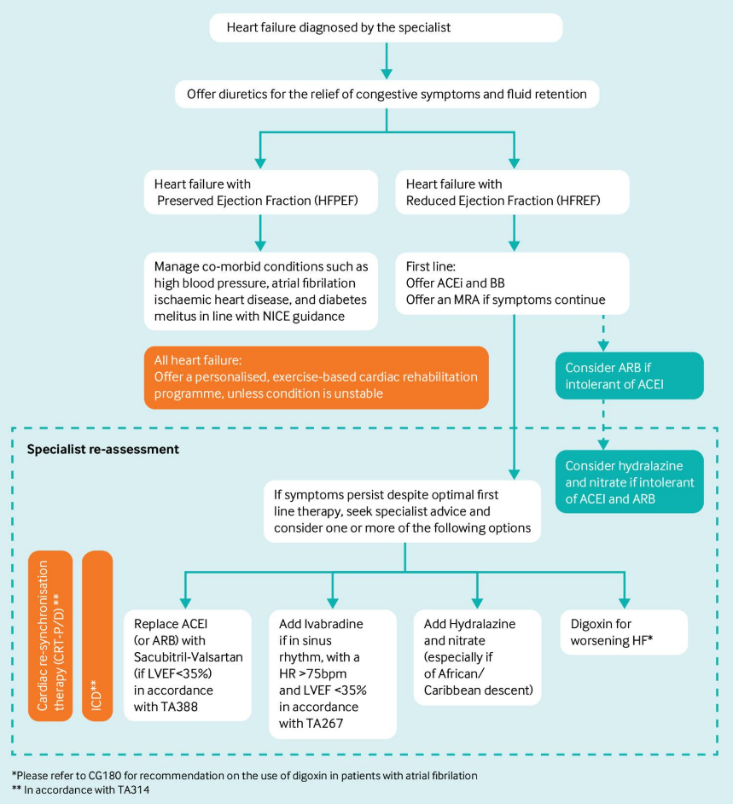
Fig 3. Evidence-based core pharmacological treatments for chronic heart failure according to ejection fraction classification.
Source: NICE (2025).

4.2 Non-Pharmacological and Rehabilitative Interventions
Cardiac rehab is a valuable adjunct to drug therapy. A Cochrane review concluded that rehabilitation is likely to decrease hospital admissions and improve health-related quality of life, but the evidence of a reduction in all-cause mortality is unclear (Molloy et al., 2024).
This was also noted in a review of the under-representation of older adults, women, and those with HFpEF. Thus, results must not be blindly assumed for all groups of patients.
Other interventions include providing the appropriate kind of exercise, smoking cessation, nutrition advice and health education about worsening symptoms. However, dietary and fluid advice should be tailored to each person, not given as blanket advice (NICE, 2025a).

4.3 Multidisciplinary NHS Care and Service Coordination
NHS management requires collaboration between cardiologists, heart failure nurses, general practitioners, pharmacists and the community. Medication monitoring and coordinated review, specialist multidisciplinary assessment (NICE, 2025a).
Appropriate prescribing and monitoring is also a quality expectation laid out in Quality Standard QS9 (NICE, 2025b). However, clinical guidance is not sufficient to ensure effective implementation. Treatment optimisation could be delayed due to workforce pressures, limited capacity in the community and poor communication.
The benefits of intensive follow-up after hospitalisation support the critical need for coordinated, transitional care (McDonagh et al., 2023). Hence, services need to be effective and involve prompt specialist services and long-term primary and community services.

5. Theoretical Models and Frameworks for Long-Term Condition Management

5.1 The NHS House of Care Framework: A UK Perspective
The NHS House of Care framework encourages partnership working in the care and support planning of individuals with long-term conditions. Its principles focus on the informed patient, the professional healthcare user, supportive organisational processes and the appropriate community resources (Coulter et al., 2016).
This framework helps engage in individual conversations about treatment goals, monitoring symptoms, daily functioning and family engagement for CHF. It goes beyond the treatment plans that are professionally determined and allows for consideration of the patient's priorities and preferences.
Strengths are its integration of clinical management and other areas of life. But to be involved means time, information and continuity of professional relationships. Cognitive impairment, language barriers or limited health literacy may necessitate extra support for a patient.
In addition, it is not by itself enough to ensure collaborative planning is in place. Patient involvement and the ways in which this is achieved practically are still key (NHS England, 2018).
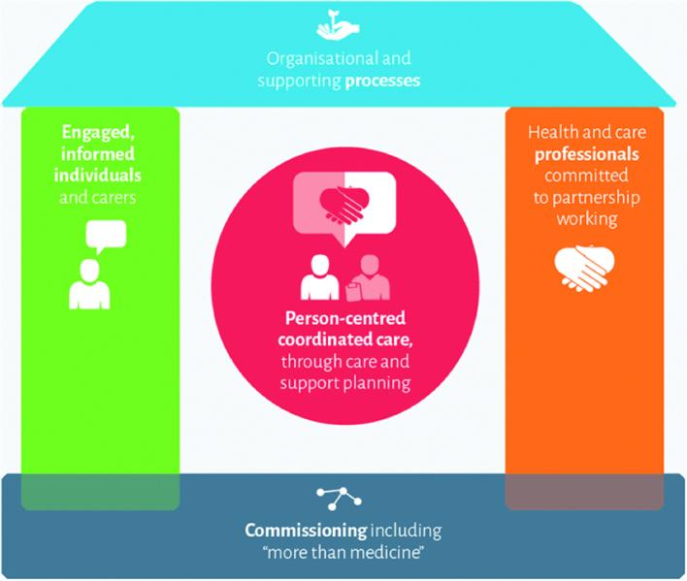
Fig 4: The House of Care framework for person-centred and coordinated long-term condition management. Source: British Heart Foundation (n.d.).

5.2 The Chronic Care Model: An International Perspective
The Chronic Care Model (CCM) developed by Wagner (2002) is a conceptual approach to enhancing the management of LTC in the context of six interacting elements: healthcare organisation, community resources, self-management support, design of the delivery system, decision support, and clinical information systems.
When applied to CHF, the CCM upholds planned multidisciplinary reviews, guideline-based treatment, patient education and systematic monitoring. Self-management support can help to identify earlier deterioration; clinical information systems can identify individuals who need intervention.
The systematic review of chronic care approaches suggests some potential improvements in healthcare processes and outcomes, but the interventions vary widely in their design and implementation (Effectiveness of Chronic Care Models, 2015).
This variability restricts the view that the use of the model will automatically lead to a decrease in hospitalisation or death. It is effective depending on the characteristics of the local population, accessible technology, and staff training and organisational capacity.
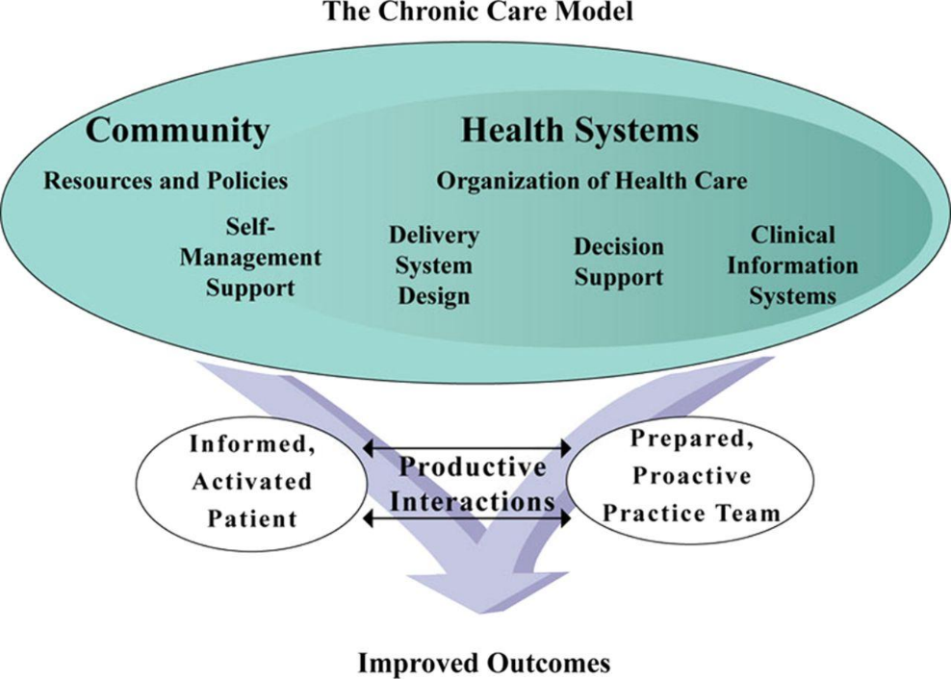
Fig 5. The Chronic Care Model illustrating the relationship between health systems, community resources and productive patient-provider interactions.
Source: Wagner (1998), reproduced in the linked research article.

5.3 Comparative Evaluation of the Two Models
Both models acknowledge the need for long-term care management to be actively managed, coordinated and involving the patient. But the House of Care emphasises collaborative planning and individual priorities, while CCM offers a more general organisational structure for systematic service redesign.
Their combined use could be particularly beneficial: the House of Care can support individualised goals and CCM principles can enhance follow-up, data exchange and proactive management for CHF.
However, both models alone do not address health inequities or gaps in the workforce. They can be useful if there is the right funding, evaluation and implementation in place within the existing NHS structures.

6. Critical Evaluation of UK Health and Social Care Policies

6.1 National Policy and Clinical Guidance for Heart Failure Management
There are significant benchmarks for diagnosis, pharmacological optimisation, specialist review and rehabilitation in NG106 and QS9 of NICE guidelines for England (NICE, 2025a and NICE, 2025b).
The revisions reflect the changing therapeutic evidence and respond to clinical research. However, local service capacity and compliance with national guidance will influence how effective the guidance is.
NHS England's personalised care strategy supports the approach to shared decision-making, co-ordinated support planning and engagement (NHS England, 2023). Meanwhile, Core20PLUS5 provides the framework for focused action on inequalities in health care (NHS England, n.d.-b).
While these initiatives provide complementary priorities, the limited resources and unequal service provision can impede the translation of these into measurable improvements. Treatment uptake, patient experience, and outcomes should therefore be considered in assessing a policy rather than published commitments.

6.2 Local Integrated Care Systems and Community-Based Service Delivery
A relevant example of integrated CHF service development is Greater Manchester. It has a Joint Forward Plan that highlights heart failure diagnostics and standardised digital care planning and remote monitoring. It also has an ambition to reach 33% of eligible newly diagnosed patients to undertake personalised cardiac rehabilitation by 2028/29 (Greater Manchester Integrated Care Partnership, n.d.).
The region's heart failure digital care-plan program aims to facilitate better information sharing and community care co-ordination. Consistent practice is also supported by a local clinical toolkit (Greater Manchester Medicines Management Group, 2026).
But the implementation of digital pathways is not an indicator of effectiveness if a proper evaluation system is not in place. New challenges can arise where patients don't have access to the internet or have a lack of digital confidence, and this can lead to an extra burden for the workforce with an increase in monitoring.

6.3 Policy Implementation, Health Inequalities and Service Improvement
Greater Manchester's integrated approach provides opportunities for earlier intervention, more consistent monitoring and less care fragmentation. Digital heart failure pathways show encouraging lower numbers of admissions across the local area, but results from selected groups of patients should be interpreted with caution (University of Manchester, n.d.).
As a result, assessments should include clinical outcomes and equity, affordability and patient experience. A coordinated pathway can be effective at making services more efficient but not necessarily at providing equitable services to disadvantaged groups.
This requires a systematic process of monitoring inequitable access, workforce sustainability and quantifiable patient outcomes that support the national standards and local innovation.

7. Recommendations for Person-Centred Care, Self-Management and End-of-Life Support

7.1 Strengthening Personalised and Shared Decision-Making
Individualised care and support plans should include clinical needs, treatment preferences and emotional and personal circumstances. Structured discussions should not only address biomedical indicators, but should also include patient goals.
Applying this approach can be done using the House of Care framework and NHS personalised planning guidance (Coulter et al. 2016; NHS England 2023). Where appropriate and with the patience of the family, participation should be encouraged.
Patients' understanding and involvement in decision-making should be evaluated in service evaluation, not just the documentation.

7.2 Improving Self-Management Education and Digital Support
Medication and symptom monitoring and appropriate activity and recognising deterioration should be accessible educated to healthcare professionals. Instructions should be customised to health literacy, language and the person's capability.
An umbrella review of heart failure self-care interventions indicates that interventions involving education and psychological support with telehealth may be more effective than stand-alone interventions (Effectiveness of Interventions to Improve Heart Failure Self-care, 2025).
However, remote monitoring should not be used in lieu of proper clinical contact. There should be ways of offering alternatives for patients who are digitally excluded, and clear escalation procedures should be in place.

7.3 Enhancing Multidisciplinary and Community-Based Coordination
Communication between heart failure nurses, social care professionals, pharmacists, general practice and hospital specialists needs to be a key priority for integrated services.
Post-discharge clinical review and proper allocation of professional responsibility, along with medication reconciliation, can help eliminate unnecessary discontinuities in care. These priorities are in accordance with the importance of co-ordinated service delivery within NICE guidance (NICE, 2025a) and international heart failure recommendations (McDonagh et al., 2023).
Monitoring of implementation should be done by checking referral completion, optimisation of treatment and patients' experience.

7.4 Integrating Palliative and End-of-Life Care
Palliative care should be integrated into the care of patients based on their needs and not only at the end of CHF. The goal of its use is symptom relief, psychological support, advance care planning and family involvement (Rogers et al., 2017).
The Heart Failure Association believes that supportive care should be implemented across the disease course, as there is no certainty about progression or treatment goals change (Sobanski et al., 2020).
Patients with advanced disease should be given opportunities to consider preferences, limitations of treatment and future care, and continue to be offered access to appropriate disease-modifying treatment. These discussions need to be sensitive, voluntary and regularly audited.

8. Conclusion
Chronic HF is a multi-faceted chronic condition that introduces many clinical, psychological, social and family problems. Appropriate implementation of evidence-based medicines and cardiac rehab is associated with better outcomes, while continued access to medically coordinated services is essential for their benefits.
The NHS House of Care framework and Chronic Care Model from abroad are complementary models of personalised planning and systematic service improvement. There are opportunities to improve the management of CHF healthcare across the country and through Greater Manchester's integrated approach, but inequalities, workforce shortages and digital exclusion are significant issues.
In conclusion, to achieve improvements in outcomes, an integrated approach is needed that integrates clinical effectiveness with meaningful patient engagement, family support, timely palliative care, and equitable community palliative care services.

Reference List
Anker, S.D. et al. (2021) ‘Empagliflozin in heart failure with a preserved ejection fraction’, New England Journal of Medicine, 385(16), pp. 1451–1461. Available at: https://doi.org/10.1056/NEJMoa2107038
Bodenheimer, T., Wagner, E.H. and Grumbach, K. (2002a) ‘Improving primary care for patients with chronic illness’, JAMA, 288(14), pp. 1775–1779. Available at: https://doi.org/10.1001/jama.288.14.1775
Bodenheimer, T., Wagner, E.H. and Grumbach, K. (2002b) ‘Improving primary care for patients with chronic illness: The Chronic Care Model, Part 2’, JAMA, 288(15), pp. 1909–1914. Available at: https://doi.org/10.1001/jama.288.15.1909
Bragazzi, N.L. et al. (2021) ‘Burden of heart failure and underlying causes in 195 countries and territories from 1990 to 2017’, European Journal of Preventive Cardiology, 28(15), pp. 1682–1690. Available at: https://doi.org/10.1093/eurjpc/zwaa147
British Heart Foundation (2025) Cardiovascular Disease Statistics 2025. Available at: https://www.bhf.org.uk/what-we-do/our-research/heart-statistics/heart-statistics-publications/cardiovascular-disease-statistics-2025
Coulter, A., Kramer, G., Warren, T. and Salisbury, C. (2016) ‘Building the House of Care for people with long-term conditions: The foundation of the House of Care framework’, British Journal of General Practice, 66(645), pp. e288–e290. Available at: https://doi.org/10.3399/bjgp16X684745
Greater Manchester Integrated Care Partnership (n.d.) Joint Forward Plan. Available at: https://gmintegratedcare.org.uk/greatermanchester-icp/icp-strategy/joint-forward-plan/
Greater Manchester Integrated Care Partnership (n.d.) Improving health and care in Greater Manchester. Available at: https://gmintegratedcare.org.uk/greatermanchester-icp/icp-strategy/improving-health-and-care-in-greater-manchester/
Greater Manchester Integrated Care Partnership (n.d.) Greater Manchester Integrated Care Partnership strategy. Available at: https://gmintegratedcare.org.uk/greatermanchester-icp/icp-strategy/
Greater Manchester Medicines Management Group (2026) Clinical guidance and pathways: Heart failure toolkit. Available at: https://gmmmg.nhs.uk/guidance/clinical-guidance-and-pathways/
McDonagh, T.A. et al. (2023) ‘2023 focused update of the 2021 ESC Guidelines for the diagnosis and treatment of acute and chronic heart failure’, European Heart Journal, 44(37), pp. 3627–3639. Available at: https://doi.org/10.1093/eurheartj/ehad195
McMurray, J.J.V. et al. (2019) ‘Dapagliflozin in patients with heart failure and reduced ejection fraction’, New England Journal of Medicine, 381(21), pp. 1995–2008. Available at: https://doi.org/10.1056/NEJMoa1911303
Molloy, C. et al. (2024) ‘Exercise-based cardiac rehabilitation for adults with heart failure’, Cochrane Database of Systematic Reviews, 2024(3), CD003331. Available at: https://doi.org/10.1002/14651858.CD003331.pub6
NHS England (2018) Making it happen: Personalised care and support planning. Available at: https://www.england.nhs.uk/publication/making-it-happen-personalised-care-and-support-planning/
NHS England (2023) Personalised care and support planning: A brief summary guide. Available at: https://www.england.nhs.uk/long-read/personalised-care-and-support-planning-a-brief-summary-guide/
NHS England (2026) Providing proactive care for people living in care homes: Enhanced health in care homes framework. Available at: https://www.england.nhs.uk/long-read/providing-proactive-care-for-people-living-in-care-homes-enhanced-health-in-care-homes-framework/
NHS England (n.d.-a) About the prevention programme. Available at: https://www.england.nhs.uk/ourwork/prevention/about-prevention-programme/
NHS England (n.d.-b) Core20PLUS5 (adults): An approach to reducing healthcare inequalities. Available at: https://www.england.nhs.uk/about/equality/equality-hub/national-healthcare-inequalities-improvement-programme/core20plus5/
NHS England (n.d.-c) Comprehensive model of personalised care. Available at: https://www.england.nhs.uk/personalisedcare/comprehensive-model-of-personalised-care/
NHS England (n.d.-d) Personalised care and support planning. Available at: https://www.england.nhs.uk/personalisedcare/pcsp/
National Institute for Health and Care Excellence (NICE) (2025a) Chronic heart failure in adults: Diagnosis and management. NG106. Available at: https://www.nice.org.uk/guidance/ng106
National Institute for Health and Care Excellence (NICE) (2025b) Chronic heart failure in adults. Quality Standard QS9. Available at: https://www.nice.org.uk/guidance/qs9
National Institute for Health and Care Excellence (NICE) (2025c) Chronic heart failure in adults: Diagnosis and management. Rationale and impact. Available at: https://www.nice.org.uk/guidance/ng106/chapter/Rationale-and-impact
National Institute for Health and Care Excellence (NICE) (2025d) Chronic heart failure in adults: Resource impact summary report. Available at: https://www.nice.org.uk/guidance/ng106/resources/resource-impact-summary-report-15434371117
National Institute for Health and Care Excellence (NICE) (2015) Acute heart failure: Organisation of care, early specialist input. QS103. Available at: https://www.nice.org.uk/guidance/qs103/chapter/Quality-statement-3-Organisation-of-care-early-specialist-input
Oberfrank, N.d.C.F. et al. (2026) ‘Effectiveness of interventions to improve heart failure self-care: An umbrella review of systematic reviews’, Journal of Cardiovascular Nursing, 41(4), pp. E133–E170. Available at: https://doi.org/10.1097/JCN.0000000000001253
Rogers, J.G. et al. (2017) ‘Palliative care in heart failure: The PAL-HF randomized, controlled clinical trial’, Journal of the American College of Cardiology, 70(3), pp. 331–341. Available at: https://doi.org/10.1016/j.jacc.2017.05.030
Sobanski, P.Z. et al. (2020) ‘Integration of a palliative approach into heart failure care: A European Society of Cardiology Heart Failure Association position paper’, European Journal of Heart Failure, 22(12), pp. 2327–2339. Available at: https://doi.org/10.1002/ejhf.1994
Solomon, S.D. et al. (2022) ‘Dapagliflozin in heart failure with mildly reduced or preserved ejection fraction’, New England Journal of Medicine, 387(12), pp. 1089–1098. Available at: https://doi.org/10.1056/NEJMoa2206286
Xu, M., Ruan, T., Luo, Z., Sun, L., Zhu, L. and Hu, S. (2023) ‘Empowered but isolated: A qualitative research on experiences of family caregivers of patients with acute heart failure in China’, Journal of Cardiovascular Nursing, 38(6), pp. 546–554. Available at: https://doi.org/10.1097/JCN.0000000000000990

