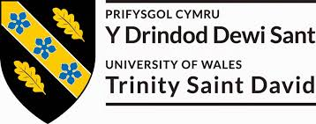
2020
Mark S Rogers 1907288
Academic Reflective Report
5/5/2020
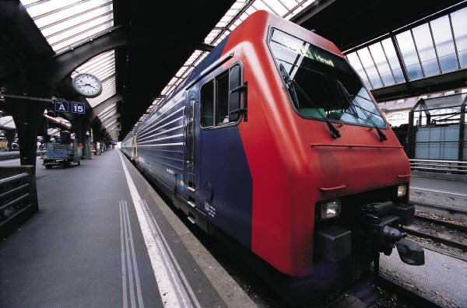
Academic and Employability Skills (BMSW 4001) MD Kalam

Table of content

Introduction 3
Aims 3
Why reflection? 4
Description 5
My feelings 6
Evaluation 6
Strength 6
Weakness 7
Description 7
My feeling 7
Evaluation 7
Analysis 8
Conclusion 9
Action plan PDP 11
Discussion 12
Conclusion 13
Reference 14
Works Cited 14

Introduction
This paper briefly introduces my personal reflection on the experiences I have Learned in both term 1 and term 2 of my Academic journey on health and Social Care from where I started to where I am now. Reflecting on the changes that occurred during my studies from classroom based learning to virtual learning environment couple with some mistakes and difficulties alone the way.

Aims
The aim of this reflection report is to make an honest and self evaluation about my learning style during this Academic year journey. It let me evaluate my learning style during this academic journey, taken into account what I have learned, couple with mistakes and difficulties during this journey and what would I have done differently if I am to do it all over again, Areas needed to be improved, draw analysis and conclusion from this reflection.
The expected outcome of this report is to reflect my Learning style and to prepare me to use the skills and knowledge that I have learned on this journey and used it on the job market. At the end of this certificate program, I would love to continue my academic journey in mental health nurse.

Why reflection?
In Educational perspective reflection is part of a learning process. As human we reflect on everything that we do from learning to relationship or our lives as a whole. Reflection is a type of learning and thinking process, finding ways on where you need an improvement. As human, we reflect in order to learn from a given situation. Reflection can be refer to as “thinking about individual mental processes from first person point of view” (Kornblith 2012: 28), many argument are seen as observation from the past of their mental state of mind such as habits and dispositions (Doris, 2015.)
However for this assignment, I have evaluated all four model of reflection and I gained immense knowledge about their reflective models such as:
- Kolb model
- Schon model
- John Gibbs model
- Honey and Mumford
I have decided to use John Gibbs model of reflection because it is the most popular and simplest method of learning. Making a honest assessment of yourself, realising your strengths, weakness and areas needed to be improved. The model includes six (6) stages of reflection which are shown in a diagram below.
On the other hand, Kolb model of reflection is wholly based on experimental learning theory. Kolb model is based on four-stage cycle of learning and four separate learning style which includes experience, perception, cognition and behaviour this type of learning. This style of learning process does not work for me but rather John Gibbs theory of learning process is a perfect match for me. I will be using this diagram in a given context in this report as I progresses.

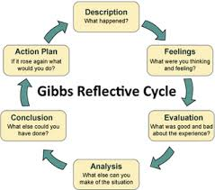

From my findings Gibbs cycle of reflective model practice is been acknowledge in a Nursing Diploma Program curriculum by MOH, Oman. Gibbs model of reflection demand once to think systematically about different aspect of experience and offers a straightforward structure for student thought (Jayasree, 2013)

Description
Going back to school was a long thought ideal for a change of career development in mental health nurse. This decision was not taken lightly after having left school for a long time. It was a decision based on the feature plan that I have set for myself. Full with passion and enthusiasm I hit the road to the University of Wales Trinity Saint David for admission. It turned out not as easy as I thought. I was too enthusiastic the fact of being studying in a University at this time. I was also overwhelmed filled with pride fu for having taken the first step to a university something I have long for ever since. I can still imagine my first day in the university campus taken pictures and making new friends I was excited. We began lectures the next day the lecturers were professional explained the course structure to us, it was at this time reality start to sink in. The inner conversations start how can you study and work at the same time? Why not just continue with work? Why school, why do you want to take a loan at this time?

My feelings
Presently I am now in second semester of my education journey it has not been easy but through hard work and dedication I am now in the second semester of my journey busy writing a reflection about this remarkable journey and at the end of day earning my certificate.

Evaluation
I started this journey with little knowledge but for the past two semesters I have gained immense knowledge, skills which I hadn’t learned before I started studying. I have also learned skills that will prepared me for the job market such as academic writing skills, paraphrasing, listening skills and Time management skills

Strength
My strength is that I have a good communication skills, can easily engage someone in a straight forward conversation and I speak fluent English in both written and oral. As a care worker, it is very essential to be fluent in English because you need to engage client in a conversation and writing a daily report, care plan etc.
I am also good in working with people I see myself as a team player have no problem in working as a group. My main strength lies in team work. I used my good communication skills to resolve conflict as it arises among group members.

Weakness
My main weakness is Time Management in both my professional and my private life. Doing things at the last minute has always run me into problem. Presently I am working to develop myself in this area. During the two semesters I have done three class excises on Time Management. During this session I learned to set priorities in my day to day activities. It is certainly about using method that will increase real effectiveness available time to do a specific task.

Description
Also, attending the seventh week lecture on the topic Academic and Employability Skills on a revision period I asked the lecturer to give us a step by step guideline format for the assignment. This question makes the tutor somehow angry, in his explanation he said the question let him feel that he has not given us enough information concerning writing the report.

My feeling
I felt ashamed of myself because of the manner in which the tutor responded to my question. The situation was embarrassing everyone in class was quiet while the tutor continues calling my name in his respond. My feeling was why I asked such an embarrassing question. After the incident I thought that I might cause problem for my classmate.

Evaluation
My reaction was to remained calm without being defensives. The situation was afterwards resolved because the tutor was able to show his maturity and understanding of the kind of pressure (covid-19) has put on us. However the lecturer decided to give the guideline even more explicit than I have requested. I later find out that I lack confident and I was focusing too much on the complexity at the time corona virus that led us to doing online learning.

Analysis
The situation was made even worse when my fellow student started calling me and expressing their disappointment of my action that the tutor was going to be very strict in his making of the paper because I have made him feel angry. However the tutor being very mature later in a further discussion said that he understand the enormous implication ( corona virus covid-19) for us as student and advice we can even reflect on the introduction of virtual learning environment into our program and that gave me a huge relief.

Conclusion
I concluded that the lecturer was angry because he is human and he express his feelings of disappointment that he has not done enough for us. The situation also put enormous pressure on both tutors and students due to the outbreak of corona virus covid-19
I have learned about the sensitive role play by the web in education and the society in general, also the various types of world wild web, for example virtual learning environment has replace the traditional classroom based education.

Action plan PDP:
Skills | Why it is important | What is your plan to improve the skills | Resources you will use | Review date
Academic writing skills | Important for academic work, doing research | Writing exercise | Library | This semester
Employability skills | Skills needed for the job market | Studies and exercise | Library | Lunch time
Negotiation skills | For problem solving skills | Developed reading articles | School | School time
Time management skills | Job market | Prioritise your plan | Self planning | This semester
Communication skills | Job market problem solving skills | Reading | Report Writing | Next semester
Problem solving skills | Team work | Work in a team | Reading conflict resolution | This semester
Presentation skills | Academic skills | school | At work | This semester
Critical thinking | Solving problem | Work | Self decision making | This semester

Discussion
This journey has been Interesting and challenging, Challenging because of working and studying at the same time can be a daunting task. Interesting because of doing what I love and the wonderful people I met on the way both tutors and colleagues. I initially came from the Nederland just a year in the country before I started school so there a cultural shock when I first came to the u k. First semester went on well without any major accident the lesson were interesting lot of fun. My first day in school was funny I was standing in front of the university while asking someone for direction. It was a cultural shock because the building looked to me like a residential house or office compare to the Nederland where I come from university are of a bigger compound.
The lecturers were more experience and amazing I enjoyed every bit of my lectures, until the corona virus covid-19 outbreak, the whole country including uwtsd schools were shot down. London been the financial capital of the world was shot down the virus spread like a wild fire and the Government insist on stay home and social distancing was put in place. I have seen nothing like this over twenty-two thousand death. As a care worker, I went into self isolation for 21 days because I had symptom of the virus coughing and headache this put a huge stress on me. I was sick while attending classes online and doing the assignment at the same time.
The university worked round the clock for student to continue taking lectures on line. At this time, the university fully embrace Virtual Learning Environment; this transforms the traditional classroom teaching to an online teaching. Where in student were connected to a single network. Before the he covid-19 outbreak, the University of Wales Trinity Saint David was partially engage with e-learning because most of the study materials were done online but all that change when the corona virus outbreak. It was interesting and challenging situation for both tutors and students but it was quickly embraced by students the fact of learning at your own discretion was interesting part.

Conclusion
Why this journey has been remarkable from the start to now. I wish I could have waited at least a year before starting this course. I was just a year in the country not even settled; job was not forth coming moving from one place to another it was challenging. However I am very prove of myself for the challenge I pose on myself because I have learned a lot during this academic year. I have learned skills which prepare me for the job market and for further academic studies couple with the wonderful people I met during my studies.
The corona virus outbreak changes our learning process from traditional classroom learning to e-learning. Virtual learning environment has become the new frontier used as today’s educational tool. It proved itself very efficient and formidable to traditional classroom face to face teaching.

Reference

Works Cited

Doris, J. ,. .., 2015.. Reflection. In Talking to Our Selves. Oxford University Press: s.n.
Doris, J. ,. .., 2015.. Reflection. In Talking to Our Selves. Oxford University Press: s.n.
Jayasree, R. &. J. S., 2013. Learning to Become a Nurse: Nursing Student's Perceptions on Reflective Practice.. International Journal of Nursing Care, Volume 1(1), p. pp.33–38.

https://www.e-lfh.org.uk/programmes/coronavirus/

