Portfolio of Writing
Manifesto Writing - 574 Words
Observational Writing – 500 Words
Practice-based Writing – 530 Words
Student Number: 2104610
BA Course: Illustration
Tutor: Gwenllian Beynon

Task 1 – Manifetso
Followed by 500 words and bibliography
- Cartoon styled art inspires me because you’re basically looking at something you wouldn’t see in real life.

- I would like to see more colour in the world instead of walking on dismel gray bricks on the street Perhaps I will be Motivated to go outside.

- I would love to be a comic artist to entertain others with my creations, Creating a brand new story that will bring people joy.

- I believe that creating mistakes are the only way to improving. Embracing mistakes gives you the motivation to try for a second attempt and other attempts to come.

- I treat my attitude towards illustration with a bright and positive view. If you’re doing mentally fine, your illustrations will catch the same vibe and look better in quality.

- I value people wanting to create art for to entertain others, most importantly for their own enjoyment aswell and willing to look for work that will make that successful.

- Digital Ilustration has always facinated me because It gives me a feel of futurism. You also have the ability to undo, redo, copy and paste, add effects and print them out digitally which screams out the digital, technology future.

- Seeing a bright, colourful rainbow after the rain and sun mixes together brings inspiration to me. This proves that the earth itself, the entire existence of everything is a creation itself.

Keywords & Images
Mental Health
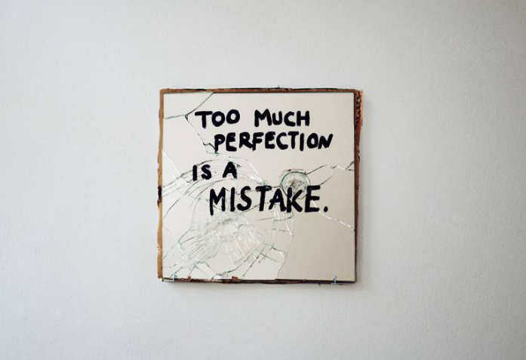
Fig. 1. Arianna Palazzi, (2011) Too much perfection is a mistake

- I believe that creating mistakes are the only way to improving. Embracing mistakes gives you the motivation to try for a second attempt and other attempts to come.

I believe that making mistakes are the only way to improvement. Embracing mistakes gives you the motivation to try for a second attempt and other attempts to come. Nobody is instantly perfect at what they do and even your inspirational artists have been through many trails and errors to get where they are now for years. Small Things Considered: Why There Is No Perfect Design (2007, p.9), a book written by Henry Petroski has a sentence that perfectly sums up my belief in perfection with stronger words, “Even in nature, absolute perfection, in the sense of something being completely flawless, is rare, if not totally absent”. I strongly agree with this sentence as there is no end to improvement, like how there isn’t an end to a rainbow to find perfection, it will continue to move further away the closer you get.

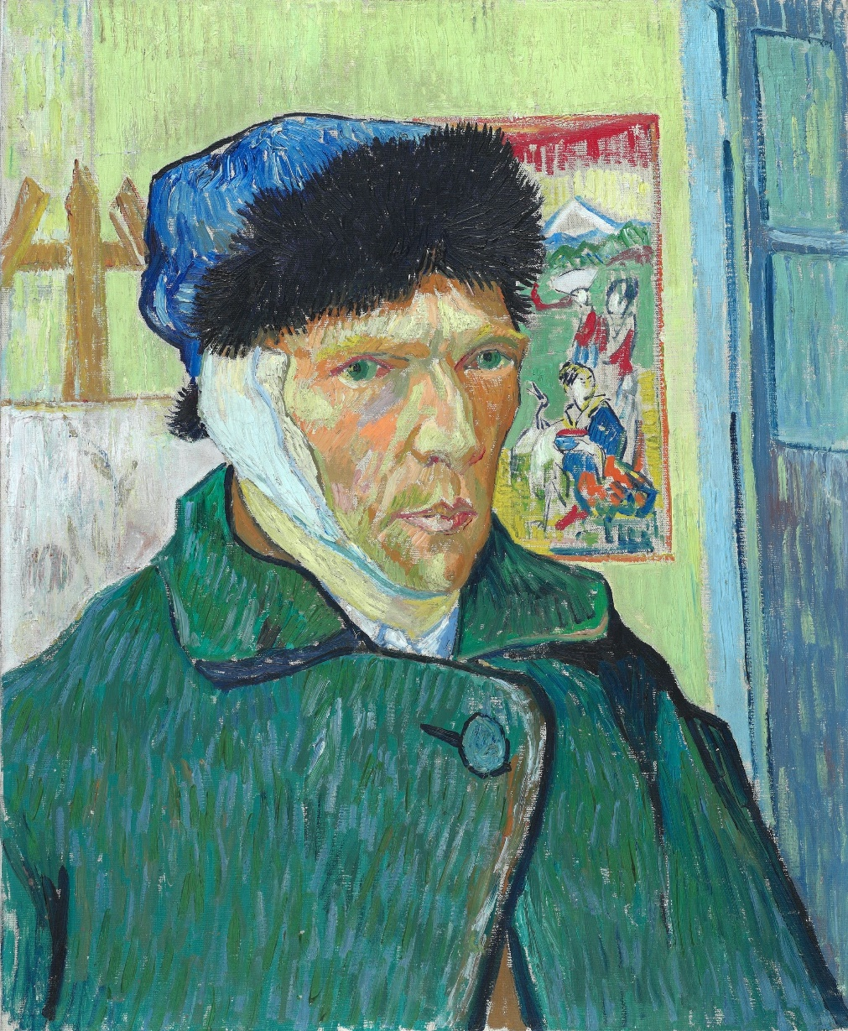
Fig 2. Van Goch, (1889) Self-Portrait with Bandaged Ear

- I treat my attitude towards illustration with a bright and positive view. If you’re doing mentally fine, your illustrations will catch the same vibe and look better in quality.

Your mental health plays a big role within your ability to create art, even when you cannot see it for yourself. If you aren’t doing your best in terms of emotions and feelings, your art will turn towards the same direction. A book written by Paul W. O’Neal, Motivation of Health Behaviour (2007, p.7) explains how motivation is a key-factor to behavioural change and wanting to improve on your mental health. I strongly agree with Paul’s words because without motivation, you will struggle to begin working on an artwork and fail to reach your full protentional. You could find yourself in an endless art block or heavily disliking anything you create along with it. For every artist, it is always recommended to create a schedule to help organize when you’ll start creating and when you’ll take a deserved break for yourself. Moving on how mental health could affect your art, Self-Portrait with Bandaged Ear (1889), painted by Van Goch is a good example of unhealthy mental health showing through art. A Q&A page submitted to www.vangoghmuseum.nl, an official Van Goch website explains how he began suffering from an attack, following after by cutting his ear off which was then drawn as a self-portrait by Van Goch himself. It is clear that in the painting, his facial expression looks distressed; the look of discomfort and pain.

- I value people wanting to create art for to entertain others, most importantly for their own enjoyment aswell and willing to look for work that will make that successful.

I value artists and illustrators creating art to entertain others, but most importantly for their enjoyment. There is only an amount of work you can create for entertainment purposes, only for it to become a chore later on. You might experience a quick or slow journey into finding a job that features your hobby but it will be worth the wait. I believe that our minds are our biggest enemies when it comes to drawing for our own pleasure. Burnout, Fatigue, Exhaustion: An Interdisciplinary Perspective on Modern Affliction (2017), edited by Anna Katharina Schaffner, Greta Wagner and Sighard Neckel (p.291), explains how contests, which are supposed to multiply resources, ends up compelling into a person investing in nothing but their own competitiveness. This is an experience I’ve been through before as I wanted to be as good as the artists I thought had ‘better art’ than me. This affected my passion to draw for my own pleasure, but to only draw art for what I thought would gain me more followers and attention. As soon as I realised how unhealthy this phase was for me, I started drawing what I wanted which made me realise I didn’t hate art after all; burnouts would be less apparent too.

Bibliography
Henry Petroski, (2007) Small Things Considered: Why There Is No Perfect Design (p.9). Broadway, New York: Knopf Doubleday Publishing Group
Paul W. O’Neal. (2007) Motivation of Health Behaviour (p.7). New York: Nova Science Publishers
Van Goch, () Why Did Vincent van Goch Cut off His Ear?, vangoghgallery.com Available at: https://www.vangoghmuseum.nl/en/art-and-stories/vincent-van-gogh-faq/why-did-vincent-van-gogh-cut-off-his-ear (Accessed on 29th December, 2021)
Anna Katharina Schaffner, Greta Wagner, Sighard Neckel, (2017) Burnout, Fatigue, Exhaustion: An Interdisciplinary Perspective on Modern Affliction (p.291). Switzerland: Springer International Publishing

List of figures
Figure 1: Arianna Palazzi, (2011) Too much perfection is a mistake [Marker on glass]. Saachi Art.com. Available at: https://www.saatchiart.com/art/Sculpture-Too-much-perfection-is-a-mistake/375985/3816670/view (Accessed on 11th November, 2021)
Figure 2: Van Goch, L. (c1889) Self-Portrait with Bandaged Ear [Oil on canvas]. Courtault Gallery: London.

Task 2 – Observatinal Writing
Followed by 500 words, bibliography and mind-map
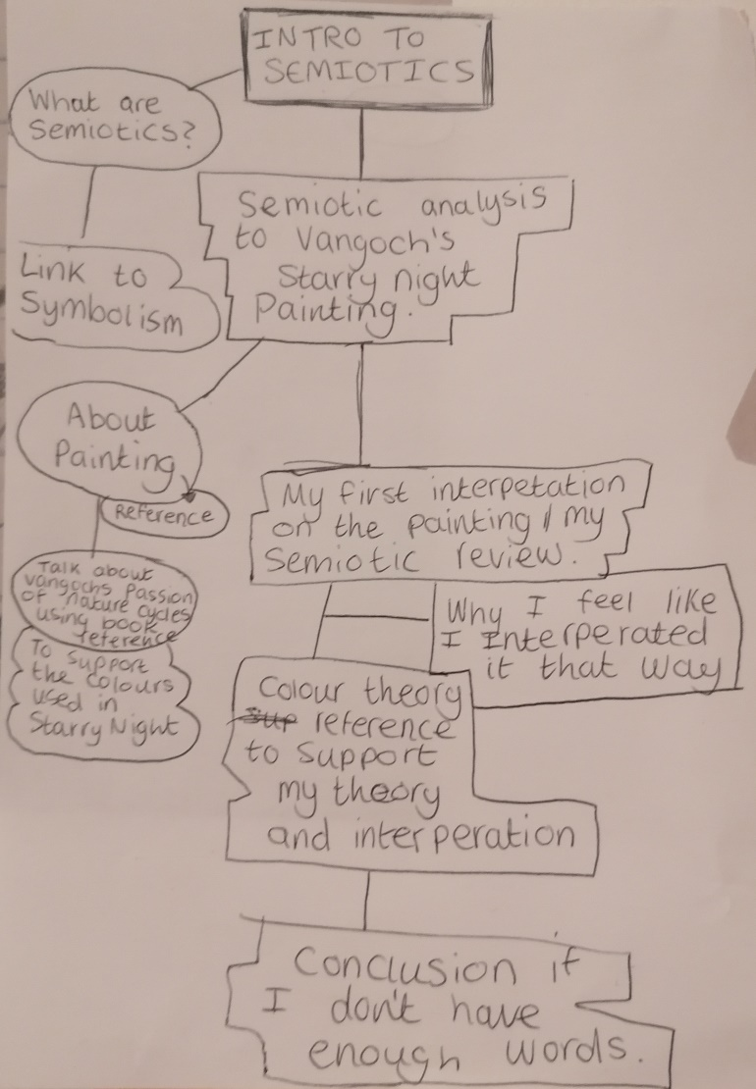
Semiotics is the study of sign processes that is featured in activities and conducts. These signs are up to the viewer to interpret their own meaning behind them by communicating with the picture, signs or visuals. An example of how a semiotic can be used are street signs. By looking at a stop sign, our minds interpret meaning behind it, signalizing that it’s symbol is telling us to stop what we’re doing emedietly. In other cases, a person who has never experienced a stop sign could interpret it differently.
Realistically, we’ve been exposed to semiotics since we were babies. As an example, bright toys and children-based company logos would draw our attention, letting us process that it’s for our demographic and relates to fun. The same goes for when you’re older which we use in the same way, it helps us determin whether we are interested or not into the subject behind the sign.
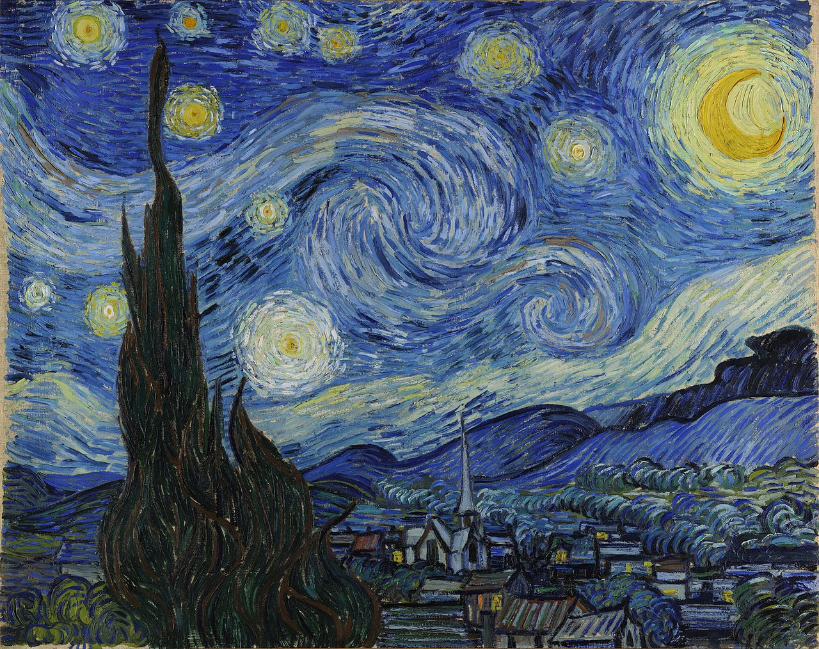
Fig 1, Van Goch, (1889) Starry Night
Starry Night (1889), painted with oil on canvas by Vincent Vangoch in an asylm from the view of his window consists of a quiet village, sitting infront of a beautiful night sky filled with swirls. Written in my own understanding, Vangoch and the colours of the night (2008, p.9), Vincent van Goch, Sjraar van Heugten, Joachim Pissarro, Chris Stolwijk, Geera Bruin, Museum of Modern Art (New York), Vangoch Museum, Amsrerdam, talks about how the famous painter was facinated with the cycles of nature, capturing mood and light through colours he used in his artworks. You can see this take effect in Starry Night as he uses a bright yellow for the stars to symbolize heaven, freedom and happiness. The same goes for the dark colours which symbolize abandonment and coldness using my semiotic view on the painting.
Using my semiotic analysis of the painting, it gave me thoughts of taking a relaxing trip outside under a beautiful, starry night sky, looking down at a village from a moutain view point. Although the original meaning behind this masterpiece is different to mine and understood by it’s creator, looking at it through my perspective signalized a different meaning for me, which is an example of semionics being used. After researching the original meaning for this painting, I can understand why I interpreted it differently before having the knowledge. I believe the reason on why I interperated it this way is because of the muted colour choice Vangoch uses. A semiotic colour theory, written by Mario Van Der Meulen (2019) The semiotics of colour, an online witing explains how colour semiotics are used to convey colour with certain brands, places and emotions. I believe this theory supports my writing because in my perspective, blue and yellow mixed together are accociated with space to me, escpecially the swirl textures of yellow and blue in the sky that make them look like fireflies, smoothly moving around like swishing the paint off your brush in a cup of water which I believe is why I saw this painting as a relaxing setting.

Bibliography
Mario Van Der Meulen, (2019) The semiotics of colour, Foolproof.co.uk. Available at:
https://www.foolproof.co.uk/journal/the-semiotics-of-colour/ (Accessed: 23 November 2021)
Vincent Van Goch, (1889) Starry Night, vangochgallery.com Available at:
https://www.vangoghgallery.com/painting/starry-night.html (Accessed: 23 November 2021)
Vincent van Goch, Sjraar van Heugten, Joachim Pissarro, Chris Stolwijk, Geera Bruin, Museum of Modern Art (New York), Vangoch Museum, Amsrerdam, (2008) Vangoch and the colours of the night (p.9). New York: The Museum of Modern Art
List of figures
Figure 1: Vincent Van Goch, L. (c.1889) Starry Night [Oil on canvas]. The Museum of Modern Art: New York

Task 3 – Practice-based Writing
Followed by 500 words and bibliography
A practical reflection of good Character Design Featuring one of my Character Design Illustrations
The biggest importance to creating a well recognized, designed character is starting loosely, as your character will not be perfect on its first design. This allows you to create rounder figures, multiple versions of your creation without the stress of getting it perfect on your first attempt. You will then have multiple versions of said character, which you can decide on which one you like best, or take certain parts of them and mash it together into one design.
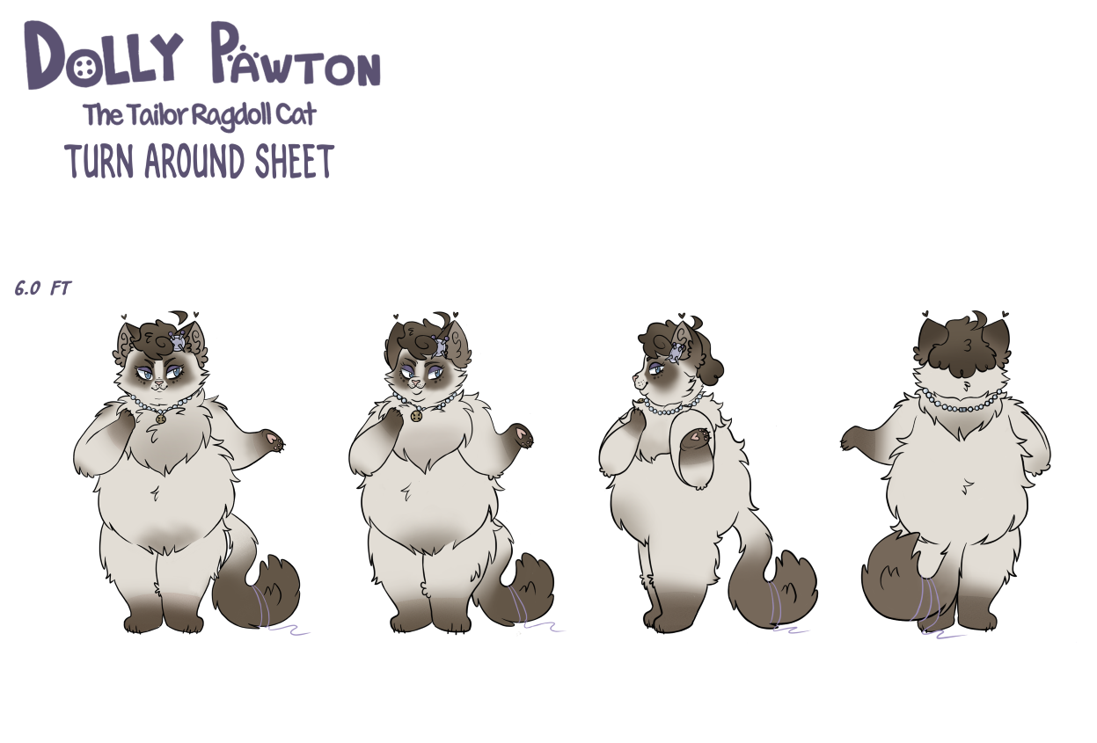
Fig 1. Turner, (2021) Dolly Pawton Turn Around Sheet
An online PDF submitted to waltdisney.org by The Walt Disney Family Museum titled, Tips & Techniques Shape Language (2020), explains how using shapes with your character helps give them personality and language without describing them with a description. Using this technique myself, I agree that using shapes in your design gives your character personality as using circles for Dolly Paw-ton made her’s look soft, sassy and cuddly. When introducing her to an audience, I hope that familiar traits are shown to the viewer with first impression. If I were to use squares instead of circles, my character would give off a bulky type of appearance, thus why I’ve decided to stick with circles to fit her bubbly personality.
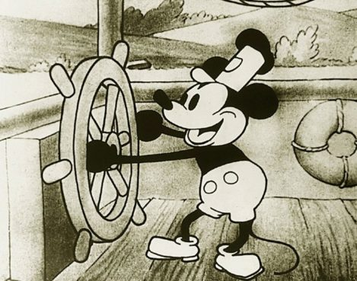
Fig 2. Disney, Ub Iwerks (1928) Steamboat Willie
A book created by Scott McCloud titled, Making Comics, story telling secrets of comics, manga and graphic novels (2006, p.64), educates on how it’s important and helpful to plan down your characters personality before making a design for them. I agree with this tip as not making a biography for your character before moving further in development will make it harder for you to personally connect with it; as I believe that personality tags along with appearance and one can’t go without. I took this tip as influence by writing down the dislikes, likes, hobbies, job occupation, backstory, etc, of my character, and only then I was able to picture my designed character, Dolly Paw-ton, onto paper as a design. With that information you’ve created, you can move futher into its development while adding more onto them later.
I believe that colour plays a strong role with good character design as it leaves a first impression onto your character when presented. As humans, we usually accociate colours with actions and moods, and the same method repeats itself when one dominant colour is being used on your design. For example, red being a dominant colour may relate to strength, anger and action to a percentage of people which could be their first impression on how your creation may feel or act. This goes for all existing colours as they too, have their own accociations.
A video titled, Good vs Bad Character Design: Tips and Tricks!, uploaded to Youtube by Brent and Max (2020, 5:25), on a channel going by BaM Animation, has a good example of using colour theory for your character, as they suggest creating a colour hierarchy to help your design compliment together, with one colour as a dominant and the other colours to support it without clashing. Using this tip on my own character, I agree that this improves your design greatly and believe it supports your creation being regognizable and eye pleasing when the colours being used are complimenting eachother.

Bibliography
www.waltdisney.org, (2020) Tips and Techniques Shape Language, The Walt Disney Family Museum Available at:
https://www.waltdisney.org/sites/default/files/2020-04/T%26T_ShapeLang_v9.pdf
(Accessed: 27th November)
Scott McCloud, (2006) Making Comics, storytelling secrets of comics, manga and graphic novels. New York: William Morror Paperbacks.
BaM Animation, (2020) Good vs Bad Character Design: Tips and Tricks!, Avaiable at: https://www.youtube.com/watch?v=8wm9ti-gzLM&t=328s (Accessed: 21 December 2021)

List of figures
Figure 1: Ross Turner, (2021) Dolly Paw-ton Turn Around Sheet [Digital], (Illustration)
Figure 2: Disney, Ub Iwerks, (1928) Steamboat Willie [Black and white cel animation]

