Skills for the Workplace
Module Assignment Submission
Student Name: | Mark Dacosta
Student Number: | 2016824
Module No: | BMSK6001
Module Title: | Emergent Leadership Skills for the Workplace

Statement of Confirmation of Authenticity
By the act of making this submission, the student declares that the work of the student named above. The work has not, in whole or in part, been knowingly presented elsewhere for assessment, or where assessment has been built on a previous assessment, this has been identified. Where materials have been used from other sources it has been properly acknowledged. If this statement is untrue, the student acknowledges that an assessment offence has been committed.
Attention is drawn to the plagiarism and unfair practice policies of UWTSD.

Contents
Introduction 3
What is the Definition of a Leader 3
What is the Role of a Leader? 4
The Importance of Leadership in Change 5
Leadership Models 6
Transformational Leadership 6
Situational Leadership Theory 6
Contingency Theory 6
Authentic Leadership 6
Servant Leadership 6
Transactional Leadership 7
Examples of Leadership Models 8
Case Study: Martin Luther King Jr. and his Leadership Characteristics 8
Kings Leadership Model 9
Leadership Styles 10
Authoritarian Leadership: 10
Democratic Leadership: 10
Laissez-Faire Leadership: 10
Leadership Skills 11
Employing a Leadership Model to bring about Workplace Change 11
Conclusion 13
References 14
Appendix 16

Introduction
The world is constantly changing, and those changes are becoming more and more frequent as technology increases. Leadership therefore is becoming more important as one of the main functions of leadership is the successful navigation of change.
This report looks at what a leader is and why leadership is important. It will do this firstly by looking at what the role of a leader is, and then by assessing different leadership models using a case study to show an example of some of these models in action.
Finally, the report will look at the authors own leadership styles and asses their ability to set direction, motivate, delegate, and empower others in the workplace.

What is the Definition of a Leader
A leader can be defined as an individual who guides, influences, and inspires others towards the achievement of a shared vision or goal. Leaders provide direction, support, and motivation to their team or followers, fostering an environment of trust, collaboration, and growth. The definition of a leader can vary depending on different perspectives and theories. Here are a few definitions of a leader:
According to Northouse (2021), a leader is "someone who influences others and has managerial authority." He emphasizes the importance of influence in leadership and distinguishes it from simply holding a position of authority.
Bass and Riggio (2006), define a leader as "an individual who induces employees to transcend their own self-interests for the good of the organization" and highlights the transformative aspect of leadership.
In the book Transformational and Charismatic Leadership: The Road Ahead. Emerald Group Publishing (Avolio & Yammarino, 2013), the editors state that leaders "energize, inspire, and motivate others to perform beyond their own capabilities and expectations." They highlight the ability of leaders to inspire and empower others to achieve extraordinary outcomes.
Goleman, Boyatzis, and McKee (2013), define a leader as "someone who can create resonance in a group." They emphasize the importance of emotional intelligence and the ability to create a positive emotional climate within the team or organization.
These definitions provide different perspectives on what a leader is, highlighting aspects such as influence, transformation, inspiration, and emotional intelligence. Ultimately, a leader is someone who guides and influences others towards a common purpose, exhibiting qualities and behaviours that inspire trust, collaboration, and the achievement of collective goals.

What is the Role of a Leader?
The role of a leader is multifaceted and encompasses various responsibilities. Some key roles that leaders fulfil are:
Setting Direction: Leaders play a crucial role in defining the organization's vision, mission, and strategic goals. They provide clarity and purpose, outlining the path for the organization to follow. For example, a CEO of a technology company might set the direction by envisioning the company as a global leader in sustainable innovation (Boisot & Child, 1999).
Inspiring and Motivating: Leaders inspire and motivate their team members to achieve their best. They foster a positive and engaging work environment that encourages collaboration, creativity, and dedication. For instance, a team leader might inspire their team by recognizing their efforts, providing constructive feedback, and creating opportunities for growth and development.
Decision-Making and Problem-Solving: Leaders are responsible for making informed decisions and solving complex problems. They analyse information, weigh options, and consider the impact of their choices on the organization and its stakeholders. An executive manager might make strategic decisions regarding resource allocation, market expansion, or product development based on thorough analysis and careful consideration (Ashmos, Duchon, McDaniel, & Huonker, 2002).
Building and Developing a Team: Leaders are responsible for building effective teams and developing their members' skills and capabilities. They identify talent, create opportunities for growth, and foster a culture of collaboration and continuous learning. For instance, a project manager might assemble a cross-functional team, provide guidance, and facilitate teamwork to deliver a successful project outcome (Wheatley, 1999).
Communication and Relationship Building: Leaders are effective communicators, both internally and externally. They convey messages clearly, listen actively, and build strong relationships with stakeholders. A political leader might engage with the public through speeches, media interviews, and town hall meetings to communicate policies, build trust, and gain support.
Role Model and Ethical Behaviour: Leaders set an example through their behaviour and actions. They embody the values and ethics of the organization and uphold high standards of integrity and professionalism. A team supervisor might demonstrate ethical behaviour by addressing conflicts fairly, treating employees with respect, and adhering to company policies.
Change Management: Leaders play a critical role in navigating and managing change within the organization. They anticipate and respond to external and internal factors that require adaptation, guiding the organization and its members through transitions. A change management leader might communicate the need for change, engage stakeholders, and provide support and resources during the change process (Yukl, 2002).
It is important to note that the role of a leader may vary depending on the level of leadership within the organization. However, these examples illustrate the general roles and responsibilities that leaders fulfil in guiding and influencing their teams and organizations toward success. The long-term success of a company largely relies on that company’s ability to navigate change, therefore one of the most difficult challenges for a leader is to transition their followers through inevitable changes.

The Importance of Leadership in Change
"Change is the only constant in life." - This quote is attributed to the Greek philosopher Heraclitus and reflects the idea that change is an inherent and unavoidable aspect of life. If this quote is true, then Leadership is integral to the human existence as leadership can determine if change makes things better or worse.
The nature of change is complex and multifaceted. Change refers to any alteration or modification that occurs within an individual, organization, or society. It can be driven by various factors such as technological advancements, economic shifts, social dynamics, or internal needs for growth and adaptation. Change can be gradual or sudden, planned, or unplanned, and can have both positive and negative consequences.
Change seems to be inevitable and constant. It is an inherent part of human existence and organizational development. Individuals and organizations must continuously adapt to changes in their external environment to remain relevant and competitive. The pace of change has accelerated in recent times due to rapid advancements in technology and globalization. This requires leaders and managers to be adept at navigating and managing change effectively.
Change can be challenging and disruptive. It often involves uncertainty, resistance, and the need to break away from established routines and comfort zones. People may resist change due to fear of the unknown, loss of control, or perceived threats to their status or security. Therefore, successful change management requires leaders to understand and address the psychological and emotional aspects of change and create an environment that encourages and supports individuals through the transition. Change is often complex and has many factors to consider which need to be considered by a leader in order to navigate the changes successfully.
In conclusion, the nature of change is dynamic, and effective leadership is crucial in managing change successfully. Leaders must provide a clear vision, engage stakeholders, communicate effectively, empower change agents, and exhibit adaptive and emotionally intelligent leadership. By embracing complexity and focusing on the human aspects of change, leaders can guide individuals and organizations through the challenges and opportunities that change presents.
There are many models that categorise the role of a leader and the next section will highlight a few.

Leadership Models
It's important to note that leadership models and theories have their unique perspectives and strengths. They provide different lenses through which to understand leadership and its impact.
Here are a few of the more popular models.
Transformational Leadership (Bass & Riggio, 2006):
- Focuses on inspiring and motivating followers to achieve exceptional performance.
- Emphasizes charismatic leaders who stimulate their followers intellectually and emotionally.
- Encourages individual development, empowerment, and a shared vision.
- Transformational leaders inspire trust, foster creativity, and promote a positive organizational culture.

Situational Leadership Theory (Hersey & Blanchard, 1969):
- Proposes that effective leadership depends on matching leadership style with followers' readiness levels.
- Leadership styles vary from directing, coaching, supporting, to delegating, depending on followers' competence and commitment.
- Provides a flexible framework that recognizes the need for leaders to adapt their approach based on followers' development.

Contingency Theory (Fiedler, 1967):
- Asserts that leadership effectiveness depends on the match between the leader's style and the situation.
- Differentiates between task-oriented and relationship-oriented leadership styles.
- Contends that the situational favourableness, leader-member relations, task structure, and positional power impact leadership success.

Authentic Leadership (Avolio & Gardner, 2005):
- Focuses on leaders being genuine, self-aware, and true to their values and beliefs.
- Emphasizes transparency, integrity, and ethical behaviour.
- Authentic leaders build trust and strong relationships, and their authenticity inspires followers to be more authentic.

Servant Leadership (Greenleaf, 1970):
- Advocates leaders serving others and prioritizing their followers' needs.
- Leaders exhibit humility, empathy, and a focus on personal growth and development.
- Encourages collaboration, empowerment, and a sense of community.

Transactional Leadership (Bass, 1985):
- Emphasizes exchanges between leaders and followers, focusing on rewards and punishments.
- Transactional leaders set clear expectations, use contingent rewards, and manage performance through monitoring.
- Relies on a transactional approach to motivate followers based on extrinsic rewards.
While some models, such as transformational and authentic leadership, focus on the positive and inspiring aspects of leadership, others, like transactional leadership, concentrate on more transactional exchanges. The situational and contingency theories highlight the importance of adapting leadership approaches based on specific situations and follower characteristics.
One thing that is agreed upon with most models is that the leadership needs to be authentic to be effective. Luthans & Avolio (2003), define authentic leadership as “a process that draws from both positive psychological capacities and a highly developed organizational context, which results in both greater self-awareness and self-regulated positive behaviours on the part of leaders and associates, fostering positive self-development.”
This definition explains that positive psychology coupled with well developed organization improves self-awareness of employees which in turn causes these employees to naturally self-regulate and promote positive behaviour. Not all scholars agree with this definition, however.
Some scholars (Cooper et al. 2005, Sparrowe 2005) express concerns over Luthan & Avolio’s definition of authentic leadership. These scholars seem to go along with the more widely accepted four components of authentic leadership: balanced processing, internalized moral perspective, relational transparency, and self-awareness.
The four components of authentic leadership is a leadership approach that emphasizes the importance of leaders being true to themselves and their values, as well as being transparent and genuine in their interactions with others. The four components, balanced processing, internalized moral perspective, relational transparency, and self-awareness—are considered essential for authentic leadership.
Balanced processing refers to a leader's ability to objectively analyse information and consider different perspectives before making decisions. It involves actively seeking input from others, listening to diverse viewpoints, and weighing various options. Authentic leaders who engage in balanced processing are open-minded and willing to challenge their own beliefs and assumptions. This quality is important because it helps leaders make informed decisions and avoid biases or personal agendas that may compromise the well-being of their team or organization.
Authentic leaders possess a strong moral compass and internalize their values and principles. They have a clear sense of what is right and wrong, and they consistently act in alignment with their ethical standards. This internalized moral perspective guides their decision-making and behaviour, and it ensures that they act in the best interest of their followers and the organization as a whole. By demonstrating integrity and ethical behaviour, authentic leaders inspire trust and create a positive organizational culture.
Relational transparency involves being open, honest, and authentic in interpersonal relationships. Authentic leaders build trust and credibility by openly sharing information, admitting mistakes, and expressing vulnerability. They create an environment where open communication is encouraged and foster a sense of psychological safety within their teams. Relational transparency allows for stronger connections and collaborations, as followers feel comfortable expressing their ideas and concerns without fear of retribution.
Self-awareness is a fundamental aspect of authentic leadership. It involves understanding one's own values, strengths, weaknesses, emotions, and impact on others. Authentic leaders are introspective and actively seek feedback to gain insights into their behaviours and their effects on their followers. By having a deep understanding of themselves, authentic leaders can regulate their emotions, make conscious choices, and adapt their leadership style to meet the needs of their team. Self-awareness also enables leaders to demonstrate humility and empathy, which enhances their ability to relate to others and build strong relationships.
In summary, balanced processing, internalized moral perspective, relational transparency, and self-awareness are integral components of authentic leadership. Together, they contribute to a leader's ability to make sound decisions, act ethically, build trust, and foster meaningful relationships with their followers. These qualities are vital for creating a positive work environment and promoting the well-being and success of individuals and the organization as a whole. As such the author finds this definition of authentic leadership to have more practical application.

Examples of Leadership Models

Case Study: Martin Luther King Jr. and his Leadership Characteristics
Martin Luther King Jr. was a prominent leader of the civil rights movement in the United States during the 1950s and 1960s. He played a pivotal role in advocating for racial equality and social justice through nonviolent means. King's leadership was characterized by several key qualities that enabled him to inspire millions of people and bring about significant social change.
Martin Luther King Jr. possessed a compelling vision for a racially just society, where individuals are judged by the content of their character rather than the colour of their skin. He articulated this vision through his famous "I Have a Dream" speech, which outlined a future where racial equality and harmony prevailed. King's ability to clearly communicate his vision and rally people around a common purpose was instrumental in mobilizing support for the civil rights movement.
King demonstrated tremendous moral courage in his unwavering commitment to nonviolent resistance. He faced numerous threats, physical violence, and even imprisonment, yet he remained steadfast in his belief that love, and peaceful protests could overcome injustice. King's moral courage inspired others to stand up for their rights and challenged societal norms and prejudices.
One of King's greatest strengths was his ability to deliver powerful and emotionally resonant speeches. He possessed exceptional oratory skills and employed rhetorical techniques to captivate and motivate his audience. His speeches, such as the "I Have a Dream" speech and the "Letter from Birmingham Jail," conveyed a sense of urgency, hope, and moral conviction, stirring deep emotions and igniting a sense of collective responsibility for social change.
King was a strategic leader who carefully planned and organized civil rights campaigns. He understood the importance of timing and selecting strategic locations for protests to maximize visibility and impact. King's leadership ensured that the civil rights movement gained widespread attention and support, leading to policy changes and the eventual passage of landmark legislation, such as the Civil Rights Act of 1964 and the Voting Rights Act of 1965.
King recognized the importance of building diverse coalitions and forging alliances with different groups and individuals. He sought to unify people from various backgrounds, including African Americans, whites, religious leaders, and labour activists. King's ability to bridge divides and create inclusive movements strengthened the civil rights cause and broadened its impact.
Despite facing significant adversity, including personal threats and setbacks, King exhibited remarkable resilience and perseverance. He maintained his focus on the ultimate goal of racial equality and refused to succumb to discouragement or despair. King's determination to continue the struggle, even in the face of tremendous obstacles, inspired others to persevere and remain committed to the cause.
Martin Luther King Jr. exemplified extraordinary leadership characteristics that continue to inspire generations. Through his vision, moral courage, inspirational communication, strategic leadership, coalition building, and resilience, King became an iconic figure in the fight for civil rights. His leadership legacy serves as a powerful example of how individuals can create meaningful and lasting change through visionary leadership, moral conviction, and unwavering commitment to justice and equality.

Kings Leadership Model
On reflection, King undoubtably represented the Transformational Leadership model (Bass & Riggio, 2006). This model focuses on inspiring and motivating followers to achieve extraordinary results. It emphasizes charismatic leaders who stimulate their followers intellectually and emotionally. This is exactly what King did and his followers were empowered and shared his vision.
His followers not only bought into what he was doing emotionally, but he educated them in how to achieve their goals in a new way (nonviolence).
Transformational leaders also inspire trust, and King did these with great affect. When your very safety is challenged but you still trust the direction you are being led in this shows trust in leadership of the highest degree.
Another reason Martin Luther King is so iconic and memorable is because his leadership also perfectly matches both Authentic Leadership and Servant Leadership as well. Remember Authentic leaders focuses on their leadership being genuine, self-aware, and true to their values and beliefs, emphasizes transparency, integrity, and ethical behaviour. They also build trust and strong relationships, and their authenticity inspires followers to be more authentic. King ticked all these boxes.
Not only those boxes but the Servant Leadership boxes as well. These leaders serve others and prioritise their followers' needs which is exactly what King did, even to the point of going to jail. These Leaders also exhibit humility, empathy, and a encourage collaboration, empowerment, and a sense of community. Again, King displayed all of these attributes in abundance.
In summary, we can surmise that the leadership models are not necessarily competing models but on the contrary, a really good leader will display multiple models. Rather than sticking to one model it would benefit a leader to display characteristics from multiple models in order to be a well-rounded leader.

Leadership Styles
In order to identify what style of leader an individual is likely to be, it is important to gather feedback and reflect on one’s own attitudes and perceptions. One way to this is to complete questionnaires as this helps to identify assumptions and provides a guide of the leadership qualities of an individual.
Once the leadership style of an individual is predicted, it would make selecting a leadership model that is likely to suit the individual based on their leadership style.
Figure 1 in the appendix displays the first questionnaire completed by the author. The points scored in each style was:
17 Authoritarian
26 Democratic
16 Laissez-Faire
These results show that the author has a high tendency toward a Democratic leadership style and is to a lesser degree Authoritarian and Laissez-Faire. Below is a brief outline of the characteristics of these leadership styles.

Authoritarian Leadership:
Characteristics: Authoritarian leaders tend to have a strong control over decision-making and the overall direction of the group. They provide clear instructions, expect strict adherence to rules and procedures, and may enforce a hierarchical structure where authority is concentrated at the top. Communication is often one-way, with limited input from subordinates.

Democratic Leadership:
Characteristics: Democratic leaders encourage participation and collaboration among team members. They seek input, consider diverse perspectives, and involve others in the decision-making process. Communication is open and two-way, fostering a sense of inclusiveness and empowerment. Decision-making is shared, and trust and teamwork are emphasized.

Laissez-Faire Leadership:
Characteristics: Laissez-faire leaders provide minimal guidance and supervision, allowing individuals or teams to make decisions and manage their own tasks independently. They provide little structure or direction, offering freedom and autonomy to subordinates. This style can lead to a lack of accountability and may be suitable in situations where employees are highly skilled and self-motivated.
It's important to note that leadership styles like leadership models can be situational, and effective leaders often exhibit a combination of different styles depending on the context and the needs of their team or organization (House & Aditya, 1997).
The democratic leadership style in particular comes to the fore in the authors assessment due to having experienced authoritarian leadership and seeing first hand how its missuses cause significant drop in moral and attrition.
As highlighted earlier the democratic process fosters a sense of inclusion and involves others in decision making. In complete opposition to this idea the author experienced job role changes that were imposed without any consultation or consent which ultimately ended up in low morale, job resignations, and even legal proceedings being taken against these changes.
Naturally the author attitudes and beliefs were impacted by this experience and has adopted a more democratic approach to leadership as a result. It also has to be considered that the author may have a negative bias against authoritarian leadership as a result of this experience. It would therefore be important to reflect on any future authoritarian experiences with this bias in mind.
In conclusion, there would potentially be limitations the authors own ability to use an authoritarian leadership style as there would be an overcompensation of empathy towards followers thoughts and feelings. This means the author would naturally lean toward a democratic leadership style which is evident in the questionnaire results.

Leadership Skills
The author also completed a leadership skills questionnaire to try and identify strengths and weaknesses in the skills they have developed. The three areas scored:
Administrative Skill Score 18
Interpersonal Skill Score 26
Conceptual Skill Score 23
In combination, these three skill sets complement each other and contribute to leadership effectiveness. Administrative skills provide the structure and organization needed for efficient operations, interpersonal skills foster strong relationships and effective communication, and conceptual skills enable leaders to think strategically and make informed decisions. A well-rounded leader who possesses a balance of these skills can effectively navigate complex challenges, motivate their team, and drive organizational success.
Rather than looking at these as strengths and weaknesses it would be better to view them as scores out of thirty where the aim is to push each area as close to thirty as possible. This way, the score is telling the individual what they need to work at rather than a description of what they are good or not so good at.
From this perspective it is clear that the author needs to make big improvements in administrative skills in order to be more organised and efficient. This will help to become a more effective communicator and allow better engagement with the organisation.

Employing a Leadership Model to bring about Workplace Change
The question remains what model would best help the author bring about workplace change? Having established the styles and models can be used interchangeably depending on the person or situation, it is feasible that a flexible model that embodies these findings would best suite the author. This of course is the situational leadership model.
The Situational Leadership Model, developed by Paul Hersey and Ken Blanchard, is a widely recognized leadership theory that emphasizes the importance of adapting leadership style to the needs of the situation and the maturity level of the followers. The model suggests that there is no one-size-fits-all leadership approach and that effective leaders adjust their behaviour based on the specific circumstances and the development level of their followers.
Although the model has been tested, a lot of the academic testing has been subjective using measurements such as supervisor ratings (Fernandez and Vecchio, 1997; Norris and Vecchio, 1992; Thompson and Vecchio, 2009; Vecchio, 1987; Vecchio et al., 2006). There would also be bias in self-assessments where a leader would want display favourable results (Schriesheim et al., 2011).
Despite the subjectivity of the results, the model effectiveness is widely accepted (Franklin 2009)
The Situational Leadership Model identifies four leadership styles, which are based on a combination of two factors: directive behaviour (task-focused) and supportive behaviour (relationship-focused). The four leadership styles are:
1: Directing/Telling: In this style, the leader provides clear instructions, closely supervises tasks, and makes decisions for the team. It is most appropriate when followers have low competence and low commitment. The leader assumes a directive role to guide the followers in performing their tasks effectively.
The author would adopt a directing style for a new employee who requires extensive guidance and instruction. In doing so the author would set direction for the followers.
2: Coaching/Selling: In this style, the leader continues to provide direction and support but also encourages two-way communication. The leader provides explanations, offers assistance, and facilitates skill development. This style is effective when followers have some level of competence but still require guidance and motivation.
The author would adopt a coaching style for a team member who has basic knowledge and skills but lacks confidence. This action demonstrates the author’s ability to motivate followers.
3: Supporting/Participating: This style involves a more supportive and less directive approach. The leader empowers followers by involving them in decision-making and encouraging their input. The leader provides support and resources while allowing followers to take more ownership of their work. This style is suitable for followers who have a moderate to high level of competence but may lack full commitment or confidence.
A supporting style would be used by the author when a team member has expertise in a specific area but needs some autonomy. In doing this the author demonstrates their ability to empower followers rather than directing them.
4: Delegating: In this style, the leader provides little direction and support, allowing followers to take responsibility for their tasks and decisions. The leader entrusts followers with autonomy and encourages self-management. This style is appropriate when followers have high competence and commitment (EPM 2018).

The author would adopt a delegating style for an experienced and self-motivated team member who has demonstrated high levels of competence and commitment. This demonstrates the authors ability to delegate when the appropriate skill levels are demonstrated by the follower.
The key aspect of the Situational Leadership Model is that leaders need to adapt their leadership style to match the needs of the situation and the maturity level of their followers. To be effective the author would assess the competence and commitment of their followers and choose the most appropriate leadership style accordingly.
This model suggests that leadership is not fixed but dynamic and that leaders should be flexible in their approach to meet the evolving needs of their team members.

Conclusion
In conclusion, the Situational Leadership Model allows the author the freedom to lead followers in a way that is most appropriate to the type of follower they are dealing with and also the situation that they are presented with. This means the author can use motivation, delegation, empowerment and set direction when it is appropriate to affect positive workplace change when necessary.

References
Ashmos et al., 2002 D. P. Ashmos, D. Duchon, R. R. McDaniel, and J. W. Huonker, What a mess! Participation as a simple managerial rule to ‘complexify’ organizations, Journal of Management Studies.
Avolio, B. J., & Gardner, W. L. (2005). Authentic leadership development: Getting to the root of positive forms of leadership. The Leadership Quarterly.
Avolio, B. J., & Yammarino, F. J. (Eds.). (2013). Transformational and Charismatic Leadership: The Road Ahead. Emerald Group Publishing.
Bass, B. M. (1985). Leadership and performance beyond expectations. Free Press.
Bass, B. M., & Riggio, R. E. (2006). Transformational leadership. Psychology Press.
Bass, B. M., & Riggio, R. E. (2006). Transformational Leadership (2nd ed.). Psychology Press.
Blanchard, K. (1988), Situational Leadership II, Facilitators Guide, Blanchard Training and Development, San Diego, CA.
Blanchard, K.H. (2008), “Situational leadership. Adapt your style to their development level”, Leadership Excellence, Vol. 25
Boisot and Child, 1999 • M. Boisot and J. Child, Organizations as adaptive systems in complex environments: The case of china, Organization Science: A Journal of the Institute of Management Sciences.
EPM (2018). Situational Leadership Model Explained. YouTube. Available at: https://www.youtube.com/watch?v=pykuvuA-QFU.
Fernandez, C.F. and Vecchio, R.P. (1997), “Situational leadership theory revisited: a test of an across-jobs perspective”, Leadership Quarterly.
Fiedler, F. E. (1967). A theory of leadership effectiveness. McGraw-Hill.
Franklin, T. (2009), “Situational leadership: an analysis of public school teachers’ readiness levels and preferred principal leadership style”, Humanities and Social Sciences, Vol. 70 Nos 1-A.
Goleman, D., Boyatzis, R. E., & McKee, A. (2013). Primal Leadership: Unleashing the Power of Emotional Intelligence. Harvard Business Review Press.
Greenleaf, R. K. (1970). The servant as leader. Robert K. Greenleaf Center.
Hersey, P., & Blanchard, K. H. (1969). Life cycle theory of leadership. Training and Development Journal.
House, R. J., & Aditya, R. N. (1997). The social scientific study of leadership: Quo vadis? Journal of Management.
Luthans F, Avolio BJ. 2003. Authentic leadership: a positive developmental approach. In Positive Organizational Scholarship: Foundations of a New Discipline, ed. KS Cameron, JE Dutton, RE Quinn. San Francisco, CA: Berrett-Koehler.
Northouse, P. G. (2021). Leadership: Theory and Practice (8th ed.). Sage Publications.
Schriesheim, C.A., Joshua B., Wu, J.B. and Cooper, C.D. (2011), “A two-study investigation of item wording effects on leader-follower convergence in descriptions of the leader-member exchange (LMX) relationship”, Leadership Quarterly, Vol. 22.
Thompson, G. and Vecchio, R.P. (2009), “Situational leadership theory: a test of three versions”, Leadership Quarterly.
Vecchio, R.P. (1987), “Situational leadership theory: an examination of a prescriptive theory”, Journal of Applied Psychology, Vol. 72.
Vecchio, R.P. (1997), Leadership: Understanding the Dynamics of Power and Influence in Organizations, University of Notre Dame Press, Notre Dame, Ind.
Wheatley, 1999 M. Wheatley, Leadership and the new science, Berrett–Koehler, San Francisco (1999).

Appendix
Fig 1 Leadership Styles Questionnaire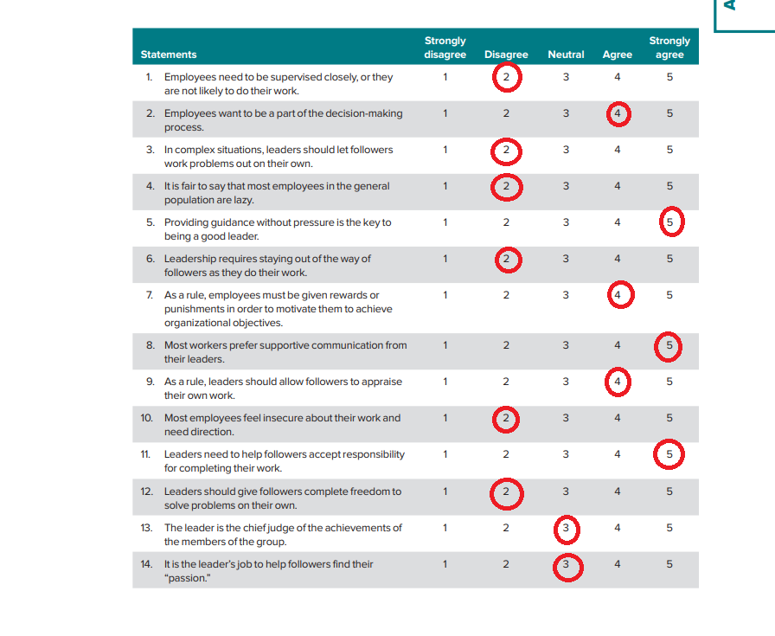
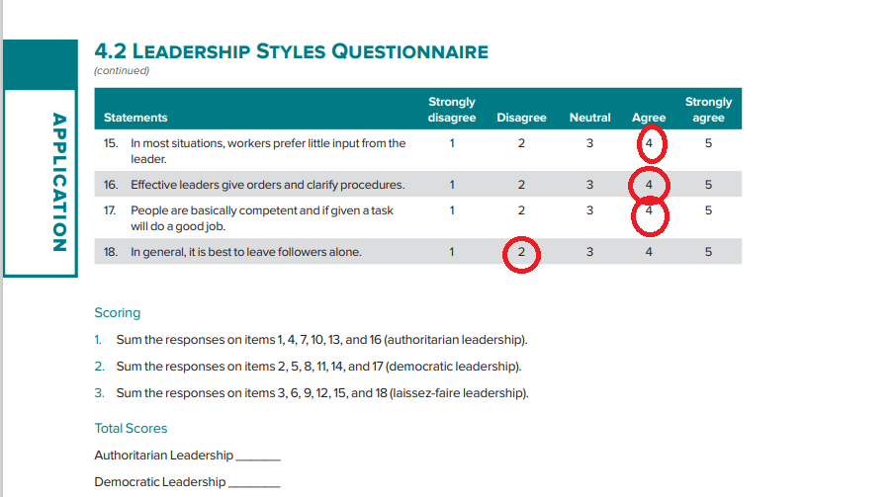

Fig 2 Leadership Skills Questionnaire


