

LOCATION: Swansea | LLEOLIAD: abertawe
LEVEL 6 | LEFEL 6
EXAMINATION PERIOD | CYFNOD ARHOLIADAU
may 2023 | mai 2023
MODULE CODE: acca6023
Enterprise Networking, Security and Automation

TIME: 2 HOURs
answer all questions

Equipment or materials required. Please select from the following:
Adnoddau neu ddefnyddiau sydd eu hangen.

Cyfrifiannell/Calculator

Llyfr Agored/Open Book

Arall/Other

ANSWER ALL QUESTIONS
Use self-Marking Packet Tracer File

Part 1: IN-CLASS ASSESSMENT (15 Marks)
1. SIC_OSPF (3 Marks)
2. SIC_IPV4_ACL (3 Marks)
3. SIC_IPV4_NAT (3 Marks)
4. VPN Challenge (3 Marks)
5. Trouble Shooting Enterprise Networks (3 Marks)

Topology
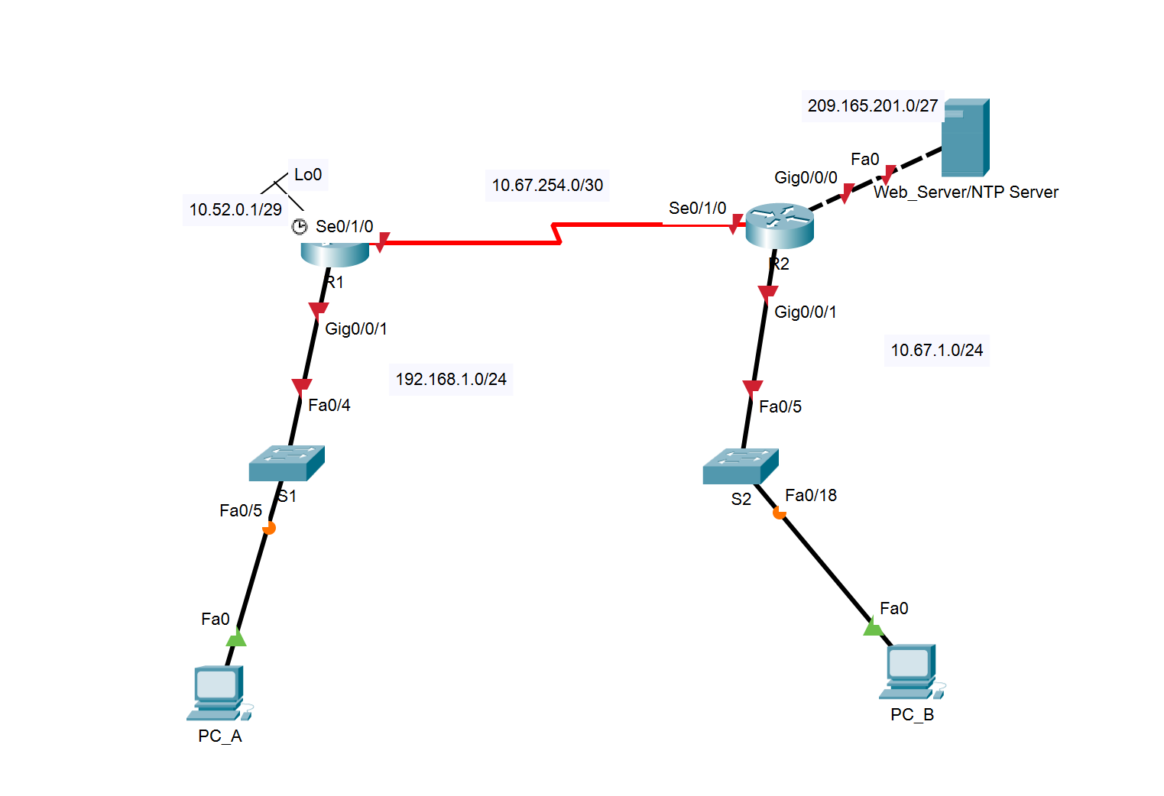

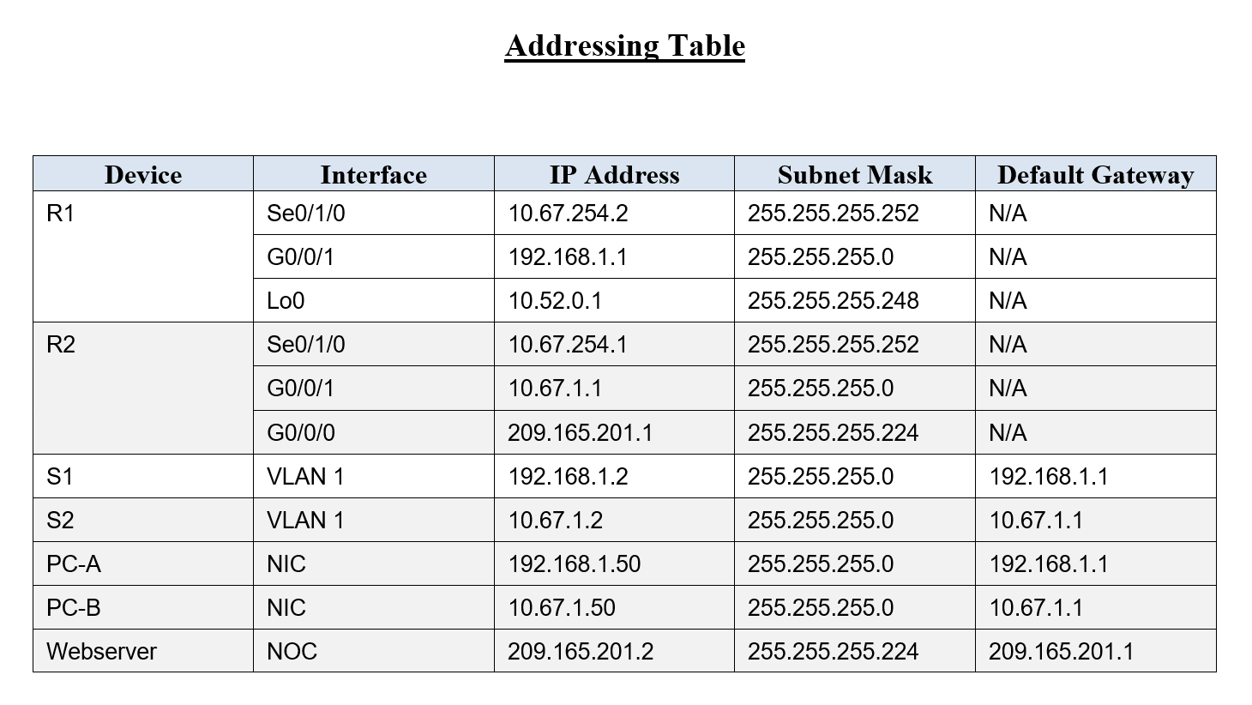

Part 2: - Device Configuration and Network Connectivity (85 marks)
1. Basic Configuration: (On all devices)
a. Configure hostname on all devices.
b. Disable DNS lookup!
c. Configure all devices with IP address shown in the above tables and network topology.

ON Route R1 and R2 do the following configurations
d) Domain name ensa.com
e) Encrypted privileged EXEC password cisco123
f) Console access password cisco123
g) Create an administrative user in the local database
Username: admin
Password: cisco123
h) Set login on VTY lines to use local database
i) Set VTY lines to accept telnet connections only
j) Encrypt the clear text passwords
k) Generate an RSA crypto key 1024 bits modulus

2. Single Area 0 OSPF Configuration
a) Configure the OSPF routing process with process ID 10
b) Set Router ID, 1.1.1.1 on R1 and 2.2.2.2 on R2
c) Configure a network statement for each locally attached network using a wild card mask that matches each network’s subnet mask. NB Do NOT advertise the networks 192.168.1.0/24 on R1 and 209.165.201.0/27 on R2.
d) Configure all passive interfaces.
e) Configure the hello time for 15 seconds.
f) Configure the dead time for 60 seconds.
g) Configure Loopback0 as a point-to-point network for OSPF on R1
h) Configure a static default route with Gig0/0/0 as the exit interface on R2, then share the default information with other OSPF speakers.

3. Test network connectivity before applying ACL and NAT

Source | Target | Protocol | Expected Result
PC-A | PC-B | Ping | Failure
PC-B | http://209.165.201.2 | HTTP | Success
PC-A | 209.165.201.1 | telnet | Failure
PC-B | 209.165.201.1 | telnet | Success

4. Network Address Translation
The decision has been made that the entire organization should be using addresses in the 10.0.0.0/8 network space. R1’s LAN is out of compliance. There are applications and services running in the R1 LAN that cannot have their IP address changed without the entire system being rebuilt, so NAT is in order. Here are the configuration tasks at R1:
Task | Specification
Create an ACL to identify hosts allowed to be translated | Create an ACL that matches the 192.168.1.0 network. Use Standard numbered list 1
Configure Port Address Translation on the outside interface of R1 | Configure the NAT association between the ACL and the interface Se0/1/0 so that it uses port address translation
Identify the interfaces involved in NAT | Specify inside or outside on the appropriate interfaces

5. Test network connectivity after applying NAT.
Source | Target | Protocol | Expected Result
PC_A | PC-B | Ping | Success
PC-A | http://209.165.201.2 | HTTP | Success
PC-A | 209.165.201.1 | telnet | Success
PC-B | 209.165.201.1 | telnet | Success

6. Configure Access Control on R2

Create and apply an extended access control list on R2 named R2_SECURITY to do the following:
Task | Specification
Create an access control list | R2_SECURITY
Control HTTPS traffic | HTTPS is not allowed to the address 209.165.201.2 from any network
Control HTTP traffic | PC_B not Allowed to access 209.165.201.2 using HTTP
Permit traffic | All other traffic, regardless of protocol, is allowed
Apply the ACL | Filter traffic originating from both R1 and PC_B

7. Test network connectivity after applying ACL.
Source | Target | Protocol | Expected Result
PC_A | PC-B | Ping | Success
PC-A | https://209.165.201.2 | HTTPS | Failure
PC-A | 209.165.201.2 | HTTP | Success
PC-B | 209.165.201.2 | HTTP | Failure

8. Layer 2 security on S1 and S2

a) Shut down all unused ports.
b) Enable port security.
c) Allow only one MAC address to be learned by each port before a violation occurs.
d) Configure sticky Mac addresses.

On S1
e) Configure the ports to send Syslog notification and drop packets from MAC addresses that exceed the maximum number that is permitted. Note the port should NOT be SHUTDOWN.

On S2
f) Configure the ports to send Syslog notification and drop packets from MAC addresses that exceed the maximum number that is permitted. Note the ports should SHUTDOWN when security is violated.

6. Configure CDP, LLDP, and NTP

a) Configure R2 to use the sever at 209.165.201.2 as NTP Server
b) Disable CDP on R2
c) Enable LLDP globally on R2.
d) On R2, configure the link to S2 to only receive LLDP messages.
e) Disable CDP on S2
f) Enable LLDP globally on S2.
g) On S2 switch, configure the link to R2 router to only send, not receive, LLDP messages.
h) Disable LLDP completely on access port fa 0/18 that is in use.

Diwedd/End

