
17/12/2025


Module Name: Computer Architecture and Operating Systems
Module Code: ACCA 4022
Student Name: Ma. Crystal Pearl Grajewski
Student ID: 2442405
Group: 1
Lecturer’s Name: Redhwan-Al-Amri
Assignment
Computer Architecture and Operating Systems
University of Wales Trinity Saint David
LONDON CAMPUS

Table of Contents
Introduction 2
Main Body 2
Task 1 Operating system…………………………………………………………………………..3
Task 2 Windows CLI Command………………………………………………………………..13
Task 3 Linux CLI Command……………………………………………………………………..19
Task 4 Windows OS Scripts…………………………………………………………………..…24
Task 5 Linux OS Scripts…………………………………………………………………………..28
Conclusion…………………………………………………………………………………32
References…………………………………………………………………………………33

Introduction
This assessment 2 in Computer Architecture and Operating System are focus on fundamental component of computer system. Operating System is responsible for managing software and hardware operation, providing essential services for users and applications. The main function of Operating System is to act as interface for the user and a resource manager. Popular operating systems include Microsoft Windows and Linux which are widely uses as personal, academic and enterprise purposes.
In this assessment also explore the basic use of Command Line Interface (CLI) in Windows and Linux, a method where text based-command is used to interact with operating system in your device. In parallel to GUI or graphical user interface, CLI allows user to perform efficiently to automate processes and gain more and deeper control in system device. You can use cmd or Command Prompt or PowerShell in Windows or Linux OS.
Basic and fundamental use of Batch and Bash scripting are also mentioned, define and provided sample in this assessment. Scripting in Windows and Linux enable to execute and automate repetitive tasks, at first doing this is hard but when you use to do this, it’s helpful and efficient when you want to control and gain deeper access to your device. Scripts enhance productivity and manage system operations effectively.

Main Body
This aseesment consist of 5 tasks:
- Key functions of Operating System
- Use of Windows OS CLI commands
- Use of Linux OS CLI commands
- Use of Windows OS scripts
- Use of Linux OS scripts

Task 1
Key functions of general Operating Systems
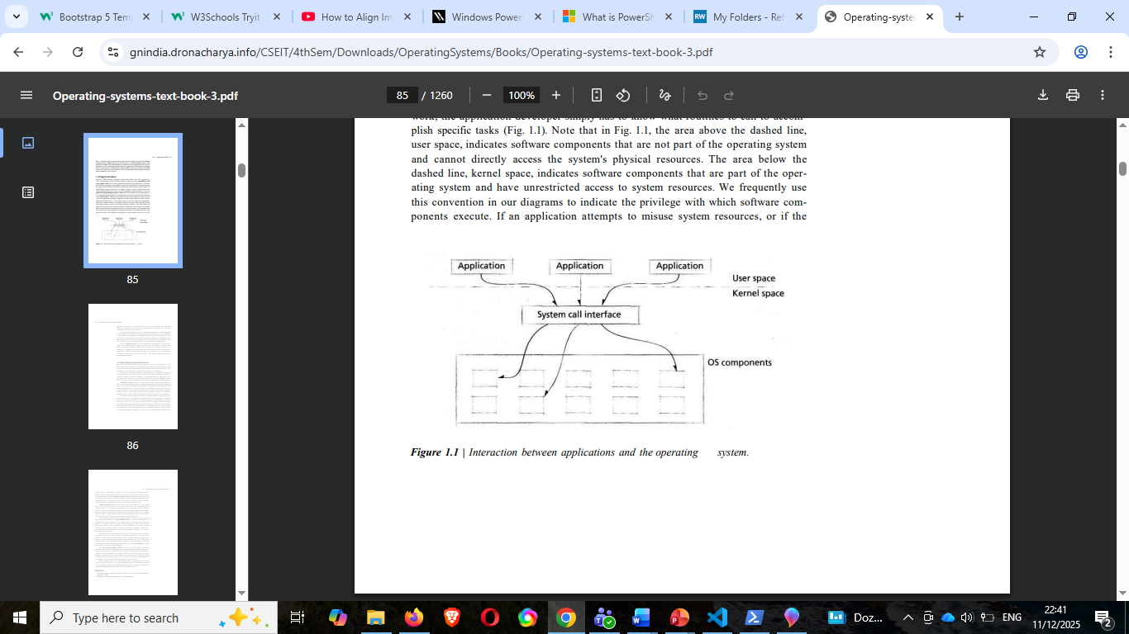
In the past OS could have been describe as “software that controls hardware” to simplify, nowadays computer systems evolved overtime and expand also the definition of Operating System. As of today, hardware execute different software applications, increases utilization, and applications are designed meticulously to avoid interfering one another resulting of software application on what we called Operating System. To users’ point of view, it serves as “black box” between the application and the hardware giving correct input and output [1]
Figure 1 Interaction between application and Operating System [1]
Technology have evolved from early system that Operating System went to multiprogramming machines, not only in computer but also appliances technology based like printer, washing machine, microwave etc.
In short, an Operating System is the controller that execute application programs at the same time acts as interface between the application of the computer and its hardware with the goal: to provide convenience and efficiency. The Operating System has two major aspects, managing hardware which the OS acts as user/computer interface and managing software, OS acts as a resource manager [2]

Operating System main functions:
1. Process, and Memory Management- this Is about managing processes, this is a running program in the computer that process the application cycle from the start until finish usage of a computer. It includes scheduling using algorithm or priority scheduling, synchronization, deadlock handling, and Inter-Process Communication (IPC) Memory Management- controls how data is stored ensuring programs gets the memory they need and freeing it when no longer needed. Activities such as allocation and deallocation, where assigning memory happen, protectiin to prevent interfering each other memory, virtual memry using disk space as an extra space for large data and disk manangement responsible for handling file storage, freeing space, disk scheduling and backups [3]. Sample image below.
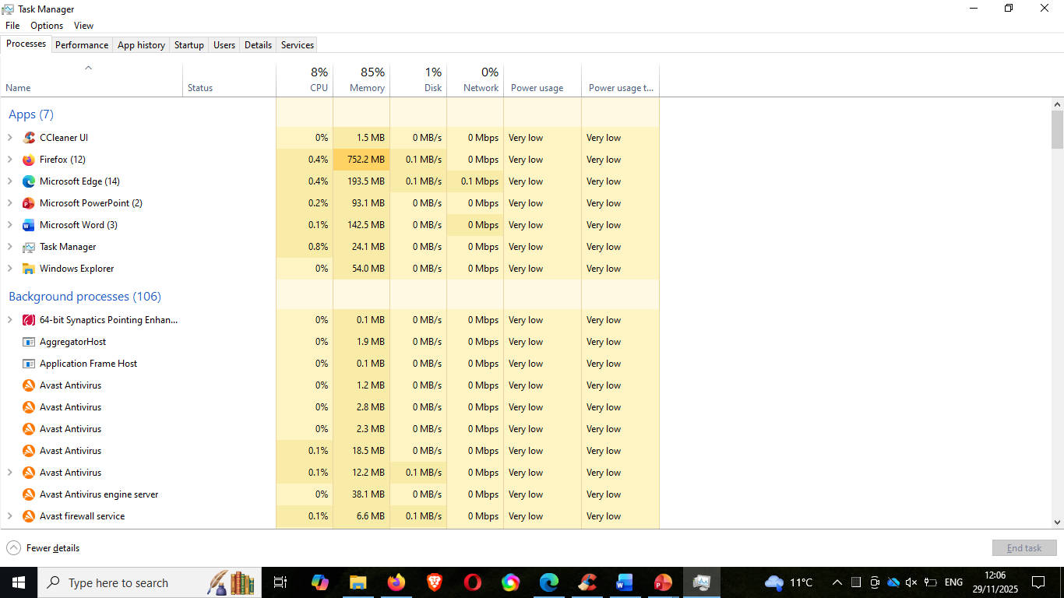
Figure 2 Windows Task Manager- using task manager
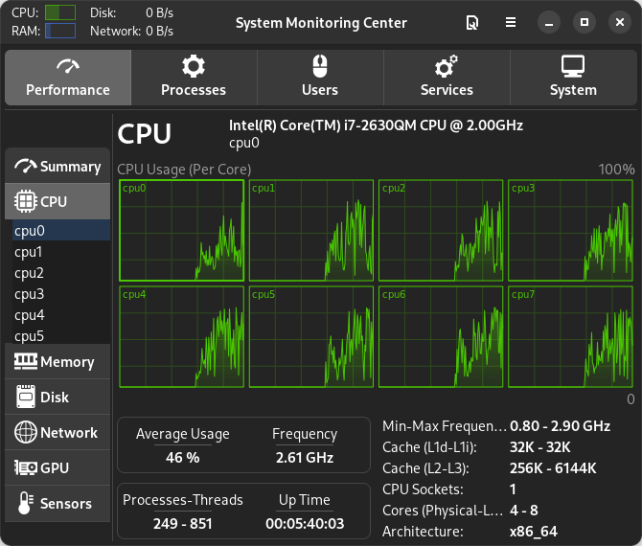
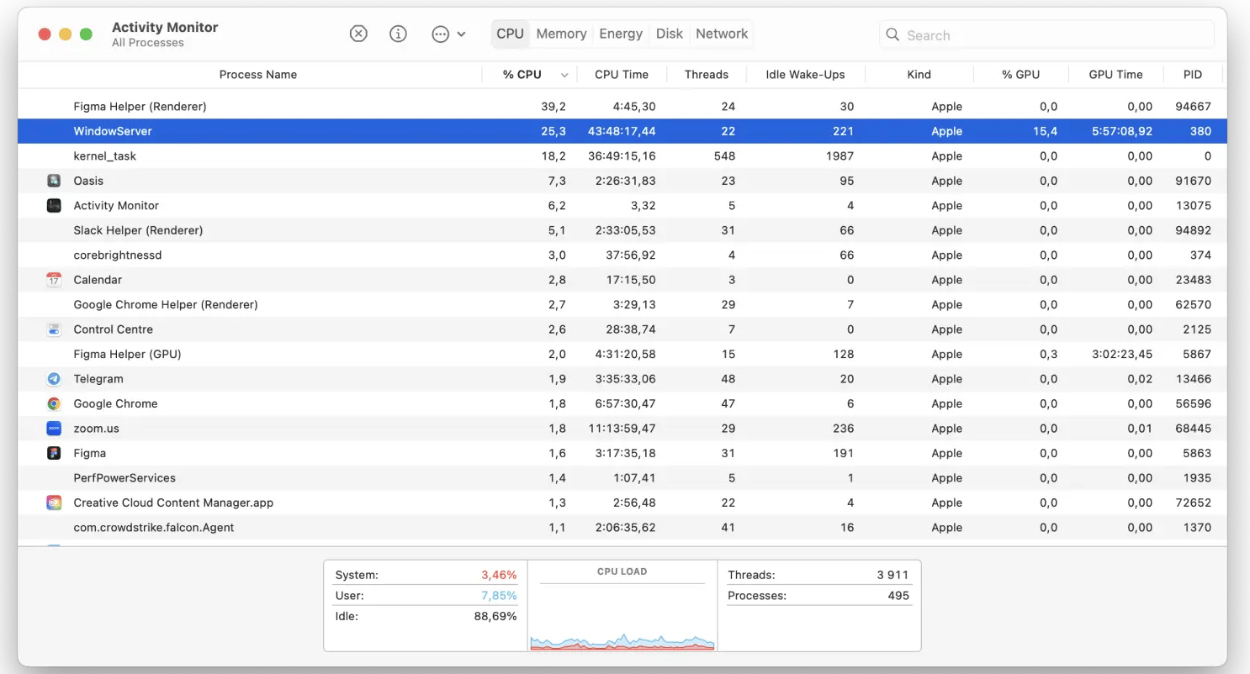
Figure 3 Linux using System Monitor [4]
Figure 4 MacOs using Activity Monitor [5]

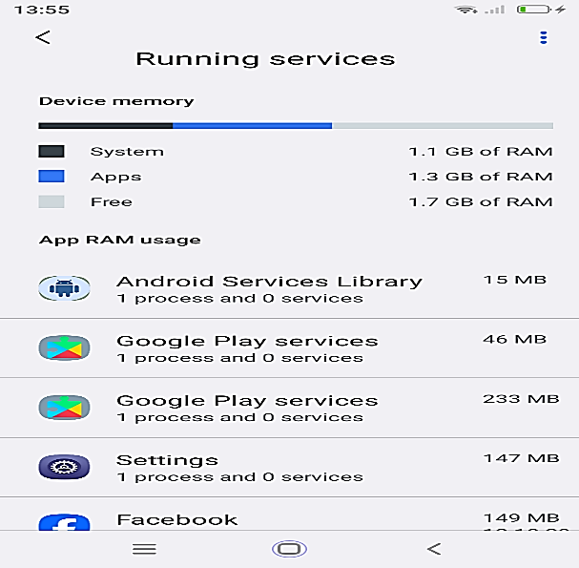
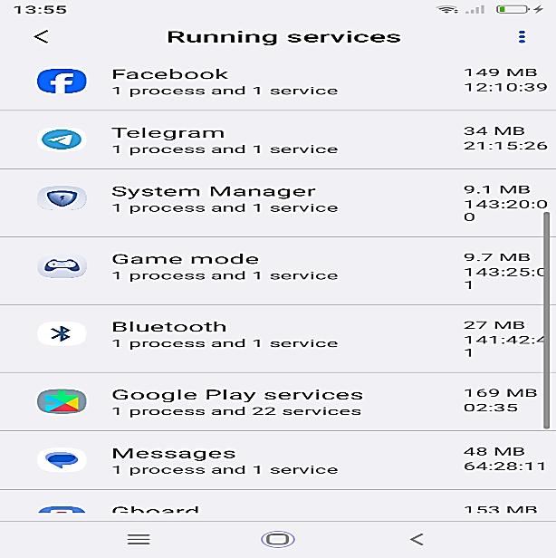

Figure 5 Android Phone Running Services (sample of Process management)

2. Device Management: OS controls how the computer or any devices communicates such as peripheral devices like printer, disks, mouse etc. components in Device mangement are device drives which is interface between hardware and OS, buffering and caching where storing temporarily data is needed to match device peromarmance and speed and spooling which waitig data is processed [3]

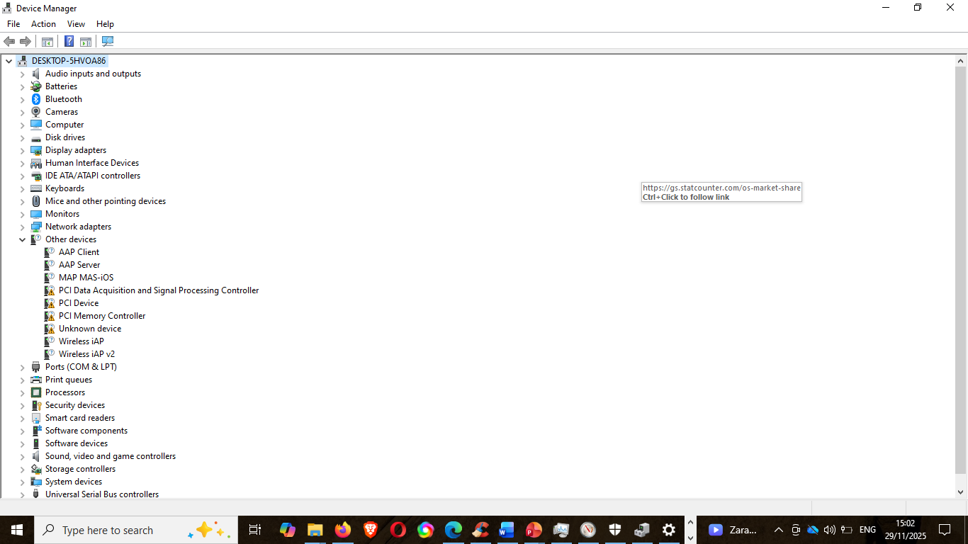

Figure 6 Windows Control Panel

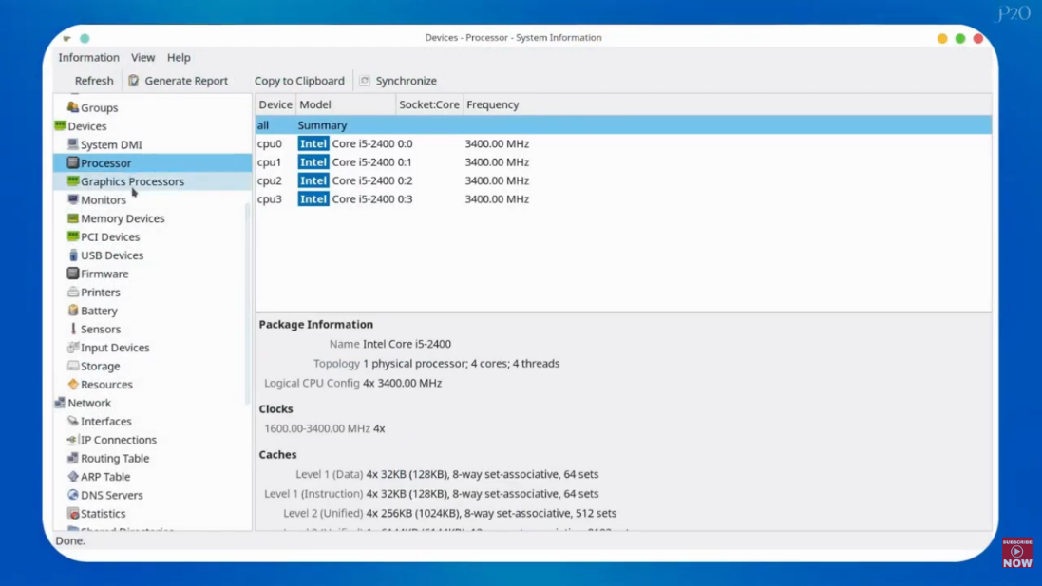

Figure 7 Linux Device Manager using HardInfo software [6]

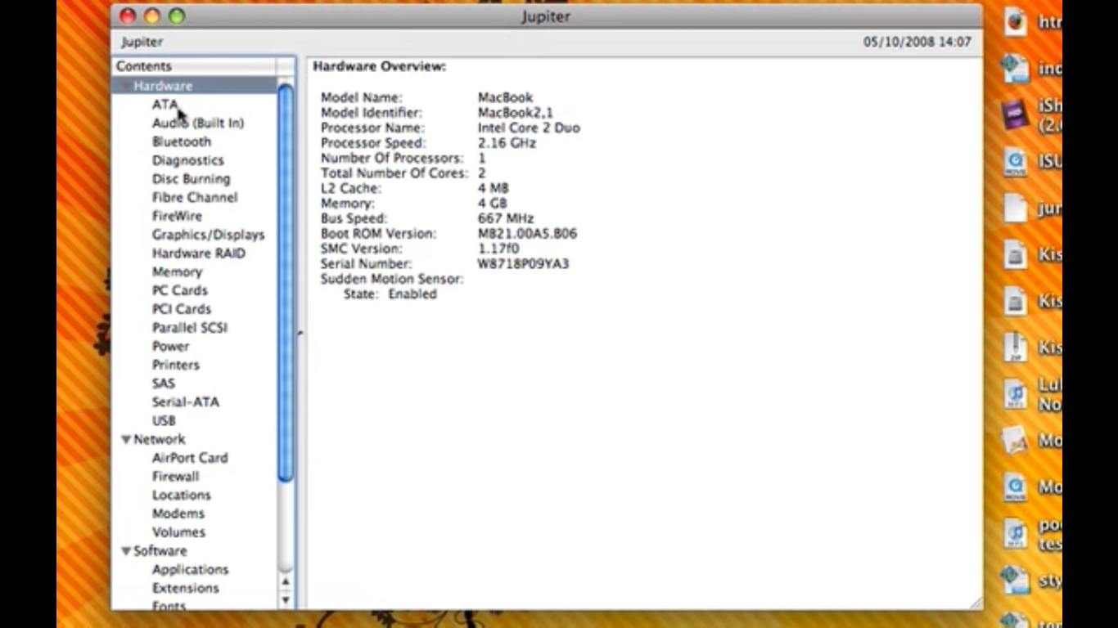

Figure 8 MacOs view in System Profiler [7]

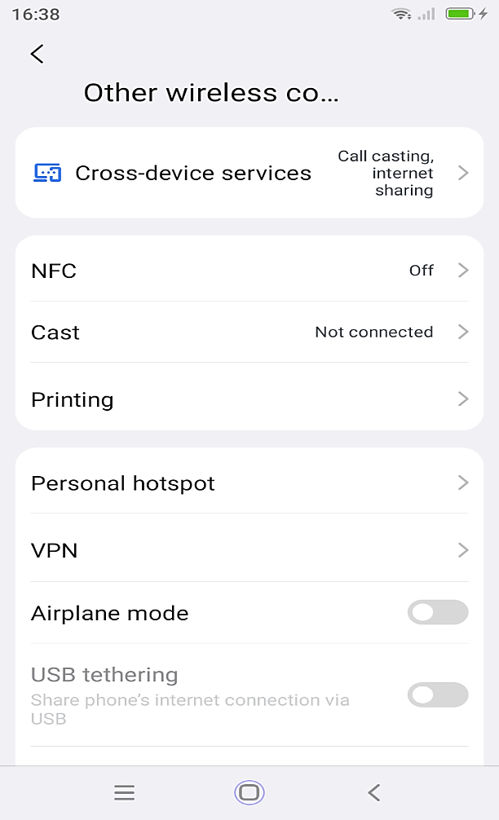
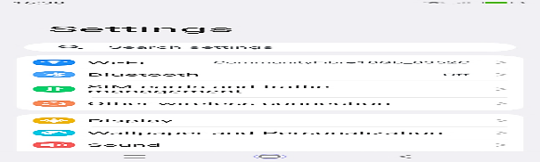

Figure 9 In android phone, device Manager spread across the settings, sample photo of Blackview Android phone

3. File System Management: organize and control how data stored, saved, named and easier access on the storage. Files Management manage file attributes, file types, operation, and access method.
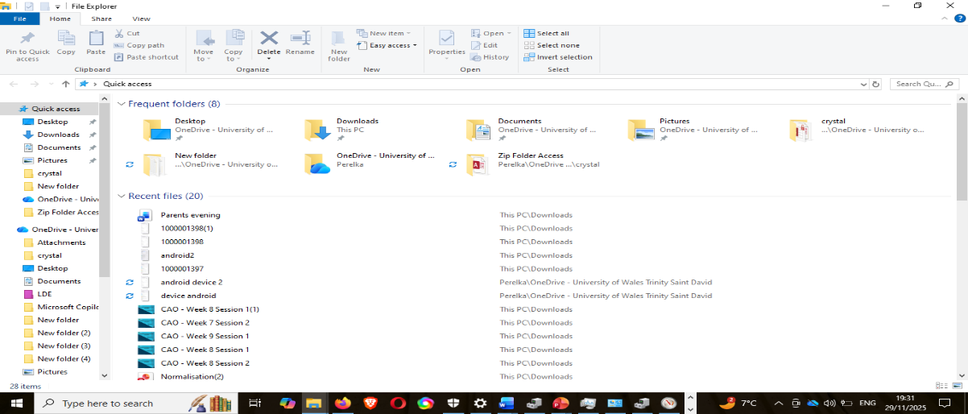
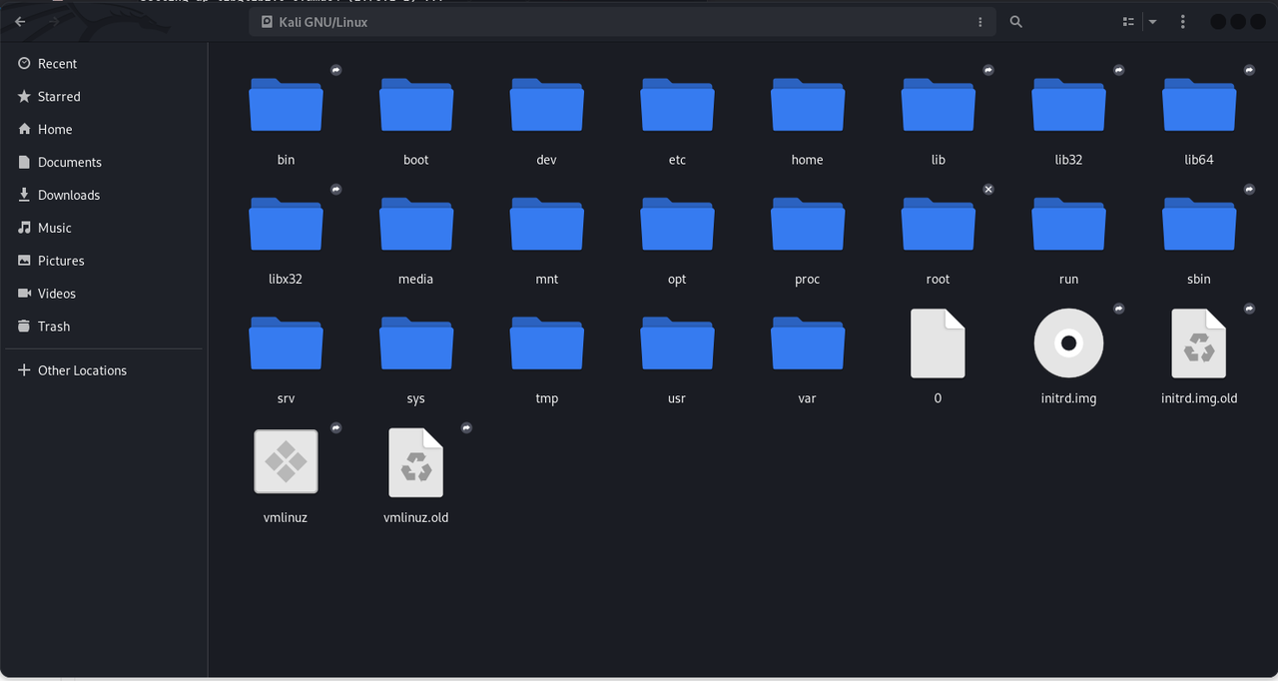
Figure 10 access File Management via File Explorer in Windows

Figure 11 File manager, Dolphin default manager for KDE Plasma Environment
(A built-in terminal emulator, which lets you run linux terminal commands in file
manager) [8]
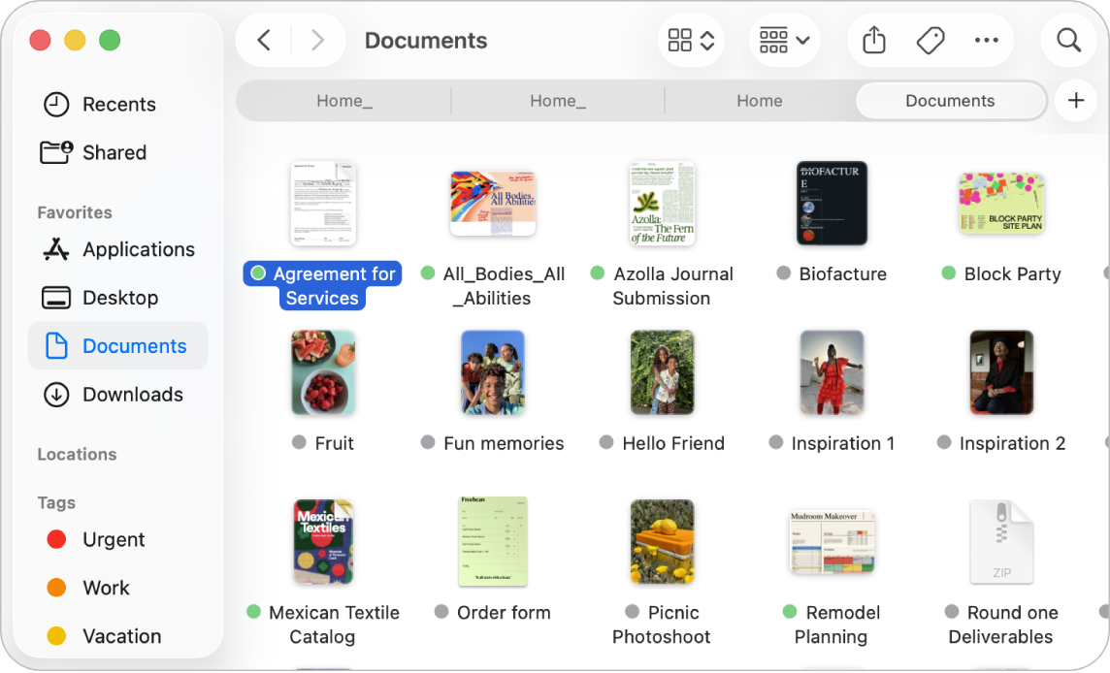
Figure 12 Finder View (MacOs) [9]
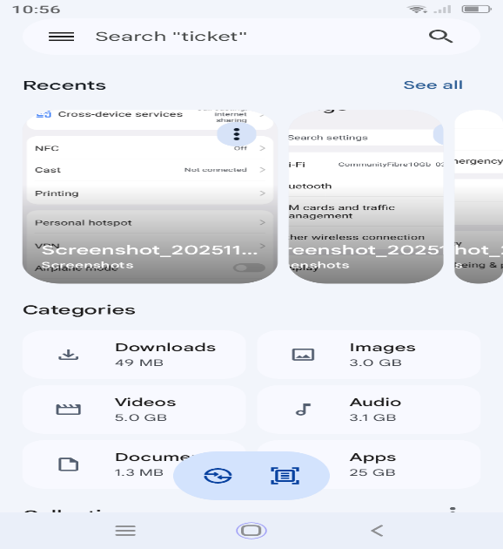

Figure 13 Sample File Manger on Blackview Pro Android phone

4. Protection and Security Management: created to protect system resources for unauthorized access. This is to control which users can access ensuring authorized users can do specific action. This include access control to limit and process permission, authentication for verifying users, resource protection prevents misuse of data, and security to guard against attack, theft viruses etc [3]

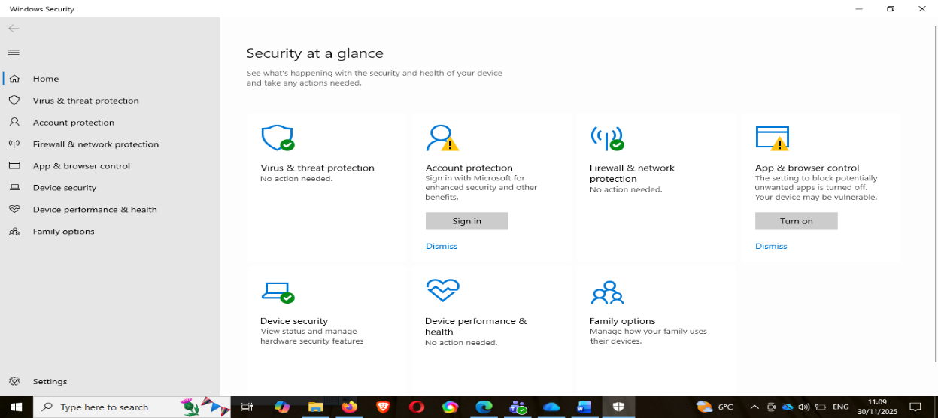
Figure 14 Windows Security

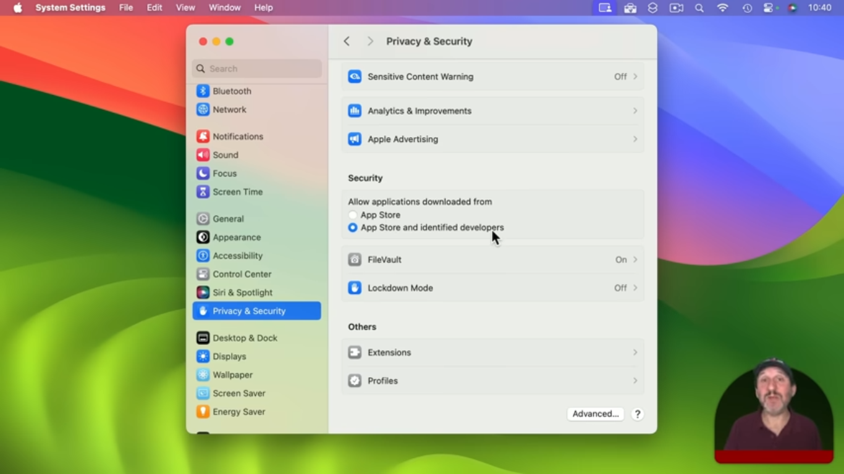
Figure 15 Mac Privacy and Security [10]

Task 2
Use if Windows OS CLI commands
CLI Commands: a line program that uses text input to execute operating system. Use in the old days to interact with computers unlike now that mostly use graphical user interfaces (GUI). However, CLI used by software developers and system administrators for configuration, installing software and accessing features that are not available in UI [11]
What is PowerShell?
PowerShell is a cross-platform task automation solution that made up of a command-line shell, a scripting language, and a configuration management framework that runs on Windows, Linux, and macOS.
PowerShell is a modern command shell that includes the following features:
- Robust command-line history
- Tab completion and command prediction
- Supports command and parameter aliases
- Pipeline for chaining commands
- In-console help system, similar to Unix man pages
Scripting language
PowerShell as a scripting language is widely employed for automating management of systems. It's also utilised to build, test, and deploy solutions, frequently in CI/CD environments. PowerShell is built on the .NET Common Language Runtime (CLR). All inputs and outputs are .NET objects eliminating the necessity to parse text output to extract information, it incorporates the following features:
- Extensible through functions, classes, scripts, and modules
- Extensible formatting system for easy output
- Extensible type system for creating dynamic types
- Built-in support for common data formats like CSV, JSON, and XML [12]

Sample command run in windows PowerShell:
- Command Help- provides all commands available in a device.
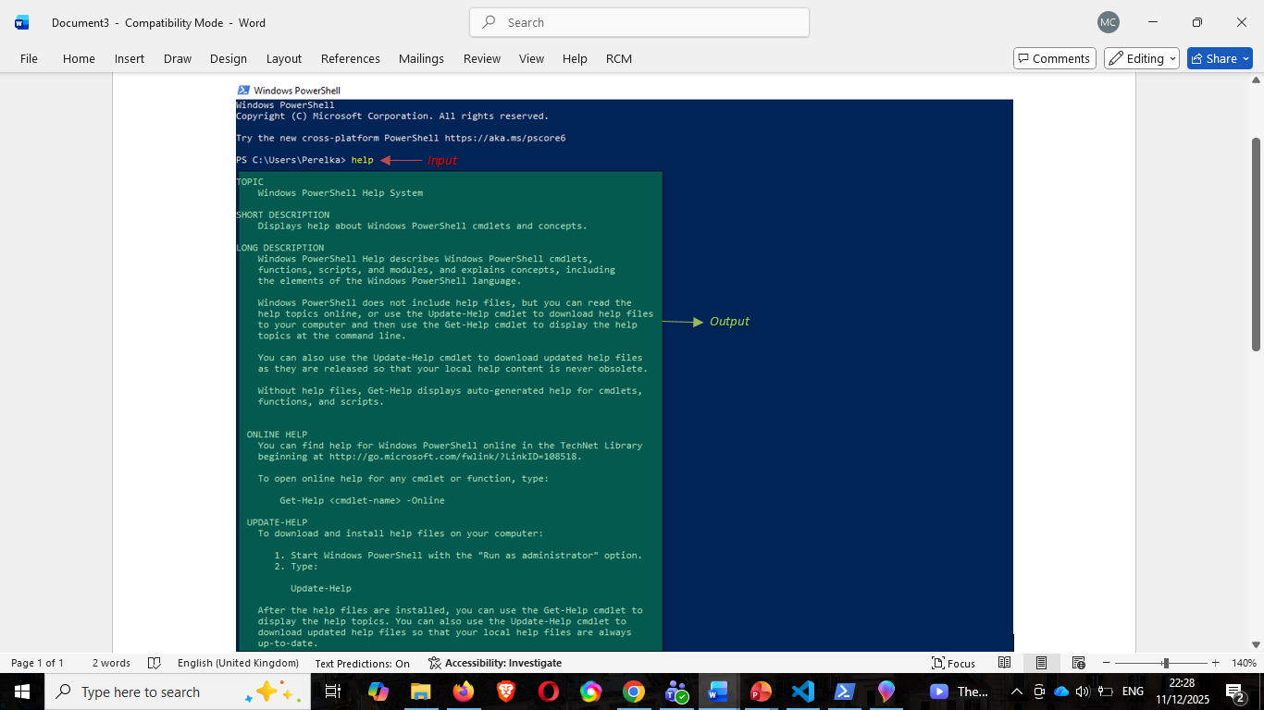
Figure 16

- Command Alias- run all available commands code called commandlets.
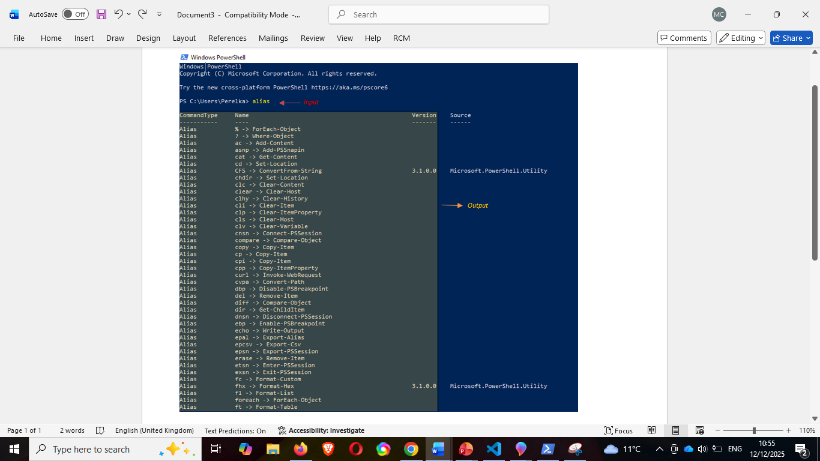
Figure 17

- Command Echo- command to put a text file.
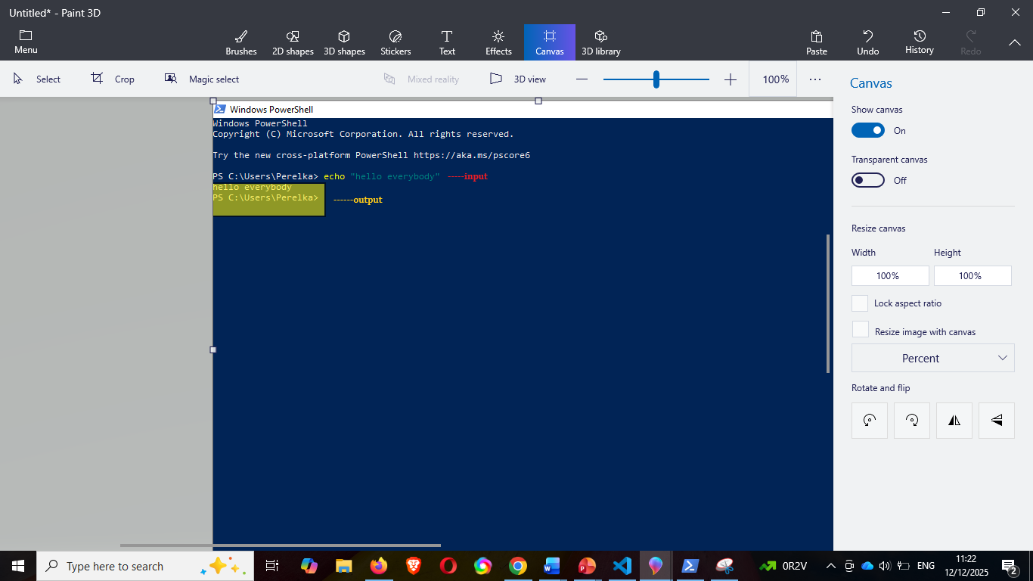

Figure 18

- Command ls- common use to list files in the current directory.
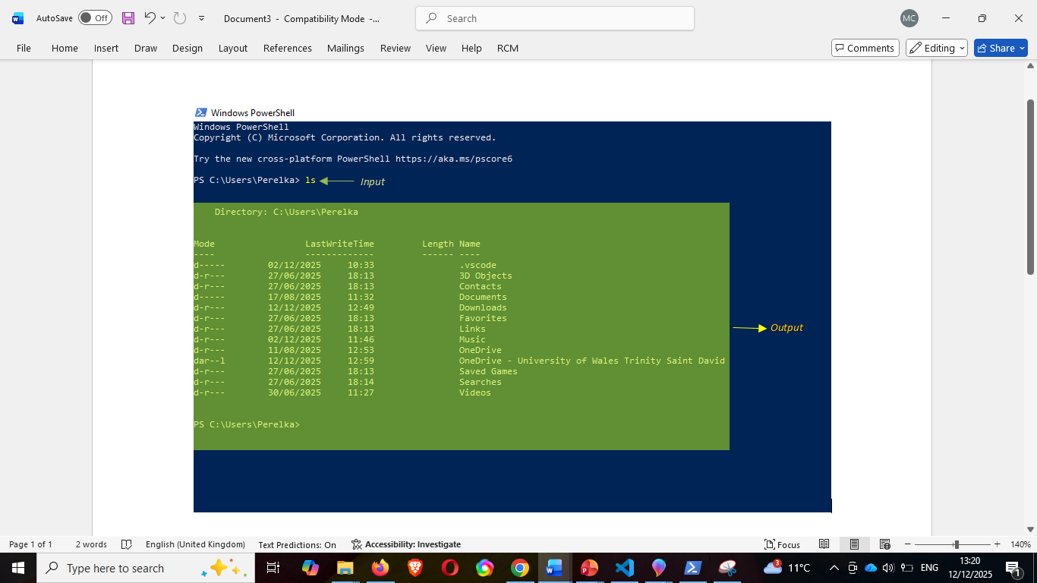
Figure 19

- Command mkdir- use to create folder/directory.
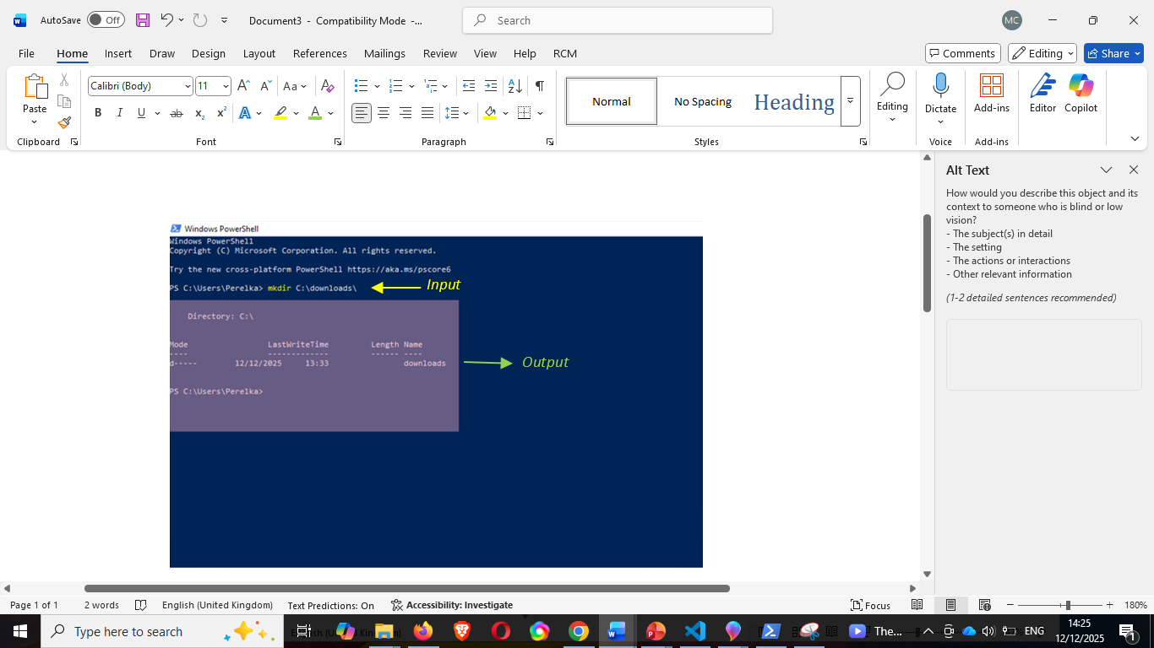
Figure 20

- Command Get-PSDrive- it gets the drive in the current session.
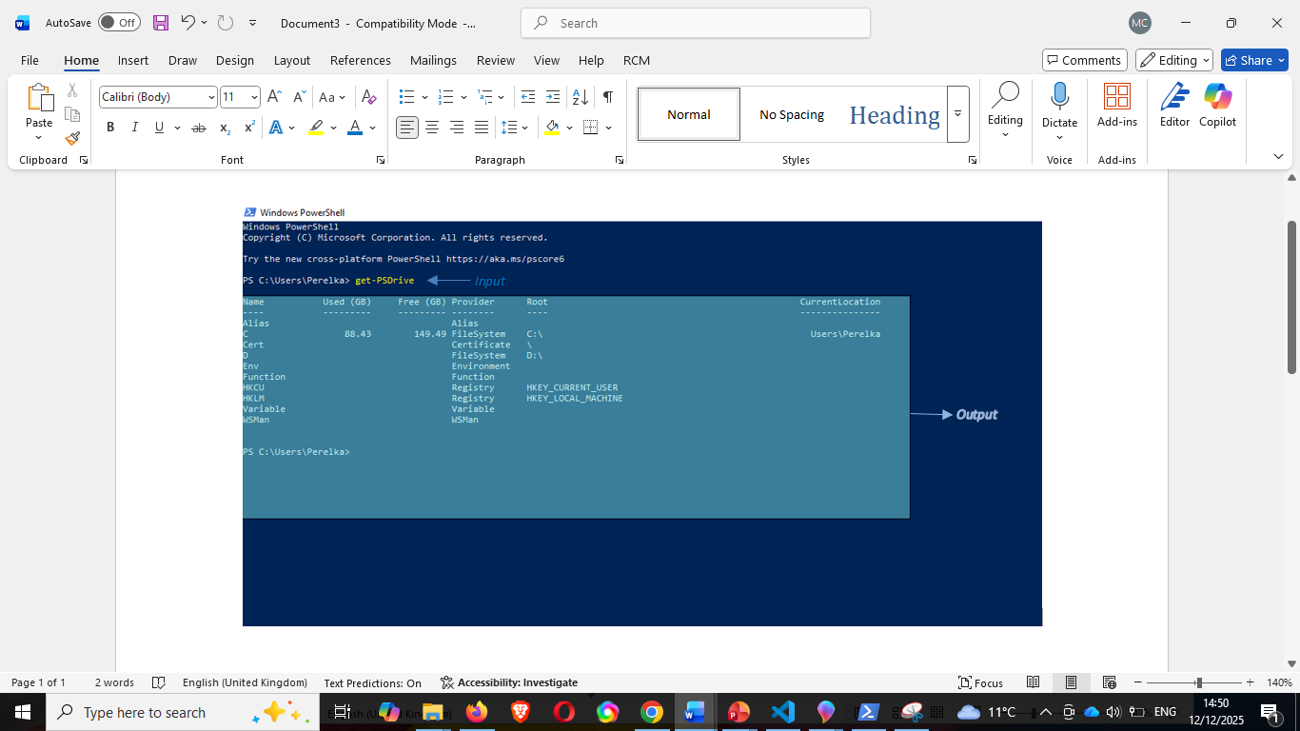
Figure 21

- Command Get-service- let you see or inspect services, status, troubleshooting issues or filtering based on name, or service.
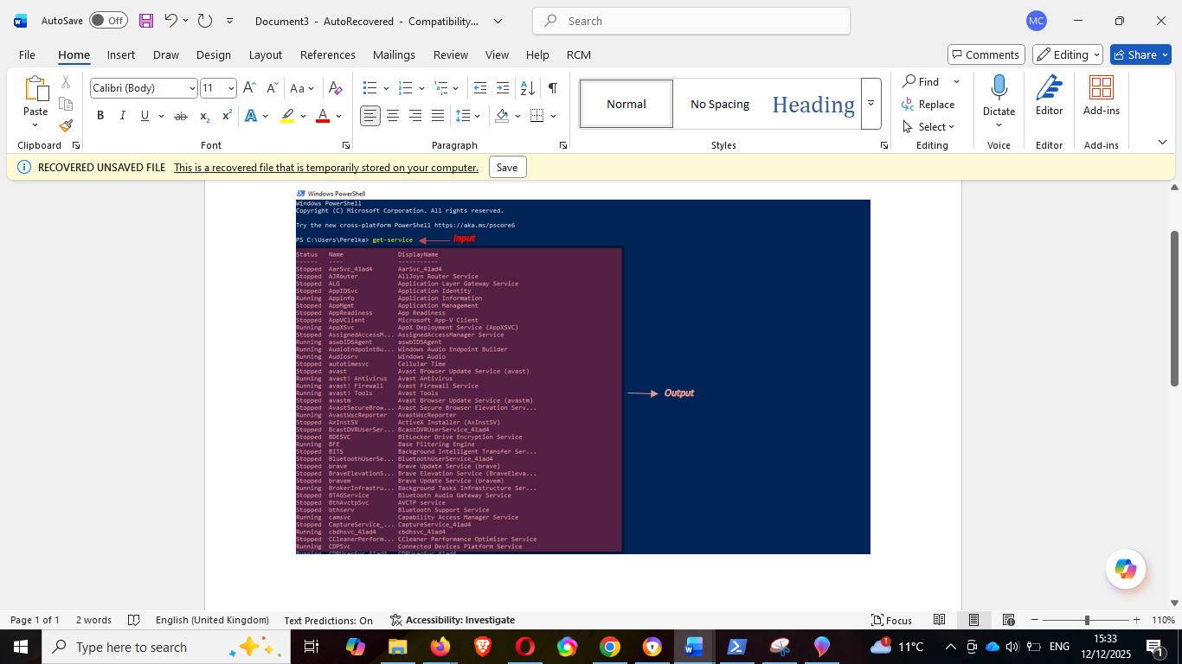
Figure 22

- Command Get-process- one of commandlet that lets get the processes on your local device/current directory.
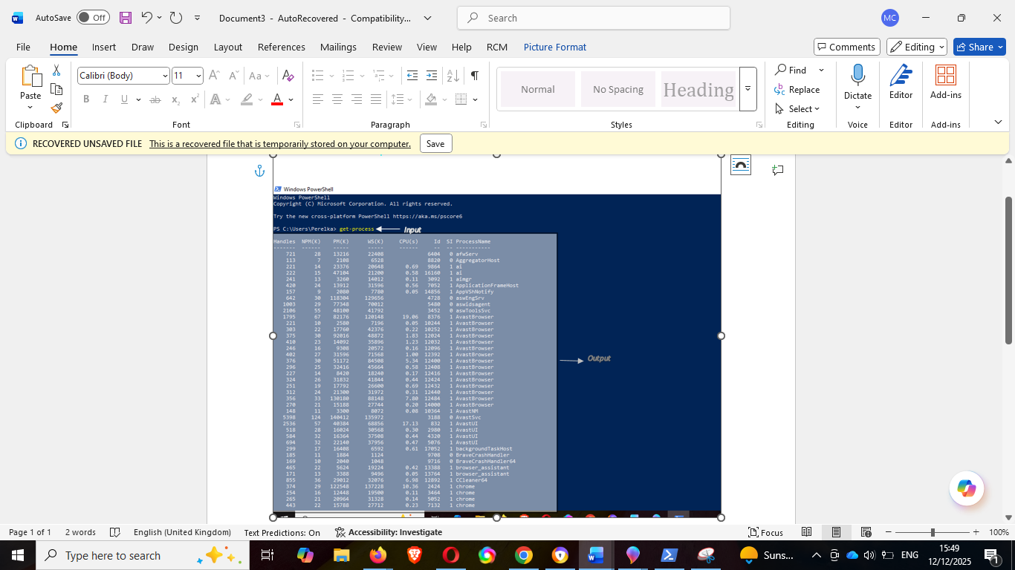
Figure 23

- Command Get-timezone- let’s you see the current time zone.
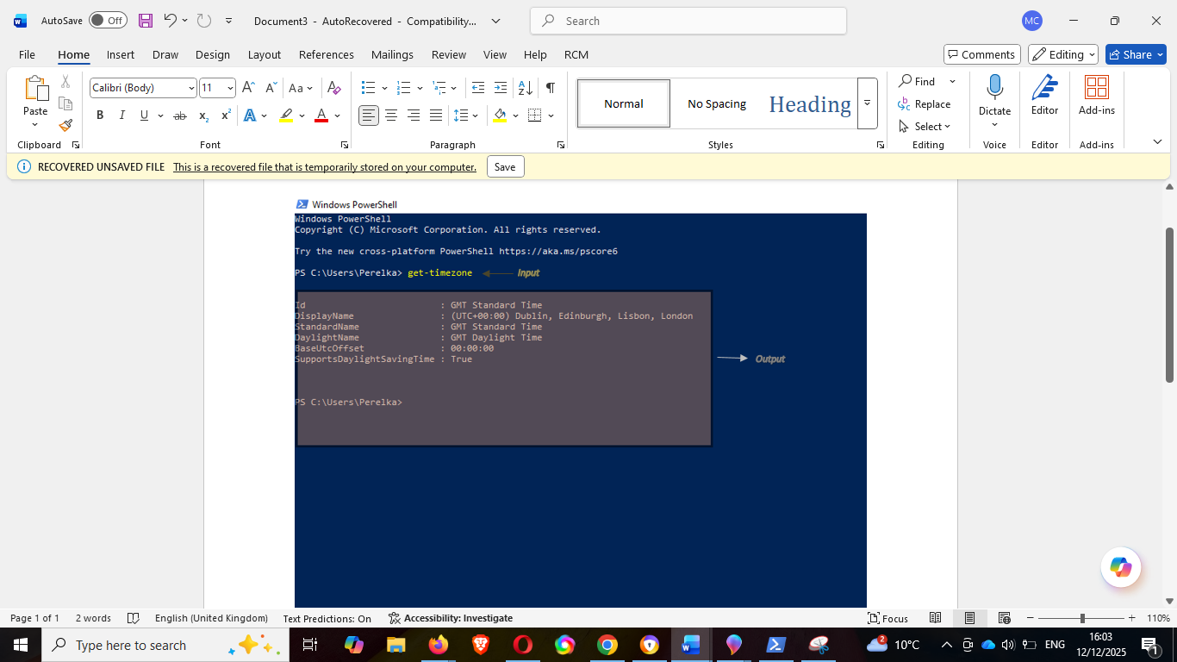
Figure 24

- Command Get-package- let you see the software packages installed in your local device
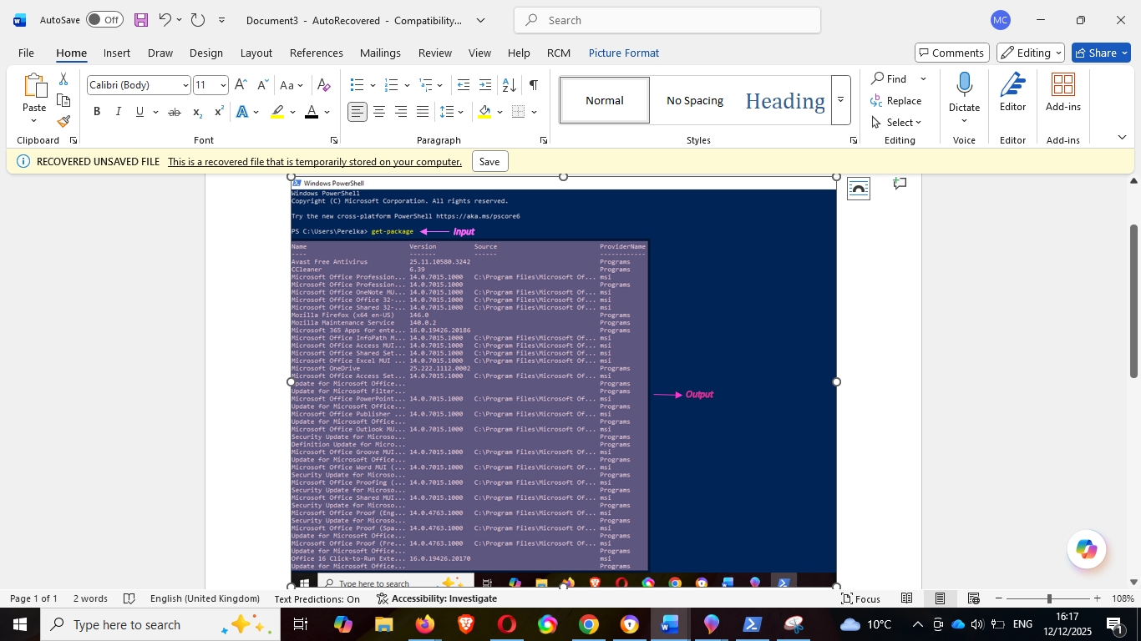
Figure 25

Task 3
Use of Linux OS CLI commands
-A type of Unix or shell procedure parallel to Windows OS commands.

1. Command pwd- stand for Print Working Directory, it will insert the complete pathname of the current place/directory into the output.
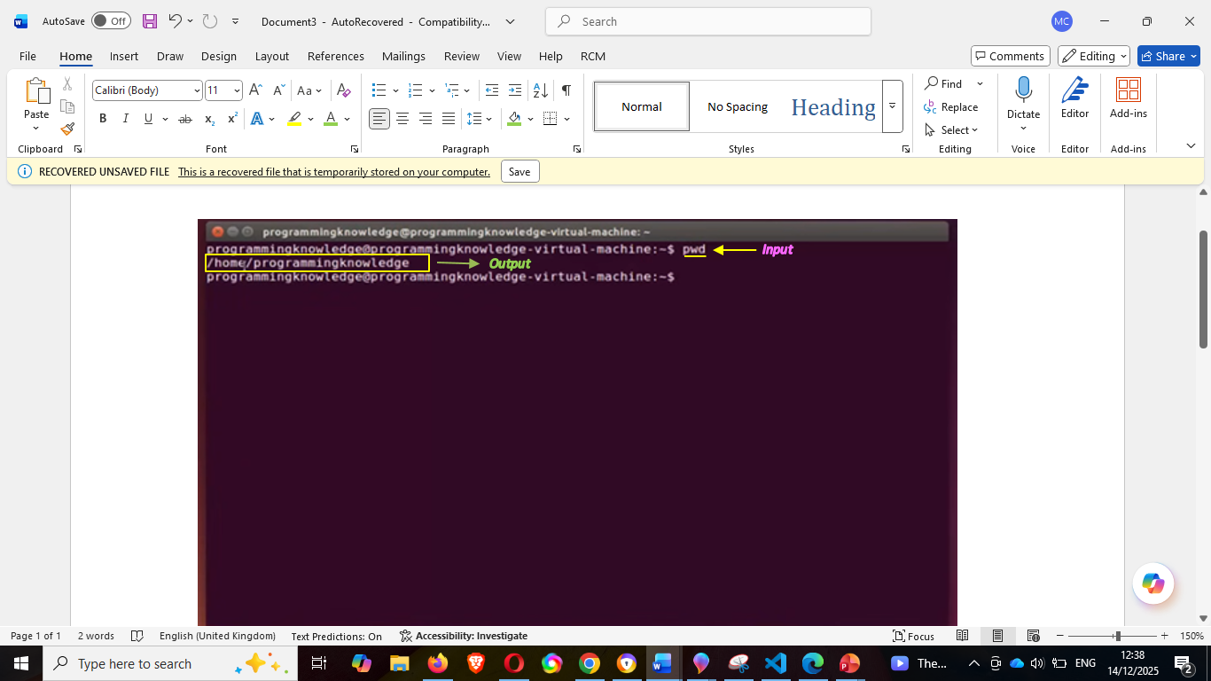
[13]

2. Command df and df- h- literally means ‘disk free’, tells you the information of file system disk space. Command df -h displays the information in human readable format [14]
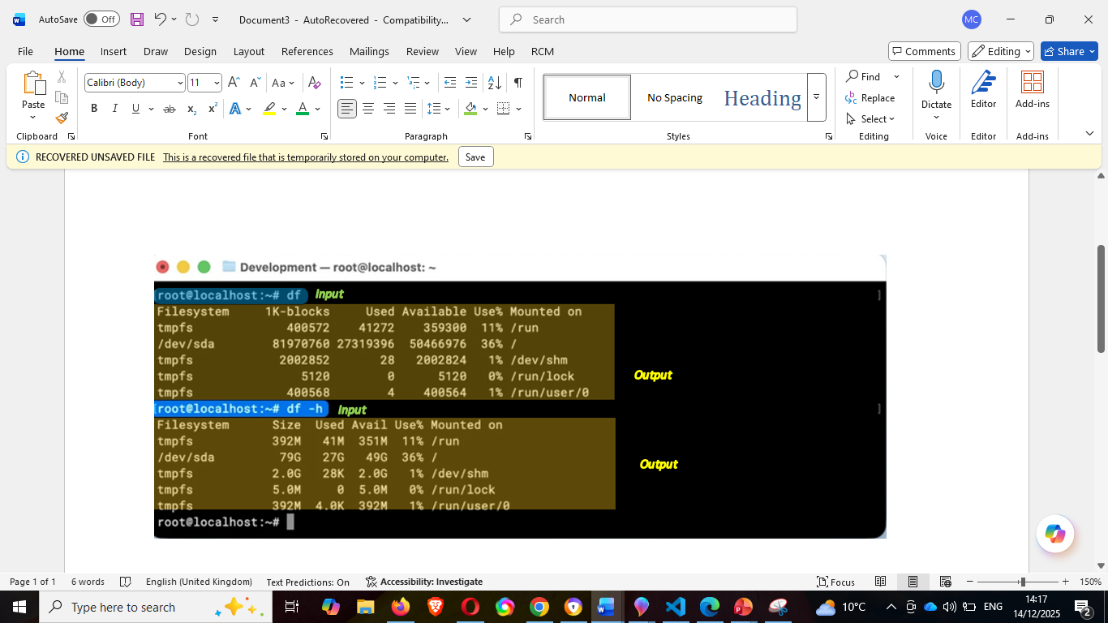
[14]

3. Command history- (without other option) let you see the previous command you executed. You can manipulate by adding command history with how many commands you want to retrieve ex. ‘history n’ etc.
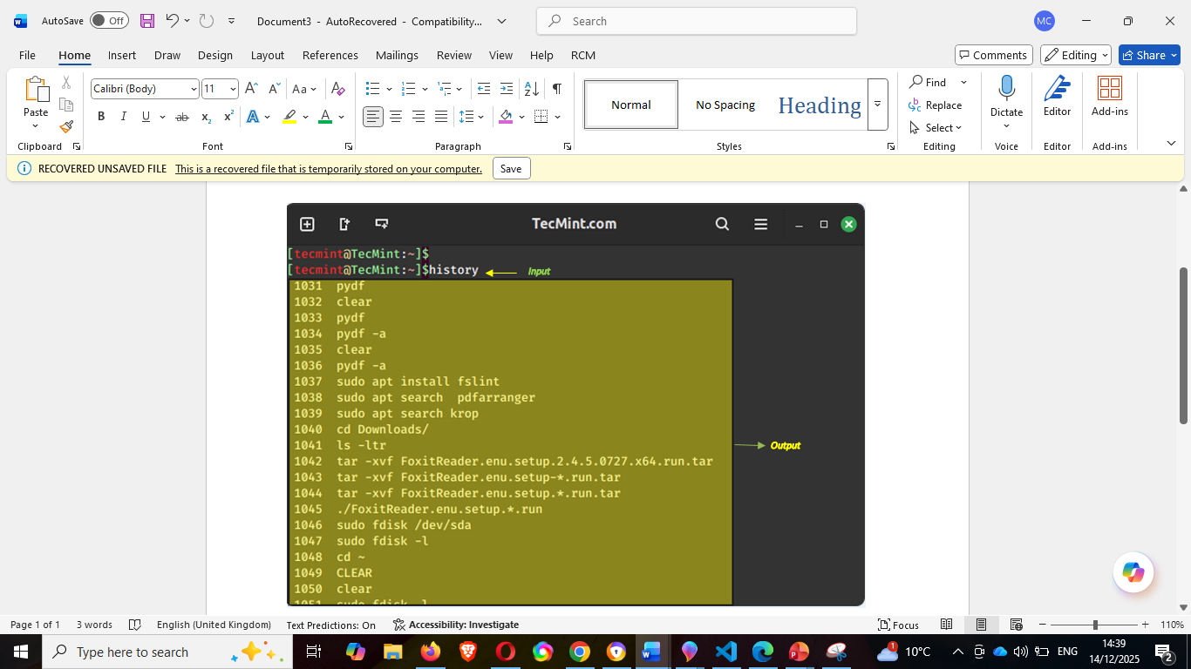
[15]

4. Command cal- shows calendar
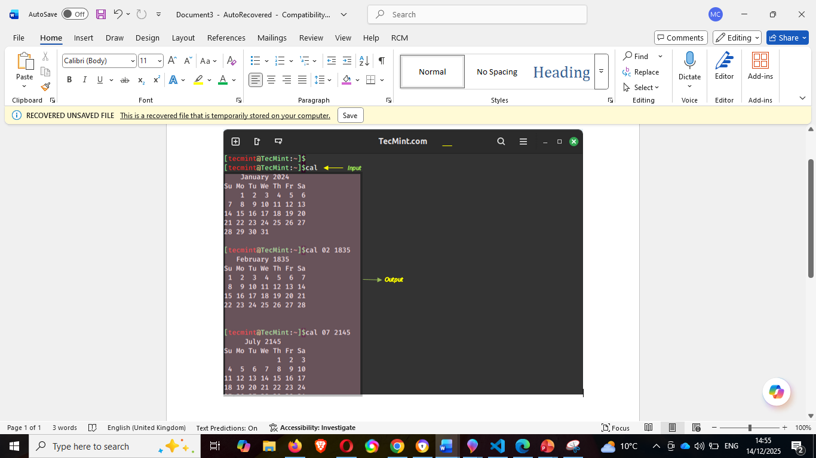
[15]

5. Command cd- stands for ‘change directory’ to execute this, run the current directory and change the directory [16]
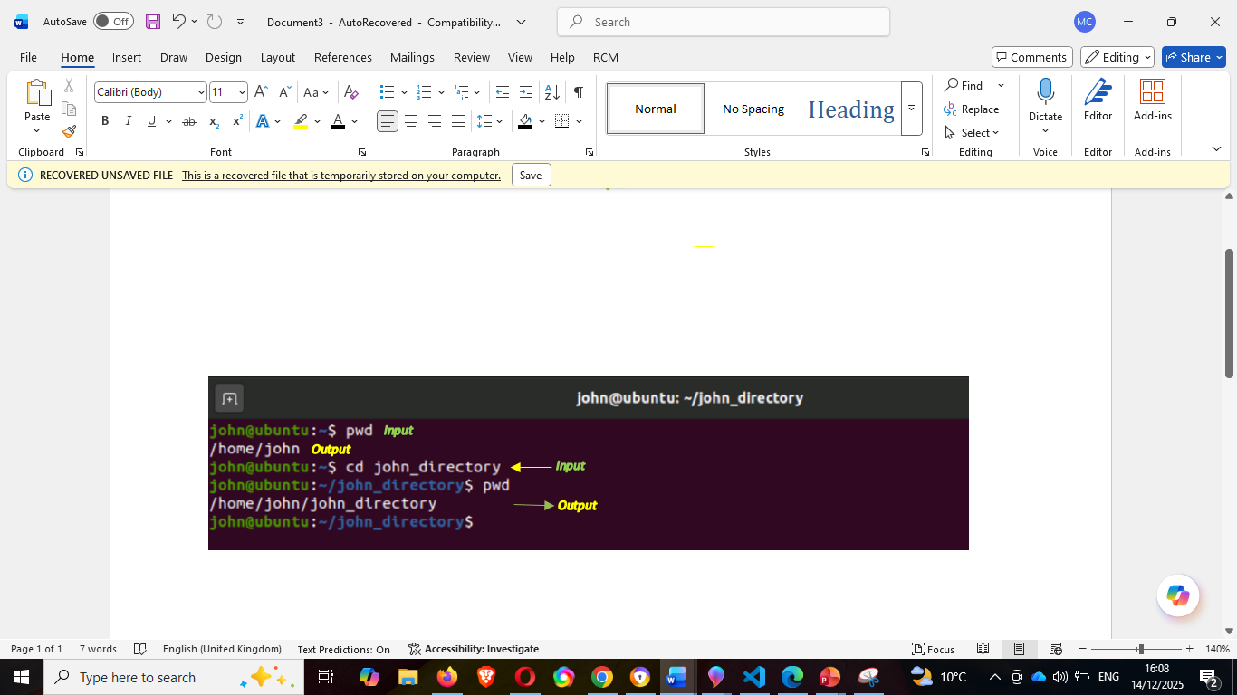
Figure 30 [16]

6. Command ip address show- specific command to show the scope or network parameter, in this example ip address to show. [17]
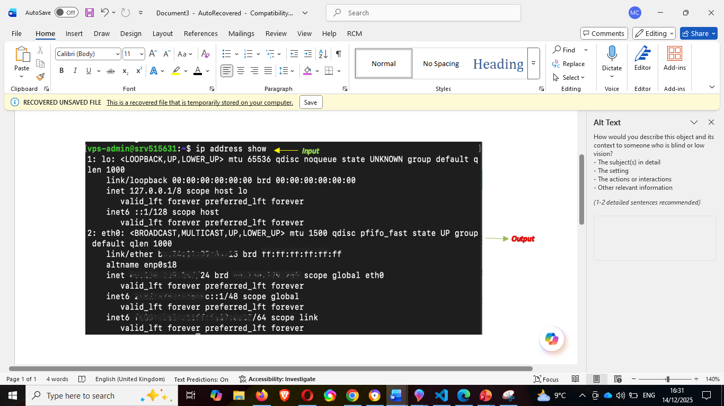
[17]

7. Command find- command that allows you to find or search files/directories [18]
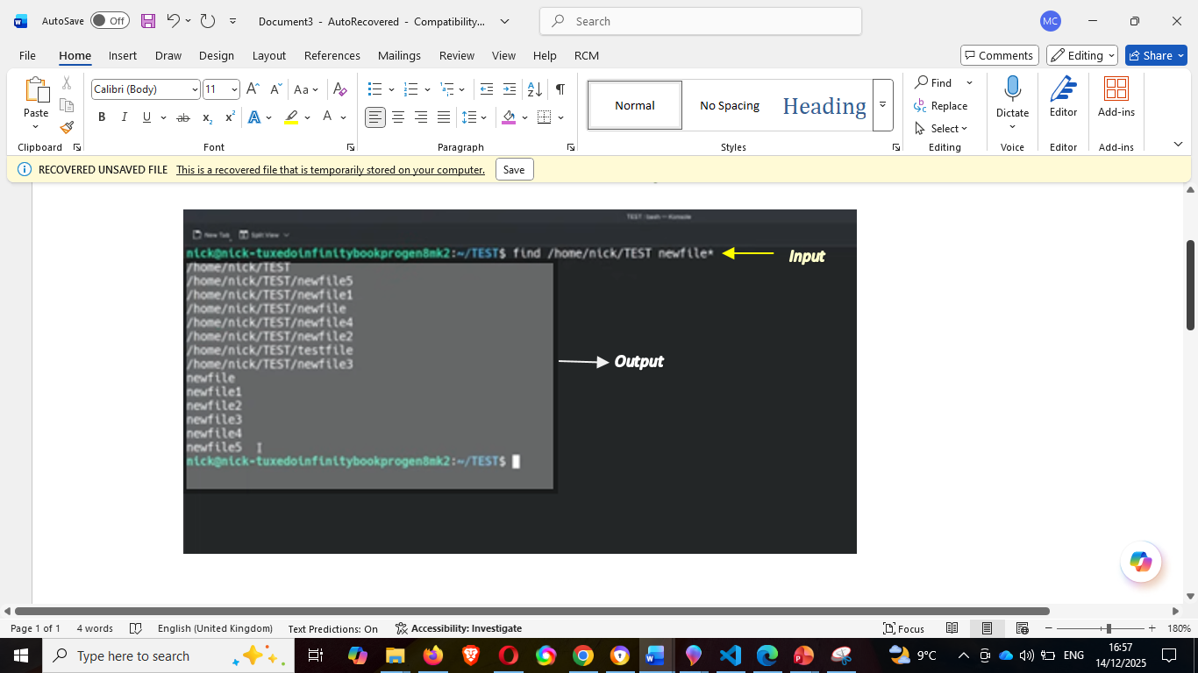
Figure 32 [18]

8. Command zip- type zip in the command line with the file/directory you want to compress. Sample given below [18]
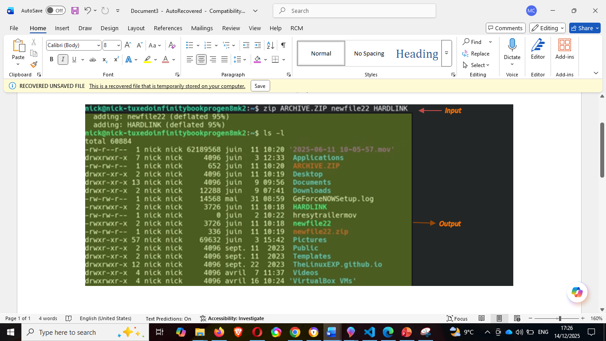
Figure 33
[18]

9. Command top- means table of process shows the real time view of running processes and kernel tasks in Linux.
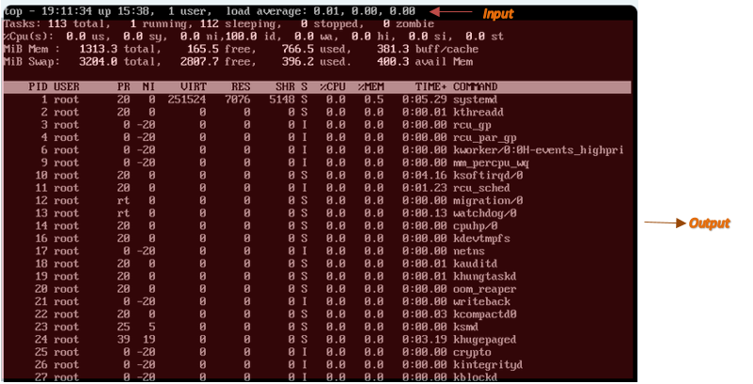
[15]

10. Command ls-a or ls -la – ls is list of files in alphabetical order ls-a gives you even the hidden files and ls -la command gives you better view.
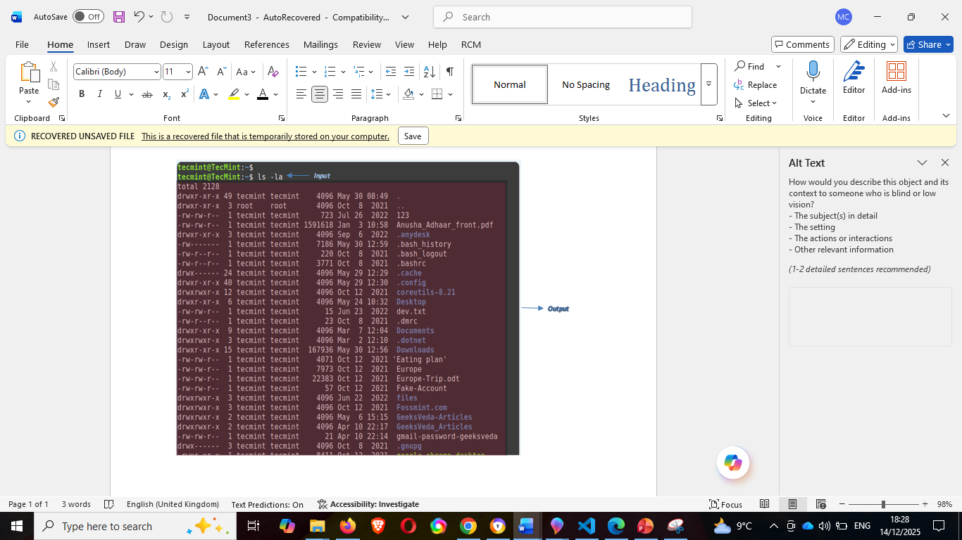
Figure 35 [15]

Task 4
Use of Windows OS scripts
-Windows OS scripts or batch scripting is a tool for automating tasks on windows. Batch scripts are stored straightforward text files containing command lines executed sequentially. Scripting is a method that enables one to alleviate this necessity by automating these command sequences, thereby simplifying and enhancing productivity. Batch Scripts feature:
- User input: Batch scripts can read user input for further processing.
- Decision-making Structures: supports control structures such as if, if/else and nested statement. It also supports looping command like for and while loops for enhanced automation and scripting capabilities.
- Advanced features: provides functions and arrays for more intricate operations.
- String Operations: includes support for string and string manipulation.
- Debugging: batch scripts comes with debugging capabilities to facilitate troubleshooting and error solution [19]
Here is sample of quite simple and basic execution of batch script using command-- echo, title, and pause.
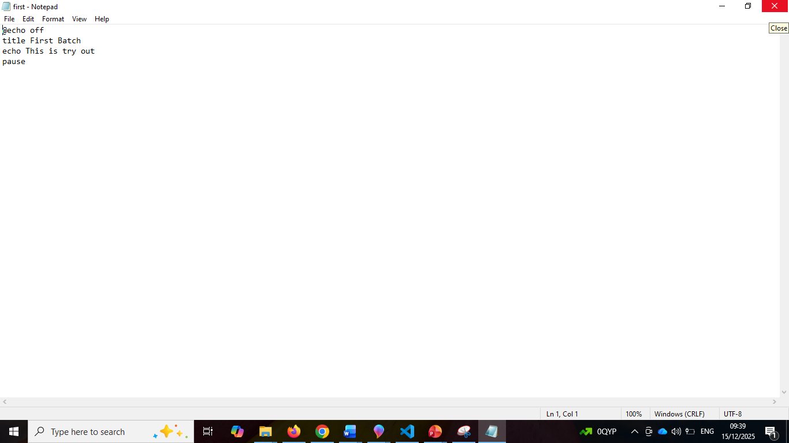
1. To start, open the notepad and type, see sample below:

Figure 36

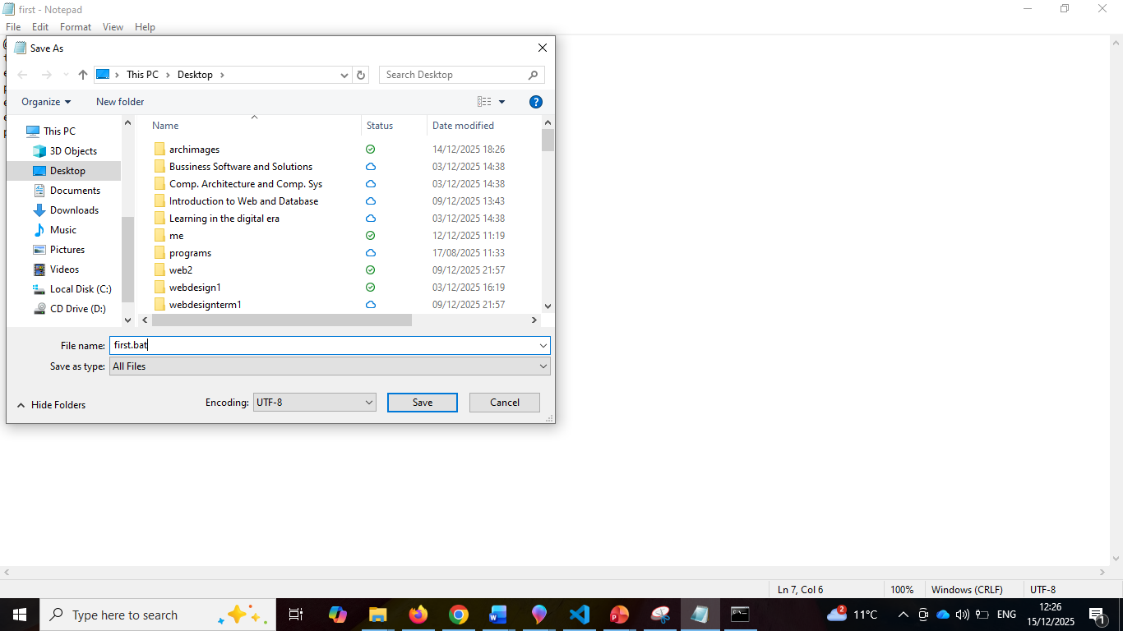
2. Then save it, name and put the extension .bat so it will be identified as batch file and is executable file.
Figure 37

3. Save it where you want it, as for me I save it in desktop
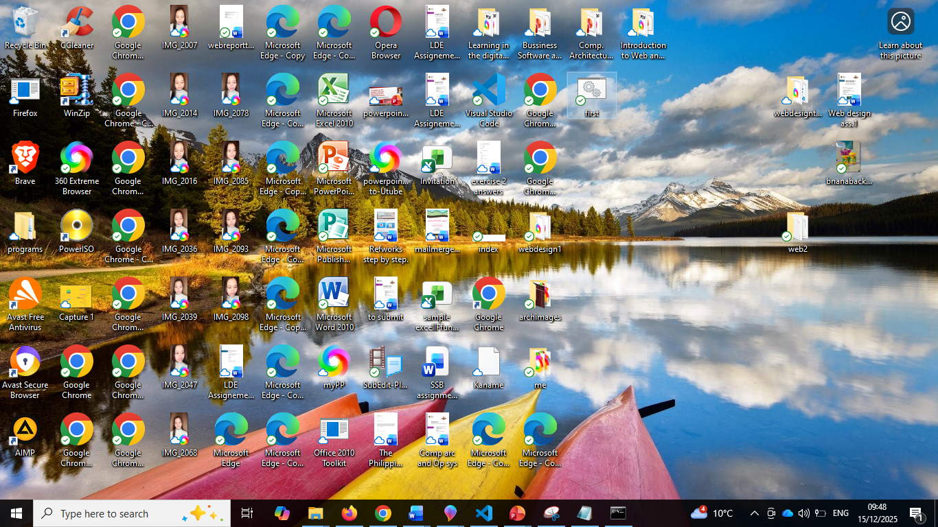

file

Figure 38

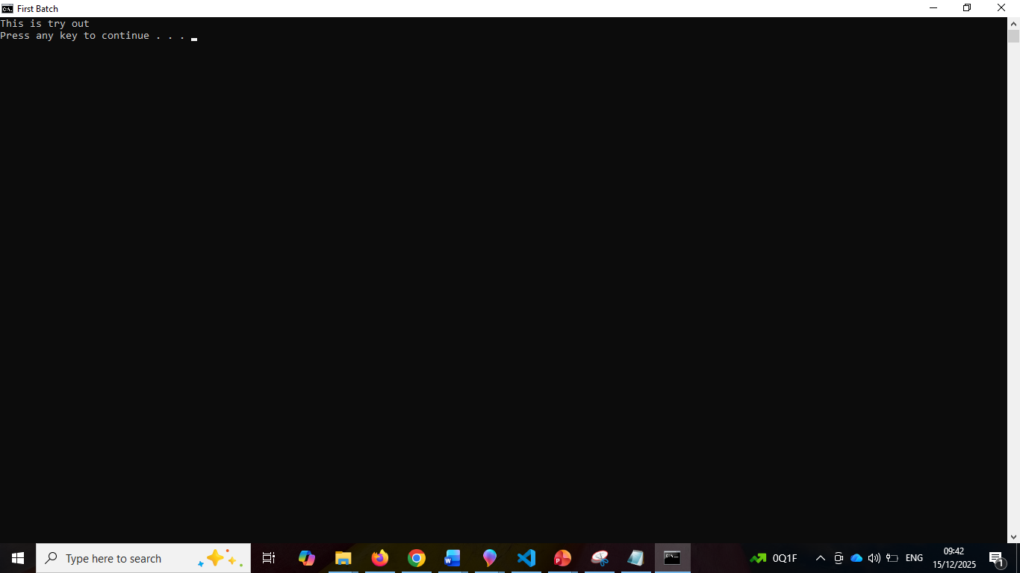
4. Right click to open, or double click and it will run in cmd prompt.
Figure 39
“This is try out” the output from the script done in the notepad.

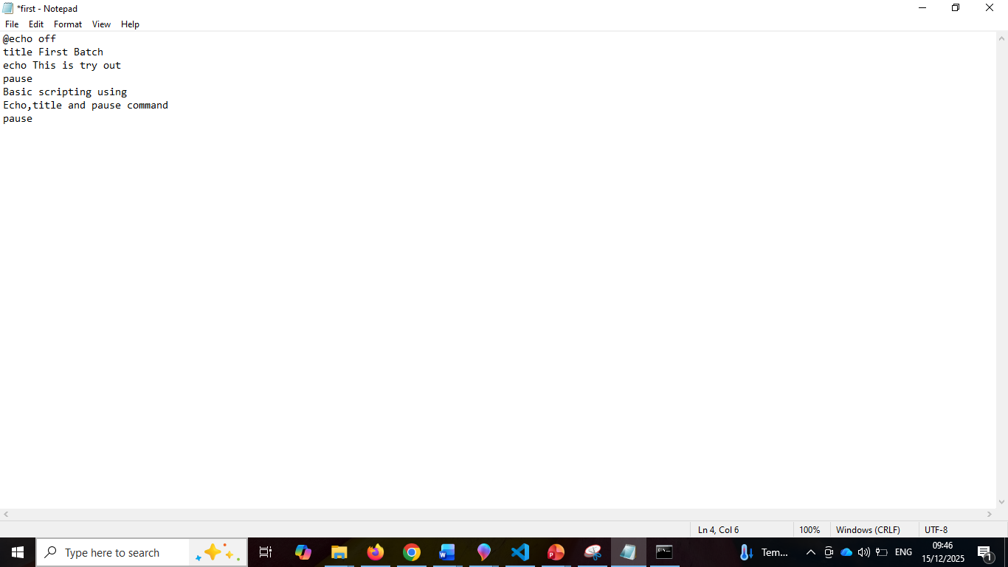
5. Add another line to see more, using echo as prompt:
Figure 40
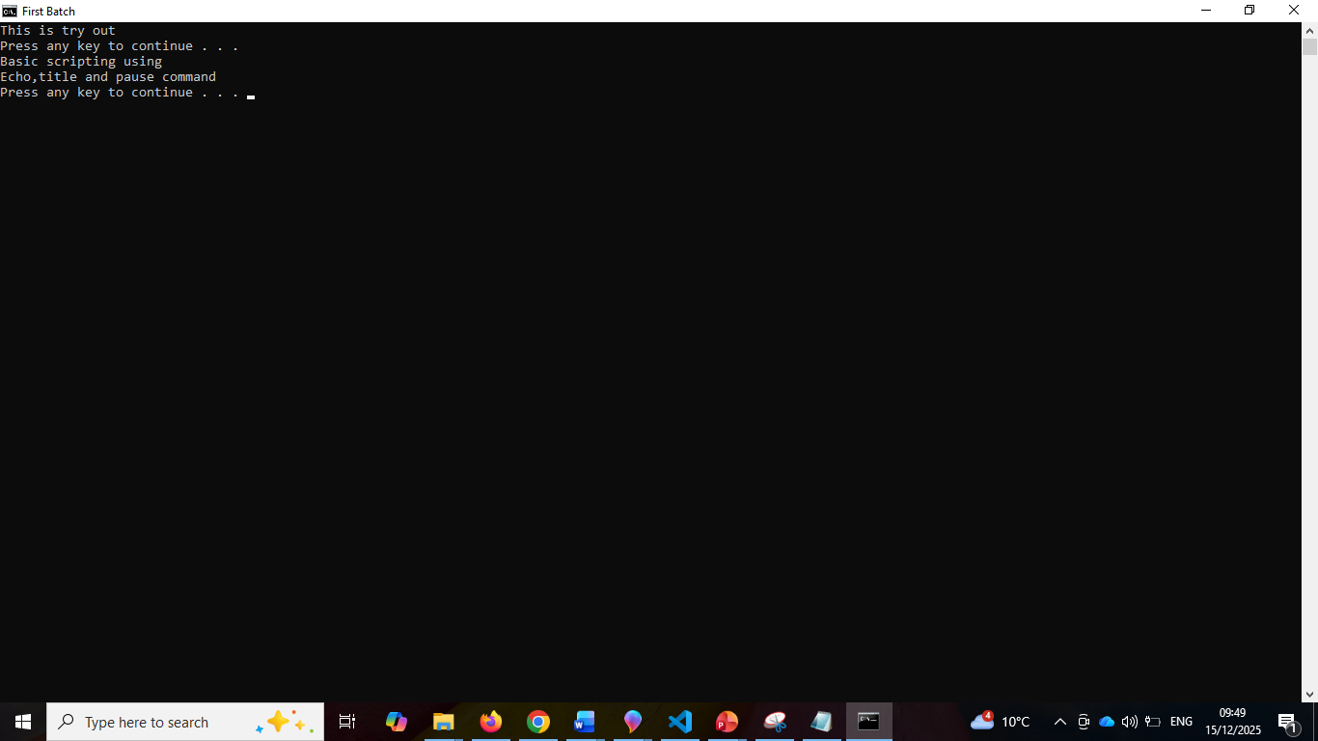
6. Now here’s the output in cmd:
Figure 41

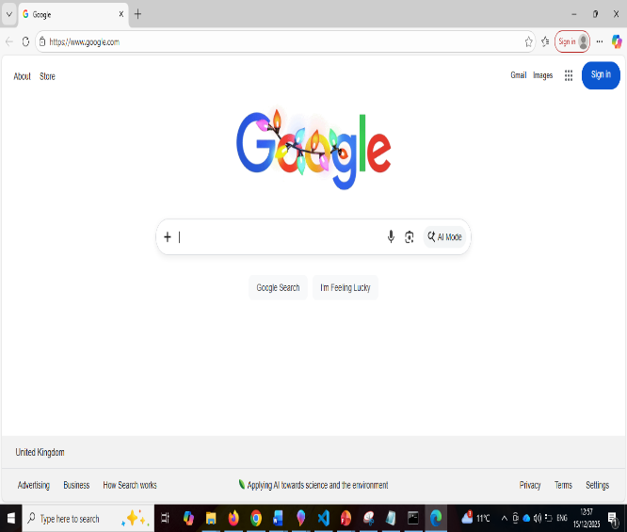
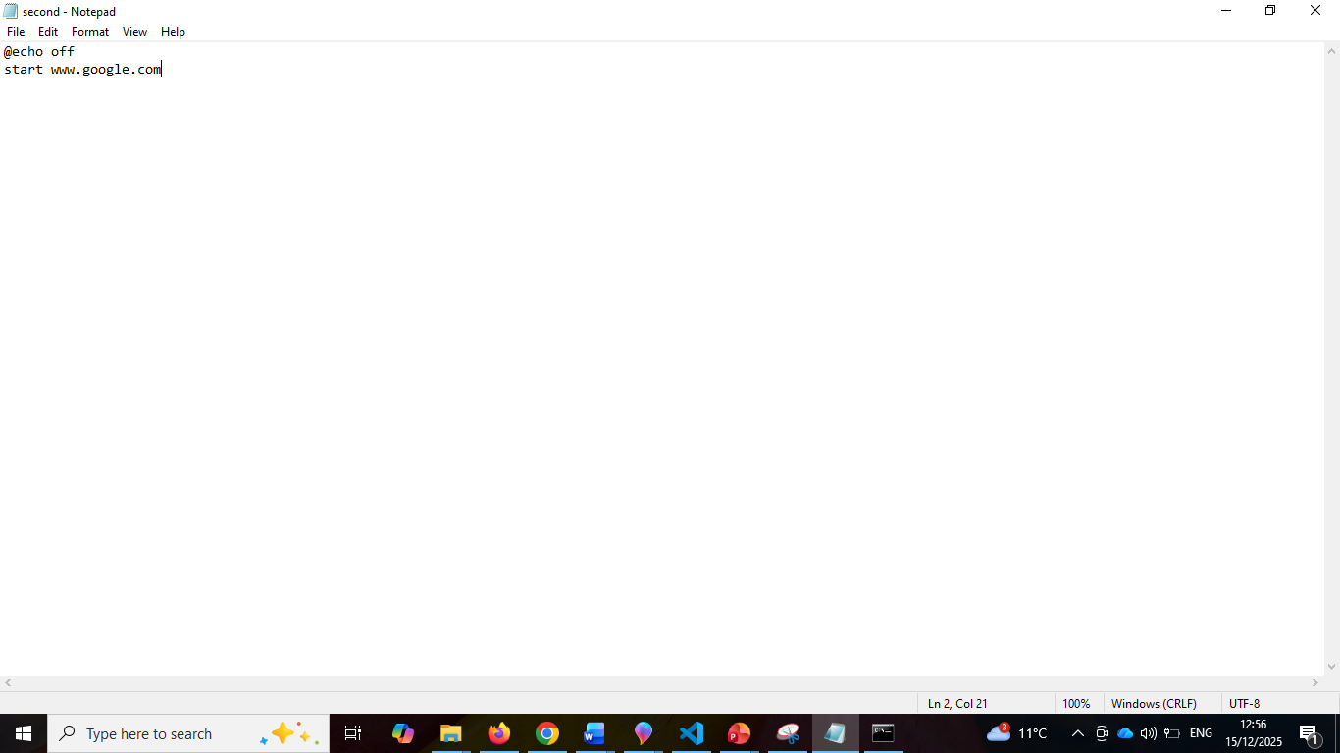
7. Another simple sample is to open a browser, open notepad, and type the browser you wanted to try. Save again using extension .bat then open the file, and it will take you to the browser page.

Figure 42

Task 5
Use of Linux OS scripts
- parallel to Windows OS script, Linux use shell scripting called Bash script. You can identify a bash script by .sh file extension, without this, command still run fie, but for editor like visual code, note pad etc. to identify the file, it is best to use this extension to identify what file you are executing.
Advantage of Bash Scripting:
- Automation-Automate repetitive tasks and process, saving effort and time and reduce error.
- Portability: run on various platforms and operating systems, Unix, Linux, MacOs even Windows through virtual machines.
- Flexibility: shell script is highly customized and can be modified to suit specific requirements. They can also combine any other language for better scripts.
- Accessibility: easy to use and do not need any other tools or software. They can run through any text editor or built-in shell interpreter.
- Integration: can be integrated with other tools and applications like database, web servers and cloud servers.
- Debugging: easy to debug, most shells have bult-in debugging and error reporting tools that can help fix the issues quickly [20]

Scripts start with a combination of hash and bang (#!). It simply tells this is an absolute path to the bash interpreter. Example of path: #! /bin/bash
Execution rights: User may have right to read, write, and execute when you see ‘rwx’ depending on user has right to:

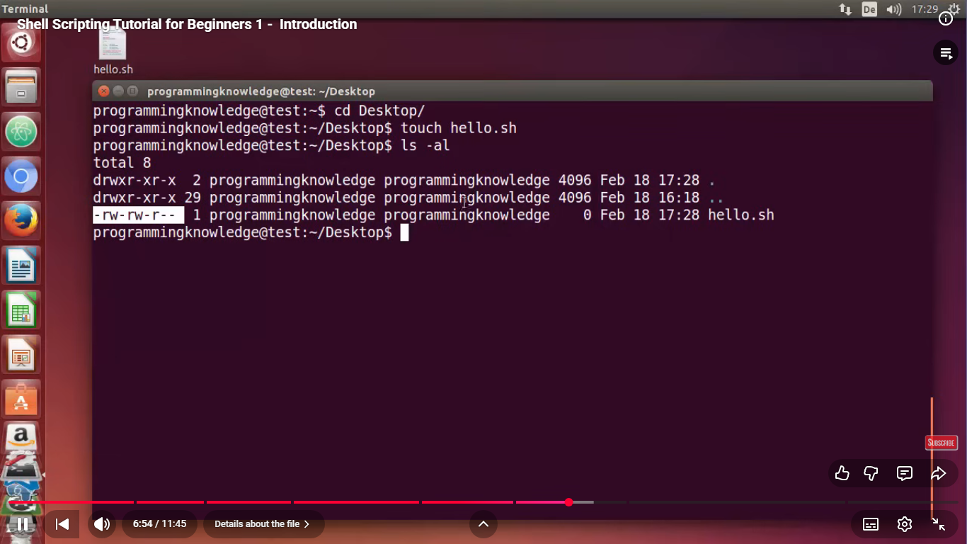
[21]
This sample figure when run is denied since the permission is only read and write when the user edits it in visual code. See figure 44
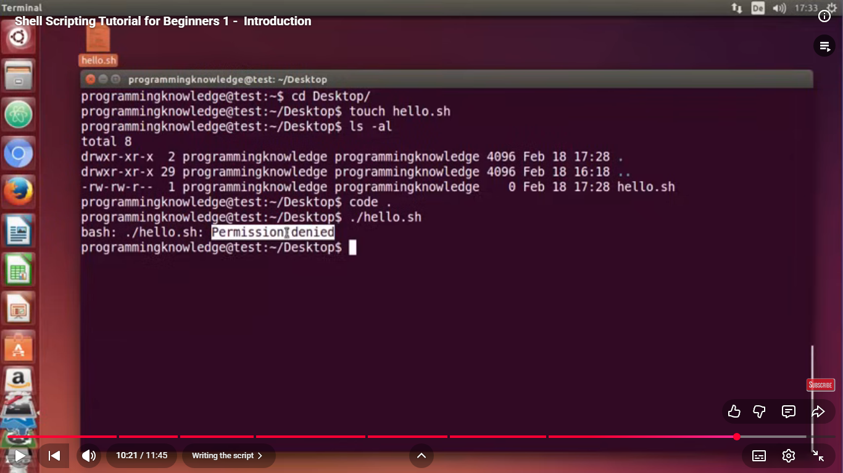
Figure 44 [21]
This shows, when you use the command ‘touch’ only allowed you to read and write permission but not execute permission, so user will rewrite the script as seen below.
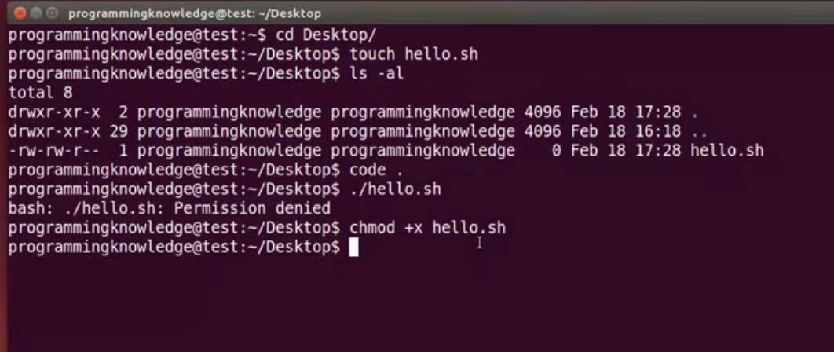
Figure 45 [21]
User change the command to chmod +x and the name of the file to change the permission to be able to automate the script. Chmod command modifies the read, write and execute permission of a file.
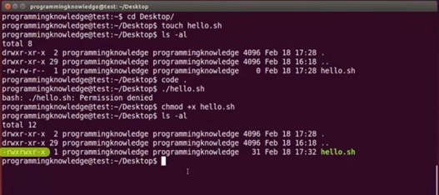
Figure 46 [21]
The permission change to rwx, which now read, write and execute.

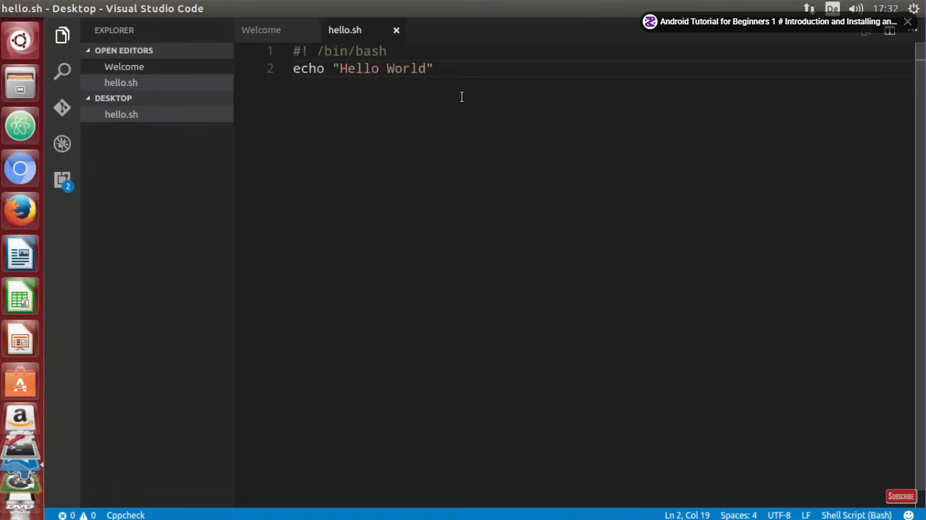
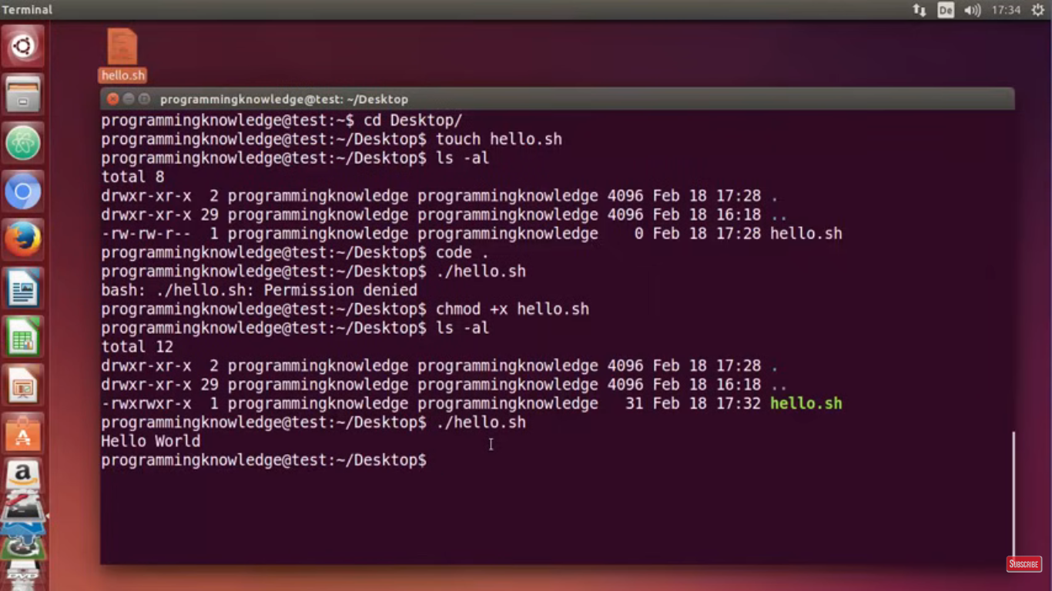
Figure 47 [21]
Sample simple script using bash script ‘Hello World’.

Conclusion
In summary, Operating System knowledge together with practical activities to Windows and Linux command and scripting, provides a robust foundation of understanding how computer system works and manage beyond interface.
Operating System acts as brain of the computer where process, memory, device management and security and protection are managed.
Windows and Linux CLI command function as tools for executing system tasks for efficient and easy way if learned how to properly and accurately used. Commands empower users to effectively manage files, monitor process, and configure settings.
Furthermore, scripting in Windows and Linux greatly helps in repetitive tasks, avoids human error, augmented productivity and important in managing system specially in administration where you can have permission deeper than being a user.
I can say that having knowledge how operating system works and learning how to use command line and script to automate the system is such a highly skills that I can use in the future if I work and study more about this, building my technical and computing skills which a good step for higher competency in IT area.

References
[1] H. M. Deitel, P. J. Deitel and D. R. Choffnes,Operating systems, Pearson/Prentice Hall, 2004.

[2] W. Stallings, Computer Organization and Architecture, 10th Edition Ed. Upper Saddle River, NJ: Pearson education Limited, 2006. [Online]. Available: http://bvbr.bib-bvb.de:8991/F?func=service&doc_library=BVB01&local_base=BVB01&doc_number=013328735&sequence=000001&line_number=0001&func_code=DB_RECORDS&service_type=MEDIA

[3] GeeksforGeeks. "Functions of an Operating System." GeeksforGeeks. [Online]. Available: https://www.geeksforgeeks.org/operating-systems/functions-of-operating-system/

[4] Hazem Abbas. "22 System Monitor Apps and Device Information Scanners for Linux Systems." medevel.com. [Online]. Available: https://medevel.com/linux-system-monitor-apps-2200/

[5] Nathalie Polishchuk."In-depth guide to the Mac task manager: My key insights" November 6, 2025.

[6] P20. "Best Device manager for Linux." [Online]. Available: https://www.youtube.com/watch?v=jSpcCH7SNqw

[7] Tom Rogers. "Mac Tip: Where's Device Manager?" [Online]. Available: https://www.youtube.com/watch?v=J1og_lUJmdQ

[8] G. Knoetze. "The Best Linux File Managers for Managing Your Files." [Online]. Available: https://www.itprotoday.com/linux-os/the-best-linux-file-managers-for-managing-your-files#What%20Is%20a%20Linux%20File%20Manager?

[9] Apple. "Mac User Guide: Use the Finder on Mac." apple support. [Online]. Available: https://support.apple.com/en-gb/guide/mac-help/mchlp2605/mac

[10] macmostvideo. "15 Mac Settings To Make Your Mac More Secure." [Online]. Available: https://www.youtube.com/watch?v=NSoUh3Duqrc

[11] W3 schools. "What is Command Line Interface?" www.w3schools.com. [Online]. Available: https://www.w3schools.com/whatis/whatis_cli.asp

[12] Microsoft. "What is PowerShell?" www.microsoft.com. [Online]. Available: https://learn.microsoft.com/en-us/powershell/scripting/overview?view=powershell-7.5&source=recommendations

[13] Programming Knowledge. "Linux Command Line Tutorial For Beginners 1 - Introduction." [Online]. Available: https://www.youtube.com/watch?v=YHFzr-akOas&list=PLS1QulWo1RIb9WVQGJ_vh-RQusbZgO_As

[14] M. Stamp."30+ Essential Linux Commands You Need To Know" www.dreamhost.com. (September 82025). Available at: https://www.dreamhost.com/blog/linux-commands/

[15] R. Saive."Level Up Linux: 20 Must-Know Commands for Newbies" www.tecmint.com. (January 292024). Available at: https://www.tecmint.com/useful-linux-commands-for-newbies/

[16] A. Riso. "Linux Command Line Interface Introduction: A Guide to the Linux CLI." www.linuxjournal.com. [Online]. Available: https://www.linuxjournal.com/content/linux-command-line-interface-introduction-guide

[17] A. S. "60 Essential Linux Commands." www.hostinger.com. [Online]. Available: https://www.hostinger.com/tutorials/linux-commands

[18] The Linux Experiment. "Learn the LINUX Command Line: 40 commands in15 mins.!" [Online]. Available: https://www.youtube.com/watch?v=QhvDvpyvPSE

[19] Tutorial Point. "Batch Script Tutorial." www.tutorialspoint.com. [Online]. Available: https://www.tutorialspoint.com/batch_script/index.htm

[20] Z. Hira. "Bash Scripting Tutorial – Linux Shell Script and Command Line for Beginners." www.freecodecamp.org/news/. [Online]. Available: https://www.freecodecamp.org/news/bash-scripting-tutorial-linux-shell-script-and-command-line-for-beginners/

[21] Programming Knowledge. "Shell Scripting Tutorial for Beginners 1 - Introduction." [Online]. Available: https://www.youtube.com/watch?v=cQepf9fY6cE&list=PLS1QulWo1RIYmaxcEqw5JhK3b-6rgdWO_

