University of Wales Trinity Saint David

Wales institute of Science and Arts



Transient vehicle response modelling

Advanced motorsports dynamics (ACEA7003)

Joseph Britton

2104278

February/2025

Table of Contents

Table of figures iv
Table of tables v
Table of equations v
Nomenclature vii
1. Introduction 1
2. Background research 2
2.1. Vehicle dynamics overview 2
2.2. Vehicle dynamic modelling 2
2.2.1. Existing dynamics models 2
3. Methodology 5
3.1. Simulation scenarios 5
3.1.1. Lane change 6
3.1.2. Slalom 6
3.2. Input variables 7
3.3. Assumptions made in modelling 9
4. Vehicle model development 12
4.1. Overview of 7 DOF model 12
4.2. Model validation 14
4.2.1. Model limitations 20
5. Sensitivity analysis 21
5.1. Spring stiffness analysis 21
5.1.1. Spring stiffness analysis for slalom 21
5.1.2. Spring stiffness analysis for lane change 23
5.2. Damper coefficient analysis 24
5.3. ARB analysis 25
6. Conclusion and recommendations 29
References 30
Appendix 32

Table of figures
Figure 1 - 1 DOF Simulink model 2
Figure 2 - 2 DOF Simulink model 3
Figure 3 - 4 DOF Simulink model 4
Figure 4 - Lateral force in G for the lane change scenario for default setup (a) – Initial turn in (b) - levelling out (c) - return to original path 6
Figure 5 - Lateral force in G for the slalom scenario for default setup 6
Figure 6 - 7 DOF model for vehicle (Zheng, 2015) 7
Figure 7 - Diagram showing the calculation of the distance between the RC height and COG height 9
Figure 8 - Damper curves for default setup front and rear 10
Figure 9 - Damper velocities for default setup front and rear corners for the slalom test from simulator 10
Figure 10 - Subsystems of 7 DOF model within Simulink 12
Figure 11 - Calculation of roll angle within Simulink 12
Figure 12 - ARB force calculation within Simulink front and rear 13
Figure 13 - Lateral force input on Simulink model 13
Figure 14 - Damper velocity calculation within Simulink for each corner of the vehicle 14
Figure 15 - Tyre load calculation within Simulink for each corner of the vehicle 14
Figure 16 - Roll angle comparisons between Simulink and simulator data for the default setup 15
Figure 17 - Damper velocity comparisons for slalom testing for default setup for each corner of vehicle 18
Figure 18 – Tyre load comparisons for slalom testing for default setup for each corner of vehicle 18
Figure 19 – Damper velocity comparisons for lane change testing for default setup for each corner of vehicle 19
Figure 20 - Tyre load comparisons for lane change testing for default setup for each corner of vehicle 19
Figure 21 - Comparisons of runs 2 through 7 for the slalom test from Simulink data 22
Figure 22 - Damper velocities comparing runs 6 and 7 for slalom testing from Simulink data 22
Figure 23 - Comparisons of runs 2 through 7 for the lane change test from Simulink data 23
Figure 24 - Comparison of roll angles for different damper curves for slalom test from Simulink data 24
Figure 25 - Comparison of lateral force input for different damper curves for slalom test from Simulink data 25
Figure 26 - Comparisons of ARB effects on roll angle for slalom test from Simulink data 26
Figure 27 - Comparisons of ARB effects on tyre loads for slalom test from Simulink data 27
Figure 28 - Comparisons of ARB effects on damper velocities for slalom test from Simulink data 27
Figure 29 - Comparison of tyre loads for slalom test for setup 18 between Simulink and simulator data 28

Table of tables
Table 1 - Constant variable list 8
Table 2 - Variable list with variable to be altered throughout analysis 8
Table 3 - List of changes made to each setup 16
Table 4 - RMSE and MAE values for slalom test for roll angle 17
Table 5 - Setup variables 21

Table of equations
Equation 1 2
Equation 3 2
Equation 4 3
Equation 5 3
Equation 6 3
Equation 7 3
Equation 8 5
Equation 9 5
Equation 10 5
Equation 11 5
Equation 12 5
Equation 13 5
Equation 14 5
Equation 15 9
Equation 16 9
Equation 17 12
Equation 18 13
Equation 19 14
Equation 20 14
Equation 21 14

Nomenclature
Abbreviation | Description | Units
$$\ddot{z}$$ | Heave acceleration | m/s/s
$$m$$ | Mass | Kg
$$k$$ | Stiffness | N/m
$$z$$ | Heave | m
$$y$$ | Displacement | m
$$c$$ | Damping | Ns/m
$$\dot{z}$$ | Heave velocity | m/s
$$\dot{y}$$ | Displacement velocity | m/s
$$ms$$ | Sprung mass | Kg
$$mf$$ | Unsprung mass front | Kg
$$mr$$ | Unsprung mass rear | Kg
$$k_{s}$$ | Spring stiffness | N/m
$$C_{s}$$ | Sprung mass damping | Ns/m
$${\ddot{z}}_{u}$$ | Unsprung mass heave acceleration | m/s/s
$$m_{u}$$ | Unsprung mass | Kg
$$k_{u}$$ | Tyre stiffness | N/m
$$z_{u}$$ | Unsprung mass heave | m
$$C_{u}$$ | Tyre damping | Ns/m
$${\dot{z}}_{u}$$ | Unsprung mass velocity | m/s
$$k_{f}$$ | Spring stiffness front | N/m
$$k_{r}$$ | Spring stiffness rear | N/m
$$C_{f}$$ | Damping front | Ns/m
$$C_{r}$$ | Damping rear | Ns/m
$$z_{f}$$ | Heave front | m
$$z_{r}$$ | Heave rear | m
$${\dot{z}}_{f}$$ | Heave velocity front | m/s
$${\dot{z}}_{r}$$ | Heave velocity rear | m/s
$${\ddot{z}}_{f}$$ | Heave acceleration front | m/s/s
$${\ddot{z}}_{r}$$ | Heave acceleration rear | m/s/s
$$θ$$ | Pitch angle | Degrees
$$\dot{θ}$$ | Pitch velocity | Degrees/s
$$\ddot{θ}$$ | Pitch acceleration | Degrees/s/s
$$a$$ | Distance from centre of gravity to front axle | m
$$b$$ | Distance from centre of gravity to rear axle | m
$$h$$ | Distance between centre of gravity height and roll centre height | m
$$m_{f1}$$ | Unsprung mass front corner | Kg
$$m_{f2}$$ | Unsprung mass front corner | Kg
$$m_{r1}$$ | Unsprung mass rear corner | Kg
$$m_{r2}$$ | Unsprung mass rear corner | Kg
$$I$$ | Moment of inertia | kgm²
$$I_{xx}$$ | Roll moment of inertia | kgm²
$$I_{yy}$$ | Pitch moment of inertia | kgm²
$$α$$ | Distance from centre line of vehicle to side track | m
$$β$$ | Distance from centre line of vehicle to side track | m
$$∅$$ | Roll angle | Degrees
$$\dot{∅}$$ | Roll angle velocity | Degrees/s
$$\ddot{∅}$$ | Roll angle acceleration | Degrees/s/s
$$z_{f1}$$ | Heave front corner | m
$$z_{f2}$$ | Heave front corner | m
$$z_{r1}$$ | Heave rear corner | m
$$z_{r2}$$ | Heave rear corner | m
$${\dot{z}}_{f1}$$ | Heave front corner velocity | m/s
$${\dot{z}}_{f2}$$ | Heave front corner velocity | m/s
$${\dot{z}}_{r1}$$ | Heave rear corner velocity | m/s
$${\dot{z}}_{r2}$$ | Heave rear corner velocity | m/s
$${\ddot{z}}_{f1}$$ | Heave front corner acceleration | m/s/s
$${\ddot{z}}_{f2}$$ | Heave front corner acceleration | m/s/s
$${\ddot{z}}_{r1}$$ | Heave rear corner acceleration | m/s/s
$${\ddot{z}}_{r2}$$ | Heave rear corner acceleration | m/s/s
$$y_{f1}$$ | Front corner displacement | m
$$y_{f2}$$ | Front corner displacement | m
$$y_{r1}$$ | Rear corner displacement | m
$$y_{r2}$$ | Rear corner displacement | m
$${\dot{y}}_{f1}$$ | Front corner displacement velocity | m/s
$${\dot{y}}_{f2}$$ | Front corner displacement velocity | m/s
$${\dot{y}}_{r1}$$ | Rear corner displacement velocity | m/s
$${\dot{y}}_{r2}$$ | Rear corner displacement velocity | m/s
$$k_{f1}$$ | Front corner spring stiffness | N/m
$$k_{f2}$$ | Front corner spring stiffness | N/m
$$k_{r1}$$ | Rear corner spring stiffness | N/m
$$k_{r2}$$ | Rear corner spring stiffness | N/m
$${kt}_{f1}$$ | Front corner tyre stiffness | N/m
$${kt}_{f2}$$ | Front corner tyre stiffness | N/m
$${kt}_{r1}$$ | Rear corner tyre stiffness | N/m
$${kt}_{r2}$$ | Rear corner tyre stiffness | N/m
$$C_{f1}$$ | Front corner damping | Ns/m
$$C_{f2}$$ | Front corner damping | Ns/m
$$C_{r1}$$ | Rear corner damping | Ns/m
$$C_{r2}$$ | Rear corner damping | Ns/m
$${Ct}_{f1}$$ | Front corner tyre damping | Ns/m
$${Ct}_{f2}$$ | Front corner tyre damping | Ns/m
$${Ct}_{r1}$$ | Rear corner tyre damping | Ns/m
$${Ct}_{r2}$$ | Rear corner tyre damping | Ns/m
$$F_{ARB}$$ | Anti-roll bar force | N
$$T$$ | Track width | m
$$θ_{L}$$ | Roll angle left | Degrees
$$θ_{R}$$ | Roll angle right | Degrees

Introduction
This study aims to analyse the transient response of vehicles through different testing procedures, the fundamentals of transient response are paramount within motorsport engineering, enabling engineers to predict vehicle response for a range of suspension setups allowing for optimal handling characteristics. This study will develop a 7 degree of freedom (DOF) vehicle model to analyse handling characteristics and compare this data to a simulator setup with advanced physics models. Transient response analysis is very important in motorsport engineering as race cars are often subjected to highly dynamic, non-steady-state conditions: sudden steering, rapid accelerations, and high-speed cornering during manoeuvres such as chicanes, overtaking, or emergency corrections. Poorly tuned transient responses cause delayed build-up of yaw rate, excessive roll, or instability and hence deteriorate lap times while increasing the likelihood of losing control. In motorsport, transient response inspires driver confidence to push the car hard to the limit while in control (Baur, 2006). Additionally, it plays a major role in component tuning, such as suspension geometry, anti-roll bars, dampers, and aerodynamics to optimize weight transfer and maximize the tire grip during rapid changes in direction. Additionally, active aerodynamics, torque vectoring, and electronic stability programs-if the regulations allow-can further improve high-speed, high-load stability based on accurate transient response analysis. By analysing and refining transient behaviour, the engineers can make sure that not only are the race cars fast, but they are also predictable and agile, providing the driver with a real competitive edge regarding performance and safety.

Background research

Vehicle dynamics overview
Understanding vehicle dynamics is imperative to optimization of vehicular performance. Transient response is likely the area of largest importance within vehicular performance with respect to motorsport applications. Key parameters within transient response relate to the moment of inertia for a vehicle, this describes the resistance for a vehicle to rotational acceleration about its axes. A vehicle with a lower yaw inertia will respond quicker to steer inputs, yet this can have a negative effect for high-speed stability (Aripin, 2014) (Wang, 2009). Other factors to consider for transient response are the suspension dynamics, these being stiffness values and damping coefficients for all areas of a vehicle being sprung and unsprung masses along tyre dynamics. These play a crucial role in governing the roll and pitch characteristics of a vehicle (Zehsaz, 2014) (Xiao, 2024).

Vehicle dynamic modelling

Existing dynamics models
Many equations can be used to describe the dynamics of a vehicle, these equations increase in complexity when higher accuracy is required accuracy. These equations in simple states range from 1 to 4 DOF, a Simulink model for a 1 DOF model is shown though figure 1 with its relevant motion equation shown through equation 1 (Macfarlane, 2018).
$\ddot{z}=-\frac{1}{m}\left[k\left(z-y\right)+c(\dot{z}-\dot{y})]\right.$ Equation 1

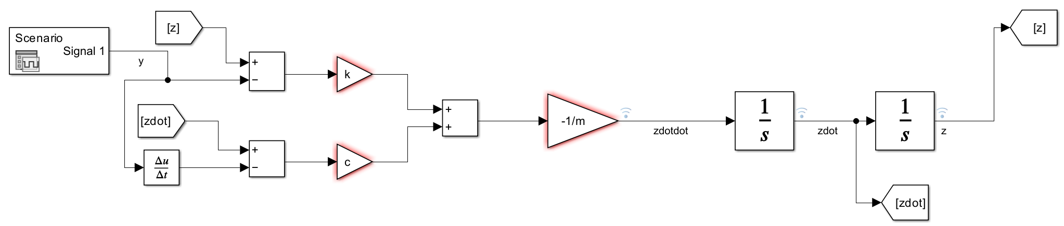
Figure 1 - 1 DOF Simulink model
When the DOF is increased to 2, the accuracy of the model is improved, allowing analysis of both sprung and unsprung masses, shown in equations 2 and 3 and figure 2 (Attia, 2014).
$\ddot{z}=-\frac{1}{m_{s}}\left[k_{s}\left(z-y\right)+C_{s}(\dot{z}-\dot{y})]\right.$ Equation 2
${\ddot{z}}_{u}=-\frac{1}{m_{u}}[k_{u}\left(z_{u}-y\right)+C_{u}\left({\dot{z}}_{u}-\dot{y}\right)-k_{s}\left(z-z_{u}\right)-c_{s}\left(\dot{z}-{\dot{z}}_{u}\right)]$ Equation 3
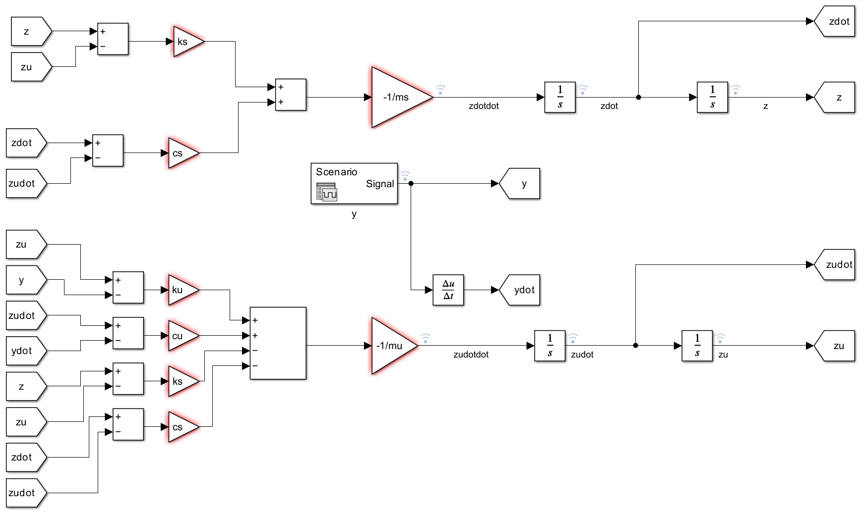
Figure 2 - 2 DOF Simulink model
With a 4 DOF model, the equations of motion begin to get extensive, equations 4 through 7 show the relative motions of sprung mass, unsprung masses for front and rear and pitch/roll angle, see figure 3 (Zhang, 2016).
$\ddot{Z}s=-\frac{1}{m_{s}}[Kf\left(Zs-Zf-aθ\right)+Kr\left(Zs-Zr+bθ\right)+Cf\left(\dot{Z}s-\dot{Z}f-a\dot{θ}\right)+Cr\left(\dot{Z}s-\dot{Z}r+b\dot{θ}\right)]$ Equation 4
$\ddot{θ}=-\frac{1}{I}[bKr\left(Zs-Zr+bθ\right)-aKf\left(Zs-Zf-aθ\right)+bCr\left(\dot{Z}s-\dot{Z}r+b\dot{θ}\right)-aCf\left(\dot{Z}s-\dot{Z}f-a\dot{θ}\right)+\left(ma_{x}h\right)]$ Equation 5
$\ddot{Z}f=-\frac{1}{m_{f}}[Ktf\left(Zf-yf\right)-Kf\left(Zs-Zf-aθ\right)+Ctf\left(\dot{Z}f-\dot{y}f\right)-Cf\left(\dot{Z}s-\dot{Z}f-a\dot{θ}\right)]$ Equation 6
$\ddot{Z}r=-\frac{1}{m_{r}}[Ktr\left(Zr-yr\right)-Kr\left(Zs-Zr+bθ\right)+Ctr\left(\dot{Z}r-\dot{y}r\right)-Cr\left(\dot{Z}s-\dot{Z}r+b\dot{θ}\right)]$ Equation 7
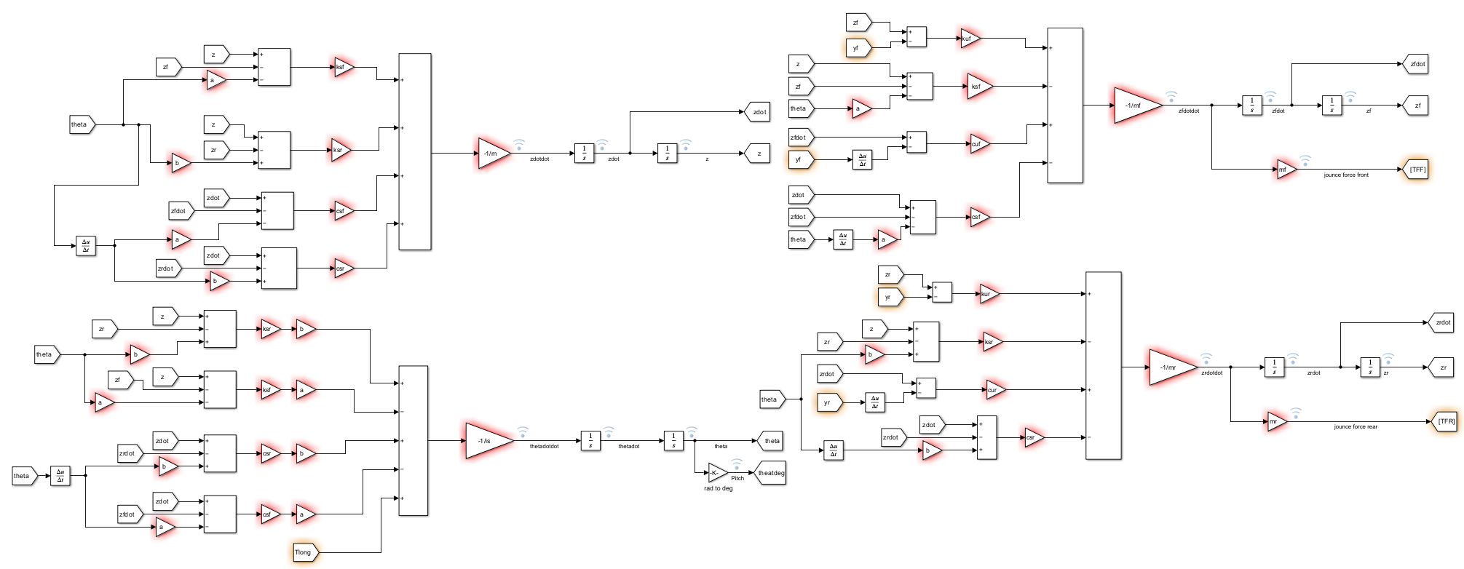
Figure 3 - 4 DOF Simulink model

Methodology
The approach to modelling the 7 DOF model begins by defining the equations for motion of this system, as seen in equations 8 through 14 (Jazar, 2008), they are rather extensive meaning the model should be split into subsystems to simplify model creation and possible troubleshooting should it be necessary.
$\ddot{z}=-\frac{1}{m}[k_{f1}\left(z-z_{f1}-aθ-β∅\right)+C_{f1}\left(\dot{Z}-{\dot{z}}_{f1}-a\dot{θ}-β\dot{∅}\right)+k_{f2}\left(z-z_{f2}-aθ-α∅\right)+C_{f2}\left(\dot{Z}-{\dot{z}}_{f2}-a\dot{θ}-α\dot{∅}\right)+k_{r1}\left(z-z_{r1}+bθ-β∅\right)+C_{r1}\left(\dot{z}-{\dot{z}}_{r1}+b\dot{θ}-β\dot{∅}\right)+k_{r2}\left(z-z_{r2}+bθ+α∅\right)+C_{r2}\left(\dot{z}-{\dot{z}}_{r2}+b\dot{θ}+α\dot{∅}\right)]$ Equation 8
$\ddot{θ}=-\frac{1}{I_{xx}}[bk_{r1}\left(z-z_{r1}+bθ-β∅\right)+bC_{r1}\left(\dot{z}-{\dot{z}}_{r1}+b\dot{θ}-β\dot{∅}\right)+bk_{r2}\left(z-z_{r2}+bθ+α∅\right)+bC_{r2}\left(\dot{z}-{\dot{z}}_{r2}+b\dot{θ}+α\dot{∅}\right)-ak_{f1}\left(z-z_{f1}-aθ-β∅\right)-aC_{f1}\left(\dot{Z}-{\dot{z}}_{f1}-a\dot{θ}-β\dot{∅}\right)-ak_{f2}\left(z-z_{f2}-aθ-α∅\right)-aC_{f2}\left(\dot{Z}-{\dot{z}}_{f2}-a\dot{θ}-α\dot{∅}\right)]$ Equation 9
$\ddot{∅}=-\frac{1}{I_{yy}}[α+k_{f2}\left(z-z_{f2}-aθ-α∅\right)+αC_{f2}\left(\dot{Z}-{\dot{z}}_{f2}-a\dot{θ}-α\dot{∅}\right)+αk_{r2}\left(z-z_{r2}+bθ+α∅\right)+αC_{r2}\left(\dot{z}-{\dot{z}}_{r2}+b\dot{θ}+α\dot{∅}\right)-βk_{f1}\left(z-z_{f1}-aθ-β∅\right)-βC_{f1}\left(\dot{Z}-{\dot{z}}_{f1}-a\dot{θ}-β\dot{∅}\right)-βk_{r1}\left(z-z_{r1}+bθ-β∅\right)-βC_{r1}\left(\dot{z}-{\dot{z}}_{r1}+b\dot{θ}-β\dot{∅}\right)]$ Equation 10
${\ddot{z}}_{f1}=-\frac{1}{m_{f1}}\left[{kt}_{f1}\left(z_{f1}-y_{f1}\right)-k_{f1}\left(z-z_{f1}-aθ-β∅\right)-C_{f1}\left(\dot{Z}-{\dot{z}}_{f1}-a\dot{θ}-β\dot{∅}\right)+{Ct}_{f1}\left({\dot{z}}_{f1}-{\dot{y}}_{f1}\right)\right]$ Equation 11
${\ddot{z}}_{f2}=-\frac{1}{m_{f2}}[{Kt}_{f2}\left(z_{f2}-y_{f2}\right)-k_{f2}\left(z-z_{f2}-aθ-α∅\right)-C_{f2}\left(\dot{Z}-{\dot{z}}_{f2}-a\dot{θ}-α\dot{∅}\right)+{Ct}_{f2}\left({\dot{z}}_{f2}-{\dot{y}}_{f2}\right)]$ Equation 12
${\ddot{z}}_{r1}=-\frac{1}{m_{r1}}[{kt}_{r1}\left(z_{r1}-y_{r1}\right)-k_{r1}\left(z-z_{r1}+bθ-β∅\right)-C_{r1}\left(\dot{z}-{\dot{z}}_{r1}+b\dot{θ}-β\dot{∅}\right)+{Ct}_{r1}\left({\dot{z}}_{r1}-{\dot{y}}_{r1}\right)]$ Equation 13
${\ddot{z}}_{r2}=-\frac{1}{m_{r2}}[{kt}_{r2}\left(z_{r2}-y_{r2}\right)-k_{r2}\left(z-z_{r2}+bθ+α∅\right)-C_{r2}\left(\dot{z}-{\dot{z}}_{r2}+b\dot{θ}+α\dot{∅}\right)+{Ct}_{r2}\left({\dot{z}}_{r2}-{\dot{y}}_{r2}\right)]$ Equation 14
Validation of the Simulink model will be done through comparison of data attained through a simulator using the Automobilista software, this software uses similar motion equations with a higher degree of accuracy due to the inclusion of other modelling techniques like tyre modelling through the pacejka magic formula to predict tyre forces described in (Belrzaeg, 2021). This validation will serve to prove whether the 7DOF model is satisfactory for analysing simple parameters around a vehicle’s transient response, done through many investigations showing its validity here (Westermark, 2013) (Levantaci, 2022).

Simulation scenarios
Two dynamic manoeuvres are used through this analysis, these being a slalom and lane change manoeuvre. Both provide helpful insight into vehicle behaviour from steer input, whilst each differ in the conclusions that can be drawn. Both tests were performed at a constant velocity using the pit limiter set on the vehicle, set to 21.86 m/s.

Lane change
This manoeuvre, commonly known as the moose test, simulates a fast lateral input before steading back out and returning the original path after another fast lateral input in the opposing direction. To better visualise this, the measured lateral g force on the vehicle through this manoeuvre from the simulator data is shown through figure 4.
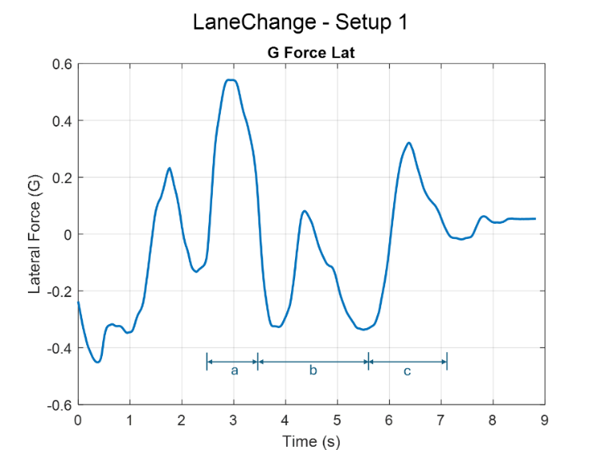
Figure 4 - Lateral force in G for the lane change scenario for default setup (a) – Initial turn in (b) - levelling out (c) - return to original path

Slalom
The slalom manoeuvre simulates constant changes in lateral force to see how well suspension and ARBs respond to steer inputs in quick succession. It is also valuable to analyse whether a vehicle can sustain this constant alternating movement. The G force output from the simulator data is shown through figure 5, it was paramount that the user of the simulator tried best to replicate the steer inputs changes for each change in input.
Figure 5 - Lateral force in G for the slalom scenario for default setup

Input variables
There are many vehicle parameters required to run the model; inputs can be seen through figure 6. For the Simulink model, a list of inputs used can be seen through tables 1 and 2. The initial setup was gathered from standard data for the formula ford vehicle within Automobilista, initial testing is conducted with the removal of the anti-roll bars, hence the value for 0 in table 2. Some of the values were not provided through the system and hence for implementation into Simulink, research into suitable values for theses parameters is required.
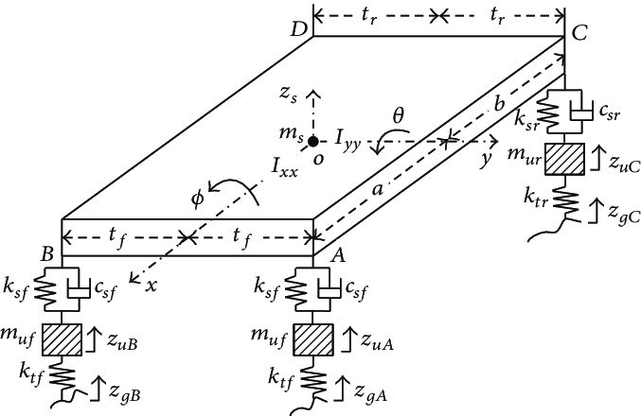
Figure 6 - 7 DOF model for vehicle (Zheng, 2015)

Table 1 - Constant variable list
Variable name | Value | Description
alphaf | 1.62/2 | 1/2 front track (m)
alphar | 1.57/2 | 1/2 rear track (m)
betaf | 1.62/2 | 1/2 front track (m)
betar | 1.57/2 | 1/2 rear track (m)
a | 2.443*0.45 | Distance to COG from front axle (m)
b | 2.443*0.55 | Distance to COG from rear axle (m)
ms | 426 | Sprung mass (kg)
mf1 | 22 | Unsprung mass front corner (kg)
mf2 | 22 | Unsprung mass front corner (kg)
mr1 | 22 | Unsprung mass rear corner (kg)
mr2 | 22 | Unsprung mass rear corner (kg)
ixx | 0.28*(ms+mf1+mf2+mr1+mr2)-71.6 | Roll moment of inertia
iyy | 2.56*(ms+mf1+mf2+mr1+mr2)-1103 | Pitch moment of inertia
h | 0.277-0.02609-0.0009 | Distance between RC and COG height (m)
Table 2 - Variable list with variable to be altered throughout analysis
Variable name | Value | Description
kf1 | 18000 | Spring stiffness front corner (N/m)
ktf1 | 180000 | Tyre stiffness front corner (N/m)
ctf1 | 330 | Tyre damping front corner (Ns/m)
kf2 | 18000 | Spring stiffness front corner (N/m)
ktf2 | 180000 | Tyre stiffness front corner (N/m)
ctf2 | 330 | Tyre damping front corner (Ns/m)
kr1 | 16000 | Spring stiffness rear corner (N/m)
ktr1 | 180000 | Tyre stiffness rear corner (N/m)
ctr1 | 330 | Tyre damping rear corner (Ns/m)
kr2 | 16000 | Spring stiffness rear corner (N/m)
ktr2 | 180000 | Tyre stiffness rear corner (N/m)
ctr2 | 330 | Tyre damping rear corner (Ns/m)
karbf | 0 | Front anti roll bar stiffness (N/m)
karbr | 0 | Rear anti roll bar stiffness (N/m)
damp | 1 | Number corresponding to damper curve switch

The calculation of inertia values is done through the equations 15 and 16 found through the document within the appendix. For this application the value of $Ixx$ and $Iyy$ come to be 72.32kgm² and 212.84kgm² respectively.
$Ixx=0.28×W_{t}-71.6$ Equation 15
$Iyy=2.56×W_{t}-1103$ Equation 16
The value of h describes the distamce between the the centre of gravity (COG) height and the roll centre (RC) height. To calculate this value, trigonemtry is required, a diagram is shown in figure 7. From the diagram, the value of ? must be calculated, as the front RC height is known and the COG height is known, this then allows calculation of h which comes to 0.2501m.
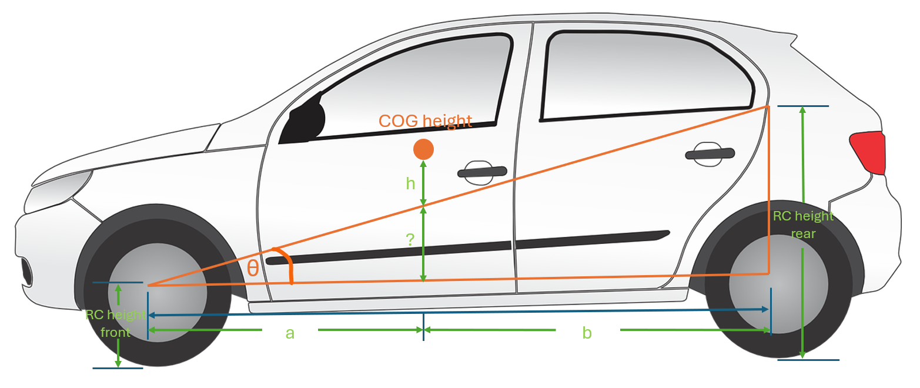
Figure 7 - Diagram showing the calculation of the distance between the RC height and COG height
Spring stiffnesses are present within the dataset given through the software, however values for tyre stiffnesses and tyre damping are not, selecting suitable values for these is crucial to represent a true system. Through research of tyres used for formula ford, it is found that the tyres used are the Avon ACB10 tyres within the national formula ford championship (brssc, 2022). Tyre stiffness and damping for these tyres is not publicaly available, meaning they must be estimated, the values used within the study fall within a suitable range of that shown through (Zuska, 2023) and (Zehsaz, 2014).
Spring stiffnesses were known for the vehicle and as standard are shown as 18000N/m for the front suspension and 16000N/m for the rear, yet as they work as a cantilever system the motion ratio (MR) is required to understand the spring stiffness at the wheel. The MR given is 1 for both front and rear of the vehicle meaning that the Stiffnesses seen at the component are the same seen at the wheel.

Assumptions made in modelling
The model uses non linear damping coeffiencts to model both slow and fast settings for rebound and compression. The switch point between these two scenarios is unknown leaving it as an assumption. Reasearch of similar dampers used through motorsport shows 0.05m/s as a suitable velocity to use as suggested by (TonyC63, 2019). Figure 8 shows the standard damper curve for the model, this curve extends to 0.5m/s as with analysis of the dynamic damper velocity data obtained through the simulation showed maximum damper velocities well below this threshold, see figure 9. As seen in figure 8, there is no transition period between slow and fast settings, meaning that there may be complicsations with modelling specifically within this region due to the harsh change in damping coefficients.
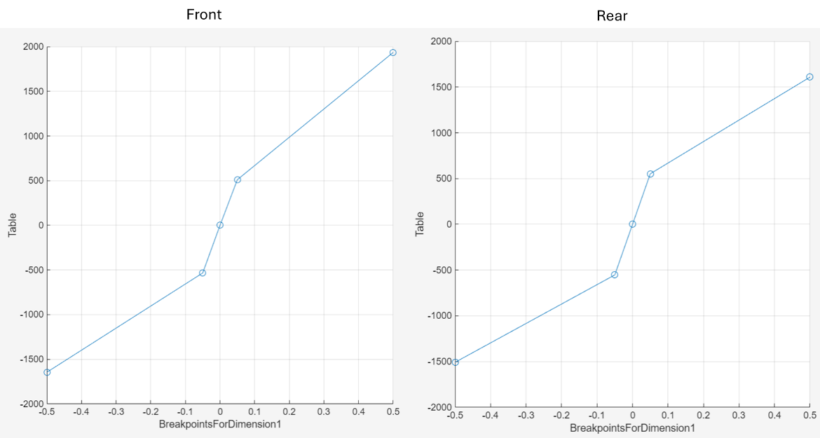
Figure 8 - Damper curves for default setup front and rear
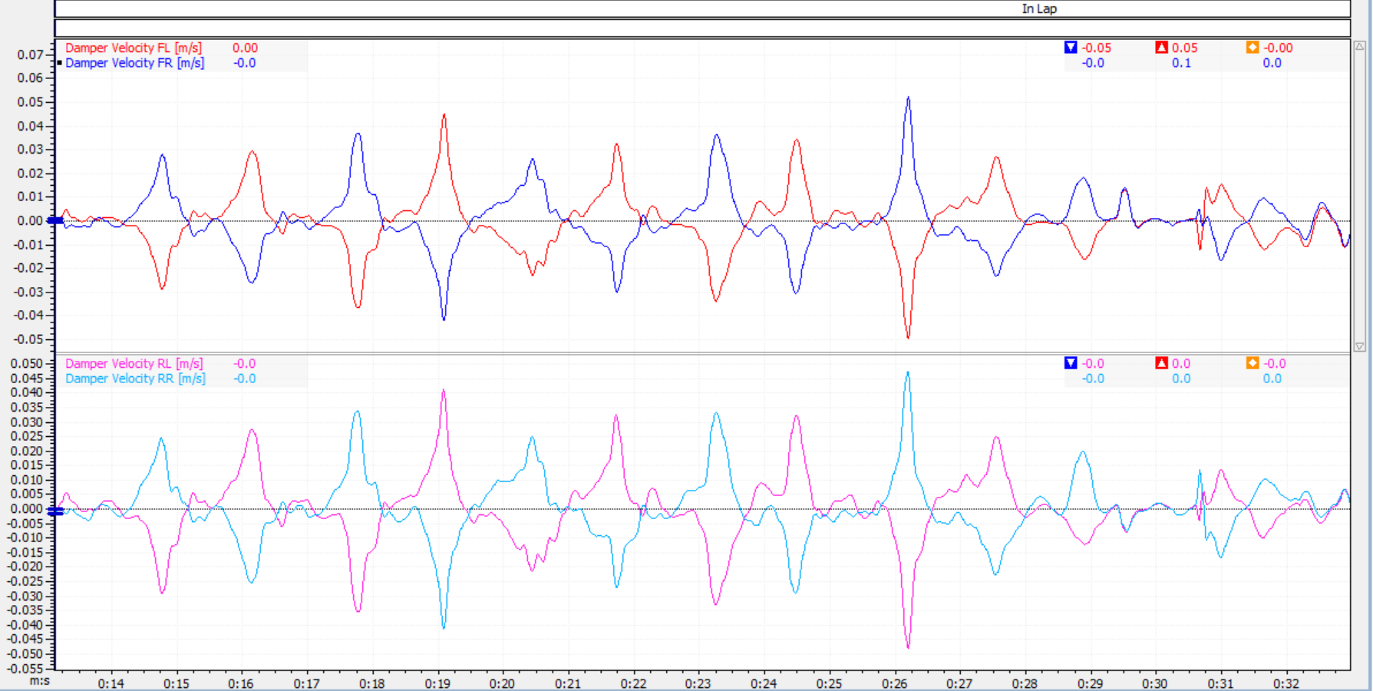
Figure 9 - Damper velocities for default setup front and rear corners for the slalom test from simulator
Another assumption used in modeling is the lack of longitudinal force input as both testing techniques were performed at a constant velocity, hence no longtitudinal acceleration. In this case it was left out to reduce complexity and computation time, however the ability to include both longitundal and lateral force inputs is still possible.
A 7 DOF model uses unprung masses as lumped masses, combining wheels, brakes and suspension components into point masses, this ignores the effect of suspension geometry into force transfer across the vehicle, decreasing the accuracy of the model.
Another assumption made in modelling is the constant value for h, this value relies on the roll cnetre height. During anlysis the static roll centre height it used, whevere through suspension movenet the roll centre migrates according this, thus altering the value of h. To apply a migrating roll centre into the model, suspension gemotry for the vehicle is required. Yet, in this case it is unknown, leaving this assumption. A study incorporating this from Jung shows it can be incorporated to a vehicle dynamics model (Jung, 2009).

Vehicle model development

Overview of 7 DOF model
The model uses the equations 8 through 14, allowing the pitch, roll, heave and all four vertical wheel displacements through transient response. The model is split into subsections allowing ease of use, which can be seen through figure 10. An example of one of the equations within the model is shown through figure 11, this shows the inputs of equation 10, with the lateral force input from the simulator data.
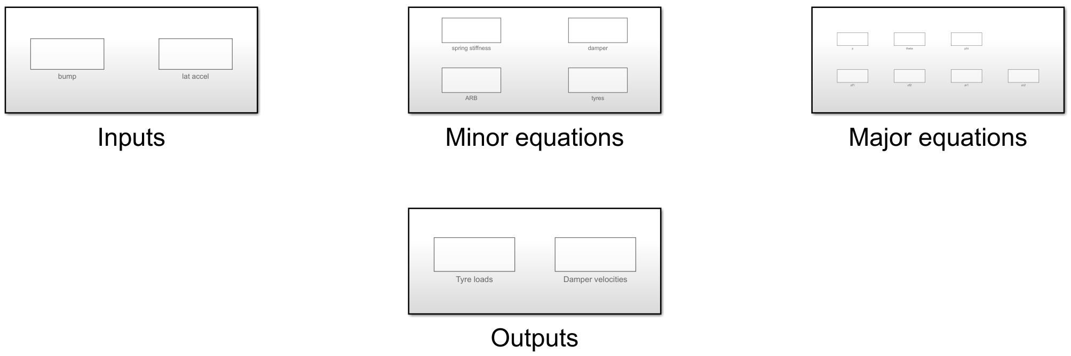
Figure 10 - Subsystems of 7 DOF model within Simulink
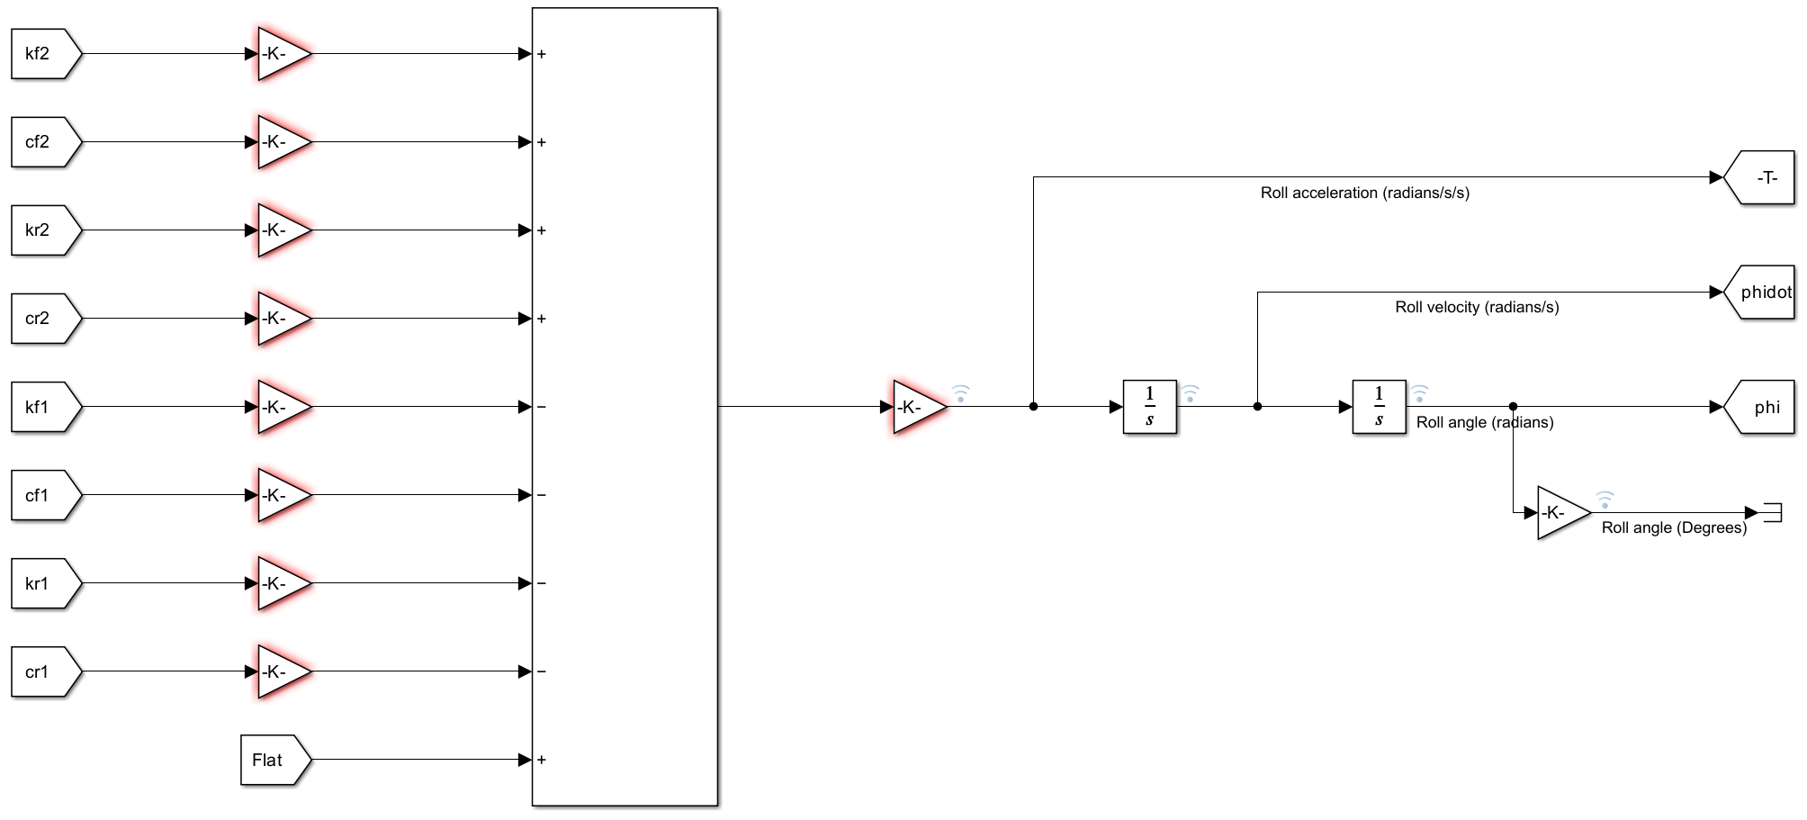
Figure 11 - Calculation of roll angle within Simulink
In addition to this, modelling of the ARBs is done through figure 12, these forces are then input to the heave calculation of each corner of the vehicle, these forces are then distributed across the vehicle as on side is positive and the other negative to represent the behaviour of the ARB. The calculation of these forces is based on equation 17. As previously stated, the MR is equal to one, hence theta left minus theta right is equal to zf1 minus zf2, shown in equation 18.

$F_{ARB}=\frac{K_{ARB}}{T}(θ_{L}-θ_{R})$ Equation 17
$θ=MR×Wheel displacement$ Equation 18

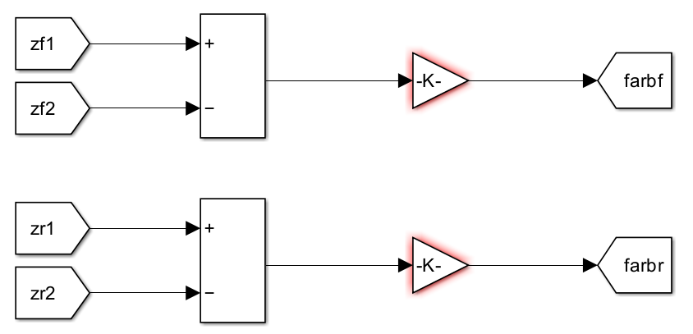
Figure 12 - ARB force calculation within Simulink front and rear
Input of the lateral force is done through the signal editor block, this has a .MAT input file containing 36 signals for both test types (slalom and lane change) for all 18 setups. The output values from the simulator came as g forces, they needed to be converted to a lateral acceleration which is used to calculate tyre loads on the vehicle. To be used as an input force to the subsystem in figure 11, the acceleration must be multiplied by the sprung mass and the value of h, this can be seen in figure 13.
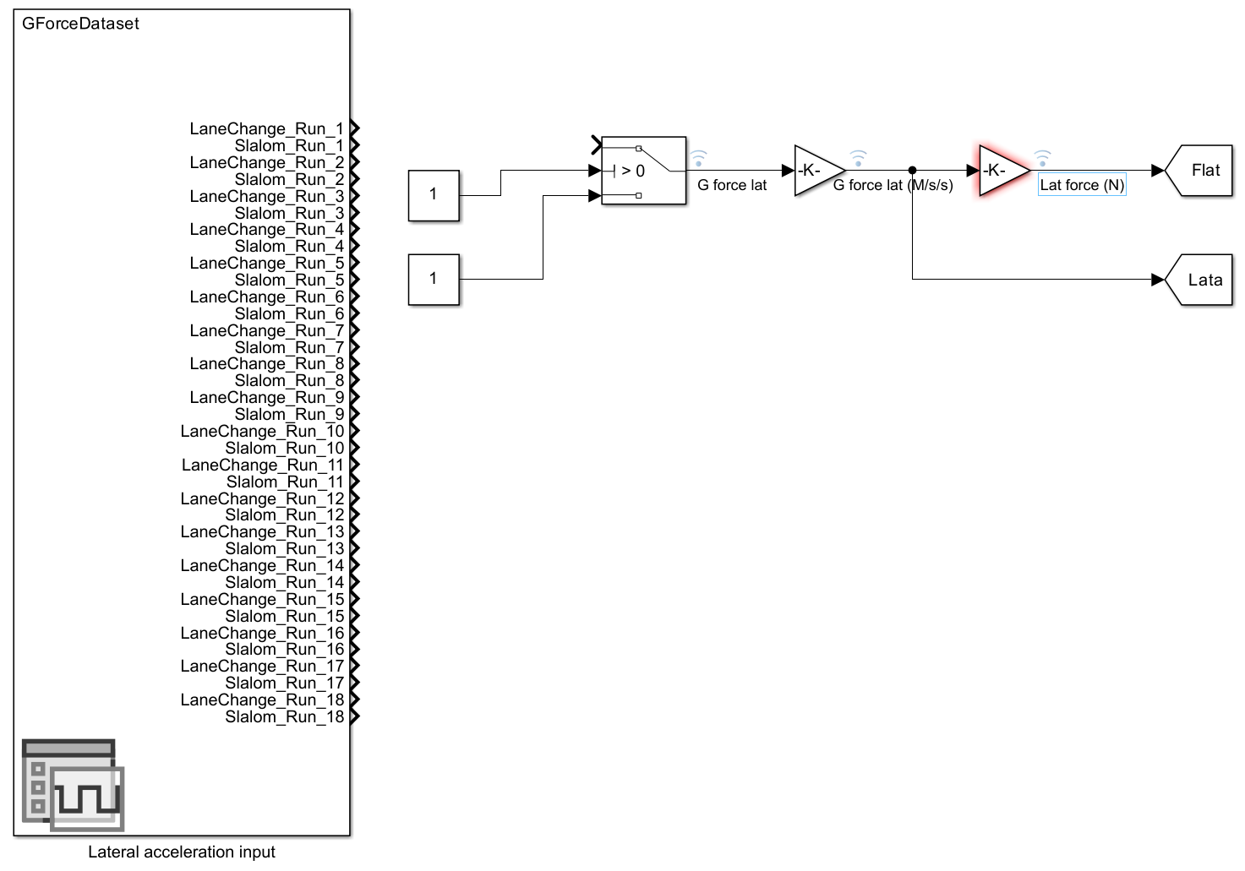
Figure 13 - Lateral force input on Simulink model
Tyre loads are one of the two additional comparison values used to validate the Simulink model to the simulation, alongside damper velocity, this is calculated through equation 19 and input to the model through figure 14. The application of tyre loads to the system uses a MATLAB function block as shown in figure 15.
$Damper Velocity \left(Corner\right)=Heave-Corner heave$ Equation 19
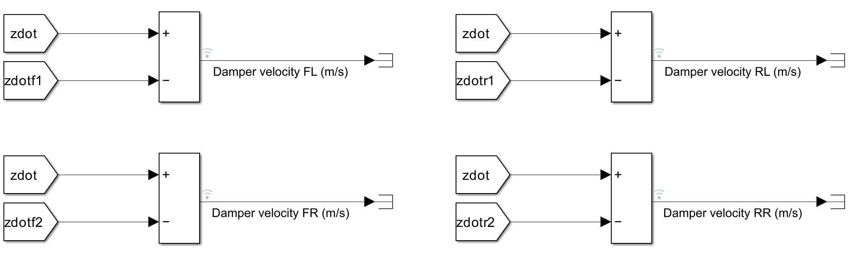
Figure 14 - Damper velocity calculation within Simulink for each corner of the vehicle
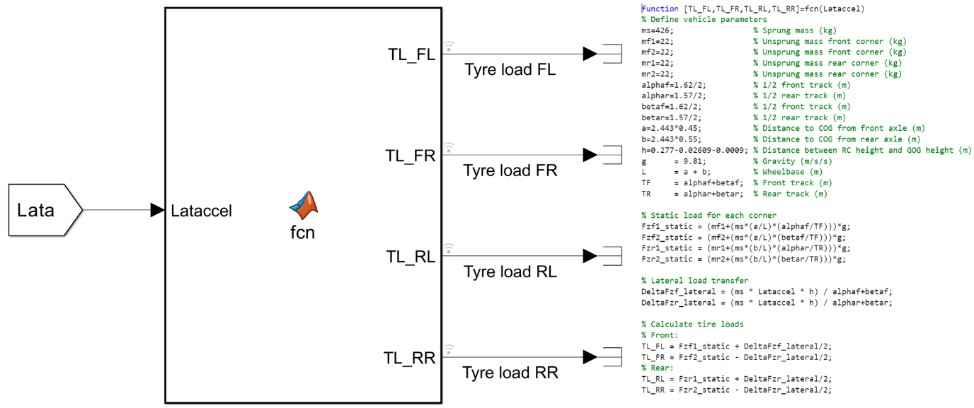
Figure 15 - Tyre load calculation within Simulink for each corner of the vehicle

Model validation
Alongside graphical representation of the data, analytical comparators are used here to draw conclusions on the validity of the model, these being root mean square error (RMSE) and mean absolute error (MAE), see equations 20 and 21. The RMSE measures the average magnitude of error, whilst the MAE measures the average absolute difference between the two signals.
$RMSE=\sqrt{\frac{1}{N}\sum{{(y_{Simulink}-y_{Simulator)}}^{2}}}$ Equation 20
$MAE=\frac{1}{N}\sum{|y_{Simulink}-y_{Simulator}|}$ Equation 21
Figure 16 shows comparisons of roll angle for the simulator and Simulink model for both tests on the base setup. A clear trend of accuracy is seen, with variations in peak values. This validates that the model is working correctly however it is showing an overestimation of roll. Using the RMSE and MAE values to assess this overestimation, it can be concluded that the error seen is reasonable and expected with the assumptions used and limitations of the 7 DOF model. Also, it is observed a maximum deviation of roughly 0.1 degrees of roll at any point showing good correlation between to two methods for a well-balanced setup. Another conclusion is the delay in roll visible on both plots, this suggests a lack of stiffness in the system which agrees with the overestimation in roll angle.
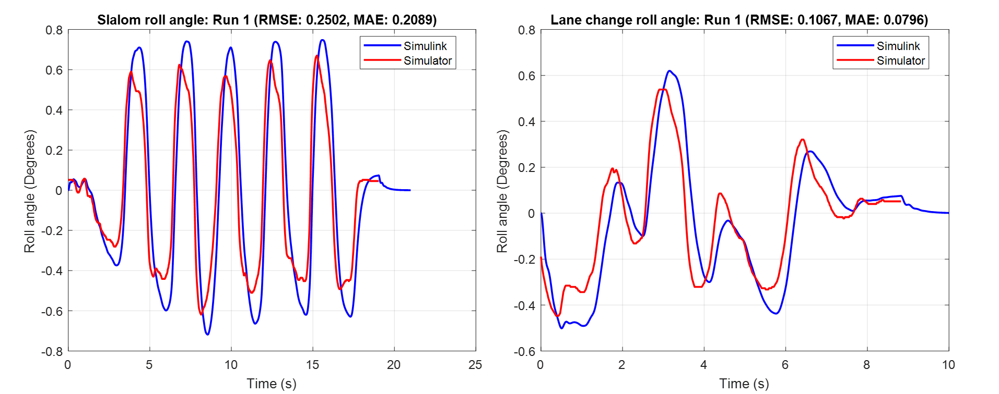
Figure 16 - Roll angle comparisons between Simulink and simulator data for the default setup
This trend doesn’t carry through all setups however, it is observed that throughout testing the accuracy of the model is dependent upon the setup. For setups with under damper systems or soft springs the accuracy decreases significantly, speaking to the validity of the for-modelling setup changes. Table 4 shows the RMSE and MAE values for all 18 setups, comparing this data with the setup aims shown through table 3, it is visible that the soft and underdamped systems are not as accurately modelled.

Table 3 - List of changes made to each setup
Setup | Setup changes
1 | Default
2 | Semi stiff
3 | Stiff
4 | Semi soft
5 | Soft
6 | Front stiff, rear soft
7 | Front soft, rear stiff
8 | Fast bump lower
9 | Fast bump higher
10 | Slow bump lower
11 | Slow bump higher
12 | Fast rebound lower
13 | Fast rebound higher
14 | Slow rebound lower
15 | Slow rebound higher
16 | Default (ARB front and rear)
17 | Default (ARB front)
18 | Default (ARB rear)

Table 4 - RMSE and MAE values for slalom test for roll angle
Setup | RMSE | MAE
1 | 0.25016 | 0.20895
2 | 0.28374 | 0.22057
3 | 0.20712 | 0.15701
4 | 0.50489 | 0.41382
5 | 0.90568 | 0.73103
6 | 0.38005 | 0.30050
7 | 0.41681 | 0.32947
8 | 0.34010 | 0.24359
9 | 0.46519 | 0.37840
10 | 0.69275 | 0.44762
11 | 0.37065 | 0.26482
12 | 0.32866 | 0.23754
13 | 0.45061 | 0.35394
14 | 0.36940 | 0.26482
15 | 0.33660 | 0.24439
16 | 0.25998 | 0.19817
17 | 0.27222 | 0.19672
18 | 0.30997 | 0.21494

Alternatively, analysis of tyre loads and damper velocities with comparison to the simulator data can further validate the accuracy of the model. Damper velocities, seen in figure 17, show very good correlation between both methods with very low RMSE and MAE values, suggesting both systems use the same method of calculation. In contrast to this, tyre loads, see figure 18, show large inaccuracies in peak values but true trends. This suggest a lack of accuracy in tyre modelling due to the simple characteristics input to the system, implementation of improved tyre modelling would be suggested to improve the loads seen alongside aerodynamic inputs.
Figure 17 - Damper velocity comparisons for slalom testing for default setup for each corner of vehicle
Figure 18 – Tyre load comparisons for slalom testing for default setup for each corner of vehicle
The same conclusions can be crawn from the data associated with the lane change, as displayed through figures 19 and 20, showing good correlation for damper velocities whilst tyre load calculation is inaccurate.
Figure 19 – Damper velocity comparisons for lane change testing for default setup for each corner of vehicle
Figure 20 - Tyre load comparisons for lane change testing for default setup for each corner of vehicle

Model limitations
The model provides a good insight into the expected trends seen through transient manoeuvres, yet the exact values returned are not completely accurate. This is a result of the limitations in model complexity. The simulator incorporates many more mathematical models to improve the accuracy of results to ensure the closest correlation to true vehicle dynamics.
The Simulink model does not input any aerodynamic forces onto the vehicle, this will result in inaccurate tyre loadings due to the additional downforce or lift. To correctly implement aerodynamic forces on the vehicle, an aero map of the vehicle would need to be created and recalculated at various points as the vehicles heave, pitch and roll alternates through the transient manoeuvres. This process is computationally extensive, and difficult to implement to the model providing small accuracy gains for simple transient manoeuvres. This was implemented on a study on active aerodynamics (Kurec, 2019) and a study on the aerodynamic effects on vehicle stability (Brandt, 2023) showing its possibility for implementation. Aerodynamic equations are described through
The modelling of tyres within the model is very simple, using just two values to describe the response from each corner of the vehicle. To improve the modelling accuracy, a tyre model like the pacejka magic formula could be implemented which simulates tyre characteristics to a higher exactness than current. This is an empirical tyre model that describes tyre forces and moments based on parameters like slip angle, slip ratio and load (Pacejka, 1992). While computational efficient, it requires empirical data for tuning which is not widely available and requires large amount of known tyre data. The output of tyre forces would enable comparisons between the output forces from the simulator allowing further model validation.
Alongside complex tyre data required for the pacejka magic formula, the system needs to calculate slip angles and slip ratios, without data for vehicle yaw this isn’t possible, highlighting another shortcoming of the 7 DOF model (pan, 2024). This requires additional calculations that would increase the DOF of the model yet also improving modelling accuracy and comparative ability.

Sensitivity analysis
Table 5 - Setup variables
Detailed in table 5 are the changes made throughout testing, runs 2 through 7 altered spring stiffnesses, whilst runs 8 through 15 made changes to damper coefficients. Finally runs 16, 17 and 18 retained the default spring and damper variables with the addition of an ARB.

Spring stiffness analysis

Spring stiffness analysis for slalom
The variations seen across the x axis of the graph shown through figure 21 comes from slight variation in alignment of the beginning of slalom testing from the full data extraction, yet the main analysis of y values is still valid and shows expected trends. The largest roll angles are shown through run 5 whilst smallest shown through run 3. With comparisons to table 3, it is visible that these are soft and stiff setups respectively, aligning with expected trends, maximum deviation between these runs shows a 0.8 degree increase in roll angle. This shows that between the soft and stiff setups roll angle roughly doubles in magnitude, aligning with the findings of Soliman and Hamed (Soliman, 2001) (Hamed, 2018). Another analysis of figure 21 shows that lack of significant change when reducing and increasing the spring stiffness by smaller margins as indicated by runs 2 and 4, when roll angle is affected less significantly, aligning with expected results. Stiffness changes of this magnitude are usually made upon driver request where performance is not as significantly affected however driver feel and feedback is still affected.
Figure 21 - Comparisons of runs 2 through 7 for the slalom test from Simulink data
Analysis of setups 6 and 7 from figure 21, shows the roll angle remains relatively similar whether the front or rear suspension is set to a soft spring stiffness. To further analyse this, figure 22 indicates the damper velocities front to rear comparing both setups. It is visible that throughout the whole slalom test, run 6 (stiff front, soft rear) shows faster velocities, leading to the conclusion that increasing spring stiffness results in increased damper velocities. Comparing this conclusion with published data Hamed states that with increased spring stiffness, you will see reduced suspension travel resulting in increased damping acceleration and thus increased damper velocity (Hamed, 2018).
Figure 22 - Damper velocities comparing runs 6 and 7 for slalom testing from Simulink data

Spring stiffness analysis for lane change
Similar conclusions can be drawn from the lane change testing to that of the slalom testing, see figure 23, with run 5 showing the largest roll angles whilst run 3 returns maximum roll angles roughly 0.5 degrees lower. One outlier within this analysis is the positive roll angle seen from run 2 at the rough 6 second mark. This may be resultant of inconsistent driver input from the simulator testing. These inconsistencies are commonly observed throughout the lane change analysis making it harder to draw conclusive analysis in comparison to the slalom testing which returned consistent results at a higher frequency compared to the lane change testing. This led to the conclusion that for further analysis the lane change test would lead to confusion in results, thus it is decided to remove it from future analysis.
Figure 23 - Comparisons of runs 2 through 7 for the lane change test from Simulink data

Damper coefficient analysis
Figure 24 - Comparison of roll angles for different damper curves for slalom test from Simulink data
The largest difference in roll angle, shown through figure 24, is between setup 11 and 13. Comparing these setups through table 3, it is visible that setup 11 increases damping coefficients for slow bump whilst setup 13 increases damping coefficients for fast rebound. Indicating the testing challenges slow bump and fast rebound specifically. Despite this, changes in roll angle are sporadic throughout testing meaning conclusive conclusions are difficult to make. Comparing figures 24 and 25, very similar trends are seen, drawing conclusions that for this test type that damping coefficients have little effect on roll angle and that differences seen are a result on variations in driver input to the simulator. A remedy for this could be increased speed of testing to implement higher suspension frequencies requiring larger damper work.
Figure 25 - Comparison of lateral force input for different damper curves for slalom test from Simulink data

ARB analysis
Analysis on the effects of ARBs on vehicle dynamics begins though figure 26. From this graph, minor increases in roll angle are seen between setup 1 (default) and setup 16 (default with ARB both front and rear), this could be resultant of inconsistent driver input which due to the scale of difference would be a fair assumption. Setup 17 displays minor increases over 16, whilst this could be resultant for reasons stated previously, another hypothesis is the imbalance of stiffness front to rear. This is then increased when the rear is stiff and front soft as displayed through setup 18. These conclusions suggest the imbalance in stiffness causes larger implications on roll angle in comparison to whether the stiffness is applied to the vehicle system at all, and then this is amplified across the front axle when soft. Reasoning behind this could be due to the front wheels being steered and doing a larger amount of work compared to the rear wheels for this manoeuvre.
Figure 26 - Comparisons of ARB effects on roll angle for slalom test from Simulink data
The trends analysed through figure 26 are further reinforced through figures 27 and 28. Setup 18 signifies much larger tyre loads on rear wheels in comparison to front wheels suggesting this imbalance in stiffness between the front and rear axles not only increases roll angle significantly, yet it increases damper velocity, and tyre loads also leading to increased tyre wear across the rear axle and damper work across the rear axle.
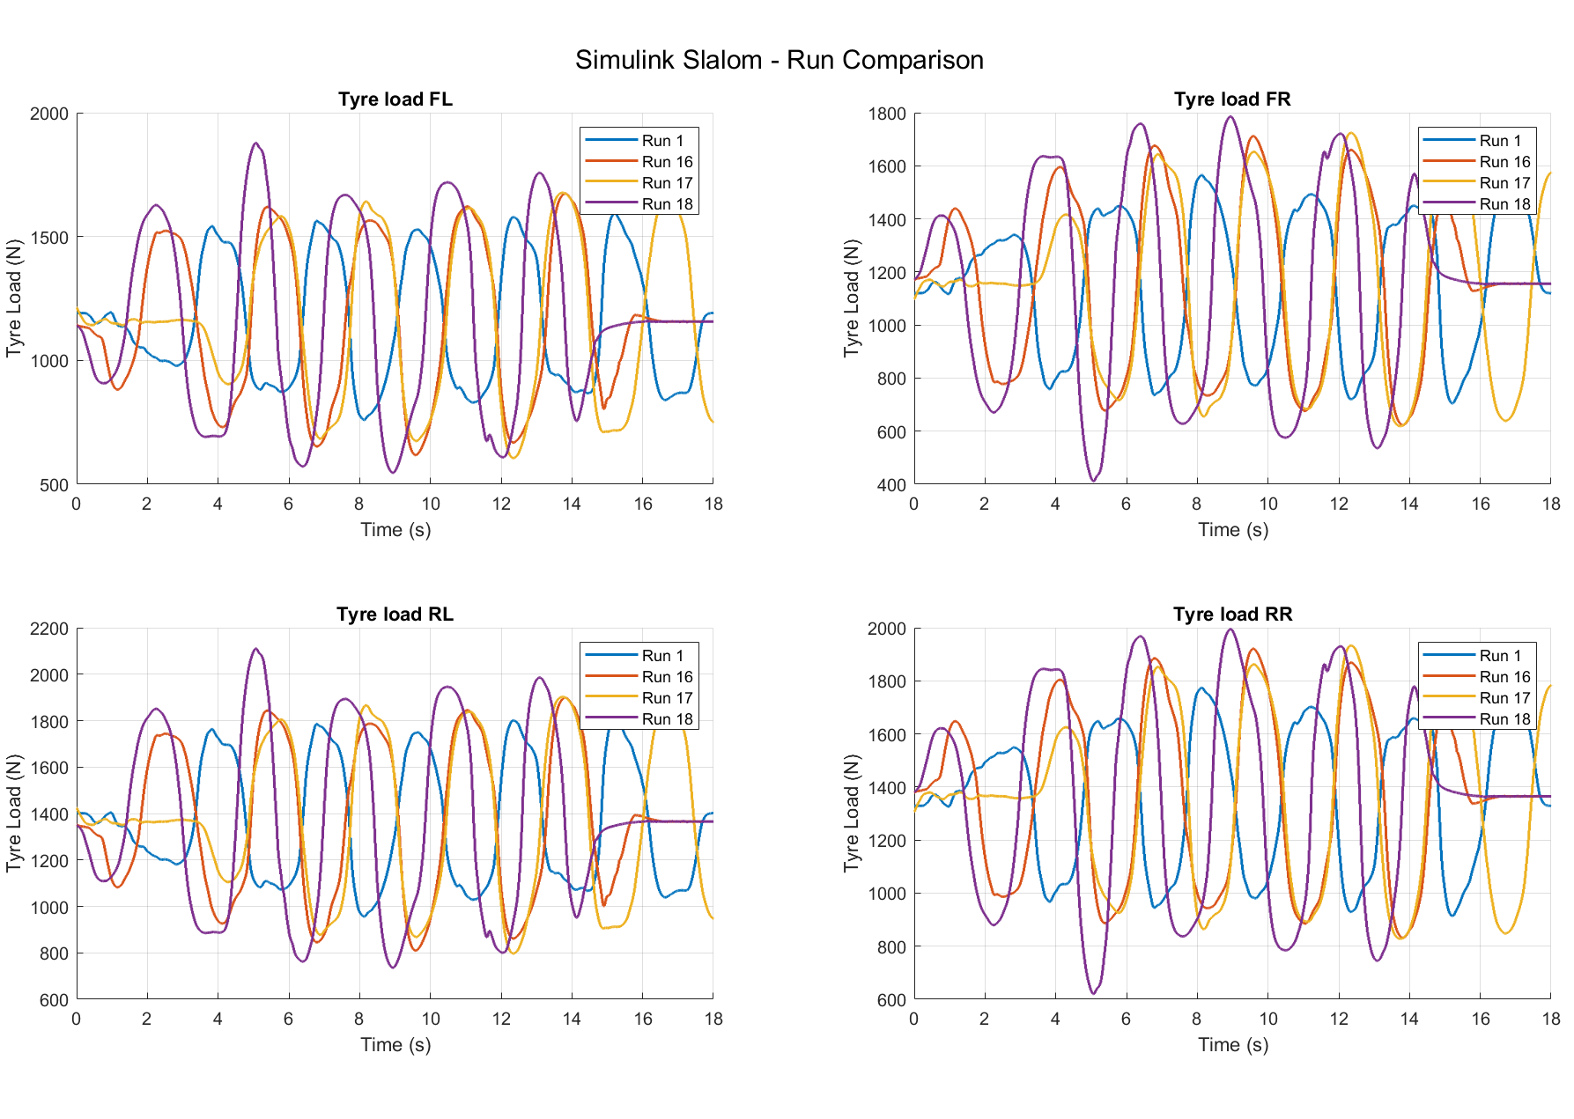
Figure 27 - Comparisons of ARB effects on tyre loads for slalom test from Simulink data
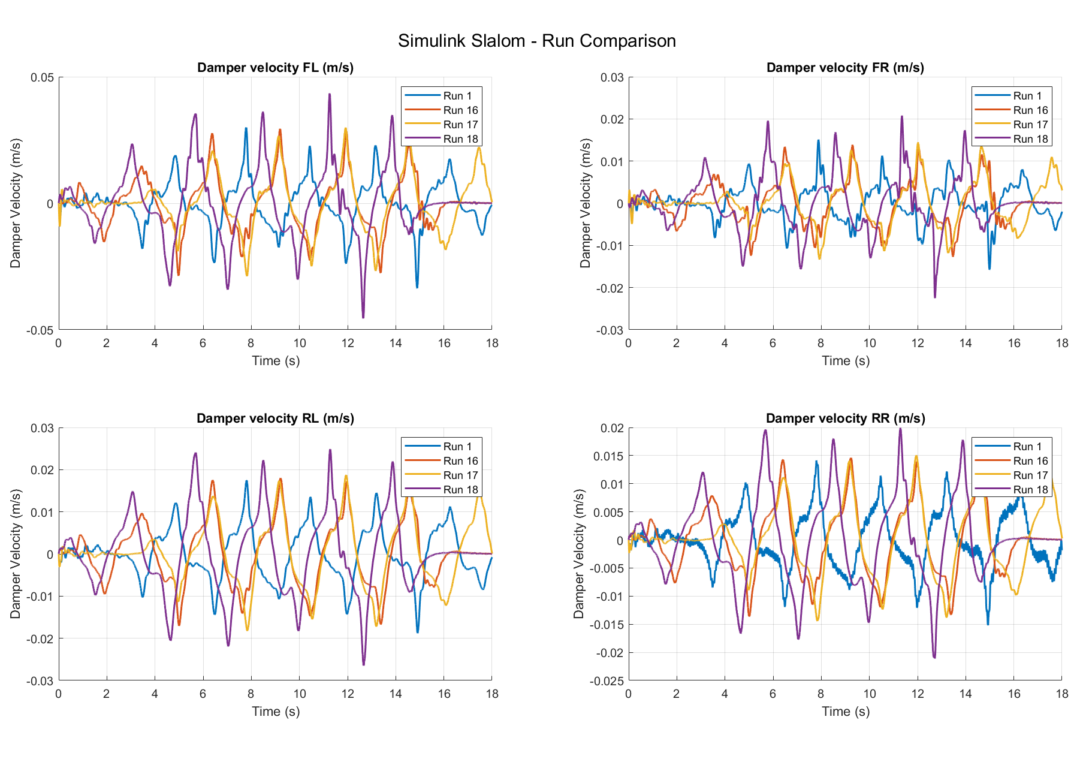
Figure 28 - Comparisons of ARB effects on damper velocities for slalom test from Simulink data
To validate the previous findings, see figure 29. Showing agreement between Simulink and simulator calculations, thus validating the hypothesis. Also shown through figure 29, are tyre loads roughly 400N smaller calculated by the simulator in comparison to the Simulink data. This suggests that tyre modelling within Simulink requires further work to improve accuracy across all four corners of the vehicle.
Figure 29 - Comparison of tyre loads for slalom test for setup 18 between Simulink and simulator data

Conclusion and recommendations
Predicted trends through transient manoeuvres for both slalom and lane change testing are successfully captured by the Simulink model, thus validating this methodology. A strong correlation between roll angle rand damper velocity from both simulator and Simulink data is seen for the baseline setup, showing an RMSE of 0.25016 and an MAE of 0.20895 for roll angle and averaging under 0.01 for both RMSE and MAE for damper velocity.
The investigation in on alternate setups shows good results for spring stiffness testing with expected trends seen. With roll angle differences of up to 0.8 degrees observed between the softest and stiffest settings. However, changes in the damper coefficient had little influence on roll angle, with RMSE values ranging from 0.20712 to 0.90568. This suggests that the chosen transient events did not produce significant damping effects. Differences in stiffness between front and rear with the addition of an ARB on the rear through setup 18 resulted in differences in tyre loads of 400n, a vast underestimating when compared to simulator data, thus invalidating tyre loads calculations.
Key limitations noted through analysis is the simple tyre characteristic modelling resulting in inaccurate load calculations and minor discrepancies through analysis. Additionally, the lack of aerodynamic input to the system causes errors throughout estimation, due to transient behaviour in performance vehicles being highly affected by aerodynamic forces. The accuracy of the model for modelling underdamped and soft spring models varies, potentially indicating further flaws in the modelling.
Suggested model enhancement comes in the form of the introduction of a pacejka formula to enhance tyre dynamics allowing improved tyre modelling and load calculations. This, alongside the inclusion of aerodynamic forces through a dynamic aero map of the vehicle would help model real world behaviour to a higher degree of accuracy. Furthermore, increases the degrees of freedom of the model, incorporating yaw dynamics to the vehicle would further improve the accuracy of vehicle modelling.
Finally, the model serves as good tool to gather basic vehicle data and showing true trends of results with comparisons to Ubaidillah (Ubaidillah, 2015) and Ahmad (Ahmad, 2014). Yet, to accurately model vehicle dynamics with full confidence, further model enhancement is required.

References
Ahmad, F. M. S. A. Z. H. J. H., 2014. Modelling and Validation of the Vehicle Longitudinal Model. International Journal of Automotive and Mechanical Engineering , 10(1).
Aripin, M. K. S. Y. M. D. K. A. H. K. P. N. I. M. F., 2014. A Review of Active Yaw Control System for Vehicle Handling and Stability Enhancement. International journal of vehicular technology, Issue 1.
Attia, R. B. M. O. R., 2014. Combined longitudinal and lateral control for automated vehicle guidance. Vehicle system dynamics, 52(2), pp. 261-279.
Baur, H. M. S. H. A. H. G. M. F., 2006. Reactivity, stability, and strength performance capacity in motor sports. Br J sports med, Volume 11, pp. 1-40.
Belrzaeg, M. A. A. A. A. A. Q. K. M. M. A. A. A. A. M., 2021. Vehicle dynamics and tire models: An overview. World journal of advanced research and reviews, 12(1), pp. 331-348.
Brandt, A., 2023. Unsteady aerodynamic effects on the driving stability of passenger vehicles, Gothenburg: s.n.
brssc, 2022. 2022 BRSCC Avon tyres national formula ford 1600 championship sporting and technical regulations, s.l.: s.n.
Hamed, M. E. M. G. F. B. A., 2018. Effects of spring stiffness on suspension performances using full vehicle models. s.l., AIJR .
Jazar, R. N., 2008. Vehicle dynamics: theory and applications. Manhattan: Springer.
Jung, J. S. T. G. J., 2009. A Vehicle Roll-Stability Indicator Incorporating Roll-Center Movements. IEEE transactions on vehicular technology, 58(8), pp. 4078-4087.
Kurec, K. R. M. B. J. B. P. t. S. P. J., 2019. Advanced Modeling and Simulation of Vehicle Active Aerodynamic Safety. Journal of advanced transportation, Issue 1.
Levantaci, M., 2022. Modelling and validation of an adaptive cruise control using a high fidelity dynamic driving simulaotr, s.l.: s.n.
Macfarlane, A. B. U. N. T. V., 2018. Oleo Strut for use on Modular Electric Automatic Guided Vehicles. Port Elizabeth, s.n.
Pacejka, H. B. B. E., 1992. The madic formula tyre model. International journal of vehicle mechanics and mobility, Volume 21.
pan, Y. H. W., 2024. Tire dynamixs simulation based on MATLAB/Simulink. Journal of Physics Conference Series, 2787(1).
Soliman, A. M. A. A. A. S. A. E.-B. A. A. H. M. S., 2001. Effect of suspension spring stiffness on vehicle dynamics. International journal of heavy vehicle systems , 8(3).
TonyC63, 2019. Hi/Lo Damper velocity threshold. [Online]
Available at: https://www.overtake.gg/threads/hi-lo-damper-velocity-threshold.163385
[Accessed 9 February 2025].
Ubaidillah, .. P. K. N. M. M. S. A., 2015. Simulation and model verification of a vehicle handling dynamics. s.l., IEEE.
Wang, J. H. M., 2009. Vehicle Yaw Inertia and Mass Independent Adaptive Control for Stability and Trajectory Tracking Enhancements. s.l., IEEE Xplore.
Westermark, C., 2013. Validation of vehicle model in car simulator, Stockholm: s.n.
Xiao, G. L. Z. S. N. Z. Y., 2024. Research on the Stability Control Strategy of High-Speed Steering Intelligent Vehicle Platooning. Design Theory, Method and Control of Intelligent and Safe Vehicles, 15(4).
Zehsaz, M. V.-T. F. P. A., 2014. Investigation on the effects of stiffness and damping coefficients of the suspension system of a vehicle on the ride and handling performance. U.P.B Science bulletin , 76(1).
Zhang, H. Z. N. M. F. R. S. S. C. W. E., 2016. Coupling mechanism and decoupled suspension control model of a half car. Mathematical problems in engineering.
Zheng, M. P. P. Z. B. Z. N. W. L. C. Y., 2015. A New Physical Parameter Identification Method for Two-Axis On-Road Vehicles: Simulation and Experiment. Shock and vibration, Volume 2.
Zuska, A. J. J., 2023. Influence of Changes in Stiffness and Damping of Tyre Wheels on the Outcome of the Condition Assessment of Motor Vehicle Shock Absorbers. energies, Volume 16.

Appendix

