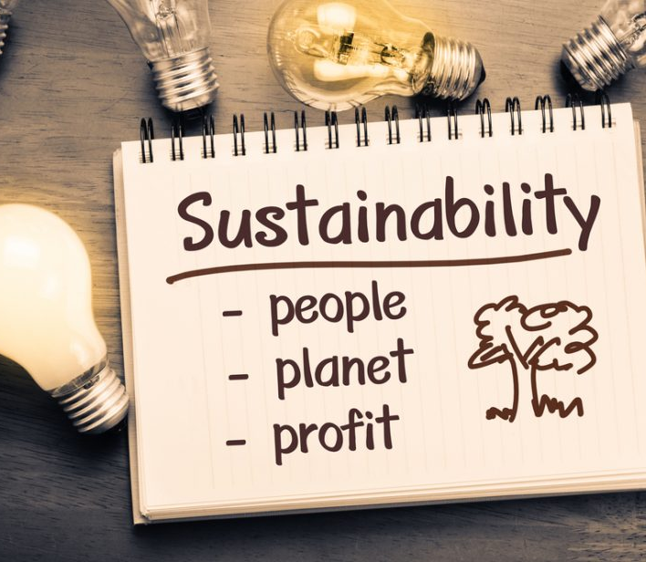
Sustainability Report
Module: Sustainable Hospitality & Tourism Management
Module Code: BMIH5006
Lecturer: Christopher Wilkins
Author: MARINELA COVASNEANU | Student number: 1920078 | Word count:2186

“I confirm that I have not used any AI tools in the research and creation of this assignment. I confirm that I have not presented any AI generated materials as my own work. I confirm I have copies of my drafts, notes, and other resources I used, which I may be asked to provide in evidence.”

Executive summary

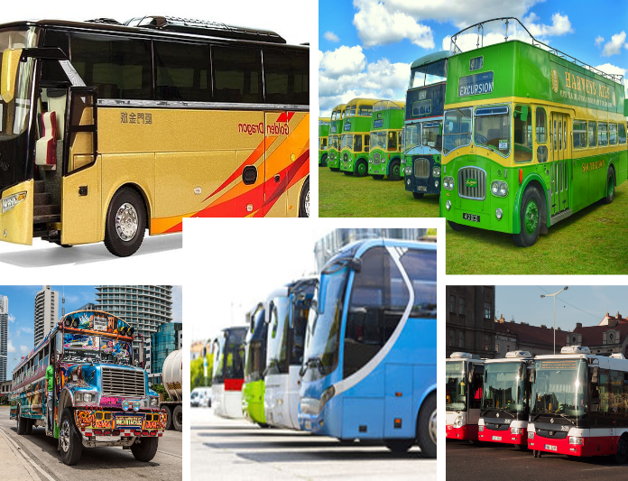
This report explores the environmental impact of buses used in hospitality transport and presents solutions to mitigate these impacts, as well as the challenges associated with implementing these solutions. Buses contribute to greenhouse gas emissions, air pollution, and resource consumption during both construction and operation. The emission from diesel engines exacerbates climate change and deteriorate air quality, affecting public health. Transitioning to electric, hydrogen fuel cell, and biofuel buses can significantly reduce emissions and improve air quality. Efficient route planning, energy efficient technology like regenerative braking and lightweight materials and using recycled materials can further minimise resource consumption. Investing in charging stations and hydrogen refuelling
(Bing, 2025)
infrastructure is crucial for supporting the transition to alternative fuels. However, challenges include high upfront cost, technological barriers, and the need for coordinated efforts from government, manufacturers, and operators. Transitioning to sustainable bus transportation in the hospitality industry transport offers significant environmental benefits but requires strategic planning, high investments, and collaboration to overcome the challenges.

Contents
Executive summary 1
Introduction 4
Main body 5
Types of hospitality transport buses 6
Hotel shuttle buses 6
Tour buses 6
Event transportation busses 7
Luxury coaches 7
Buses negative impacts 7
Carbon emission 7
Solution 8
Switch to electric or hybrid buses 8
Optimising routes and schedules 9
Recommend eco-friendly driving practices. 9
Adopt alternative fuel and invest in renewable energy. 10
Noise pollution 10
Solution 10
Engine and exhaust systems upgrading 10
Maintenance 11
Driver training and bus design 11
Urban planning and noise barriers 11
Resource consumption 11
Solution 11
Recycling and reuse 11
Sustainable procurement 12
Lightweight materials 12
Road wear and tear and fuel spills and leakages 12
Solution 12
Strategic planning 12
Innovative technology 12
Conclusion 13
References 13
Appendices 20

Introduction

Transport is an essential component of tourism industry and leisure experience. (Page & Davies, 2019) The different modes of transportation that enable the movement to and from hospitality destination like hotels, tourism attractions, resorts, spas, restaurants, and many others define the hospitality transport. (Virkar et al., 2018)
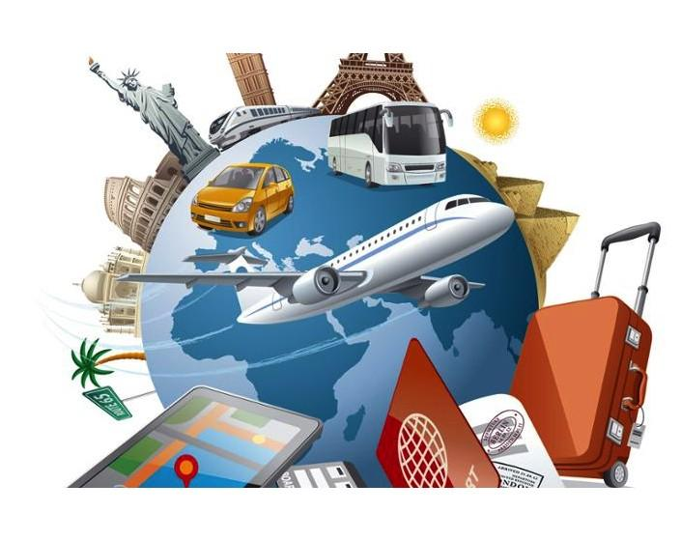
(Beautiful places in the world, 2021)
These services include event transportation, airport shuttles (Mest, 2015), local sightseeing buses (Yarcan & Cetin, 2021), limousine and car services (Rose & Hensher, 2018), boat transfers (Kaluđerović, 2019) (Diaz, 2023), bicycle rental (Genikomsakis et al., 2021) and other forms of travel to ensure convenience and comfort for the guests. These services are design to be dependable, efficient, comfortable, and providing to the needs of customers making sure they have a pleasurable journey. (Walker, 2021) Choosing the right transportation option can make a significant difference in the overall travel experience considering the key factors as: convenience, cost, comfort, reliability, safety (Blair-Frasie, 2024), destination, coverage, special requirements and finally and one of the most important at the moment environmental impact.
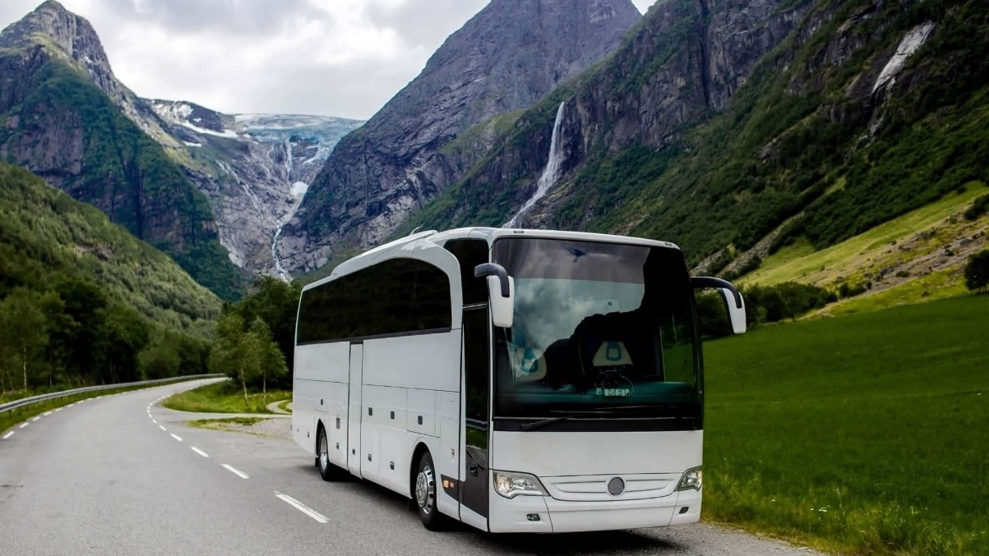
(Wallpapers, 2024)
This report aims to explore the role of buses within the context of hospitality transport, examining their damages, benefits, challenges, future viable solutions in resolving and responding to their environmental impact and their future potential. It will analyse how buses can be designed and managed to align with principles of hospitality considering operational strategies to overcome all obstacles and to position between the sustainable methods of transport.

Main body

Buses play an essential role in contemporary transportation systems, serving as an indispensable mode of public tourism transport both in urban and rural areas. (Kudirat, 2020) While they provide an efficient and cost-effective way of transferring from one destination to others of a large number of guests, minimising the dependency of individual car usage, the environmental impact of buses must not be overlooked. Their impact contributes to both positive and negative environmental outcome. (Nyong et al., 2024)

Types of hospitality transport buses
Beside the public transport that the hospitality customers are able to use there are other mor specific types of buses, with distinct purpose and features, which are used as hospitality transport.

Hotel shuttle buses

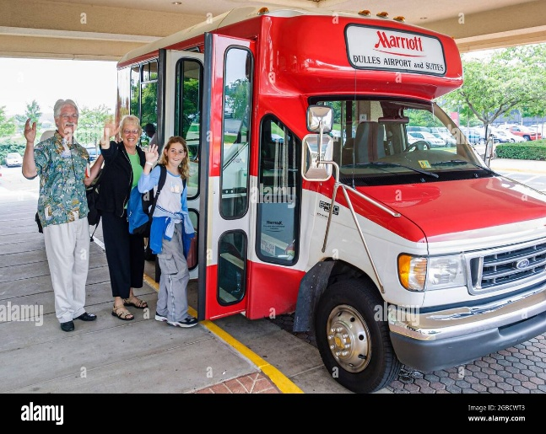
It transports the guests from other mode of transportation such as planes, trains or any tourist attractions offering comfortable seating, wi-fi, accessible for luggage and sometimes refreshments. Some examples of hotel that offer these services are Marriott, Hilton, Holiday Inn, and many others. (Heathrow, 2025)
(Alamy, 2025)

Tour buses

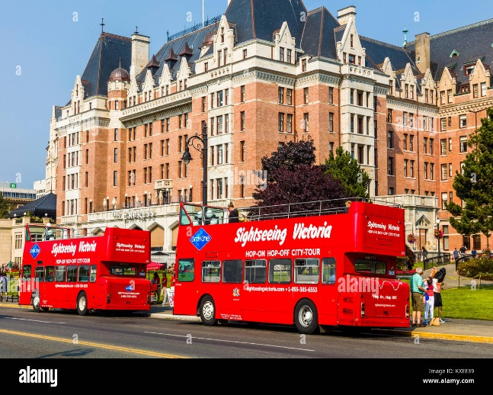
It provides guided tours for the hotel tourists and guests of the cities, historical sites and scenic routes and offering audio guides, large windows for sightseeing, uncovered up level with comfortable seats for an enjoyable panoramic view. Mystery Coach Trips & Breaks with Hotel Stays - National Holidays is an example of hotels stay with bus tour offers. (National holiday, 2025)
(Alamy, 2025)

Event transportation busses

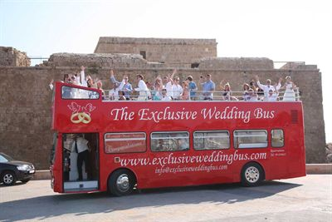
Transfer the guests between hotels and venues for large gatherings like life events, conferences, concerts, or festivals, having a right scheduled arriving times and efficient with crowd management. An example is Holiday Inn Express Heathrow that offers convenient transports to events to their customers.
(Exclusive Wedding Buses, 2022)

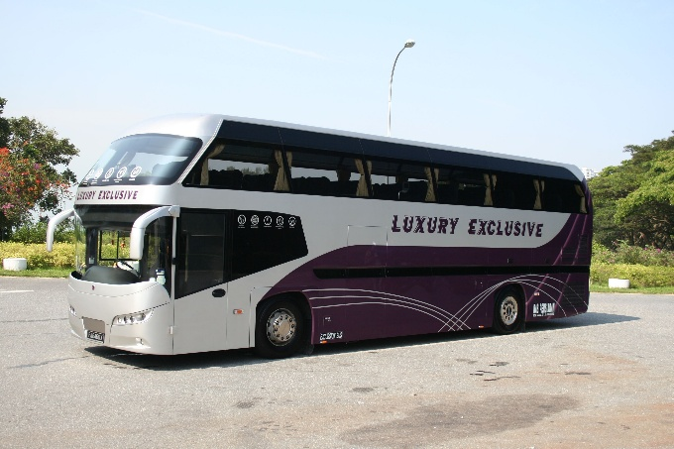
Luxury coaches

These buses offer premium travelling for high-end guests having onboard restrooms, reclining chairs, and catering services.

(Pinterest, 2025)
Buses are defined as a cost-effective asset of leisure travel providing affordable option of transport, quick and improved access to recreational attraction. (Rhoden & Kaaristo, 2020) Even if they are considered more sustainable than individual cars, buses still have a negative impact on the environment.

Buses negative impacts

Carbon emission
In 2022 global direct carbon dioxide emission from buses approached 452 million metric tons (MtCO2) accounting 6% of transport CO2 emission in UK. (GOV.UK, 2023) Buses caused 3% of these emissions and 1% of total mileage in 2019. (GOV.UK, 2023) (Appendix B)
According to a Statista research buses and coaches have a carbon footprint, calculated in grams per kilometre of 135.7 situating this mode of transport in the middle of the chart but still with a significant impact on the environment. (Statista, 2024)
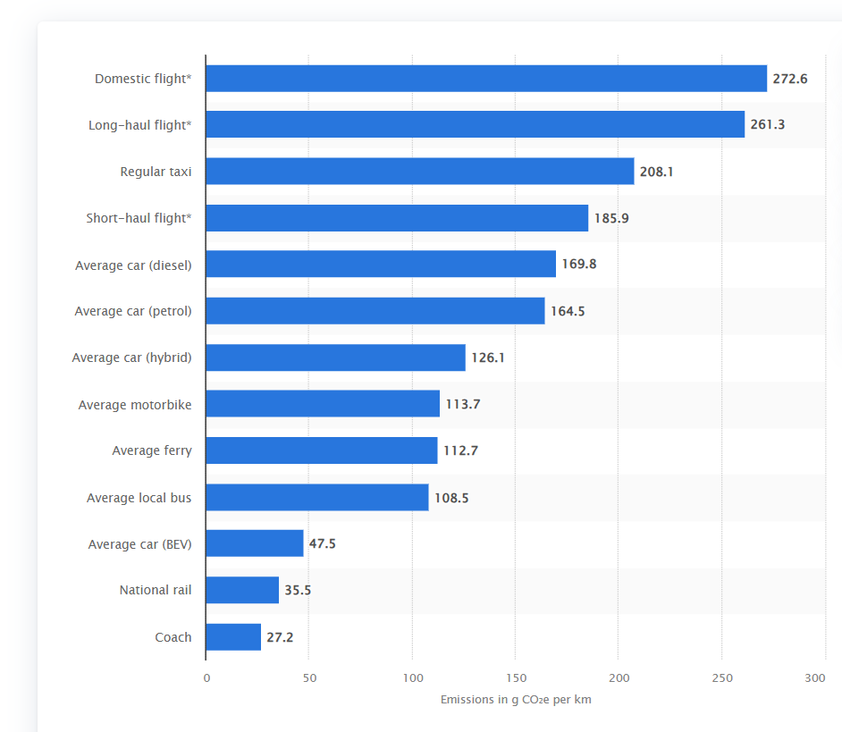
(Statista, 2024)
Looking ahead and taking in consideration the UK and the worldwide buses and coaches’ sector had a massive change to reach the current years demand, is predicted that only the UK bus market has currently more than 6430 vehicles with a growth rate of 1.54% until 2030, some strategic measure should be implemented to minimise their environmental impact. (GOV.UK, 2024) Particularly when 72.7% of fuel type are diesel only in England and approximately the same value around the world. (GOV.UK, 2024) (Appendix A)

Solution
Despite that over the last couple of years the buses in Uk and worldwide have seen an essential reduction in carbon footprint and from 1990 until 2023 the UK buses emissions had a considerable 57.7% decrease, there is more possible ways to improve and develop strategies to lower carbon emission figures. (GOV.UK, 2025)

Switch to electric or hybrid buses
To be in accordance with the goals of Paris Agreement (Meinshausen et al., 2022) the carbon and other emissions cuts are crucial. (Martini et al., 2024) Switching to electric and hybrid buses eliminates the exhaust emissions but different pollution agents are arising such as particulate matter (Kole et al., 2017) from dust resuspension, tire wear and others, emissions considered a significant health risk for urban and rural population. (Ravi et al., 2020)
The UK Government is already investing over£500 million in Zero Emission Bus Regional Areas (ZEBRA Scheme) to produce more than 1200 new zero emission buses, but in present only 10% of the operating buses are electric. (GOV.UK, 2024)
Using electric vehicles is a viable solution in decreasing fossil fuel consumption, improving the air quality and reducing the maintenance costs, but all with taking in considerations the possible challenges. (Aldenius, 2022) Alongside the upfront large investments and the constantly developing technology (Bakker & Konings, 2018) the most important obstacles are the limited range, less route flexibility (Mohamed et al., 2018), (Bloomberg New Energy Finance, 2018) and the impediments in developing the charging infrastructure. (Wang et al., 2018), (Xylia et al., 2017)
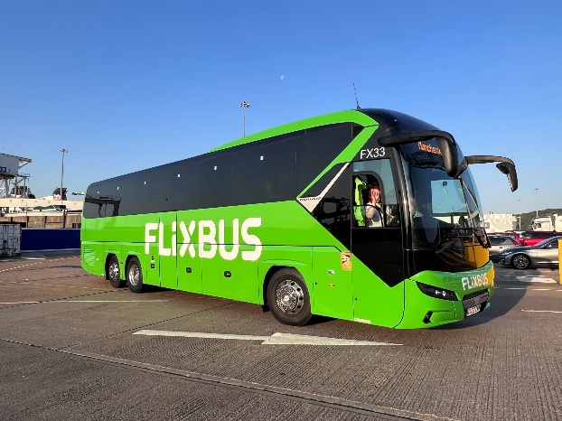
Flixbus is an example of the possible commitment to carbon emission reduction and promise to carbon neutrality in Europe by 2040. They are assessing already the first long distance electric buses and coaches that will save 352 kg of carbon emission per day driven on a selected route and more than 126 tones saved over in one year. (Flixbus, 2024)
(Flixbus, 2024)

Optimising routes and schedules
Optimizing the routes through fleet management can minimise the fuel consumption and lower the distance travelled by efficient route planning. (Cui et al., 2022)

Recommend eco-friendly driving practices.
Regular vehicle maintenance especially keeping the engine in perfect condition, regularly oil change and filters, tire checks with correct pressure and wear and tear measures, turning off the engine on stationary times and also maintaining a steady speed avoiding sudden accelerations or breaking are some of the practices needed to be implemented. (Wei, 2023)

Adopt alternative fuel and invest in renewable energy.
Installing solar panels at the bus depot or partnering with renewable energy providers and exploring the possibility of using biodiesel, hydrogen or compressed natural gas can provide cleaner option for powering buses with fewer emission such as nitrogen oxides (Nox) and particulate matter (PM) compared to traditional diesel. (Li et al., 2024), (Jelti et al., 2021) This alternative choices help mitigate climate change and its resulted impacts such as extreme weather events and rising sea levels. (Sidharthan & Kashyap, 2024)

Noise pollution
Due the poor maintenance or advanced age the buses can exceed the normal noise level especially in the urban areas and negatively impact the human and other living beings’ health. (Kaleniuk et al., 2021) This noise surpass can increase stress levels, creates sleep disturbance, and can be a reason for other health conditions for surroundings and also for the bus drivers. (Zhang & Zhou, 2023)
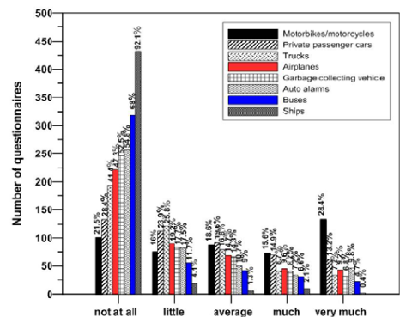
Even being between the last positions on the noise chart from a questionnaire result with only 11.3% of people annoyed of the bus noises, this polluting source still needs improvement, mostly because the people affected are the one on the main streets where usually the buses are travelling and not taking in consideration the surrounding people opinions. (ResearchGate, 2012)
(ResearchGate, 2012)

Solution

Engine and exhaust systems upgrading
Changing to lower noise production buses such as electric and hybrid versions or if this is not possible to upgrade to quitter engines and to use improved exhaust systems. (Suhanek, 2023)

Maintenance
The buses components and especially the engine having a regular and rigorous maintenance provides a smooth and quite running and excludes the use of worn-out parts that can be a significant part in noise appearance. (Alawaysheh, 2020)

Driver training and bus design
By implementing eco-friendly driving techniques and give the appropriate training to the bus and coach drivers that enhance the smooth acceleration and breaking and by designing the buses with better insulation, soundproofing materials and aerodynamic form prototypes can be particularly helpful in noise reduction. (Rony et al., 2024)

Urban planning and noise barriers
The most ideal way of minimising the impact on the communities of buses noises is to redesign the routes away from the residential areas and sensitive locations and to install noise barriers along these to help block and absorb the sound.
Adopt all this combination of measures can create a less noise environment but with a massive cost investment and people resilience to modern technology and its impact. Easy to say this is the solution but time consuming and with great amount of money invested and the incertitude that this is achievable.

Resource consumption
To mass produce all the necessary number of buses, even the electric and hybrid ones, is required a significant amount of plastic, glass, metal, and fossil fuel. The process of obtaining these resources starting with their extraction until the actual manufacturing can lead to habitat destruction, water and air pollution and other environmental negative consequences.

Solution

Recycling and reuse
The way of reducing the demand for new raw materials is incorporating in the construction process of buses recycled materials. Also, by designing them from the start with an effortless way of disassembly the process of recycling the plastic, metal, and other materials at the end of their life cycle is less time consuming or expensive and a solution to minimise the resource consumption. (Abdallah, 2017)

Sustainable procurement
In the current times there are many suppliers that prioritise recycling, adhere to sustainable practices and use eco-friendly materials. Sourcing the necessaries from an environmentally responsible supplier can reduce the environmental impact in bus construction.

Lightweight materials
To improve the fuel efficiency, to reduce the weight of buses and to minimise the use of metal and plastic required is recommended to utilise composite materials and aluminium. This can lower the energy consumption and reduce the ecological footprint. An example, Ebusco prides itself on the choice of composite materials that are lighter and with greater rigidity for a more significant passenger protection. (Busworld, 2025)

Road wear and tear and fuel spills and leakages

Buses are pretty heavy vehicles that can damage the roads and bridges through the wear and tear and highly increase the costs and the demand on the reconstruction materials. (Ohm et al., 2023) Due the excessive acceleration, sudden breaks, the significant amount of transit and the changing weather conditions the pavement can suffer substantial damage such as rutting, cracks and structural integrity that leads to environmental impact through extra materials needed, maintenance noise, dust, and habitat disturbance. (Batioja-Alvarez, et al., 2018) (Severino et al., 2022)
Also, the environmental impact from fuel leakages resulted from accidents or unmaintained vehicles that can affect not only the pavement quality but also the around animal or vegetation habitat.

Solution

Strategic planning
With a right planning strategy such as steering the buses from the susceptible to wear and tear roads to more durable and accessible alternatives and investing in upgrading or reinforcing the infrastructure can reduce the damage on the road foundation and improve the transport efficiency.

Innovative technology
Implementing Intelligent Traffic System is a way to reduce impact through easy monitor, manage and optimize traffic to reduce congestions, to prioritize heavy traffic on peak hours and assist accidents or bus breakage solving the spills or leakage on the pavement and surroundings not to affect the habitats.

Conclusion

Contributing to greenhouse gas emission, air pollution and resource consumption buses have an important environmental impact. Transitioning to alternative fuels such electric, hybrid and biofuel they can reduce emission, enhance energy efficiency, and air quality improvement. Adopting lightweight, recycled materials and energy-efficient manufacturing further minimise resource consumption. Efficient planning and sustainable suppliers are vital for a successful transition.
However, challenges include the need for substantial infrastructure investment, overcoming technical challenges, people disbelief and upfront costs. Electric and hybrid buses are the ideal to minimise exhaust and noise, but the charging infrastructure and the amount of energy used is also part of the environmental impact through the energy manufacturing industry and the demand of raw material growing.
This solution suggested are viable, time consuming but offer substantial environmental benefits in hospitality transportation.

References
Abdallah, T. (2017) Sustainable Mass Transit: Challenges and Opportunities in Urban Public Transportation. 1st end. Chantilly: Elsevier.
Alamy, (2025), Marriott airport shuttle Stock Photos and Images, available at: https://www.alamy.com/stock-photo/marriott-airport-shuttle.html?sortBy=relevant, (Accessed: 20 February 2025).
Alawaysheh, I. et al. (2020) ‘Selecting maintenance practices based on environmental criteria: a comparative analysis of theory and practice in the public transport sector in UAE/DUBAI’, International journal of system assurance engineering and management, 11(6), pp. 1133–1155. Available at: https://doi.org/10.1007/s13198-020-00964-1. (Accessed: 22 February 2025).
Aldenius, M., Mullen, C. and Pettersson-Löfstedt, F. (2022) ‘Electric buses in England and Sweden – Overcoming barriers to introduction’, Transportation research. Part D, Transport and environment, 104, pp. 103204-. Available at: https://doi.org/10.1016/j.trd.2022.103204. (Accessed: 21 February 2025).
Bakker, S. and Konings, R. (2018) ‘The transition to zero-emission buses in public transport – The need for institutional innovation’, Transportation research. Part D, Transport and environment, 64, pp. 204–215. Available at: https://doi.org/10.1016/j.trd.2017.08.023. (Accessed: 21 February 2025).
Batioja-Alvarez, D. et al. (2018) ‘Statistical Distributions of Pavement Damage Associated with Overweight Vehicles: Methodology and Case Study’, Transportation research record, 2672(9), pp. 229–241. Available at: https://doi.org/10.1177/0361198118793243. (Accessed: 23 February 2025).
BBC News, (2019), Climate change: Should you fly, drive or take the train?, available at: https://www.bbc.co.uk/news/science-environment-49349566, (Accessed: 21 February 2025).
Beautiful places in the world, (2011), The links between the transport industry and the tourism industry, available at: https://addresssbeautifulplaces.blogspot.com/2021/06/the-links-between-transport-industry.html, (Accessed: 19 February 2025).
Bing, (2025), Online pictures, available at: https://www.bing.com/images/, (Accessed: 24 February 2025).
Blair-Frasie, R. (2024) ‘Securing Hospitality: Balancing Guest Experience and Safety’, Security, 61(8), pp. 19–20.
Bloomberg New Energy Finance, 2018. Electric Buses in Cities - Driving Towards Cleaner Air and Lower CO2, available at: https://about.bnef.com/blog/electric-buses-cities-driving-towards-cleaner-air-lower-co2/, (Accessed: 21 February 2025).
Business world (India), (2025), Chauffeuring guest satisfaction in hospitality New Delhi: Athena Information Solutions Pt. Ltd.
Busworld, (2025), Reduced energy consumption with composite material, available at: https://www.busworldeurope.org/news/reduced-energy-consumption-composite-material, (Accessed: 22 February 2025).
Cui, Q., Lei, Y. and Li, Y. (2022) ‘Potential carbon emissions reduction from fleet schedule reconfiguration of China’s and India’s external routes’, Patterns (New York, N.Y.), 3(11), pp. 100614–100614. Available at: https://doi.org/10.1016/j.patter.2022.100614. (Accessed: 22 February 2025).
Diaz Pranita (2023) ‘Revisiting Ferry Tourism Development in Indonesia’, Proceedings, 83(1), pp. 63-. Available at: https://doi.org/10.3390/proceedings2022083063. (Accessed: 19 February 2025).
Exclusive Wedding buses, (2022), Pictures, available at: https://exclusiveweddingbus.com/gallery/?s=#top, (Accessed: 20 February 2025).
Flixbus, (2024), FlixBus Pilots First Electric Coach Service for England and Wales, available at: https://www.flixbus.co.uk/Electric, (Accessed: 21 February 2025).
Genikomsakis, K.N., Galatoulas, N.-F. and Ioakimidis, C.S. (2021) ‘Towards the development of a hotel-based e-bike rental service: Results from a stated preference survey and techno-economic analysis’, Energy (Oxford), 215, pp. 119052-. Available at: https://doi.org/10.1016/j.energy.2020.119052. (Accessed: 19 February 2025).
GOV.UK, (2023), Carbon dioxide (CO₂) emissions in the United Kingdom (UK) from 1990 to 2023, by sector (in million metric tons of carbon dioxide), available at: https://assets.publishing.service.gov.uk/media/6604460f91a320001a82b0fd/uk-greenhouse-gas-emissions-provisional-figures-statistical-release-2023.pdf, (Accessed: 21 February 2025).
GOV.UK, (2024), Annual bus statistics: year ending March 2024 (revised), available at: https://www.gov.uk/government/statistics/annual-bus-statistics-year-ending-march-2024/annual-bus-statistics-year-ending-march-2024, (Accessed: 21 February 2025).
GOV.UK, (2024), Half a billion-pound investment in electric buses secured ahead of International Investment Summit, available at: https://www.gov.uk/government/news/half-a-billion-pound-investment-in-electric-buses-to-spark-a-new-era-of-green-growth, (Accessed: 21 February 2025).
GOV.UK, (2025), Percentage change in road transportation carbon dioxide (CO₂) emissions in the United Kingdom from 1990 to 2023, by mode, : Department for Energy Security and Net-Zero (UK), available at: https://www.gov.uk/government/organisations/department-for-energy-security-and-net-zero, (Accessed: 21 February 2025).
Heathrow, (2025), All hotels featured on Heathrowhotels.com offer shuttle bus transportation to all terminals, available at: https://www.heathrowhotels.com/providers, (Accessed: 20 February 2025).
Jelti, F. et al. (2021) ‘Environmental life cycle assessment of alternative fuels for city buses: A case study in Oujda city, Morocco’, International journal of hydrogen energy, 46(49), pp. 25308–25319. Available at: https://doi.org/10.1016/j.ijhydene.2021.05.024. (Accessed: 21 February 2025).
Kaluđerović, M. (2019) ‘Interaction and Conditionality of Hotel Business and Maritime Tourism, as a Significant Factor in Increasing Revenues in Tourism’, Economics (Bijeljina.), 7(1), pp. 19–29. Available at: https://doi.org/10.2478/eoik-2019-0002. (Accessed: 19 February 2025).
Kole, P.J. et al. (2017) ‘Wear and Tear of Tyres: A Stealthy Source of Microplastics in the Environment’, International journal of environmental research and public health, 14(10), pp. 1265-. Available at: https://doi.org/10.3390/ijerph14101265. (Accessed: 21 February 2025).
Kudirat Oyebisi Bakare (2020) ‘Perceived influence of transportation services on tourism participation among travellers in Ibadan, Oyo State, Nigeria’, African journal of hospitality, tourism, and leisure, 9(1).
Li, Y. et al. (2024) ‘Optimizing the photovoltaic-assisted electric bus network with rooftop energy supply’, Renewable energy, 234, pp. 121244-. Available at: https://doi.org/10.1016/j.renene.2024.121244. (Accessed: 21 February 2025).
Maksym Kaleniuk, Oleg Furman and Taras Postranskyy (2021) ‘Influence of traffic flow intensity on environmental noise pollution’, Transport technologies, 2(1), pp. 39–49. Available at: https://doi.org/10.23939/tt2021.01.039. (Accessed: 21 February 2025).
Martini, D., Bezzini, P. & Longo, M. 2024, "Environmental Impact of Electrification on Local Public Transport: Preliminary Study", Energies, vol. 17, no. 23, pp. 5886.
Meinshausen, M. et al. (2022) ‘Realization of Paris Agreement pledges may limit warming just below 2 °C’, Nature (London), 604(7905), pp. 304–309. Available at: https://doi.org/10.1038/s41586-022-04553-z. (Accessed: 21 February 2025).
Mest, C.E. (2015) Getting guests from A to B: transportation, Hotel management (Duluth, Minn.). Questex, LLC, pp. 54-.
Mohamed, M., Ferguson, M. and Kanaroglou, P. (2018) ‘What hinders adoption of the electric bus in Canadian transit? Perspectives of transit providers,’ Transportation research. Part D, Transport and environment, 64, pp. 134–149. Available at: https://doi.org/10.1016/j.trd.2017.09.019. (Accessed: 21 February 2025).
National Holidays, (2025), Mystery Breaks, available at: https://www.nationalholidays.com/britain/mystery-breaks, (Accessed: 20 February 2025).
NYONG, A.E. et al. (2024) ‘EXPLORING INTRA-CITY TRANSPORTATION SYSTEM AS A CATALYST FOR SUSTAINABLE TOURISM DEVELOPMENT IN CALABAR, NIGERIA’, Geo Journal of tourism and geo sites, 56(4), pp. 1856–1866. Available at: https://doi.org/10.30892/gtg.56439-1353. (Accessed: 20 February 2025).
Ohm, B.-S. et al. (2023) ‘Assessing the Viability of Waste Plastic Aggregate in Stone-Modified Asphalt Concrete Mix for Bus Rapid Transit Pavement Maintenance’, Buildings (Basel), 13(12), pp. 3069-. Available at: https://doi.org/10.3390/buildings13123069. (Accessed: 23 February 2025).

Page, S. and Davies, M. (2019) Tourism management. Sixth edition. London: Routledge.
Pinterest, (2025), Coach Hire Sydney and Corporate Charter services, available at: https://fr.pinterest.com/pin/810085051692815928/, (Accessed: 20 February 2025).
Rhoden, S. and Kaaristo, M. (2020) ‘Mobile landscapes and transport tourism: the visual experience of mobility during cruises and coach tours’, Consumer Behavior in Tourism and Hospitality, 14(3), pp. 307–319. Available at: https://doi.org/10.1108/IJCTHR-01-2020-0036. (Accessed: 20 February 2025).
Ravi, S. et al. (2020) ‘Generation, Resuspension, and Transport of Particulate Matter from Biochar‐Amended Soils: A Potential Health Risk’, Geo health, 4(11), p. e2020GH000311-n/a. Available at: https://doi.org/10.1029/2020GH000311. (Accessed: 21 February 2025).
ResearchGate, (2012), Annoyance from noise pollution: case of Heraklion, Greece, available at: https://www.researchgate.net/publication/313665975_Annoyance_from_noise_pollution_case_of_Heraklion_Greece, (Accessed: 21 February 2025).
Rony, M.R. et al. (2024) ‘Optimizing Fuel Efficiency in Intercity Buses: Aerodynamic Design Enhancements and Implications for Sustainable Transportation in Bangladesh’, Journal of applied fluid mechanics, 17(12), pp. 2592–2607. Available at: https://doi.org/10.47176/jafm.17.12.2664. (Accessed: 22 February 2025).
Rose, J.M. and Hensher, D.A. (2018) ‘User satisfaction with taxi and limousine services in the Melbourne metropolitan area’, Journal of transport geography, 70, pp. 234–245. Available at: https://doi.org/10.1016/j.jtrangeo.2018.06.017. (Accessed: 19 February 2025).
Severino, A. et al. (2022) ‘Evaluation of the environmental impacts of bus rapid transit system on turbo roundabout’, Transportation engineering (Oxford), 9, pp. 100130-. Available at: https://doi.org/10.1016/j.treng.2022.100130. (Accessed: 23 February 2025).

Sidharthan P, V. and Kashyap, Y. (2024) ‘Investigation of performance and technical assessments of hybrid source electric vehicles under different locations and driving conditions’, International journal of green energy, 21(3), pp. 535–554. Available at: https://doi.org/10.1080/15435075.2023.2200545. (Accessed: 21 February 2025).
Statista, (2024), Carbon footprint of selected modes of transportation in the United Kingdom in 2024, available at: https://www.statista.com/topics/755/uk/#statisticChapter, (Accessed: 21 February 2025).
Suhanek, M. (ed.) (2023) Management of Noise Pollution. London: Intech Open.
Virkar, A.R. and (India), P.D.M. (2018) ‘A Review of Dimensions of Tourism Transport affecting Tourist Satisfaction’, Indian journal of commerce and management studies, IX (1), pp. 72–80. Available at: https://doi.org/10.18843/ijcms/v9i1/10. (Accessed: 19 February 2025).
Walker, J.R. (2021) Introduction to hospitality. Eight, Global edition. Harlow, England: Pearson.
Wallpapers, (2024), High-Rise Bus Pictures, available at: https://wallpapers.com/picture/bus-pictures-dcx40022epk7s7yb.html, (Accessed: 20 February 2025).
Wang, Y. et al. (2017) ‘Optimal recharging scheduling for urban electric buses: A case study in Davis’, Transportation research. Part E, Logistics and transportation review, 100, pp. 115–132. Available at: https://doi.org/10.1016/j.tre.2017.01.001. (Accessed: 21 February 2025).
Wei, Z. (2023) Advanced Eco-Driving for Connected and Automated Vehicles in Complex Traffic Scenarios. scholarship, University of California.
Xylia, M. et al. (2017) ‘Locating charging infrastructure for electric buses in Stockholm’, Transportation research. Part C, Emerging technologies, 78(2017), pp. 183–200. Available at: https://doi.org/10.1016/j.trc.2017.03.005. (Accessed: 21 February 2025).
Yarcan, S. and Cetin, G. (2021) Tour Operating Business. 1st ed. Istanbul, Türkiye: Istanbul University Press.
Zhang, X. and Zhou, S. (2023) ‘Building a City with Low Noise Pollution: Exploring the Mental Health Effect Thresholds of Spatiotemporal Environmental Noise Exposure and Urban Planning Solution’, International journal of environmental research and public health, 20(5), pp. 4222-. Available at: https://doi.org/10.3390/ijerph20054222. (Accessed: 21 February 2025).

Appendices
Appendix A
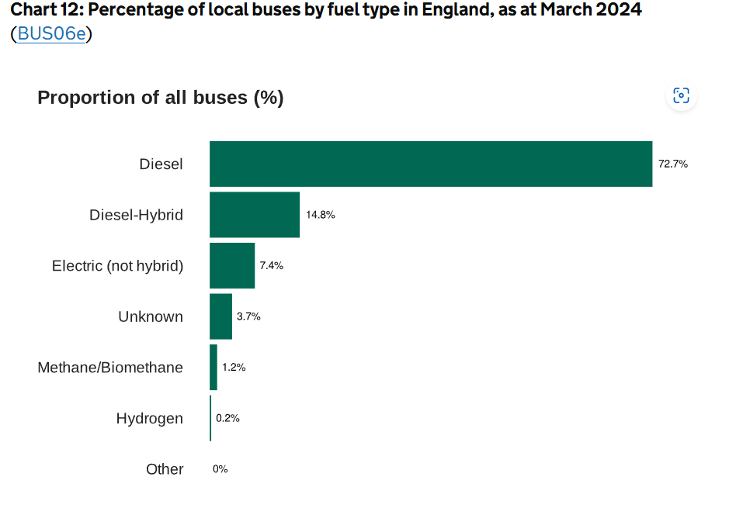
(GOV.UK, 2024)
Appendix B
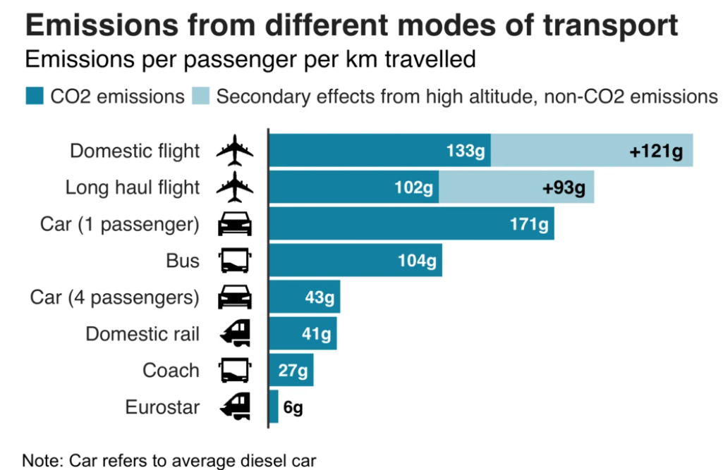
(BBC News, 2019)

