Article Review
By Sarah Jones

Submission date: 3rd January 2022

Article: The Minimum Age of Criminal Responsibility: The Need for a Holistic Approach Aaron Brown and Anthony Charles (2019)
The article was first published online in December 2019. The author Aaron Brown is a PHD student from Swansea University and Anthony Charles is a Professor in Criminology and Sociology at Swansea University. Charles is an expert in the field of Youth Justice, Children’s Rights and Youth Offending.
The article aims to provide the reader an understanding of what are the principal factors surrounding the minimum age of criminal responsibility (MACR) in the UK and explores the ideas surrounding whether there is a need of reform. There is no requirement for the reader to have any prior knowledge of MACR to recognise and understand the findings within the article.
Brown and Charles (2019) highlight several main themes including the rationale of the current MACR in England and Wales, the relationship between MACR and the diversion to crime, the comparison of MACR to other countries, and the existing rights of children in England and Wales.
The article begins with exploring the views of a consultation in 2018 by the United Nations Committee on the Rights of Children, which highlighted that the United Kingdom’s present minimum age is not compatible to the standards of that of other countries. The UK Government conducted a Review in 2012 where The Minister of Youth Justice concluded that the UK MACR was appropriate and there were no plans to change the age of MACR as they believe children aged 10 years were able to distinguish right from wrong (Parliament UK, 2011). Furthermore, according to Bateman (2012) the UK MACR has breached the United Nations Convention on the Rights of the Child and believed that the UK government review of MACR is flawed and criminalises children at a young age. This view confirms that there is still a debate ongoing, and the matter in question has not been resolved.
Brown and Charles (2019) emphasise that many European countries have begun to change their approaches to MACR and their attitude towards youth criminality, with the average MACR for Europe being 14 years. However, the authors further notes that many countries have yet to embrace change for example the United States of America do not have a formal MACR. According to Child Rights International Network (2021) it has been recognised that some USA states have a MACR such as North Carolina who has a level as low as 7 years of age. This could lead to the exploitation of younger children to commit crimes.
The article questions why MACR in the UK has not changed since the 1960’s and although it was reviewed in 2011 by the UK Government, it should be returned to a Parliamentary agenda. The authors direct the reader to research presented by several sources who have argued that through research and practice youth crime can be managed in different ways rather than criminalising the child (National Association for Youth Justice, 2012). It provides evidence of the relationship between MACR and diversion and explores the work of National Youth Offending Teams and the relationship to the reduction of first-time offenders, producing evidence of a reduction of 86% over 10 years (Brown and Charles, 2019).
The article reveals that diversion is an effective tool for engaging with children, but it only takes place after the child has had contact with the criminal justice system. Williams (2020) argues against this view and recognises that changes to legislation in Wales and the development of new schemes to engage with children before criminality has shown a progressive reduction to Youth Crime.
In addition, another aspect explored within the article is the connection between age and capacity in youth justice and sources research provided by neuroscientists that state 12-year-olds show more maturity in their development compared to 10-year-olds. This view is supported by the Scottish Government (date) who have increased their MACR to 12 years (Scottish Children’s Reporter Administration, 2021) However, this view is refuted by the British Government who state that there is no evidence to suggest 10-year-olds are immature and by criminalising them adversely effects their prospects and likelihood to reoffend (Houses of Parliament, 2018)
The authors question whether MACR in other countries is relevant to the UK but concludes that the UK is isolating themselves especially as they represent a country who promotes Human Rights. The author argues that it is the responsibility of Parliament to raise MACR and bring it in line with article 12 of the legislation which focuses on children having human rights. However, it could be said that following the removal from the European Union, Human Rights legislation is currently being amended by UK government which may prove more difficult for international bodies to dictate and enforce their views (The Human Rights Act, 1998)
Furthermore, the article focuses on the differing views of the devolved administrations in the United Kingdom and argues that this alone is a reason to reform the current MACR legislation. As stated by Brown and Charles (2019) Scotland who have full devolved powers have amended their MACR legislation in 2019. Wales has partial devolved justice powers and does not have the capacity to change legislation, which is written by Westminster (Institute for Government, 2021) It is important to note that Wales is reviewing the workings of their Criminal Justice System and changes may be made to Youth Justice in the future (Brown, (2020) It could be said that if this conclusion is reached in Wales, it provides further argument for MACR to be reviewed by UK Government.
In summary, there are several themes that run throughout the article and the authors have explored the rationale for raising MACR in England and Wales, but it could be said they show bias in their findings and have not investigated reasons why MACR should remain in its present form. The article explores that MACR is still a well debated issue amongst national and international organisations and governing bodies, and although the authors have considered alternative holistic approaches to youth justice and explored a child’s Human Rights, the authors have concluded that the UK political argument is the only feature that prevents any changes to UK legislation. Brown and Charles have presented an argument that the devolved power of the UK is reason for the debate to be brought before Parliament again, however the flaw in this reasoning is it did not draw upon the analysis and research presented to the UK Government, which upon review recommended why the current MACR is suitable. Further research into why the government is resisting change may be required to present as an objective argument. (1087)

References

Bateman, T. (2012) Criminalising Children for no good purpose: The age of criminal responsibility in England and Wales, Available at: 2012-The-Age-of-Criminal-responsibility.pdf (thenayj.org.uk) Accessed 01 December 2021
Brown, A (2020) A Rights-Based Analysis of Youth Justice in the United Kingdom, Available at: UnicefUKYouthJusticeExecSummaryInfographic_2020_2.pdf Accessed 02 December 2021
Brown, A and Charles, A , (2019) The Minimum Age of Criminal Responsibility: The Need for a Holistic Approach, Available at: The Minimum Age of Criminal Responsibility: The Need for a Holistic Approach’ (swan.ac.uk) Accessed 01 December 2021
Child Right International Network (2021) Minimum Ages of Criminal Responsibility Around the World, Available at: Minimum ages of criminal responsibility around the world | CRIN Accessed 01 December 2021
The Human Rights Act, (1998) Human Rights Remedial Order 2020, Available at: The Human Rights Act 1998 (Remedial) Order 2020 (legislation.gov.uk) Accessed 05 December 2021
Houses of Parliament, (2018) Age of Criminal Responsibility, Available at: Age of Criminal Responsibility (parliament.uk) Accessed 05 December 2021
Institute for Government, (2021) Criminal Justice and Devolution, Available at: Criminal justice and devolution | The Institute for Government Accessed 04 December 2021
National Association for Youth Justice, (2012) The State of Youth Justice, Available at:
Campaigns and Publications | NAYJ (thenayj.org.uk) Accessed 03 December 2021
Parliament UK, (2011) Commons Debate: Daily Hansard Young Offenders, Available at: House of Commons Hansard Debates for 08 Mar 2011 (pt 0001) (parliament.uk) Accessed 05 December 2021
Scottish Children’s Report Administration, (2021) Age of Criminal Responsibility, Available at: Age of Criminal Responsibility - SCRA Accessed 01 December 2021
Williams, J. (2020) A Rights-Based Analysis of Youth Justice in the United Kingdom, Available at: UnicefUKYouthJusticeExecSummaryInfographic_2020_2.pdf Accessed 02 December 2021

Reflective Report
By Sarah Jones

Whilst attending the university for lectures relating to my MA in Criminal Justice and Policing, my knowledge and understanding has developed amongst a broad collection of subject areas. My attendance to the module named The Criminal Justice System, Youth Justice and Prison Systems in England and Wales has led me to undertake further research into the prison crisis within the UK.
The main aim of this assignment was to reflect upon the Prison Crisis by exploring the subject in more detail and sharing my opinion and observations.
To assist with my reflection effectively, I shall use Gibbs Reflective Cycle 1988. According to The University of Edinburgh (2019) Gibbs Reflective Cycle is argued to be one of the most famous models of reflection. This cycle explores six stages of reflection, ‘Description, Feelings, Evaluation, Analysis, Conclusion and Action Plan’ (The University of Edinburgh, 2019) and these stages will aid me to adequately reflect on my experiences of the learning that I undertook. Graham Gibbs developed this reflective model in 1998 and it provides a framework to aid the examining and evaluation of experiences. Each stage asks a set of questions to help the learner to deliberate on their own experiences (Gibbs, 1988)
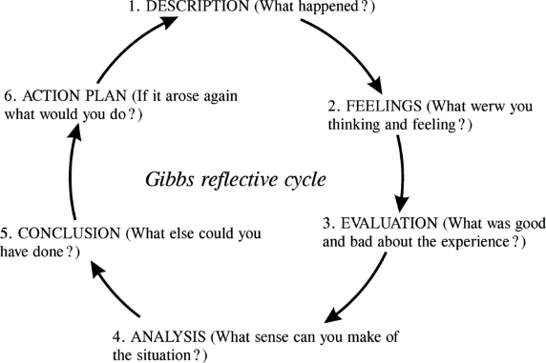
Figure 1 – Gibbs Reflective Cycle (Gibbs, 1988)
Throughout this reflection I shall refer to Gibbs model of reflection whilst sharing my observations of the research I have embarked on.
Description
When undertaking this module, I was presented with a selection of subject areas that I could choose to research as part of my first academic assignment. I chose the title ‘Discuss the purposes of imprisonment in England & Wales and evaluate the extent to which the current ‘prison crisis’ impacts on these’.
My professional background of twenty years in policing lent itself well to study this area, as I felt my existing knowledge of the profession could bring a balanced approach required to study the subject. Although my experience in policing is broad, I wished to expand my knowledge and understanding of the criminal justice system that was closely associated with my day-to-day role as a police officer.
I began my research into the prison crisis by exploring the history of the prison system and gaining an understanding of the formation of the prison service that is recognised today. I utilised the university library and online resources, which provided me with further sources of academic research that I was able to utilise for my study. The history of the prison service was widely sourced and covered an international perspective, which allowed me to make comparisons to imprisonment in the UK. I identified that the Roman Ages laid the foundations of law and punishment (Looman and Carl, 2015) however Morris and Rothman (1995) argued that it was a modern concept and had only been inexistence for less than 300 years.
My study led me to understand the purpose of imprisonment and although Coyle (2005) proposed that prison is traditionally used to punish, deter and reform, some sources suggested the main aim of imprisonment was to protect the public from a significant threat of harm. I identified that as society became more complex, the proportionality of punishment was brought into question by the UK Government, and this brought about a change in UK legislation.
The Prison Reform Trust (2021) provided me with further reading, and I was able to identify that the changes in UK law had a prominent effect on the prison crisis that we see today.
There is evidence that the strategies adopted by the prison service to prevent reoffending whether through vocational, therapeutic, or academic programmes played a significant role within the crisis faced by the UK prison service (Blakey, 2017)
Through my research I was able to broaden my understanding of the purposes of imprisonment and evaluate how the prison crisis has been affected by this.
Feelings
When I started my research, I felt confident in the subject matter and the question asked of me. However, I soon began to feel daunted by the vast number of sources I faced. The subject area has been researched by many academics across the world, and it was difficult to draw down the information I required to enable me to answer the question. However, once I implemented a structure to my research, I was able to manage the sources by relevance and importance.
I found the subject matter extremely interesting and could recognise a link between the research of the criminal justice system and professional application of policing. It opened my eyes to a greater understanding of the issues faced by the prison service today and how potential reform is needed to manage the crisis.
Evaluation
My experience of this research is overall a very positive one. I conducted the research alone and was able to utilise an array of sources from the online library and other alternative online platforms to assist me. At the time of my research the country was under national restrictions of a global pandemic, and this caused a few restrictions surrounding my ability to conduct further research that was not computer based. I was keen to liaise with prison service staff who work within the prison service and broaden my understanding of the crisis that they directly face.
My organisational skills were prominent throughout this study, as I started my research early and was able to submit my work prior to the submission date.
Analysis
The UK Government brought this issue of a ‘Prison Crisis’ to my attention and it was because of this I chose to research this subject (UK Parliament, 2019) This research contributed to a gap in my knowledge and understanding of the prison crisis and whilst there is a vast number of studies conducted on this subject, the issue is far from being resolved. My motivation to research this area is drawn from my previous professional background of policing, and the connection I once had with the prison service when I was involved in the arrest and conviction of offenders who were given a custodial sentence.
Although my research allowed me to answer the question, I believe that my conclusion was slightly restrictive due to the vast number of journals and books that I could have read. My research led me to believe that cuts in government funding and increased prison populations have contributed towards the prison crisis, however, I would have liked to have explored further how the global pandemic may have ignited what is already a crisis in UK prisons.
My research allowed me to explore the use of rehabilitation in the prison service and how it may have inadvertently contributed to the prison crisis. This concept has been explored by the Ministry of Justice (2018) who argue that the rehabilitation of offenders is a positive contributing factor within prison reform.
Conclusion
Throughout my study I gained a valuable insight into the history of the prison service and how this archive of information has contributed to the crisis that faces prisons in the UK today. I have a broader understanding of the contributing factors that have caused the crisis and conclude that prison reform needs to be addressed. Whilst the UK Government has designed a strategy to manage the crisis by building new prisons to accommodate the increased prison population Ministry of Justice (2018), my research suggested that this alone may not be the answer to prevent the prison crisis from spiralling out of control in the coming years.
Action Plan
Upon undertaking further research, monitoring the wide range of literature I choose to read, to ensue I use a wide range of academic and credible sources, such as articles and books, rather than relying heavily on internet sources.
In order to further advance my knowledge and understanding of the impact of the global pandemic of the prison service, I will ensure to embrace the release of credible research and statistics that are collated and published.
This assignment has allowed me to appreciate the different methods of research and the importance of effective secondary analysis of literature. My confidence has grown when managing secondary research, which shall inevitably assist me with conducting primary research in preparation for my dissertation, through the analytical skills I have gained. (1366)

References
Blakey, R, (2017) Rehabilitation in Prisons, Available at: Rehabilitation in Prisons (parliament.uk) Accessed 12 October 2021
Coyle, A, (2005) Understanding Prisons: Key Issues in Policy and Practice, McGraw-Hill Education, UK,
Gibbs, G (1988) Learning by Doing: A guide to teaching and learning methods, Oxford: Further Education Unit, Oxford Polytechnic
Looman, M and Carl J, (2015) A country Called Prison: Mass Incarceration and the Making of a New Nation, Oxford University Press, New York
Ministry of Justice, (2018) Prison Reform Speech, Available at: Prisons reform speech - GOV.UK (www.gov.uk) Accessed 16 December 2021
Morris, N and Rothman D, (1995) The Practice of Punishment in Western Society, Oxford Press, New York
Prison Reform Trust (2021) Projected 25% Increase in prison numbers will undermine post pandemic prison recovery, Available at: Prison Reform Trust > Press & Policy > News Accessed 15 October 2021
UK Parliament (2019) Prison Estate in “Appalling” State of Crisis, Available at: Prison estate in “appalling” state of crisis - Committees - UK Parliament Accessed 16 December 2021
The University of Edinburgh, (2019) The Reflection Toolkit: Gibbs' Reflective Cycle. Available at: <https://www.ed.ac.uk/reflection/reflectors-toolkit/reflecting-on-experience/gibbs-reflective-cycle> Accessed 16 December 2021
Academic Poster
By Sarah Jones

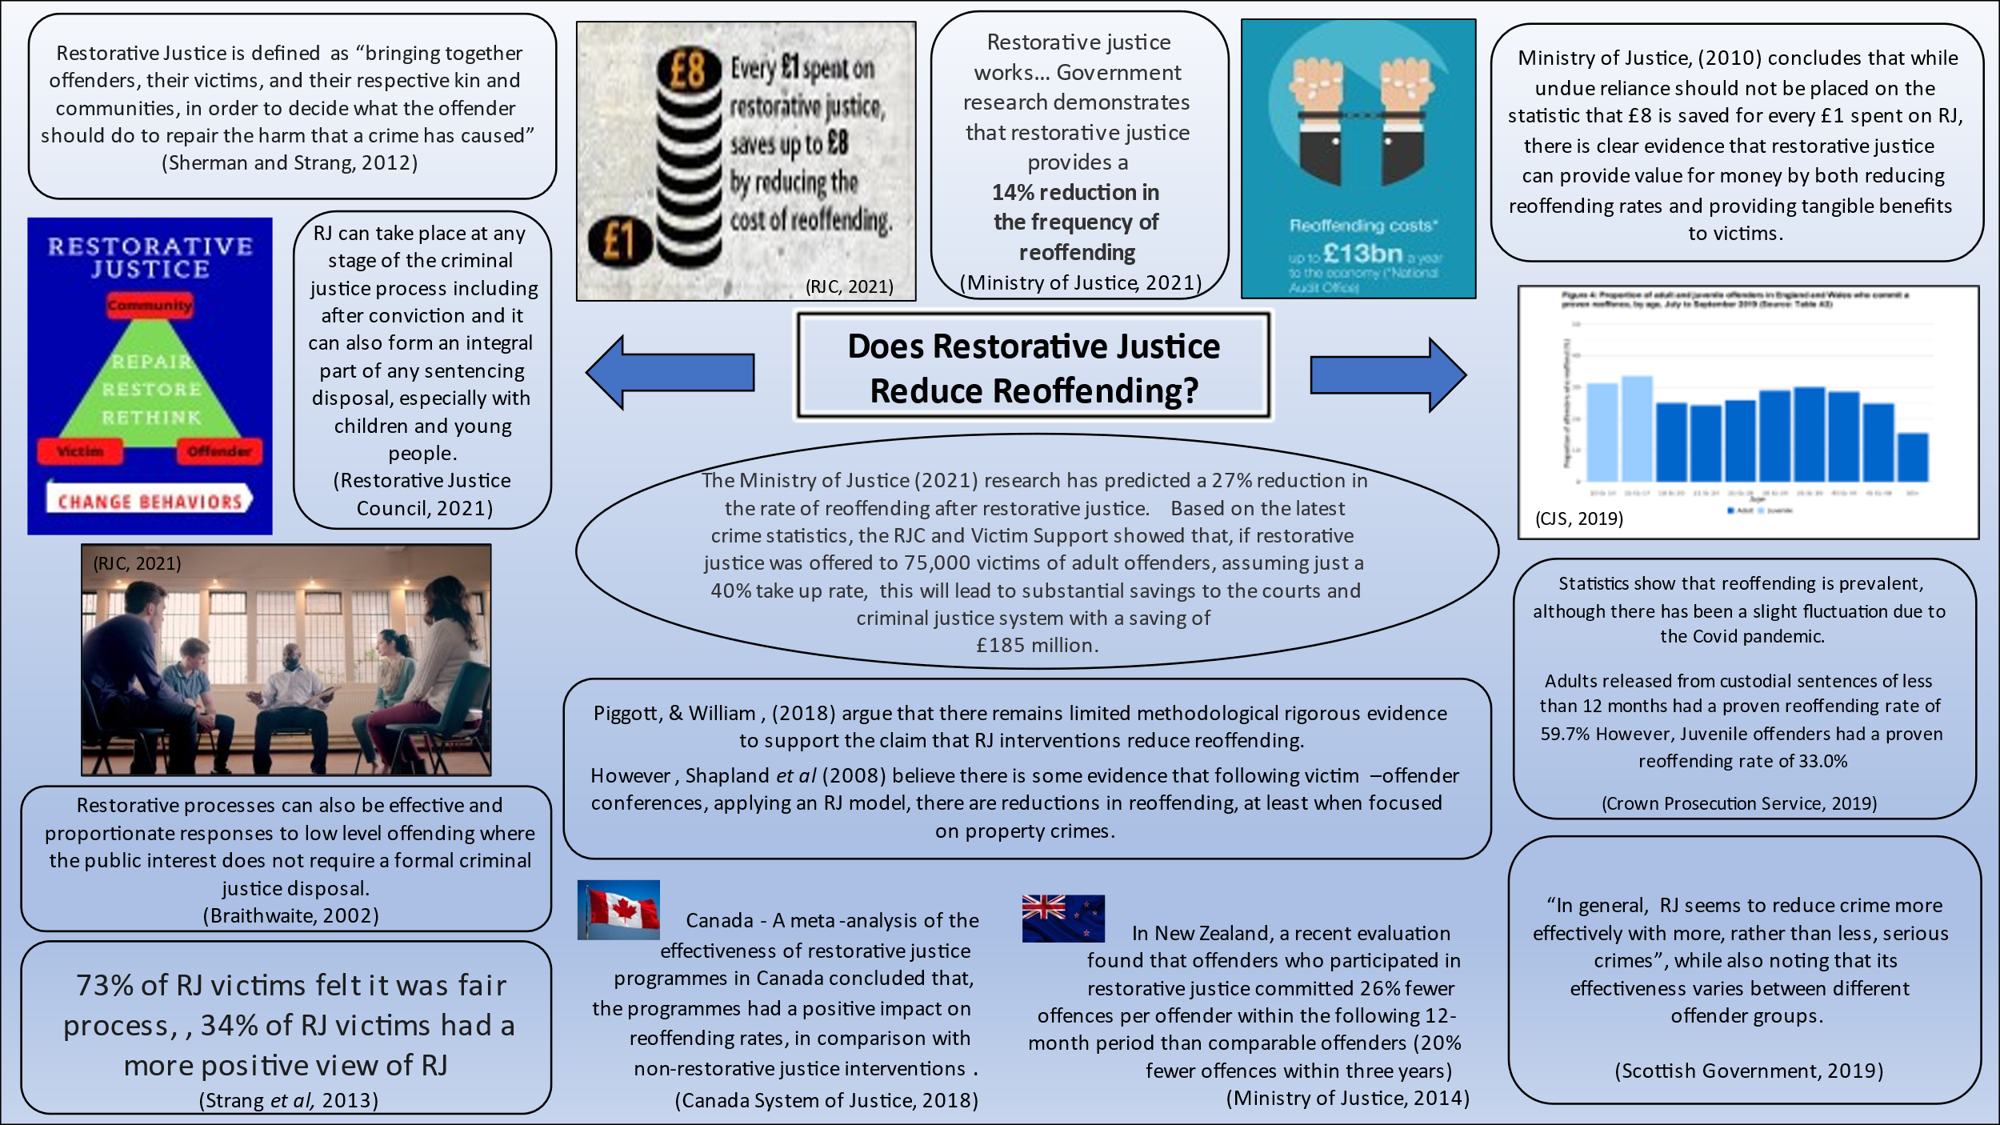

References
Braithwaite, J (2002) Restorative Justice and Responsive Regulation, Studies in Crime and Public Policy, Oxford University Press, Oxford
Canada System of Justice, (2018) The Effectiveness of Restorative Justice Practices: A Meta Analysis, Available at: Conclusion - The Effectiveness of Restorative Justice Practices: A Meta-Analysis Accessed 04 November 2021
Crown Prosecution Service, (2019) Restorative Justice, Available at: Restorative Justice | The Crown Prosecution Service (cps.gov.uk) Accessed 03 November 2021
Ministry of Justice, (2010) Green Paper Evidence Report: Breaking the Cycle, Effective Punishment, Rehabilitation and Sentencing Offenders, Available at: Green Paper Evidence Report - Breaking the Cycle: Effective Punishment, Rehabilitation and Sentencing of Offenders (restorativejustice.org.uk) Accessed 03 November 2021
Ministry of Justice, (2014) Reoffending Analysis for Restorative Justice Cases 2008-2013: Summary Results, Available at: rj-Reoffending-Analysis-for-Restorative-Justice-Cases-2008-2013-Summary-Results.pdf Accessed 03 November 2021
Ministry of Justice, (2021) Proven Reoffending statistics Quarterly Bulletin July to September 2019, Available at: Proven_reoffending_stats_bulletin_julsepFinal.pdf (publishing.service.gov.uk) Accessed 03 November 2021
Piggot, E and Wood, W, (2018) Does Restorative Justice Reduce Recidivism? Assessing evidence and claims about restorative justice and reoffending, Available at: (PDF) Does restorative justice reduce recidivism? Assessing evidence and claims about restorative justice and reoffending. (researchgate.net) Accessed 03 November 2021
Restorative Justice Council, (2021) Criminal Justice, Available at: Criminal justice | Restorative Justice Council Accessed 03 November 2021
Scottish Government, (2019) Uses of Restorative Justice: Evidence Review, Available at: Uses of Restorative Justice: evidence review - gov.scot (www.gov.scot) Accessed 05 November 2021
Sherman, L, and Strang, H, (2012) The Oxford Handbook of Sentencing Corrections, Restorative Justice as Evidence-Based Sentencing, Oxford University Press, New York
Shapland, J, Robinson G, and Sorsby, A, (2011) Restorative Justice in Practice: Evaluating What Works for Victims and Offenders, London and New York, Routledge
Strang, H, Sherman, L, Mayo-Wilson, E, Woods , D, Ariel, B, (2013) Restorative justice conferencing (RJC) using face-to-face meetings of offenders and victims: Effects on offender recidivism and victim satisfaction, A systematic Review, Volume 9, Issue 1 Pages 1-59

