Assessment Four: Image Commentary

Fitzwilliam Museum, MS 1-2005, fol. 39r, The Anointing of David
Created in East Anglia, probably Norwich c. 1330-1340.

In September 2004, Sotheby’s auctioned items from the library of the Earls of Macclesfield. Of these, the Macclesfield Psalter, purchased by the Getty Museum, caused the greatest excitement.
This item was of such national importance that an export licence was denied and £1.7 million raised by the British public, enabling the Fitzwilliam Museum, Cambridge to purchase the Psalter.
Assisted by Psalters, medieval monastic communities across Western Christendom chanted the 150 Psalms every week during seven daily Offices. Following the fourth Lateran Council (1215), devout lay people sought a deeper experience of faith. An increasingly literate gentry drove the market for Psalters, giving way to shorter Books of Hours after the Black Death.
This essay describes folio 39r (see Plate 1), from the Macclesfield Psalter, and considers what might be learned about its manufacture, historical context and cultural significance.

Description
The Macclesfield Psalter codex, rebound in white goatskin for the Fitzwilliam Museum in 2007, contains 252 illuminated vellum folios (105x62mm) arranged in thirty-two quires, each of four bifolios. It contains psalms and prayers written in Latin, designed to assist a cleric or pious layperson to recite a daily office.

Opening portraits of locally revered Saints Edmund and Andrew (fol. 1r-2v) and a liturgical calendar (fol. 3r-7v), including local saints, suggest the East Anglian origin. The Suscipere dignare domine prayer precedes a miniature of Christ on a rainbow throne (fol. 8r-v). A historiated capital indicates each section of the Psalter proper (fol. 9r-207v). Canticles, Te deum and Athanasian Creed (fol. 207v-227r), Litaniae Sanctorum (fol. 227v-233r), Collects (233r-235r), Offices of the Dead, Vespers and Matins follow with the Confiteor and accompanying prayers (fols. 235r-252r). Six folios are missing.
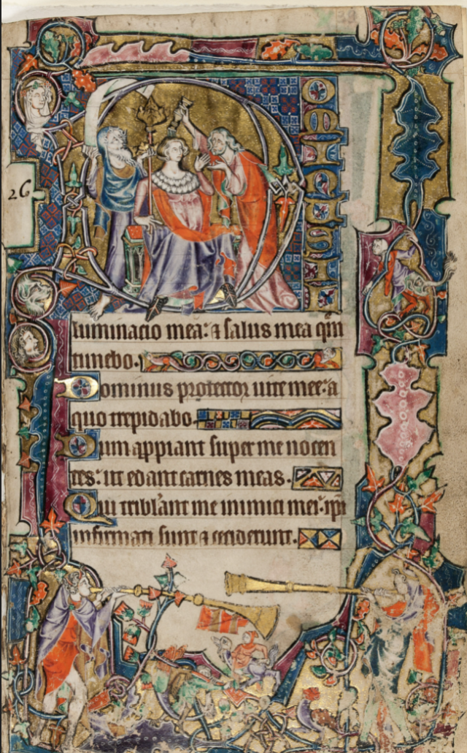
Plate 1. Fitzwilliam Museum, MS 1-2005, fol. 39r. The Anointing of David.
Presented on vellum, folio 39r (Plate 1) displays Psalm 26:1-2, introducing the Psalms set for Mondays. Apart from minor damage to the bas-de-page, the condition is excellent, with preservation of bright colours and detailed artwork.

Dominus te
The historiated capital ‘D’, portraying the prophet Samuel anointing David, makes unnecessary the omitted Biblical preamble, Psalmus David priusquam linitretur. Attired for the 14th century, Jesse (left) hands his rod to his son David (centre). David receives the rod with the right hand, extending his left towards Samuel (right). Samuel’s left hand touches David’s right whilst Samuel’s right hand pours oil on David’s head. The identities of Jesse and David are confirmed by comparing their likenesses with the historiated capital, Tree of Jesse, heading Psalm 1 (fol. 9r).

Text
The Gothic quadrata text block, in black-brown ink, is illuminated at line one. An elongated ornate capital “I”, maroon and blue with foliate motifs borders the left side. On lines three, five and seven, blue and maroon patterning decorate gold-leaf initial capitals.

Illumination fills lines where text is sparse:
- Line two: two composite beasts stand apart on a golden background. One, a pink duck-headed reptile with white underparts and orange fox legs. The other, looking backwards, a white-headed dog with orange fox legs. Their tails merge into vines bearing green and orange foliage.
- Line four: blue, maroon and gold chequerboard adjacent to a double arcade of rainbows on an orange and pink background.
- Line six: pink and orange triangles on a gold-painted background.
- Line eight: orange, blue and gold-painted triangles.
Borderwork
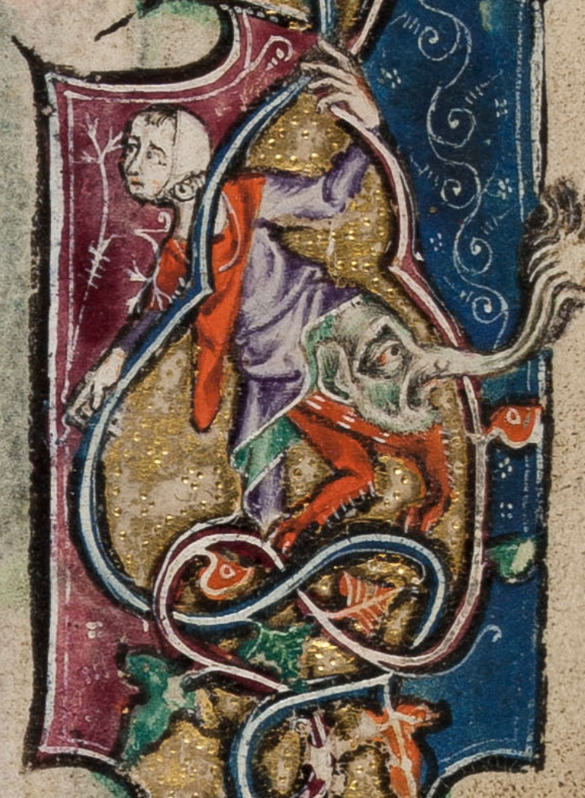
A vine weaves around the border crossing gold, maroon and blue blocks. The ends and middle of the upper border bear orange and green foliage. The decorated broad pink wave-like block on the left and forms the template for blue and pink leaf-like patterns along the right border. These bracket a man dressed in purple and green, with orange fox-like legs and rump like an elephant’s head (figure 1). Supported by the vine, this grotesque observes David’s anointing. In the bas-de-page, despite minor damage to paintwork, two heralds wearing the colours of the Earls of Arundel, blow fanfares on long golden trumpets, presumably to honour David. Between them, on a background of gold-leaf and solid colour blocks, are a pedlar in green carrying a backpack into the jaws of a wolf (left); a man in orange riding a duck-headed wolf (centre) and fox-headed bird-wolf (right). In the left border, vine loops enclose miniatures of three faces, all watching David. Surrounded by a sea of blue diamonds, the woman in white wimple and jewelled circlet is probably Mary, David’s descendant, and Christ’s Mother. The grey beast portrayed beneath her, is probably the Devil, whose head she metaphorically ‘crushed’ by giving birth to the Saviour. Similarities with the figure in fol. 8v suggest the third face might be Christ observing his forbear. Or, being situated on the “I” of Illuminado mea, perhaps an unidentified man seeking wisdom from the Lord (Dominus).
Figure 1. Grotesque demonstrating outlining, gold-leaf work, and fine detailing. Fitzwilliam Museum MS 1-2005, fol. 39r (detail).

Discussion

Macclesfield Artists
These craftsmen probably operated from Norwich, the nearest important commercial and religious centre. Artistic techniques, learned from reference texts, were developed and perfected. Pigment and ink recipes, modified over time, passed down from master to apprentice. Stylistic similarities between the Macclesfield Psalter, Stowe Breviary, Douai Psalter and Gorleston Psalter suggest an East Anglian workshop. These suggest the Macclesfield as an artistic ‘missing link’ between the Gorleston and Douai. All three Macclesfield artists collaborated on fol. 39r. The Anointing Master (identified as the Gorleston and Stowe Master) created the historiated capital, adding portraits and border work elsewhere in the Psalter. The Macclesfield Master (identified as the Douai Assistant) added border art, creating historiated capitals elsewhere. The Assistant coloured the minor illuminated lettering and borderwork.

Manufacturing Process
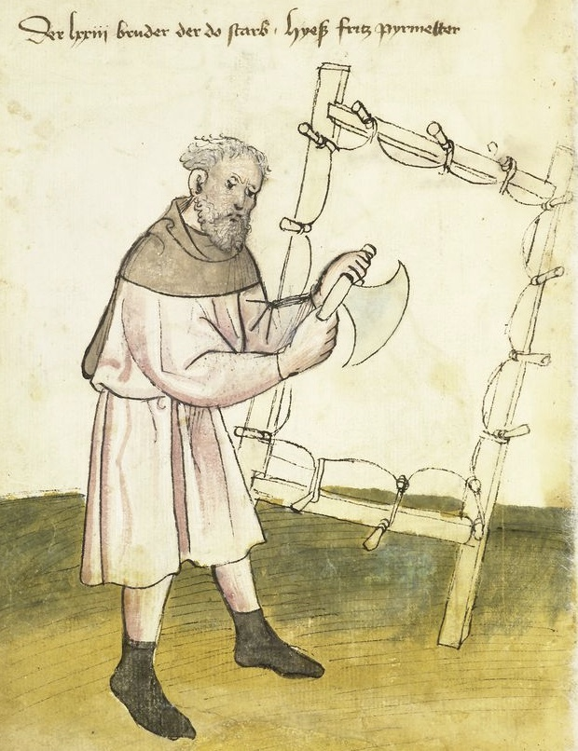
Durable and reusable, parchment was the preferred writing surface in Medieval Europe. Manufactured from animal skins (sheep parchment, calf vellum), a codex might require slaughter of a flock. Drenching the skin in caustic lye removed fat and loosened hair.
Figure 2. Parchment maker preparing at work with a lunellum. Nürnberg, Amb. 317.2°, fol.34v (Mendel I).
After washing and hanging over a frame, hair was scraped off with a flat-bladed scudder. Next, stretched across a frame it was worked using a sharp crescent-shaped lunellum, the fat-side dried with pumice/gum sandarac and the hair-side blanched with pumice and chalk (Figure 2). Finally, it was cut into rectangular sheets. The fol. 39r vellum was undamaged prior to illumination.

Wide-bored flight feathers (swan or goose) were required to make the broad-nibbed quills suitable for Gothic quadrata text. Quill barrels were cleaned, hardened and the nibs fashioned with a penknife.

Paint brushes, made from stoat or weasel tail-hairs, were bunched, tied and inserted into a quill of appropriate bore for the delicacy of the work intended.

In creating folio 39r, the planned page layout included a space for the historiated capital and text block situated within a wide border. Lines were inked between prick marks made with an awl. The scribe added black-brown text without rubification.

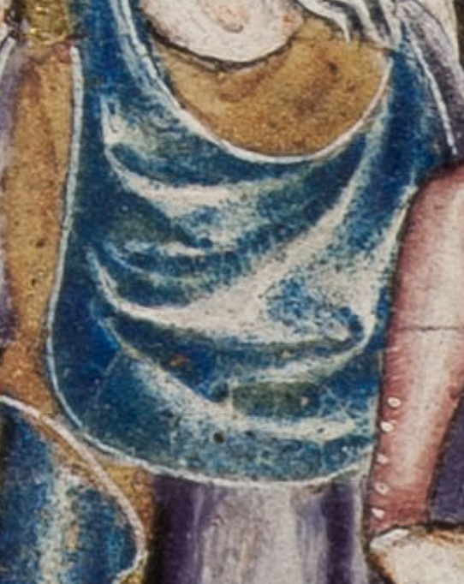
Next, the illuminator dried the drawing surface with pumice and chalk. Pictorial outlines were charcoaled onto thin vellum, traced onto the page, and overdrawn in black. Areas for gold-leaf were prepared with gesso (gum Arabic or egg white), activated to stickiness by the breath, gold-leaf applied, centre-punched peripherally to secure, then buffed to luminosity. After laying down base colours, further colour was applied before adding fine details. Figure 1 shows worked gold-leaf, black outlining to provide definition and detailed highlighting and lowlighting with a fine brush. Figure 3 demonstrates how layering azurite blue and verdigris over a white lead base suggests folds in draperies.
Figure 3. Jesse’s hood, demonstrating layering of azurite blue and verdigris over white lead. Fitzwilliam Museum MS 1-2005, fol. 39r (detail).
Finally, a bookbinder sewed together quires of four bifolios along the midline. These were gathered and sewn to a parchment spine before adding a cover, producing the codex.
Analysis has identified the pigments used by the Macclesfield artists. These were prepared for optimal binding to the parchment, mixed and applied to produce the desired hue or effect. Locally sourced materials drove down costs. Black ink was made from iron-gall. Pink and maroon derived from insect blood, indigo from elderberry. Red lead coloured orange; white lead or gypsum, white. Gold-leaf, the costliest item here, was replaced by cheaper mosaic gold paint (tin sulphide) elsewhere. Verdigris green, produced by immersing copper in urine, was mixed with gum to prevent degradation of the writing surface. Imported from Europe, azurite provided a bright blue.

Patronage
Manufactured objects ‘reflect the belief patterns of individuals who made, commissioned, purchased or used them’ and of wider society.
Patrons, whether nobles or gentry, demonstrated wealth and prestige by sponsoring impressive religious items to educate and inspire piety whilst ensuring they were remembered. The Psalter sits alongside stained glass, church statuary and wall paintings in this regard. Bestowing patronage on clerics promised patrons eternal benefits gained by their prayers. Although not naming the patron, the fol. 39r heralds wear the colours of Richard Fitzalan, Earl of Arundel, nephew of John de Warenne, patron of the Gorleston Psalter, implied by rabbits in the marginalia of both works.

Original Owner
The original owner, the cleric depicted kneeling in fol. 246r, recited the Office in a culture where sights and materials carried meaning.
Touching vellum recalled the sacrifice of Christ, Agnus Dei. Navigating the codex by historiated capitals, he found David’s Anointing, marking todays psalms. The illumination provides more than a Bible story. It tells of the Trinity. God as Father (Father/Jesse) giving his Son (Jesus/David) who receives the Spirit (Spirit/Samuel pouring the oil), unified in gold (God as Light). David’s red mantle recalled Christ’s blood. The blue chequerboard, Mary’s colour, drew him to her portrait. The vine (Christ) bears green foliage symbolising new life. These meditations engendered piety. Should his mind wander, then the marginalia might amuse (grotesques, drollery), prompt him to intercede for his patrons (heraldic livery) or since they all looked towards the Anointing scene, point him back to the Trinity.
Macclesfield marginalia recount 14th century daily life, as informative to medievalists as they were an inspiration to prayer and good works for the owner. We find costumes and coiffures to inspire fashion historians. Clerics, peasants, tradesmen and gentry at work and play, in sickness and heath, to occupy social historians, and death ever present. The pedlar under attack by the wolf in folio 39r is a typical example. A reminder to the original owner of his duty to the common man, and the constant presence of peril.

Later Ownership
As a Catholic nun in pre-Reformation England, ‘Syst[er] Barbara Barsie’
no doubt treasured and prayed the Psalter. However, she later deleted her signature, still discernible under ultraviolet light on fol. 1v), perhaps to expunge evidence of her former loyalty to the Pope, or perhaps due to marriage, since ‘barbara boke’ appears on fol. 8v.

The Psalter may have proved professionally interesting to Anthony Watson, the next owner who felt able to add his name to Psalter. John Smeaton and his acquaintance the Earl of Macclesfield probably valued it as a work of fine art, keeping it in their libraries. At auction in 2004, it was acclaimed a historically important national treasure. Now residing at the Fitzwilliam Museum, it is accessible for all online.

Conclusion
Investigating folio 39r proved interesting, informative and sometimes uplifting. Most surprising is the quantity of information a visual source can yield. Whilst having considered a wealth of research, many questions remain unanswered. What more can be learned, from this work and elsewhere, about the lives and influences of artists, owners and characters in the marginalia? What more can the work teach about medieval spirituality, spiritual formation and mysticism? This could easily be a springboard to a lifetime of research.

Bibliography

Archives

Douai, Bibliothèque municipal, MS 171. The Douai Psalter.

Cambridge, The Fitzwilliam Museum, MS 1-2005. The Macclesfield Psalter.
Available at:<https://www.fitzmuseum.cam.ac.uk/illuminated/manuscript/discover/the-macclesfield-psalter/section/make [accessed 8th December 2021].

London, British Library, Add. MS 49622. The Gorleston Psalter.
Available at:, http://www.bl.uk/manuscripts/FullDisplay.aspx?ref=add_ms_49622> [accessed 9th December 2021].

London, British Library, MS Stowe 12. The Stowe Breviary.
Available at:< http://www.bl.uk/manuscripts/FullDisplay.aspx?ref=Stowe_MS_12> [accessed 8th December 2021].

Nürnberg, Stadtbibliothek im Bildungscampus Nürnberg, Amb.317.2°, folio 34v (Mendel I). Die Hausbücher der Nürnberger Zwölfbrüderstiftungen.
Available at:< https://hausbuecher.nuernberg.de/75-Amb-2-317-34-v> [accessed 11th December 2021].

Books

Bernhard Bischoff Latin Palaeography, (Cambridge: Cambridge University Press, 1990).

Eamon Duffy, Marking the Hours: English People in their Prayer, 1240-1570. (New Haven and London: Yale University Press, 2006).

Eamonn Duffy, The Stripping of the Altars : Traditional Religion in England, 1400-1580, Second Edition, 2nd ed. (New Haven, CT: Yale University Press, 2005).

E. B. Fryde, D. E. Greenway. S. Porter & D. E. Greenway, (eds.), Handbook of British Chronology, Third Edition. (London: Royal Historical Society, 1986).

Patricia Lovett, The Art and History of Calligraphy, (London: The British Library, 2017).
Diarmaid MacCulloch., A History of Christianity: the First Three Thousand Years (London: Allen Lane, 2009).

Stella Panayotova, Colour: The Art & Science of Illuminated Manuscripts. (London: Harvey Miller, 2016).

Stella Panayotova, The Macclesfield Psalter. (Cambridge: The Fitzwilliam Museum, 2005).

Thomas J. Schlereth, Material Culture Studies in America. (Nashville: Rowman Altamira, 1983).

Websites

English Heritage. (2004) History of Castle Acre Priory. https://www.english-heritage.org.uk/visit/places/castle-acre-castle-acre-priory/history/ [accessed 7th December 2021].

Fitzwilliam Museum The Macclesfield Psalter
online at: https://www.fitzmuseum.cam.ac.uk/illuminated/manuscript/discover/the-macclesfield-psalter/section/make [accessed 23rd November 2021].

Sotheby’s (2004) The Library of the Earls of Macclesfield removed from Shirburn Castle: Part 3 Western Manuscripts / Lot 587 (The Macclesfield Psalter, in Latin, illuminated manuscript on vellum).
online at: http://www.sothebys.com/en/auctions/ecatalogue/2004/the-library-of-the-earls-of-macclesfield-removed-from-shirburn-castle-part-3-western-manuscripts-l04242/lot.587.html [accessed 23rd November 2021].

University of Cambridge, (2005) News:Macclesfield Psalter saved for the nation. https://www.cam.ac.uk/news/macclesfield-psalter-saved-for-the-nation [accessed 27th November 2021].

Stella Panayotova, Colour: The Art & Science of Illuminated Manuscripts. (London: Harvey Miller, 2016). pp. 244-145.
Cambridge, Fitzwilliam Museum, MS 1-2005. Available online with commentary at https://www.fitzmuseum.cam.ac.uk/illuminated/manuscript/discover/the-macclesfield-psalter/section/make [Accessed 8th December 2021].
University of Cambridge, (2005) News:Macclesfield Psalter saved for the nation. https://www.cam.ac.uk/news/macclesfield-psalter-saved-for-the-nation [accessed 27th November 2021].
Eamon Duffy, Marking the Hours: English People in their Prayer, 1240-1570. (New Haven and London: Yale University Press, 2006) p.5. Part of Judaic worship since ancient times, the Psalms of David, suitably translated remain an important resource for Christian liturgical prayer.
Diarmaid MacCulloch., A History of Christianity: the First Three Thousand Years (London: Allen Lane, 2009). p405-406.
Duffy, Marking the Hours. p.11.
Fitzwilliam Museum, The Macclesfield Psalter: Physical Description. < https://www.fitzmuseum.cam.ac.uk/illuminated/manuscript/discover/the-macclesfield-psalter/make/physical-description-40?back=section/make> ; Fitzwilliam Museum, The Macclesfield Psalter: Binding. https://www.fitzmuseum.cam.ac.uk/illuminated/manuscript/discover/the-macclesfield-psalter/make/binding-43?back=section/make ; Fitzwilliam Museum, The Macclesfield Psalter: Collation https://www.fitzmuseum.cam.ac.uk/illuminated/manuscript/discover/the-macclesfield-psalter/make/collation-42?back=section/make [all accessed 8th December 2021].
Much of the description and subsequent discussion is informed by Christopher de Hamel’s and Stella Panayotova. See: Christopher de Hamel in Sotheby’s (2004) The Library of the Earls of Macclesfield removed from Shirburn Castle: Part 3 Western Manuscripts / Lot 587 (The Macclesfield Psalter, in Latin, illuminated manuscript on vellum). online at: http://www.sothebys.com/en/auctions/ecatalogue/2004/the-library-of-the-earls-of-macclesfield-removed-from-shirburn-castle-part-3-western-manuscripts-l04242/lot.587.html [accessed 23rd November 2021]. Also, Stella Panayotova, The Macclesfield Psalter. (Cambridge: The Fitzwilliam Museum, 2005).
Fitzwilliam Museum, The Macclesfield Psalter: Script and Textual Contents. https://www.fitzmuseum.cam.ac.uk/illuminated/manuscript/discover/the-macclesfield-psalter/make/script-and-textual-contents-41?back=section/make [accessed 8th December 2021].
Two after fol.1 and one each after fols. 95, 117, 141 and 252. See Fitzwilliam Museum, The Macclesfield Psalter: Collation at https://www.fitzmuseum.cam.ac.uk/illuminated/manuscript/discover/the-macclesfield-psalter/make/collation-42?back=section/make [accessed 8th December 2021].
Panayotova, Macclesfield Psalter, p.20.
The tale is related in 1 Samuel 16:1-13.
For discussion and examples of Gothic textura, including quadrata (fractus), see: Bernhard Bischoff, Latin Palaeography, (Cambridge: Cambridge University Press, 1990)., p.129; Patricia Lovett, The Art and History of Calligraphy, (London: The British Library, 2017)., p.19.
See Matthew 1:6-16 and Luke 2:4-7.
See Genesis 1:26 “She will crush thy head” (Vulgate).
For fol. 8v see https://www.fitzmuseum.cam.ac.uk/illuminated/manuscript/discover/the-macclesfield-psalter/folio/folio-8v-460/section/panel-intro
Panayotova, Macclesfield Psalter, p.14.
For example, the Schedula of Theophilus Presbytr, referred to in Panayotova, Colour. pp.89-96.
Panayotova, Colour. p.90.
The original manuscripts are the Gorleston Psalter (c1320) (London, British Library, Add. MS49622) ; Douai Psalter (c1330) (Douai, Bibliothèque municipale, MS 171) ; Stowe Breviary (1325) (London, British Library, MS Stowe 12). The Gorleston and Stowe are available online (see Bibliography for details). These similarities, including conclusions around the developing style of the artists involved in these works down the years, are discussed at length in: Lynda Dennison, The Technical Mastery of the Macclesfield Psalter a Preliminary Stylistic Appraisal of the Illuminators and their Suggested Origin. Transactions of the Cambridge Bibliographical Society, 2006, Vol. 13, No. 3 (2006), pp. 253-288. See also: Panayotova, Macclesfield Psalter, pp.6-14.
Panayotova, Macclesfield Psalter, p.6.
Whilst artistic collaboration within 14th century manuscripts was not unusual, collaboration on a single folio is very much a feature of this particular East Anglian workshop. See Dennison, Technical Mastery, p.254.
Dennison, Technical Mastery, p.256.
Christopher de Hamel in Sotheby’s, Lot 587. Available online.
Whilst a discussion of other writing surfaces is beyond the scope of this essay, which is focussed on a single manuscript, Bernhard Bischoff and Patricia Lovett both provide background to the use and development of papyrus, parchment, palimpsest and paper. See Bischoff Latin Palaeography, pp.7-19; Patricia Lovett, Calligraphy, pp.39-42.
The following description is based on Lovett, Calligraphy. pp.39-42.
Lovett, Calligraphy, p.35.
Lovett, Calligraphy p.42.
Lovett, Calligraphy p.50.
See Lovett, Calligraphy. p. 46-49. Also Panayotova, Colour. p36-37, 193-198.
These specialist techniques, namely reflectance spectroscopy and X-ray fluorescence, are discussed in more detail in: Panayotova, Colour p.376-9.
For more information on the variety, sourcing, production and usage of pigments and binders see: Panayotova, Colour. pp. 14-73, 89-97, 108-117, 192-219. Ingredients not identified in the Macclesfield Psalter are excluded for the purposes of this essay. It should be noted that worldwide, there were far more sources of colour available than those used in this example. Premium-priced pigments such as Tyrian purple (extracted from Mediterranean sea snails), cinnabar red, ultramarine blue (derived from ground lapis lazuli, mined in Afghanistan) and Kermes red (from Mediterranean scale insects) were superior and probably available, but perhaps not within budget for this item.
For methods of production of verdigris, and many other medieval inks and pigments, see Smith, Cyril Stanley, and John G Hawthorne, ‘Mappae Clavicula: A Little Key to the World of Medieval Techniques’, Transactions of the American Philosophical Society, 64.4 (1974), 1–128. For a discussion of verdigris and other sources of the colour green, see Panayotova, Colour, p.31-32.
Thomas J. Schlereth, Material Culture Studies in America. (Nashville: Rowman Altamira, 1983) p.3.
Duffy explains that the illiterate visual culture reinforced prayer and preaching in spiritual formation. See: Eamonn Duffy, The Stripping of the Altars : Traditional Religion in England, 1400-1580, Second Edition, 2nd ed. (New Haven, CT: Yale University Press,, 2005), p62.
Backhouse, J, ‘Art and Patronage in Late Medieval England’, History Today, 53 (2003), pp.11–19.
Rabbits are discussed further in: Panayatova, Macclesfield Psalter, p.56. Examples include fols.15r, 115v and 116v.; The Gorleston Psalter is at: British Library, Add MS 49622, The Gorleston Psalter.; For more information about Richard Fitzalan, Earl of Arundel, see: C. Given-Wilson, C. Fitzalan, Richard, third earl of Arundel and eighth earl of Surrey (c. 1313–1376), soldier, diplomat, and royal councillor. Oxford Dictionary of National Biography. Retrieved 8 Dec. 2021, from https://doi.org/10.1093/ref:odnb/9534 . ; The de Warennes had long patronised religious foundations and art works in East Anglia. See: English Heritage. History of Castle Acre Priory. History of Castle Acre Priory | English Heritage (english-heritage.org.uk) [accessed 7th December 2021]. John de Warenne, Seventh Earl of Surrey and Sussex (1286-1347) was a serial adulterer much in need of intercession! See: Scott L. Waugh, "Warenne, John de, seventh earl of Surrey [earl of Surrey and Sussex, Earl Warenne] (1286–1347), magnate." Oxford Dictionary of National Biography. 24. Oxford University Press. Date of access 8 Dec. 2021, https://doi.org/10.1093/ref:odnb/28735 .
Panayotova https://www.fitzmuseum.cam.ac.uk/illuminated/manuscript/discover/the-macclesfield-psalter/section/panel-intro/folio/folio-246r/section/panel-intro
See: 1 John 1:5.
Panayotova, Colour. p.345
See: John 15:5.
These are comprehensively detailed in the Sotheby’s listing. See: Sotheby’s, Lot 587.
De Hamel refers to both signatures. See Sotheby’s. Lot 587. Available online. Also, devout Catholic practice remained the norm until the Act of Supremacy (1534) demanded public acknowledgment of the King’s supremacy under pain of prosecution. See Eamonn Duffy, The Stripping of the Altars. p.4.
Sotheby’s, Lot 587.
Anthony Watson, Bishop of Chichester (1596-1605). See: E. B. Fryde, D. E. Greenway. S. Porter & D. E. Greenway, (eds.), Handbook of British Chronology, Third Edition. (London: Royal Historical Society, 1986). p.240. As an Anglican churchman he is more likely to have used the Book of Common Prayer than a Medieval Psalter.
Acclaimed physicist and engineer, John Smeaton (1724-92) and the Earl of Macclesfield were members of the Royal Society and were in communication. See John Smeaton. (1757), Letter. XXV. An account of the effects of lightning upon the steeple and church of Lestwithiel, Cornwall; in a letter to The Right Honourable the Earl of Macclesfield, President of the R. S. By Mr. John Smeaton, F. R. S, Philosophical Transactions of the Royal Society of London 1 January 1757, Vol. 50 pp. 198-204. Available at https://doi.org/10.1098/rstl.1757.0026 [Accessed 22nd November 2021].
Cambridge, Fitzwilliam Museum, MS 1-2005. Available online with commentary at https://www.fitzmuseum.cam.ac.uk/illuminated/manuscript/discover/the-macclesfield-psalter/section/make [Accessed 8th December 2021]..

