Title Page
University of Wales Trinity Saint David
School of Engineering
Title of the coursework: Motion simulation and FEA
Your Name: Loaghan Slade
Your Student Number: P151151
Date: 29/12/19
Module Name and Code: Advanced computational method M6X00408
Lecturer’s name: Andrew Harrison

Abstract
The connecting rod and forces acting on it are calculated and analysed to produce a finite element analysis. The FEA is then used to optimize the part to make it lighter and stronger.

Contents
Abstract II
1 Introduction 1
1.1 Aims 1
1.2 Objectives 1
2 Simulation 2
2.1 Part selection 2
2.2 Simulation process 2
2.3 Solidworks component modeling 2
2.4 Solidworks assembly 7
3 EXCEL force simulation 8
3.1 Time per degree 8
3.2 Gas force 9
3.3 Inertia force 9
3.3.1 First order inertia force 9
3.3.2 Second order inertia force 9
3.3.3 Combined inertia force 10
4 Net force 10
5 Motion simulation and loads 11
5.1 Motion simulation 11
5.2 Initial FEA results 11
5.3 Optimisation 12
6 Recommended Further Work 17
7 Bibliography 18
8 Figures, Tables and Graphs. 18

Introduction

Aims
To find and make a component in the computer aided design (CAD) software Solidworks; the part must be relevant to the subject of motorcycle engineering. The part must then be analysed and optimised to be either lighter or stronger but still fit for purpose.

Objectives
To accurately model and simulate a part in Solidworks; the part must be modelled as closely as possible to its real-world counterpart, the forces must also be calculated accurately to the actual operating conditions that the part would face.

Simulation

Part selection
The part selected for this assignment is a connecting rod from a 2011-2012 Triumph Daytona 675R. This part was selected due to easy access to real-world pressure data that can be used to calculate accurate forces which can then be used to accurately calculate the forces that act on the part at any crank angle across a range of RPM values, from 10250 to 14400. The pressure data was collected from a telemetry system fitted to the bike while it was running.

Simulation process
The simulation will be split into two parts, the CAD modelling and simulation, and data calculations in EXCEL. All calculations performed in EXCEL use equations from the report “Design optimisation and analysis of a connecting rod using ANSYS” (Rao, 2013 ).
The simulation procedure in Solidworks will use all the tools available within the software in order to produce an accurate motion simulation. Forces will then be taken from the completed motion simulation in order to create an accurate Finite Element Analysis (FEA) report; this will then be used to optimise the design of the part to be stronger and last longer.

Solidworks component modelling
The initial design of the part was taken from a picture of a standard connecting rod that had been removed from a Triumph Daytona 675R engine.
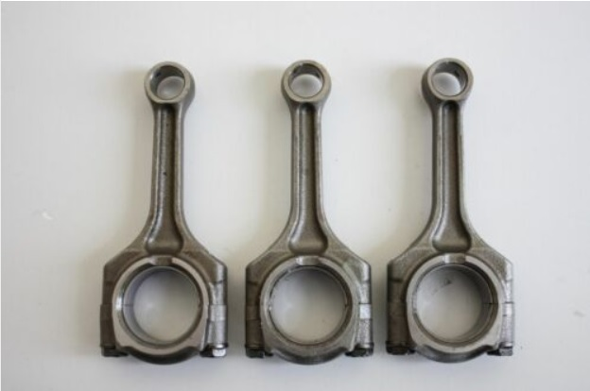
Figure 1 Triumph Daytona 675R connecting rods (Motorcycles, 2019)
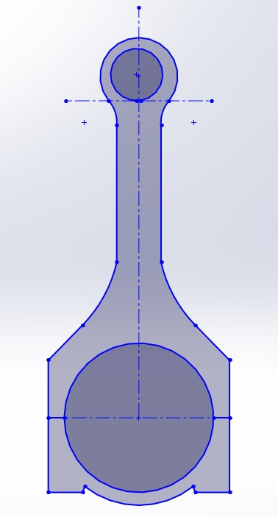
The length of the connecting rod from centre to centre was specified as 104.6mm (aperaceparts, 2019) The material is also specified as an alloy steel containing chrome and molybdenum, commonly known as chrome moly steel. Now that a dimension is known it is possible to create a scale drawing in Solidworks to find the remaining unknown dimensions of the part.
Figure 2 Triumph Daytona 675R connecting rod draft 1
From the newly found dimensions and draft it is possible to create an accurate representation of the part.
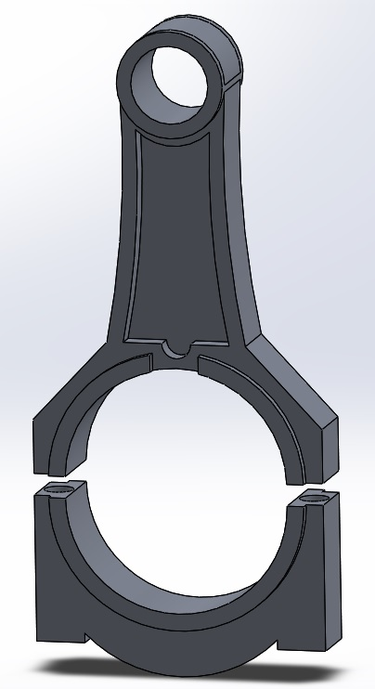
Figure 3 Standard Triumph Daytona 675R connecting rod
The above figure is the completed model of a standard Triumph Daytona 675R connecting rod; the model is not a perfect representation of the real part as the reference material used to create the model did not contain some vital information; this was found by consulting the service manual for the motorcycle. (Triumph, 2011).
In order to conduct an accurate motion simulation some other parts must also be modelled though these are not done to the same degree of accuracy as the connecting rod. The piston head is using a typical model of a piston with the same diameter as the bore of a Triumph cylinder, this provides the same area for the forces to act upon.
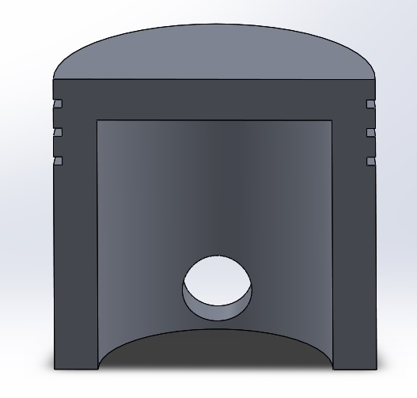
Figure 4 Triumph Daytona 675R Piston Cap
The piston head provides the surface on which forces act downwards during firing, though a model of the Gudgeon pin must also be modelled to translate the forces from the piston cap to the connecting rod. The diameter and thickness of the Gudgeon pin was taken from the scale drawing and the Service manual.

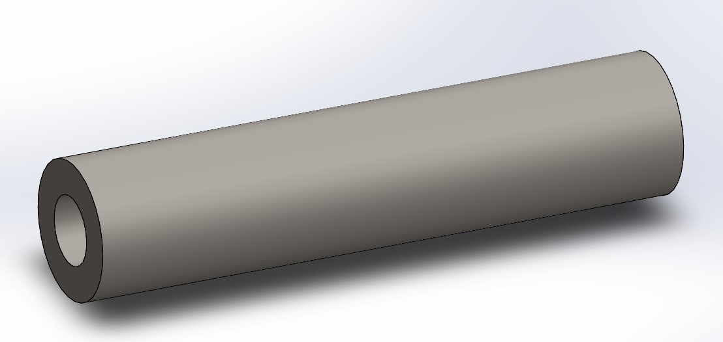
Figure 5 Triumph Daytona 675R Gudgeon pin
For forces acting upwards a model of the crankshaft must be made. This part is also not made to exact measurements; however, it has the same radius as the real counterpart. Crank radius is found by subtracting the engine stroke from the connecting rod length. (aperaceparts, 2019), (Rao, 2013 ).
$$Connecting rod length-stroke=crank diameter$$
$$104.6mm-52.3mm=52.3mm$$
$$\frac{52.3mm}{2}=26.15mm=crank radius$$
The diameter of the mounting area for the connecting rod also has the same diameter as the “Big end” found in the scale drawing of the part.
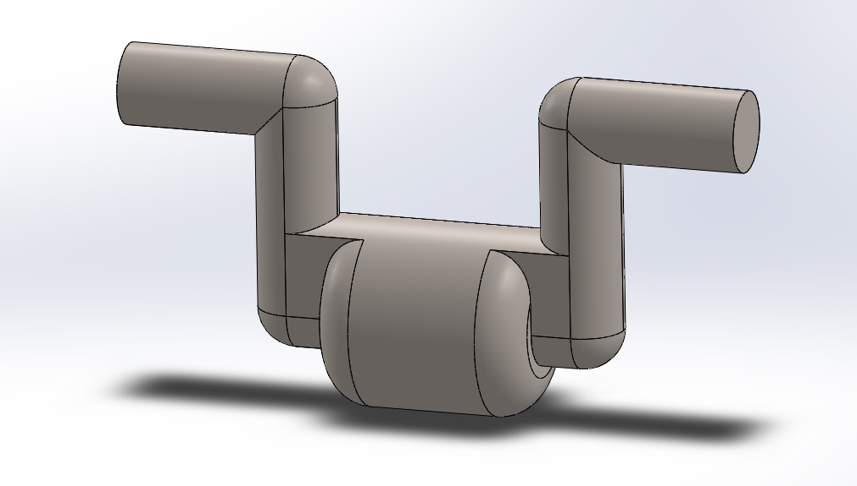
Figure 6 Triumph Daytona 675R Crank model
One final part must be made to complete the model and make it functional; the cylinder is created purely as a reference part in order to align and control the parts that move during the motion simulation. The bore of cylinder is created to match that of the actual motorcycle.
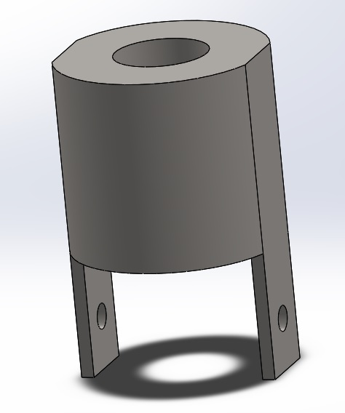
Figure 7 Triumph Daytona 675R cylinder model

Solidworks assembly
After all the components have been modelled it is possible to assemble them in preparation for completing a motion simulation with accurate forces.
To ensure all the parts operate smoothly without interference the equation tool is used to link the dimensions of all the round parts in the assembly, this ensures that if a change is made to the diameter of one part it does not break the entire assembly.
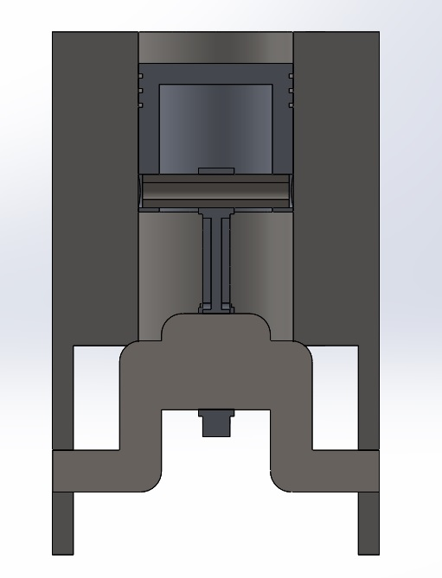
Figure 8 Full Solidworks cylinder assembly

EXCEL force simulation
Before an accurate motion simulation can be carried out the forces acting on the piston must be found; this is done by taking pressure data collected from the motorcycle and performing calculations. The motion simulation will be carried out at 10250 RPM.

Time per degree
To find the time taken per degree of crank travel at 10250 RPM, first the rotations per second must be calculated. This is done by dividing the RPM by 60 as there are 60 seconds in a minute.
$$\frac{10250}{60}=170.833$$
To find the time taken for 1 rotation, 1 is divided by the number of rotations per second.
$$\frac{1}{170.833}=0.00585 seconds per rotation$$
Finally, to find time per degree, the time taken to complete 1 full rotation is divided by 360.
$$\frac{0.00585}{360}=0.00001625 \left(1.625×{10}^{-5}\right) seconds per degree of crank travel$$

Gas force
The gas force is the force acting downwards on the piston created by the firing of the engine. This is used to calculate the inertia force, acceleration, and net forces which will be used in the motion simulation.
To calculate gas force, first the pressure in the cylinder must be converted from BAR to $\frac{N}{mm^{2}}$ this is done by multiplying the BAR value by 10000000000 or $×{10}^{5}$. The gas force is then found by multiplying the pressure in the cylinder by the bore area.
$$F_{Gas}=Pressure(\frac{N}{mm^{2}})×\frac{π×D^{2}}{4}$$

Inertia force
The inertia force acting on the piston is separated into two orders, first and second order inertia forces. This is to reduce vibration within an engine by balancing moments of inertia about the crankshaft (Xiaobo Yang, 2019). The first and second order forces must be combined in order to calculate an accurate figure for the total inertia force within the piston.

First order inertia force
The first order inertia forces are those exerted by oscillating parts in the engine and only peaks once per rotation of the crank shaft.
$$First order inertia force=M_{Piston}.Rω^{2}\cos{θ}$$

Second order inertia force
Second order inertia forces occur at twice the frequency of first order inertia forces; it is this order of inertia that causes vibration in a standard engine. In order to run the engine safely the two forces must be balanced.
$$Second order inertia force=M_{Piston}.\frac{R}{L}.Rω^{2}\cos{2θ}$$

Combined inertia force
Combining the two inertia forces allows for harmonic balancing of the engine, it also gives one of the forces needed in order to calculate the net force acting on the piston. This is the force needed to find accurate motion loads acting on the connecting rod when the engine is running.
$$Combined inertia force=\left(First order inertia+Second order inertia\right)×Rotating mass$$
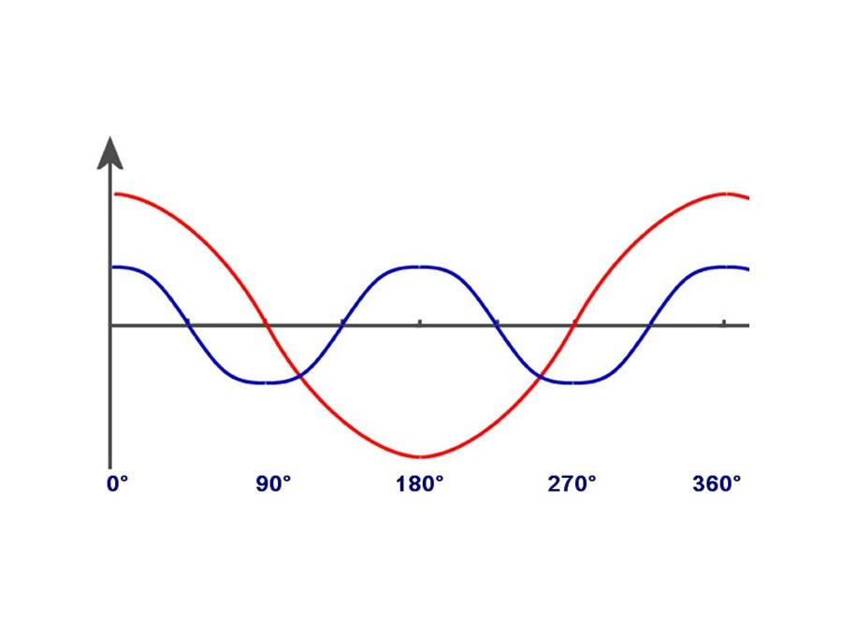

Figure 9 Example of first and second order inertia forces plotted on a graph (KZF-Tech, 2019)

Net force
The net force acting on the piston is the force required to accurately model a motion simulation; this is simply the net resultant force from the forces acting up (inertia force) and down (Gas force). Net force is found by subtracting the inertia force from the gas force.
$$F_{Net}=F_{Gas}-F_{Inertia}$$

Motion simulation and loads
When both the initial EXCEL calculations and Solidworks assembly have been completed it is possible to extract the information required to accurately model the forces acting on the piston. The factors used for the motion simulation carried out are the net force per degree of crank travel, and the time taken for each degree of motion travel. The analysis used an engine speed of 10250 RPM.

Motion simulation
The final Solidworks assembly with equations linking its components is loaded into the Solidworks motion simulation suite; from there a motor rotating at 10250 RPM is applied to the crankshaft to ensure it spins at the correct velocity. Forces are loaded onto the top of the piston; these forces have been calculated in Excel and act on the piston for two complete rotations of the crank. Owing to the short time period the forces act on the piston a simulation of only 0.1 seconds is needed. Forces are imported from a text document containing two columns of information separated by a comma; in the first column is the total time elapsed since the start of the simulation, and on the right is the corresponding net force value.
The frame closest to the peak load is found in the motion simulation; for this instance the peak force acting on the piston occurs at 0.006884615 seconds. The frame closest to this exact value is taken and motion loads are imported onto the part using the “import motion loads” tool in Solidworks.

Initial FEA results
When the initial motion simulation has been completed and the loads have been calculated, Solidworks can complete FEA on the part; this will map out on the model the peak stress and displacement. It will also model the deformation expected of the part under the loads selected from the motion simulation.
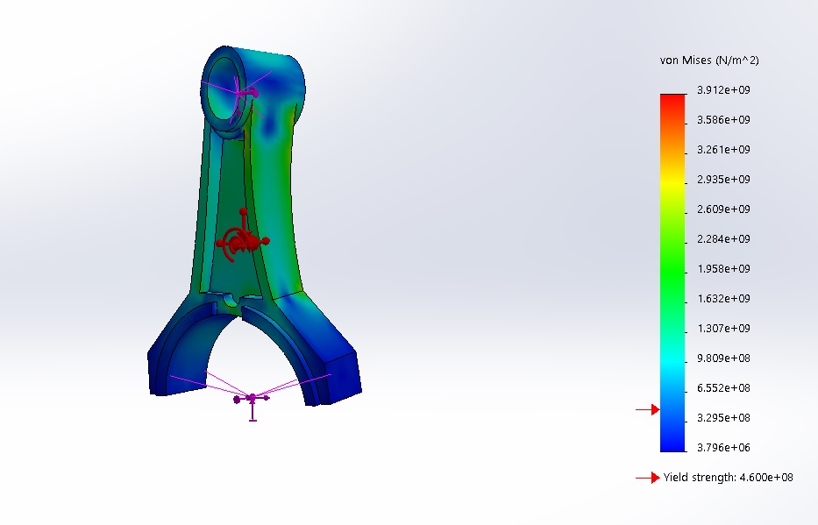
Figure 10 Initial FEA of Triumph Daytona 675R Connecting Rod
From the initial FEA of the part it is clear that the model is not fit for purpose; this is because a large percentage of the main shank of the connecting rod has stress readings well above the yield of the material from which it is manufactured. The rod also appears to twist, which would be a catastrophic failure of the part were it to manufactured and fitted to an engine as it would cause the inertia force pushing up on the piston to be unevenly distributed, causing wear to piston head and cylinder wall. (Watson, 2019). Due to the failure of the part, it must be optimised and strengthened to withstand the forces it is exposed to.

Optimisation
From the initial FEA it is clear that optimisation is required. The simplest way to optimise a part is to alter the material from which it is made. The connecting rod from the factory is made from a steel alloy; steel alloys are used because they are cheap and strong although they may not be ideal for this application as steel tends to be heavy. (T Arun Kumar Reddy, 2015). The material selected to replace the steel is a titanium alloy that has been treated and aged; this improves the tensile strength of the material from 731 $\frac{N}{mm^{2}}$ with asi 4130 chrome moly steel to 1050$\frac{N}{mm^{2}}$ with the titanium alloy.
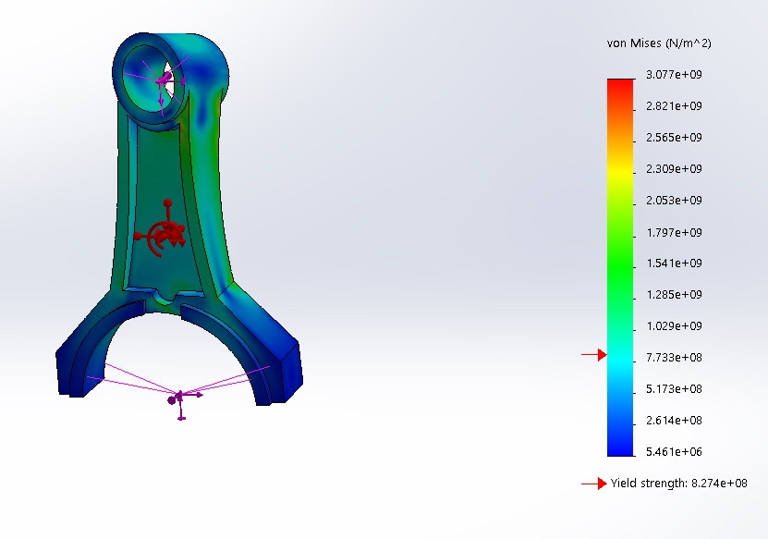
Figure 11 First FEA optimisation Titanium
Although the yield strength of the material has been significantly improved the part still has the same problem with the shank sitting above the yield point of the material; further improvements are required. To ensure the part remains strong the inset of the connecting rod is decreased by 50% from 4mm on each side to only 2mm, cross-hatching is also added level with the perimeter, finally the thickness of the overall part is increased from 13mm to 24mm. This increases the mass of the part from 53.08g when made of titanium (148.81g for steel alloy) to 98.25g this is an increase of 54.025% but still 33.97% lighter than the standard connecting rod made from steel.
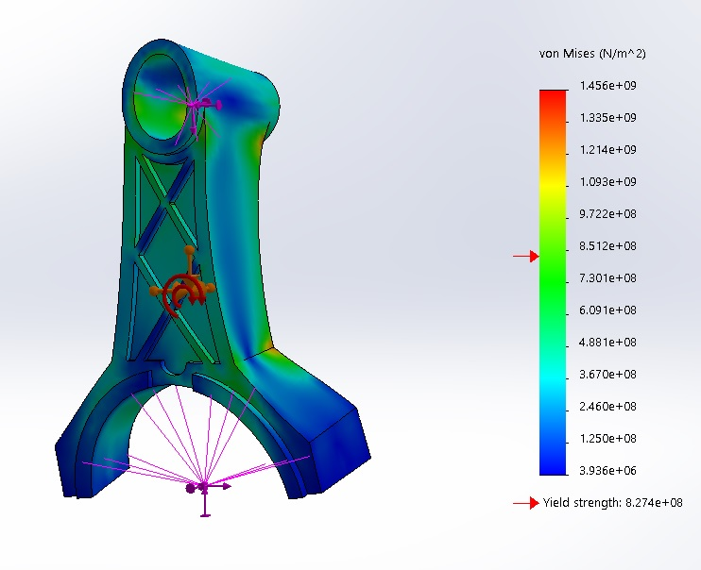
Figure 12 FEA improved Connecting Rod
The improvements made to the part have solved the problems previously encountered with the shank having stresses above the yield strength of the material. Though the twisting of the rod still occurs due to the clearance required for the rod to work correctly, no modifications are possible to the Gudgeon pin hole. This is solved by modifying the piston cap to shorten the moment of force acting on the connecting rod by reducing the distance between the mounting holes for the Gudgeon pin and the connecting rod. (Dr Ramesh B T, 2017)
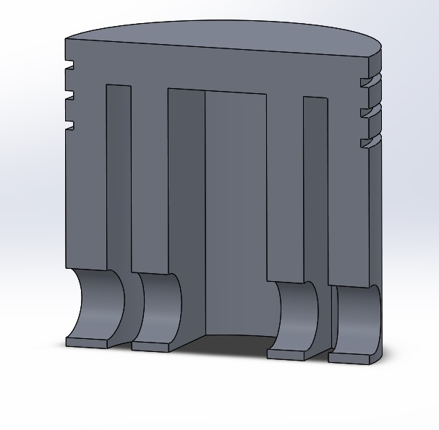
Figure 13 FEA Improved Piston Cap
The combination of the two parts’ optimisations should eliminate the twisting force acting on the connecting rod and reduce the overall stress acting on the connecting rod.
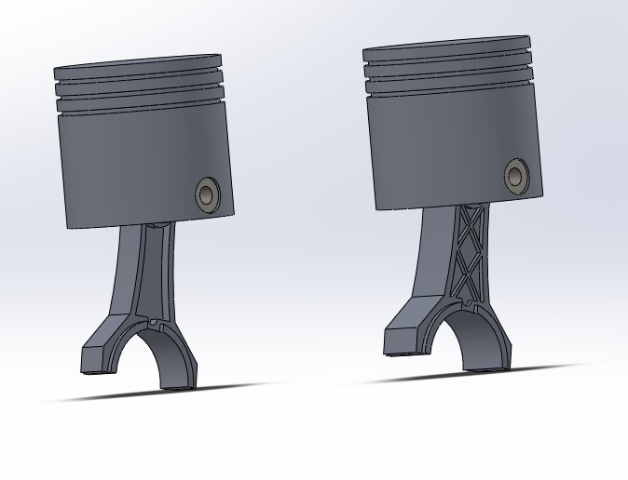
Figure 14 Side by Side comparison of initial connecting rod and optimised connecting rod
With the changes made to the initial design of the connecting rod the new design is 33% lighter, but it is significantly stronger. The increase in cross-sectional area will reduce the impact of the forces acting on the connecting rod by increasing surface area and cross-sectional area and reducing the force per square millimetre.

Recommended Further Work
Repeat the entire process for a variety of different connecting rods and vehicles in order to create a library of models for use in future studies. More research could also be done into the effects of material selection when used in the connecting rod.

Bibliography
aperaceparts. (2019, December 29). 2011 Triumph Daytona 675R. Retrieved from aperaceparts.com: https://www.aperaceparts.com/tech/2011triumphdaytona675r.html
Dr Ramesh B T, V. K. (2017). Analysis and optimization of connecting rod with different materials. World journal of research review (WJRR), 33-39.
KZF-Tech. (2019). Inertial forces and torques. Retrieved from Kzf-tech.de: http://www.kfz-tech.de/engl/biblio/verbrennung/massenkraefte01.htm
Motorcycles, T. (2019, December 29). Crankshaft-connecting rods-pistons & liners for Triumph Daytona 675. Retrieved from bike-parts-triumph: https://www.bike-parts-triumph.com/triumph-motorcycle/Daytona/Daytona-675/daytona-675/Crankshaft-Connecting-Rods-Pistons-x-Liners/22/10006796737/0/22
Rao, G. N. (2013 ). Design optimisation and analysis of a connecting rod using ANSYS. International Journal of Science and Research (IJSR), 225-229.
T Arun Kumar Reddy, M. S. (2015). Comparisson of two different materials for connecting rod using Ansys. International journal for innovative research in science & technology, 306-313.
Triumph. (2011). Triumph Daytona 675, Street triple, Street triple R Service manual. Triumph.
Watson, B. (2019). Pro Engine Blueprinting. Motorbooks PowerTech Series.
Xiaobo Yang, P. X. (2019, December 30). Inertia force. Retrieved from Sciencedirect.com: https://www.sciencedirect.com/topics/engineering/inertia-force

Figures, Tables and Graphs.
Figure 1 Triumph Daytona 675R connecting rods (Motorcycles, 2019) 2
Figure 2 Triumph Daytona 675R connecting rod draft 1 3
Figure 3 Standard Triumph Daytona 675R connecting rod 4
Figure 4 Triumph Daytona 675R Piston Cap 5
Figure 5 Triumph Daytona 675R Gudgeon pin 5
Figure 6 Triumph Daytona 675R Crank model 6
Figure 7 Triumph Daytona 675R cylinder model 7
Figure 8 Full Solidworks cylinder assembly 8
Figure 9 Example of first and second order inertia forces plotted on a graph (KZF-Tech, 2019) 10
Figure 10 Initial FEA of Triumph Daytona 675R Connecting Rod 12
Figure 11 First FEA optimisation Titanium 13
Figure 12 FEA improved Connecting Rod 14
Figure 13 FEA Improved Piston Cap 15
Figure 14 Side by Side comparison of initial connecting rod and optimised connecting rod 16

Appendix
https://uowtsd-my.sharepoint.com/:f:/g/personal/lslade_151151_student_uwtsd_ac_uk/EizrOobIBh5IqjCyJ9B8kcYBvytu0rKDIU9fAPjpdh7xgg?e=yZB8Ly

