Student Name: Kiran Naz
Student Number: 2319990
Module: BMHP5016 – Principles of Health and Social Care Practice Reflective Report on Person- Centred Care, Partnership Working and Ethical Practice.

Table of Contents
Title Page ……………………………………………………………… 1
Table of Contents ……………………………………………………2
Introduction …………………………………………………………… 3
Task 1: Principles of Health and Social Care Practice …..3
Person-Centred Care …………………………………………. 3
Partnership Working …………………………………………4
Ethical Practice ……………………………………………….5
Task 2: Robyn Case Study (Practical Application) ………… 6
Task 3: Self-Reflection as a Health and Social Care Professional ………………………………………………………… 7
Conclusion …………………………………………………………… 8

My Strengths and Development…………………………………………………9/10
Reference List ……………………………………………………….11

Introduction Health and social care practices are underpinned by a number of core principles which are intended to ensure that individuals receive care that is safe, effective and tailored to their individual needs. The most important aspects of social care are person-centred care, working in partnership and ethical practice. These principles are embedded in legislation such as The Care Act 2014 and The Health and Care Act 2022 which focus on wellbeing, independence and collaborative practice. However, in practice, these principles are often hindered by shortages in the workforce, growing demand, fragmentation of services and the constraints of time.This creates a gap between the policy aims and the lived experience of service users.

This report critically examines these principles through academic literature, relevant policies and legislation and a real-life example of Robyn who received a Personal Health Budget (PHB). Reflective learning and analysis will be integrated into my health and social care practice where relevant, using Gibbs’ Reflective Cycle to evaluate my professional growth and development.

Task 1: Principles of Health and Social Care –Person-Centred Care

Person-Centred Care looks at each individual as an entity unto themselves and makes sure that the care provided is consistent with their unique wants and values, as well as their needs. Meeting the individual's needs is more than just treating an illness. It includes providing dignity, independence, choice, and respect for the individual as a whole person. The approach of person-centred care is recognised throughout the United Kingdom as the most effective way to provide quality and compassion. Maslow (1943) demonstrated how people have a number of complicated needs and how the fulfilment or satisfaction of those needs is essential for achieving optimal levels of wellbeing as a human being. According to Maslow, the first needs are the basic physiological needs (food, water, shelter, and so on) and the next need is the safety and security of the individual; the last of the first needs is social belonging.

After basic needs are established in order of hierarchy, esteem and self-actualisation will follow. However, the way we satisfy our needs are not necessarily sequential in their order; for example, a person may choose their emotional wellbeing (their need for love) and independence before they reach a state of decline in their physical health (the inability to gain physical independence).

This illustrates that care must be prioritised according to the individual rather than by fixed theory. Laws, such as The Care Act 2014, require healthcare professionals to promote an individual’s well-being and independence, and to include the individual during the care planning process, thereby supporting person-centred care; this is further supported by NICE, who are providing advice for shared decision making, in empowering people's choice of how they are cared for. Furthermore, Skills for Care (2023) have identified through their research, that engaging individuals using person-centred models of care builds trust, engagement and, satisfaction.

Partnership Working

Partnership working brings together various professionals, organisations, and agencies to deliver coordinated and effective care. This approach is especially important when supporting individuals with complex needs or long-term conditions. Since no single person can address all of someone’s requirements, collaboration with the individual and other professionals is essential. Policy is advancing partnership working through Integrated Care Systems (ICSs), established by the Health and Care Act 2022. ICSs integrate NHS services, local authorities, and partner organisations to create seamless care. Their goal is to reduce fragmentation between teams, enhance communication, and ensure smooth service transitions. Bronfenbrenner’s Ecological Systems Theory applies to healthcare by underscoring the necessity of partnership working. The theory identifies several systems influencing an individual’s life, including medical professionals, family, education and community services, and social policy. When these systems fail to collaborate, it negatively affects care and outcomes for the person. Although policies promote partnership working, in practice, it’s not always achieved. The NHS and social care often operate separately, with limited communication among professionals. Barriers to sharing resources and finances can hinder collaboration, leading to duplicated assessments, delays in care, and fragmented experiences for service users.

Ethical Practice

Ethical practice ensures that care is delivered fairly and prioritizes protecting individuals' rights. Ethical theories often revolve around four key principles: autonomy, beneficence, non-maleficence, and justice (Beauchamp and Childress, 2019). These principles form the foundation for decision-making within UK healthcare. They are also embedded in laws and regulations such as the Care Act 2014 and the NMC Code (2018), addressing themes like consent, dignity, safeguarding, and accountability. While ethical principles serve as a guide similar to laws, applying them requires professional judgment, especially in complex situations. Ethical dilemmas typically arise when two principles come into conflict. For instance, if someone refuses treatment, their right to autonomy must be balanced against our responsibility to protect them. Ethical decisions are rarely straightforward and depend heavily on professionals employing critical thinking, reflection, and accountability in their choices.

Task 2: Robyn Case Study

Robyn’s case highlights both the strengths and weaknesses of personalised care. After suffering a spinal injury that resulted in tetraplegia, she initially relied on several different carers. The lack of continuity affected her trust, sense of security, and emotional wellbeing, despite her physical needs being met. Because Robyn had little say in who supported her, her care didn’t follow a person-centred approach. While this support addressed her basic care needs, it did not align with the principles of the Care Act 2014, which emphasises independence, dignity, and involving service users in their care plans. Robyn’s situation improved significantly once she was given a Personal Health Budget (PHB), which allowed her to choose carers who understood her preferences and needs. This boost in autonomy, dignity, and emotional wellbeing illustrates how personalised care can work well when implemented properly. However, the delay in approving her PHB reveals weaknesses in partnership working, despite the introduction of Integrated Care Systems (ICS) aimed at fostering better collaboration.

Robyn faced significant delays caused by bureaucratic hurdles and poor communication between services. Her case also sheds light on issues related to equality of service provision. Personal Health Budgets (PHBs) aren't always accessible, depending on where someone lives and the resources available to Clinical Commissioning Groups (CCGs), which results in an uneven system. Ethically, Robyn's care initially deprived her of autonomy and control, which she regained only after receiving a PHB. This example illustrates how ethical outcomes depend heavily on the structure of the healthcare system.

Task 3: Reflection

While carrying out my placement, there was an occasion where I witnessed a situation where the service user had no involvement in any decisions around the delivery of their care. The service user received adequate physical care, but when it came to the emotional aspect of their care and being included in an involved manner with regards to their care, they were not included in any decision-making process. As a result, I felt uncomfortable and restricted my ability to interact meaningfully with this individual and left them feeling powerless. Through this experience I learned that if a task is completed it does not indicate that the individual has received good care; therefore, dignity, autonomy and inclusion are equally as important. This directly relates to the principles of person-centred care and the ethical principle of autonomy. While I believe that the personnel involved with delivering care attempted to provide quality care, the overall quality was affected by the systemic issues of the workplace. Bronfenbrenner’s Ecological Systems Theory would assist in understanding how the broader social context influences the frontline worker. In addition to emphasising the significance of communication and how easily communication can be forgotten under pressure of time limitations, I plan to employ open-ended questions, actively listen and use the SBAR (Situation, Background, Assessment, Recommendation) technique in my practice. I have also recognised that ethical considerations are a key part of professional practice in a care environment. Furthermore, the Mental Capacity Act 2005 directly relates to this content.

Conclusion

The principles that should shape practice within health and social care have been examined within this report, particularly regarding: person-centred care, partnership working, and ethical practice in the context of delivering care. The exploration of these aspects has demonstrated that these underpin safe, effective, compassionate and respectful care by promoting dignity, choice and independence, while being compliant with UK legislation such as the Care Act 2014 and Health and Care Act 2022. Despite this, there are many factors that create barriers to the implementation of these principles in practice. The delivery of person-centred care is hindered by the pressures of a reducing workforce and limited time spent with service users. Ineffective structures for partnership working with others involved in care provision, along with poor communication, impede collaborative working between care providers. Ethical considerations underpin all care decisions and although principles such as autonomy, beneficence, and safeguarding may sometimes be in conflict with one another, health and social care professionals need to be able to assess which of these principles takes precedence in each situation. The example of Robyn has shown how the application of policy does not always match actual practice. Overall this report has shown that while delivering high quality care and improving the outcomes for service users is achievable, consistency of application is essential.

My Strengths and Development.

I effectively communicate with respect to others both as service users and colleagues; modifying my communicative ability according to the particular needs of the person I am communicating with. By using language that emphasises the needs of those I am caring for (i.e., person-centred language) I have been able to effectively engage with service users and, therefore, build trusting relationships in the delivery of care.

My practice demonstrates an increasing awareness of theory as it relates to the delivery of care to people (i.e., person-centred care and ethics) and my understanding of theory enables me to better reflect upon this theory and how it is applied in the delivery of care.

The use of reflective practice has provided me with the ability to positively evaluate my observations and identify my performance improvement opportunities; reflective practice is important for practitioners within the fields of health and social care to ensure they keep their practice up-to-date.

Developmental Opportunities:

• Increased ability to manage complex ethical scenarios with increased confidence.

• Improved knowledge of safeguarding.

To continue developing in these two areas (i.e., increasing my knowledge and skills), I will engage in additional continuing professional development opportunities and actively participate in training opportunities as they arise. Additionally, I will make a point of seeking advice from experienced members of my multifaceted and multidisciplinary health and social care team.

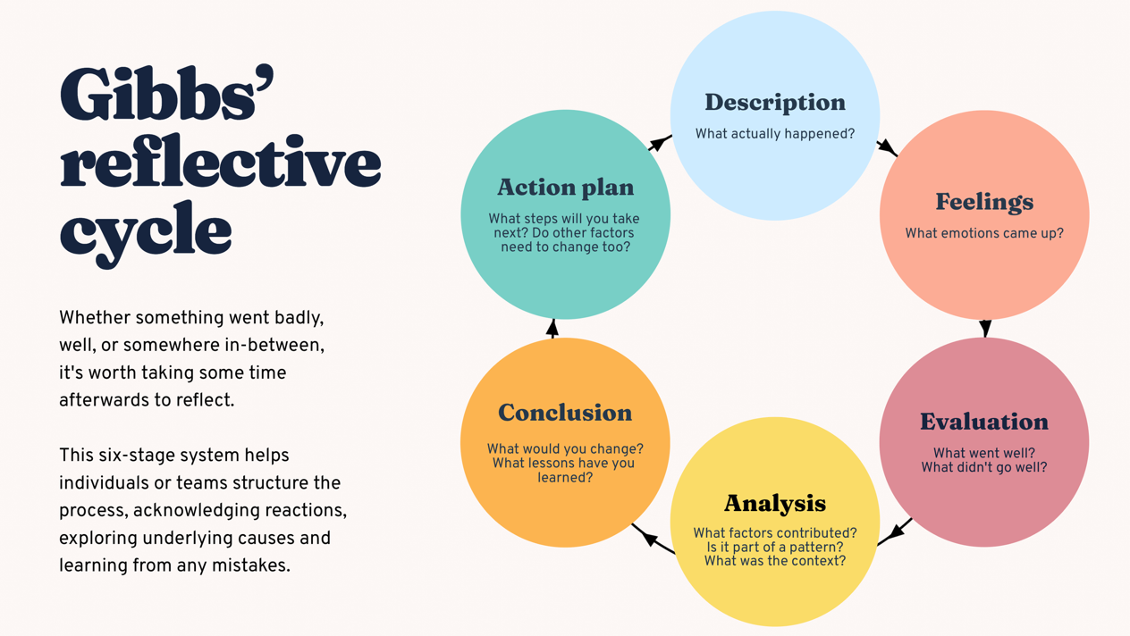
Figure 1: Gibbs’ Reflective Cycle (1988), a model used to structure reflective practice in health and social care.

Reference List
Beauchamp, T.L. and Childress, J.F. (2019) Principles of Biomedical Ethics. 8th edn. New York: Oxford University Press.
Bronfenbrenner, U. (1979) The Ecology of Human Development: Experiments by Nature and Design. Cambridge, MA: Harvard University Press.
Care Act 2014. c.23. London: The Stationery Office. Available at: https://www.legislation.gov.uk/ukpga/2014/23/contents (Accessed: 28 June 2026).
Gibbs, G. (1988) Learning by Doing: A Guide to Teaching and Learning Methods. Oxford: Oxford Polytechnic.
Health and Care Act 2022 (2022) c.31. Available at: https://www.legislation.gov.uk/ukpga/2022/31/contents (Accessed: 28 June 2026).
Maslow, A.H. (1943) ‘A Theory of Human Motivation’, Psychological Review, 50(4), pp. 370–396.
Mental Capacity Act 2005 (2005) c.9. Available at: https://www.legislation.gov.uk/ukpga/2005/9/contents (Accessed: 28 June 2026).
National Institute for Health and Care Excellence (NICE) (2021) Shared Decision Making (NG197). Available at: https://www.nice.org.uk/guidance/ng197 (Accessed: 28 June 2026).
Nursing and Midwifery Council (NMC) (2018) The Code: Professional Standards of Practice and Behaviour for Nurses, Midwives and Nursing Associates. Available at: https://www.nmc.org.uk/standards/code/ (Accessed: 28 June 2026).
Skills for Care (2023). The State of the Adult Social Care Sector and Workforce in England. Available at: https://www.skillsforcare.org.uk (Accessed: 28 June 2026).

