

MODEL CODE:M5X01923

COURSE TITLE: Cultural awareness

NAME: BISWAJIT MUKHERJEE

NUMBER:1815040

LECTURER: DALE CLARKE

WRITTEN ASSIGNMENT

 introduction………….……………………………………………………………p2

Guest service experience for international visitor….…………………..p3-p4

Key cultural differences ,customs and behaviour ………………………p4-p6

Do’s and don’t for hotel staff…………..…………………………………….p7-p8

Conclusion……………………………………………………………………….p8-p9

References………………………………………………………………………p9-p10


The research based on international guest and hospitality employee help to manage their guest experience and valuable service .
Guest service is very important part of this hospitality sector and international guest is also important. All hospitality sector conscious that they must be good in their guest service. Guest satisfaction should be a top priority at each and every hotel, whether controlling the a large chain of corporate hotels or setoff an intimate property in a quite location.
The guest experience at hospitality sector is going to confirm far beyond the duration of their stay. Guest contentment ratings every hospitality sectors take very seriously its behind has so many reason. Guest always most strong marketing tool or biggest critics if guests have a good experiences. So many ways its affects can come which are guest can share their experience through social media, as well as recommend that particular hotels to their friends and relatives. On the opposite way if they face bad experience then their opinion will appear through social media reviews and go to extra mile to make sure people know about what happened. Here is research based on cultural awareness so every hospitality sectors are really very serious about it. Lac of enlightenment can conduct to abominable decisions and increases the chance of creating more insightful, considered decision. It has positive advantages that could be achieved if manager to grateful for cultural value , perspective differences of each and everyone. This is also need to be clarify that cultural multifariousness is highly important in hospitality business due to multicultural guest related industry. cultural awareness is knowledge of the differences between themselves and society from different countries or backgrounds, especially inconsistency attitude and values. Considering those components today’s hospitality industry managers have to discern the consequence of multi cultures idea and discussion skills in order to be able to work in a workforce assorted environment. In general there are some privileges that can be achieved from apprehension the different cultures for the hotel industry. it cultivate good interconnection between employee in the overcomes anti inequity.
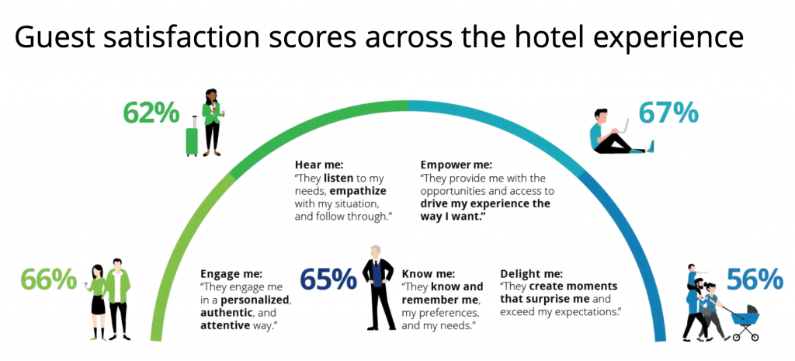
The world becoming more and more connected, travel(especially, international travel) is no longer luxury. The report is saying that travel tourism industry came up with 7.6 trillion us dollar in 2016, to the global ceremony. This is the opportunity to change hospitality industry sector as well as. Promoting more and more hoteliers the world over to open their doors to international travellers. Sounds like advantageous plan! But there is a big question which is how can hotels enchants international travellers? The things always should be come that as a hotel manager what will be the plan to attract foreign guests, as well as need to find about increase international booking for the hotel. This part of the research will be discuss significant ways to bring more international guests.
Geo specific targeting:
In this present days every hospitality sectors use their websites. So fancy to carry on with the expectation that hotel need to use place an operational brand website. As per google research enable analytics allows hotel to easily gather information on particular factors which will support design an productive hotel marketing strategy. always need to keep in their mind to look after about international guests full details in websites. Then they can easily keep the record maximum visits and from which country. All hospitality sectors can get information from which country and region visits more , also they can get information about which gender is visiting more such as male or female. So by this things they make their marketing strategy and look after their international guests.
Social media: in this present time social media is one of the noticeable platform. The power of social media can make, it as beset or collective as they need directions. Most social media platform at present help to concentrate insights on where the audiences live.so marketing team in their marketing campaign to focus only those region or countries where they are popular.
As an example; one of the hotel in USA and their marketing team found that in their Facebook insights suggest that the majority of guests age between 23 and 30 and they are from Mexico.so in this case hotels should be more focus to make marketing advertisement on social media between that age group in Mexico. For international guests hotel need to make sure their advertisement copy recorded with the analytical so as to direct them to create a contingency . this is true that the advertisement could be in Mexican to make that much more impingement. Hotel employee by applying this process can easily give best service for international guest.
Ota: otas are an endorsement to all hotel employee who wish to attract to invited international hotel guests. As in the previous synopsis recognise geo that wish to target first. The best bet now is to attach hotel pms to a channel manager that provides with the most popular otas in that region. Online queries for hospitality industries are on the rise, even the world over.



In this report need to discuss about international countries and identified key cultural
differences, customs and behavior.
So after research found some between countries cultural differences and this report is trying to discuss about this things. Chinese and American people will find they have more comparability than cultural dissimilarity. People are inspired by the same things. Luxury ,economy, assuming for the family, work contentment and security. But each culture standing these goals through distinctive alternatives and on the surface ,can sometimes seem poles apart. Understanding that why people are motivated to conduct the way they do can go a long way to eminent intercultural conversation. This research show table below between two countries cultural differences:
The significant religion in china is tourism. Who do not follow Tourism primarily subscribe to Buddhism, followed by Christianity and Islam. Tourism is an extinct godly framework which basis on the imperative to live in understanding with the tao which is put simply the source of all existence. Family relation in china are of principal consequence and extensive significance is placed upon stratification. Many of the value I Chinese culture are based upon Confucianism which maintain duty, honesty, commitment ,filial piety and honor. Class distinction revealed in Chinese society as early as 221 in time of the first Qin decent when class segmentation were clearly dominique life styed. At the head of the


The American way of the life or simply the American way is the extraordinary behavior of the people of the United states of America. It introduces to a superpatriot principals that attach to the ethos of life ,emancipation, and the pursuit of happiness. American culture consists of the customs and traditions of the united states, culture in consists of divinity, food, language, marriage ,music. The united states one of the culture distinct countries in the world. Nearly every divinity of the world has manipulated American culture, most principally the English who occupied the country beginning in the early 1600s. U.S culture has also been modeled by the cultures of native Americans, Latin Americans, Africans, and Asians.



The culture of India recommended inclusively to the thousands of apparent and unique cultures of all religions and peoples present in India. Indians languages, religions, dance, music, food, customs vary from place to place within the country.
India is home to some of the most antiquated accomplishment, containing four major world religions, Hinduism, Buddhism, Jainism , Sikhism and other religions. It is true that culture of India is one of the primogenital and unique. In India there s amazing cultural multiplicity throughout the country. One of the most essential elements of Indian culture is hospitality. People in India have the highest cognizance for tourist and appraisal hospitality. A common saying here is “atithi devo bhav”, meaning, guests are from of good” in India, guests are likely to be welcomed in to the homes of people with whom guests collaborate.


Conventional tradition method of hospitality remain an important part of sub-Saharan African traditional communities. They experience even between Africans living in urban settings. Pastoral groups of sub-Saharan African traditional societies provide drink, food, shelter and accompaniment for hosts, guests, travelers and strangers. African culture is articulated in its arts and crafts, folklore and religion, clothing, cuisine, music, and languages. Utterance of culture are extensive within Africa, with huge amounts of cultural diversity originate not only across different countries but also within single countries.



Everyone is probing about hospitality improvement. For this reason do’s and don’t its very important and should no forget. This research is discussing bellow about do’s and don’t .

DO’S | DON’T’S
Its need to understand that hospitality contains of three especial principals. These elements are attitude commitment, and surroundings. | Don not accumulate a manual of the consignment of money stuffs express. Everyone is distinctive and fits his hospitality in his own way.
always need to understand that distinctive knowledge need to be apply for different guests. | Don’t think there is only one type of guest. The meaning of that only one type of service have to presuming for all the guests in every condition.
make different types of expedition for guests preplanned desired experience. | Don’t think only few staffs are include in this hospitality policy.
utilize each staff with the hospitality policy. | Incorporate rules in which staffs should comport in common situations.
Decide that staffs have their own emancipation to decide their behavior themselves. | Staffs make each other check for good behavior.
Guests also need to behave nicely with all hotel or hospitality staffs or employee. | Don’t criticism the hotel employee if he or she barges into guestroom if guest hope not to be disturb.
Be attentive of other guests. Circumvent making noises that might be feel disturbance other guests. | As a guests think about hotel staffs who are doing hard work to clean and tidy the room so don’t leave mess and try to co-operate with them.



After analysis this research now its time to make conclusion about this cultural awareness.
Cultural association is difficult as well as inspiring in todays hospitality business. There are uncountable differences between cultures . there is very important things is to distinguish them , respect them, try to understand them when needed. Always need to maintain politeness. Communal respect is the key to successful culture communication .this is also true that with prospects of culture in mind have to improved conversation accordingly. Guest reviews and ratings are also important to invite international tourists as it satisfies approaching guests. While all this elements do provide increased and best service for international guests at every hotels, but most of this will not be fully helpful except hotel industry have cloud based property management system in place. In according to “Dissatisfied customers are unlikely to return to an establishment, and may provide negative feedback to family and friends, which may ultimately affect their destination choices in the future (Chen and Gursay, 2001; Ford and Heaton, 2000; Ive, 2000).”
When employees are happy can do their job polyphony , they are able to presuming better service to guests in order to confirm the guest’s gratification. Therefore hotel managers must have proficiency to conduct and deal effectively with people from different cultures, as they are tasked with the commitment of ensuring that association between staffs, workmate , clients and customers is clear , consistent and free from intercultural misunderstandings. In order to obtain this, they have to command certain key elements. These are namely intercultural awareness , elasticity and subsidizing on differences. In this research is indicating that the hotel industry as a service industry has begun to distinguish the value of advanced communication as a essential to implementing and amplifying aspect, efficiency and effectiveness.



Adler, Leonore; Gielen, Uwe Peter (2001). Cross-cultural Topics in Psychology. 2001: Greenwood Publishing Group. p. 211. ISBN 978-0275969738.

Ayeh, J.K.; Au, N.; Law, R. Investigating cross-national heterogeneity in the adoption of online hotel reviews. Int. J. Hosp. Manag. 2016, 55, 142–153

Boboc, A. (2009). Cultură şi comunicare, Acta Universitatis Danubius, No. 1/2009, retrieved
from journals.univ-danubius.ro/index.php/communicatio/article/download/./343.

Gonçalves, A. (2014). The Journey not the Arrival Matters: Developing Intercultural Awareness and Communication Skills in Tourism Education, ENCATC Journal of Cultural and Policy, 4(1) 2014/ISSN 2224-2554.

Kubokawa, Amanda (2009). "Positive Psychology and Cultural Sensitivity: A Review of the Literature". Graduate Journal of Counseling Psychology. 1: 2.

Mattila, Anna S. (1999), “The Role of Culture in the Service Evaluation Processes,” Journal of Service Research, 1 (3), 250-61.

Mok, C., & Armstrong, W. R. (1998). Expectations for Hotel Service Quality: Do they differ from Culture to Culture? Journal of VacationMarketing,4(4), 381–39

Seo, Yeji, "Cultural Impact on Customer Satisfaction and Service Quality Evaluation in Hotels" (2012). UNLV Theses, Dissertations, Professional Papers, and Capstones. 1370. https://digitalscholarship.unlv.edu/thesesdissertations/1370

