
Ella Williams
Data Handling
1707424
Data Handling: Assignment 2
Executive Summary
This report gives the reader the knowledge and awareness of the traditional and new modern-day data mining software. Each have their own strengths and weaknesses which are shown throughout the report through screenshots. Sarn Helen is able to look at the data that has been analysed and become aware on how easy it is to use both methods to analyse their data. However, Weka is able to predict the future, which would benefit the organisation a lot as they would be able to improve on their losses before it is too late.
The purpose of this report is to show Sarn Helen that staying up-to-date with the modern-day technology can benefit their organisation a lot.
This report concludes by saying how although Microsoft Excel™ is a very useful software it can be very time consuming which could have a huge impact on the organisation. However, new modern-day technology called data mining is able to predict into the future from just analysing their data. This would benefit the organisation as they would be able to see where they are going wrong to improve on it fast before it is too late.

Table of Contents

- Introduction……………………………………………………………………3-4
  - Report Remit
- Part 1…………………………………………………………………………….4-8
  - Pivot Table
  - IF Statement
  - Look Up
  - Strengths and weaknesses of Excel
- Part 2…………………………………………………………………………..8-13
  - Prediction, Association and Clustering Definition
  - Prediction
  - Association
  - Clustering
- Conclusion……………………………………………………………………….14
- Recommendations…………………….………………………………………..14

Table of Figures
Figure 2.1.1: Pivot Table…………………………………………………………….5
Figure 2.1.2: Pivot Table Chart……………………………………………………..5
Figure 2.2.3: IF Statement…………………………………………………………..6
Figure 2.2.4: IF Statement 2………………………………………………………..6
Figure 2.3.5: Look Up……………………………………………………………….7
Figure 3.2.6: Linear Regression Model…………………………………………..10
Figure 3.2.7: Decision Tree………………………………………………………..11
Figure 3.3.8: Association Diagram ………………………………………………12
Figure 3.4.9: Sarn Helen Cluster…………………………………………………13
- Introduction

  - Report Remit
This report looks into two data mining software’s Microsoft Excel™ and Weka to analyse an office supplies company called Sarn Helen (SH). In 2017, the organisation has noticed a reduction in profits and want to find out why it was happening. Screenshots will be shown throughout this report to show the differences between the two data mining programmes. This will help Sarn Helen to know how they are able to engage with analytics in the future to better inform their decision-making process.

  - What is Data Mining?
Data mining is a process where organisations can find patterns, correlations and anomalies within large data sets to predict outcomes. Data mining consists of a broad range of techniques. The information found can then be used to increase revenues, reduce risks, cut costs and improve customer relationships (SAS, 2019).
Data Mining techniques are used to create and build machine learning models that are able to power modern artificial intelligence (AI) just like recommendation systems and search engine processes. Data Mining is also able to predict future outcomes. This would benefit organisations just like Sarn Helen as they would be able to use the software to look into the future so they would be more aware of what they need to improve on, to make sure they stay successful (MicroStartegy, 2019).

  - What is Excel?
Microsoft Excel™ is a traditional software that uses spreadsheets to organize data and numbers through functions and formulas. Organisations worldwide use Excel to perform financial analysis and organise data. Excel includes shortcuts, formulas and functions which can improve its functionality. Organisations are also able to track their accounting, forecasting and budgeting functions with the Excel spreadsheets (CFI, 2019). A lot of organisations use Microsoft Excel™ as it is much cheaper than the modern-day data mining software.

- Part 1
When analysing the Sarn Helen data you can see areas where there the profitability is low or negative within the Microsoft Excel™ functions; the If Statement, Look Up, Pivot Tables, charts and graphs.

  - Pivot Table
Pivot Tables are important as it summarises information clearly. In Figure 2.1.1, There is a lot of profits and loses that are made throughout five regions; Dyfed, Mid Glamorgan (MG), South Glamorgan (SG) and West Glamorgan (WG). Firstly, ‘Bookcases’ are losing money in the regions MG, SG and WG giving a grand total of -14309.89. ‘Computer Peripherals’ are losing money in SG with a negative of -313.85. ‘Copiers and Fax’ are losing money in Dyfed with a loss of -148.68 and MG with -6511.61. However, ‘Scissors, Rulers and Trimmers’ and ‘Tables’ have a negative grand total, showing they are losing a lot of money within the five regions. Although the grand total sum is positive with 741,904.20, Figure 2.1.1 shows where there are a lot of negatives that the Sarn Helen need to turn to positives.
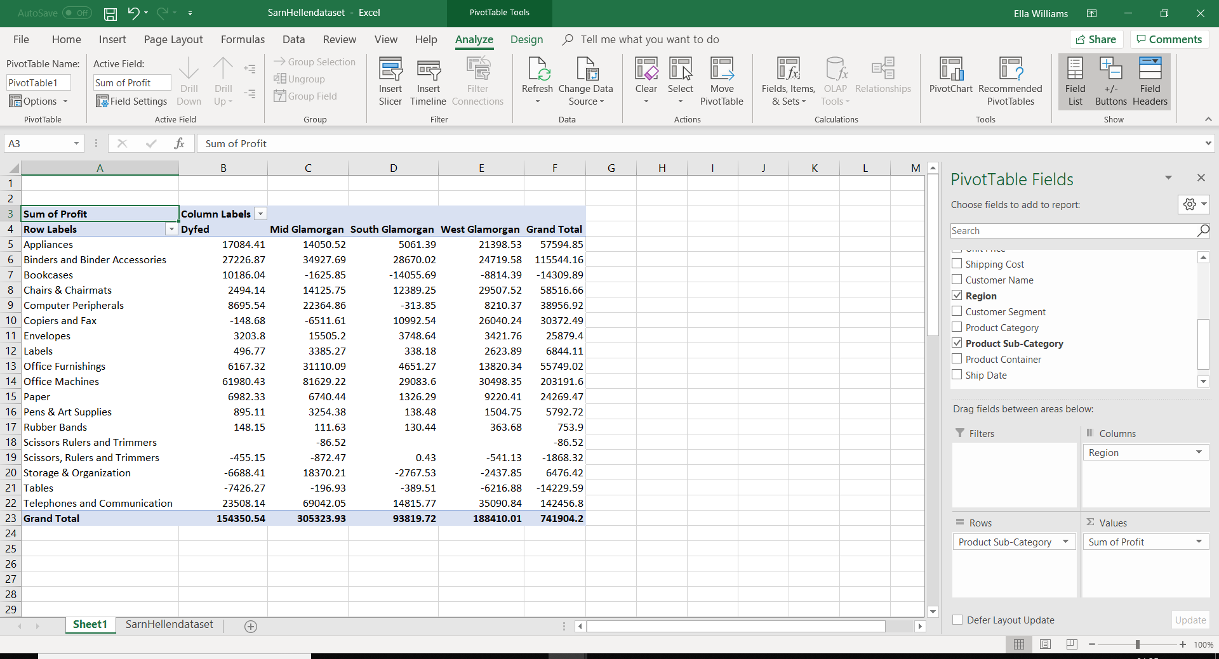
Figure 2.1.1: Pivot Table

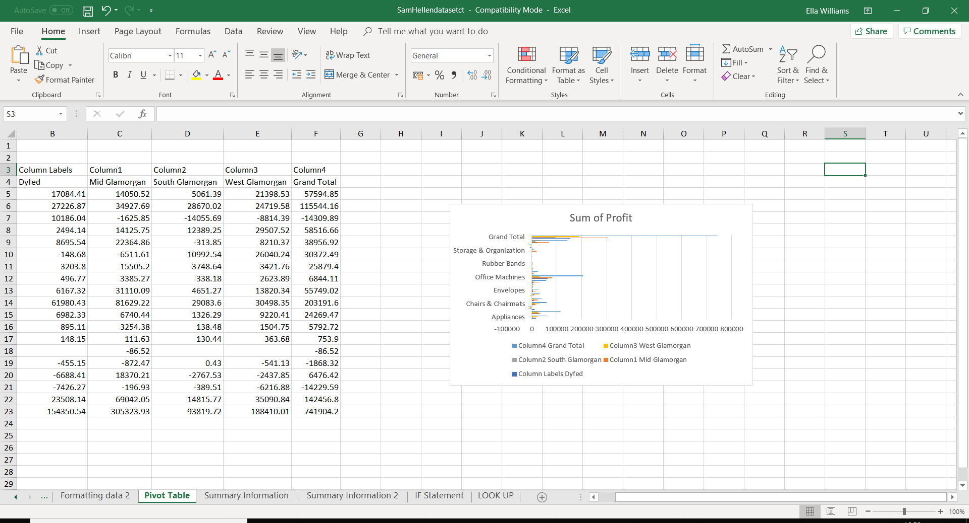
Figure 2.1.2: Pivot Table Chart

  - IF Statement
Within Figure 2.2.3 you can see that there is a mixture between the profit and loss’. However, because the data is mixed you cannot see whether there are more losses or profits that have occurred.
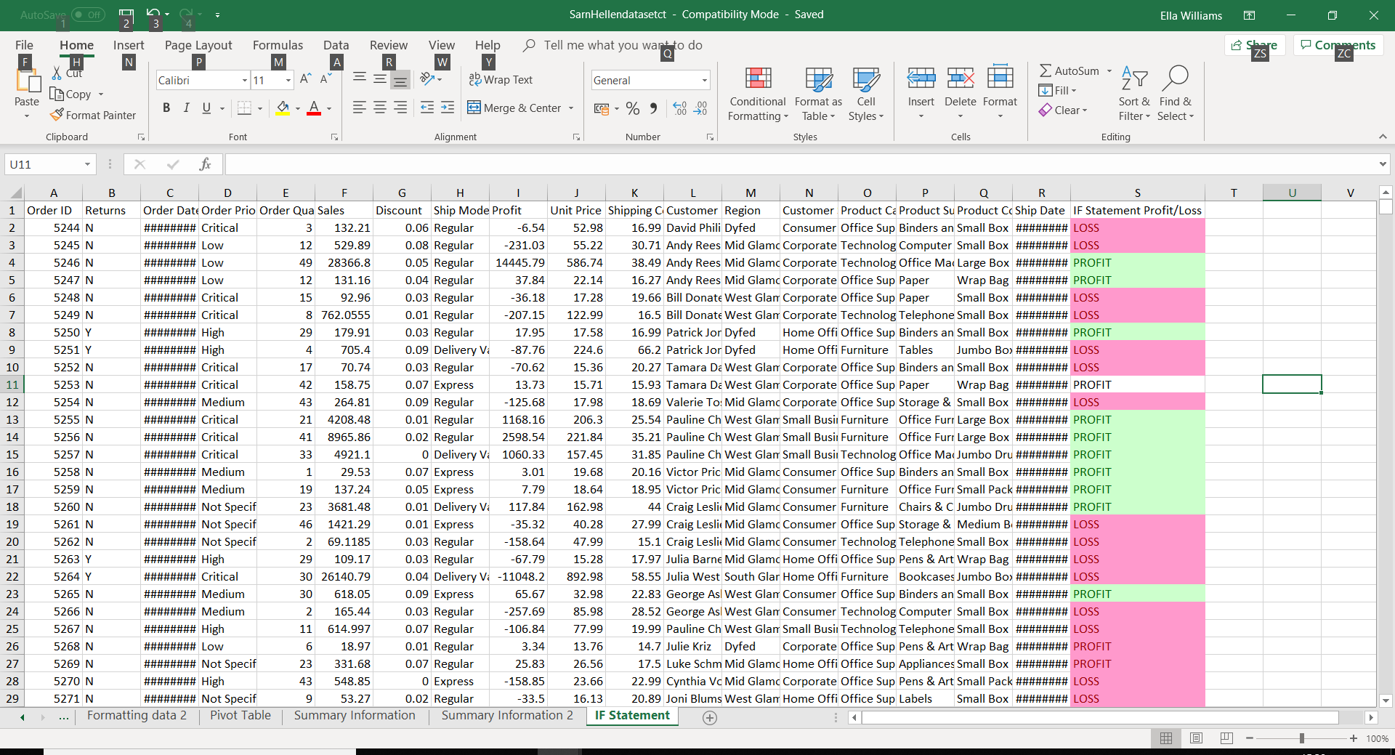
Figure 2.2.3: IF Statement
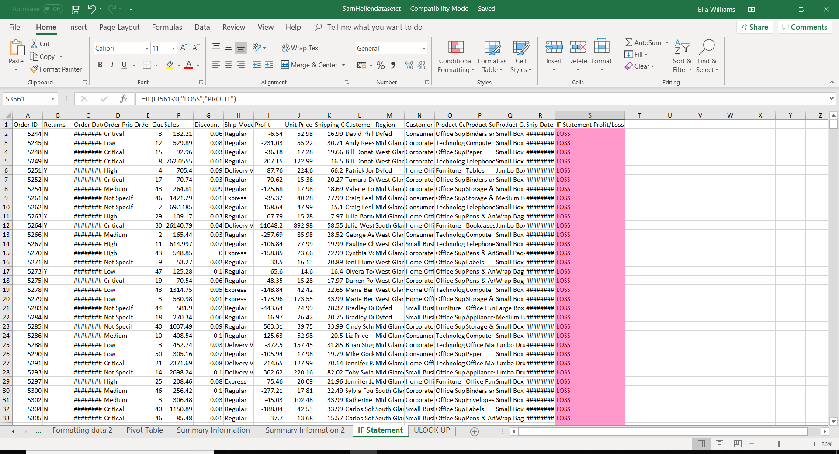
Figure 2.2.4: IF Statement 2

In Figure 2.2.4, you can see that the data has been put in groups, so all of the losses and profits have been grouped together. Using this method enables Sarn Helen to be able to see that there are 1,638 losses and 1,921 profits. However, although there are more profits that have been made the organisation need to act fast as there are only 283 profits between them.

  - Look Up
Figure 2.3.5 shows that there is 102 losses and 102 profits that were made. This shows the data was even. However, there should be more profits that should have been made for the organisation to be successful.
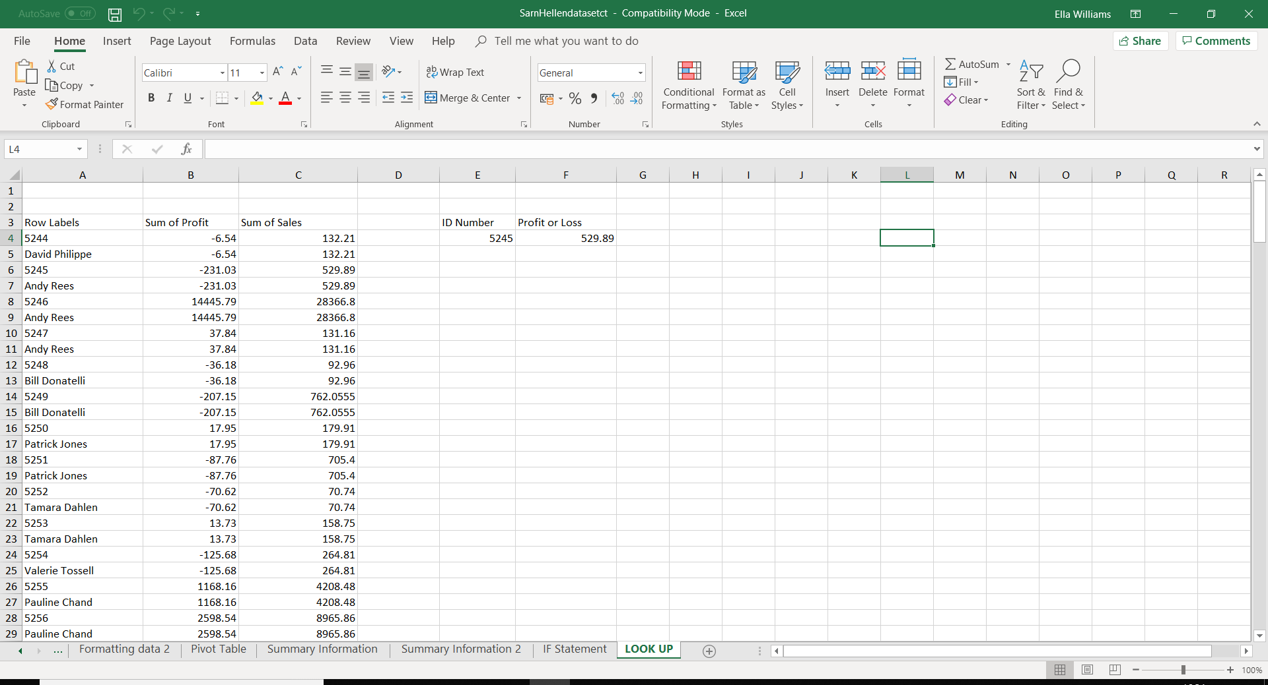
Figure 2.3.5: Look Up

  - Strengths and weaknesses of Excel
Microsoft Excel™ has so many strengths to the popular software. For an example, when using Excel you are able to organisation a large amount of data and put it into an ordered spreadsheet. When the data is put into a spreadsheet it is easy for people to read the data and analyse it. This would benefit Sarn Helen a lot as they are able to then see where they are making their profit and losses. The software also enables users to use formulas and equations with a click of a button. It is very simple and can compute just one formula on a large amount of data (Lemoine, 2019). Using formulas would help the organisation see their data better.
Although there are a lot of strengths there can be some weaknesses too. For example, Microsoft Excel™ is the traditional software in which organisations still use, however, it can be very time consuming manually entering their data into the Excel sheets (Lemoine, 2019). Now in the modern-days there are many data mining methods that organisations are able to use which are quick to use.

- Part 2
Within this section of the report it will show the data mining approaches that will be used to understand the data; prediction, association and clustering. The data will be used to critically evaluate whether it is helpful for Sarn Helen to use in the future.

  - Prediction, Association and Clustering Definition
In data mining, prediction is used to identify data from the description of a different related data values. This does not have to be related to events in the future, but the used variables are unidentified. Prediction is also known as Numeric Prediction and is a regression analysis. Prediction originates the relationship between something you know about and something you need to predict for future reference. Data mining prediction models can be used by marketing managers to predict an amount a particular customer will spend during a sale. This would then help sales in the future, as the sale amount can be planned accordingly (Marker, 2017). Forecasting is another word which is usually associated with prediction.
Predication would benefit Sarn Helen a lot the data would be able to predict the future and give the organisation a head start.
Association is another very popular data mining method which organisations are able to use to help analyse their data by finding frequent patterns and correlations. Association is known as the ‘market basket analysis as it finds interesting patterns that show why certain items are usually purchased together (Techopedia, 2019). For example, in the past data has shown how that nappies and beer has been purchased together as studies have shown that dads are always sent to do the shopping whilst the mums are looking after the baby (Swoyer, 2016). It is clear that this rule is a part of the machine learning family and it does not need supervised learning as it does it all by itself. Within the data there is no output variable.
This would benefit Sarn Helen as they would be able to predict and become aware of what their customers purchase together. This would be helpful as the organisation would know how to sell more items by promoting the products that sell well together together. This would increase their sales and profits.
Clustering is the grouping of a particular set of objects which can be based on their similar characteristics, helping to predict the future behaviour of a new product or service with similar characteristics. Clustering can also be known as segmentation. This data mining method is suitable for people who seek information analysis. Also, within clustering it can be used to identify natural groupings of things automatically and does not require supervised learning by employees as there is not an output variable. The method is also able to learn the clusters of things from past data and then allocates new instances (Big-Data-Made-Simple, 2015). Clustering is very useful to explore data as it identifies groupings of customers, provides characterisation and decreases the size of problems. This would benefit the organisation as they need a software which runs smoothly without any errors.

  - Prediction
When using the Sarn Helen data with Weka you can see that you are able to create a Linear Regression Model to show the profit. Figure 3.2.6 shows that the overall profit is 718,536.30, with an order quantity of -10,521.60, sales of 0.4068, unit price of -2,383.1, and a shipping cost of -27,137.8. This shows that although the organisation has a positive profit, there are a lot of negative numbers which they need to work on.

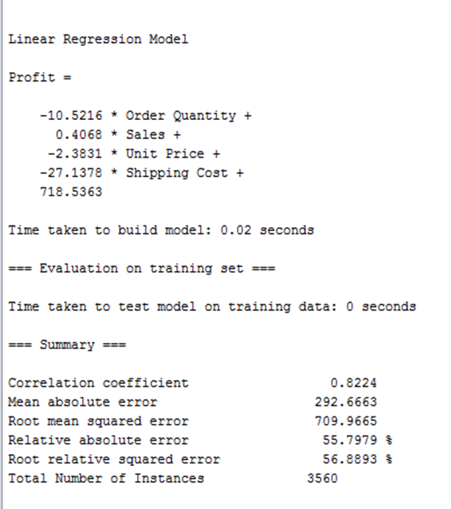
Figure 3.2.6: Linear Regression Model

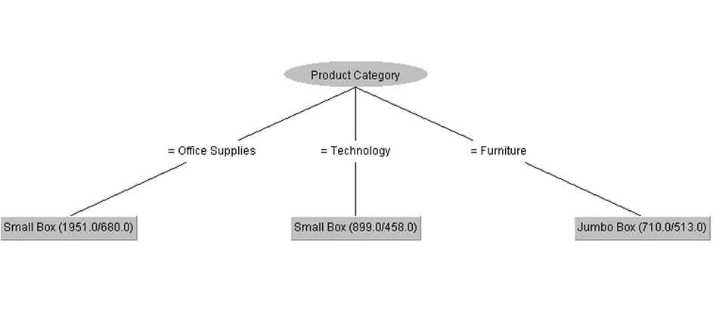
Figure 3.2.7: Decision Tree

In Figure 3.2.7, it shows that there are three product categories; Office Supplies, Technology, and Furniture. From the office supplies and technology is a ‘Small Box’ and from the furniture shows a ‘Jumbo Box’. This gives the organisation an idea of the product categories and the box sizes they need.

  - Association
Within the Association analysis of Sarn Helen you can see that there were 56 instances, 0.9 minimum metric’s and there were 18 cycles performed throughout this process. Also, Figure 3.3.8 shows that Group 2 generated the largest itemset with a total of 47, with Group 3 showing 26 and Group 1 with 16.
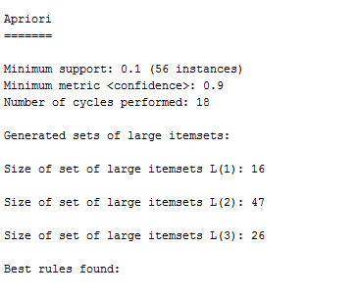
Figure 3.3.8: Association Diagram

  - Clustering
Figure 3.4.9 shows that there are five groups created within the output, so you can see similar data. This is helpful for Sarn Helen as the data uses different groups who purchase the same products, so it can be used for marketing purposes. As you can see Group 0 have purchased the most products with a grand total of 27. Group 4 was second with a grand total of 15.4167, Group 3 with 12.4, Group 1 had 11.0505, Full Data with 6.3685, and Group 2 with 4.1618. This shows how each of the groups purchased all of the products, some more than others which will give the organisation an idea of what customers like to buy together.

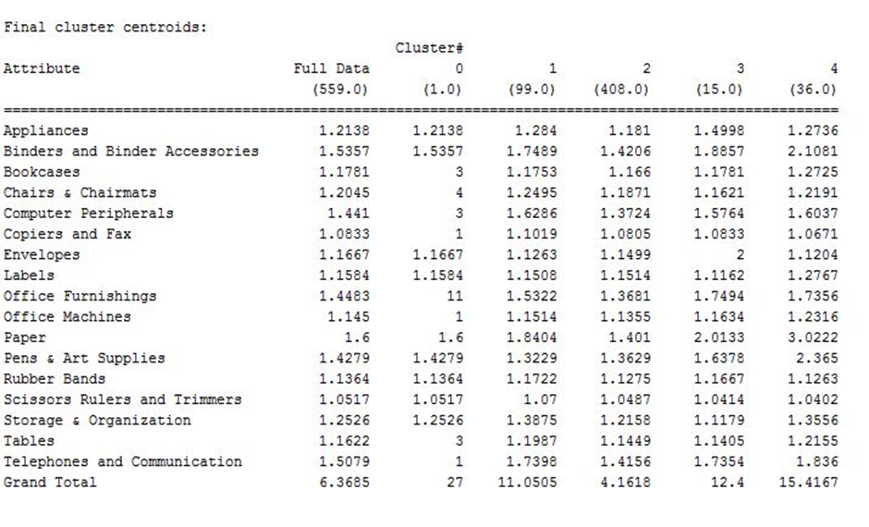
Figure 3.4.9: Sarn Helen Cluster

- Conclusion
To conclude, Microsoft Excel™ is a very useful software and has been around for years for organisations to be able to analyse and organise their data. However, it can be very time consuming which can cause a huge problem to the organisation. It has shown throughout this report that the new modern data mining methods have a huge impact on helping organisations manage and organise their data and predict their future. The screenshots have shown that although the Excel software helped analyse the data, Weka helped predict their future. This would help to solve their problem as they would be able to see where and why there are losses and be able to solve it before it is too late.

- Recommendations
To help Sarn Helen on how they can engage with analytics in the future to better inform their decision-making process, I would recommend the organisation to make changes.
I would recommend the organisation to stay up-to-date on the data mining software if they would like to continue being a successful business. Due to Microsoft Excel™ being a traditional software it can be very time consuming manually entering data into the Excel sheets. Instead of taking time on one task I would recommend the organisation to undertake data mining methods that organisations are able to use which are quick to use.

References

Big-Data-Made-Simple, 2015. What is Clustering in Data Mining?. [Online]
Available at: https://bigdata-madesimple.com/what-is-clustering-in-data-mining/
[Accessed 27 April 2019].
CFI, 2019. Microsoft Excel Definition. [Online]
Available at: https://corporatefinanceinstitute.com/resources/excel/study/excel-definition-overview/
[Accessed 22 April 2019].
Lemoine, J., 2019. Advantages & Disadvantages of Microsoft Excel. [Online]
Available at: https://www.techwalla.com/articles/advantages-disadvantages-of-microsoft-excel
[Accessed 29 April 2019].
Marker, A., 2017. What is prediction in data mining?. [Online]
Available at: https://www.quora.com/What-is-prediction-in-data-mining
[Accessed 25 April 2019].
MicroStartegy, 2019. Data Mining Explained. [Online]
Available at: https://www.microstrategy.com/us/resources/introductory-guides/data-mining-explained
[Accessed 28 April 2019].
SAS, 2019. Data Mining. [Online]
Available at: https://www.sas.com/en_us/insights/analytics/data-mining.html
[Accessed 21 April 2019].
Swoyer, S., 2016. Beer and Diapers: The Impossible Correlation. [Online]
Available at: https://tdwi.org/articles/2016/11/15/beer-and-diapers-impossible-correlation.aspx
[Accessed 26 April 2019].
Techopedia, 2019. What does Association Rule Mining mean?. [Online]
Available at: https://www.techopedia.com/definition/30306/association-rule-mining
[Accessed 26 April 2019].

