Problem Solving and Decision Making
Student Name: Rusu Catalin Nicolae
Student ID:212702
Module Code:4004
Module Title:– No Room for Grow
Lecturer Name: Diola Bijlhout

Table of Contents
Introduction 3
Complex Problem in a Workplace – Scope and Impact 4
Analysing the Identified Problem through the Problem-Solving Process 5
Range of Alternative Solutions to the Identified Problem 6
Communicating the Plan to the Stakeholders 8
Decision-Making Technique for Evaluating Various Solutions and Identifying the Most Appropriate One 8
Developing a Plan for Implementing the Solution 8
Appropriate Monitoring and Review Techniques for Successful Implementation of the Solution 9
Conclusion 11
Reference List 12

Introduction
Workplace problems are prevalent in most organisations in terms of issues in organisational culture, workforce management, employee satisfaction and productivity, and much more. These problems may hamper the process of career development of the employees and decrease their motivation level, thereby, negatively impacting the organisational growth. Therefore, it is essential to identify such problems and implement appropriate solutions with the help of a proper decision-making process (Cletus et al., 2018). The report aims to define a complex problem in a workplace and justify it with the help of decision-making techniques. Moreover, it will also include the implementation of solutions along with communicating them to the stakeholders. Lastly, it will focus on monitoring the implementation plan to ensure that the solutions are working successfully.

Complex Problem in a Workplace Scope and Impact
Workplace problems are a significant part of any organisation which does not allow employees and individuals to realise their true potential. One such major workplace problem is no room for growth. Growth is an essential part of an employee’s both personal as well as professional development. It acts as fuel for increasing the productivity of the employees and working effectively towards the organisational goals (Edmondson, 2018). Sometimes, organisations fail to provide their employees with such growth and career opportunities which slows down the progress of the latter, thereby, decreasing their satisfaction and productivity level.
The scope of this problem is large enough as it does not leave behind any area of the organisation. It extends from higher authorities to smaller departments without getting observed until the organisational performance starts getting affected as a whole. There is no scope for growth, especially for the employees who are not able to demand such opportunities due to the inability of understanding their true potential (Edmondson, 2018). The impact of this problem seems to be pretty worse for the profitability and reputation of the organisation. When employees are not given room for growth, it starts getting monotonous to work towards the set objectives due to decreased satisfaction levels. They may feel that their development is hampered in the current organisation and may easily switch to a new organisation for experiencing career growth opportunities, thereby, increasing the employee turnover rate. Therefore, organisations must sincerely work on this problem and ensure that employees are not deprived of growth opportunities in the workplace (Nwanaka, 2022).

Analysing the Identified Problem through the Problem-Solving Process
The workplace problem of no room for growth can be analysed and solved effectively with the help of a problem-solving process. The process consists of five stages which are as follows:
Identify the Problem:
The first stage includes the identification of the problem. Here, the problem is no scope for growth in the workplace. Organisations need to understand the depth and seriousness of this problem as it affects organisational performance and productivity in the long run (Decius et al., 2019).
Generating Various Solutions: The second stage includes brainstorming various solutions for addressing the workplace problem. The organisation will think about certain ways in which they can provide growth and development opportunities to the employees to enhance their satisfaction and productivity level.
Evaluating the Solutions:
In this stage, various chosen solutions will be evaluated for checking their effectiveness in resolving the problem. The organisation will scrutinise whether the solutions will lead to the growth of the employees or not. This stage will help in leaving behind ineffective solutions (Na-Nan and Sanamthong, 2019).
Implementation of a Specific Solution:
After the entire evaluation process, the organisation will pick one solution and move forward with it. It will try to choose the best possible solution which will increase the room for growth of the employees and reduce the employee turnover rate.
Reviewing the Results:
After the implementation of the solution, the organisation will continuously monitor its outcome. It will check whether the chosen solution can encourage the growth process of the employee or not. If this solution doesn’t work, then it will have to pick another one and review its results (Na-Nan and Sanamthong, 2019).

Range of Alternative Solutions to the Identified Problem
With every problem come a handful of solutions that can help in addressing them in a better and more effective manner. The organisation has to brainstorm and develop various solutions for minimising or eliminating the problem of no room for growth in the workplace (Kenny, 2019). A range of alternative solutions include:
Training and development programmes:
The organisation can establish training programmes for upgrading the professional skills and competencies of its employees. This will not only help in their personal and professional growth but also enable them to attract better career and growth opportunities in their future endeavours (Kenny, 2019).
Providing networking opportunities:
For providing growth opportunities, the organisation must conduct various networking events which will enable the employees to interact with the leading professionals. This will not only enhance their knowledge but also help them in analysing future opportunities and their true potential.
Assigning challenging tasks and responsibilities:
When an organisation provides its employees with challenging tasks, it pushes them to make extra efforts toward its accomplishment. This not only expands their knowledge but also helps them in developing additional skills and competencies, thereby, promoting their career growth (Atkinson et al., 2022).
Constructive feedback:
When employees are provided with constructive criticism, they tend to improve their style of working. Organisations need to provide their employees with regular feedback to improve their performance and professional growth, thereby, enhancing their motivation and level of productivity. The employees are also required to take this feedback positively for realising their full potential.

Decision-Making Technique for Evaluating Various Solutions and Identifying the Most Appropriate One
After deciding upon various solutions, it is crucial to evaluate the pros and cons of each which will help in selecting the most appropriate one. Therefore, to resolve the problem of no room for growth, the organisation will adopt the technique of cost-benefit analysis. The cost-benefit analysis will help in assessing the costs incurred in implementing the solution and the benefits received from it. It will assist in identifying the best solution with the most benefits and lowest cost for maximising profit and providing growth opportunities (Mishan and Quah, 2020).
For enhancing growth through training programmes, the organisation will have to hire a highly qualified team of professionals who can provide the employees with expert knowledge and skills. While conducting networking events, the employees will gain a lot of industry knowledge which will encourage their growth but the cost will be higher than the benefits. Assigning challenging tasks to the employees will involve no organisational cost but the former might get intimated by such tasks which will hinder their growth (Mishan and Quah, 2020). Lastly, the feedback mechanism is also a no-cost solution for encouraging growth. But if the employees do not consider the feedback positively, it will result in a situation of no benefits.
Therefore, the evaluation of the cost and benefits of all the solutions determines that the most appropriate solution is conducting training and development programmes for the growth of the employees. Its benefits will overcome the cost incurred as employees will start contributing more effectively towards the organisational objectives. This solution will provide mutual benefits to both the employees and the organisation (Ali and Mehreen, 2018).

Developing a Plan for Implementing the Solution
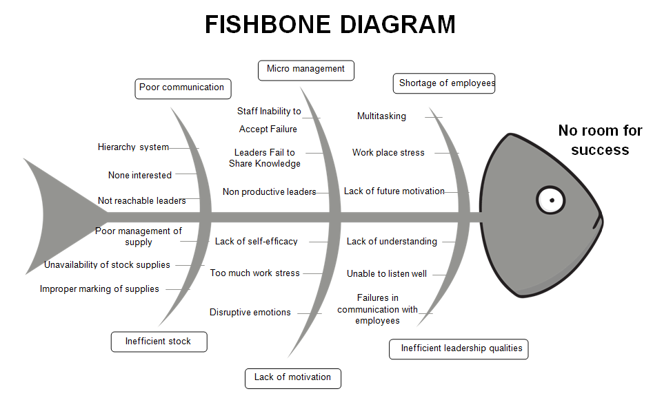
The organisation evaluated the possible solutions with the help of the decision-making technique of cost-benefit analysis and selected the most appropriate solution, i.e., training and development programmes. Training and development programmes enable employees to improve their professional skills which can be utilised in enhancing the overall productivity and success of the organisation (Fernandez et al., 2019). Therefore, it is essential to develop a plan for implementing the solution which will help the organisation in solving the problem of no room for growth.
The development plan will commence with assessing the needs and requirements of individual employees. Different employees belonging to different departments will have different growth requirements. Therefore, the organisation is required to analyse the needs accordingly. The next step will include creating an action plan by considering the budget, size of the employees' team which is to be trained, finalising the content of the training programme, resources required, hiring of professionals from different areas of specialisation, etc. (Fernandez et al., 2019). This will help the organisation in assessing the growth needs of employees in a better way. It will be followed by the delivery of the training and development session in which the focus will be on improving the skills and core competencies of the employees so that they can realise their growth potential and work effectively towards the organisational objectives. This will also make the employees realise that the organisation is not only concerned about their success but also the personal and professional growth of its employees. Lastly, the organisation will evaluate and monitor the success of the training programme. This will be ensured with the efforts made by the employees and their increased skills, knowledge, and capabilities (Numonjonov, 2020).

Communicating the Plan to the Stakeholders

After developing the implementation plan, it is essential to communicate it effectively to the important stakeholders of the organisation. Communicating the plan with these stakeholders will enable the organisation to receive constructive and critical feedback regarding any decisions that might affect them in the long run. A stakeholder communication plan is an important aspect of any organisation which helps it in connecting better with its crucial stakeholders and analysing whether the plan developed will reap benefits or not (Nguyen et al., 2018).
For communicating about the plan developed for conducting training and development programmes, the organisation will focus on the internal and external stakeholders who will be affected by these decisions. The most important stakeholders will be the employees for who the development plan has been initiated. The other important stakeholders will include the top management, department heads, managers, clients, training professionals, etc. (Coombs, 2021). The top management will be responsible for communicating the growth plan to the lower departments of the organisation. They may conduct conferences or meetings with specific departments for communicating the growth opportunities of the employees. The organisation may also choose to directly address the employees by telling them about the conduction of training programmes which will fuel the growth process of the employees. They can also consider communicating via emails or newsletters or even presentations highlighting the benefits of conducting training and development programmes (Coombs, 2021).

Appropriate Monitoring and Review Techniques for Successful Implementation of the Solution
The last stage of the process will be to monitor and review the progress for tracking the successful implementation of the solution. This will help in ensuring that the chosen solution has the potential of minimising or eliminating the problem of having no room for growth in the workplace. Moreover, it will also help the organisation in determining whether the chosen solution needs to be replaced with another solution or not (Rudman, 2020). This can be done with the help of certain monitoring and review techniques which are as follows:
Direct observation:
The seniors and department heads can observe the performance of the employees which will help them in knowing whether the latter have improved their skills and professional competencies or not. This observation technique will assist in determining the effects of the training programme on the growth of individual employees (Rudman, 2020).
Formal surveys:
The organisation can develop a formal questionnaire or a survey that will consist of questions related to the training and development programme. The employees will be required to answer those questions which will help the organisation in assessing the growth potential of the employees. It will also check whether the employees have inculcated appropriate skills through the programme or not.

Group discussions:
It is another useful technique for monitoring the growth of the employees. The organisation can conduct group discussion meetings in which the employees will be asked to provide feedback regarding the training programme. They will also be asked to explain the learnings developed and whether the programme supported their growth objectives or not (Narkunienė and Ulbinaitė, 2018).

Conclusion
It could be concluded that organisations need to focus equally on the growth of their employees while ensuring their success. The organisation considered the problem-solving process and decision-making technique of cost-benefit analysis for solving the problem of no room for growth. The most appropriate solution is to conduct training and development programmes along with reviewing its success constantly to ensure the growth of employees.

Reference List
Ali, Z. and Mehreen, A. (2018). Understanding succession planning as a combating strategy for turnover intentions. Journal of Advances in Management Research.
Atkinson, A., Watling, C.J. and Brand, P.L. (2022). Feedback and coaching. European journal of pediatrics, 181(2), pp.441-446.
Cletus, H.E., Mahmood, N.A., Umar, A. and Ibrahim, A.D. (2018). Prospects and challenges of workplace diversity in modern day organizations: A critical review. HOLISTICA–Journal of Business and Public Administration, 9(2), pp.35-52.
Coombs, W.T. (2021). Ongoing crisis communication: Planning, managing, and responding. Sage Publications.
Decius, J., Schaper, N. and Seifert, A. (2019). Informal workplace learning: Development and validation of a measure. Human Resource Development Quarterly, 30(4), pp.495-535.
Edmondson, A.C. (2018). The fearless organization: Creating psychological safety in the workplace for learning, innovation, and growth. John Wiley & Sons.
Fernandez, M.E., Ten Hoor, G.A., Van Lieshout, S., Rodriguez, S.A., Beidas, R.S., Parcel, G., Ruiter, R.A., Markham, C.M. and Kok, G. (2019). Implementation mapping: using intervention mapping to develop implementation strategies. Frontiers in public health, 7, p.158.
Kenny S, V. (2019). Employee productivity and organizational performance: A theoretical perspective.
Mishan, E.J. and Quah, E. (2020). Cost-benefit analysis. Routledge.
Na-Nan, K. and Sanamthong, E. (2019). Self-efficacy and employee job performance: Mediating effects of perceived workplace support, motivation to transfer and transfer of training. International Journal of Quality & Reliability Management.
Narkunienė, J. and Ulbinaitė, A., 2018. Comparative analysis of company performance evaluation methods. Entrepreneurship and sustainability issues, 6(1), pp.125-138.
Nguyen, T.S., Mohamed, S. and Panuwatwanich, K. (2018). Stakeholder Management in Complex Project: Review of Contemporary Literature. Journal of Engineering, Project & Production Management, 8(2).
Numonjonov, S.D. (2020). Innovative methods of professional training. ISJ Theoretical & Applied Science, 1(81), pp.747-750.
Nwanaka, C. (2022). FIRM SIZE AND PERFORMANCE OF ORGANISATION. BW Academic Journal, pp.6-6.
Rudman, R. (2020). Performance planning and review: Making employee appraisals work. Routledge.

