Draft Chapter 1 and 2

Barriers to accessing Mental Health Services among young adults in the UK

Student ID: 2313058

Student Name: Razia khan

CHAPTER 1: Introduction
1.1 Introduction
The issue of mental health is a significant challenge to the overall public health in the United Kingdom in young adults. Recent data suggest that approximately 1 in 5 people between the age of 8 to 25 years have a likely mental disorder and it is higher than 21 % in a specific age group of 20-25 years (Albadi et al., 2025). This is an important growth compared to the past years, which is influenced by the growing awareness and by the deteriorated conditions. Also, over 3.8 million individuals were receiving mental health services in 2023-24, and the need is on the rise. Nevertheless, the access is not even and adequate (Andersen, 1995).
The National Health Service is experiencing mounting pressure because of increment in referrals, shortage of work forces and funding limitations. The number of referrals has grown by about 38 % since 2019, whereas the service capacity has not improved by a similar percentage (Benoni et al., 2025). Consequently, there have been delays in timely interventions due to long waiting time.
In conjunction with structural issues, social and individual barriers, including stigma and low mental health literacy levels and complicated referral pathways also restrict access. Therefore, a number of young adults are only assisted at the crisis level.
This dissertation critically analyses these obstacles to determine areas within the system that have gaps and enhance a fair access to mental health care.
1.2 Definitions and Terminology
Mental health can be described as a condition of emotional, psychological and social wellbeing that determines the way people think, feel, and act. It is a dynamic state that is influenced by biological, social and environmental factors. In this dissertation, young adults are defined as those who are between the ages of 16 and 25 as this is the critical stage in life where one develops mental illnesses at an approximated rate of 75 % (Birgel et al., 2025).
Mental medical services cover a wide range of support systems such as psychological therapies, psychiatric interventions and community based services. These are majorly provided in the UK under the National Health Service with the assistance of voluntary and private services (BMA, 2025). Access to these services is not only based on the availability but also on the timely, suitable and fair utilisation.
Barriers to access is a term which is used to refer to any factor that slows, cripples or prevents individuals to access mental health support. Such obstacles are normally classified into:
- Organizational obstacles (e.g., waiting time, workforce shortages)
- Social (e.g., stigma, cultural perceptions) barriers.
- Personal barriers (e.g. lack of awareness or perceived requirement).
There are a number of acronyms applicable to this study. NHS can be defined as the healthcare system in the United Kingdom that is funded by the state. The Child and Adolescent Mental Health Services (CAMHS) are the services that support the needs of those who are below the age of 18 and are usually accused of having extensive waiting lines and a small number of capacities (CQC, 2024). IAPT (Improving Access to Psychological Therapies) is a national initiative aimed at improving the access to evidence-based therapy of common mental health disorders. As far as access challenges are to be analysed, it is necessary to understand such systems.
1.3 Rationale for Research
This paper is based on the reasoning that there is an increasing discrepancy between the rising numbers of mental health concern and the inaccessibility of mental health services among young adults in the UK. Even though prevalence has been increasing, access to timely care has not been improving correspondingly. According to recent findings more than 78,000 youths have been waiting more than one year of treatment with more than 2000 waiting more than two years (Department of Health and Social Care, 2023). Also, approximately 40 % have excessive waiting periods, and one per three waits more than three months to receive some first support (Lazzarino et al., 2024). Such delays are symptomatic of systemic failures and not individual inefficiencies.
These barriers have a great effect. Approximately half of the youth reports that their mental health is getting worse when they are awaiting care, which indicates the dangers of untimely intervention. Moreover, people are much more apt to experience extended queues to seek mental health care than to receive treatment pertaining to physical health, which proves the evident structural inequalities.
Current studies have been mostly prevalence based and not analytical towards the barriers to access which creates a fragmented view of the problem. This paper fills this gap by combining structural, social and behavioural approaches.
This research is timely and relevant as it has played a crucial role in improving access, which will help in reducing inequalities, early intervention, and the long-term costs to the society.
1.4 Aim and Objectives
Research Aim:
This research study intends to critically analyze the obstacles that impede access to mental health services among young adults in the United Kingdom with respect to structural, social as well as individual determinants with the aim of establishing gaps in service delivery and inform new interventions in both health and social care systems.
Research Objectives:
- Objective 1: To form a critical analysis of mental health needs among young adults in the UK and service utilisation patterns among this group.
- Objective 2: To identify the main obstacles to the access of mental health services, such as stigma, long waiting periods, access to services, and socioeconomic disparities.
- Objective 3: To review existing mental health policies and models of service delivery in the National Health Service.
- Objective 4: To offer evidence-based suggestions to enhance access, engagement, and equity when it comes to mental health services in young adults.
1.5 Conclusion
The chapter has presented a critical introduction of the problem of access to mental health services among the young adults in the UK with the support of the current statistical evidence and policy context. It has established that against the backdrop of a growing demand and awareness, major challenges still limit access to care. The most important definitions and concepts have been made clear to have a solid base on the study, and the rationale has pinpointed weaknesses in the current research. The research aims and objectives provide a proper direction to the dissertation as they focus on the necessity of an extensive and evidence-based analysis.
In chapter 2, the basis will be enlarged through carrying out a critical literature review on the available literature, theoretical frameworks, empirical studies and policy developments on mental health service access. This will allow further consideration of the identified obstacles and facilitate the general argument of the research.

CHAPTER 2 – Background Information and Analysis
2.1 Introduction
This chapter gives the conceptual and contextual framework of the barriers to access to mental health services among the young adults in the UK. It places the research in the context of larger historical, theoretical, international and national concerns where one can fully understand how the access problems of the current situation have developed (Macdonald and Lucas, 2025).
This chapter starts with an historical discussion of the development of mental health services in the past, which represents some of the major policy and structural transformations that have influenced access. It goes on to review pertinent theoretical frameworks, such as behavioural and health service utilisation models that describe the help seeking behaviour (NHS, 2024). After that, the scope of discussion is widened to that of the whole world, where the author compares the approaches taken by various nations to curb the challenges of mental health access. Lastly, the chapter lays emphasis on the UK scenario, critically examining the policies, structures of services and pressure under the system.
This multi-level analysis is critical in proving that mental health access barriers are not single phenomena but deep-rooted in historical systems and theoretical frameworks and policy-makers.
2.2 Historical Background
The evolution of mental health services in the UK has experienced a massive change in the last century. Mental health care has been historically an institutionalised process and people were treated in large psychiatric hospitals. But after the middle of the 20th century, a movement towards community-based care has taken place, as deinstitutionalisation policies and the shift in societal attitudes towards mental illness have influenced it.
One of the most significant developments was the concept of community care model that was introduced in the 1980s-1990s and was meant to take mental health services to the community (NHS Digital, 2023). Although such practice enhanced accessibility in theory, it resulted in disjointed delivery of services because resources were not always adequate to assist community-based care.
More policy changes in the 2000s sought to make services more accessible by introducing programmes like IAPT (Improving Access to Psychological Therapies) to expand the range of psychological therapies. Nonetheless, structural issues have remained even with these developments. As an example, the services are in high demand, and it is documented that since 2019, mental health referrals have become stronger than they were before, which puts significant pressure on the available systems (Oha et al., 2025).
Less historical evidence but much more recent points to persistent challenges in the system. The mental health services have been reported to be under-resource and fragmented especially among the youth, causing the gaps in continuity of care. Also, the child to adult service transition is a serious weak area which on most occasions causes the youth to lose touch of care in the service transition phase.
Another central problem of the history that has still narrowed the access barriers is the unceasing gap between the demand and capacity of the services. The waiting time is now being a core characteristic of the system, as the research shows that one of the most reported obstacles is a long waitlist throughout the UK and Europe (Perowne et al., 2025). This implies that structural inefficiencies are endemic even after decades of reforms.
The historical development of mental health services shows that even though accessibility and community-based care have become a focus of the policy, gaps in its implementation and a lack of resources have always prevented successful access, especially in the case of young adults.
2.3 Theoretical Background
The barriers to accessing mental health services among young adults need to be understood with the application of the established theoretical frameworks that explain the health behaviour and service utilisation. The most powerful model is the Health Belief Model (HBM), which has been designed by Irwin M. Rosenstock (Rosenstock, 1974) . According to this model, the more people believe that their mental state is severer and that treatment will help them, the more likely they are to seek help, as well as the less they feel there are obstacles they face on their way to accessing help. Nonetheless, stigma, fear of judgement and perceived need are some of the factors which tend to mitigate the help-seeking behaviour amongst young adults.
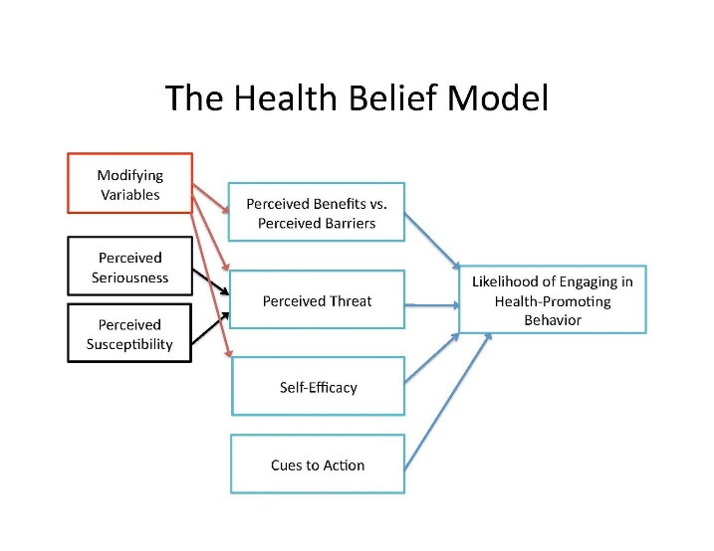
Figure 1: The Health Belief Model (Source: PennState)

The other framework is the Andersen Behavioural Model of Health Service Use, which was suggested by Ronald M. Andersen (Andersen, 1995). This model divides the access into predisposing factors (e.g., beliefs and attitudes), enabling factors (e.g., income, availability of services), and need factors (e.g., severity of symptoms). It offers a more in-depth view of access through the identification of personal and structural factors. This model has been broadly used in research that has shown that barriers are not purely psychological but also systemic due to issues like long waiting lines and low service capacity (Rethink Mental Illness, 2025).
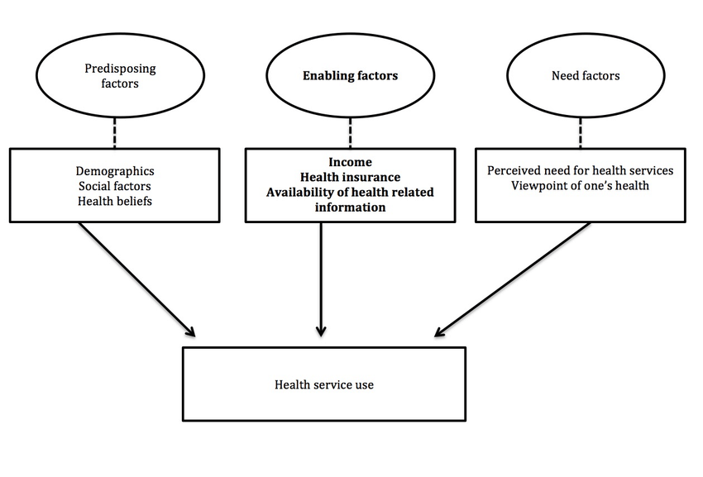
Figure 2: Andersen behavioral model of health services use. (Source: ResearchGate)
Moreover, Social Ecological Theory provides a multi-level approach because it focuses on the creation of a multi-level approach by which individual behaviour is impacted by interpersonal, community and societal factors. This especially applies the area of mental health where family attitudes, cultural norms and healthcare systems all interact to influence help-seeking behaviour.
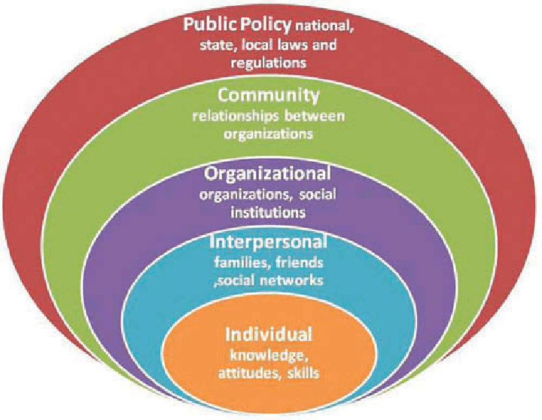
Figure 3: Social Ecological Theory (Source: ResearchGate)
These theories have been widely used in the past studies. Indicatively, research in the HBM has revealed that stigma and perceived barriers are critical determinants that decrease chances of seeking mental health support. On the same note, the studies conducted on the basis of the Andersen model have established the socioeconomic status and access to services as key determinants of access (Royal College of Psychiatrists, 2019). Social Ecological theories have also shown that wider social environments such as education systems and community support have a role to play in mental health outcomes.
Nevertheless, these structures also are limited. HBM has been attacked on grounds that it emphasizes much on individual decision-making, and leaves out broader structural limitations. The Andersen model, more complex, can simplify and ignore complicated social inequalities and cannot adequately address cultural effects. The Social Ecological Theory is holistic and may not be easily operationalised in empirical studies as it is broad.
Although these theories offer useful understanding regarding access to mental health services, it has been highly debated that there is a need to integrate frameworks that cut across behavioural, structural and social levels to give a better picture of the situation on access barriers among young adults.
2.4 International Context
It is a well-established global concern that access to mental health services among the youth is an urgent social health concern, with most countries being faced with similar challenges linked to service capacity, stigma, and inequality. Although the awareness level grows, the high %age of the youth in both high- and low-income environments continues to be incapable of accessing accessible, proper, and timely care.
High-income countries (Australia and Canada, in particular) have actively changed the policy in favour of early intervention and integrated care models. Programs like youth mental health hubs (e.g., Headspace in Australia) offer multidisciplinary, community-based services, which are psychological services in combination with social care and digital access (Young Minds, 2025). These models are designed to minimize the barriers through providing youth-friendly environments that are accessible. There has been an indication that this type of practice can enhance the interaction and minimize the use of crisis services, which underscores the essence of preventive care.
Conversely, the situation is worse in low and middle-income nations where there are challenges such as insufficient funding, inadequate supply of workforce and infrastructures. Mental health services are also concentrated in urban areas in most areas, posing a great geographical disparity. These barriers are also complicated by cultural stigma and lack of knowledge that restricts help-seeking behaviour. It proves that the access strongly depends on socioeconomic and cultural contexts and needs to be approached as a context-specific issue.
One of the most significant worldwide tendencies is the growth of digital mental health services, such as online counselling and mobile apps. Although these innovations can remove geographical restrictions and achieve the increase of scale, they are not equally effective. Their impact can be restricted by such problems as low user engagement, digital exclusion, and privacy concerns especially affecting disadvantaged groups.
In comparison, whereas in certain countries, there has been successful implementation of integrated and preventive systems, there are other countries in which the care is provided on a crisis-driven basis. The UK lies in the intermediate position as they have good policy frameworks, however, suffer with implementation and service provision problems. In general, the global evidence points out the fact that despite the global barriers, innovative, integrated solutions can provide useful lessons on enhancing the access in the UK.
2.5 National/Local UK Context
Mental health services in the UK are mainly provided by the National Health Service that is assisted by voluntary organisations and an expanding private sector. Although it is publicly funded and is based on the principle of universal access, the system has been struggling to cope with the challenges of capacity, workforce shortage, and increasing demand. References to mental health services have dramatically increased in the last few years, which puts strain on already stretched resources.
Waiting times is one of the most serious problems. The results are always indicative that a long delay in obtaining care may aggravate mental health outcomes. An example is that of approximately 71 out of every 100 people waiting more than six months report that their conditions have deteriorated, and some surveys indicate that 80 out of 100 people experience increasing symptoms during delays (Zhu, Wang and Hu, 2024). These delays shatter all the early intervention strategies and most of the time an individual finds themselves in the more intensive or crisis-based support. This is an indicator of an imbalance in the demand and supply of services on a systemic level.
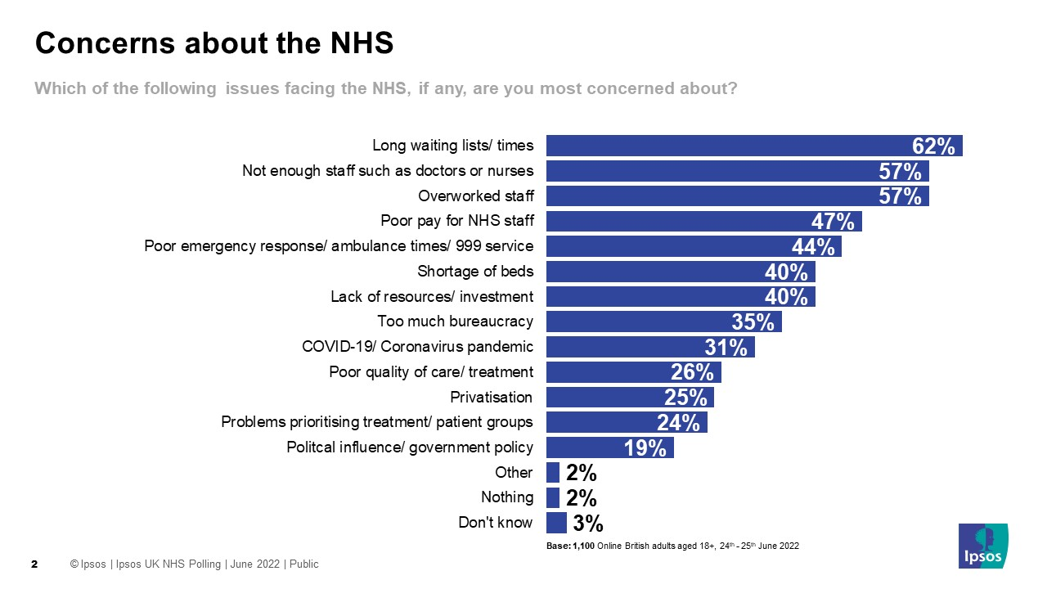
Figure 4: Long waiting lists/times seen as biggest issue facing the NHS (Source: Ipsos)
Disparities in access are a significant issue. It has been shown that the socioeconomic status, ethnicity, and geographic location affect access to services, with disadvantaged populations having more barriers. Lower-income populations can face the problem of lacking access to the options of the privatized sphere, whereas ethnic minorities face such issues as cultural stigma, language obstacles, and diminished confidence in the healthcare services. Such inequities lead to unequal health outcomes and reflect structural inequities of service delivery.
The UK government has made a number of access enhancement initiatives, such as increased funding, workforce development, and programmes like Improving Access to Psychological Therapies (IAPT) (Royal College of Psychiatrists, 2019). However, as much as it has done, there has still been an outrun between demand and supply. According to reports by organisations like the British Medical Association, mental health services are still under great pressure, and the policy interventions are not as effective as they would have been.
Services are also provided differently at the local level, which creates an unusual scenario of a postcode lottery in access to care. Funding, staffing, and service integration are better in some regions, and severe shortage and increased waiting time are experienced in others. On the whole, although the UK has achieved some advances in the area of considering mental health a priority, systemic pressures, regional inequalities, and enduring inequalities still limit the equitable accessibility, especially among young adults.
2.6 Conclusion
This chapter has offered a thorough discussion of the background information of mental health service access among the young adults. It has revealed that the existing issues are deep-rooted in the course of history, theoretical approaches, and international trends, as well as domestic policies.
The case study of the past revealed the same structural problems especially the lack of balance between demand and service capacity. Theoretical frameworks gave an understanding of the complex interplay of individual, social as well as systemic factors contributing to access. The global outlook revealed that the impediments are international but new solutions may be useful. Lastly, the UK setting identified serious issues associated with waiting time, inequalities, and implementation of policies.

References

Albadi, M.S. et al. (2025) ‘Barriers and Predictors of Seeking Mental Health Care Among Adults in Oman, 2023: A Cross-Sectional Study’, Journal of the Oman Medical Association, 2(2), p. 15. Available at: https://doi.org/10.3390/joma2020015.
Andersen, R.M. (1995) ‘Revisiting the behavioral model and access to medical care: does it matter?’, Journal of Health and Social Behavior, 36(1), pp. 1–10.
Benoni, R. et al. (2025) ‘Barriers and facilitators to accessing mental health services among young people living with HIV and healthcare professionals in Mozambique: a content and sentiment analysis using the capability, opportunity, motivation and behaviour (COM-B) framework’, BMC Public Health, 25(1). Available at: https://doi.org/10.1186/s12889-025-22695-3.
Birgel, V. et al. (2025) ‘Barriers to accessing psychotherapeutic care among young adults: Individual and regional associated factors’, Journal of Health Monitoring, 10(4), p. e13549. Available at: https://doi.org/10.25646/13549.
BMA (2025) Mental health pressures data analysis, The British Medical Association. Available at: https://www.bma.org.uk/advice-and-support/nhs-delivery-and-workforce/pressures/mental-health-pressures-data-analysis.
CQC (2024) The state of health care and adult social care in England 2024/25 - Care Quality Commission, Cqc.org.uk. Available at: https://www.cqc.org.uk/publications/major-report/state-care/2024-2025.
Department of Health and Social Care (2023) Major Conditions strategy: Case for Change and Our Strategic Framework, GOV.UK. Available at: https://www.gov.uk/government/publications/major-conditions-strategy-case-for-change-and-our-strategic-framework/major-conditions-strategy-case-for-change-and-our-strategic-framework--2.
Lazzarino, A.I. et al. (2024) ‘Inequalities in mental health service utilisation by children and young people: a population survey using linked electronic health records from Northwest London, UK’, J Epidemiol Community Health, 78(3), pp. 191–198. Available at: https://doi.org/10.1136/jech-2023-221223.
Macdonald, G. and Lucas, P.J. (2025) ‘The barriers and facilitators to help-seeking: What young people in the UK Say: A systematic review’, The British Journal of Social Work [Preprint]. Available at: https://doi.org/10.1093/bjsw/bcaf278.
NHS (2024) NHS England» England’s NHS mental health services treat record 3.8 million people last year, England.nhs.uk. Available at: https://www.england.nhs.uk/2024/10/englands-nhs-mental-health-services-treat-record-3-8-million-people-last-year/.
NHS Digital (2023) Mental health of children and young people in england, 2023 - wave 4 follow up to the 2017 survey, NHS Digital. NHS England. Available at: https://digital.nhs.uk/data-and-information/publications/statistical/mental-health-of-children-and-young-people-in-england/2023-wave-4-follow-up.
Oha, J.T. et al. (2025) ‘Gaps and opportunities in mental health support for young people: a process evaluation of a multi component intervention’, Frontiers in Public Health, 13. Available at: https://doi.org/10.3389/fpubh.2025.1684562.
Perowne, R. et al. (2025) ‘Barriers and Facilitators to The Involvement of Under-Represented Children and Young People (aged 8–25) in Mental Health Research – a Systematic Review’, Clinical Child and Family Psychology Review [Preprint]. Available at: https://doi.org/10.1007/s10567-025-00544-4.
Rethink Mental Illness (2025) New Analysis of NHS Data on Mental Health Waiting Times, New analysis of NHS data on mental health waiting times. Available at: https://www.rethink.org/news-and-stories/media-centre/2025/02/new-analysis-of-nhs-data-on-mental-health-waiting-times.
Rosenstock, I.M. (1974) ‘Historical Origins of the Health Belief Model’, Health Education Monographs, 2(4), pp. 328–335. Available at: https://doi.org/10.1177/109019817400200403.
Royal College of Psychiatrists (2019) Young people’s mental health, RC PSYCH ROYAL COLLEGE OF PSYCHIATRISTS. Available at: https://www.rcpsych.ac.uk/mental-health/parents-and-young-people.
Young Minds (2025) Mental Health Statistics UK | Young People, Young Minds. Available at: https://www.youngminds.org.uk/about-us/media-centre/mental-health-statistics/.
Zhu, S., Wang, Y. and Hu, Y. (2024) ‘Facilitators and Barriers to Digital Mental Health Interventions for Depression, Anxiety and Stress in Adolescents and Young Adults: A Scoping Review (Preprint)’, Journal of Medical Internet Research [Preprint]. Available at: https://doi.org/10.2196/62870.

