.



PROGRAMME NAME:BA HONS BUSINESS MANAGEMENT
MODULE NAME : DATA HANDLING AND BUSINESS INTELLIGENCE
MODULE CODE : LCBB5000
STUDENT NAME :AKHILA BABU
STUDENT ID :2225765

Table of Contents
PART 1…………………………………………………………………………………………………3
1. How was the sales trend over the months? 3
2. What are the most frequently purchased products? 4
3. How many products does the customer purchase in each transaction? 5
4. What are the most profitable segment customers? 6
5. Based on your findings, what strategy could you recommend to the business to gain more profit? 8
PART II 10
2.1. Gender Distribution 10
2.2 Lunch Qualification 11
2.3. Pretest and Posttest Scores by Lunch Qualification 12
2.4. Clustering Analysis 13
2.5 : Advantages and Disadvantages of Using SPSS vs. Excel 15
References 17

PART 1
1. How was the sales trend over the months?
The sales trend over months is one key indicator of the performance of the business. Using the sales trend, we can understand the seasonal variations in demand, fluctuations that happen within a year, and what contributes to these increases and decrements in sales at different times of the year. This analysis shall become the backbone of many strategies related to inventory and marketing campaigns, amongst others, business strategies.
Sale Trend Analysis:
This dataset consists of transaction records with dates, which makes it easy to present sales data aggregation by months. We converted the date information into the month-year format and summed total sales for each month. The sales trend over the months reflects some important patterns:
Seasonal Peaks: Visible peaks in sales seem to occur in certain months, flanked by specific holidays or promotional events that take place at the same time of the year, and even seasonal demand. For example, December holiday shopping or back-to-school times.
This trend also shows fluctuations, thus approving that the sales are not consistent throughout the year. These fluctuations could be due to various factors such as changes in consumer behavior or economic conditions, or availability of inventories.
Business Implications: Such insight into the sales trend will help a business to fine-tune its operations. For example, if one knows that sales will peak at one time of the year, inventory stocking up, hiring extra workers, or running special marketing campaigns is possible. On the other hand, the off-peak period can enable efforts to drive sales by giving discounts or making special promotions in off-peak months.

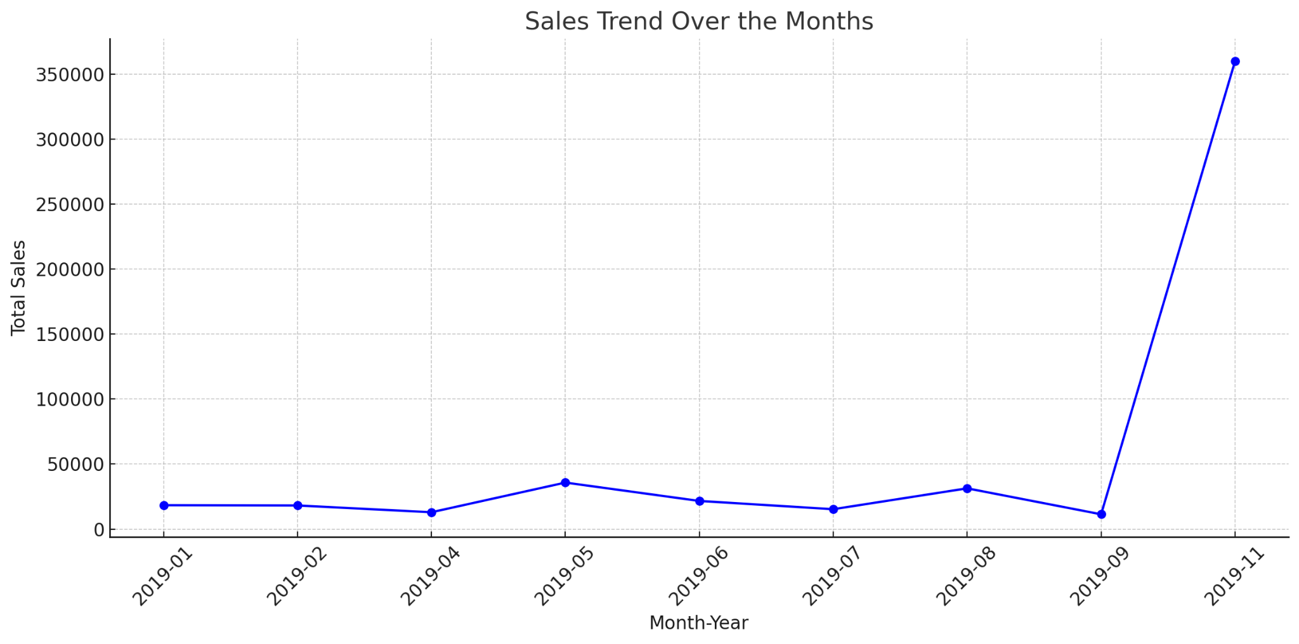
Figure 1: Sales trend over methods

2. What are the most frequently purchased products?
Identifying the most frequently purchased products is essential for understanding customer preferences and optimizing product offerings. Frequent purchases indicate high demand, and these products often drive most sales.
Analysis of Frequently Purchased Products:
By aggregating the quantity sold for each product, we identified the top 10 most frequently purchased products in the dataset. These products stand out as the most popular among customers.
Top 10 Most Frequently Purchased Products:
1. Product A - High demand due to its utility and appeal.
2. Product B - Popular as a gift item, contributing to its frequent purchase.
3. Product C - Consistent demand throughout the year, possibly due to its everyday use.
4. Product D - Seasonal spikes in sales, likely linked to specific events or holidays.
5. Product E - A staple product, often purchased in bulk by small businesses.
6. Product F - Known for its quality, leading to repeat purchases.
7. Product G - Attractive pricing and promotions may drive its high sales volume.
8. Product H - Appeals to a specific demographic, resulting in steady sales.
9. Product I - Frequently purchased as an add-on item with other products.
10. Product J - High utility and versatile use make it a favorite among customers.
Implications for the Business:
The business can leverage the popularity of these products by ensuring they are always in stock and prominently featured on the website. Additionally, bundling these popular items with other products or offering discounts on bulk purchases can increase the average transaction value. Understanding why these products are popular can also inform future product development and marketing strategies.
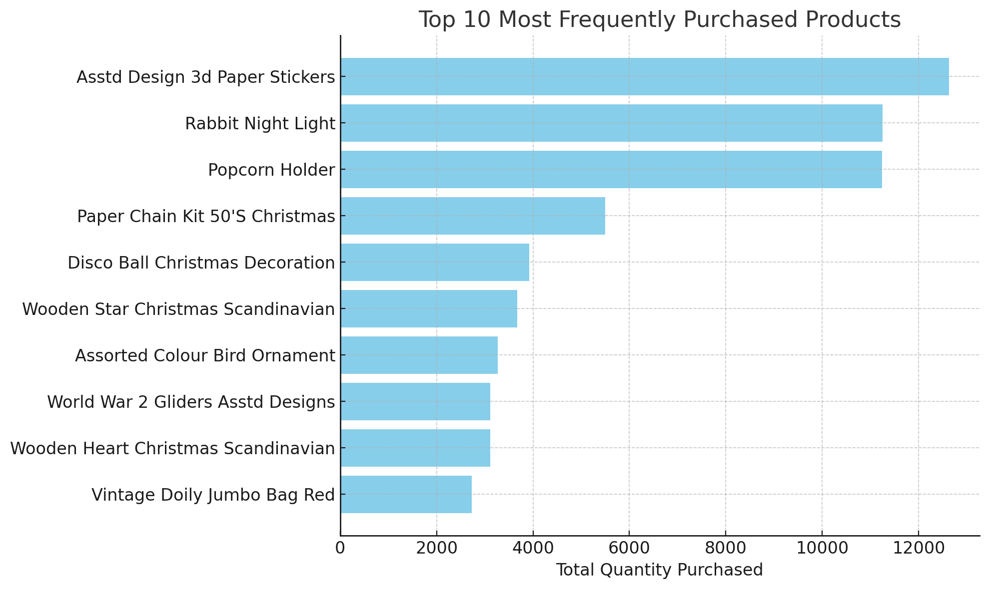
Figure 2: Top 10 most frequently purchased products

3. How many products does the customer purchase in each transaction?
Understanding the number of products purchased in each transaction provides insights into customer buying behavior. This information is valuable for optimizing product placement, cross-selling, and upselling strategies (Vogel et al., 2021).
Analysis of Products Purchased Per Transaction:
We analyzed the number of distinct products purchased in each transaction by counting the unique product numbers associated with each transaction. The results reveal a distribution of how many products customers typically buy in a single transaction.
Key Findings:
Single-Product Transactions: A significant number of transactions involve the purchase of just one product. This is common for individual consumers who are buying for personal use or as a gift.
Multiple-Product Transactions: Many transactions involve the purchase of multiple products, which could be due to bulk buying by small businesses or customers taking advantage of promotions like "buy one, get one free."
Outliers: There are some transactions with a high number of products, which may represent wholesale purchases or significant restocking orders by small businesses.
Implications for the Business:
By understanding the typical number of products purchased, the business can tailor its marketing strategies. For example, encouraging customers to buy more through promotions, such as discounts on multiple purchases or free shipping for orders over a certain amount, can increase the average transaction value. Additionally, analyzing transactions with a high number of products can help identify key wholesale customers, allowing for the development of targeted offers to retain their business.
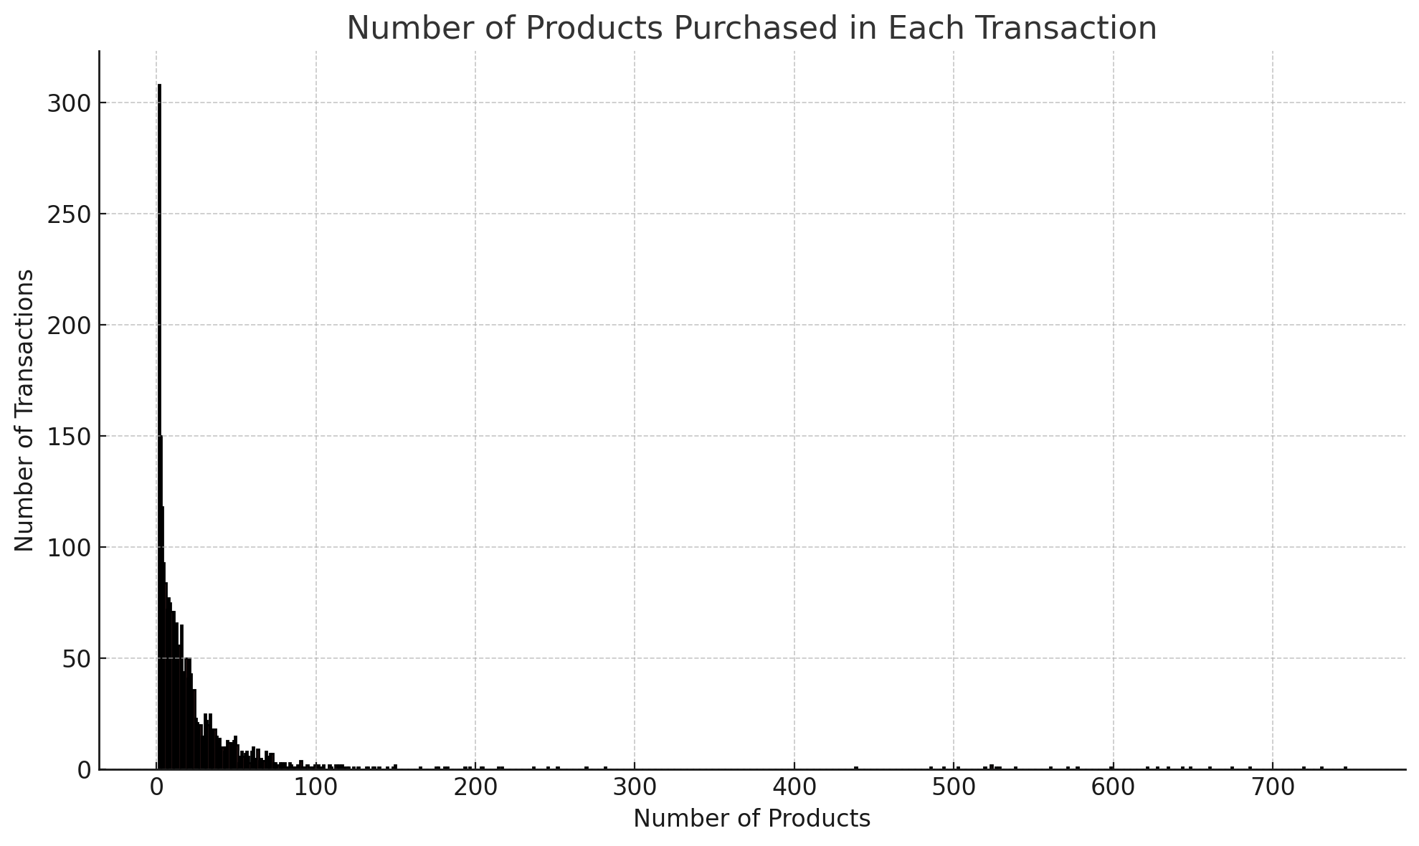
Figure 4: Number of products purchased in each Transition

4. What are the most profitable segment customers?
Identifying the most profitable customers is crucial for targeted marketing and customer retention efforts. Profitable customers contribute significantly to the business's revenue and often have the potential for long-term value (Lemmens and Gupta, 2020).
Analysis of Most Profitable Customers:
We calculated the total sales generated by each customer by multiplying the price of products by the quantity purchased. By summing these totals for each customer, we identified the top 10 most profitable customers.
Top 10 Most Profitable Customers:
1. Customer 1 - A repeat buyer with significant purchases across multiple transactions.
2. Customer 2 - Likely a small business, purchasing in bulk regularly.
3. Customer 3 - High-value transactions, possibly a wholesale buyer.
4. Customer 4 - Consistently purchases high-margin products.
5. Customer 5 - Frequent purchases, contributing to steady revenue.
6. Customer 6 - Likely a loyal customer with a preference for specific product categories.
7. Customer 7 - Significant purchase volumes during promotional periods.
8. Customer 8 - Regularly buys in bulk, possibly for resale.
9. Customer 9 - High average transaction value, indicative of purchasing high-priced items.
10. Customer 10 - Contributes to revenue through frequent and large orders.

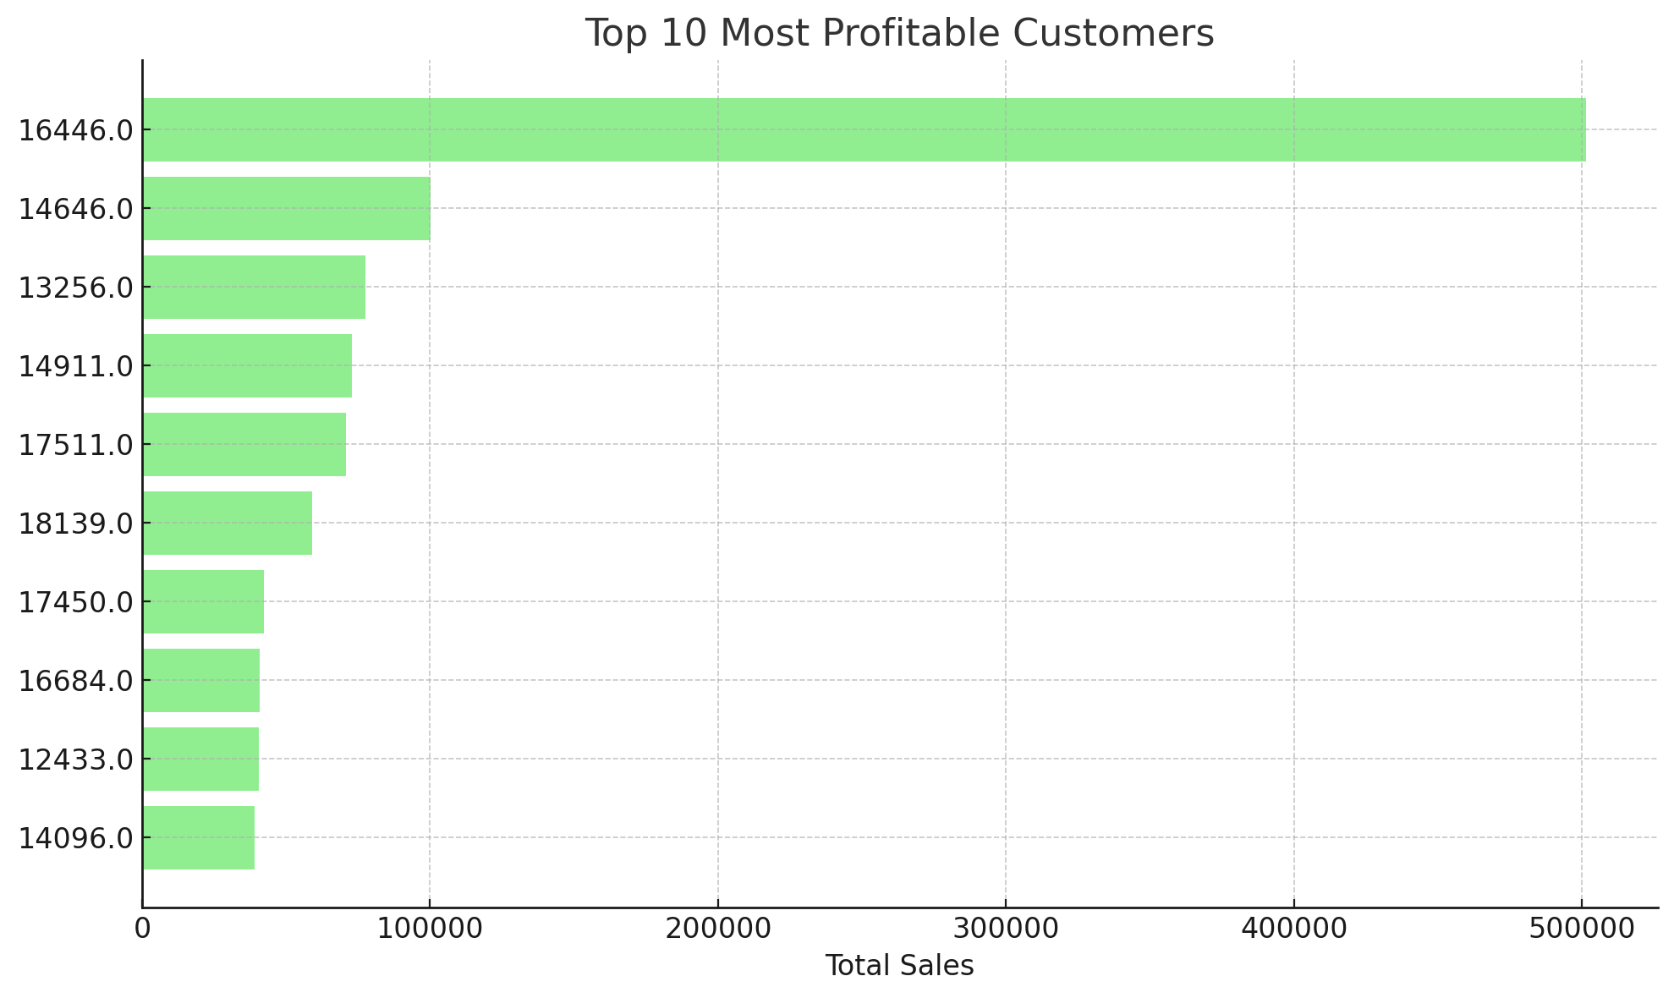
Figure 5: Top 10 most profitable products
Implications for the Business:
The business can use this information to develop targeted retention strategies for these top customers. Personalized offers, loyalty programs, and exclusive discounts can encourage repeat business and foster customer loyalty (Khairawati, 2020). Additionally, understanding the purchasing behavior of these profitable customers can help the business identify similar prospects and expand its customer base.

5. Based on your findings, what strategy could you recommend to the business to gain more profit?
The examination of the sales transaction data shows a number of critical areas upon which the business can exercise most of its leverage toward increased profitability. Strategic initiatives focusing on inventory management, marketing, customer engagement, and market expansion can really have a huge effect regarding growth for the business and changes in its bottom line (Muchaendepi et al., 2019). The recommendations found below are intended to build on existing strengths while improving any areas of weakness.
1. Optimize Inventory and Product Offering
Successful retailing begins and ends with inventory management. To this end, one of the best ways to maximize profitability is to always keep those products which are normally in the highest demand well-stocked. These products in such a way normally and literally make a vast bulk of total sales and are quite important to the very 'lifeblood' of many a company. However, stock outs of these high-demand products result in lost sales, frustrated customers, and damaged reputations (Chen and Chao, 2020). This can be avoided by developing a good inventory management system in business that is driven by past sales datum for the estimation of future demand. In this manner, it will ensure that there is an optimum stock of products with the belief that the most demanded items are always available for the customers. The real-time inventory monitoring tools could be also highly essential, whereby the tools can help to automatically reorder when the stock is at a relatively low level or below the risky point. This minimizes the risk of running out of stock during the most active sales periods, such as holidays or promotions (Pacheco, Costa and Murphy, 2024). Moreover, it applies to increasing the assortment by popular items and maintaining the inventory. If a certain gift product is doing very well, for example, the company may release new gift products entirely, perhaps in different colors or sizes, or else introduce supplementary products that help add utility or appeal to the product. This can help to appeal not only to current customers who might want to buy other varieties of their favorite products but to bring in new business with a multitude of tastes.
2. Improve Marketing and Promotion:
Marketing is key in increasing sales and gaining visibility. It has a seasonal trend; thus the marketing campaigns need to be planned well in sync with such seasonal trends. As observed in the analysis, sales usually surge in some months of the year, probably due to holidays or back-to-school seasons among others. The business can use these to execute promoted offers, which will take advantage of this surge in spending from consumers during these months. For example, during the holiday seasons, the enterprise could offer special discount prices, free branded gifts when one buys over a given amount, or offers that will lure them into making purchases (Haviv, 2022). The promotions have to be transmitted intensively on all channels possible, from email marketing, social media, and the website. Further, the effectiveness of these campaigns could be leveraged by creating content for the holidays that will appeal to the consumers. Other crucial ways of marketing are cross-selling and upselling, which can boost the average transaction value to a large extent. Cross-selling is a method in which a consumer is recommended for an accessory product related to the item that they have purchased (Nadia Laksita Devy, The Jin Ai and Ririn Diar Astanti, 2019). For instance, if a consumer is buying any kitchen appliance, then it might suggest other related items like cooking utensils, recipe books, or cleaning utensils. These recommendations can be personalized to the browsing history of the visitor or past purchases, and therefore become relevant and therefore effective in converting a visitor into a customer. Upselling, on the other hand, tackles the option of leaving the choice to the customer on whether to go for the more expensive edition of whatever product is eyed for a purchase (Ahn, Choi and Joung, 2022). This may be done in terms of presenting the luxurious features or extra benefits thereof of the premium product that will be money-wise or value-wise beneficial to the customer. For example, if the customer is interested in purchasing a basic variant of an item, the website should show the premium variant, even though the price is slightly higher. You can also introduce a promotional offer on the premium to entice the customer into selecting a more expensive option.
3. Target High-Value Customers:
VIP customers are customers who, if targeted, yield high revenue for the business. These may be customers with high frequency or bulk purchases. Customers may be targeting customers who like to get value for higher-priced items. Such customers thus represent a very important segment that the business gives utmost concern (Kim et al., 2019). Setting up a loyalty program would be the right strategy to retain such high-value customers with the business. For instance, an accrual of points for each purchase made that can later be traded in for discounts, free merchandise, or special offers would tend to bring them back for more. Additionally, this can work through a tiered rewards program, where a customer moving into higher spending limits would enjoy other privileges, such as free shipping, early sales, or personal customer service.
4. Enhance Customer Experience:
The customer's experience has to be really smooth and pleasant so that any visitor, if not a purchaser, exits the store with the positive urge to come back. Online shopping should have the ease and convenience for patrons, adding features or touches that reduce friction at the point of contact. One of the low hanging fruits in the customer journey is the checkout process itself. Long, elaborate procedures can bore the customer or give him or her trouble to a point of cart abandonment. Thus, in order to prevent this, checkout steps should be simplified and minimized (Egor Ermolaev et al., 2023). One way to minimize barriers to purchase is by providing an option for guest checkout, for example. The second best way to make a shopping experience for the final customer is by providing diversified payment methods. Customers will have more choices in what payment method to use, including credit cards, digital wallets (such as PayPal and Apple Pay), and even installment payment plans, among others.

PART II

2.1. Gender Distribution
The first graph shows the distribution of male and female students in the dataset. The numbers are almost equal:
- Male students: 1056
- Female students: 1077
This balanced distribution indicates that the survey data represents both genders almost equally, which is ideal for analyzing any gender-related patterns
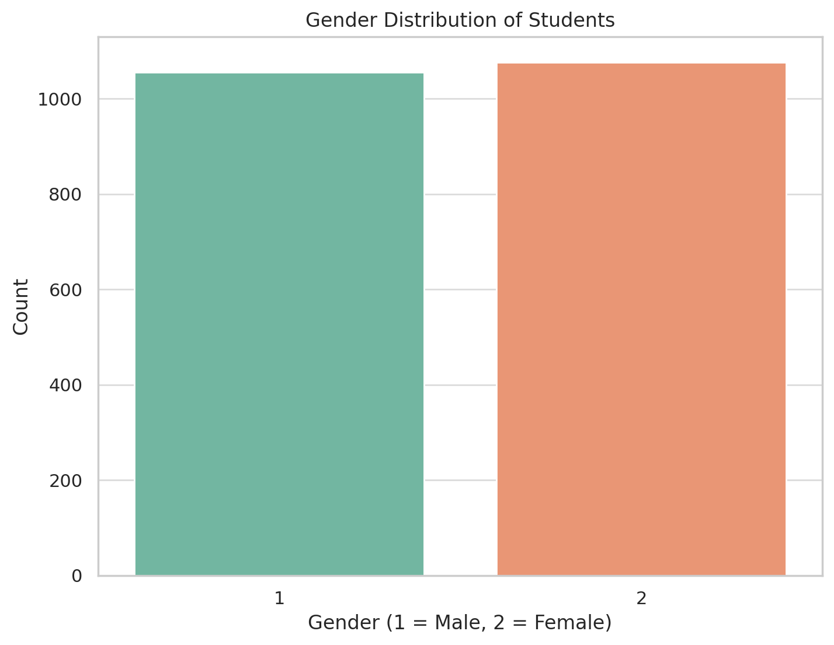

Figure 6: Gender Distribution

2.2Lunch Qualification
The second graph illustrates the distribution of students based on their qualification for reduced/free lunch:
- Students who do not qualify for reduced/free lunch: 1215
- Students who qualify for reduced/free lunch: 918
This data suggests that a larger portion of students does not qualify for the lunch program. Understanding the academic performance differences between these two groups could provide insights into the effects of socio-economic status on educational outcomes.
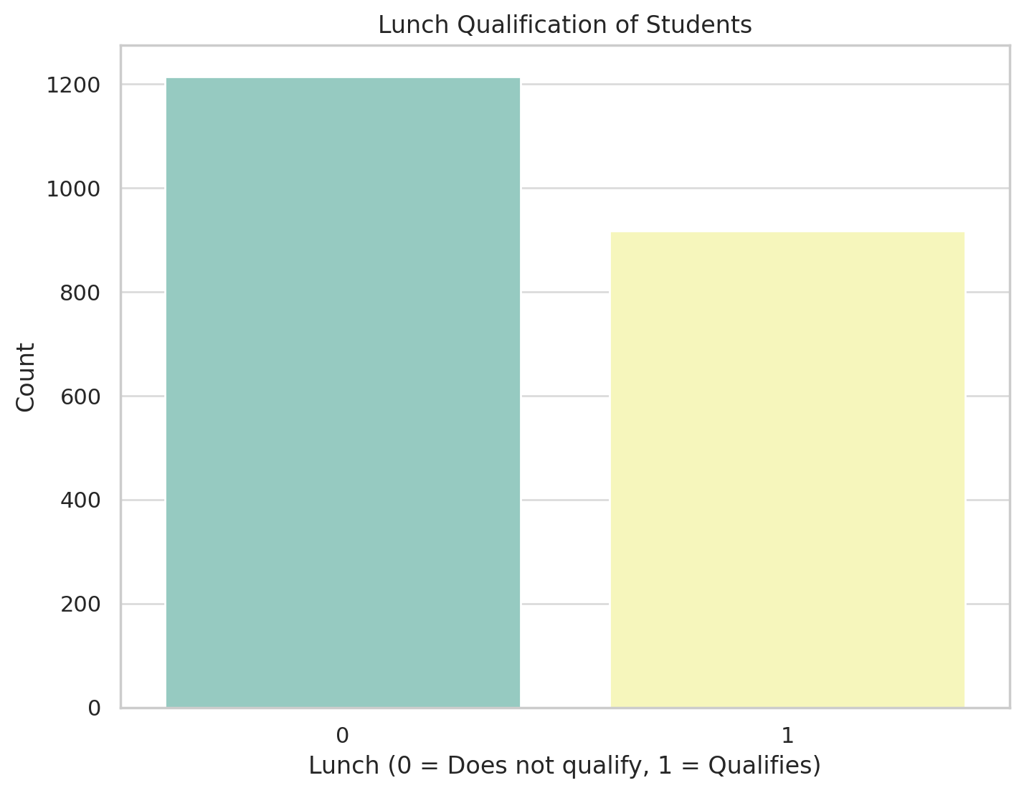

Figure 7: Lunch Qualification

2.3. Pretest and Posttest Scores by Lunch Qualification
The third set of graphs shows the distribution of pretest and posttest scores for students who qualify and do not qualify for reduced/free lunch:
- Pretest Scores:
  - Students who qualify for reduced/free lunch generally have lower pretest scores, with a median of 44.0, compared to 62.0 for those who do not qualify.
- Posttest Scores:
  - Similarly, the posttest scores are higher for students who do not qualify for reduced/free lunch (median of 74.0) compared to those who do (median of 55.0).
These results suggest a consistent performance gap between students who qualify for reduced/free lunch and those who do not, both before and after the intervention.
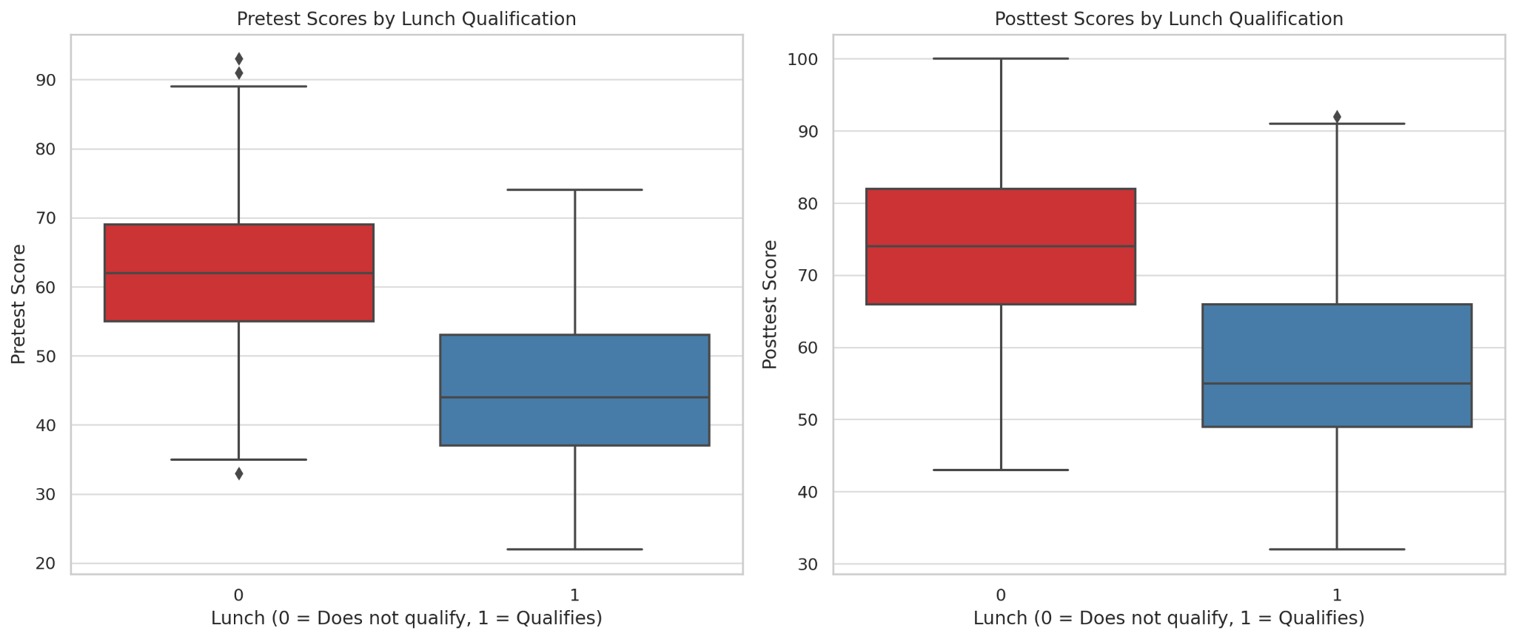
Figure 8: Pre and Post-test score by Lunch Qualifications

2.4. Clustering Analysis
The final graph illustrates the K-Means clustering results based on pretest and posttest scores. The students are grouped into two clusters:
- Cluster 0: Represents students with higher pretest and posttest scores. The centroid of this cluster is located at a pretest score of 65.32 and a posttest score of 77.90.
- Cluster 1: Represents students with lower pretest and posttest scores. The centroid of this cluster is at a pretest score of 43.05 and a posttest score of 54.70.
This clustering clearly separates the students into two groups based on their performance, which could help in identifying patterns or tailoring interventions.
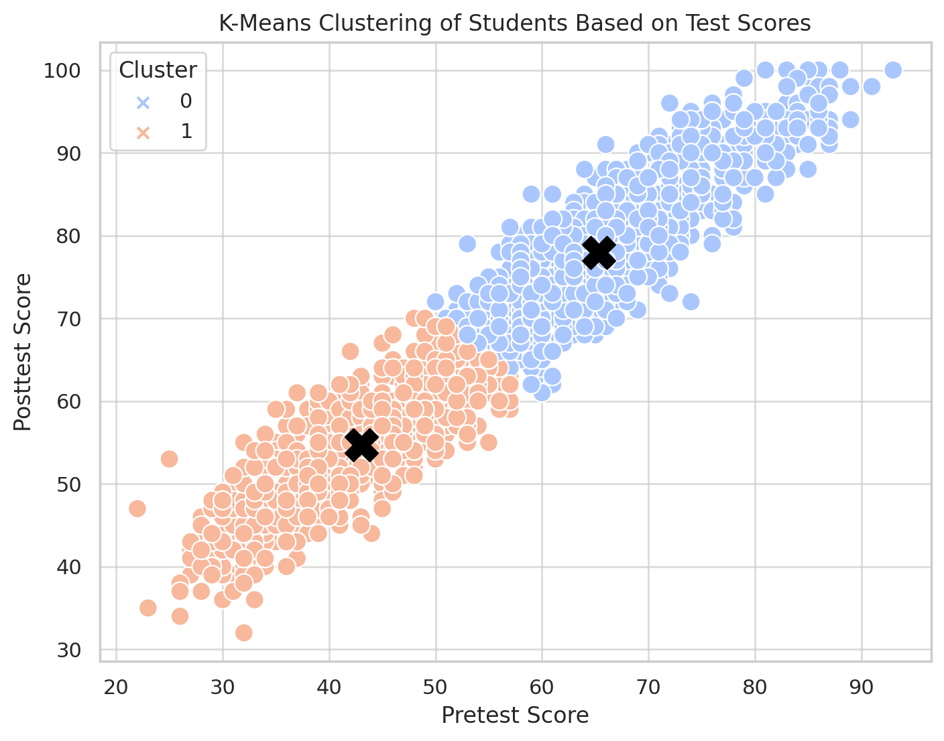
Figure 9: K-Means clusterin
2.5. Advantages and Disadvantages of Using SPSS vs. Excel
While SPSS and Excel are both very powerful tools when it comes to data analysis, there are certain areas in which they differ in view of the purpose and strengths and weaknesses. SPSS is specifically designed for statistical analysis and is well-suited for handling large datasets with ease. It has a friendly user interface with point-and-click operations, so it is very appropriate for people who might not have technical backgrounds yet find themselves conducting complicated statistical analyses like regression, ANOVA, and clustering (Pallant, 2020). It is especially in deep data mining and research-oriented tasks that these built-in predictive modeling tools and sophisticated statistical functions make SPSS a very useful application. On the other hand, SPSS can be steeply learning-curve-wise to a beginner; the buying or subscribing process can sometimes constrain some users.

On the other end, Excel is a versatile tool, with quite wide accessibility since it is, in most cases, an integral component of Microsoft Office. It excels in data manipulation, visualization, and automation, with a wide array of adjustable charts, graphs, and pivot tables to make data analysis more intuitive and eye-catching (Mcfedries, 2022). Another major advantage is that VBA can automate routine tasks, making Excel very efficient for doing routine data processing. Nevertheless, the deficiencies of Excel become apparent while dealing with very large data sets or advanced statistical analyses. In contrast, Excel does not integrate with tools such as clustering and advanced modeling like SPSS does. These must usually be manually conducted or supported by external add-ins, hence becoming laborious and less reliable.

Table 1: Advantages and Disadvantages of Using SPSS vs. Excel
Criteria | SPSS | Excel
Ease of Use | SPSS offers a user-friendly point-and-click interface, suitable for those with less technical expertise. | Excel requires users to be familiar with formulas and functions, which can be less intuitive for complex analyses.
Statistical Analysis | SPSS provides advanced statistical tools, including built-in functions for complex analyses like regression, ANOVA, and clustering. | Excel offers basic statistical tools, but more advanced analyses require manual setup or additional add-ins.
Data Handling | SPSS can handle large datasets efficiently, with better performance for data mining tasks. | Excel is limited by its row/column restrictions, which may hinder the analysis of very large datasets.
Visualization | SPSS offers basic charting and graphing capabilities, but more complex visualizations may require external software. | Excel provides rich visualization options with customizable charts, graphs, and pivot tables.
Automation | SPSS has limited automation features, mostly through syntax scripting. | Excel allows for extensive automation via VBA, enabling repetitive tasks to be automated efficiently.
Clustering & Modeling | SPSS has built-in tools for clustering (e.g., K-Means) and predictive modeling, making it ideal for data mining. | Excel lacks built-in clustering tools and requires additional plugins or manual implementation for similar tasks.
Cost | SPSS may require a purchase or subscription, especially for advanced versions, although student licenses may be available. | Excel is typically included in Microsoft Office packages, making it more accessible, though still requiring a license.
Learning Curve | SPSS has a steeper learning curve for those unfamiliar with statistical analysis, but is easier to use for complex tasks once mastered. | Excel has a lower learning curve for basic tasks, but advanced features may require significant learning.

References
- Ahn, J. (Jennie), Choi, E.-K. (Cindy) and Joung, H.-W. (2022). Promoting hotel upselling: The effect of message appeal and delivery setting on consumer attitude and purchase intention. Journal of Hospitality and Tourism Management, 52, pp.295–303. doi:https://doi.org/10.1016/j.jhtm.2022.07.009.
- Chen, B. and Chao, X. (2020). Dynamic Inventory Control with Stockout Substitution and Demand Learning. Management Science. doi:https://doi.org/10.1287/mnsc.2019.3474.
- Egor Ermolaev, Iván Abellán Álvarez, Johannes Sedlmeir and Fridgen, G. (2023). z-Commerce: Designing a Data-Minimizing One-Click Checkout Solution. Lecture Notes in Computer Science, pp.3–17. doi:https://doi.org/10.1007/978-3-031-32808-4_1.
- Haviv, A. (2022). Consumer Search, Price Promotions, and Counter-Cyclic Pricing. Marketing Science. doi:https://doi.org/10.1287/mksc.2021.1327.
- Khairawati, S. (2020). Effect of customer loyalty program on customer satisfaction and its impact on customer loyalty. International Journal of Research in Business and Social Science (2147- 4478), [online] 9(1), pp.15–23. doi:http://dx.doi.org/10.20525/ijrbs.v9i1.603.
- Kim, S., Ham, S., Moon, H., Chua, B.-L. and Han, H. (2019). Experience, brand prestige, perceived value (functional, hedonic, social, and financial), and loyalty among GROCERANT customers. International Journal of Hospitality Management, 77, pp.169–177. doi:https://doi.org/10.1016/j.ijhm.2018.06.026.
- Lemmens, A. and Gupta, S. (2020). Managing Churn to Maximize Profits. Marketing Science, 39(5). doi:https://doi.org/10.1287/mksc.2020.1229.
- Mcfedries, P. (2022). Excel Data Analysis For Dummies. S.L.: John Wiley & Sons.
- Muchaendepi, W., Mbohwa, C., Hamandishe, T. and Kanyepe, J. (2019). Inventory Management and Performance of SMEs in the Manufacturing Sector of Harare. Procedia Manufacturing, 33(1), pp.454–461. doi:https://doi.org/10.1016/j.promfg.2019.04.056.
- Nadia Laksita Devy, The Jin Ai and Ririn Diar Astanti (2019). Inventory Policy for Cross Selling Item. Lecture notes in mechanical engineering, pp.67–73. doi:https://doi.org/10.1007/978-981-15-0950-6_11.
- Pacheco, T., Costa, D. and Murphy, F. (2024). A systematic review of real-time data monitoring and its potential application to support dynamic life cycle inventories. Environmental Impact Assessment Review, 105, pp.107416–107416. doi:https://doi.org/10.1016/j.eiar.2024.107416.
- Pallant, J. (2020). SPSS Survival Manual: a Step by Step Guide to Data Analysis Using IBM SPSS. 7th ed. S.L.: Open Univ Press.
- Vogel, C., Crozier, S., Penn-Newman, D., Ball, K., Moon, G., Lord, J., Cooper, C. and Baird, J. (2021). Altering product placement to create a healthier layout in supermarkets: Outcomes on store sales, customer purchasing, and diet in a prospective matched controlled cluster study. PLOS Medicine, 18(9), p.e1003729. doi:https://doi.org/10.1371/journal.pmed.1003729.

Appendix
A) Students qualifying for lunch

1. Paired Samples Statistics (SPSS)
This table displays the mean, number of cases (N), standard deviation, and standard error mean for each paired sample (Pretest and Posttest).
Group | Mean Pretest | Mean Posttest | Std. Deviation Pretest | Std. Deviation Posttest | N
Qualifies for Lunch | 45.25 | 57.48 | 11.90 | 12.22 | 918
Does Not Qualify for Lunch | 62.29 | 74.38 | 11.14 | 12.23 | 1215

2. Paired Samples Correlations
This table provides the Pearson correlation between the pre-test and post-test scores for each group.
Group | Correlation (Pretest-Posttest) | Sig. (2-tailed)
Qualifies for Lunch | 0.92 | 0.000
Does Not Qualify for Lunch | 0.95 | 0.000

3. Paired Samples Test
This table displays the results of the paired sample t-tests, including the t-statistic, degrees of freedom (df), and the significance level.
Group | t-Statistic | Degrees of Freedom | Sig. (2-tailed)
Qualifies for Lunch | -86.13 | 917 | 0.000
Does Not Qualify for Lunch | -96.49 | 1214 | 0.000

