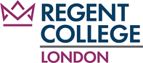

(BMIH4005)

Marketing Essentials

Marketing Plan and Presentation Slide

Student ID:
Student Name:
Lecturer name:
Word Count:
Table of Contents
Introduction 3
Situation Analysis 3
Objectives 5
Strategy 5
Tactics 6
Action 7
Control 7
Conclusion 8
References 9
Appendices 11

Introduction
Holiday Inn marketing strategy strives to improve communication. It focuses on recognising business possibilities and resolving present company difficulties. The programme is designed for professionals in the hotel management and driving industries. The programme will analyse the hotel's situation, create goals, strategize, implement strategy, and assess progress using methodologies such as SOSTAC, 4Ps, and Ansoff Matrix. The goal is to boost Holiday Inn's business objectives, performance, and overall performance.

Situation Analysis
Company: A SWOT analysis will reveal Holiday Inn internal strengths and weaknesses as well as external opportunities and threats.
Strengths | Weaknesses
- Reputation and acclaim  - Global reach and hotel size expansion  - Excellent service and facilities (ArmstronG and Kotler, 2017). | - Depending on the hotel area's market  - Potential compatibility difficulties between hotel locations  - In the premium hotel market, there is fierce rivalry.
Opportunities | Threats
- Increasing desire for luxury travel  - Expansion into new markets  - Technological breakthroughs | - Tough competition  - Economic downturns  - Travel companies and other service providers on the internet (Asdecker, 2022).

Customers: A corporation may obtain information about client behaviour, preferences, and demographics using technologies like SimilarWeb to better understand their marketing goals. Consider the following crucial factors:
- Demographic segmentation: target clients' age, income, employment, and ethnicity
- Psychographic segmentation: Lifestyle, values, tastes, and behaviour are all psychographic segments (Asdecker, 2022).
- Behavioral segmentation: Travel, frequency of hotel stays, and preferences are all examples of behaviour.
Competitors: There are two ways available to assess Holiday Inn's competitive landscape and position:
Perception Report: It is simpler to understand where the brand stands in relation to other brands by organising Holiday Inn Hotels and their rivals on this map (Dalgiç, Güler and Birdir, 2017).
Bowman's Strategy Timer: Holiday Inn Hotels can uncover potential for differentiation and competitive advantage by examining pricing levels and seeing prices given by rivals.
Collaborators: Holiday Inn must exhibit knowledge of business-to-business interactions, partnerships, and marketing. Identifying essential partners such as travel brokers, event planners, airlines, and corporate partners is part of this process (Emir et al 2016).
Climate: Take a look at the following:
- Political: Government restrictions, safety, and travel and tourism legislation
- Economical: Trade, barter, inflation, and consumer disposable income are all aspects of business (Kotler et al 2016).
- Social: Changes in consumer tastes, lifestyle, and culture
- Technological: Technological advancements, internet booking systems, and digital marketing trends
- Legal: Legal considerations include labour regulations, health and safety, and intellectual property.
- Environmental: Environmental regulations and technical support for safe, ecologically friendly practises
Marketing Mix: The marketing mix includes crucial components that Holiday Inn Hotels may utilise to provide value to consumers.
- Product: Holiday Innsuite of hotel services, facilities, and rooms.
- Price: the best price, the room rate, and the suggested price in comparison to rivals eight
- Place: Distribution networks, online booking systems, and cooperation are examples of locations. Physical locations of travel companies and hotels (Lu, Chen and Law, 2018).
- Promotion: Advertising, public relations testing, digital marketing, media, and loyalty programmes are all examples of promotion.
- People: Employee training and teamwork, as well as customer service
- Process: Inspection and testing procedure
- Physical Evidence: Hotel facilities, design, and atmosphere are physical evidence.

Objectives
In the next 12 months, increase Holiday Inn's market share by 10% through digital marketing initiatives, customization, and strategic alliances. The objective is to attract a larger audience, boost consumer engagement, and increase revenue by using data from insights and inventive promotional techniques. To position itself as the first option of travellers, the hotel will focus on optimising its online presence through a customer segmentation strategy and generating distinctive value propositions (NUGRAHA, 2018).

Strategy
Consider the following when determining the modifications that need to be made to the marketing mix:
Product: Determine whether adjustments or enhancements to Holiday Inn goods are required to solve the reputational issue. This might involve enhancing service quality, launching new sites, or redesigning existing ones (Osborne, 2018).
Price: Determine whether the repair cost is acceptable in order to attract clients and reestablish their confidence. This might include giving discounted prices, bundles, or pricing that are comparable with other hotels in the market.
Place: Evaluate the geographical distribution and physical location of Holiday Inn's hotel business. Consider opening your doors to new companies or institutions that will appeal to your target demographic and boost the reputation of your hotel (Piehler et al 2019).
Promotion: Create a communication and marketing strategy to promote your brand. This will entail utilising digital marketing, social media, public relations, and advertising campaigns to promote the hotel's quality and rectify any shortcomings.

Tactics
To address identified shortcomings and improve Holiday Inn's communications, the following tactics will be implemented:
- Social Media Engagement: Holiday Inn Hotels will prioritise audience engagement via social media channels. Posting great material on a regular basis, including appealing images and up-to-date information, will enhance brand recognition (Pride and Ferrell, 2019).
- Influencer Partnerships: Partnerships with travel and hospitality sector influencers will help Holiday Inn increase its reach. Partnering with relevant people that share your hotel's brand values can allow you to reach a larger audience and increase reservations (Buhalis, 2020).
- Personalized Email Marketing: Personalised messages based on guest choices will be used to strengthen Holiday Inn's email marketing. unique promotions, unique discounts, and personalised suggestions will be included in email marketing campaigns (Scott, Hall and Gössling, 2019).
- Online Reputation Management: Monitoring and managing a hotel's internet reputation will help it retain a positive reputation. Responding to guest input on the review site promptly and efficiently will fix concerns and display a commitment to visitor happiness.
- Enhanced Website Experience: It is critical to optimise Holiday Inn's website for a better user experience and usability. This includes quick load times, simple navigation, attractive design, and mobile capabilities. Integrating online reservation systems, virtual tours, and thorough information about attractions and local attractions would enhance the client experience and generate traffic (Sigala and Haller, 2019).
Holiday Inn Hotels hopes to enhance communication, raise business recognition, benefit customers, and boost reservations by using these techniques. Regular outcomes monitoring and analysis will enable for further optimisation and adjustment of communication tactics to suit company objectives.

Action
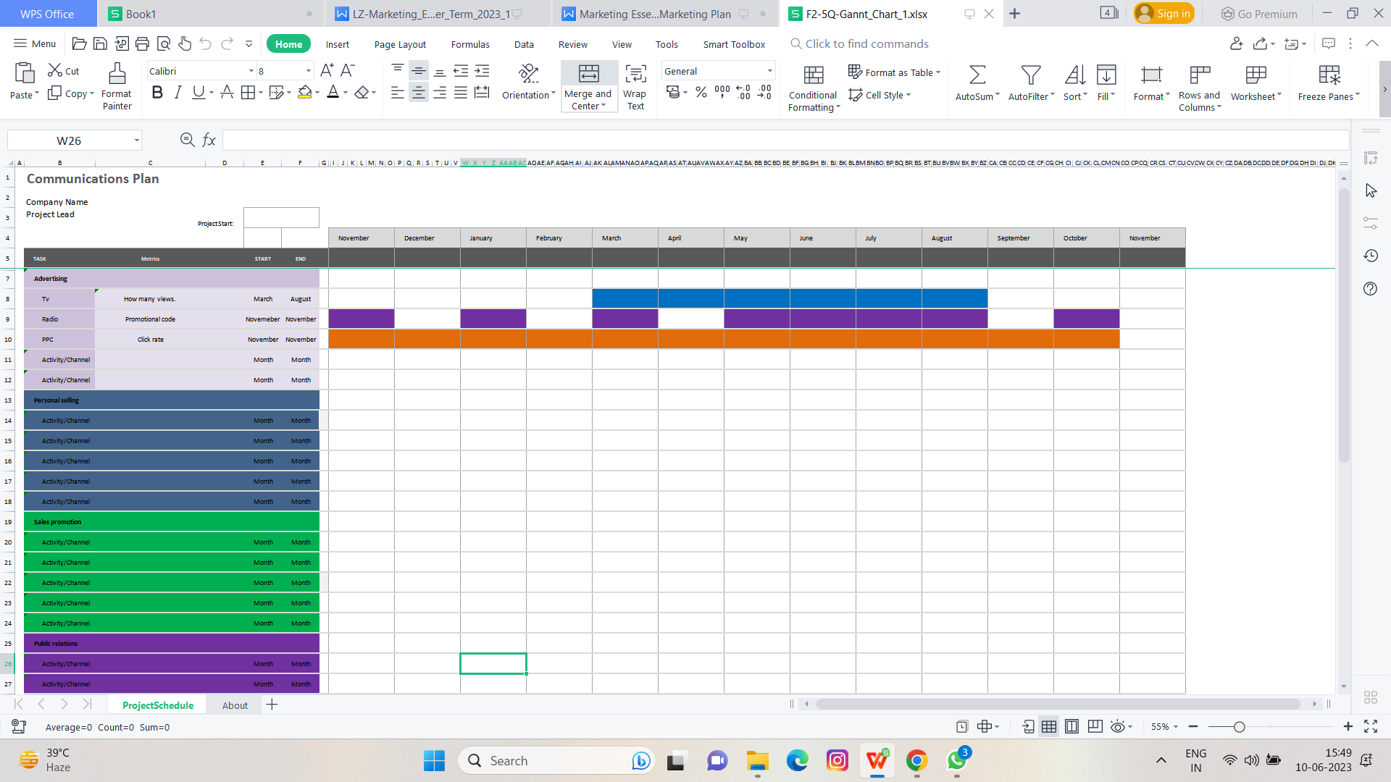

Control
Holiday Inn Hotels hopes to enhance communication, raise business recognition, benefit customers, and boost reservations by using these techniques. Regular outcomes monitoring and analysis will enable for further optimisation and adjustment of communication tactics to suit company objectives.
The following metrics and key performance indicators (KPIs) will be used to assess the effectiveness of Holiday Inn's marketing strategy:
- New customers: Keep track of the amount of new consumers you've obtained. Adoption of the programme will provide great outcomes in terms of recruiting and converting new Holiday Inn Hotel clients (Villamediana-Pedrosa, Vila-Lopez and Küster-Boluda, 2019).
- Positive brand attitudes: Surveys and feedback will be used to assess consumers' opinions and attitudes towards the Holiday Inn hotel brand, providing information into the project's performance in achieving a good target.
- Increase in profits: Financial data like as revenue growth, average daily wage (ADR), and occupancy will be analysed to determine the program's impact on Holiday Inn profit and company growth (Xiang et al 2017).
- Customer satisfaction and loyalty: Evaluating customer satisfaction and employing service loyalty will gauge the service's success in offering the greatest customer experience and assistance, resulting in customer loyalty.
Regularly monitoring these indicators will assist in measuring the success of company activities and making the required modifications to be effective and meet desired aims.

Conclusion
In short, Holiday Innbusiness goals are centred on overcoming competition, satisfying changing client expectations, and responding to the COVID-19 pandemic's impact. Customers should be empowered, sustainability and health should be addressed, partnerships should be formed, and performance should be measured, according to the recommendations. Holiday Inn Hotels may use these tactics to differentiate itself, provide a personalised experience, and overcome problems. Holiday Inn Hotels may establish itself as a brand for long-term success in the hospitality sector by focusing on client happiness and creative business tactics.

References
- Armstrong, G. and Kotler, P., (2017). Marketing An Introduction Thirteenth Edition. pearson.
- Asdecker, B., (2022). Travel-related influencer content on instagram: How social media fuels wanderlust and how to mitigate the effect. Sustainability, 14(2), p.855.
- Buhalis, D., (2020). Technology in tourism-from information communication technologies to eTourism and smart tourism towards ambient intelligence tourism: a perspective article. Tourism Review, 75(1), pp.267-272.
- Dalgiç, A., Güler, O. and Birdir, K., (2017). Promotion in the hospitality industry. In The Routledge Handbook of Hospitality Marketing (pp. 168-179). Routledge.
- Emir, A., Halim, H., Hedre, A., Abdullah, D., Azmi, A. and Kamal, S.B.M., (2016). Factors influencing online hotel booking intention: A conceptual framework from stimulus-organism-response perspective. International Academic Research Journal of Business and Technology, 2(2), pp.129-134.
- Kotler, P., Keller, K.L., BRADY, M., GOODMAN, M. and HANSEN, T., (2016). Marketing Management. Edinburgh Gate.
- Lu, Y., Chen, Z. and Law, R., (2018). Mapping the progress of social media research in hospitality and tourism management from 2004 to 2014. Journal of Travel & Tourism Marketing, 35(2), pp.102-118.
- NUGRAHA, A., (2018). The Effects of Vlogger Credibility as Marketing Media on Brand Awareness to Customer Purchase Intention (Study on Traveloka With Arief Muhammad as a Vlogger on Youtube) (Doctoral dissertation, Universitas Jenderal Soedirman).
- Osborne, S.P., (2018). From public service-dominant logic to public service logic: are public service organizations capable of co-production and value co-creation?. Public Management Review, 20(2), pp.225-231.
- Piehler, R., Schade, M., Hanisch, I. and Burmann, C., (2019). Reacting to negative online customer reviews: Effects of accommodative management responses on potential customers. Journal of Service Theory and Practice.
- Pride, W.M. and Ferrell, O.C., (2019). Marketing. Cengage Learning.
- Scott, D., Hall, C.M. and Gössling, S., (2019). Global tourism vulnerability to climate change. Annals of Tourism Research, 77, pp.49-61.
- Sigala, M. and Haller, C., (2019). The impact of social media on the behavior of wine tourists: A typology of power sources. Management and Marketing of Wine Tourism Business: Theory, Practice, and Cases, pp.139-154.
- Villamediana-Pedrosa, J.D., Vila-Lopez, N. and Küster-Boluda, I., (2019). Secrets to design an effective message on Facebook: an application to a touristic destination based on big data analysis. Current issues in tourism, 22(15), pp.1841-1861.
- Xiang, Z., Du, Q., Ma, Y. and Fan, W., (2017). A comparative analysis of major online review platforms: Implications for social media analytics in hospitality and tourism. Tourism Management, 58, pp.51-65.

Appendices


