MODULE CODE/ COD Y MODIWL: LCBB4003
ASSESSMENT-1
INTRODUCING THE MODERN WORKPLACE
STRUCTURE AND CULTURE (ROLLS ROYCE)
STUDENT NAME: Cristi-Gabriel Tudosie
STUDENT ID: 1906879
LECTURER’S NAME: Rexon Nting

Table of Contents
Introduction: 3
Overview of RollsRoyce: 3
Discussion: 3
Organizational Performance 3
Relationship between culture, culture and organizational performance 4
Nature of managerial work 5
Role of leadership 6
Behavioral approach to management 7
Conclusion: 8
Reference list 9

Introduction:
Organizational culture is easily defined as one of the specific collections regarding the norms and values that help in sharing controlling groups or people while interacting in a working environment. Culture of an organization is generally determined as a personality of the business organization which helps smoothly running of the business in the market and focus over the production. The assessment is usually based upon the structure and organizational culture of Rolls-Royce, which determines contribution towards the work, leadership and managerial culture. It provides a centralized structure that helps Rolls Royce in taking various decisions for retaining the Management of the top-level by having close control and monitoring.

Overview of Rolls-Royce:
Rolls-Royce was founded in 1906, where they maintained their various event company and started to operate in the global market with civil aerospace, Marine aerospace and energy among the top 3 global competitors. Rolls-Royce generally provides both military and commercial engines that help in increasing the business with a customer base. Moreover, the organization also maintains a building of 650 airlines, 160 armed forces, and 4000 aircraft. The organization also supplies various power generation systems with the help of gas and oil that is also determined by the most extensive marine propulsion system (Edensor, 2020). Moreover, it also maintains its operation over various markets of the Middle East, North America, Asia and Europe. With the help of strategic leadership and Management, the organization has generally gained revenue of £10414 million, from where 44% of revenue usually came from defence aerospace, civil aerospace.

Discussion:

Organizational Performance

The essential business quickly depends upon the Management generally developing various innovative ideas for running their business where it is also seen Rolls Royce has associated a behavioural field of Management. Moreover, general help in origin eating per Management and behaviour for taking various decisions regarding the business objective and goal. It also includes multiple behavioural Management which provide analysis about the culture and structure of Rolls Royce business performance. The organizational structure generally relates about the effectiveness of business performance in the various market of Middle East, Asia, Europe etc. where the corporate structure help typically in understanding about the business performance which also determines the formal system that relates the work role and discovers about the managers of the working environment that help in increasing the business performance (Blecke, 2018). Moreover, the structure also operates by concentrating over the significant key aspects generally like attracting customers by providing efficient quality of product and efficient service over the vehicles or internal system. The organizational structure helps in influencing the farm and also implementing various changes that will generally result in developing and planning about future construction for attaining success. Moreover, organizational structure results typically in referring to the method and practices followed by Rolls-Royce regarding the operation in the global market.
The model error has generally been evaluated according to the structure and culture that is required for Rolls Royce for managing their internal business environment.
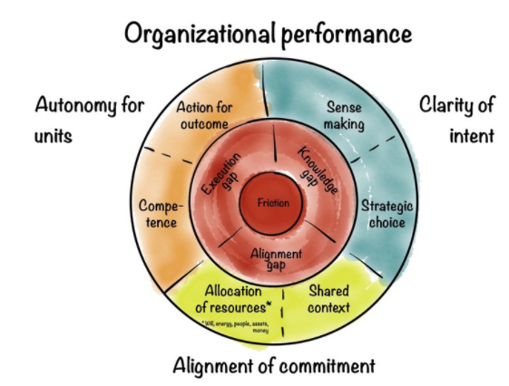
Figure 1: Organisational Performance
(Source: Blecke, 2018)

Relationship between culture, culture and organizational performance
However, the fabric is also determined as one of the integral parts of the business organization whose primary deal with their establishment of culture for motivating their employee and providing a better direction regarding the organizational goal. While conducting business, various issues may arise regarding the Management of work or supervising. This generally results in creating conflict in the working environment, which can be reduced with effective leadership and also determining the organizational structure for conflict management. Several issues are usually related to the effectiveness of the organizational structure and also discover one of the critical issues for achieving the profit from the market share. It also determines the significant way for building interrelationship between the cultural fabric that will increase the business performance of Rolls Royce and also help in identifying the working arrangement. The organization structure generally allows for creating a group which is interrelated with the operation and running of the business smoothly in different working environments (Pearce, 2016).
Where the framework generally alarms for coordinating and communicating with a healthy culture and also results for motivating the employee regarding the moving direction. The structure also helps in defining various roles and responsibilities of the organizational culture and managers while serving with customers and also building a proper relationship with behavioural management theory. It generally helps in determining the coordination and communication between the customer and the employee regarding the achievement of the objective. More about the positive culture helps in participating in helping the manager for the organization mission, goal and vision.
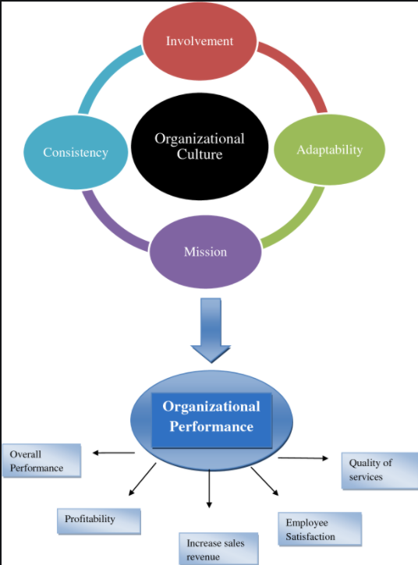

Figure 2: Relationship between culture, culture and organizational performance
(Source: Harrison, 2017)
Organizational culture determines essay variances towards values motivation, and experience, which also result in increasing the behaviour. Organization structure also described as a mechanism that helped rules for integrating through the business market and controlling the activities while performing (Harrison, 2017). It is also determined as symbolic Management that results in describing the mechanism of behaviour norm goal and shared values that help Rolls-Royce for increasing their market share and even result in retaining the stakeholder for the improvement of the business. Moreover, it also helps in clearing the relationship between the culture of Rolls-Royce and the structure of Rolls Royce for directing their employees and also providing strategic effort according to the determined objective. It generally helps in providing necessary information that includes support for developing the mechanism and also reducing various uncertainties while achieving common market goals.

Nature of managerial work
The essential nature of a manager while conducting business and also discovering objectives for the organization generally like organizing, planning, staffing, leading and controlling where they can quickly help in making out of various problems and also achieve a particular goal by collaborating with the team members in different working environments. When the manager you decide about the necessary steps that are required for accomplishing the purpose and also increase the advertisement through online portals and increase the sales staff by developing essential plans. Also, help the manager following the complete goal and improving the sales of Rolls Royce (Armitage, 2019). Organizing is the plan that the manager requires for providing relevant material and resources according to the program, necessary for granting and assigning the work according to the element of the organization. Staffing is easily determined on the managerial decision that helps in recruiting training, selecting employees and also developing according to the requirement of the business organization. Where the manager usually accomplishes their goal with the help of human resources, leading is also determined by the plan for organizing and achieving the common objective of the business. It also helped in guiding, communicating, motivating and even encouraging their employees and also motivating according to the requirement in solving various issues in the working environment. Controlling also determines one of the jobs that is provided to the manager and also constantly checking for the corrective lens, which will also determine the business objectives of a task or not (Sharpe, 2017).
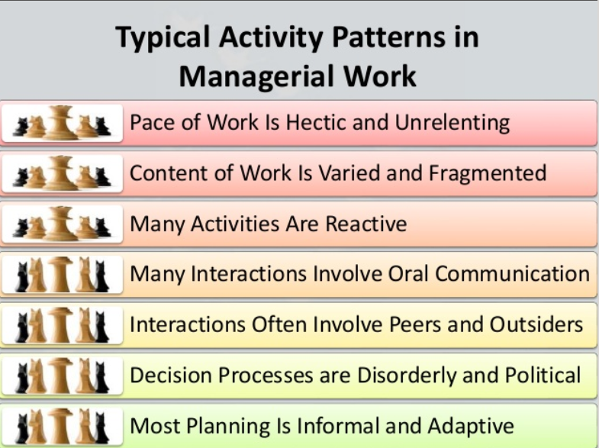

Figure 3: Nature of managerial work
(Source: Jefferies and Barnard, 2018)
Managers also play a vital role in the organization regarding the performance and also demonstrate the culture of the business organization while contacting and performing the work regarding the expansion of the business.
While conducting work for organizations like Rolls-Royce, it is essential for delivering a connection with confidence that will also result in increasing the vision of the company. Also, help in gaining customer insight and even result in building brand loyalty for new customers. Priority is also determined one of the essential aspects that help in learning for the mistake which arises because of poor communication. But with the help of the desired outcome of the specific task and also contacting the responsibility of the deadline will generally hold the leaders for achieving the organizational objective (Jefferies and Barnard, 2018). Repeat communication helps in developing areas' messages to the employee working for the positive outcome in a given period and also results in strengthening their understanding. Cavalla to result in creating a better communication platform and even result in monitoring the business and mitigating various risks, It also ensures the repeating message that provides usefulness for that organizational team. Being visible for the organization generally helps the stakeholder for increasing their demand and also provide additional support regarding any problem while conducting business in different global markets.

Role of leadership
Leadership style generally determines one of the more respects for motivating the employee and also results in the success of individual career while performing for Rolls-Royce. Manager approach typically at the beginning with the worker for building a good relationship which generally helps in knowing about the mental stage and results reducing losing employee (Rees and Smith, 2017) It also produce in approaching towards the employee knowing about the importance for increasing the knowledge and performing the work environment of Rolls-Royce with a consultative style and also motivating for meeting the future target.

Organization structure effortlessly defines the task and job of the divided group and also coordinated in the working environment of Rolls Royce. Moreover, it is done according to the capability objective of the business organization where the functional structure is generally arranged for performing according to the section (Ryder,2019). This section also helps in increasing accountability and clarifying the functionality of the business organization. The downside generally resistance changes and also creates difficulty for essay writing about various parts which result in a saving of performance with overall managerial activity. It is also defined as a communication effect on lack of congruence where the structuring is generally determined about the geographical location where Rolls-Royce is going to expand the business by satisfying the requirement of the customer. It is also essential for knowing about the quality of modern vehicle technology and the functionality that is generally resulting in creating an attachment between them working employees for the long run. The structural generally considered about the culture which is manifested physically.
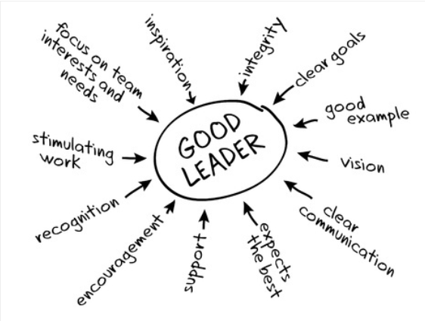
Figure 4: Leadership role
(Source: Svasek and Meyer, 2016)
It also determines the core principle that results in the setting up of structure by the market perception, which also results in providing a scenario for building relationships with critical components, where the principal component will generally result in determining the future activities of Rolls Royce with the better Irish site. The market chain is easily one of the unique workforces where the members are identified regarding their races and culture. Where it is also seen the manager has to face various difficulties for allocating jobs and also completing the task by driving the organizational employee with conventional bonding in the organizational structure (Svasek and Meyer, 2016). But the conflict that arises because of race, religion, culture, sex which of the result introducing the organization of output and lead to increase the friction over losses of the worker.

Behavioural approach to management
The status of an individual works out the influencing behaviour that is usually conducted while working. It results in coordinating and also reserve in leading the team with useful behavioural traits which managers have to follow because of retaining their employee and saving the organization from employee turnover. Leadership is defined in the process that generally has individuals for guiding and directing and sharing their vision towards the common objective or goal (Holt,2018). Leadership helps typically with building a better future for employees and also provides a future pathway. Moreover, the organizational theory helps in knowing about the discipline culture structure that is designed by Rosemary oil for increasing the business in the global market where the effectiveness initially reduced by employee’s collaboration.

Conclusion:
It can be concluded that organizational behaviour is generally the discipline that is multifaceted and also crucial for managing the business of Rolls-Royce effectively in a dynamic environment. The motivational theory helps typically in building a proper leadership style and even reserves for carefully identifying the factors that affect individual behaviour which may result in increasing the employee turnover rate. The different action is one of the equilibriums that is required to get fitted in the organization with the context of the technology team as a group for playing a crucial role regarding the increase of business performance.

Reference list
Alosaimi, N., Boyd, M. and Boardman, H., 2019. Cultural intelligence of MPharm undergraduates. International Journal of Pharmacy Practice, 27(S2).
Armitage, J., 2019. Being Luxurious: On the Rolls-Royce Ghost Black Badge and beyond. The Third Realm of Luxury: Connecting Real Places and Imaginary Spaces, p.25.
Black, J., 2018. Project Management Methods in the Context of Intercultural Multi-party Projects-Example Rolls-Royce Power Systems AG.
Edensor, T., 2020. National identity, popular culture and everyday life. Routledge.
Harrison, A., 2017. Design for Service: The Advanced Services Transformation Roadmap at Rolls-Royce The Advanced Services Transformation Roadmap ensures that service considerations are integrated into every step of the engine design process. Research-Technology Management, 60(4), pp.19-25.
Holt, Y., 2018. Performing the Anglo-Scottish Border: Cultural Landscapes, Heritage and Borderland Identities. Journal of Borderlands Studies, 33(1), pp.53-68.
Jefferies, M. and Barnard, K., 2018. Rolls-Royce University Technology Centres: Relationships Matter. In Strategic Industry-University Partnerships (pp. 81-103). Elsevier.
Lee, S.M., Lee, D. and Kim, Y.S., 2019. The quality management ecosystem for predictive maintenance in the Industry 4.0 era. International Journal of Quality Innovation, 5(1), p.4.
MULLEN, A. and Ruiz Darasse, C., 2020. Gaulish language and epigraphic culture. Palaeohispanica, 20.
Noke, H. and Mosey, S., 2017. 4 Entrepreneurial culture and leadership. Building an Entrepreneurial Organisation, 47.
Pearce, B., 2016. Gatsby's Rolls-Royce: reflections on the automobile and literature. English Academy Review, 33(2), pp.52-67.
Rees, G. and Smith, P. eds., 2017. Strategic human resource management: An international perspective. Sage.
Ryder, P., 2019. A New Sound; A New Sensation: A Cultural and Literary Reconsideration of the Motorcar in Modernity. Southern Semiotic Review, 11(1).
Sharpe, C., 2017. How Rolls-Royce devised it is first Meet the board'. Governance Directions, 69(8), p.500.
Svašek, M. and Meyer, B. eds., 2016. Creativity in transition: Politics and aesthetics of cultural production across the globe (Vol. 6). Berghahn Books.

