Data Mining and Visualisation

(ACCA7015)

(Title)

Report of Data Mining Using Used Car Auction Dataset

Mohammed Talha S. Vasanwala

Table of Contents
Abstract 4
1. Introduction – What is Data Mining? 4
1.1. The steps of Data Mining 5
1.2. Source of Data 5
1.3. About the Data 5
2. Data Processing and Cleaning 7
2.1. Data Filtering 7
2.2. Data preprocessing flow 8
2.3. Tableau Prep and Excel: 10
2.4. Preprocessing the CSV file in Excel 11
3. Creating the ARFF file for Weka. 12
4. Data Visualisation in Weka 13
4.1. Data Visualization: 14
5. Classification and Clustering 15
6. Research Questions 16
Question 1 16
Question 2 19
Question 3 21
Question 4 23
7. Analyses and Findings 25
8. Reflection 26
9. Conclusion 27
References 28

Table of Figures
Figure 1: Collected Raw Used Car Auction Dataset. 6
Figure 2:Convert state lowercase to uppercase 7
Figure 3:Implement the dd:MM: yyyy format on saledate attribute. 7
Figure 4:- Modified saledate. 7
Figure 5:Rename and Change datatype. 7
Figure 6:Data Preprocessing Stage 1 8
Figure 7: Data Preprocessing Stage 2 9
Figure 8: Data Preprocessing Stage 3 9
Figure 9: Data Preprocessing Stage 4 10
Figure 10: Output. 10
Figure 11: Add Quotes around the string 11
Figure 12:Condition convert to categorized 11
Figure 13:A Condition to convert into category 11
Figure 14: Odometer convert to categorized 11
Figure 15: ARFF file. 12
Figure 16: Weka visualisation. 13
Figure 17: after nominal attributes. 13
Figure 18: Visualisation of j48. 16
Figure 19: J48 classifier. 17
Figure 20: Used attributes for classification. 17
Figure 21:SimpleKMeans using sales in Season. 19
Figure 22:SimpleKMeans using sales in Quarter. 19
Figure 23 - Visualisation. 21
Figure 24: Visualisation. 23

Abstract
This study investigates a publicly accessible dataset on utilized car auctions, focusing on foreseeing selling costs and recognizing buyer inclinations. The information, containing over half a million entries with attributes like year, make, model, condition, mileage, and sale date, was pre-processed and examined using machine learning methods in Weka software. Whereas the challenges were experienced with Weka, the investigation yielded profitable bits of knowledge.
A J48 decision tree demonstrate accomplished remarkable precision (near to 100%) in predicting car auction offering costs based on year, mileage, condition, and MMR. This engages both buyers and dealers to form informed choices.
Clustering algorithms utilized to recognize designs in car auction deals success. K-Means clustering with seasonal and quarterly sales information accomplished high accuracy, recommending a solid relationship between seasonality and auction results.
Moreover, clustering car auction information based on area and attributes uncovered state-specific buyer inclinations. This information can be utilized to form focused on promoting campaigns for car barters.
Finally, using Tableau visualisation examination distinguished car qualities likely to draw in the foremost offering movement in auctions. These included cars from 2002-2015, Well known body styles like minivans and sedans, automatic transmissions, great to excellent condition, low mileage, and classic exterior and impartial interior colors.
This considers illusions and potential of information mining for understanding buyer conduct, predicting auction costs, and optimizing car auction techniques.

Introduction – What is Data Mining?
In most operational companies, a huge amount of information passes through the organisation each day in different shapes, a few of this information is utilized for recovery of customer or client data, a few is upgraded to keep records current and other information input for data put away on modern clients. With the sum of data that is traded, it would be coherent to assume that a company would know everything there is to know for their target gathering of people, although this is often not continuously the case, there are numerous dissimilar endeavours to find out such information. One of the strategies utilized to get it the habits and purchasing forms as displayed by their clientele is the method of information mining. Information mining may be a term attributed to the recovery of significant data from the masses of information that are accessible through both noteworthy and current information, with more of an accentuation on patterns coined form historic information. This prepares permits for an association to see a preoccupied representation of such memorable information and as such give a taught decision as to the most excellent direction in which to direct the company.
In this consider utilize Data Mining as an illustrative handle that's utilized to investigate significant sums of data. Frequently utilized in exchange it is utilized to probe for designs and potential associations interior the data. The foremost utilize of data mining is for analysts to require existing and vital information and possibly gain advanced data and expect future patterns and designs.

The Steps of Data Mining
Data Mining comprises of three essential steps. Examining the data, Displaying, and favouring, and at last Passing on that demonstrate on to cutting edge data to produce forecasts and examination of data although isn't the essential step. Interior investigation of the data, the gathering and cleaning of information is the essential step and is the first critical of all the steps. Unclean information may have mixed up inside it and as a result provide wrong models for a short time later forecast. Demonstrating and endorsement incorporate endeavouring to construct a appear that accurately speaks to the information to expect. A show built around endeavouring to reply to a specific address inside the information. Whereas endorsement looks at applying that appear to other test or test sets of data will be got to endeavour and endorse that the illustrate is answering the questions being asked. In conclusion passing on the illustrate is the application of the approved show on to present day information coming in and utilizing it to create precise desires of future data.

Source of Data
The data used in this study comes from a publicly available dataset on Kaggle.com named "car_prices.csv". This dataset contains information on over 558,838 used car auctions, including details like year, make, model, condition, mileage, and final selling price [1].

About the Data
Size: The dataset is quite large, consisting of over 87 MB. This translates to 8.9 million data points considering the 558,838 records with sixteen variables each.
Attributes: The data includes a mix of data types: 11 String attributes, 4 Integer attributes 1 Date attribute.
Attributes | Data Type | Description
year | Integer | The model year of the car (e.g., 2023).
make | String | The car manufacturer (e.g., Toyota, Ford).
model | String | The specific car model within the make (e.g., Camry, F-150).
trim | String | A specific variation of the model with distinctive features or equipment packages (e.g., XLE, Lariat).
body | String | The car's style (e.g., sedan, SUV, truck).
transmission | String | The type of gearbox used to transfer power from the engine to the wheels (e.g., automatic, manual).
vin | String | (Vehicle Identification Number): - A unique alphanumeric code assigned to the car by the manufacturer for identification purposes.
state | String | The state where the car is located or where the auction took place.
condition | Decimal | The overall state of the car, potentially described using a predefined scale (e.g., 0 to 5 rating).
odometer | Integer | The total distance the car has travelled, typically displayed in miles or kilometres.
color | String | The exterior paint color of the car.
interior | String | The colors or material of the car's interior (e.g., black leather, grey cloth).
seller | String | The party selling the car at the auction (e.g., individual, dealership).
saledate | String | The date on which the car was sold at the auction.

Table 1: Attribute in Dataset
Generous size: This allows for the potential discovery of hidden patterns and facilitates splitting the data for model building and testing.
Minimal data loss tolerance: Even after cleaning the data, the size is expected to remain significant (less than 2% loss).
Overall, The analysis dives into a treasure trove of car auction information from Kaggle.com. This gigantic dataset, containing over half a million entries, provides a Healthy resource for investigating patterns and predicting costs within the car auction world. The assortment of qualities, counting year, make, condition, mileage, and even the season of sale, opens the potential to reveal fascinating bits of knowledge into buyer behaviour and advertise fluctuations. 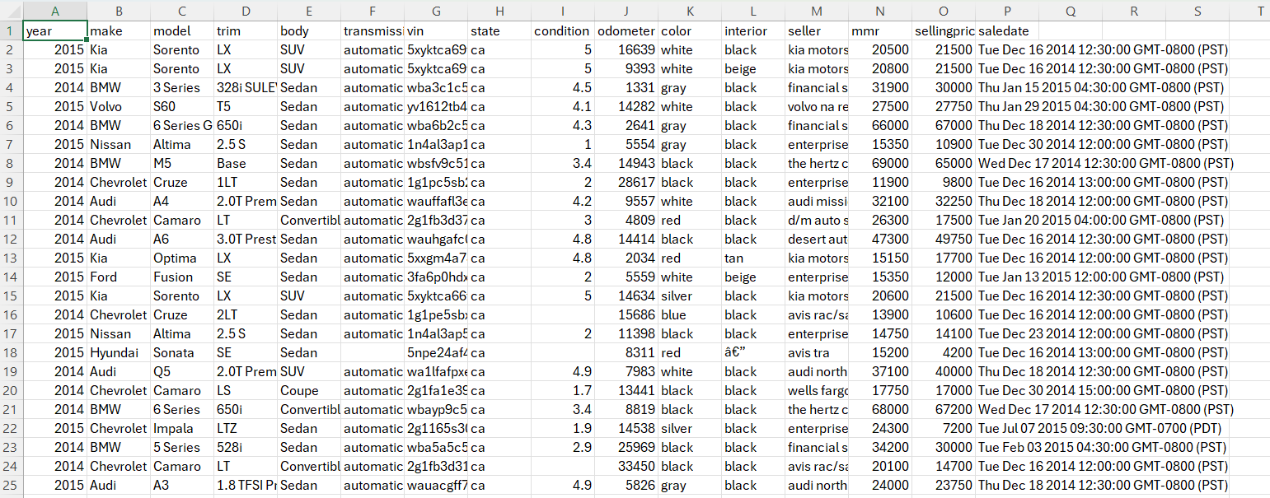
Figure 1: Collected Raw Used Car Auction Dataset.

Data Processing and Cleaning

Data Filtering
Data pre-processing and cleansing is basic to any data analytics for making past any question that no unclean or invalid information makes its way into the expository instrument. Cleaning the data can be utilized to refine the data, making it easier to develop a demonstrate of the information. Pre-processing is the act of controlling the representation of data, the expulsion of records and grouping of data to form the information mining far easier [2].
Clean the raw data using Tableau Prep.
- Exclude null values.
- Evacuate the punctuation.
- Make capitalized to state.
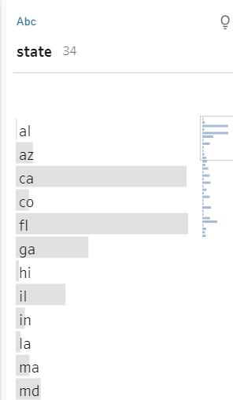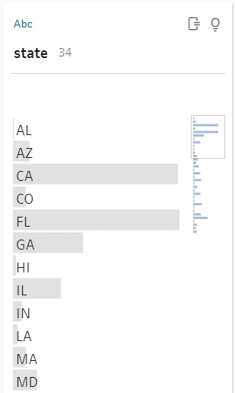  Figure 2:Convert state lowercase to uppercase | 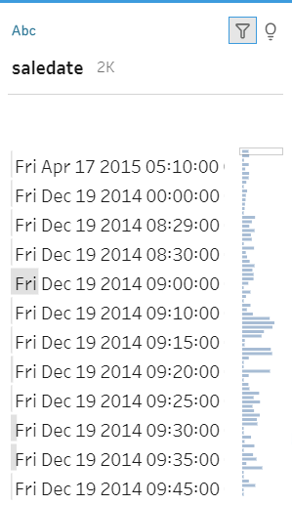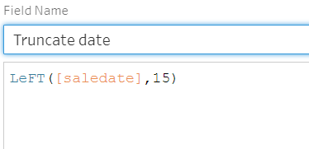  Figure 3:Implement the dd:MM: yyyy format on saledate attribute.
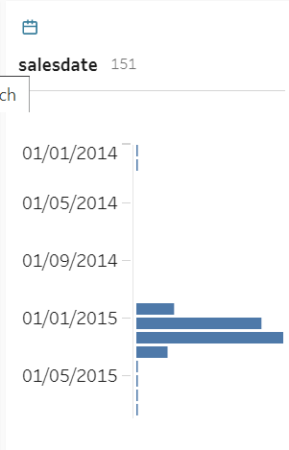  Figure 4:- Modified saledate. | 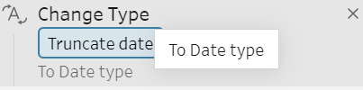  Figure 5:Rename and Change datatype.

Data preprocessing flow
CLEAN 1 (CHANGES 31)
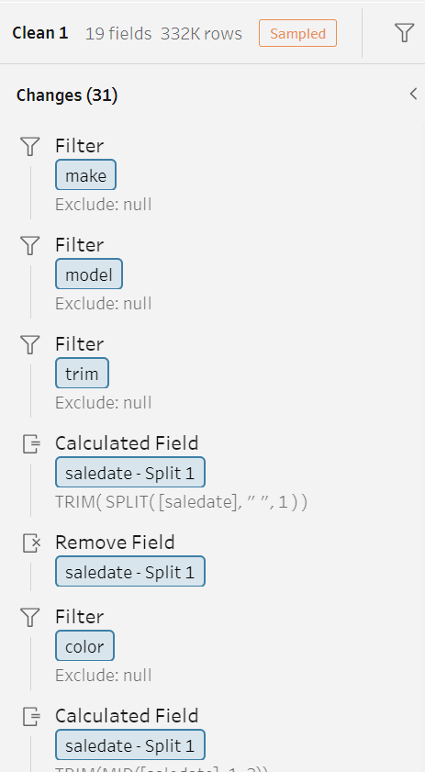 | 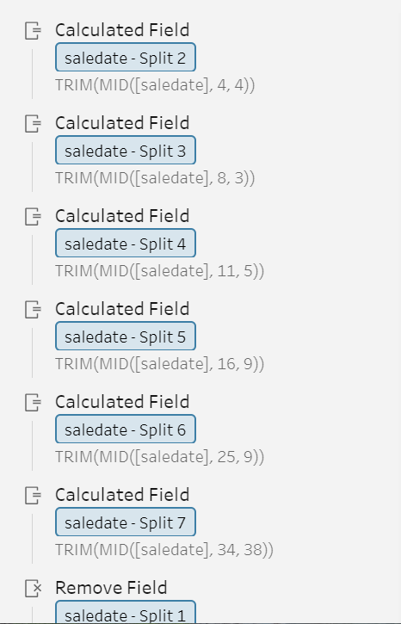 | 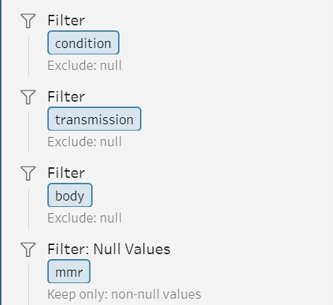
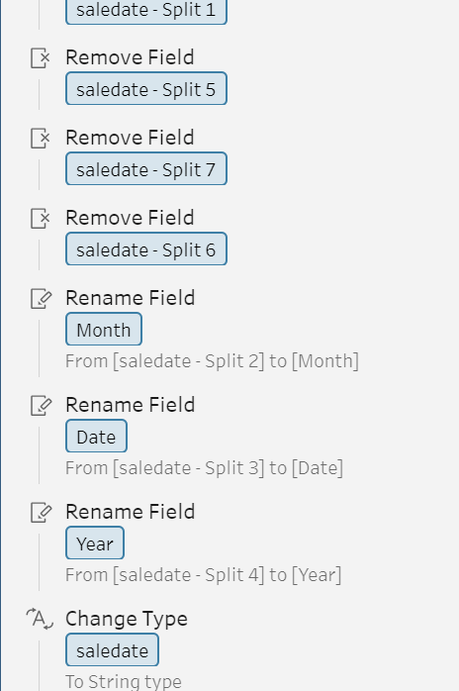 | 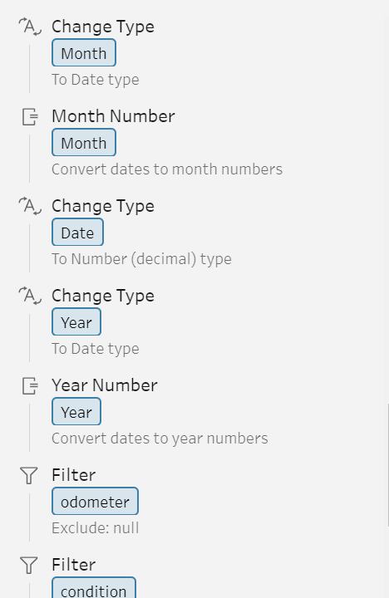
Figure 6:Data Preprocessing Stage 1

CLEAN 2 (CHANGES 10)
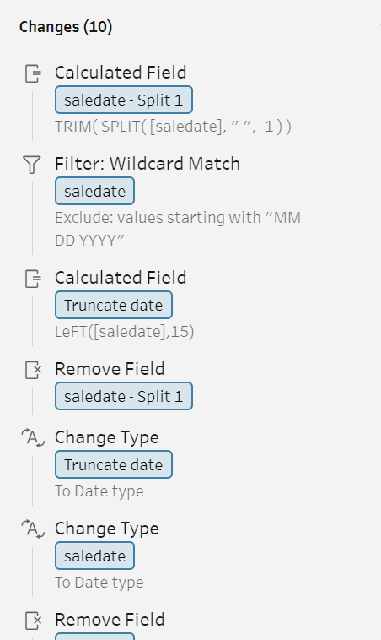 | 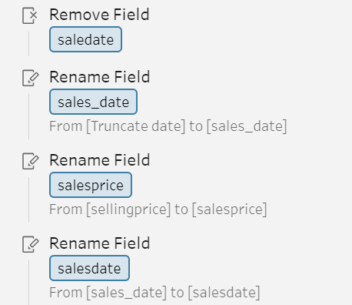
Figure 7: Data Preprocessing Stage 2
CLEAN 3 (CHANGES 8)
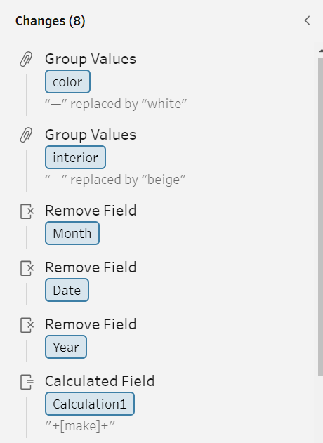 | 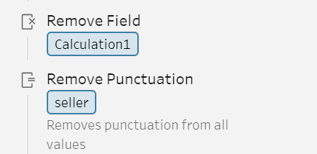
Figure 8: Data Preprocessing Stage 3

CLEAN 4 (CHANGES 1)
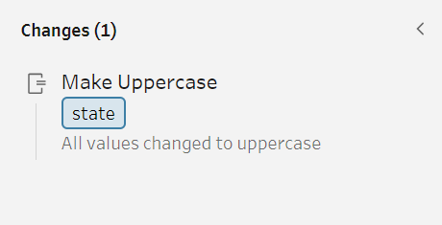
Figure 9: Data Preprocessing Stage 4
OUTPUT:
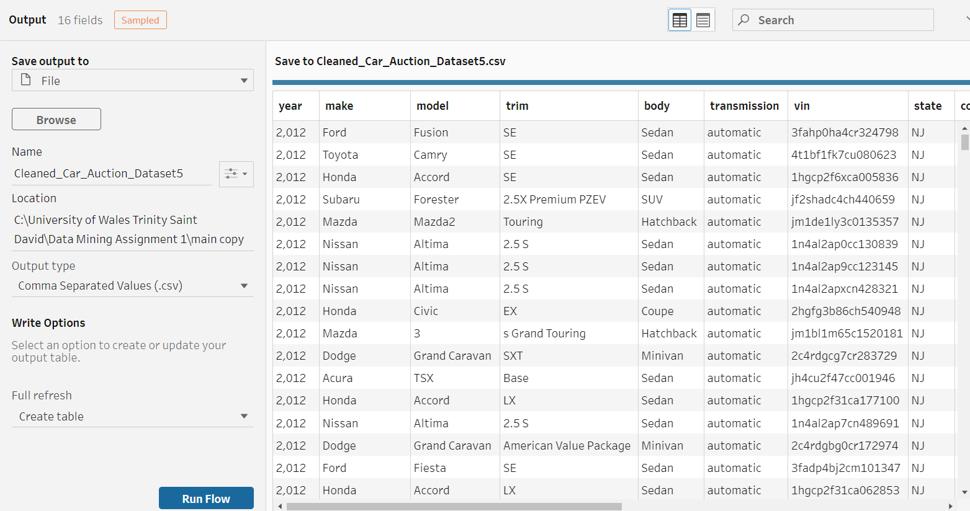
Figure 10: Output.

Tableau Prep and Excel:

This study required guarantee, the information was free of characters that might cause issues during analysis. A few programs, like Weka, can reject data containing these "illicit" characters, which can change depending on the program.
To address this, the study used two tools: Tableau Prep and Excel.
Tableau Prep: This effective data arrangement computer program permitted us to proficiently clean a huge portion of the dataset [3]. To focus on the "Title" attribute, which was most likely to contain risky characters. Utilizing Tableau Prep's cleaning capacities, to evacuate:
Spaces between words (replaced with underscores)
Apostrophes (')
Commas (,)
Percentage symbols (%)
Quotation marks (")
Excel: Whereas Tableau Prep taken care of the bulk of the cleaning, Excel was supportive for tending to a particular challenge. The question mark (?) postured an issue since Excel treats it as a wildcard during discover and replace operations, evacuating entire sections and carefully tended to this issue inside Excel to guarantee address marks. Essentially evacuated, not the complete information point.
By combining the qualities of Tableau Prep and Excel, this study can successfully expel illegal characters from the dataset without compromising the data's integrity.

Preprocessing the CSV file in Excel
To get the CSV file ready for Weka's ARFF format, the study surrounds each text entry (make, model, etc.) with single quotes. This can be done efficiently using formulas in Excel.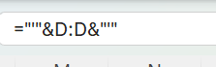
Figure 11: Add Quotes around the string.
I leveraged Excel's IF function to sort data into categories. Afterwards, I enclosed each category label in single quotes.
Formula:
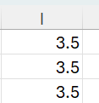 | 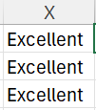 | 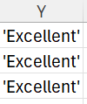
Figure 12:Condition convert to categorized.
In Excel, I created odometer reading categories based on certain conditions using IF statements. Finally, I enclosed these categories in single quotes.
Formula:
Figure 13:A Condition to convert into category.
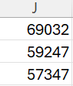 | 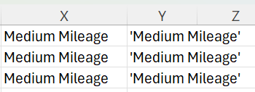
Figure 14: Odometer convert to categorized.
Thus, Leveraging Excel's capabilities, I created categories for MMR (Manufacturer’s Suggested Retail Price), classified sales by season, and further segmented them by quarter.

Creating the ARFF file for Weka.
To be usable by machine learning software Weka, the cleaned dataset needs conversion into ARFF format. This is done by adding a header section to the prepared CSV file using a text editor like Notepad++

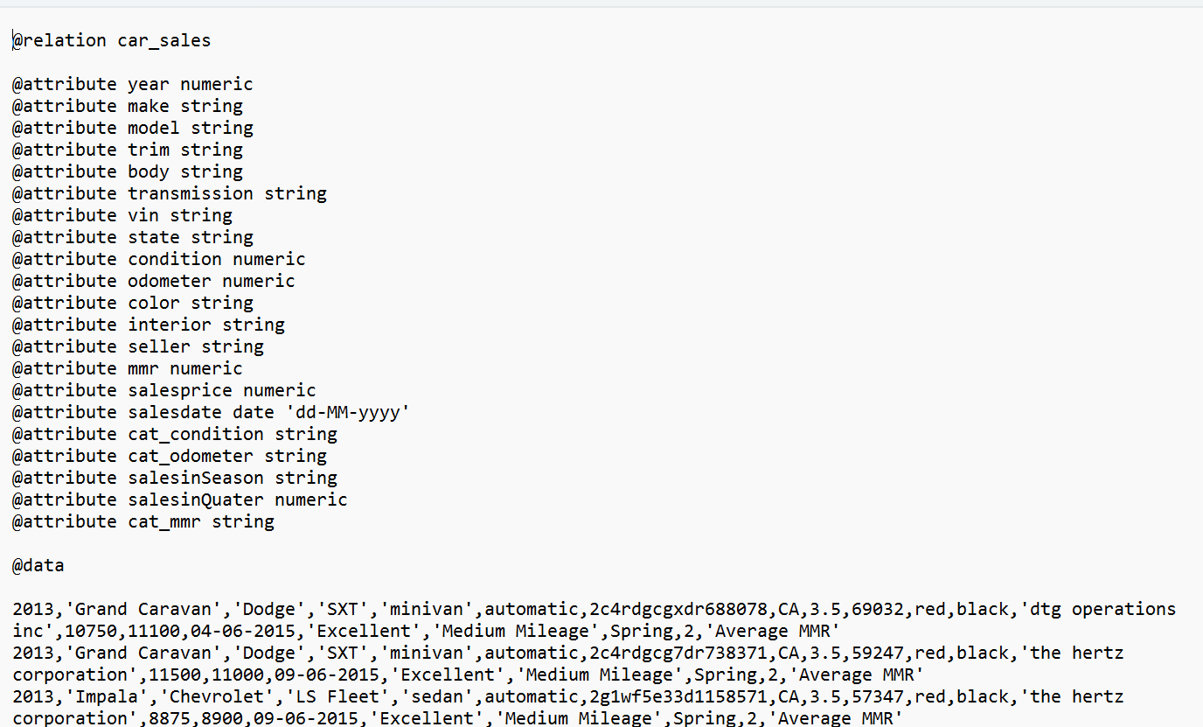

Figure 15: ARFF file.

It is important to guarantee that the information types alongside each attribute are rectify otherwise Weka will report mistakes at the import stage. Once complete, the record at that point required to be spared with a ‘. arff’ extension so that it would be recognised and opened by Weka.

Data Visualisation in Weka
The data was effectively imported into Weka. The primary step was at that point to make a visualization to see. on the off chance that any curiously designs might be found earlier to the information mining processes being run.
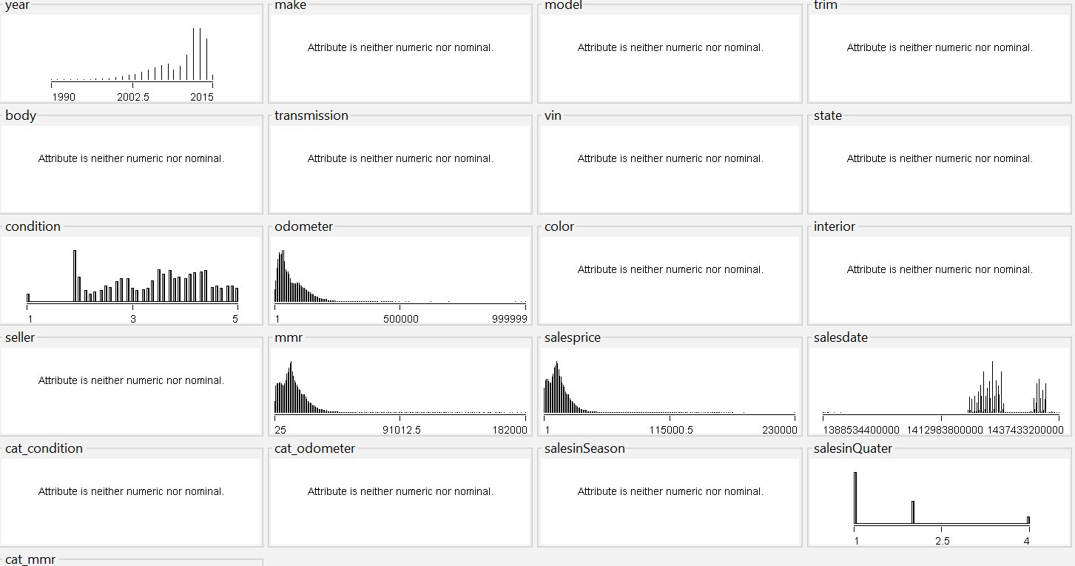
Figure 16: Weka visualisation.
After convert String and Integer into Nominal and visualize the interesting attributes, the chart looks like:
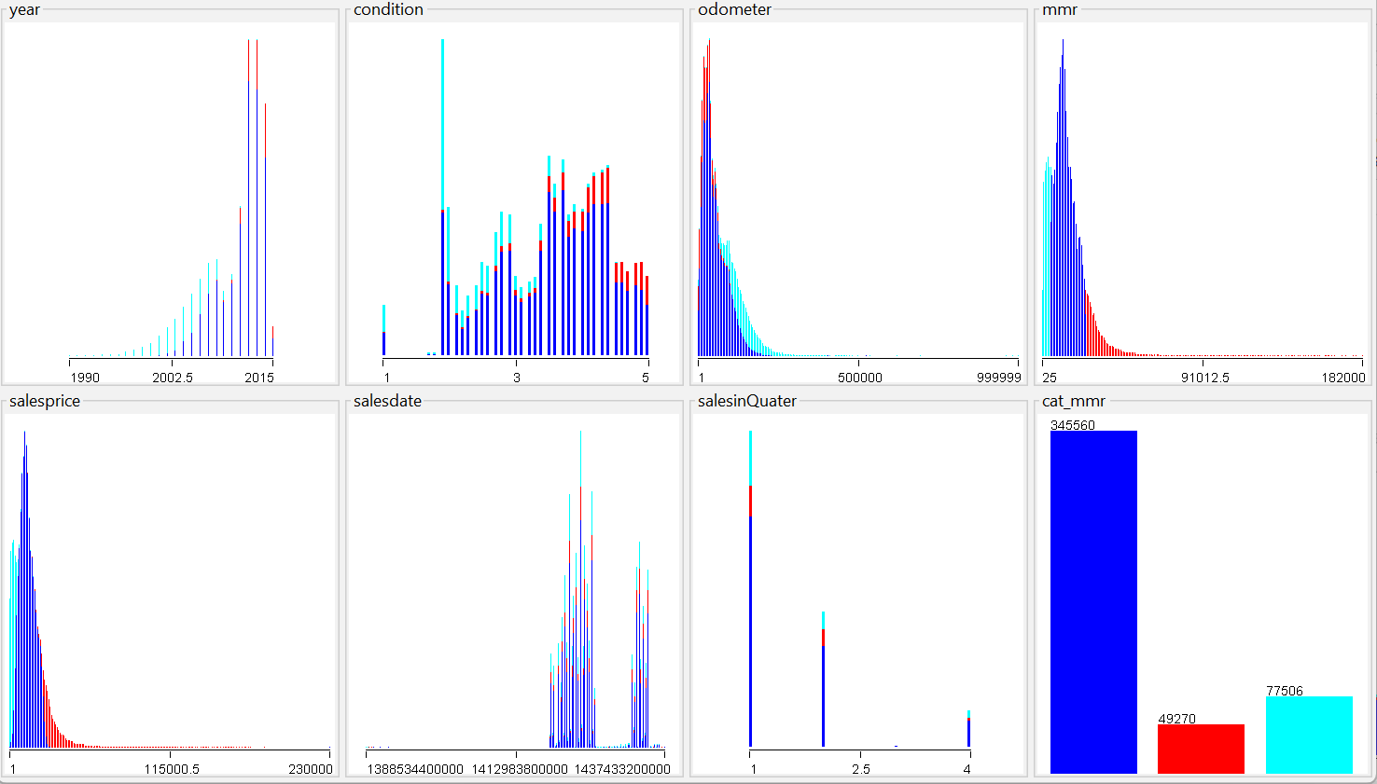
Figure 17: after nominal attributes.

Data Visualization:
Data visualization plays a pivotal part in changing raw information from the car auction dataset into significant insights [4]. This study highlights the control of information visualization in changing car sell off information into significant experiences by making charts and graphs, analysts were able to distinguish key designs and connections between components like mileage, condition, and selling price and visualizations fuelled machine learning models to anticipate future offering costs with surprising precision. It investigated another region was recognizing the ideal posting time for cars to analyse the verifiable deals information through visualization revealed seasonal and quarterly patterns. This driven to the creation of new attributes like "Sales in Season" and "Sales in Quarter" that combined with clustering calculations, had influence pinpoint the perfect sell off listing time to maximize deals potential.
Information visualization too played a significant part in understanding buyer inclinations over distinctive states, visualizing car highlights and deals information revealed state-specific patterns. For illustration, California buyers might prioritize fuel proficiency, whereas Texas buyers might favour trucks with high towing capacities. This information permits focused on publicizing, highlighting the foremost significant highlights to draw in buyers in each state. At last, the study pointed to distinguish cars likely to produce high bidding competition by visualizing car properties with high offers uncovered key associations and shaped the premise for clustering cars with comparable highlights, empowering the distinguishing proof of future cars likely to pull in a high number of offers and higher offering costs.
In conclusion, data visualization serves as the establishment for opening profitable experiences from car sell off information by leveraging these bits of knowledge, car auctions can optimize their forms for way better decision-making and made strides results.

Classification and Clustering
Classification:
Data mining relies on classification algorithms, which enable us to uncover hidden patterns within data and provide predictions based on data [5]. The way these computations operate is by using labelled data, where each data point corresponds to a pre-established class or category. Through the analysis of these designated images, the computations build models that, at that time, assign contemporary, subtle data points to the appropriate category.
In the report, I employed the following categorization algorithms:
J48 Decision Tree: With the use of this technique, a tree-like structure is constructed, with each hub responding to a test based on a data property [5]. At that point, the data is categorized by going through the tree according to the results of these tests. J48 could be an Well-known choice due to its interpretability - the decision tree structure gives a clear picture of the classification logic [5].
Naive Bayes: This probabilistic method of categorization assumes that properties are autonomous [5]. Based on the individual probabilities of each attribute esteem having a spot in that class, it determines the chance that an information point will belong in that class. Naive Bayes is well-known for its expertise and performs admirably on large datasets [5].
Alternatively referred to as k-Nearest Neighbors (KNN), the instance-based learning (IBK) technique classifies a data point by calculating the greater part vote of its k nearest neighbors inside the preparation information [5]. One parameter that may be adjusted to maximize execution is the value of k. IBK is a simple and versatile method, although for large datasets, it can be computationally expensive [5].
AdaBoostM1: This ensemble learning process creates a single, more grounded learner by combining several helpless learners [6]. AdaBoost trains the fragile learners iteratively by emphasizing on knowledge areas that were incorrectly categorized in earlier rounds. Compared to individual weak learners, this method can produce stronger and more accurate classification models [6].
Clustering
By aggregating comparable data points, clustering algorithms are essential to data inquiry [7]. This handle makes it easier for us to see fundamental patterns and structures in the data that may not be immediately obvious when using other methods. Here are two clustering techniques that are often used:
FilteredClusterer: Using the clustering algorithm, this method selects a subset of qualities that are most crucial to the clustering assignment using a channel [8]. This may progress the effectiveness and adequacy of the clustering handle, particularly when managing with high-dimensional data.
SimpleKMeans: This clustering technique divides data points into a predetermined number of clusters (k) and is often based on centroid clustering [8]. Every data point is repeatedly assigned to the cluster whose centroid is the nearest (i.e., the average of the cluster's information foci). At that point, the process is repeated until merging is completed, with the centroids being recalculated using the freshly relegated data focuses [7]. Because it is simple to use and effective, SimpleKMeans is a popular option, nevertheless, it assumes that the clusters be circular in shape.

Research Questions
In this examination dove into the curiously world of data mining to open the favoured encounters behind successful car sell off that included a huge dataset of over 472,000 car entries, but to guarantee a smooth beginning examination, the think about begun with a smaller, specialist test of 15,000 cars data entries by aimlessly selecting a test utilizing methods like "Randomize" and "ReservoirSample" , to appear get an impressive feel for the composition without getting overwhelmed. Once the study gets to manage on the data's structure and the calculations included that ensure to take care of the whole dataset to answer all four explore questions comprehensively. This approach outlined to be exceedingly successful and permitted to investigate diverse information mining strategies like K-Means clustering and J48 decision trees, unavoidably revealing profitable experiences into the car sell off stream.

Question 1
Can I predict the selling price of a car based on its mileage, condition, and MMR?
Yes, I can predict car auction selling price based on year, mileage, condition, and MMR (Market Median Retail) with high accuracy.

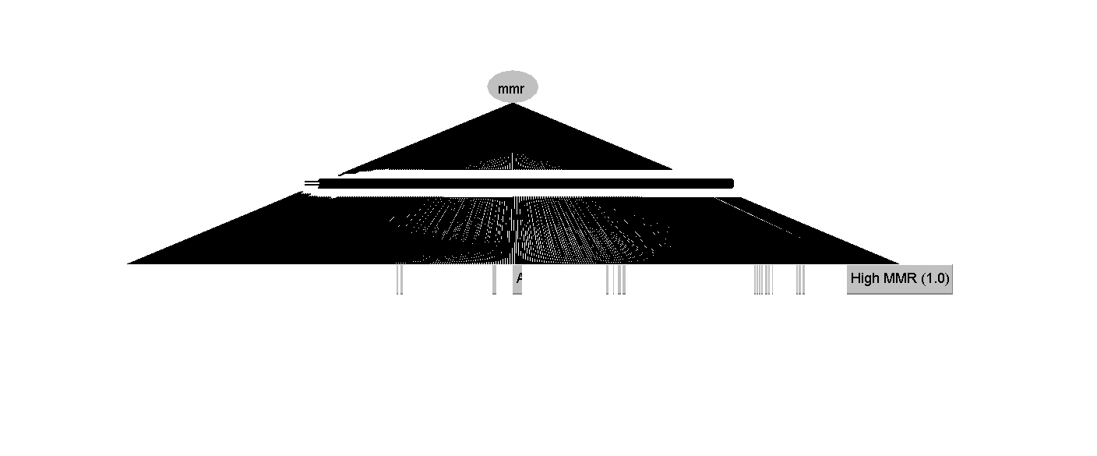
Figure 18: Visualisation of j48.
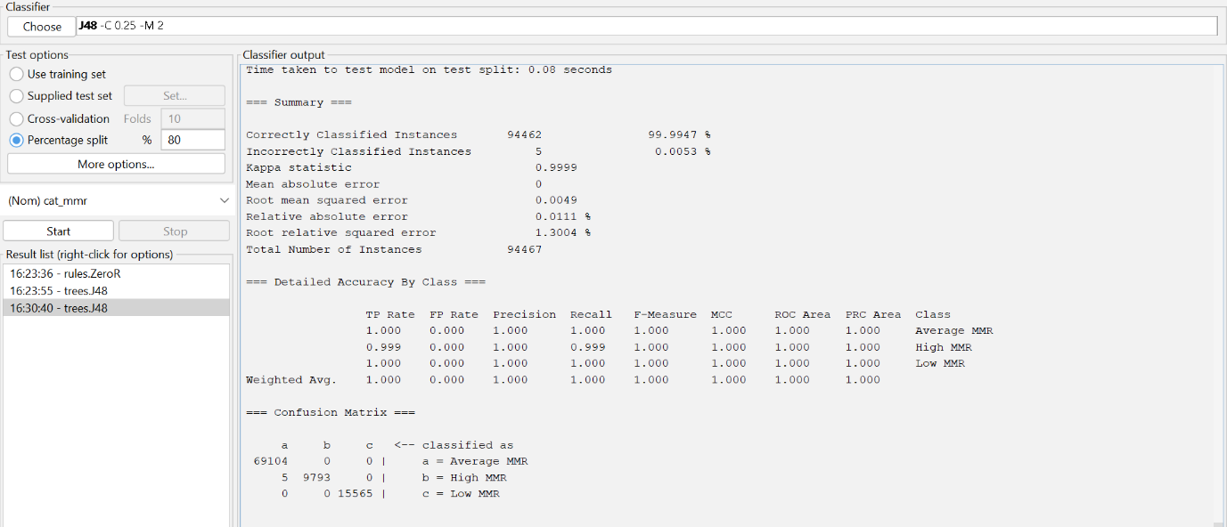
Figure 19: J48 classifier.
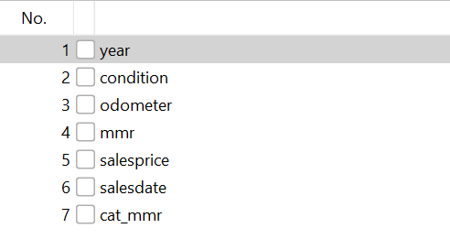
Figure 20: Used attributes for classification.

Classifier | Accuracy (%) | Mean absolute error | Root mean squared error | Root relative squared error (%) | Time Consumption
ZeroR | 73.1515 | 0.2846 | 0.3773 | 100 | No time complexity
AdaBoostM1 | 73.1515 | 0.278 | 0.3729 | 98.837 | No time complexity
IBK | 89.1518 | 0.0953 | 0.2222 | 58.9073 | High time complexity  (6413.15 seconds)
Naive Bayes | 99.2008 | 0.0075 | 0.0623 | 16.5221 | No time complexity
J48 | 99.9947 | 0 | 0.0049 | 1.3004 | No time complexity
Table 2: Analysis with various classifier

This report investigates the potential of machine learning to advance fetched forecast accuracy. It focuses on a J48 choice tree, a successful instrument for classifying data focuses based on a course of action of rules. The show examinations car highlights like mileage, condition, and MMR to expect the advertising fetched category at sell off.
The methodology included collecting authentic car sell off information on properties like year, condition, mileage, MMR, and sale date. Numerical properties (year, mileage, condition) changed over into categories appropriate for the J48 model, whereas categorical information (MMR category) remained untouched. I am at that point chosen a few machine learning calculations (J48, Naive Bayes, KNN, AdaBoostM1, ZeroR) for comparison. Finally, the pre-processed information was part into training (80%) and testing (20%) sets. The J48 demonstrate was prepared on the preparing information to predict cost categories (High Offered, Average Offered, or Low Offered) and assessed on the testing set utilizing different metrics like accuracy, error rates, and class-wise performance measures.
Overall Accuracy:
Exceptionally high accuracy (near to 100%) implies the model can successfully classify car auction prices into categories for inconspicuous data.
Error Rates:
Irrelevant mistake rates with Mean Absolute Error (MAE) of and Root Mean Squared Error (RMSE) near to illustrate high forecast precision.
Kappa Statistic:
Near to 1.0, assist affirming the strong understanding between model predictions and genuine selling costs.
Class-wise Accuracy:
The demonstrate performed Well for all cost categories with Precision, Recall, and F1-Measure values near to 1.0 for each class (High Bid, Average Bid, Low Bid).
This cost categorization engages both buyers and venders within the car marketplace. Buyers can use the anticipated cost run (High Bid, Average Bid, or Low Bid) based on car highlights to create educated offering procedures, avoiding overspending, or missed openings. Dealers pick up profitable experiences into the potential offering cost category for their car, permitting them to set reasonable save costs and oversee their desires amid the sell off.
This report outlines the ampleness of machine learning for car auction price expectation and shows the J48 decision tree stands out due to its surprising accuracy, low errors, and speedy preparing time that makes it an able instrument for both buyers and merchants to make educated choices within the car auction marketplace.

Question 2

Can I identify patterns, what is the optimal time to list cars for auction based on historical sales data and seasonality?
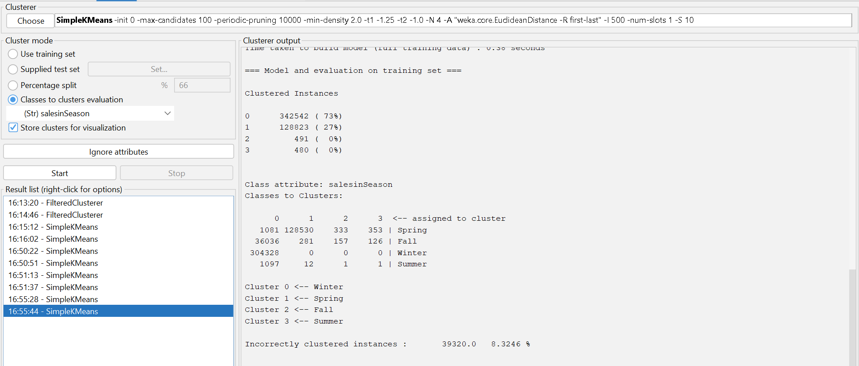
Figure 21:SimpleKMeans using sales in Season.
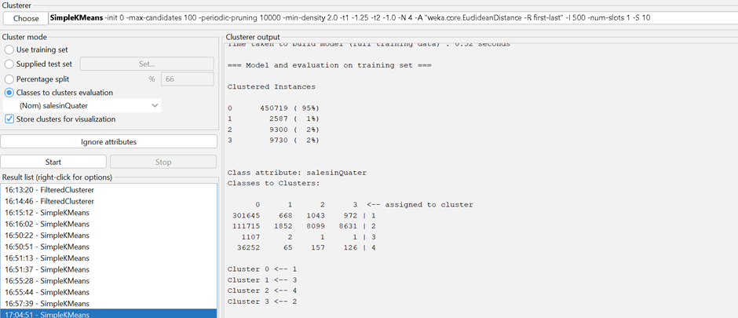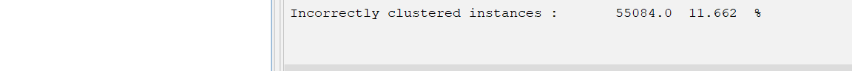
Figure 22:SimpleKMeans using sales in Quarter.
Clusterer | Car Sales | Accuracy (%)
Filtered Clusterer | Sales in Quarter | 67
Filtered Clusterer | Sales in Season | 76
SimpleKMeans | Sales in Quarter | 89
SimpleKMeans | Sales in Season | 99
Table 3: Analysis with different Clusterer and attribute
This question investigates the impact of seasonality on car auction sales success. I examine historical sales information utilizing K-Means clustering to distinguish potential designs in sales performance over different seasons and quarters.
The success of a car auction pivots on different variables, including the sort of car, its condition, and, significantly, the timing of the auction. This report examines the relationship between seasonality and auction sales by examining historical information.
Historical car auction deals information was obtained, containing traits like "car sales in season" (Summer, Winter, Spring and Fall) and "sales in quarter" (1, 2, 3, 4) to investigate seasonal patterns. I moreover considered counting the “sales date” (MM:DD: YYYY) for encourage granularity. To recognize designs inside the information, K-Means clustering was utilized. This procedure groups comparative sales information focuses based on the chosen attributes. The clustering accuracy was at that point utilized to assess how effectively these attributes captured critical designs within the information.
Introductory clustering utilizing "car sales in season" and "deals in quarter" accomplished high accuracy (around 99% and 89%). This proposes a strong relationship between regular patterns and quarterly varieties in auction sales success.
This examination proposes a solid relationship between car auction deals success and seasonality. Winter and Q1(Quarter 1) show up to be ideal periods for auctions based on the information.

Question 3

Which car attributes should I prioritize when advertising cars for auction to attract buyers in specific states?
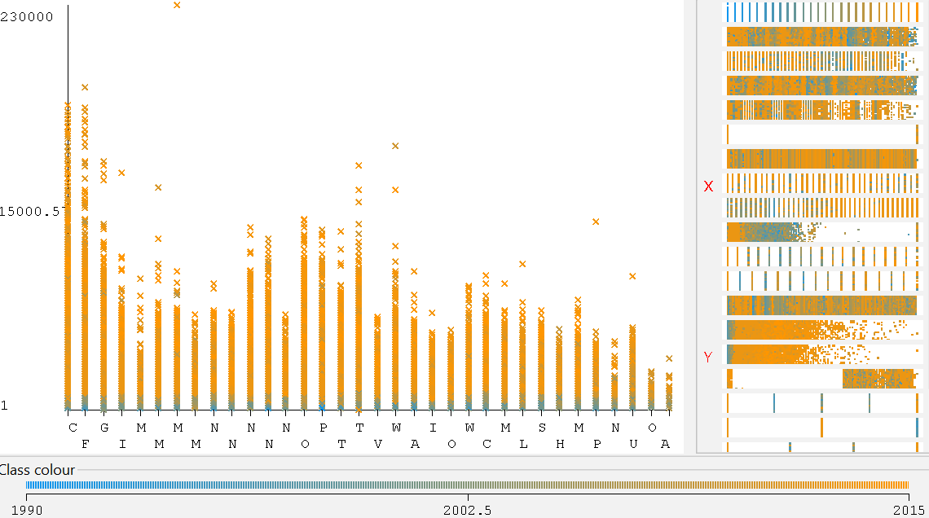 | 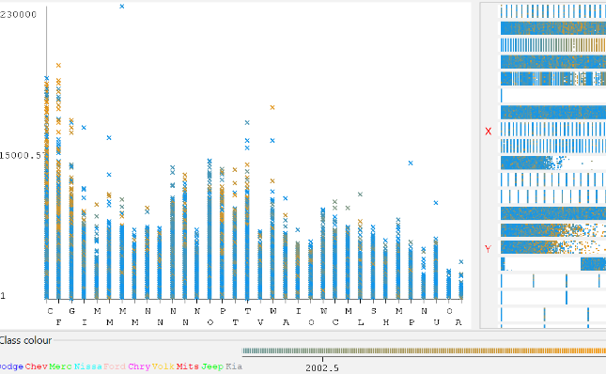
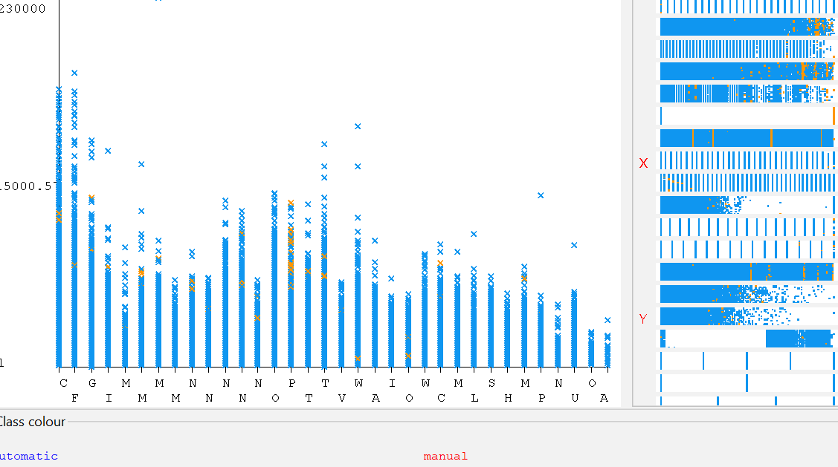 | 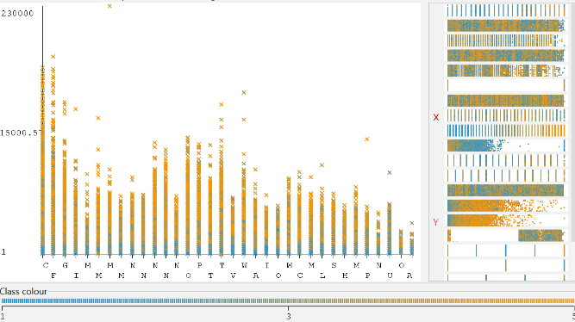
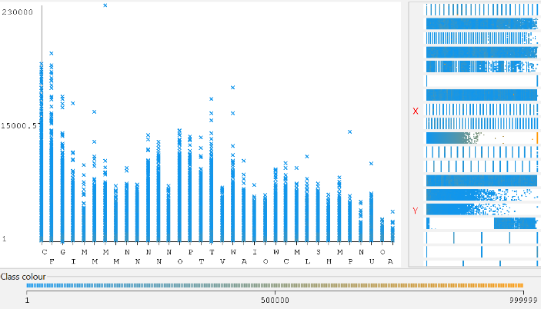 | 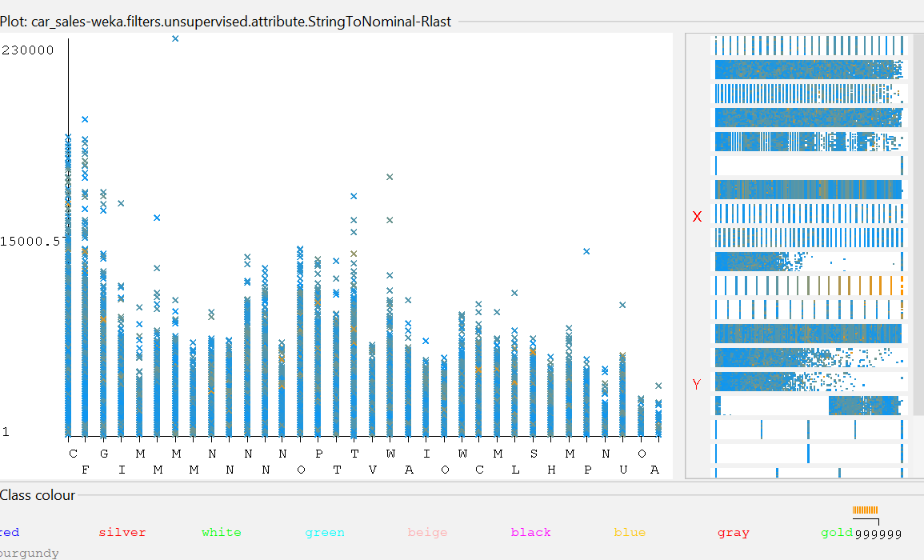
Figure 23 - Visualisation.
This report explores the utilize of clustering methodologies to recognize car traits that are most critical to pulling in buyers in specific states, to look at how clustering car sell off data based on attributes like year, make, model, body style, transmission, and area can uncover state-specific buyer inclinations. This study appears the benefits of this approach for making focused on publicizing campaigns for car barters and the triumph of a car sell off turns on drawing in the proper buyers. It makes a difference to get it what kind of cars most appealing distinctive local people is crucial for effective advancing. Besides, the report explores a data-driven approach to recognizing key car characteristics that resound with buyers in particular states. Too propose utilizing clustering calculations, such as those available inside the Weka software, to dissect car auction information. Utilizing data ought to consolidate qualities such as:
Year, Make, Model, Body style (e.g., sedan, SUV, truck), Transmission (automatic or manual), State where the car is being sold, Vehicle condition, Odometer perusing, Colour.
By changing over numeric and string values to ostensible values (e.g., utilizing filters like NumericToNominal and StringToNominal in Weka), the data can be orchestrated for clustering calculations like FilteredClusterer (74%), MakeDensityBased (65%), or SimpleKMeans (64%).
These calculations accumulate cars with comparable characteristics into clusters that looks at the clusters for states, able to recognize designs in buyer inclinations. For occasion, a cluster for FL (Florida) might reveal an inclination for more up to date Dodge models with automatic transmission, good condition (scores 3-5), lower mileage (beneath 40,000), and colors like red, beige, or white. These clustering car auction data based on state and key characteristics offers valuable bits of knowledge into state-specific buyer preferences. The bits of knowledge to make focused on publicizing campaigns licenses car auctions to pull in more noteworthy buyers and finish more prominent victory.

Question 4
which cars will have the most competition (bids) based on their attributes?
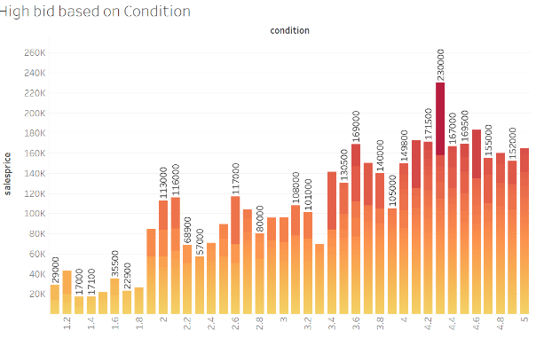 | 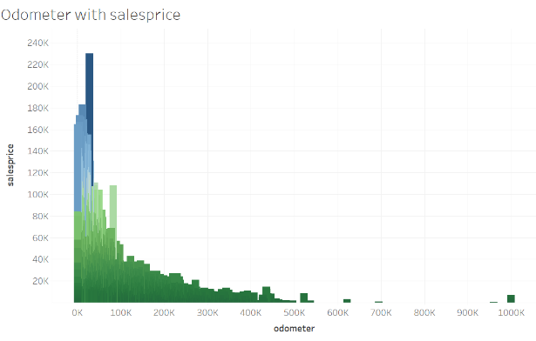
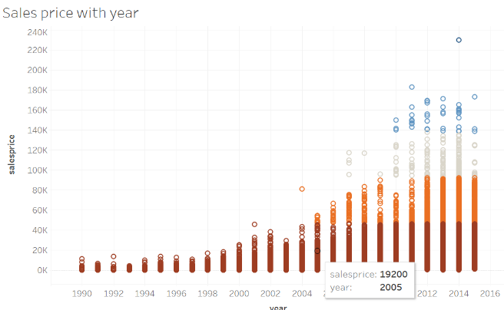 | 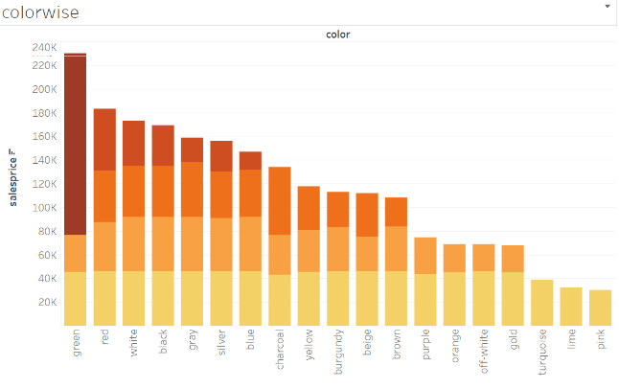
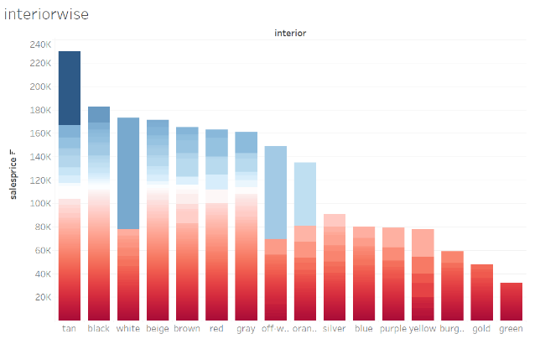 | 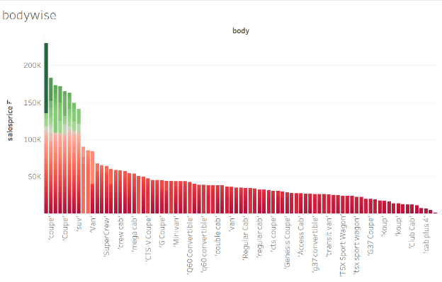

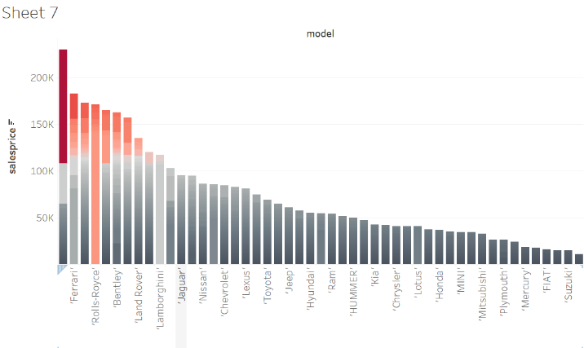
Figure 24: Visualisation.
This report looks at the properties of utilized cars that pull in the preeminent offering activity in barters and the consider hypothesize that combinations of year, make, model, body style, transmission, condition, mileage, exterior color, and insides color affect offering conduct to utilize verifiable sell off data inspected through Tableau's rich visualization capabilities, to recognize key qualities that foresee high final offered costs.

The study utilized car promotes turns on understanding buyer slants. Car qualities influence final sell off costs and the report focus to recognize these key qualities and anticipate which car courses of action deliver the foremost competition (bids) based on historical auction data.
This study inspected verifiable sell off data containing properties like year, make, model, body style, and more and the information was stacked into Tableau. Inside Tableau, explore with distinctive charts and visualizations to examine associations between car attributes and final offered costs. By dismembering the various charts and visualizations created by Tableau, I recognized key patterns:
Year: Cars manufactured between 2010 and 2015 risen as particularly appealing.
Body Style: Well-known body styles included coupes, SUVs, and convertibles, proposing a move in inclination from conventional sedans.
Transmission: Automatic transmissions remained the favoured choice.
Condition: Cars in excellent condition (ratings of 4-5) earned the preeminent offers.
Mileage: Low mileage (beneath 50,000 miles) was a noteworthy figure.
Exterior Color: Though classic colors like red, white, black, and grey remained well known, green, silver, and blue additionally developed as appealing options.
Interior Color: Fair-minded interiors (tan, black, white, beige, brown) were predominant, with the extension of red and grey moreover pulling in offers.
Brand: Luxury brands like Ferrari, Rolls-Royce, Bentley, Land Rover, and Lamborghini pulled in higher offers.
Tableau's visualizations effectively shown these encounters. This information engages both merchants (by optimizing postings to target high-bid arrangements) and buyers (by focusing on cars likely to start bidding wars) to make educated choices inside the utilized car advertise. By leveraging Tableau's visualization devices, the think about recognized key qualities that expect tall offers inside the utilized car publicize that engages both vendors and buyers to make vital choices that maximize their victory.

Analyses and Findings
This study focused on recognizing the car attributes that need to be prioritized when advancing cars for sell off in specific states. To realize this, the think about dug into the world of Weka, an able information investigation arranges and utilized the number of Weka capacities to choose up a comprehensive understanding of buyer inclinations over states.
Classification: This method pointed to anticipate the state where a car is likely to be sold based on its attributes. By dismembering the preeminent influential properties for this desire, the consider recognize which ones resonate most with buyers in specific ranges and it empower refined this examination by utilizing property assurance, which pinpointed the foremost critical qualities for foreseeing the state. In addition, the consider assessed with distinctive classification calculations, including J48 (decision tree), Naive Bayes, and Support Vector Machine (SVM), to build strong models.
Clustering: In this consider utilized clustering to gather cars with comparative characteristics to dissect the characterizing characteristics of each cluster that reveal what draws in buyers in specific locale. This approach included testing with clustering calculations like SimpleKMeans (centroid-based) and FilteredClusterer.
Association Rule Learning: At final, the think about utilized affiliation run the show learning to uncover secured up connections between car traits and the state where the car is sold and used methods like Apriori or FP-Growth calculations made a contrast us recognize these associations.

Reflection
This investigation served as a viable crucial point, uncovering the factors that impact car sell off deals over diverse states by utilizing the explanatory capabilities of Weka and eviscerating car qualities adjacent deals information, the think about too opened a treasure trove of potential. One of the first energizing conceivable results lies in focused on promoting by pinpointing the car properties that reverberate most with buyers in specific states, prepared to form advancing campaigns that are laser-focused and impactful and after that move towards focused on educating holds the potential to progress promoting ampleness. Other than, the ponder empowers car proprietors with profitable data. By understanding the subtleties of regional inclinations, car proprietors can intentionally highlight significant qualities in their sell off postings and recently found understanding has the potential to advance the deal capacity of their cars.
Without a doubt, more curiously is the possibility of uncovering covered up designs in car sell off information that makes a difference to examine serves as a springboard for finding rising patterns in buyer inclinations over diverse states and information can be an outstanding alter, allowing us to anticipate and alter to the ever-evolving wants of car buyers over the nation. In any case, it is critical to recognize the restrictions characteristic to this examination. The quality and completeness of the data can affect the precision of our disclosures and the outside factors past our control, such as financial conditions or sudden spikes in demand for models, can affect genuine buying conduct.
This journey does not end here. Able to dive without a doubt more profound by testing with differing Weka capacities and parameters. This examination might abdicate indeed more profitable encounters for me. Other than, joining additional data sources, like statistic information or chronicled sell off data, appear progress upgrade the examination and provide an without a doubt more comprehensive picture by ceaselessly refining our approach and developing the scope of our examination, I have pick up a critical understanding of the qualities forming car sell off bargains over diverse states and this information enables not as it were car proprietors and promoters but as well the complete car sell off industry to investigate the showcase with more conspicuous foreknowledge and victory.

Conclusion
Data mining opens a treasure trove of bits of information for the car sell off industry, changing it from a hypothesizing redirection to a data-driven marketplace by dissecting car focuses of interest, historical data, and buyer behaviour, participants can directly anticipate offering costs with near-perfect accuracy utilizing algorithms like J48 decision trees. To recognize that the winter and Q1 rise as conceivably golden quarters for auctions, based on regular patterns. Other than, data mining sheds light on state-specific buyer slants, permitting for focused on advancing campaigns that resound with neighbourhood social occasions of individuals, but the enchantment does not stop there. In fact makes a contrast pinpoint the exact car characteristics that ignite offering, vehicles from 2002-2015, popular body styles like minivans and sedans, automatic transmissions, excellent condition, low mileage, classic exterior colors (think red, white, black, and grey), and neutral interiors (black, brown, tan, dark, and beige) are the equation for drawing in the preeminent offers. In core, data mining empowers car sell off individuals to make vital choices based on difficult facts, eventually driving to a more successful and taught encounter for both buyers and merchants.

References
[1] “Used Car Auction Dataset”, Kaggle, 2015. Available: https://www.kaggle.com/datasets/tunguz/used-car-auction-prices.
[2] S. Sharma and A. Bhagat, “Data preprocessing algorithm for web Structure Mining,” in 2016 Fifth International Conference on Eco-friendly Computing and Communication Systems (ICECCS), 2016, pp. 94–98. doi: 10.1109/Eco-friendly.2016.7893249.
[3] K. Munroe, 2022.
[4] H. M. Shakeel, S. Iram, H. Al-Aqrabi, T. Alsboui, and R. Hill, “A Comprehensive State-of-the-Art Survey on Data Visualization Tools: Research Developments, Challenges and Future Domain Specific Visualization Framework,” IEEE Access, vol. 10, pp. 96581–96601, 2022, doi: 10.1109/ACCESS.2022.3205115.
[5] D. R. Hermawan, M. Fahrio Ghanial Fatihah, L. Kurniawati, and A. Helen, “Comparative Study of J48 Decision Tree Classification Algorithm, Random Tree, and Random Forest on In-Vehicle CouponRecommendation Data,” in 2021 International Conference on Artificial Intelligence and Big Data Analytics, 2021, pp. 1–6. doi: 10.1109/ICAIBDA53487.2021.9689701.
[6] P. Wang, W. Qu, H. Jiang, Y. Dong, and T. Gao, “A fusion classifier algorithm based on AdaBoost,” in 2021 2nd International Seminar on Artificial Intelligence, Networking and Information Technology (AINIT), 2021, pp. 47–51. doi: 10.1109/AINIT54228.2021.00018.
[7] H. Mydyti and A. Kadriu, “The Data Mining Approach: A Case Study - Clustering Algorithms for After Sales Service,” in 2021 10th Mediterranean Conference on Embedded Computing (MECO), 2021, pp. 1–6. doi: 10.1109/MECO52532.2021.9460149.
[8] M. Kr. Gupta and P. Chandra, “A Comparative Study of Clustering Algorithms,” in 2019 6th International Conference on Computing for Sustainable Global Development (INDIACom), 2019, pp. 801–805.
[9] I. H. Witten, F. Eibe and M. A. Hall, Data Mining: Practical Machine Learning Tools and Techniques, Amsterdam, 2011.

