Data Security Standards, Frameworks and Implementation within a Modern Business Network Environment

Paul M Lawrence - Postgraduate Student, MSc Computer Networks and Cybersecurity
University of Wales Trinity St David, Swansea Bay Campus SA1
plawrence.152216@student.uwtsd.ac.uk

Abstract – This research paper outlines what and why an Information Security Management System (ISMS) is used for within a business network, along with the differences between an ISMS; standard, framework and security model. The focus of the research is aimed at UK business ISMS; ISO 27001-27006, ISO 270017-27018, ITIL, PCI-DSS and Cyber Essentials. The knowledge gained from the research was then implemented within a fictious company called ‘Caribbean Coffee Ltd’ that has a hybrid Wireless Local Area Network (WLAN) and cloud services architecture in which an ISMS framework was successfully developed.

Keywords-component; ISMS, ISO 27000 Series, ITIL, PCI-DSS, Cyber Essentials, Controls, Assets, Risk Treatment, Cloud Security, WLAN, Network Security Architecture, Data Security

Introduction to - Data Security Management Frameworks

Data security frameworks within the information age we live in today play a vital role within training and/or guiding network security architects/engineers in safely securing and effectively managing customer and/or business client’s data within a modern computer network, either locally and/or remotely within a cloud architecture. [1]

Within a modern cloud driven network architecture, businesses sensitive data is often transmitted across the highly unsecure public Wide Area Networks (WAN) [2] i.e. the Internet [3], where malicious actors whom objective is to steal valuable information by exploiting the vulnerabilities that exist within the Internet in order to intercept sensitive data packets whilst they are in transit [4]. The types of data that malicious actors attempt to steal are of a highly sensitive nature such as; employee/personal data, financial and network infrastructure/device login credentials, intellectual property etc. for monetary gain. [5][6]

Malicious actors i.e. ‘Black-Hat’ hackers [7] do not only target data traversing the public WAN, but most often target internal LAN [8] architectures using various exploits and techniques such as; social engineering i.e. manipulating staff to reveal their login credentials or physically accessing a device within a network to upload malware [9] using a Universal Bus (USB) memory device [10]. [11], [12]

External threats within a contained Local Area Network (LAN) architecture from the WAN are also a major risk factor for companies such as; remote exploitation of known vulnerable ports and/or services, phishing E-Mails i.e. malware threats etc. [9], [11]

Business data theft cannot only be utilized by hackers to access bank accounts, financial spreadsheets and intellectual property for monetary gain as previously discussed, but also employee personal data and generic business data can be obtained and sold as a commodity to unscrupulous data mining companies that operate within the field of data analytics, that utilize data very efficiently by aggregating masses of raw data from various sources for; targeted marketing, election swaying and/or propaganda along with many other industries who can subsequently profiteer from such personal/business information once it has been organized, and analyzed then visualized into graphs etc to understand the data patterns monetary value potential within industries around the globe . [13]–[15]

Therefore, raw data can be described as the new oil [16] within the 21st century because of its high monetary value within todays data analytics market [17].

Because data is both highly profitable and can also be used maliciously within the wrong hands, there are laws and regulations within various countries and/or continents that have been put in place to regulate how data is stored and secured within various corporate networks across many industries to protect consumers around the globe. The governance of data protection laws and ethics vary between countries and/or continents, they outline how a company that is storing data pertaining to sensitive information such as; intellectual property, personal information and passwords should be secured. [18]–[20]

Within the European Union (EU) such governance is called; the General Data Protection Regulation (GDPR) [21] law that was introduced in May of 2018. GDPR states that if customer/client data is breached and/or stolen, the company housing the information is held accountable for the loss, thus incurring fines of up to; 20 million euros or 4% of annual turnover depending on which amount is the highest. Breaching GDPR law can cripple and even bankrupt Small-to-Medium sized Enterprises (SME) [22]. That is why protecting client/customer data is paramount for companies in today’s digital ecosystem. GDPR is widely regarded by data security professionals as the most robust and stringent data protection law in the world. [19], [21]
- Data Security Frameworks and Models
Data security frameworks and models have been developed by various organization around the world. They are tailored to provide guidance to network security architects/engineers in order to aid within designing a secure networks according to the business requirements and type of; industry, data and network infrastructure environment that the data is being stored within, these frameworks are referred to as Information Security Management Systems (ISMS) [23] that consist of controls that are designed to protect a businesses data assets. [1], [23]

Data security frameworks outline all stages of a computer network security architecture from; planning, design, development, risk evaluation and risk treatment of the business assets, through to the implementation stage, security auditing and documentation of the network along with continuous monitoring and change-controls. The asset controls within an ISMS stem from the foundations of the network security pillars; Confidentiality, Availability and Integrity (CIA) triad [24].

The foundations of a generic ISMS framework can be broken down into five distinct categories that each outline the lifecycle of an ISMS and how it should be implemented within an IT business solution. These categories can be found in figure 1.

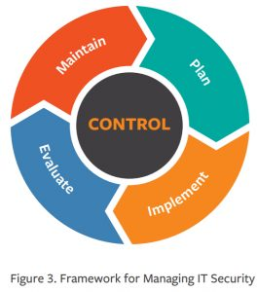
Figure 1: 5 Stages of a Generic ISMS [25]
The scope of the generic ISMS categories can be found in Table 1.

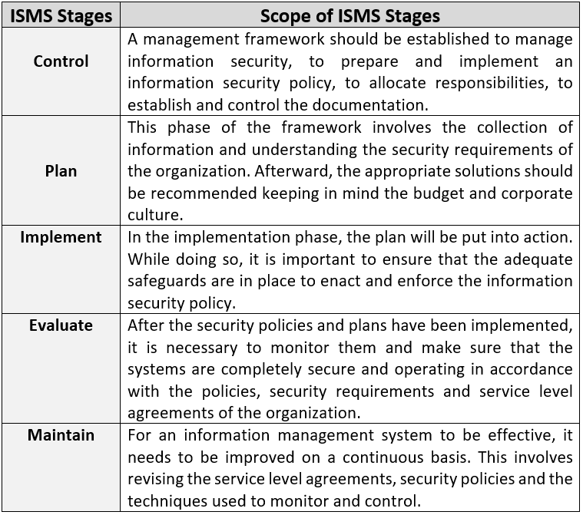
Table 1: The 5 Stages of a Generic ISMS System Defined [20], [22], [23], [24]
Four industry recognized data security ISMS; ISO 27000 universal standard [28], ITILv4 framework [25], Cyber Essentials [29] and PCI-DSS [30] security models were researched, analyzed, summarized, critiqued and discussed in order to develop a robust customized ISMS for a fictious company for the purpose of this paper.

The research pertaining to the above ISMS can be found in Appendix -A of this paper.

- Caribbean Coffee Ltd - Data Security Architecture and Framework – Case Study
Caribbean Coffee Ltd are a SME based within Jamaica, that sell a very popular sought-after proprietary coffee blend called; ‘Blue Mountain Peak’, to international customers/clients within Europe, using their cloud-based web platform that customers utilise to make payments and view marketing information pertaining to the company. The coffee blend intellectual property recipe is worth billions, so protecting the blends surreptitious ingredients is a high priority for the company.
Within their head office, all departments; Marketing, Sales, Production, Accounting and Management, that comprise of 30 staff within the head office are currently accessing the company’s ‘Legacy’ [31]Wireless LAN (WLAN) [32] that was built 15 years ago using internal company laptops/tablets, whereas all managers and heads of departments utilise wired desktop computers within their offices which they complain restricts them to confines of their office. The enterprises Chief Executive Officer (CEO) has recently come under pressure by her staff to allow them to access the companies Amazon Web Service (AWS) [33] Virtual Private Cloud (VPC) [34] Infrastructure as a Service (IaaS) [35] using their personal devices which they can then utilise to work on site and/or remotely from home.
Although a Bring Your Own Device (BYOD) [36] scheme will bring a number of benefits to the company such as; an attractive place to work for highly skilled professionals whom have dependants and/or disabilities, along with flexible working hours for all employees and also the economic benefits of the company not having to purchase end devices for employees to utilise. [37]
The Chief Technical Officer (CTO) is very apprehensive about implementing the Bring Your Own Device (BYOD) scheme, because there is no existing data securty policy that can ensure the security of the companies intellectual property, personal, staff, customer and financial data housed within their Cloud Service Provider (CSP) [38] ; AWS whom provide all their internal and external IT services via a self-managed IaaS cloud model as previously discussed. [39], [40]
Therefore, the CTO has acquired the services of a third-party data security consultancy company; ‘Matrix Security’ whom employ network securty architects to perform a security audit of the companies cybersecurity and network infrastructure.
Matrix Security have been tasked with; creating a security policy [41], redesigning the network, implementing the changes and then testing the implementations using network modelling software such as Cisco Packet Tracer (PT) [42] before implementing the changes within the live network.
The ISMS should be designed so that the company can be secured using industry best practices within data security to harden the security for such a BYOD scheme within their network and also become certified by an industry leading ISMS organization, along with gaining cybersecurity insurance [43], [44] to protect against a potential breach of company data before the BYOD scheme is rolled out across the company. The company has a budget of £40,000 for BYOD data security project.
ISMS Implementation Architecture
After analysing the companies internal network, cloud architecture [45] and business model outlined above, it has been decided that from the knowledge gained within the Appendix- A; Data Security Frameworks and Models Research section of this paper, the most cost effective and secure ISMS solution to implement within ‘Caribbean Coffee Ltd’ will be a hybrid of the ITIL framework with integration of the ISO 27017-27018 [46], [47] specialist cloud services standard, along with the ISO 27701 – Privacy Information Management specific [48] standard because of the large amount of customer/client data that is stored from Europe that is subject to GDPR laws. These specialist ISO standards will fully integrate with the ITIL ISMS framework because they are heavily based on the ISO 27000 standard that the cloud security model and GDPR privacy model was developed to be utilised with.
This hybrid ISMS solution is suited for an SME such as ‘Caribbean Coffee Ltd’ and its business requirements in order to secure the company from future cyber-attacks and also to get certifies within a timely manner for insurance purposes outlined in ISMS; Data Security Frameworks and Models research section of this paper in the event there was a security data security breach within the network.

      - Service Strategy
The identified markets for ‘Caribbean Coffee Ltd’ are coffee chains/shops around the globe along with individual customers whom wish to purchase the product. The data security strategy for this company will be one that has a large online presence for the marketing staff to promote their intellectual property coffee blend which is the primary strategic asset of this company along with relaying with customers through a web portal and/or E-Mail server so that they can request large purchasing orders and also pay for their products remotely along with the appropriate staff accessing the secure VPC server for business needs both internally and/or remotely.

      - Service Design
The data security assets within the company that were extrapolated from the case study business requirements and Service Strategy section of this paper are as follows;
- Business Data i.e. intellectual property, financial records, customer information, employee/VPC logging data such as usernames and password, staff E-mail addresses etc.

- Personal Data i.e. employee names, addresses, bank details, telephone numbers, National Insurance (NI) numbers etc.

- Network Documentation i.e. a detailed topology of the organisations network such as; Internet Protocol (IP) addressing, hardware configuration i.e. firewall, router, switches, Access Points (AP), VPC server, remote device login username/passwords, Virtual Private Network (VPN) and AP password and encryption standards, end device Operating System (OS) version identity and security software utilised.

- Organisation Management; CEO, CTO, Chief Financial Officer (CFO), Chief Operations Officer (COO), Customer Relations Officer (CRO), department managers and general staff permissions and data attributes for accessing business data within the network remotely. A hierarchical business management Data Flow Diagram (DFD) can be found in Appendix - B of this paper.

- Internetworking Devices and Technologies i.e. Routers, Switches, Access Points, end devices and AWS leased cloud infrastructure.

Utilising the identified strategic assets, a risk management strategy was developed utilising a risk management Data Flow Diagram (DFD) to create a risk probability matrix so that risks to the project can be identified and risk treatment/mitigation can be implemented in the form of protection mechanism for secure data access controls to the identified moderate-to-severe risks.
The risk management DFD can be found in figure 2.
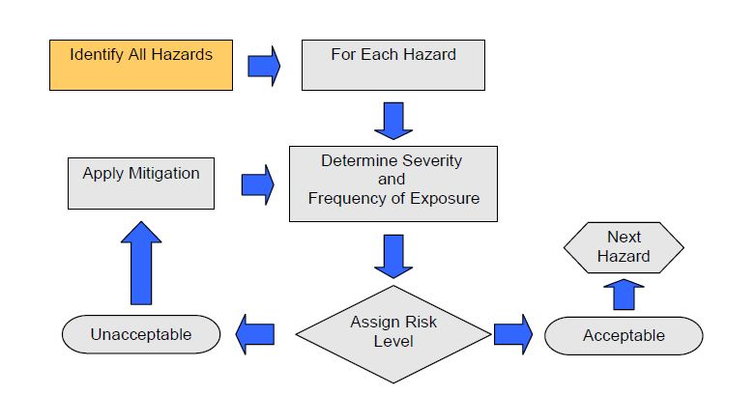
Figure 2: Project Risk Managemt DFD [49]
The risk matrix for ‘Caribbean Coffee Ltd’ can be found in figure 3.
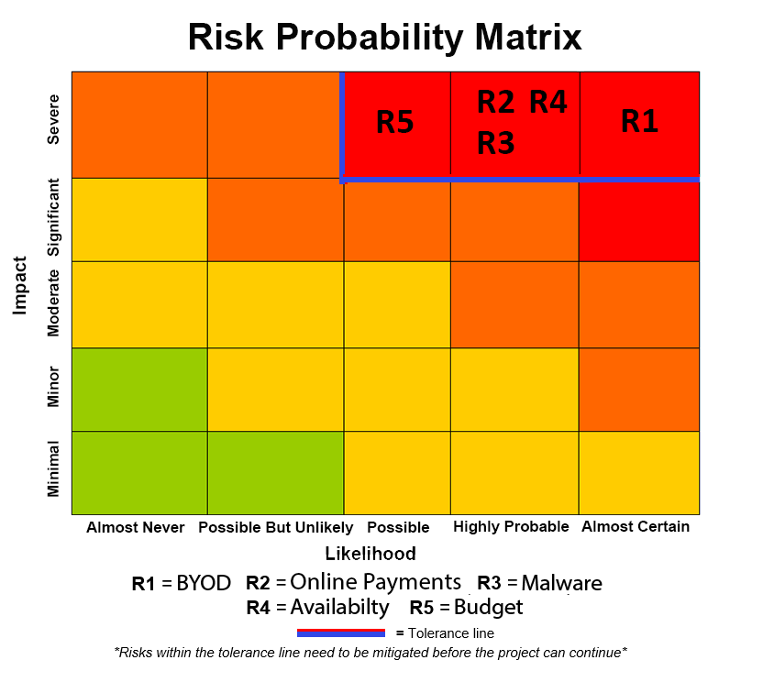
Figure 3: Risk Probability Matrix
Risk 1 – BYOD – This strategy was identified as extremely high risk to implement within the current network infrastructure, because staff will have access to the LAN and WAN cloud VPC servers from their personal devices along with the highly sensitive business data housed within the VPC Storage Area Network (SAN) [50] that could be downloaded to their devices which could then be accessed remotely from outside of the LAN network.
This poses a risk in the event a BYOD device was lost/stolen that contains highly sensitive business data that could be accessed by anyone.
Also, there is a possibility that a disgruntled and/or dishonest employee could steal and then sell intellectual property and all other sensitive data housed within the company to competitors and/or data analytics companies is also a major concern with the proposed BYOD architecture.
Risk Treatment - The proposed BYOD scheme is a severe risk if implemented within the current network infrastructure. So, to mitigate the risk, an off-premise cloud; AWS Mobile Device Management (MDM) [51] Software as a Service (SaaS) [52] server will be utilised to prevent unauthorised devices accessing the network.
Risk 2 –Online Payments – This was identified as a severe risk because processing and storing customer/client financial data across the unsecure Internet can have serious security implications if the correct security technologies and infrastructure is not utilised, which can be very expensive to maintain and monitor.
Furthermore, the company would have to comply and certify with the PCI-DSS [30] security model identified within Appendix - A of this paper, to be able to process this type of high risk data to qualify for cybersecurity insurance which is also very time consuming and expensive to implement and maintain. Companies whom process payments internally also attract malicious actors making them a high value target because of the large financial reward of accessing raw financial information making it a high probability of a malicious attack.
Risk Treatment – This risk was considered too severe and expensive to secure because of the GDPR [21] implications if the customer/client financial data was breached and also the attractive target the company would become for malicious actors if this high risk data was stored within the companies network that would also put all of the other business data assets at risk.
Therefore, it was decided to remove the risk by outsourcing the online payments to a 3rd party merchant; ‘PayPal’ [53] whom specialise in processing high risk payment data from all of the major credit/debit card companies as they already have the correct infrastructure in place to secure the data along with the PCI-DSS certification and cybersecurity insurance in the event their network was breached in which ‘PayPal’ would be subject to GDPR fines and customer/client compensation not ‘Caribbean Coffee Ltd’.
Risk 3 – Malware – Malware is responsible for the majority of cybersecurity breaches around the globe, that is why malware is viewed as a severe risk to the data security of ‘Caribbean Coffee Ltd’. The most common types of Malware as of 2019 are; Trojan-horses [54], Ransomware [55], Crypto-mining [56] and Spyware [57] i.e. keylogging.
Risk Treatment – To prevent the highly sensitive business data being transmitted across the Internet insecurely where a network-layer Man-In-The-Middle (MITM) [58] attack could be leveraged and/or remote exploitation attack, a hardware firewall will be implemented at the WAN boundary of the network containing an IPS. A secure site-to-site Virtual Private Network (VPN) [59] [60] will also be implemented, from the LAN to the CSP VPC utilizing AES-256 [61] for secure encrypted communications from the cloud server to the LAN. Each end device accessing the network will also contain anti-malware software to prevent the highly dangerous ransomware encrypting the sensitive business data within the BYOD device.
Risk 4 – Availability – This was recognised as a severe risk to the company because of the high probability of internetworking equipment failure due to the legacy technology that is currently installed within the company, along with the out of date configurations and internetworking OS firmware installed within them that could easily be exploited by malicious actors.
Furthermore, the legacy hardware was not built to handle large volumes of data and data stream throughput within the LAN,WLAN and the WAN-to-AWS cloud, so if the BYOD scheme was implemented and a large number of end devices connected to the network, there is a severe risk of hardware failure causing a network outage, that would prevent the business from accessing their data within the VPC and therefore be unable to conduct their day-to-day business.
Risk Treatment – To mitigate this risk it is recommended that the network infrastructure within the offices be upgraded to modern network equipment built to handle high volumes of data throughput and end device connectivity along with strong security encryption for the WLAN to prevent data-link layer MITM attacks.
In the short term this will be economically expensive to implement the BYOD scheme but in the long term the new equipment will be able to handle large volumes of data with high throughput rates along with a very large number of BYOD device connections within the 802.11 WLAN portion of the network that will also allow for scalability and emerging technologies such as; wireless 802.11ax 5G (WiFi-6) that is optimised for LAN IaaS cloud architectures and Internet of Things (IoT) compatible to futureproof the companies business assets. That’s why upgrading the hardware can be viewed as an investment to the company for future growth, security and network stability.
The VPC the business data and LAN services provided by the CSP are housed within AWS vast load balanced datacentre infrastructure that provides customers with a Service Level Agreement (SLA) [62] that promises that their networks will be available a minimum of 99.999% of the time which equates to 5 minutes downtime per year this type of SLA is referred to as the ‘Five Nines’ [63].
Risk 5 –Budget– The budget was quantified as a severe risk with a probability of ‘possible’ because the company has allowed a $40,000 budget for the data security ISMS framework, device hardening security audit of the company.
Because all of the legacy infrastructure currently in installed within the companies network has to be replaced, it is estimated that the cost of the project including consultancy and implementation fees will be $60,000 which is 50% more than the allotted budget for the project
If the full risk treatment plan is given the go ahead by the CEO, Matrix security will also offer a 3 year free SLA warranty that would apply to availability and configuration issues within the WLAN/LAN if they were to arise within that time frame. [64]
Risk Treatment – To mitigate against the project not going forward due to funding issues, the consultancy and network implementation fee estimation of $60,000 will be requested before the project is started during the next project meeting, along with an option of using refurbished second hand equipment to lower the costs, or to utilise new equipment as planned in order to futureproof the companies network that will also provide a 3 year warranty for the installed equipment to the company.

- Architectural Technologies and Implementation Consideration
After analysing the risk management and treatment solution previously discussed. The network architecture and technology implementation will be designed using this information.
The technology implementations from the scope extrapolated from the case study company background along with stages 1 and 2 of the ITIL lifecycle are as follows;
BYOD; The MDM SaaS application will be installed within a Ubuntu Linux OS [65] server containerised [66] within the industry standard open-source containerisation software ‘Docker’ [67] for AWS, that will also provide; Secure File services [68], Authentication Authorization and Accounting (AAA) [69], Active Directory (AD) [70], Domain Name Services (DNS) [71]to the LAN.
An AWS MDM server will be utilised to consolidate the cloud security with the existing AWS VPC. AWS MDM was chosen, not only for its security merits reported by security professionals but also for its compatibility with the AWS infrastructure in currently in place.
The VPC will consist of two spokes; [72], [73]
- Spoke 1; will contain the internal services for the organisation that can only be accessed via a Virtual Private Network (VPN).

- Spoke 2; This spoke will be an offsite cloud De-Militarized Zone (DMZ) [74] where the Hyper Text Transport Protocol Secure (HTTPS) [75] web portal [76] will have a public IP address [77] for clients/Customers to access to provide virtual network segmentation from the highly sensitive information contained within spoke-1 as an added security precaution.

Each VPC spoke will have a virtual firewall [78]instance configured for additional security of the cloud infrastructure as per the ISO 270017-18 cloud security guidelines. The cloud VPC spoke security architecture can be found in figure 4.

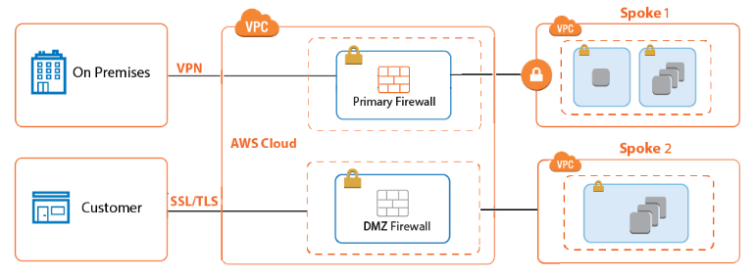
Figure 4: VPC Spokes Private and Public [79]
Authorised devices will also be secured by the MDM server before being allowed to access the LAN with anti-malware software ‘Norton Security; Enterprise’ [80] that will scan, clean, update/patch OS and remove any security threats contained within the device along with applying user and network security policies for each department such as; user permission and restrictions for accessing medium-to-highly sensitive business data and location access for medium-to-highly sensitive data. An encrypted partition [81] will also be created locally within a BYOD device during the MDM server registration and security implantation. The partition will utilise military grade encryption; Advanced Encryption Standard – 256-bit (AES-256) [82] within each BYOD device that is registered and authenticated to utilise the LAN by the AAA and MDM servers.
The files identified by the CEO as medium-to-highly sensitive will be ‘tagged’ by the AAA server within the metadata [83] of the file, that will restrict use to the company LAN during work hours. These files will also be hashed using Secure Hashing Algorithm – 256-bit (SHA-256) [84] to maintain their integrity along with logging and rehashing after any changes are made.
The files identified as ‘highly classified’ by the CEO such as the intellectual property will not be downloadable from the VPC spoke file server to BYOD devices but viewed only on a highly restricted bases from the LAN during office hours.
AD and MDM user groups and privileges will be created to create a hierarchy permission to what staff member can access information. The data security file permission groups are as follows; [85][86][87]
Full control; This group will have; read, write and executable permissions to all data housed within the file server pertaining to the staff members department within the company, apart from the Intellectual property that only the CEO has authorisation to read, write and execute to that highly encrypted directory.
Partial Control; This group will have; read, write and executable permissions to medium-to-high classified data housed within the file server and only have privileges to read highly classified documents pertaining to the department the group member works within.
Restricted Access; This group will have; read, write and executable privileges to low classified data housed within the file server and have restricted access ot read only low-to-medium classified data if approved by their department manager for a limited time.
The above groups will be applied to the staff hierarchy within the company management hierarchy depicted in Appendix – B of this paper. The CFO COO and CRO will have full control pertaining to data that is relevant to their departments. The CTO will have full access to all department data for data security reasons. Whilst the CEO will have full control of all data within the company including the intellectual property as previously discussed.
Managers within each department will have partial control to the data pertaining to their job roles. Whilst the general office staff will have restricted access to the data pertaining to their department and job roles. This data securty permissions hierarchy is paramount to control the access to data within an organisations network which also allows for traceability in the event an internal breach occurred.
Once a device is enrolled to the MDM server, the network administration team will have remote access to each device to update policies/patches and/or to wipe all company data housed within encrypted partition of the device in the event the employee leaves the company, violates the network usage policy and/or a device was lost/stolen.
USB ports within BYOD devices will also be disabled whilst connected to the company network.
All saved user and internetworking device passwords and username details will be stored as hashed versions of themselves utilising SHA-256 to prevent malicious actors accessing accounts/devices in the event of a data breach.
Screen capture prevention – Digital Rights Management (DRM) software such as; ‘Lizard Lock’ will also be utilised for the medium-to-highly sensitive Portable Document Format (PDF) files, to stop users capturing the contents of the screen to bypass the security measures in place to view outside of the LAN.
Wi-Fi Protected Access – 2 (WPA-2) Enterprise [88] will also be utilised for authenticating users and applying network/data privileges within the AAA - Remote Authentication Dial-In User Service (RADIUS) [89] and AD Ubuntu Linux server located within spoke-1 of the VPC as a container as previously discussed. This WLAN security strategy will not only apply user permissions and policies, but it also prevents datalink-layer MITM and replay attacks within the WLAN portion of the network as previously discussed.
Norton Security; Enterprise will also be utilised to secure the servers located within the VPC docker containers as per the ISO 270017-270018 standard.
Guests and unregistered BYOD devices accessing the WLAN will be given a temporary one-time access username/password along with a De-Militarized Zone (DMZ) IP address so that they can access the Internet and the AAA server before MDM registration of a BYOD device but not the VPC services located in spoke 1. A traditional DMZ was not implemented locally within the LAN because there are no internal servers to secure as all the services will be hosted externally within the VPC where a VPC spoke (spoke-2) will be used as the DMZ for the web portal as previously discussed.
An extended Access Control List (ACL) [90] will also be implemented at the boundary routers to prevent guests and/or unauthorised BYOD devices from accessing the distribution layer of the network with a DMZ temporary IP address, and only permitting HTTPS (ports 443 and 8080) [91] Internet access and AAA RADIUS server port 1812 for authentication before being allowed access to the primary VPC spoke 1.
User logs generated by the AAA server will be utilised alongside the Intrusion Prevention System (IPS) [92] logs to identify the source of a network data breach in the event the network was compromised.
A DFD outlining the logic of the MDM BYOD data security can be found in Appendix – B of this paper.
A network usage security policy related to the BYOD scheme was also created for staff to read and sign to outline the security boundaries along with their individual user responsibilities within the network as per the ITIL guidelines.
The network security policy can be found in Appendix – C of this paper.
- Malware Threats and Secure Connectivity
As previously discussed a hardware firewall that will contain an IPS along with a security edge router will be implemented to analyze and filter known suspicious packets entering the LAN proactively that will be configured for Signature-Based Detection (SBD) , Anomaly-Based Detection (ABD), and Policy-Based Detection (PBD) [93], [94] along with firewall rules preventing staff from utilizing social media websites/unsecure websites and personal E-Mail that contain a majority of ‘Trojan-Horse’ and ‘Ransomware’ malware. An exception to the rule will be applied to the marketing department who utilize these websites as part of their job role, so their Virtual LAN (VLAN) [95] will have higher security scrutiny by the software and hardware firewalls/IPS to prevent malware from these websites entering the LAN.

An IPS will also be implemented within the VPC with identical configurations to the LAN IPS and firewall additional security will be implemented within the VPC firewall with security groups configured depending on user permissions granted by the AAA server

All Internet activity outside of the VPC will utilize split tunneling [96] to prevent Internet traffic traversing the VPN to further harden the data security, latency and availability within the network.

- Availability

To prevent bottlenecks within the LAN, redundancy measures will include; two separate 3Gb/s Internet Service Providers (ISP) connected to two LAN routers along with a distribution layer mesh of Layer-3 switches providing an 8Gb/s ‘EtherChannel’ [97] throughput pipe using the open standard Link Aggregation Control Protocol (LACP) [98]. All layer-3 devices will also be configured using Gateway Load Balancing Protocol (GLBP) [99] with Message Digest 5 (MD5) [100] security configured within the reliable Open Shortest Path First (OSPF) [101]layer-3 routing protocol to prevent rogue devices being introduced to the network by malicious actors. VLAN’s will also be implemented as previously discussed to create more broadcast domains [102] within the LAN to prevent frame collisions at Layer-2.

After these implementations along with the installation and configuration of the new internetworking devices, ‘Matrix Security’ will also provide an SLA guarantee of internal availability within the LAN of 99.999% as previously discussed.

All unused ports on the internetworking devices will also be shutdown to prevent this attack whilst used access ports will be secured using switchport security.[103]

A physical WLAN survey [104] that will include 802.11ax [105] throughput , path loss and jitter [106] testing for 802.11ax 5G [107] capabilities before implementation of the 5G AP within the building will also be conducted to identify any signal ‘dead zones’ that may be caused because of Radio Frequency (RF) signals not being able to penetrate objects such as thick walls, fire doors along with environmental noise i.e. microwaves [108]. The use of 5G technology will not only provide high throughput rate and connection rates but will also further future proof the network in the event the company wanted to utilise IoT [109] smart technology.

Staff will also be able to access business data ‘tagged’ as low security and company E-Mail from home using an AWS remote- VPN [110] client installed on their personal devices.

Access to the company website with the integrated ‘PayPal’ payment system by clients/customers will be encrypted using Secure Socket Layer and Transport Layer Security version 2 (SSL/TLS) [111] also known as HTTPS for secure access and payment to the 3rd party merchant ‘PayPal’. The HTTPS server will be hosted within the VPC DMZ spoke as previously discussed with a public IP address to prevent outside access to the internal LAN VPC that contains the company’s sensitive information.

Utilizing Ubuntu Linux instead of a traditional Microsoft Windows server installed within a Docker container instead of a Virtual Machines (VM) will maximize efficiency of throughput and hardware usage within the network which in turn will lower the current cost of the AWS VPC services for the company. Containerization is a fast-emerging universal micro-services technology that will also allow for futureproofing and scalability of the company networks as well as the economic benefits previously discussed.

The current Microsoft Office 365 – SaaS [112] will remain in place as this software is the market leader within business office applications such as; word processing, E-Mail and spreadsheet design.

Traditional mirroring of data utilizing Redundant Array of Independent Disks (RAID) [113] technology to provide fault tolerance to the networking in the form of a data redundancy backup method within a different geographical location. This will not be required within this organizations network because it is a serverless LAN/Cloud architecture where all data is mirrored and backed up in various locations around the globe by the CSP. [114][115]

- Physical Security

All the physical networking infrastructure located within the LAN will be physically locked within a secure box and/or secure room secured with complex password for local and remote access that only the network administrators will have access. The AWS VPC management console will also only be accessed by the network administrators. [116][117]

- Internetworking Hardware Implementation
As previously identified, analysed and discussed in previous section of this paper, the 15-year-old legacy equipment within ‘Caribbean Coffee Ltd’ offices needed to be upgraded for compliance with the ITILv4 security configuration and availability controls for the identified business assets.
The recommended updated internetworking hardware devices that will provide robust security and networking architecture are as follows:

- Cisco ISR 4331 Router x 2 [118]

- Cisco SME Layer-3 Switch 28 Port 1Gb/s SG350 x 4 [119]
- Hardware Firewall Fortinet - FortiGate 100E SME x 2 [120]

- Cisco Systems WLAN Controller 4400 x 2 [121]

- Cisco Catalyst C9115I 5GHz Lightweight AP 802.11ax 5.38 Gbit/s x 6 [122]

- Category-6 UTP Ethernet Cable 10Gb/s 305 Meter Reel x1 [123]

These hardware devices were chosen because the manufacturers are the industry leaders within the internetworking hardware industry and their price came within the original budget because slightly older models were purchased estimation of £60,000. The prices of these devices can be found within Appendix – D.
The complete network topology of ‘Caribbean Coffee Ltd’ that was created by utilising the knowledge gained within the ITIL lifecycle stages 1-2 can be found in figure 5.
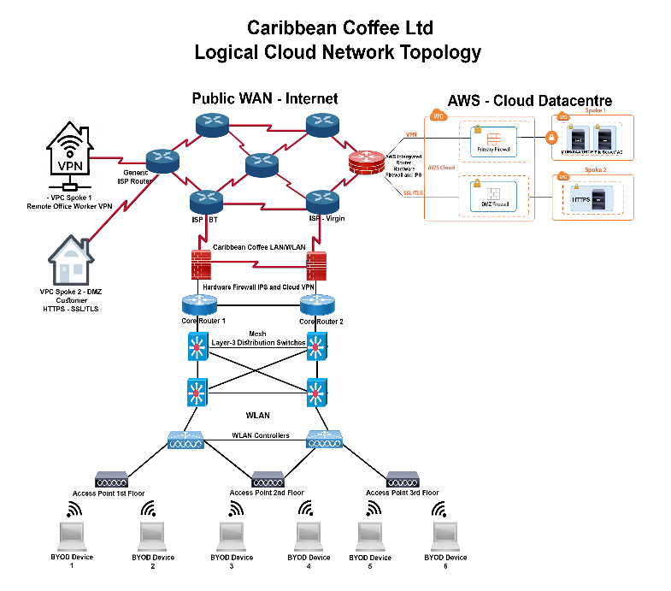
Figure 5: Caribbean Coffee Ltd ITIL Approved Logical Topology

      - Service Transition
This stage of the ITIL lifecycle is where a network simulation model [124] of Caribbean Coffee Ltd proposed ITIL network architecture was created and then would further tested within a computer laboratory in a real life scenario.
After utilizing the information gathered from stage 1 and 2 of the ITIL framework a PT. PKT network simulation model for ‘Caribbean Coffee Ltd’ was developed that can be accessed as part of the supporting documents for this paper.
Due to PT limitations the VPC, its spokes and its services were not implemented along with the testing procedures such as; network metrics; throughput, latency and packet loss to identify any bottlenecks or configuration errors along with a security penetration test previously discussed in this paper. The connectivity and limited security configurations that were implemented within the PT simulation model worked as expected from the design plan within the previous section of this report.
      - Service Operation
This stage of the ITIL lifecycle is where the laboratory tested network would be implemented within an organisation during a maintenance windows such as; during holiday periods, weekends etc when the network is not at full capacity and the office staff are not utilising the network and/or a portion of the network i.e. subnet is implemented to test the network live with end users.
This stage is a very important phase of the ITIL lifecycle because even though the network configurations were fully tested within the Service Transition stage. There would have been no end users utilising the network which is where most bugs and bottlenecks are highlighted within the network.
Because this is a fictitious case study along with the time constraints and infrastructure requirements to implement the proposed network. This stage of the ITIL framework was not undertaken as it is beyond the scope of the research paper.

      - Continual Service Improvement
The final stage of the ITIL lifecycle focuses on continual monitoring and improvements of the system by the network administrator of the company.
‘SolarWinds’ [125] network monitoring software would be recommended to be implemented within the organisations network because it is the industry leader within the network monitoring software sector that has the capabilities to monitor WLAN, LAN and cloud implementations within a network which fits the criteria for ‘Caribbean Coffee Ltd’ network scope.
SolarWinds proactively monitors all devices and user activity within a network which then prioritises the level of threat and the severity to the network. The monitoring alarms are then sent to the network administers via a notification system that can be configured for E-Mail and/or mobile phone text message alert so that the issue(s) can be negated immediately. [126]
Utilising network monitoring software not only allows a company to uphold its SLA commitments to customers/clients but it also allows network engineers to continuously improve and harden the systems cybersecurity to evolving future threats that may create vulnerabilities within the current network architecture and/or configurations.
Furthermore, network monitoring software can also aid within locating a vulnerability and or malicious actor in the event the network was breached by analysing the security logs and notifications the software produces. [126][127], [128]

Summary of Section
The final stage of the ITIL framework and ISO 270017-270019 security standard completes the data security of the vast amount of controls applied using various technologies to robustly secure the assets that encompasses all of ‘Caribbean Coffee Ltd’ requirements for secure business functionality.
Therefore, after creating a robust ISMS framework for ‘Caribbean Coffee Ltd’ the company has a vigorous cloud security and BYOD architecture, along with the safety net of cybersecurity insurance for full compliance with the ITIL and ISO 270017-18 standard to protect the companies economic assets, so that they can continue their business and expand their companies portfolio for future growth and continuous improvement of the business network. The BYOD scheme will also make the company a much more attractive place to work for professionals within industry.

Conclusions
Although ISO 27000 is a very granular and robust universal standard, it can be very complex to navigate and expensive to certify for SME around the globe whom do not have the budget and/or expertise to meet the specific requirements along with having the knowledge to be able navigate the vast amount of controls to a high standard and then implement the correct controls once identified to suit the businesses requirements. That is why ISO27000 series is mostly utilized by large corporation whom handle large quantities of public and/or private sensitive data each day from multiple locations around the globe within their datacenters, such as leading CSP; Amazon, Microsoft Azure and Google along with large social media platforms like; Facebook, Instagram and Twitter along with government departments handling highly sensitive data within their highly unique networks such as the; Driving Vehicle Licensing Agency (DVLA) based within Swansea, UK. The companies and organizations have the time and money to invest, to employ professional ISMS project managers to create a robust customized ISMS from the ISO 27000 guidelines.

That’s why a framework such as ITIL is mostly utilized within industry by SME around the globe, because a framework offers most of the protection of the ISO 27000 standard in which they are built upon without the complexity of navigating the myriad of controls to customize and implement for full compliance of the standard. Frameworks and Security models offer blueprints that detail not only the required, controls but also how to identify and then implement each control along with risk management, continual monitoring and change control guidelines for full compliance of the framework that can be easily customized by network engineers/managers to secure a company’s network according to their individual businesses service requirements for asset security and management.

The very specific data security models such as; PCI-DSS and Cyber Essentials as previously discussed are focused on a specialized service such as; payment data, governmental data etc rather than the wider broad date security requirements of the business network that comprise of all aspects of data security. That’s why a specialized service security model complements an existing framework such as; ITIL for companies whom have these very specific data security requirements within their business model.

Using the structured stages of the ITIL framework from the knowledge gained within the research section of this paper within Appendix -A to create the ISMS for ‘Caribbean Coffee Ltd’ made the process of creating an ISMS very easy to follow and implement each stage within the well-defined structure of the ITIL framework.

Future Work
Moving forward with the knowledge gained from this paper, the natural progression of this project would be to physically implement the ‘Caribbean Coffee Ltd’ ISMS system within a computer laboratory to test how robust the ISMS solution actually is, using various industry standard penetration testing techniques and tools along with utilising network monitoring security and performance software such as SolarWinds during an attack to analyse the performance metrics for efficiency and response time of the software during an attack along with the IPS/Firewall, ACL and permission control configurations. If an attack was successful, further change controls would be researched and implemented along with another penetration/performance test until the network meets the ITIL framework criteria for data security certification.

References
[1] J. S. Broderick, “ISMS, security standards and security regulations,” Inf. Secur. Tech. Rep., 2006, doi: 10.1016/j.istr.2005.12.001.
[2] Cisco, “PPP CHAP Authentication - Cisco,” cisco.com, 2018. [Online]. Available: https://www.cisco.com/c/en/us/support/docs/wan/point-to-point-protocol-ppp/25647-understanding-ppp-chap.html. [Accessed: 22-Jan-2019].
[3] ciscopress.com, “LANs, WANs, and the Internet (1.3) &gt; Exploring the Modern Computer Network: Types, Functions, and Hardware,” ciscopress.com, 2013. [Online]. Available: http://www.ciscopress.com/articles/article.asp?p=2158215&seqNum=6. [Accessed: 02-May-2019].
[4] D. Wicks, “Why everything is hackable: Computer security is broken from top to bottom,” Econ., 2017.
[5] Cloud Security Alliance, “Top Threats to Cloud Computing,” Security, no. March, pp. 1–14, 2010.
[6] P. Elkind, “Inside the hack of the century,” Fortune, 2015.
[7] K. Zetter, “Hacker Lexicon: What Are White Hat, Gray Hat, and Black Hat Hackers?,” Wired, 2016. .
[8] cisco, “Understanding LANs &gt; Cisco ICND1 Foundation Learning Guide: LANs and Ethernet,” ciscopress.com, 2013. [Online]. Available: http://www.ciscopress.com/articles/article.asp?p=2092245&seqNum=2. [Accessed: 14-Feb-2018].
[9] B. Witten and C. Nachenberg, “Malware Evolution : A Snapshot of Threats and Countermeasures in 2005,” in Malware Detection, 2007, pp. 3–15.
[10] etc.usf.edu, “What is USB? » Hardware » Windows » Tech Ease,” 2019. [Online]. Available: https://etc.usf.edu/techease/win/hardware/what-is-usb/. [Accessed: 29-Jan-2020].
[11] Symantec, “Various types of network attacks | Symantec Connect Community,” symantec.com, 2013. [Online]. Available: https://www.symantec.com/connect/articles/security-11-part-3-various-types-network-attacks. [Accessed: 11-Dec-2017].
[12] P. Muehleis, “Social engineering.,” J. Am. Dent. Assoc., vol. 141, no. 5, pp. 500; discussion 500-501, 2010.
[13] S. Zhang, C. Zhang, and Q. Yang, “Data preparation for data mining,” Appl. Artif. Intell., 2003, doi: 10.1080/713827180.
[14] D. J. Hand, “Principles of data mining,” in Drug Safety, 2007, doi: 10.2165/00002018-200730070-00010.
[15] D. Mining and T. Mining, “A Programmers Guide to Data Mining,” Text, 2017, doi: 10.1109/ISPLC.2012.6201332.
[16] P. Rotella, “Is Data The New Oil?,” Forbes, 2012.
[17] L. Einav and J. Levin, “Economics in the age of big data,” Science. 2014, doi: 10.1126/science.1243089.
[18] European Data Protection Supervisor, “Towards a new digital ethics. Data, dignity and technology,” 2015.
[19] B. Custers, F. Dechesne, A. M. Sears, T. Tani, and S. van der Hof, “A comparison of data protection legislation and policies across the EU,” Comput. Law Secur. Rev., 2018, doi: 10.1016/j.clsr.2017.09.001.
[20] FRA and EDPS, Handbook on European data protection law 2018. 2018.
[21] J. Day, “General Data Protection Regulation Guide,” GDPR Guide. pp. 4–24, 2017, doi: http://eur-lex.europa.eu/pri/en/oj/dat/2003/l_285/l_28520031101en00330037.pdf.
[22] Gartner, “What is SMB? - Gartner Defines Small and Midsize Businesses,” Gartner, 2017. .
[23] K. Haufe, R. Colomo-Palacios, S. Dzombeta, K. Brandis, and V. Stantchev, “Security Management Standards: A Mapping,” in Procedia Computer Science, 2016, doi: 10.1016/j.procs.2016.09.221.
[24] Infosec, “CIA Triad,” infosec. p. 1, 2017.
[25] BMC, “ITIL® Information Security Management – BMC Blogs,” 2019. [Online]. Available: https://www.bmc.com/blogs/itil-information-security-management/. [Accessed: 29-Jan-2020].
[26] S. V. Flowerday and T. Tuyikeze, “Information security policy development and implementation: The what, how and who,” Comput. Secur., 2016, doi: 10.1016/j.cose.2016.06.002.
[27] Invensis, “An overview of Information Security Management in ITIL | Invensis Learning,” 2019. [Online]. Available: https://www.invensislearning.com/resources/itil/overview-of-information-security-management. [Accessed: 29-Jan-2020].
[28] ISO/IEC, “ISO/IEC 27000:2016(E) Information technology — Security techniques — Information security management systems — Overview and vocabulary,” ISO.org [Online]. 2016.
[29] NCSC UK, “Cyber Essentials :: Certification,” 2019. [Online]. Available: https://www.cyberessentials.ncsc.gov.uk/getting-certified/. [Accessed: 29-Jan-2020].
[30] IT Governance UK, “The PCI DSS | IT Governance UK | IT Governance UK,” 2019. [Online]. Available: https://www.itgovernance.co.uk/pci_dss. [Accessed: 29-Jan-2020].
[31] Altexsoft, “Whitepaper - Legacy System Modernization: How to Transform the Enterprise | AltexSoft,” 2019. [Online]. Available: https://www.altexsoft.com/whitepapers/legacy-system-modernization-how-to-transform-the-enterprise-for-digital-future/. [Accessed: 29-Jan-2020].
[32] I. Mittal and A. Anand, “WLAN Architecture,” Int. J. Comput. Trends Technol., vol. 8, no. 3, pp. 148–151, 2014.
[33] Amazon, “Amazon Web Services (AWS)- Cloud Computing Services,” Amazon Web Services, Inc., 2016. .
[34] S. Chauhan et al., “Amazon Virtual Private Cloud (Amazon VPC) and Networking Fundamentals,” in AWS® Certified Advanced Networking Official Study Guide, 2018.
[35] C. Heinle and J. Strebel, “IaaS adoption determinants in enterprises,” in Lecture Notes in Computer Science (including subseries Lecture Notes in Artificial Intelligence and Lecture Notes in Bioinformatics), 2010, vol. 6296 LNCS, pp. 93–104, doi: 10.1007/978-3-642-15681-6_7.
[36] G. Disterer and C. Kleiner, “BYOD Bring Your Own Device,” Procedia Technol., 2013, doi: 10.1016/j.protcy.2013.12.005.
[37] P. Adams, “The advantages and disadvantages of BYOD.,” solarvista.com, 2016. [Online]. Available: https://www.solarvista.com/resources/the-advantages-and-disadvantages-of-byod. [Accessed: 11-Dec-2017].
[38] Microsoft Azure, “What is a Cloud Service Provider – Definition | Microsoft Azure,” azure.microsoft.com, 2019. [Online]. Available: https://azure.microsoft.com/en-gb/overview/what-is-a-cloud-provider/. [Accessed: 30-Apr-2019].
[39] G. Thomson, “BYOD: Enabling the chaos,” Netw. Secur., 2012, doi: 10.1016/S1353-4858(12)70013-2.
[40] K. W. Miller, J. Voas, and G. F. Hurlburt, “BYOD: Security and privacy considerations,” IT Professional. 2012, doi: 10.1109/MITP.2012.93.
[41] N. Sohrabi Safa, R. Von Solms, and S. Furnell, “Information security policy compliance model in organizations,” Comput. Secur., 2016, doi: 10.1016/j.cose.2015.10.006.
[42] Cisco, “Packet Tracer - Network Simulator.” .
[43] R. Pal and P. Hui, “Cyber-insurance for cybersecurity a topological take on modulating insurance premiums,” Perform. Eval. Rev., 2012, doi: 10.1145/2425248.2425271.
[44] S. J. Shackelford, “Should your firm invest in cyber risk insurance?,” Bus. Horiz., 2012, doi: 10.1016/j.bushor.2012.02.004.
[45] Y. Jadeja and K. Modi, “Cloud computing - Concepts, architecture and challenges,” in 2012 International Conference on Computing, Electronics and Electrical Technologies, ICCEET 2012, 2012, doi: 10.1109/ICCEET.2012.6203873.
[46] ISO.org, “ISO - ISO/IEC 27017:2015 - Information technology — Security techniques — Code of practice for information security controls based on ISO/IEC 27002 for cloud services,” 2019. [Online]. Available: https://www.iso.org/standard/43757.html. [Accessed: 29-Jan-2020].
[47] BSI-Group, “Security controls for cloud services ISO/IEC 27017 | BSI,” 2019. [Online]. Available: https://www.bsigroup.com/en-GB/Security-controls-for-cloud-services-ISO-IEC27017/. [Accessed: 29-Jan-2020].
[48] ISO, “ISO/IEC 27701:2019(en), Security techniques — Extension to ISO/IEC 27001 and ISO/IEC 27002 for privacy information management — Requirements and guidelines,” 2019. [Online]. Available: https://www.iso.org/obp/ui/#iso:std:iso-iec:27701:ed-1:v1:en. [Accessed: 29-Jan-2020].
[49] Paul Lawrence, “BYOD DFD: Lucidchart,” lucichart.com, 2017. [Online]. Available: https://www.lucidchart.com/documents/edit/b39e61e5-cc01-4622-b0ea-2c143041fb4a. [Accessed: 11-Dec-2017].
[50] Broadcom, “SAN Design and Best Practices (1857 KB),” broadcom.com, 2017. [Online]. Available: https://docs.broadcom.com/docs/12380347. [Accessed: 22-Jan-2019].
[51] AWS, “AWS Marketplace: Mobile Device Manager Plus Cloud,” 2019. [Online]. Available: https://aws.amazon.com/marketplace/pp/ZOHO-Corporation-Private-Limited-Mobile-Device-Man/B01LYRDNG0. [Accessed: 29-Jan-2020].
[52] K. Brown, C. W., & Nyarko, “Software as a Service (SaaS).,” Cloud Comput. Serv. Deploy. Model. Layers Manag. Layers Manag., p. 50, 2012, doi: 10.1007/s11576-008-0095-0.
[53] M. H. Sherif, “PayPal,” in Protocols for Secure Electronic Commerce, 2016.
[54] R. Ford and W. H. Allen, “Malware shall greatly increase⋯,” IEEE Secur. Priv., 2009, doi: 10.1109/MSP.2009.181.
[55] J. E. et al.. Dunn, “Ransomware,” Wikipedia. p. 7, 2012.
[56] D. Carlin, P. Orkane, S. Sezer, and J. Burgess, “Detecting Cryptomining Using Dynamic Analysis,” in 2018 16th Annual Conference on Privacy, Security and Trust, PST 2018, 2018, doi: 10.1109/PST.2018.8514167.
[57] B. Clark, “Viruses, Spyware, Malware, etc. Explained: Understanding Online Threats,” MakeUseOf, 2015. .
[58] Norton, “What is a man-in-the-middle attack?,” norton.com, 2018. [Online]. Available: https://us.norton.com/internetsecurity-wifi-what-is-a-man-in-the-middle-attack.html. [Accessed: 22-Jan-2019].
[59] Cisco, “VPN Overview,” 2013.
[60] V. Bollapragada, M. Khalid, and S. Wainner, IPSec VPN Design. 2005.
[61] T. Robertazzi, “Advanced Encryption Standard (AES),” in Basics of Computer Networking, 2012, pp. 73–77.
[62] P. Patel, A. Ranabahu, and A. Sheth, “Service Level Agreement in Cloud Computing,” Cloud Work. OOPSLA09, 2009.
[63] Cisco, “Service Level Management: Best Practices White Paper - Cisco.” [Online]. Available: https://www.cisco.com/c/en/us/support/docs/availability/high-availability/15117-sla.html. [Accessed: 29-Jan-2020].
[64] M. Meschke, “Service Level Agreement (SLA),” Controlling, 2008, doi: 10.15358/0935-0381-2008-10-562.
[65] Ubuntu, “Linux - Ubuntu Server,” ubuntu.com, 2019. [Online]. Available: https://www.ubuntu.com/download/server. [Accessed: 23-Apr-2019].
[66] C. Pahl, “Containerization and the PaaS Cloud,” IEEE Cloud Comput., 2015, doi: 10.1109/MCC.2015.51.
[67] Docker, “Docker container networking | Docker Documentation,” Docker Inc, 2018. [Online]. Available: https://docs.docker.com/v17.09/engine/userguide/networking/. [Accessed: 22-Jan-2019].
[68] Microsoft, “File and Storage Services Overview | Microsoft Docs,” docs.microsoft.com, 2016. [Online]. Available: https://docs.microsoft.com/en-us/previous-versions/windows/it-pro/windows-server-2012-r2-and-2012/hh831487(v%3Dws.11). [Accessed: 01-May-2019].
[69] security.techtarget, “What is AAA server (authentication, authorization, and accounting)? - Definition from WhatIs.com,” techtarget.com, 2017. [Online]. Available: http://searchsecurity.techtarget.com/definition/AAA-server. [Accessed: 11-Dec-2017].
[70] B. Svidergol, V. Meloski, B. Wright, S. Martinez, and D. Bassett, “Active Directory Domain Services,” in Mastering Windows Server® 2016, 2018.
[71] ccm, “DNS (Domain Name System),” cccm.net, 2018. [Online]. Available: http://ccm.net/contents/271-dns-domain-name-system. [Accessed: 14-Feb-2018].
[72] VPC SPokes, “ AWS Cloud Architecture - Transit Gateway VPC Security Spokes.” [Online]. Available: https://aws.amazon.com/blogs/aws/new-use-an-aws-transit-gateway-to-simplify-your-network-architecture/. [Accessed: 29-Jan-2020].
[73] AWS, “Transit VPC Components - Transit Network VPC (Cisco CSR),” 2019. [Online]. Available: https://docs.aws.amazon.com/solutions/latest/cisco-based-transit-vpc/components.html. [Accessed: 29-Jan-2020].
[74] Idc-online, “DMZ - Services,” idc-online.com, 2010.
[75] H. L. Kosakowski and R. Saxe, “https,” Cogn. Behav. Neurol., 2018, doi: 10.1097/wnn.0000000000000150.
[76] Microsoft, “Microsoft Azure Portal | Microsoft Azure,” 2019. [Online]. Available: https://azure.microsoft.com/en-gb/features/azure-portal/. [Accessed: 29-Jan-2020].
[77] cisco.com, “IP Addressing and Subnetting for New Users - Cisco,” cisco.com, 2016. [Online]. Available: https://www.cisco.com/c/en/us/support/docs/ip/routing-information-protocol-rip/13788-3.html. [Accessed: 11-Dec-2017].
[78] M. Anwar, “Virtual firewalling for migrating virtual machines in cloud computing,” in ICICT 2013 - Proceedings of the 2013 5th International Conference on Information and Communication Technologies: Using Technology to Create a Better World, 2013, doi: 10.1109/ICICT.2013.6732787.
[79] Barracuda, “AWS Reference VPC Security Architecture - Transit VPC using CloudGen Firewall | Barracuda Campus,” 2019. [Online]. Available: https://campus.barracuda.com/product/cloudgenfirewall/doc/73718963/aws-reference-architecture-transit-vpc-using-cloudgen-firewall/. [Accessed: 29-Jan-2020].
[80] Symantec, “Endpoint Security Solutions | Symantec,” symantec.com, 2017. [Online]. Available: https://www.symantec.com/products/endpoint. [Accessed: 11-Dec-2017].
[81] M. Descher, P. Masser, T. Feilhauer, A. M. Tjoa, and D. Huemer, “Retaining data control to the client in infrastructure clouds,” in Proceedings - International Conference on Availability, Reliability and Security, ARES 2009, 2009, doi: 10.1109/ARES.2009.78.
[82] U. S. D. of C. / the N. T. I. S. (N.I.S.T.), “Advanced Encryption Standard (AES),” 2001.
[83] S. K. Datta and C. Bonnet, “Internet of Things and M2M Communications as Enablers of Smart City Initiatives,” in Proceedings - NGMAST 2015: The 9th International Conference on Next Generation Mobile Applications, Services and Technologies, 2016, doi: 10.1109/NGMAST.2015.10.
[84] L. Latinov, “MD5, SHA-1, SHA-256 and SHA-512 speed performance,” automationrhapsody.com, 2017. [Online]. Available: https://automationrhapsody.com/md5-sha-1-sha-256-sha-512-speed-performance/.
[85] Informatica, “Users and User Groups MDM Overview,” 2019. [Online]. Available: https://docs.informatica.com/master-data-management/multidomain-mdm/10-1-hotfix-1/informatica-mdm-hub-security-guide/users_and_user_groups/users_and_user_groups_overview.html. [Accessed: 29-Jan-2020].
[86] N. Zahadat, P. Blessner, T. Blackburn, and B. A. Olson, “BYOD security engineering: A framework and its analysis,” Comput. Secur., 2015, doi: 10.1016/j.cose.2015.06.011.
[87] Microsoft, “Active Directory,” microsoft.com, 2017. [Online]. Available: https://msdn.microsoft.com/en-us/library/bb742424.aspx. [Accessed: 11-Dec-2017].
[88] Cisco, “WPA2-Enterprise Wi-Fi Encryption &gt; Two Modes of WPA/WPA2: Personal (PSK) versus Enterprise,” ciscopress, 2010. [Online]. Available: http://www.ciscopress.com/articles/article.asp?p=1576225. [Accessed: 11-Dec-2017].
[89] meraki.com, “RADIUS Authentication with WPA2-Enterprise - Cisco Meraki,” meraki.com, 2017. [Online]. Available: https://documentation.meraki.com/MR/Encryption_and_Authentication/Configuring_RADIUS_Authentication_with_WPA2-Enterprise. [Accessed: 11-Dec-2017].
[90] Cisco.com, “Access Control Lists (ACL),” cisco.com, 2014.
[91] IBM, “SSL/TLS handshake,” ibm.com, 2017. [Online]. Available: https://www.ibm.com/support/knowledgecenter/en/SSFKSJ_7.1.0/com.ibm.mq.doc/sy10660_.htm. [Accessed: 22-Jan-2019].
[92] A. A. Abdelkarim and H. H. O. Nasereddin, “Intrusion Prevention System,” Int. J. Acad. Res., vol. 3, no. 1, pp. 432–434, 2011.
[93] pala-altone-networks, “What is an Intrusion Prevention System? - Palo Alto Networks,” paloaltonetworks.com, 2019. [Online]. Available: https://www.paloaltonetworks.com/cyberpedia/what-is-an-intrusion-prevention-system-ips. [Accessed: 02-May-2019].
[94] K. Scarfone and P. Mell, “Guide to Intrusion Detection and Prevention Systems ( IDPS ) Recommendations of the National Institute of Standards and Technology,” Nist Spec. Publ., 2007.
[95] Cisco, “Understanding VLANS,” cisco.com, 2016. [Online]. Available: https://www.cisco.com/c/en/us/td/docs/switches/lan/catalyst4500/12-2/25ew/configuration/guide/conf/vlans.html. [Accessed: 11-Dec-2017].
[96] Packet Pushers, “Hub and Spoke Site-to-Site VPN Split Tunnel WAN Cloud Topology Diagram,” packetpushers.net, 2016. [Online]. Available: https://packetpushers.net/simplifying-wan-complexity-active-monitoring/. [Accessed: 30-Apr-2019].
[97] Cisco, “Etherchannel Layer-2 and 3,” cisco.com, p. 2, 2013.
[98] Ominsecu, “EtherChannel PAgP and LACP modes,” ominsecu.com, 2017. [Online]. Available: http://www.omnisecu.com/cisco-certified-network-associate-ccna/etherchannel-pagp-and-lacp-modes.php. [Accessed: 11-Dec-2017].
[99] Cisco, “GLBP - Gateway Load Balancing Protocol - Cisco Systems,” 2014. [Online]. Available: https://www.cisco.com/en/US/docs/ios/12_2t/12_2t15/feature/guide/ft_glbp.html. [Accessed: 29-Jan-2020].
[100] Cisco.com, “OSPF MD5 Authentication Overview,” cisco.com, 2005. [Online]. Available: https://www.cisco.com/c/en/us/support/docs/ip/open-shortest-path-first-ospf/13697-25.html. [Accessed: 11-Dec-2017].
[101] cisco, “Open Shortest Path First (OSPF) - Cisco,” cisco.com, 2017. [Online]. Available: https://www.cisco.com/c/en/us/products/ios-nx-os-software/open-shortest-path-first-ospf/index.html. [Accessed: 14-Feb-2018].
[102] C. O. Agwu, N. E. Nwogbaga, and C. N. Ojiugwo, “The Proposed Roles of VLAN and Inter-VLAN Routing in Effective Distribution of Network Services in Ebonyi State University,” Jar. Komput., 2013.
[103] Cisco, “Access SwitchportSecurity,” 2012. [Online]. Available: https://www.cisco.com/c/en/us/td/docs/switches/lan/catalyst4500/12-2/25ew/configuration/guide/conf/port_sec.html. [Accessed: 29-Jan-2020].
[104] P. Croak and Y. Kim, “Site Survey Guidelines for WLAN Deployment,” 2013.
[105] E. Khorov, A. Kiryanov, A. Lyakhov, and G. Bianchi, “A tutorial on IEEE 802.11ax high efficiency WLANs,” IEEE Commun. Surv. Tutorials, 2019, doi: 10.1109/COMST.2018.2871099.
[106] F. Mlinarsky, “IEEE802.11T – WLAN Test Methods and Metrics,” 2005.
[107] K. K. Masade and D. . Bhalerao, “Fifth Generation of Mobile Wireless Communication: 5G,” Int. J. P2P Netw. Trends Technol., 2017, doi: 10.14445/22492615/ijptt-v32p401.
[108] D. S. J. De Couto, D. Aguayo, J. Bicket, and R. Morris, “A high-throughput path metric for multi-hop wireless routing,” in Wireless Networks, 2005, vol. 11, no. 4, pp. 419–434, doi: 10.1007/s11276-005-1766-z.
[109] A. Al-Fuqaha, M. Guizani, M. Mohammadi, M. Aledhari, and M. Ayyash, “Internet of Things: A Survey on Enabling Technologies, Protocols, and Applications,” IEEE Commun. Surv. Tutorials, 2015, doi: 10.1109/COMST.2015.2444095.
[110] S. Jahan, M. S. Rahman, and S. Saha, “Application specific tunneling protocol selection for Virtual Private Networks,” in Proceedings of 2017 International Conference on Networking, Systems and Security, NSysS 2017, 2017, doi: 10.1109/NSysS.2017.7885799.
[111] M. Fadhli, F. A. Munshi, and T. A. Wicaksono, “Ancaman Keamanan pada Transport Layer Security,” J. Ultim. Comput., 2018, doi: 10.31937/sk.v7i2.234.
[112] A. Skendzic and B. Kovacic, “Microsoft Office 365 - Cloud in business environment,” in MIPRO 2012 - 35th International Convention on Information and Communication Technology, Electronics and Microelectronics - Proceedings, 2012.
[113] oracle, “Overview of RAID 1 (Mirror) Volumes (Solaris Volume Manager Administration Guide),” oracle.com, 2010. [Online]. Available: https://docs.oracle.com/cd/E19683-01/817-5776/about-metadevices-9/index.html. [Accessed: 14-Feb-2018].
[114] A. Sholehudin, “MIRRORING CLOUD STORAGE MENGGUNAKAN OWNCLOUD UNTUK AKSES, SINKRONISASI, DAN SHARE DATA,” J. Manaj. Inform., 2016.
[115] M. Frampton and M. Frampton, “Cloud Storage,” in Complete Guide to Open Source Big Data Stack, 2018.
[116] techtarget.com, “What is physical security? - Definition from WhatIs.com,” techtarget, 2017. [Online]. Available: http://searchsecurity.techtarget.com/definition/physical-security. [Accessed: 11-Dec-2017].
[117] Cisco, “Cisco Physical Security,” 2008.
[118] Cisco, “Cisco 4331 Integrated Services Router - Cisco,” 2020. [Online]. Available: https://www.cisco.com/c/en/us/support/routers/4331-integrated-services-router-isr/model.html. [Accessed: 30-Jan-2020].
[119] Cisco, “Cisco SGE2000 24-Port Gigabit Switch Data Sheet - Cisco,” cisco.com, 2018. [Online]. Available: https://www.cisco.com/c/en/us/products/collateral/switches/sge2000-24-port-gigabit-switch/data_sheet_c78-502447.html. [Accessed: 14-May-2018].
[120] Fortinet, “FortiGate ® 100E Series,” 2019.
[121] Cisco, “Cisco Wireless LAN Controller 4400 product specification- Cisco,” 2018. [Online]. Available: https://www.cisco.com/c/en/us/td/docs/wireless/controller/6-0/configuration/guide/Controller60CG/c60ovrv.html. [Accessed: 30-Jan-2020].
[122] Cisco, “Cisco Catalyst 9115 Series Wi-Fi 6 Access Points Data Sheet - Cisco,” 2019. [Online]. Available: https://www.cisco.com/c/en/us/products/collateral/wireless/catalyst-9100ax-access-points/datasheet-c78-741988.html. [Accessed: 30-Jan-2020].
[123] S. Gupta et al., “A 10Gb/s IEEE 802.3an-compliant Ethernet transceiver for 100m UTP cable in 0.13μm CMOS,” in Digest of Technical Papers - IEEE International Solid-State Circuits Conference, 2008, doi: 10.1109/ISSCC.2008.4523079.
[124] C. Fang and F. Marle, “A simulation-based risk network model for decision support in project risk management,” Decis. Support Syst., 2012, doi: 10.1016/j.dss.2011.10.021.
[125] SolarWinds, “SolarWinds Overview Brochure - Datasheet | SolarWinds.”
[126] SolarWinds, “Network Monitoring Alerts - Network Notification Software | SolarWinds.”
[127] L. Obregon, “Infrastructure Security Architecture for Effective Security Monitoring Infrastructure Security Architecture for Effective Security Monitoring GIAC (GCIA) Gold Certification,” sans.org, 2015.
[128] Cisco, “Network Monitoring - Cisco.” [Online]. Available: https://www.cisco.com/c/en/us/tech/network-management/network-monitoring/index.html. [Accessed: 22-Jan-2019].
[129] B. I. Lewis, “ISO - ISO/IEC 27000 – key International Standard for information security revised,” 2018. [Online]. Available: https://www.iso.org/news/ref2266.html. [Accessed: 29-Jan-2020].
[130] IT-Governance, “IT Standards | IT Governance UK,” 2020. [Online]. Available: https://www.itgovernance.co.uk/standards. [Accessed: 30-Jan-2020].
[131] ISO 5 years, “ISO - ISO/IEC 27000:2016 - Information technology — Security techniques — Information security management systems — Overview and vocabulary.” [Online]. Available: https://www.iso.org/standard/66435.html. [Accessed: 30-Jan-2020].
[132] International Organization for Standardization (ISO), “ISO/IEC 27001. Information security management.,” Website, 2015. .
[133] ISO/IEC27002, “Iso 27002,” Iso Iec, 2013, doi: 10.1016/j.emj.2004.09.025.
[134] Info Cloud, “An Overview of ISO/IEC 27000 family of Information Security Management System Standards,” 06/2016, 2016.
[135] Gartner, “Gartner Forecasts Worldwide Public Cloud Revenue to Grow 17.5 Percent in 2019,” 2019. [Online]. Available: https://www.gartner.com/en/newsroom/press-releases/2019-04-02-gartner-forecasts-worldwide-public-cloud-revenue-to-g. [Accessed: 30-Jan-2020].
[136] ITIL, “ITIL Organisation,” ITIL.org.uk. [Online]. Available: https://www.itil.org.uk/. [Accessed: 30-Jan-2020].
[137] R. Jašek, L. Králík, and M. Popelka, “ITIL® and information security,” in AIP Conference Proceedings, 2015, doi: 10.1063/1.4912775.
[138] H. Chesbrough, “Business model innovation: Opportunities and barriers,” Long Range Plann., 2010, doi: 10.1016/j.lrp.2009.07.010.
[139] HM Government, “Cyber Essentials Scheme: Assurance Framework,” Comput. Secur., 2014, doi: 10.1109/INDIN.2013.6622963.
[140] UKGovt-NCSC, “Cyber Essentials Scheme - Requirements,” Comput. Secur., 2014, doi: 10.1109/INDIN.2013.6622963.
[141] PciPolicyPortal, “PCI-DSS Merchant Levels 1 - 4 for VISA and Mastercard for SAQ and Level 1,” 2019. [Online]. Available: https://pcipolicyportal.com/what-is-pci/merchants/. [Accessed: 30-Jan-2020].
[142] A. Bhargav, “Payment Card Industry Data Security Standard (PCI-DSS),” in PCI Compliance, 2014.
[143] IT-Governence, “The PCI DSS | IT Governance UK | IT Governance UK,” 2019. [Online]. Available: https://www.itgovernance.co.uk/pci_dss. [Accessed: 30-Jan-2020].
[144] PCI-Security-Standards, “PCI DSS Quick Reference Guide Understanding the Payment Card Industry Data Security Standard version 2.0,” 2010.
[145] Varonis, “What is PCI Compliance: Requirements and Penalties | Varonis,” 2019. [Online]. Available: https://www.varonis.com/blog/pci-compliance/. [Accessed: 30-Jan-2020].
[146] Y.-S. Bae, “A study of Effect of Information Security Management System [ISMS] Certification on Organization Performance,” J. Korea Acad. Coop. Soc., 2012, doi: 10.5762/kais.2012.13.9.4224.
[147] BSI-Group, “Information Security Management Systems (ISMS) Training Course: Internal Auditor ISO/IEC 27001:2013 | India,” 2019. [Online]. Available: https://www.bsigroup.com/en-IN/ISOIEC-27001-Information-Security/Training-courses-for-ISO-27001/Information-Security-Management-Systems-ISMS-Training-Course-Internal-Auditor-ISOIEC-270012013/. [Accessed: 30-Jan-2020].

Appendix – A
Data Security Standards, Frameworks and Security Models Research

The following research was conducted to gain greater knowledge and understanding of the most common and highly regarded ISMS; standards, frameworks and security models to aid with understanding what the differences are between them, along with how and when to implement each of them, when designing an ISMS for a new or existing network infrastructure.

i) ISO 27000 Series
The Information Standards of Organizations (ISO) 27000 series [129] is a broad-spectrum ISMS standard rather than a framework, that a majority of ISMS frameworks are based and built upon according to their business requirements. The latest revision of ISO 27001-27006 was released in 2016 and costs £250 to purchase from IT-Governance [130]. A standard is reviewed every 5 years [131] by the ISO. [28], [129]

The foundational ISO 27001-27006 series relating to data security management consists of six standards pertaining to modern information security management, that encompasses the foundations of the ISO 27000 standard requirements. These standards are as follows; [132][133][28], [129] [134]

- ISO 27001 - ISMS Requirements

- ISO 27002 - ISMS Information Security Controls

- ISO 27003 - ISMS Implementation Guidelines

- ISO 27004 - ISMS Monitoring, Measurement, Analysis and Evaluation

- ISO 27005 - Risk Management

- ISO 27006 - Guidelines for ISO 27000 Accreditation Bodies

ISO 27001 alone consists of 114 controls that are split into 14 categories, so for the purpose of this paper the ISO 27001-27006 asset controls have been summarized in Table 2.

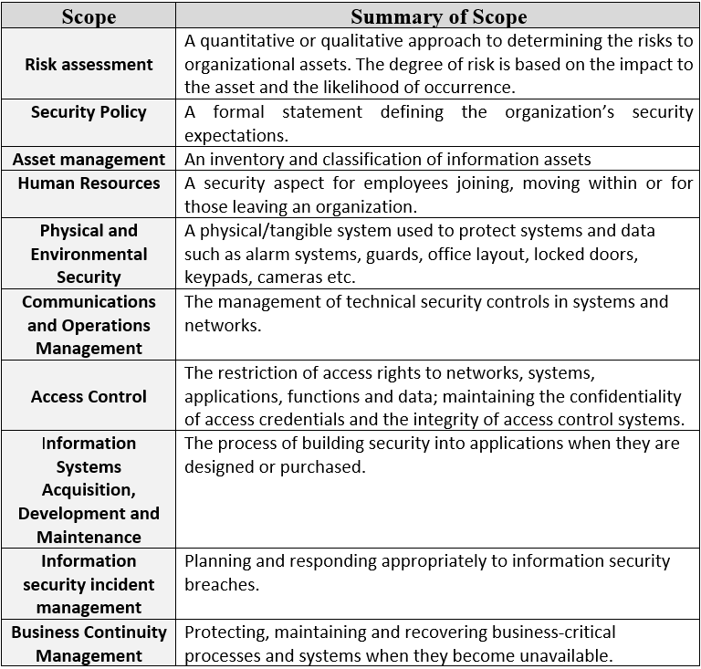
Table 2; ISO 27001-27006 standards scope summarisation [28]
The myriad of controls that are contained within the ISO 27000 series of universal standards do not all have to be implemented within a company network but rather the controls that pertain to the businesses requirements, thus why this standard was created for guidance purposes to conform with international data security regulations for the vast amount of industries that utilize computer technologies to store and transmit data.

In addition to the aforementioned series, supplementary specialist data security standards have been developed with the evolution of emerging technologies such as; ISO 27017-18 [46] released in 2015 that consists of data security guidelines pertaining to ‘Cloud’ data storage implementation and management. [46], [47]

There are seven controls within the ISO Cloud standard that can be implemented alongside ISO 27001-27006 standards within a hybrid cloud architecture.

These controls are as follows; [46], [47]

- Shared roles and responsibilities within a cloud computing environment.

- Removal of cloud service customer assets.

- Segregation in virtual computing environments.

- Virtual machine hardening.

- Administrator’s operational security

- Monitoring of cloud services

- Alignment of security management for virtual and physical networks

Cloud service architectures are steadily being adopted by businesses to centralize their network operations for ease of management and to also massively reduce costs of; specialist network professionals/infrastructure and training/maintenance that an internal datacenter requires. It is predicted by business analytics company ‘Gartner’ that the ‘cloud’ network services industry will grow to 331.2 Billion dollars by the year 2022 that will also be utilized by the majority of SME around the globe because of the monetary and flexibility benefits cloud services provide, that’s why ISO 27017-18 is such an important addition to ISO 27000 series and the future of ISMS.[135]

With the advent of the EU GDPR [21] laws as previously discussed, ISO 27701 – Privacy Information Management [48] specialist data security standard was released in response in 2019, to provide guidance to network architects/engineers so that their networks conform to the new GDPR law within the EU.

As previously discussed, the ISO 27000 is a universal standard, not a framework, that is very robust and contains a lot of granular controls for securing a wide range of business assets across multiple industries. However, for most SME utilizing the ISO 27000 ISMS and customizing it to suite the businesses requirements, would take a very long time and be very expensive for these companies to implement and get certified with the ISO organization. That’s why frameworks were developed by various professional ISMS organizations that utilize the ISO 27000 standard as the cornerstone of their framework that have been designed to be a lot less complex for Internet Technology (IT) managers and engineers to understand and comply with, as they provide an easy to follow blueprint in which a company can follow and still comply with the ISO 27000 series universal standard to secure their data, using industry best practices based on their company requirements.

ii) ITIL
The Information Technology Infrastructure Library (ITIL) [136] data security framework is the most widely utilized, flexible and highly regarded security framework in the world, due to how it addresses all fascist of IT business management strategy for data security in an industry neutral generic nature, that allows flexibility to how it can be customized and applied across multiple industries without the complexity and granular detail that ISO 27000 series provides. The ITIL framework is very robust due to the integration and customization of the ISO 2001-2006 standards without the broad depth of controls that the ISO 27000 series has within. ITIL could be defined as a watered down version of ISO 27000 standard which in essence defines it as a framework. The framework was developed by the UK government in 1989 and has been updated as data security and business requirements evolved over the years. The latest revision is ITILv4 that was released in 2019.

The ITIL framework consists of five stages within the ITIL lifecycle requirements. These stages can be found in Table 3.

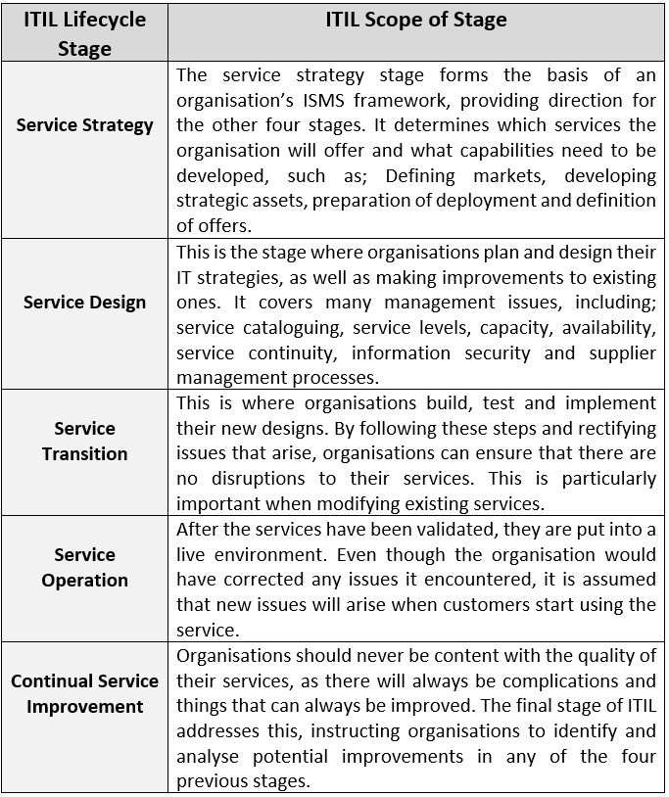
Table 3: ITIL Framework 5 Stages [137]
The stages above comprise of the foundations of the complex ISO 27000 standard but have been filtered into an easy to follow blueprint by the ITIL organization for industry best practice within data security that also conform with the generic ISMS stages previously discussed within this paper. By following the ITIL framework blueprint, companies that utilize sensitive data can effortlessly tailor the ISMS for their specific business model and asset requirements.[138]

iii) Cyber Essentials
Cyber Essentials [29] is a specialist ISMS created by the National Cyber Security Centre (NCSC) within the UK, that can be considered more of a security model rather than a framework, that is utilized alongside one or more of the major ISMS organizations standard/framework such as; ISO 27000 and ITIL. This ISMS brings more stringent controls to assets within a company already complying with a major ISMS framework that is tailored for compliance of companies that work as a third-party contractor for the UK government that handles highly sensitive data. [139]

Unlike a framework, the ‘Cyber Essentials’ security model has far fewer controls and states how to implement each control to protect assets and achieve certification as opposed to giving guidance. [140]

The five Cyber Essentials controls can be found in Table 4.

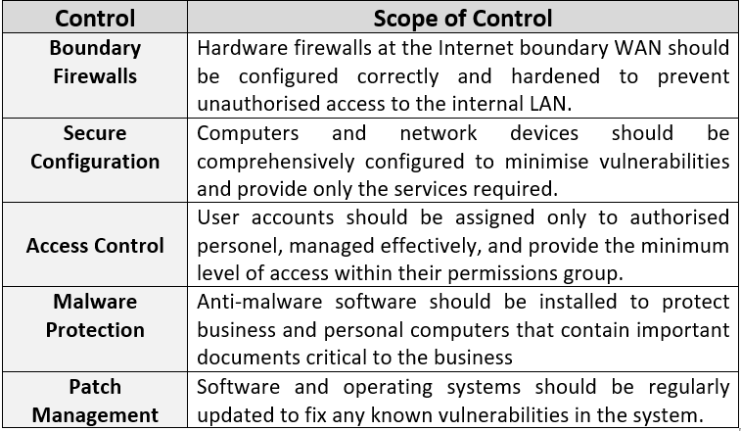
Table 4: Cyber Essentials Security Model Controls [139], [140]

A company must meet all the above controls before it can be certified to handle government data and/or contracts within the UK.

iv) PCI-DSS
Similar to the UK government Cyber Essentials security model, Payment Card Industry - Data Security Standard (PCI-DSS) [30] is designed to provide more stringent controls to an already existing ISMS framework, that is tailored for the banking industry and in particular companies that utilize credit/debit card payments though a website on the Internet. The industry leading banking merchants who utilize this framework are; PayPal, Visa, Mastercard, Discover, American Express, JCB.

There are four tiers of certification for PCI-DSS depending on the type of transactions that are being processed and the amount of transactions. These tier levels can be found in Table 5.

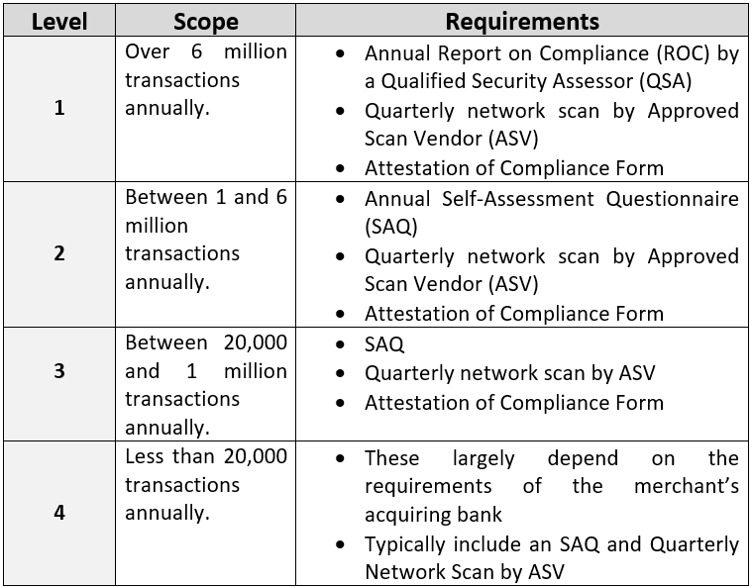
Table 5: PCI-DSS Security Model, Merchant Tier Models [141], [142]

There are also 6 controls and 12 requirements that need to be implemented within a network for full compliance with the security model, shown in Table 6. [143]

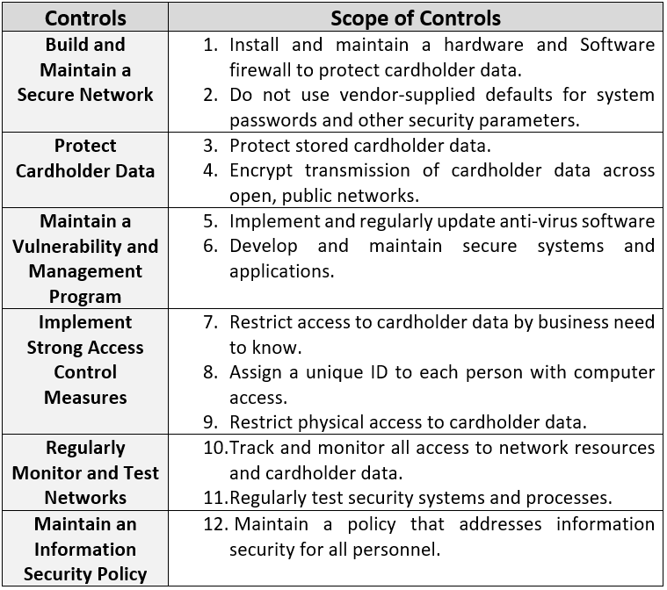
Table 6: PCI-DSS; Controls and Requirements [144] [30]
Third party banking merchants can be utilized whom are PCI-DSS certified for SME who process online credit/debit card transaction, thus mitigating the high risk of processing, storing and/or managing customers/clients’ credit and/or debit card information thus avoiding a potential fine from a data breach that ranges from $5,000 - $500,000 dollars [145], depending on the severity of the data breach.[144]

- ISMS Certifications
The aforementioned ISMS organizations award certificates to businesses whom apply for certification and fully comply to best practice data security implementations within their organizations in regards to the framework and/or standard in which the certificate adheres to, after an audit is carried out by an information security professional and/or third party data security auditing company on behalf of the accrediting body, these certificates can be utilized in conjunction with another independent specialized framework certificate by a business, to gain cybersecurity insurance in the event their network is breached and compensation has to be paid to customers and/or governmental fines for example in the form of GDPR within Europe as not all threats can be completely mitigated within a network especially emerging threats within the ever complex and evolving technologies being utilized within modern networks. [146] [147]

Appendix – B
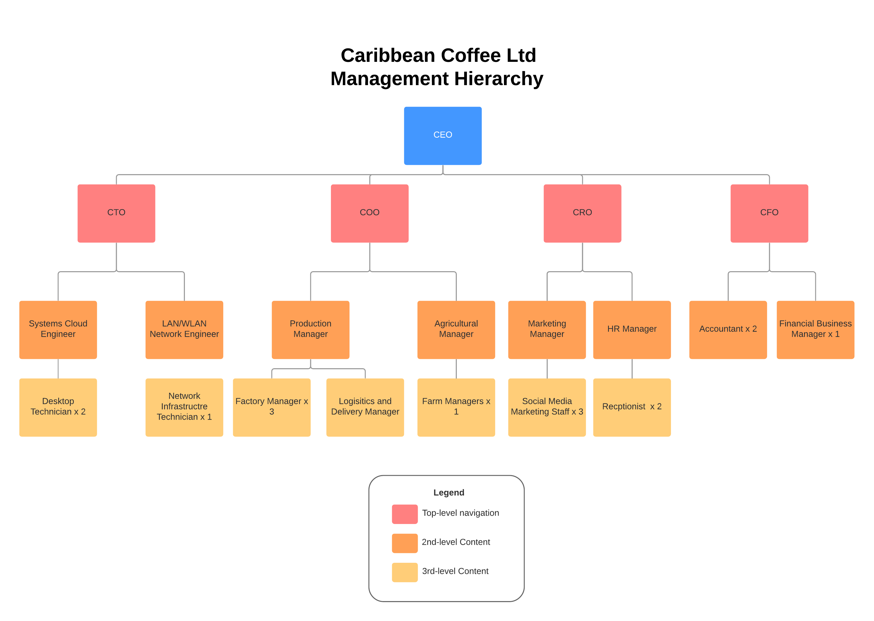
Figure 6: Caribbean Coffee Ltd Management Hierarchy

- Appendix – C
Caribbean Coffee Ltd MDM DFD Logic

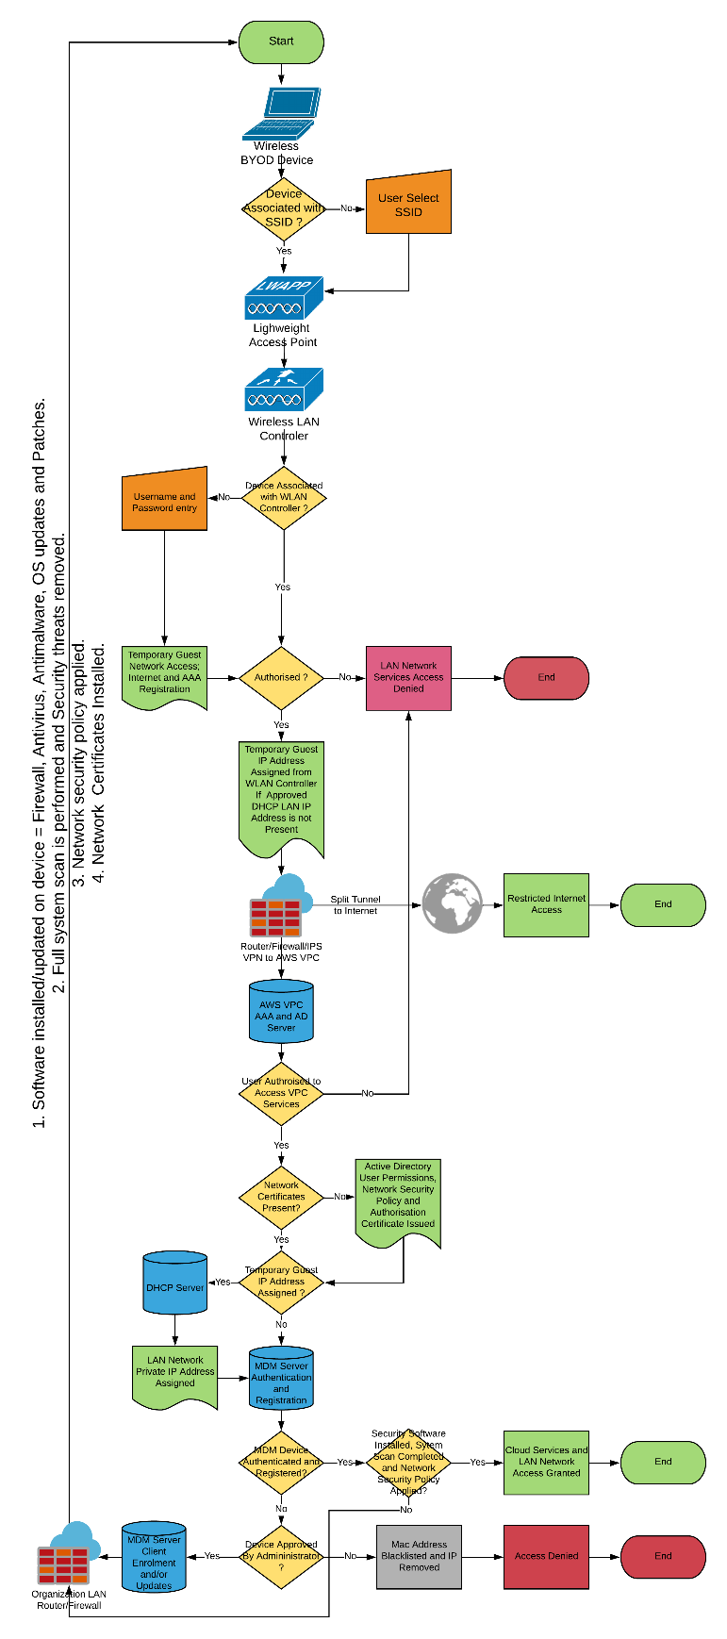
Figure 7: Caribbean Coffee Ltd WLAN-to-Cloud MDM BYOD Logic

- Appendix – C
Network Usage and Data Security Policy
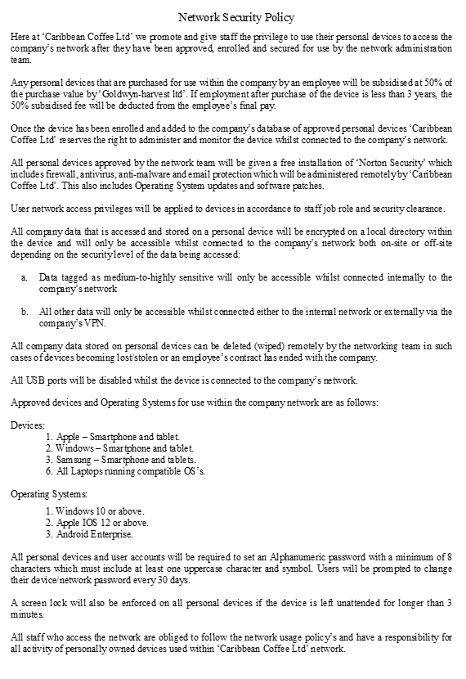
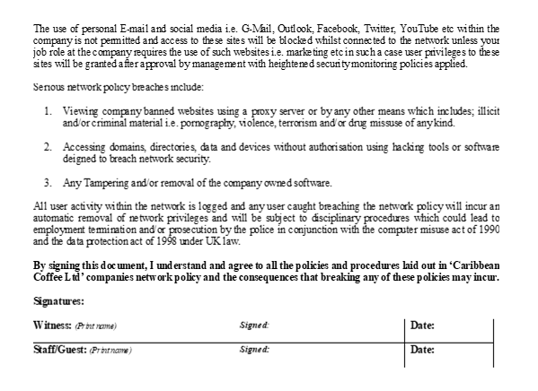
Caribbean Coffee Network Security Policy Created by Paul M Lawrence UWTSD – Swansea

- Appendix -D
‘Matrix Security’ Invoice for ‘Caribbean Coffee Ltd’ Data Security ISMS
Figure 8: Matrix Security Invoice to Caribbean Coffee Ltd for Network Security Services

- Appendix – D
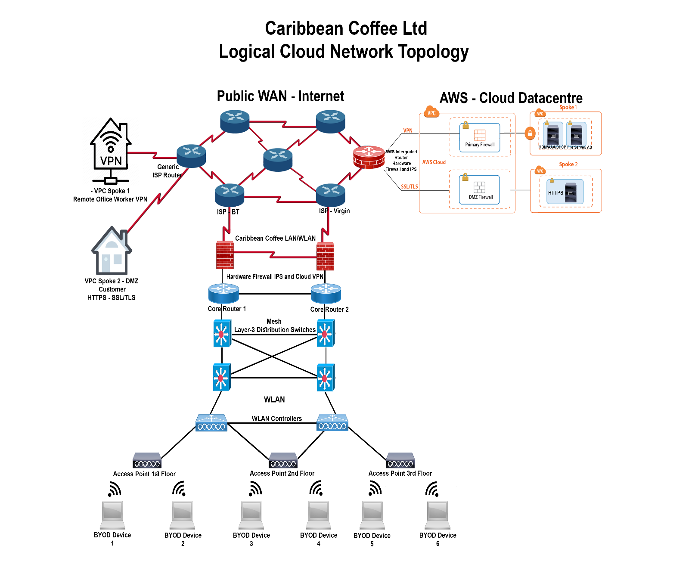
Figure 9: Caribbean Coffee Ltd Proposed Network Logical Topology

marking criteria and Student FEEDBACK

This section details the assessment criteria. The extent to which these are demonstrated by you determines your mark. The marks available for each criterion are shown. Lecturers will use the space provided to comment on the achievement of the task(s), including those areas in which you have performed well and areas that would benefit from development/improvement.

Common Assessment Criteria Applied (Assignment 1) | Marks available | Marks  awarded
1. Engagement with Literature Skills
Extent of research and/or own reading, selection of credible sources, application of appropriate referencing conventions.
You have engaged with an extensive range of relevant and credible sources. You have applied appropriate referencing convention. You could have summarised more your lit review critical discussion. (Grade mark: 93.33%) | 15 | 14
2. Knowledge and Understanding Skills
Extent of knowledge and understanding of concepts and underlying principles associated with the discipline.
Excellent understanding of the concepts of the subject area with high critical awareness of the current problems. Structure and quality of report is of an excellent standard. (Grade mark: 93.33%) | 15 | 14
3. Cognitive and Intellectual Skills
Analysis, evaluation and synthesis; logic, argument and judgement; analytical reflection; organisation of ideas and evidence
Excellent critical evaluation/critique of the research and case study discussion. However, there are some things to note which I will highlighted. Task 1 ask for you to research and discuss at least three security frameworks and models. Though you have done so, in your main report only one was discussed. You could have reduced/summarised your introduction, you could have summarised your key areas of discussions on all the framework/model (ISO 2700, ITIL, cyber essential, etc.) in the main report and includes the rest in appendix. Similarly with the case study discussions, the area on risk probability matrix the key evaluation of the diagram could be discussed and the rest goes to appendix. The architectural technologies and implementation could follow similar pattern, using the diagrams with the key recommended discussions and the rest goes to appendix. This would free up space for other key areas in the appendix to be discussed in a summary way in the main report such as the management hierarch diagram. Overall excellent report. (Grade mark: 87.50%) | 40 | 35
4. Practical Application Skills
Deployment of methods, materials, tools and techniques; application of concepts; formulation of innovative and creative solutions to solve problems.
This area has demonstrated exceptional skills with design of: 1. Packet Tracer Network Simulated design of the proposed new company network. 2. AWS VPC Spoke. 3. BOYD-Cloud MDM Logic flow chart. 4. Data Security audit and architecture invoice. 5. The Management hierarchy diagram. 6. Risk Probability Matrix. 7. Logical Cloud Network Topology. Nothing was left undone, every aspect of the case study was taken into consideration design and diagrammatically. This could be replicated for a practical real-world company. (Grade mark: 100.00%) | 20 | 20
5. Transferable Skills for Life and Professional Practice
Attributes in professional practice: individual and collaborative working; deployment of appropriate media; presentation and organisation.
Professionally done and flow excellently. Just a few minor, see comment in the report. (Grade mark: 90.00%) | 10 | 9

Assignment Mark (Assessment marks are subject to ratification at the Exam Board. These comments and marks are to give feedback on module work and are for guidance only until they are confirmed. ) | Late Submission Penalties (tick if appropriate) |  | 92%
 | Up to four weeks late |  | 92%
 | First Attempt? |  | 92%

