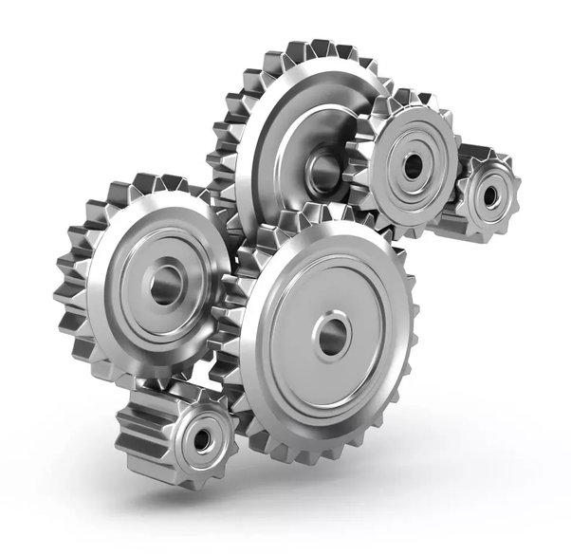

Student Name: Jordan James
Lecture Name: Morgan Lewis
Module: Engineering Design
Module Code: PSDM5010
Assignment Name: Flap Actuator Design PDS

Table of Contents
1.0 Design Brief 6
2.0 Product Design Specification 7 - 9
2.1 Performance 7
2.2 Environment 7
2.3 Life in Service 7
2.4 Maintenance 7
2.5 Shipping 7
2.6 Packing 8
2.7 Quantity 8
2.8 Size 8
2.9 Weight 8
2.10 Aesthetics, Appearance & Finish 8
2.11 Materials 8
2.12 Standards 8
2.13 Customer 9
2.14 Time Scales 9
2.15 Testing 9
2.16 Safety 9
2.17 Documentation 9
2.18 Disposal 10

3.0 Actuator Research 11 & 13
4.0 Gear Research 14
5.0 References 15
6.0 Bibliography 16

1.0 Design Brief
The brief of this project is to design a power screw flap actuator that can be used in a light aircraft. The actuator must be powered using power screws, gears, and shafts. The power screws need to be operated by an electromotor and gearbox which should be designed and supported with relevant calculation to prove the design.

2.0 Product Design Specification
2.1 Performance
- The actuator must achieve successful operation of adjusting the surface area and profile of the flaps on the aircraft wing.
- The power screw for the actuator must attain a linear velocity underload of 10.0m/s.
- Electromotor needs to be designed to operate at maximum rate for 10 hours per day for 8 years.
- The actuator needs to have a maximum extension of 200mm.
- The maximum force the actuator must produce is 11000N.

  - Environment
- The actuator must be able to operate at the maximum height that the aircraft can fly at.
- The design of the actuator must consider the pressure range as this will vary dependant on the altitude the aircraft is flying at.
- The actuator and motor must be exposed to minimal dust and dirt during fabrication, shipping, and operation. Too much exposure can potentially damage the design or effect the operation efficiency.

  - Life in service
- The life in service of the actuator is for it to operate at maximum speed for 10 hours a day, for a duration of 8 years.

  - Maintenance
- General maintenance on the aircraft actuator must take place prior to the aircraft taking off. Detailed maintenance must take place every ten weeks. This maintenance should take between 2-6 hours.

  - Shipping
- Th product is to be shipped to the fabrication shop by truck transit on land. The load is to be packed and fastened securely to avoid any unprovoked damage to the goods. The actuator is to be transported on a pallet so it can be loaded and removed by a forklift.

  - Packing
- The actuator is to be placed in an insulated padded container. Packing around the actuator is to be used to stop the actuator from moving around, and potentially damaging it. The container is to be secured to a pallet for ease of loading and unloading.

  - Quantity
- Two actuators are to be manufactured. The designs are to be identical.

  - Size
- The actuator is to be as compact as possible. Smaller the actuator, lighter the actuator will be. This is important as aircraft will require a lightweight flap mechanism. The extension of the actuator is to be exactly 200mm.
- The actuator is to be powered by a gear arrangement. The maximum size of the largest gear is not to exceed 150mm in diameter.

  - Weight
- The actuator system is to be lightweight, so it is a suitable replacement to the current hydraulic actuators. The actuator is not to exceed 10kg. This weight will be a benefit as no mechanical assistance will be required when handling.

  - Aesthetics, appearance, and finish
- The actuator does not need to be aesthetically pleasing as it will not be visible. The casing of the actuator is to have a smooth finish and be box shaped, but strong enough to protect the gear arrangement and actuator.

  - Materials
- The actuator is to be made from aircraft grade aluminium. This because it has a great strength to weight ratio and resistance to corrosion. It is important that all aspect of an aircraft is made lightweight as possible to help the aid of take-off and in flight manoeuvring.
- The gears and shafts to be made from aluminium as well. Even though gears are usually made from steel, aluminium is to be used as the force acting on the gears is minimal. Also, aluminium is lighter and cheaper than steel.

  - Standards
- The design and manufacturing of the actuator must comply with ISO 22153:2020.

  - Customer
- The customer of this product would be airline companies, such as Airbus or Virgin.
- The actuator will also be desired by private owners of aircraft.

  - Time scales
- The product is to be designed within
- 8 weeks. During this time, all drawings and calculations must be produced along with any other relevant documentation. Within this time frame the actuator designed effectively and efficiently.

  - Testing
- The actuator must be rigorously tested before issuing to any clients. The testing procedure should ensure the actuators is fully functional with no anomalies that could potentially affect the function of the actuator.
- The testing should be carried out in a controlled environment and all variables must be taken into consideration.

  - Safety
- The product must be manufactured in an environment that complies with the ‘Health and Safety at Work Act’ (HSE, 1974)
- During manufacturing all workers must comply with ‘COSHH’ (HSE, 2002) as they will be exposed to chemical substances.

  - Documentation
- The product is to have full written documentation along with all design and manufacturing drawings. The drawing will need to be backed up will relevant calculations that support the decisions made in the designing process.
- All documentation is to be provided to the client and manufacturer on completion of the actuator design.

  - Disposal
- The actuator and gears will be predominantly made from metal. All waste material is to be gathered and disposed correctly and as environmentally friendly. Any unused material to be re-used for future projects.

3.0 Actuator Research
An actuator is a device that converts energy into motion, whilst also being able to apply force. Actuators are mechanical devices that take energy which is produced by a fluid and converts it into a linear or rotary motion. There are several types of actuators. One being a hydraulic actuator, a hydraulic actuator has a cylinder-piston configuration. This meaning pressurised fluid pushes the piston, forcing it to move in a linear motion. Hydraulic actuators convert energy produced by pumps into linear or rotary meaningful work. Hydraulic actuators work by having a supply and return line connected them. ‘The lower chamber begins to fill with high pressurised fluid, posing a force on the underside of the piston which is being opposed by a spring on the top side of the piston’ (Innocent 2018). Once the hydraulic force in the chamber is greater than the force being opposed by the spring, the piston will begin to move, thus giving meaningful linear work. Hydraulic actuators tend to be used in industries where large amounts of force are required, they can produce ‘forces 25 times greater than pneumatic cylinders of equal size’ (Smith, 2004, p.293). The hydraulic actuator can withhold its force and torque even without the pump pumping more fluid into the chamber of the actuator. This is due to the incompressibility of hydraulic fluids. Disadvantages to hydraulic actuators will require tubing for the hydraulic fluid. If the actuator is remote, long runs of tubing will be required and will cause a pressure drop which could forbid the use of hydraulic actuators. Hydraulic actuators are costly to fabricate as the components of the actuator are machined to a high tolerance to ensure a successful seal throughout the actuator. This can cause a problem in the event of fire and it is likely that the actuator will not operate as usual due to different environment conditions. The hydraulic fluid the actuators are supplied have a high thermal expansion rate, a consequence of this is that the tubing system will have to be protected from potential fires. Also, due to the thermal expansion of the fluid, a relief design may need to be design and fabricated into the system to overcome any over pressurization. Both these factors will come at an additional supply and install cost along with a significant engineering design cost.
‘Pneumatic supply is generally compressed dry air, but designs are also available for natural gas’ (Smith, 2004). They are cheaper than hydraulic actuators due to the simplistic design and require minimum maintenance. Pneumatic actuators are not as powerful as hydraulic actuators but can be used for most applications which require linear motion.

Pneumatic actuators are powered by dry compressed air, but natural gas can be used as an alternative with a few design modifications to the actuator. There are three main types of pneumatic actuator:

- Diaphragm types
- Piston types
- Vane type
Electromechanical actuators work in a similar fashion to pneumatic actuators but are powered by an electric power source. A electromechanical device uses electricity to convert into a useful mechanical force. A popular power source is an electric motor. The electro motor will power a gear assembly which will operate the actuator itself. The electric motor will be fabricated to a metal shaft which will have a range of gears mounted tot them. The shaft and gears will operate in a rotary motion and will convert into linear motion when connected up to the actuator. The electric motor uses an electric current to generate a magnetic field which causes the metal shaft to rotate resulting in a rotatory force. The motor creates rotary motion by the basic principles of AC generation.

Figure 1 - Tutors (2016) What is the concept of AC generation.
Figure 1

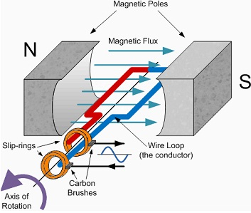

AC generators are generally used in powerplants as they tend to be cheaper to produce and have the ability to step up and step down via transformers to supply electricity to range of equipment. There are two types of AC generators, synchronous and induction.

An AC generator produces electricity based on the principle of electromagnetic induction. A radial magnetic flux is produced between the magnetic poles where the coil is rotating. Therefore, a change in flux linked to a coil induces an electric current in the coil. The direction of the induced current in the coil can be given by Fleming’s left-hand rule. The current passes down through the coil to the slip rings (the slips rings rotate with the coil. The current leaves the slips rings via the carbon bushed to a voltmeter and then renters onto the opposite side of the coil. The coil needs to be rotating consistently to be able to provide a stable AC voltage.

4.0 Gears
Gears are used in the design of actuators, they are able to change the direction of rotation, alter the torque and manipulate the rotational speed. Gears are utilised in most mechanical applications and can be large or small. However, gears need to be specially designed as they can fail on many parameters. Gears normally fail due exceeding allowable stress but can also fail due to fatigue. Therefore, it is important that they undergo routine maintenance to prevent failure.
There are many types of gear, helical, spur, worm, and bevel gear. Spur gears are commonly used due to their simplistic design. The teeth are parallel to the axis of rotation and are used to transmit motion from one parallel shaft to another. Helical gears work in a similar fashion to spur gears, but the teeth are inclined to axis of rotation. The allows the gear to engage more gradual, putting less initial impact on the gear teeth. Also, with teeth being inclined a development of thrust loads and bending couples arise. Bevel gears operate slightly different as the teeth are formed on a conical surface are used to transmit motion between intersecting shafts compare to parallel ones. For the design of this actuator, a spur gear arrangement will be pursued due to the actuator being mounted and connected to parallel shafts. Spur gears are strong type of gear and can be manufactured to fit into small spaces due to their simplistic design layout. Spur gears are also carrying positive transmission due to none of the teeth slipping as they are designed and manufactured with straight teeth.
When designing gears there are many parameters that need to be considered such as the
pitch and base circle of the gear, this will determine the size of the gear body. The module of the gear is the number of teeth it has. For a set of gears to mesh correctly both modules must be equal. The train value must be determined by dividing the output RPM by the input RPM. The maximum power, torque and speed must be calculated. These values are important, so that the operator can use the gear to its maximum potential before failure.

5.0 References

ISO-22153:2020- Electric actuators for industrial valves – General requirements

Innocent, A (2018) What is a Hydraulic Actuator? Available at: What is a Hydraulic Actuator? | Instrumentation Tools (Accessed: 05/02/2021)

Smith, P (2004) Valve Selection Handbook. Oxford: Gulf Professional

HSE (1974) Health and Safety at Work Act 1974. Available at Health and Safety at Work etc Act 1974 – legislation explained (hse.gov.uk) (Accessed: 29/01/2021)

HSE (2002) Control of Substances Hazardous to Health. Available at: COSHH basics - COSHH (hse.gov.uk) (Accessed: 29/01/2021)

Tutor (2016) Electric Hub What is Alternating Current. Available at: What is Alternating Current?? (electronicshub.org) (Accessed: 01/03/2021)

6.0 Bibliography

Smith, P (2004) Valve Selection Handbook. Oxford: Gulf Professional

IET (2018) Requirements for Electrical installation BS 7671:2018. London: Institution of Engineering and Technology

HSE (1974) Health and Safety at Work Act 1974. Available at Health and Safety at Work etc Act 1974 – legislation explained (hse.gov.uk) (Accessed: 29/0/2021)

HSE (2002) Control of Substances Hazardous to Health. Available at: COSHH basics - COSHH (hse.gov.uk) (Accessed: 29/0/2021)

Hughes, B (2019) Masoneilan- Control Valve Sizing Handbook. London: GE Company

HSE (1992) Manual Handling at work. Available at: Manual handling at work: Overview - HSE (Accessed: 29/0/2021)

John Bird (2017). Electrical and Electronic Principles and Technology.: Newnes.

